Supplementary Section

Identification of novel exosomal miRNAs and their prognostic significance in Triple Negative Breast Cancer

Ananya Choudhary¹, Priyanka Jain¹, Satish S. Poojary¹, Harit Chaturvedi², Bhudev C. Das¹*

- Amity Institute of Molecular Medicine and Stem Cell Research, Amity University Uttar Pradesh, India
- Max Institute of Cancer Care, Max Super Speciality hospital, Saket, New Delhi, India,

*Correspondence should be addressed to Bhudev Das, bcdas@amity.edu

Corresponding Author
Prof. Bhudev C. Das,
Amity Institute of Molecular Medicine & Stem Cell Research (AIMMSCR),
Amity University, Sector-125, Noida, 201313,
Uttar Pradesh, India.
Tel: +91-120-2586855, +91-9810566870
Fax: +91-120-4392114
E-Mail:- bcdas@amity.edu

Supplementary Figures : Workflows and Experimental Strategies
Figure 1
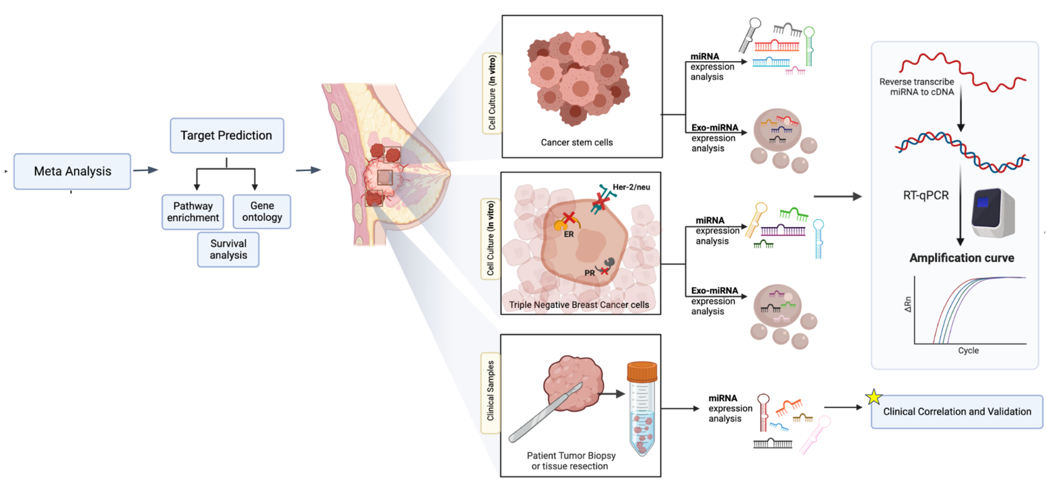
S1(Fig 1): Study workflow and etiological model for analysis of exomiRs released by TNBC and TNBC stem cells; figure created with Biorender.com

Figure 2

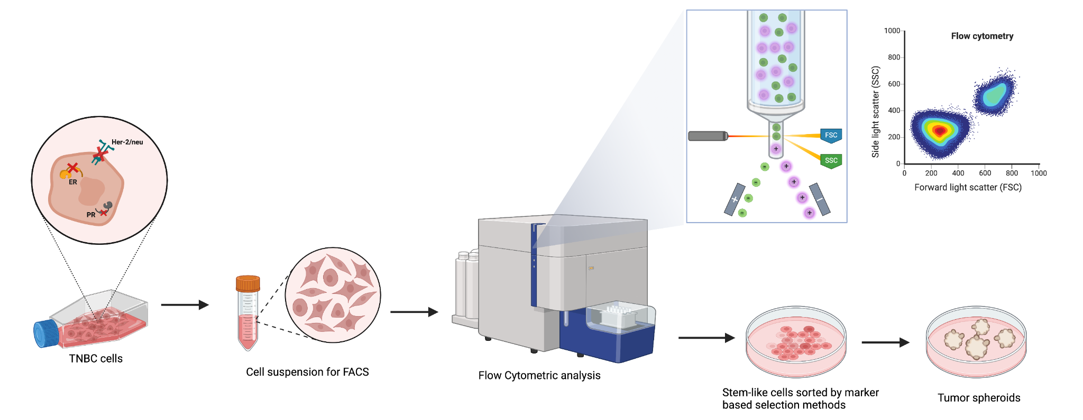
S1 (Fig 2) Representative model (workflow) depicting the isolation and characterization of TNBC derived stem-like cells. Cancer cell suspension is analysed by fluorescence activated cell sorting machines (FACS) by means of marker-based selection methods and dye-exclusion assays. Figure created with Biorender.com

Western Blots
WB Full size images
Full size blots for Fig 4 (d): Immunoblot showing expression of CD81 exosomal marker in TNBC cell line MDA-MB 231 derived exosome samples. Calnexin is used as a negative control while β-Actin is used as a positive control

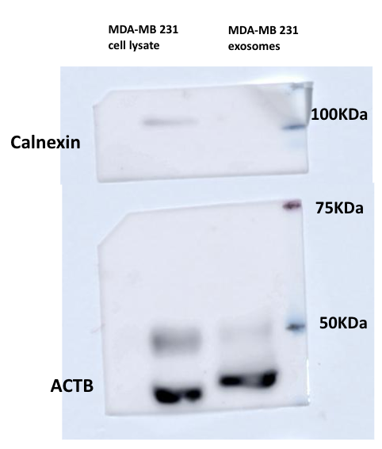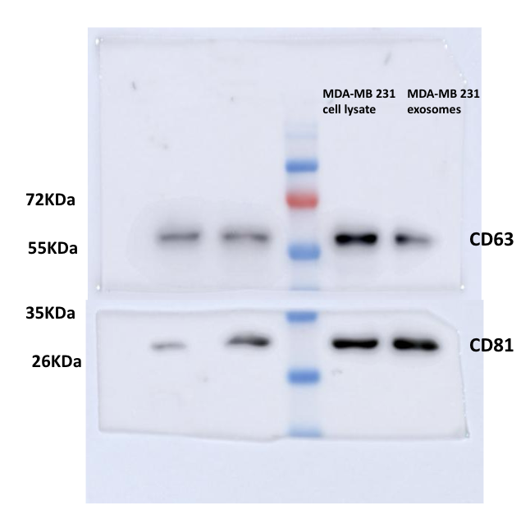

Full size blots for Fig 6 (H): Immunoblot showing expression levels of SOX2 in TNBC tumorspheres and cancer cells. GAPDH was used as positive control

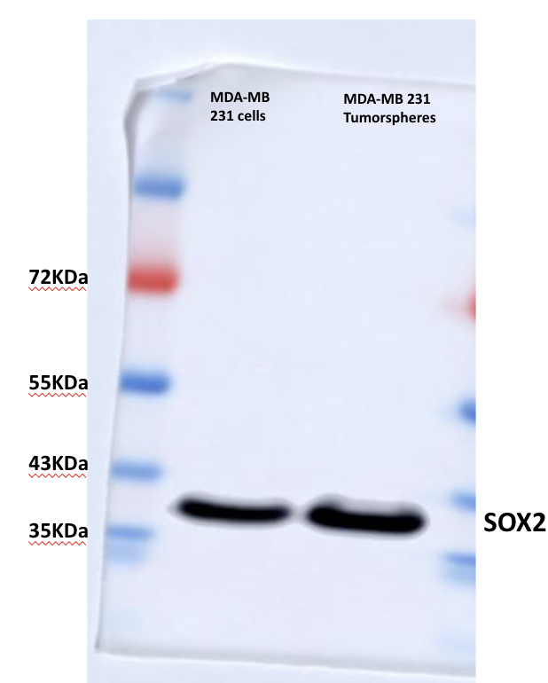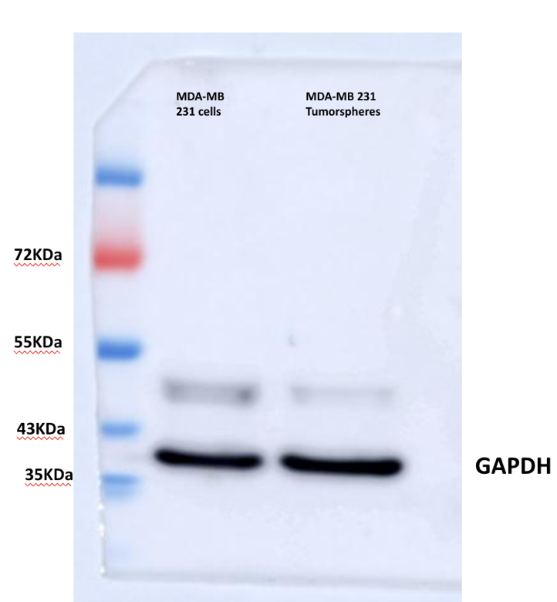

Supplementary Table 1 (S1) : List of RT-qPCR primers used in the study
SNo. | Primers | Sequence
1 | Sox2 | F: CGAGATAAACATGGCAATCAAATG  R: CACCAGAACAAATTCCGTTTGCAA
2 | ABCG2 | F: GCAGATGCCTTCTTCGTTATG  R: TCTTCGCCAGTACATGTTGC
3 | ALDH1 | F: GTCCTACTCACCGATTTGAA  R: CTTGTATAATAGTCGCCCCC
4 | miR 1915-3p  (stem loop) | GTTGGCTCTGGTGCAGGGTCCGAGGTATTCGCACCAGAGCCAACCCCGCC
5 | miR 1180-3p (stem loop) | GTTGGCTCTGGTGCAGGGTCCGAGGTATTCGCACCAGAGCCAACTATTCC
6 | miR 940  (stem loop) | GTTGGCTCTGGTGCAGGGTCCGAGGTATTCGCACCAGAGCCAACACCACA
7 | miR 6803  (stem loop) | GTTGGCTCTGGTGCAGGGTCCGAGGTATTCGCACCAGAGCCAACACGCCC
8 | miR 4728  (stem loop) | GTTGGCTCTGGTGCAGGGTCCGAGGTATTCGCACCAGAGCCAACCTGGGG
9 | miR 1180-3p (Forward) | TTTTTGGACCCACCCGGC
10 | miR 1915-3p  (Forward) | TTTTTCCCCAGGGCGACG
11 | miR 940  (Forward) | TTGTTAAGGCAGGGCCCC
12 | miR 6803  (Forward) | TTTTTCTGGGGGTGGGGG
13 | miR 4728  (Forward) | GTTTCATGCTGACCTCCCT
14 | Universal Reverse | GTGCAGGGTCCGAGGT

