Online Resource 3

Supplementary Figure A. Explanation of the choice task from the English version of the FACT-8D valuation survey
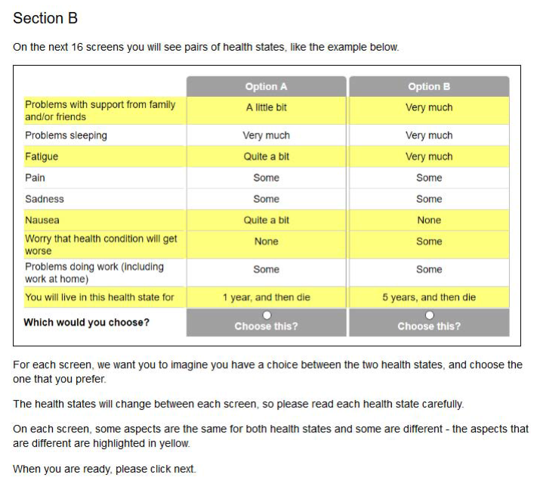

Supplementary Figure B. An example choice set from the discrete choice experiment valuation task as seen by Japanese survey participants

