Online Resource 5

Supplementary Appendix C. Data Quality Results

In total, 78 of the 2,320 people who completed all choice sets answered the same for every DCE task (i.e. 3.4% gave either all A’s or all B’s across their completed choice sets). When the data from these 78 respondents were excluded and the unweighted constrained conditional logit was re-estimated, there was little difference (max absolute difference of 0.0027) and no evidence of bias (mean difference of -0.0015).

Statistics on time for survey completion were: median 14 minutes 29 seconds (14’29”), interquartile range 9’09” to 17’53”, minimum 2’48”, maximum 60’03”.

Figure C shows that respondents in all completion time deciles sped up as they became
more familiar with the choice task.

Figure D shows the fastest completion time decile yielded the least statistically significant coefficients (8/33) and those in the middle deciles yielded the most (up to 24/33 in the 4th decile).

Supplementary Figure C. Distribution of time to completion by choice set
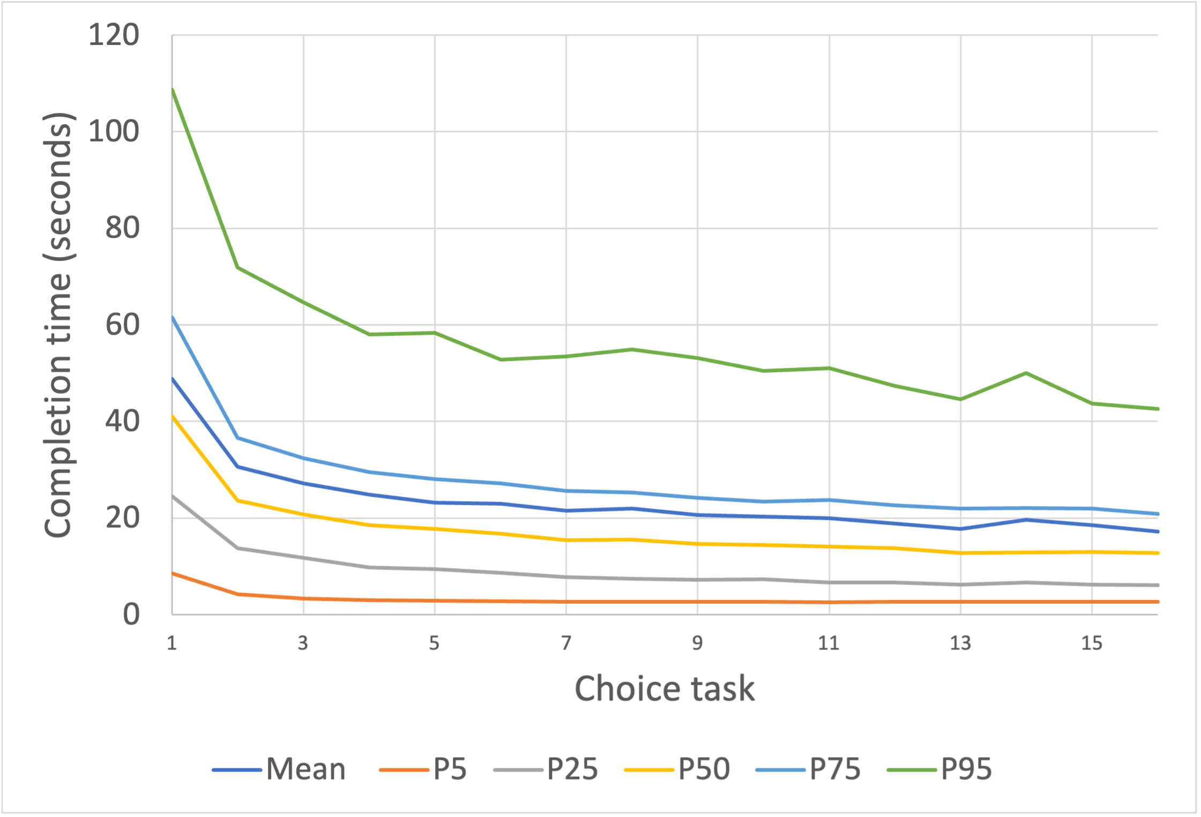

Supplementary Figure D. Relationship of completion time decile with model fit and number of statistically significant coefficients
