Table 1. The structural information and physicochemical properties of flavonoids. The range of yellow, red, and blue represent upper limit, lower limit, and compound properties, respectively.
PubChem CID | Name | Molecular Formula | 2D Structure | Physicochemical Property
125309 | Cyrtominetin | C₁₇H₁₆O₆ | 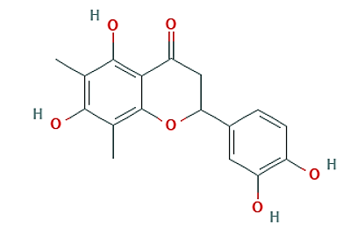 | 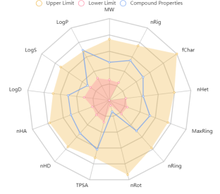
5280343 | Quercetin | C₁₅H₁₀O₇ | 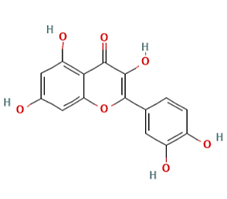 | 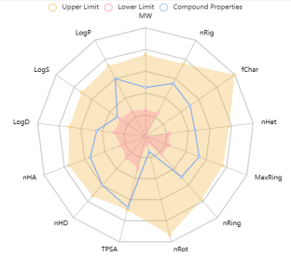
5281953 | Syringetin | C₁₇H₁₄O₈ | 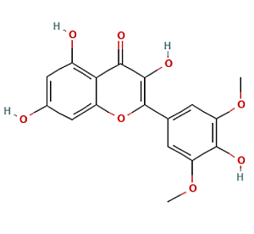 | 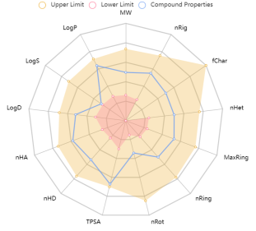
5280961 | Genistein | C₁₅H₁₀O₅ | 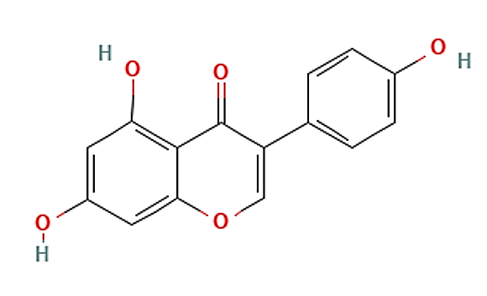 | 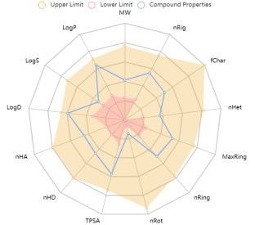
5320287 | Ombuin | C₁₇H₁₄O₇ | 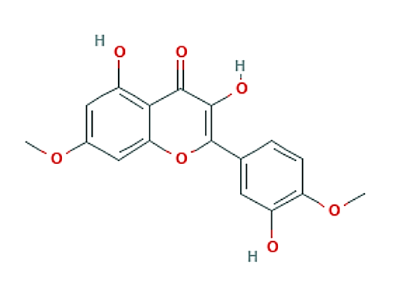 | 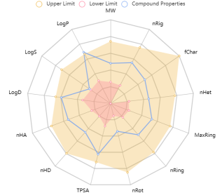
5280863 | Kaempferol | C₁₅H₁₀O₆ | 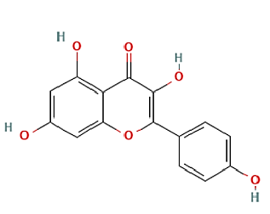 | 