Supplementary information

Ye Liu^{1†}, Yonghao Liu^{1†}, Zhifei Ye^{2†}, Xinxin Wang³, Junyi Li¹, Peter L Mei⁴, Li Duan¹, Ben Wang², Chun Xu⁵, Wei Xiong^{7***}, Yan He^{3,6**}, Qingsong Ye^{1,2,5*}

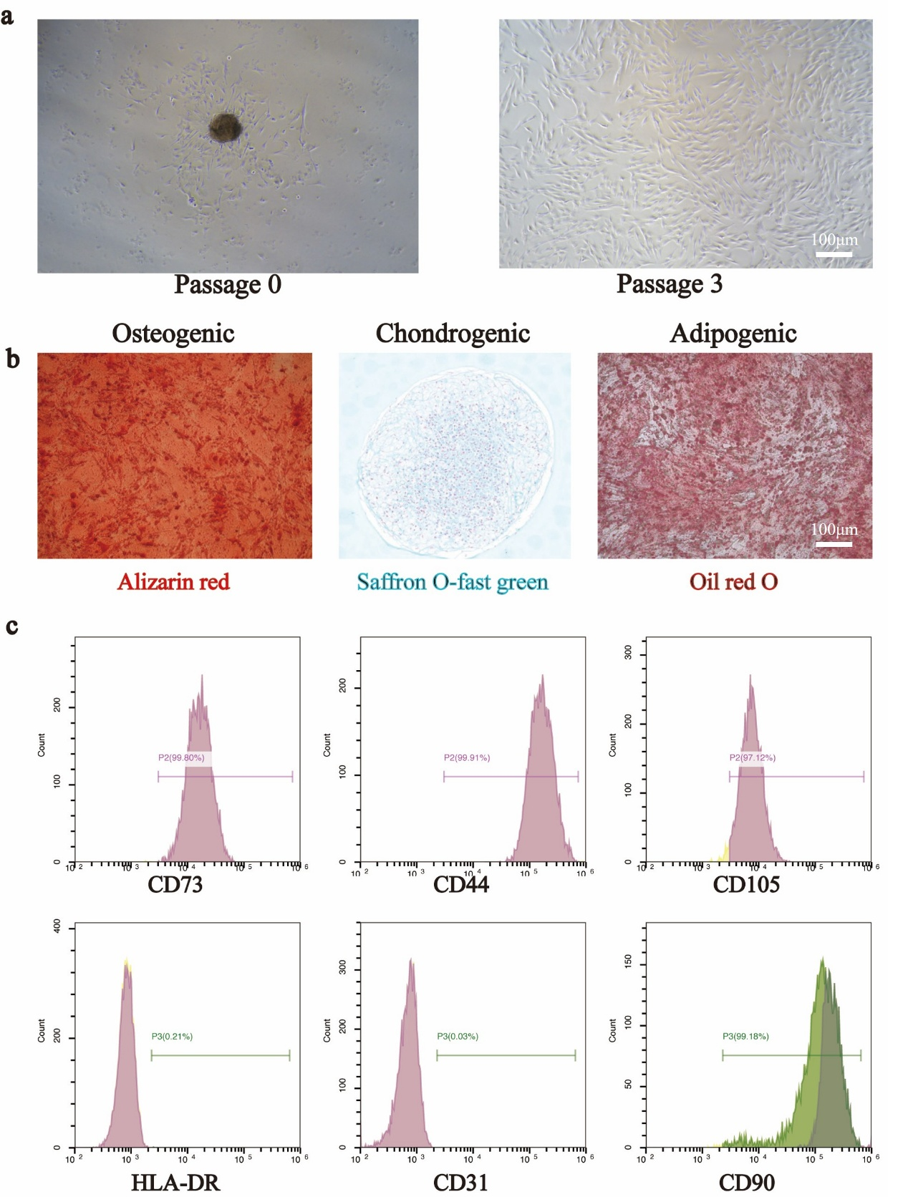

Figure S1. The morphology, differentiation potential, and phenotype of DPSCs were characterized. (a) The morphology of DPSCs (P0 or P3) were showed under light microscopy. Scale bar=100 μm. (b) The multi-lineage differentiation potential of DPSCs were confirmed. (c) Flow cytometry revealed DPSCs were positive for mesenchymal lineage markers (CD44, CD73, CD105 and CD90), negative for hematopoietic markers (CD31 and HLA-DR).

Supplementary Table 1B. Antibodies used in this study
Antibody | Cat No: | Company | Species | Application
Ki67 | A20018 | ABclone | Rabbit | ICC
TNF-α | 60291-1-Ig | Proteintech | Mouse | WB
IL-6 | 21865-1-AP | Proteintech | Rabbit | WB
IL-10 | 60269-1-Ig | Proteintech | Mouse | WB
RUNX2 | 20700-1-AP | Proteintech | Rabbit | WB/IF
OCN | A20800 | ABclone | Rabbit | WB/IF
CD31 | 11265-1-AP | Proteintech | Rabbit | WB/IF
GAPDH | 60004-1-Ig | Proteintech | Mouse | WB

