Substrate Affinity as a Key Adaptive Mechanism in Ammonia Oxidation under Acidification
Senwei Tong¹, Hui Shen¹, Li-Li Han², Jin-Ming Tang¹, Xianhui S. Wan¹, Zhen-Zhen Zheng^{2, 3*}, Shuh-Ji Kao^{2*}.
¹State Key Laboratory of Marine Environmental Science, College of Ocean and Earth Sciences, Xiamen University, Xiamen, China.
²State Key Laboratory of Marine Resources Utilization in South China Sea, Hainan University, Haikou, China
³School of Marine Science and Engineering, Hainan University, Hainan, China
*Corresponding author Email: zzz@hainanu.edu.cn; sjkao@hainanu.edu.cn

Supplementary Discussions
The Combined Impact of Substrate Availability and Affinity on Ammonia Oxidation under Ocean Acidification
To evaluate the individual and combined effect of ocean acidification on substrate availability and substrate affinity, we tested three models to predict the ammonia oxidation to ocean acidification: (I) S Avail model: considering solely the effect of substrate availability, without accounting for changes in substrate affinity induced by acidification (substrate-availability based theory proposed by previous researchers) (Fig. 4a); (II) S Affin model: considering solely the changes in substrate affinity induced by acidification, without accounting for the effect of substrate availability (Fig. 4b); (III) S Avail + S Affin model: both the two effects were taken into account (Fig. 4c, d). When comparing the fitted results with the observed results, we found the observed results were best fitted when both substrate availability and substrate affinity were considered (Supplementary Fig. 5, 6). We analysis of Taylor diagrams for the three models revealed that the S Avail + S Affin model exhibited the closest standard deviation to the observed results and the highest correlation coefficient (Supplementary Fig. 5), reinforcing the counteractive effects of substrate availability and substrate affinity in determining the net change of ammonia oxidation to the changing pH. Further assessed the model performance under a series of substrate concentrations using Root Mean Square Error (RSME), We found that the model incorporating the coupled effects of S Avail and S Affin yielded the smallest RSME across all study regions at all the tested pH levels(Supplementary Fig. 6).
Supplementary Table S1. List of environmental parameters, including study areas, stations, sampling depth, bottom depth, temperature, salinity, pH, ambient NH₄⁺, NO₂⁻ , NO₃⁻ concentration.

Study  area | Station | Sampling  depth (m) | Bottom  depth (m) | Temperature  (℃) | Salinity | pH_{T}  (converted from pH_{NBS}) | NH₄⁺  (nM) | NO₂⁻  (nM) | NO₃⁻  (nM)
Shanmei  Reservoir | SM | 16 | 42 | 17 | 0 | 7.549 | 350 | 679 | 131000
Pearl River Estuary | PRE1 | 7 | 10 | 31 | 0.14 | 7.935 | 905 | 3150 | 119000
Pearl River Estuary | PRE2 | 5 | 21 | 27 | 19.90 | 7.698 | 1580 | 1360 | 18600
Pearl River Estuary | PRE3 | 14 | 16 | 23 | 33.30 | 7.792 | 569 | 2900 | 2810
Pearl River Estuary | PRE4 | 8 | 9 | 23 | 33.90 | 7.752 | 200 | 333 | 1250
Pearl River Estuary | PRE5 | 16 | 35 | 28 | 34.30 | 8.060 | 256 | 36 | 95
Jiulong River Estuary | JRE0 | 4 | 9 | 20 | 4.10 | 7.483 | 58700 | 1060 | 182000
Jiulong River Estuary | JRE1 | 0.5 | 9 | 18 | 23.14 | 7.846 | 880 | 1010 | 28900
Jiulong River Estuary | JRE2 | 4 | 10 | 16 | 24.03 | 7.866 | 271 | 759 | 25700
Jiulong River Estuary | JRE3 | 0.5 | 10 | 24 | 29.05 | 7.921 | 2360 | 4120 | 41800
Tropical  Northwest  Pacific | NWP1 | 140 | 5724 | 23 | 34.84 | 8.090 | 27 | 13 | 1080
Tropical  Northwest  Pacific | NWP2 | 140 | 4966 | 26 | 34.94 | 8.166 | 23 | 39 | 367

Supplementary Table S2 List of experimental parameters in field study

Study area | Station | Incubation  time point (h) | In-Situ NH₄⁺  (nM) | pKa  (NH₃/NH₄⁺) | pHnbs  (measured by electrode) | Incubation  pH_{T} (converted from pH_{NBS}) | ΔpH  (compared with In-situ) | ¹⁵N-NH₄⁺ added  (nM) | Total NH₄⁺  (nM) | Total NH₃  (nM)
Shanmei  Reservoir | SM | 0, 15, 21 | 350 | 9.50 | 7.549 | 7.549 | 0 | 4990 | 5340 | 60
 |  |  |  |  |  |  |  | 19980 | 20330 | 229
 |  |  |  |  |  |  |  | 49940 | 50290 | 567
 |  |  |  |  |  |  |  | 99880 | 100230 | 1130
 |  |  |  |  |  |  |  | 199760 | 200110 | 2256
 |  |  |  |  | 7.340 | 7.340 | -0.209 | 19980 | 20330 | 142
 |  |  |  |  | 7.130 | 7.130 | -0.419 | 4990 | 5340 | 23
 |  |  |  |  |  |  |  | 19980 | 20330 | 87
 |  |  |  |  |  |  |  | 49940 | 50290 | 216
 |  |  |  |  |  |  |  | 99880 | 100230 | 431
 |  |  |  |  |  |  |  | 199760 | 200110 | 860
 |  |  |  |  | 6.730 | 6.730 | -0.819 | 4990 | 5340 | 9
 |  |  |  |  |  |  |  | 19980 | 20330 | 35
 |  |  |  |  |  |  |  | 49940 | 50290 | 86
 |  |  |  |  |  |  |  | 99880 | 100230 | 171
 |  |  |  |  |  |  |  | 199760 | 200110 | 342
 |  |  |  |  | 6.355 | 6.355 | -1.194 | 19980 | 20330 | 15
Continued on the next page

Supplementary Table S2 (continued 1)
Study area | Station | Incubation  time point (h) | In-Situ NH₄⁺  (nM) | pKa  (NH₃/NH₄⁺) | pHnbs  (measured by electrode) | Incubation  pH_{T} (converted from pH_{NBS}) | ΔpH  (compared with In-situ) | ¹⁵N-NH₄⁺ added  (nM) | Total NH₄⁺  (nM) | Total NH₃  (nM)
Pearl River  Estuary | PRE1 | 0, 10, 18 | 905 | 9.06 | 7.959  7.472  7.038 | 7.935  7.448  7.014 | 0  -0.487  -0.921 | 4000 | 4905 | 369
 |  |  |  |  |  |  |  |  |  | 120
 |  |  |  |  |  |  |  |  |  | 44
Pearl River  Estuary | PRE2 | 0, 14 | 1577 | 9.15 | 7.834  7.700  7.586 | 7.698  7.564  7.450 | 0.000  -0.134  -0.248 | 3964 | 5541 | 197
 |  |  |  |  |  |  |  |  |  | 144
 |  |  |  |  |  |  |  |  |  | 111
Pearl River  Estuary | PRE3 | 0, 12, 19 | 569 | 9.30 | 7.928  7.674  7.458 | 7.792  7.538  7.322 | 0.000  -0.254  -0.470 | 800 | 1369 | 43
 |  |  |  |  |  |  |  |  |  | 24
 |  |  |  |  |  |  |  |  |  | 15
Pearl River  Estuary | PRE4 | 0, 11, 25 | 200 | 9.30 | 7.888  7.668  7.448 | 7.752  7.532  7.312 | 0.000  -0.220  -0.440 | 4000 | 4200 | 120
 |  |  |  |  |  |  |  |  |  | 72
 |  |  |  |  |  |  |  |  |  | 43
Pearl River  Estuary | PRE5 | 0, 16, 24 | 256 | 9.13 | 8.191  7.962  7.758  7.373 | 8.060  7.831  7.627  7.242 | 0.000  -0.229  -0.433  -0.818 | 2000 | 2256 | 193
 |  |  |  |  |  |  |  |  |  | 114
 |  |  |  |  |  |  |  |  |  | 71
 |  |  |  |  |  |  |  |  |  | 29
Continued on the next page

Supplementary Table S2 (continued 2)
Study area | Station | Incubation  time point (h) | In-Situ NH₄⁺  (nM) | pKa  (NH₃/NH₄⁺) | pHnbs  (measured by electrode) | Incubation  pH_{T} (converted from pH_{NBS}) | ΔpH  (compared with In-situ) | ¹⁵N-NH₄⁺ added  (nM) | Total NH₄⁺  (nM) | Total NH₃  (nM)
Jiulong River  Estuary | JRE0 | 0, 3, 6 | 58696 | 9.38 | 7.585 | 7.483 | 0 | 5000 | 63696 | 807
 |  |  |  |  |  |  |  | 50000 | 108696 | 1378
 |  |  |  |  |  |  |  | 200000 | 258696 | 3279
 |  |  |  |  | 7.207 | 7.105 | -0.378 | 5000 | 63696 | 338
 |  |  |  |  |  |  |  | 50000 | 108696 | 577
 |  |  |  |  |  |  |  | 200000 | 258696 | 1373
 |  |  |  |  | 6.935 | 6.833 | -0.65 | 5000 | 63696 | 181
 |  |  |  |  |  |  |  | 50000 | 108696 | 308
 |  |  |  |  |  |  |  | 200000 | 258696 | 734
Continued on the next page

Supplementary Table S2 (continued 3)
Study area | Station | Incubation  time point (h) | In-Situ NH₄⁺  (nM) | pKa  (NH₃/NH₄⁺) | pHnbs  (measured by electrode) | Incubation  pH_{T} (converted from pH_{NBS}) | ΔpH  (compared with In-situ) | ¹⁵N-NH₄⁺ added  (nM) | Total NH₄⁺  (nM) | Total NH₃  (nM)
Jiulong River  Estuary | JRE1 | 0, 3, 6 | 880 | 9.46 | 7.991 | 7.846 | 0 | 500 | 1380 | 34
 |  |  |  |  |  |  |  | 1000 | 1880 | 46
 |  |  |  |  |  |  |  | 2000 | 2880 | 71
 |  |  |  |  |  |  |  | 4000 | 4880 | 120
 |  |  |  |  |  |  |  | 8000 | 8880 | 218
 |  |  |  |  |  |  |  | 20000 | 20880 | 512
 |  |  |  |  | 7.799 | 7.654 | -0.192 | 500 | 1380 | 22
 |  |  |  |  |  |  |  | 1000 | 1880 | 30
 |  |  |  |  |  |  |  | 2000 | 2880 | 45
 |  |  |  |  |  |  |  | 4000 | 4880 | 77
 |  |  |  |  |  |  |  | 8000 | 8880 | 140
 |  |  |  |  |  |  |  | 20000 | 20880 | 329
 |  |  |  |  | 7.492 | 7.347 | -0.499 | 500 | 1380 | 11
 |  |  |  |  |  |  |  | 1000 | 1880 | 15
 |  |  |  |  |  |  |  | 2000 | 2880 | 22
 |  |  |  |  |  |  |  | 4000 | 4880 | 38
 |  |  |  |  |  |  |  | 8000 | 8880 | 69
 |  |  |  |  |  |  |  | 20000 | 20880 | 162
Continued on the next page

Supplementary Table S2 (continued 4)
Study area | Station | Incubation  time point (h) | In-Situ NH₄⁺  (nM) | pKa  (NH₃/NH₄⁺) | pHnbs  (measured by electrode) | Incubation  pH_{T} (converted from pH_{NBS}) | ΔpH  (compared with In-situ) | ¹⁵N-NH₄⁺ added  (nM) | Total NH₄⁺  (nM) | Total NH₃  (nM)
Jiulong River  Estuary | JRE2 | 0, 3, 6 | 271 | 9.53 | 8.013 | 7.866 | 0 | 200 | 471 | 10
 |  |  |  |  |  |  |  | 400 | 671 | 15
 |  |  |  |  |  |  |  | 800 | 1071 | 23
 |  |  |  |  |  |  |  | 1600 | 1871 | 41
 |  |  |  |  |  |  |  | 3200 | 3471 | 76
 |  |  |  |  |  |  |  | 6400 | 6671 | 146
 |  |  |  |  |  |  |  | 12800 | 13071 | 285
 |  |  |  |  | 7.826 | 7.679 | -0.187 | 200 | 471 | 7
 |  |  |  |  |  |  |  | 400 | 671 | 10
 |  |  |  |  |  |  |  | 800 | 1071 | 15
 |  |  |  |  |  |  |  | 1600 | 1871 | 27
 |  |  |  |  |  |  |  | 3200 | 3471 | 49
 |  |  |  |  |  |  |  | 6400 | 6671 | 95
 |  |  |  |  |  |  |  | 12800 | 13071 | 185
 |  |  |  |  | 7.524 | 7.377 | -0.489 | 200 | 471 | 3
 |  |  |  |  |  |  |  | 400 | 671 | 5
 |  |  |  |  |  |  |  | 800 | 1071 | 8
 |  |  |  |  |  |  |  | 1600 | 1871 | 13
 |  |  |  |  |  |  |  | 3200 | 3471 | 25
 |  |  |  |  |  |  |  | 6400 | 6671 | 47
 |  |  |  |  |  |  |  | 12800 | 13071 | 93
Continued on the next page

Supplementary Table S2 (continued 5)
Study area | Station | Incubation  time point (h) | In-Situ NH₄⁺  (nM) | pKa  (NH₃/NH₄⁺) | pHnbs  (measured by electrode) | Incubation  pH_{T} (converted from pH_{NBS}) | ΔpH  (compared with In-situ) | ¹⁵N-NH₄⁺ added  (nM) | Total NH₄⁺  (nM) | Total NH₃  (nM)
Jiulong River  Estuary | JRE3 | 0, 4, 8 | 2362 | 9.26 | 8.059 | 7.921 | 0 | 50 | 2412 | 111
 |  |  |  |  |  |  |  | 100 | 2462 | 114
 |  |  |  |  |  |  |  | 200 | 2562 | 118
 |  |  |  |  |  |  |  | 400 | 2762 | 127
 |  |  |  |  |  |  |  | 800 | 3162 | 146
 |  |  |  |  |  |  |  | 4000 | 6362 | 294
 |  |  |  |  | 7.874 | 7.736 | -0.185 | 50 | 2412 | 73
 |  |  |  |  |  |  |  | 100 | 2462 | 74
 |  |  |  |  |  |  |  | 200 | 2562 | 77
 |  |  |  |  |  |  |  | 400 | 2762 | 83
 |  |  |  |  |  |  |  | 800 | 3162 | 95
 |  |  |  |  |  |  |  | 4000 | 6362 | 192
 |  |  |  |  | 7.674 | 7.536 | -0.385 | 50 | 2412 | 46
 |  |  |  |  |  |  |  | 100 | 2462 | 47
 |  |  |  |  |  |  |  | 200 | 2562 | 49
 |  |  |  |  |  |  |  | 400 | 2762 | 53
 |  |  |  |  |  |  |  | 800 | 3162 | 60
 |  |  |  |  |  |  |  | 4000 | 6362 | 121
Continued on the next page

Supplementary Table S2 (continued 6)
Study area | Station | Incubation  time point (h) | In-Situ NH₄⁺  (nM) | pKa  (NH₃/NH₄⁺) | pHnbs  (measured by electrode) | Incubation  pH_{T} (converted from pH_{NBS}) | ΔpH  (compared with In-situ) | ¹⁵N-NH₄⁺ added  (nM) | Total NH₄⁺  (nM) | Total NH₃  (nM)
Tropical Northwest Pacific | NWP1 | 0, 25, 37 | 27 | 9.30 | 8.225 | 8.090 | 0 | 10 | 37 | 2
 |  |  |  |  |  |  |  | 20 | 47 | 3
 |  |  |  |  |  |  |  | 50 | 77 | 5
 |  |  |  |  |  |  |  | 500 | 527 | 33
 |  |  |  |  |  |  |  | 4000 | 4027 | 249
 |  |  |  |  | 8.006 | 7.871 | -0.219 | 10 | 37 | 1
 |  |  |  |  |  |  |  | 20 | 47 | 2
 |  |  |  |  |  |  |  | 50 | 77 | 3
 |  |  |  |  |  |  |  | 500 | 527 | 20
 |  |  |  |  |  |  |  | 4000 | 4027 | 150
 |  |  |  |  | 7.820 | 7.685 | -0.405 | 10 | 37 | 1
 |  |  |  |  |  |  |  | 20 | 47 | 1
 |  |  |  |  |  |  |  | 50 | 77 | 2
 |  |  |  |  |  |  |  | 500 | 527 | 13
 |  |  |  |  |  |  |  | 4000 | 4027 | 98
Tropical Northwest Pacific | NWP2 | 0, 10 | 23 | 9.20 | 8.301 | 8.166 | 0 | 20 | 43 | 4
 |  |  |  |  | 8.093 | 7.958 | -0.208 | 20 | 43 | 2
 |  |  |  |  | 7.897 | 7.762 | -0.404 | 20 | 43 | 2

Supplementary Table S3 List of experimental parameters in pure culture study
Strain | Incubation  time point (h) | In-Situ NH₄⁺  (nM) | pKa  (NH₃/NH₄⁺) | pHnbs  (measured by electrode) | Incubation  pH_{T} (converted from pH_{NBS}) | ΔpH  (compared with In-situ) | ¹⁵N-NH₄⁺ added  (nM) | Total NH₄⁺  (nM) | Total NH₃  (nM)
SCM1 | 0, 5, 9 | 88 | 9.06 | 8.073 | 7.942 | 0 | 100 | 188 | 14
 |  |  |  |  |  |  | 300 | 388 | 30
 |  |  |  |  |  |  | 500 | 588 | 45
 |  |  |  |  |  |  | 1000 | 1088 | 83
 |  |  |  |  |  |  | 5000 | 5088 | 390
 |  |  |  | 7.727 | 7.596 | -0.346 | 100 | 188 | 6
 |  |  |  |  |  |  | 300 | 388 | 13
 |  |  |  |  |  |  | 500 | 588 | 20
 |  |  |  |  |  |  | 1000 | 1088 | 38
 |  |  |  |  |  |  | 5000 | 5088 | 176
 |  |  |  | 7.415 | 7.284 | -0.658 | 100 | 188 | 3
 |  |  |  |  |  |  | 300 | 388 | 7
 |  |  |  |  |  |  | 500 | 588 | 10
 |  |  |  |  |  |  | 1000 | 1088 | 18
 |  |  |  |  |  |  | 5000 | 5088 | 86

Supplementary Table S4 List of parameters for substrate kinetics equations fitted using field experimental data.

Study  area | Station | pH_{T} | V_{max} (nM d⁻¹) | K_{m}  (NH₄⁺ + NH₃) (nM) | K_{m}  (NH₃) (nM) | α  (NH₄⁺ + NH₃) (d⁻¹) | α  (NH₃) (d⁻¹)
Shanmei  Reservoir | SM | 7.549 | 898.1 ± 3.3 | / | / | / | /
Shanmei  Reservoir | SM | 7.130 | 828.6 ± 13.3 | 1083 ± 160 | 4.65 ± 0.69 | 0.77 ± 0.11 | 178.3 ± 37.4
Shanmei  Reservoir | SM | 6.730 | 834.6 ± 10.3 | 1887 ± 255 | 3.22 ± 0.44 | 0.44 ± 0.06 | 258.9 ± 49.6
Jiulong River Estuary | JRE0 | 7.483 | 413.0 ± 20.8 | 10460 ± 5760 | 132.60 ± 73.01 | 0.039 ± 0.022 | 3.12 ± 2.43
Jiulong River Estuary | JRE0 | 7.105 | 402.4 ± 15.2 | 16400 ± 4673 | 87.08 ± 24.81 | 0.025 ± 0.007 | 4.62 ± 1.87
Jiulong River Estuary | JRE0 | 6.833 | 383.9 ± 19.5 | 29730 ± 7434 | 84.35 ± 21.10 | 0.013 ± 0.003 | 4.55 ± 1.63
Jiulong River Estuary | JRE1 | 7.846 | 268.3 ± 4.7 | 71.8 ± 46.6 | 1.76 ± 1.14 | 3.74 ± 2.43 | 152.3 ± 139.9
Jiulong River Estuary | JRE1 | 7.654 | 268.2 ± 1.4 | / | / | / | /
Jiulong River Estuary | JRE1 | 7.347 | 245.2 ± 3.8 | 99.7 ± 42.9 | 0.78 ± 0.33 | 2.46 ± 1.06 | 316.3 ± 192.7
Jiulong River Estuary | JRE2 | 7.866 | 129.2 ± 1.7 | 55.9 ± 14.2 | 1.22 ± 0.31 | 2.31 ± 0.59 | 106.0 ± 38.1
Jiulong River Estuary | JRE2 | 7.679 | 130.3 ± 0.9 | 55.8 ± 7.9 | 0.79 ± 0.11 | 2.34 ± 0.33 | 164.8 ± 32.9
Jiulong River Estuary | JRE2 | 7.377 | 120.0 ± 0.9 | 54.6 ± 7.7 | 0.39 ± 0.05 | 2.20 ± 0.31 | 310.9 ± 62.3
Jiulong River Estuary | JRE3 | 7.921 | 357.3 ± 20.8 | 710.9 ± 224.5 | 32.80 ± 10.40 | 0.50 ± 0.16 | 10.89 ± 4.91
Jiulong River Estuary | JRE3 | 7.736 | 346.8 ± 10.9 | 433.2 ± 110.3 | 13.10 ± 3.30 | 0.80 ± 0.21 | 26.55 ± 9.59
Jiulong River Estuary | JRE3 | 7.536 | 350.1 ± 8.8 | 556.7 ± 91.1 | 10.60 ± 1.70 | 0.63 ± 0.10 | 33.06 ± 7.69
Tropical  Northwest  Pacific | NWP1 | 8.090 | 1.76 ± 0.52 | 18.3 ± 13.7 | 1.13 ± 0.84 | 0.096 ± 0.077 | 1.56 ± 1.71
Tropical  Northwest  Pacific | NWP1 | 7.871 | 1.79 ± 0.14 | 25.2 ± 10.7 | 0.94 ± 0.40 | 0.071 ± 0.031 | 1.90 ± 1.15
Tropical  Northwest  Pacific | NWP1 | 7.685 | 1.93 ± 0.25 | 26.8 ± 20.7 | 0.65 ± 0.50 | 0.072 ± 0.057 | 2.96 ± 3.27

Supplementary Table S5 List of parameters for substrate kinetics equations fitted using pure culture experimental data.

Strain | pH_{T} | V_{max} (nM d⁻¹) | K_{m}  (NH₄⁺ + NH₃) (nM) | K_{m}  (NH₃) (nM) | α  (NH₄⁺ + NH₃) (d⁻¹) | α  (NH₃) (d⁻¹)
SCM1 | 7.942 | 147.2 ± 10.3 | 952.9 ± 187.8 | 72.90 ± 14.39 | 0.1545 ± 0.0323 | 2.019 ± 0.580
SCM1 | 7.596 | 100.9 ± 2.4 | 355.5 ± 29.9 | 12.26 ± 1.03 | 0.2838 ± 0.0248 | 8.230 ± 0.999
SCM1 | 7.284 | 61.2 ± 1.2 | 241.8 ± 19.0 | 4.06 ± 0.32 | 0.2531 ± 0.0205 | 15.065 ± 1.701

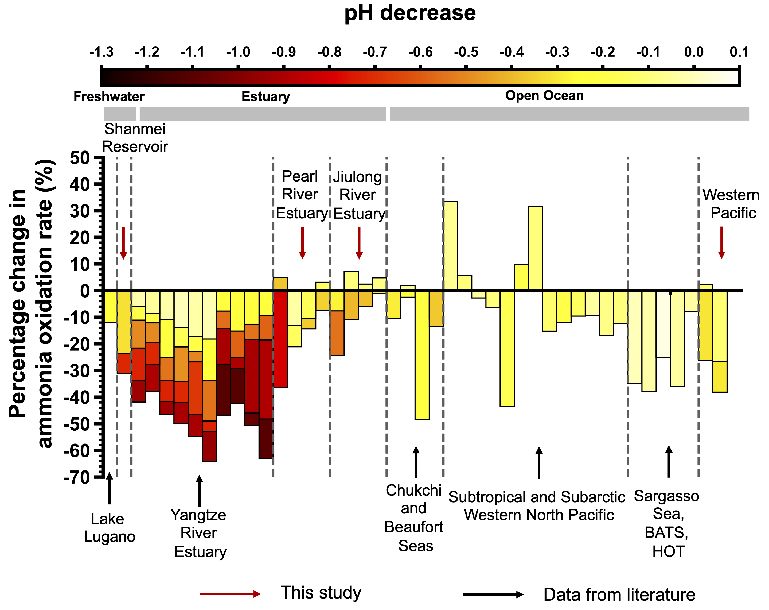
Supplementary Fig. 1 Acidification impact on ammonia oxidation process: integrating literature review¹⁻⁶ and this study. The different colors in the histogram represent varying levels of acidification. Red arrows indicate data derived from this study, while black arrows represent data from previous literature. To minimize the influence of substrate enrichment, all data are presented based on ambient substrate levels.
Ammonia oxidation rates show varying responses to acidification across different research areas, either being inhibited or enhanced.

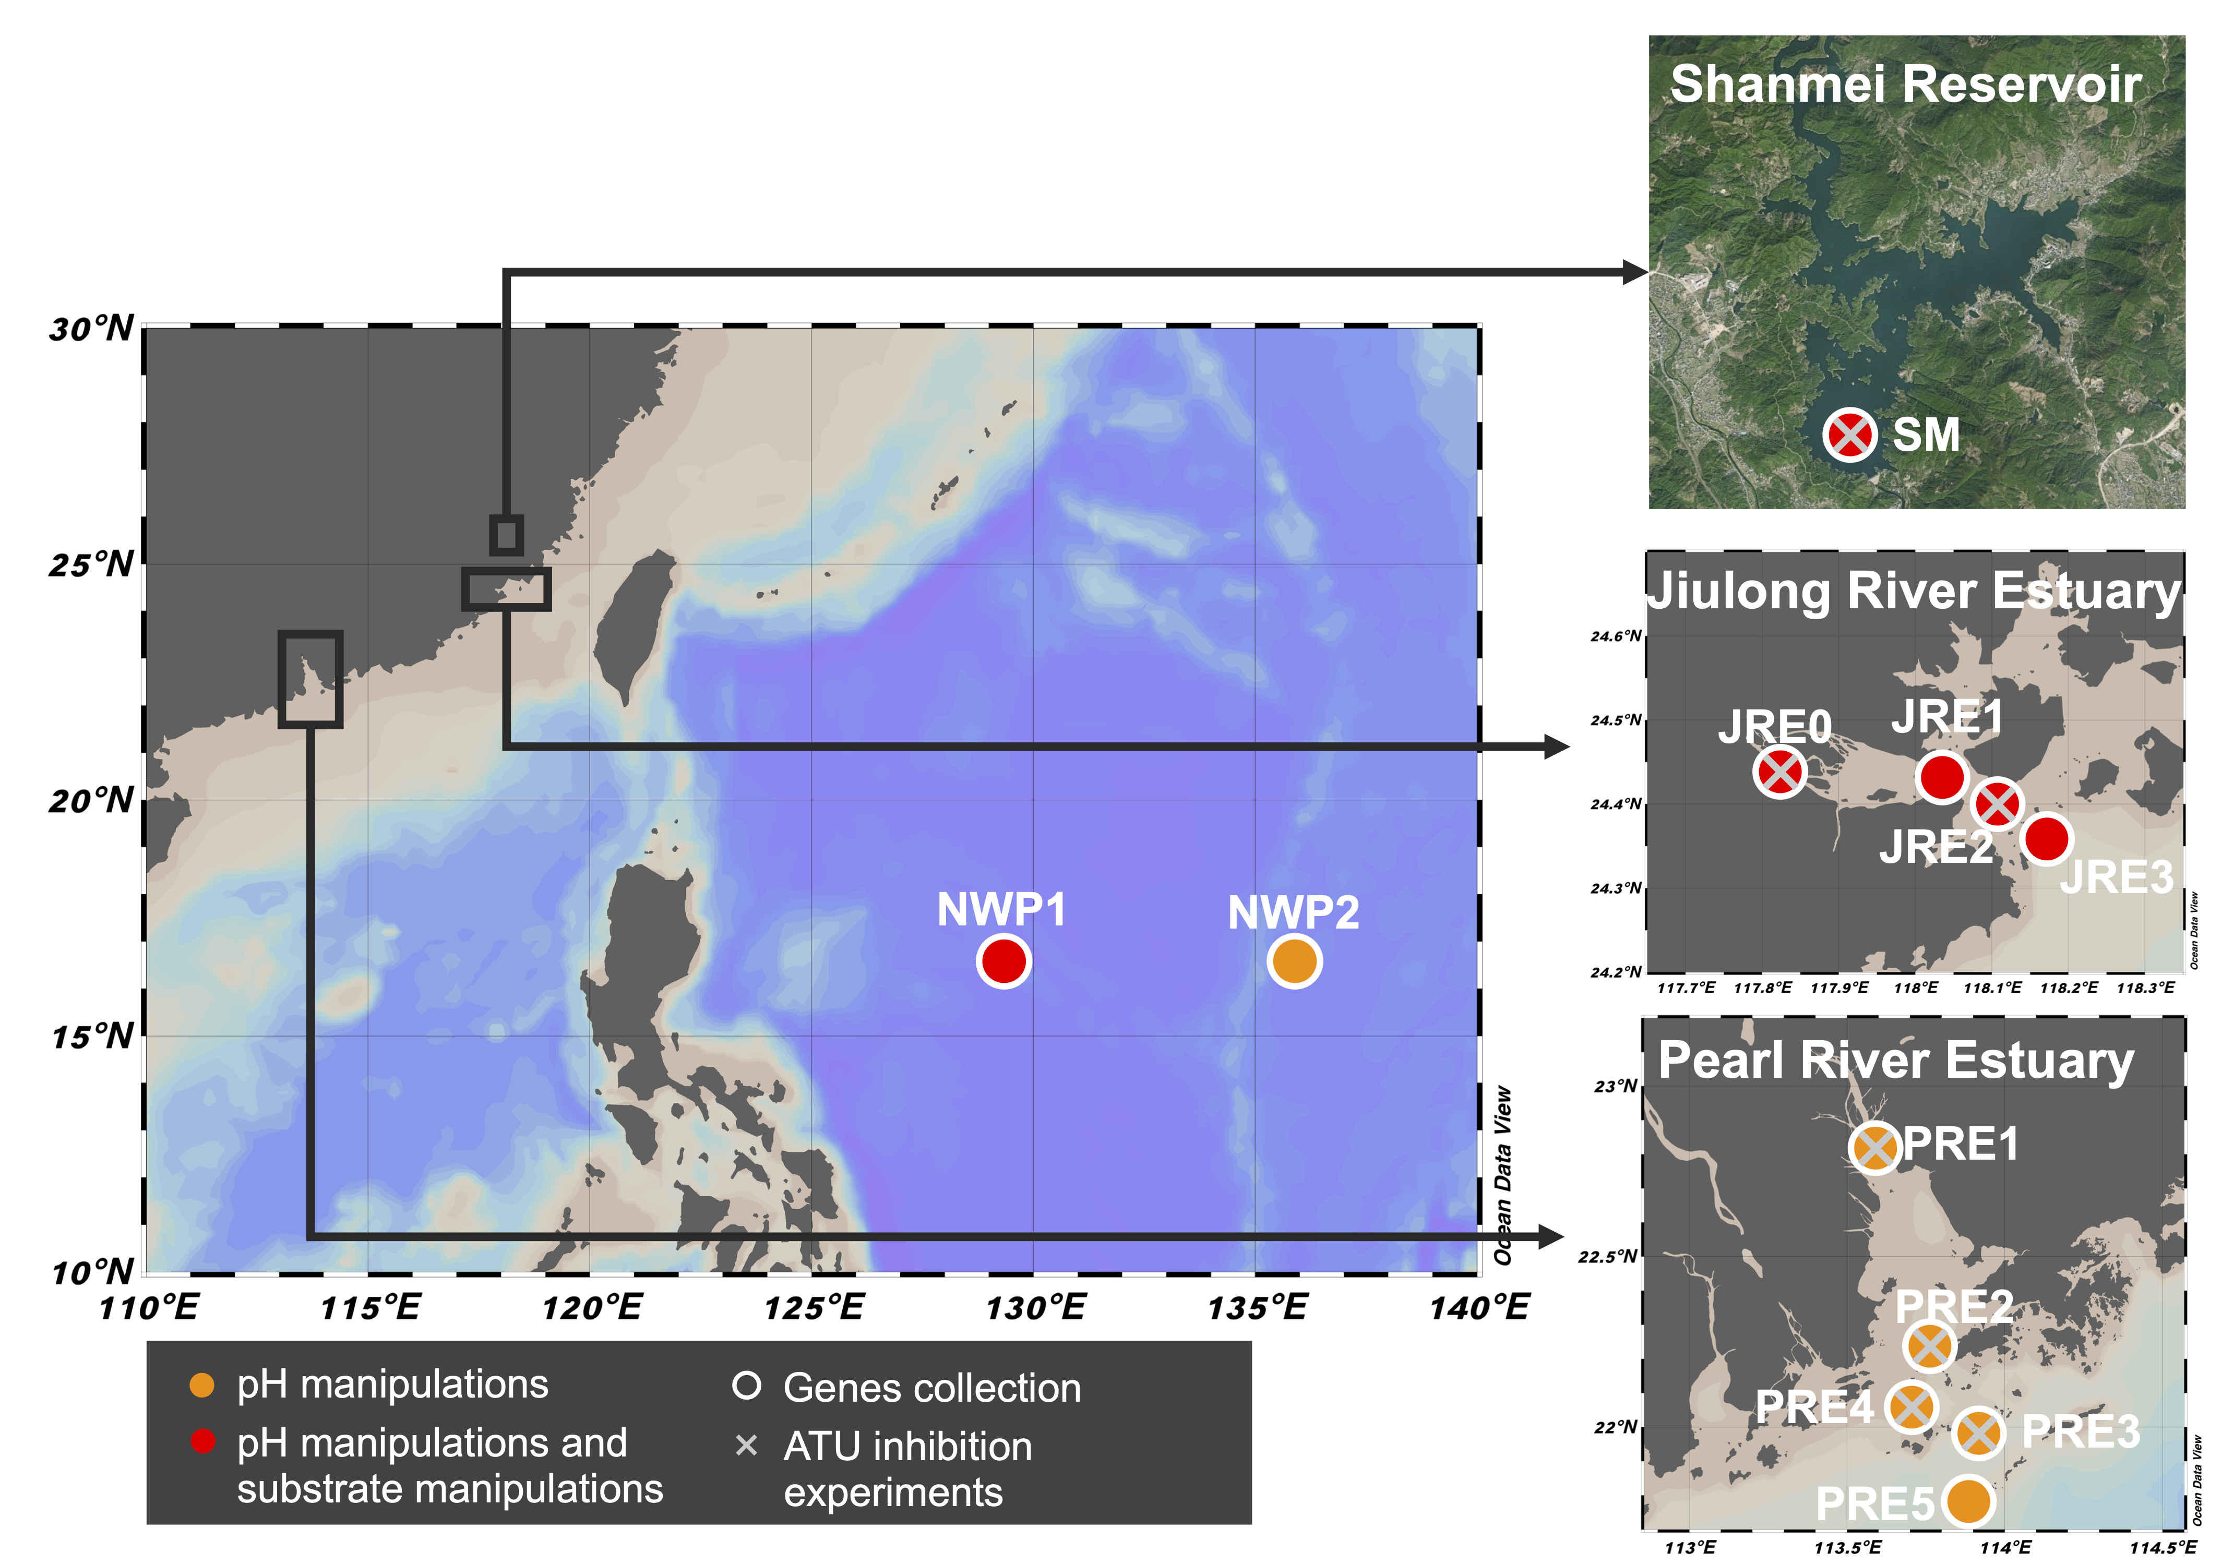
Supplementary Fig. 2 Study areas and sampling sites. Orange dots show stations where acidification manipulation incubation experiments were conducted, and red dots show stations where both acidification and substrate manipulation incubation were carried out. The white borders of the station symbols indicate locations where gene samples were collected. Stations with a cross symbol within the dot indicate sites where inhibition experiments were performed.

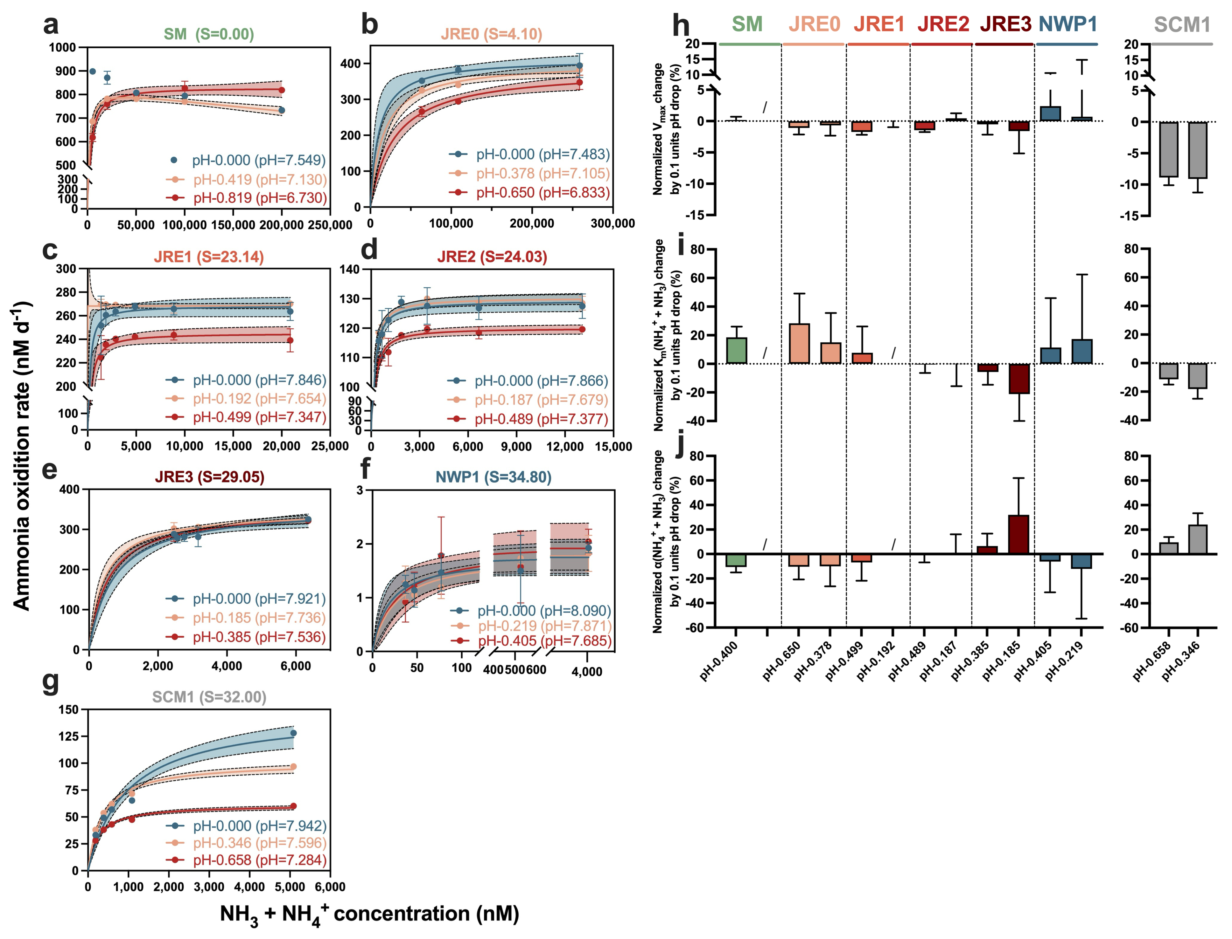
Supplementary Fig. 3 Substrate kinetics parameters towards (NH₃ + NH₄⁺) to varying pH. a-g, The dependence of ammonia oxidation rates on (NH₃ + NH₄⁺) concentration at varying pH. The station or strain names are labeled at the top of the graph, with the salinity values indicated next to their respective names. The legend indicates the degree of pH decrease and the pH value at this level. Solid lines in (a-g) represent the best fitting of Michaelis-Menten model or Haldane substrate inhibition model at various pH. The shaded area represents the 95% confidence interval. h-j, Normalized changes in kinetic parameters towards (NH₃ + NH₄⁺) per 0.1 units pH drop. Due to the unsuccess to fit the equation under in-situ pH at the SM station and pH-0.192 at JRE1 sutation, parts of kinetic parameters are missing, and the result of pH-0.400 at the SM station is the change between two pH downregulated groups (pH-0.419 and pH-0.819). The error bars in the figure represent the results obtained through the propagation of errors. “/” denotes no data.
At a given pH, the rates with (NH₃ + NH₄⁺) as the substrate followed the Michaelis-Menten model or the Haldane substrate inhibition model. The V_{max}(NH₄⁺ + NH₃) decreases gentlely with acidification, while there was no consistent trend in K_{m}(NH₄⁺ + NH₃) and α(NH₄⁺ + NH₃) against acidification.

Supplementary Fig. 4 Ratio of AOA to AOB gene copies and their relative contributions to ammonia oxidation rates across different sampling sites from nearshore to offshore. The rate contributions are obtained from ATU inhibition experiments. The black dashed line indicates the 50% rate contribution. The pink points represent the ratio of AOA to AOB gene copies on a logarithmic scale. The pink dotted line indicates where the ratio of gene copies of AOA to AOB is equal to 1. Error bars denote 1 SD among triplicate treatments.
There is a diminishing contribution of AOB and an increasing contribution of AOA from nearshore to offshore, as indicated by the ratio of AOA to AOB gene copies and their proportional contributions to ammonia oxidation rates.

Supplementary Fig. 5 Normalized Taylor diagram comparing messured rates with simulations from substrate availability (S Avail) model, substrate affinity (S Affin) model and the combined model (S Avail + S Affin) model under acidification scenarios. The diagram illustrates the correlation and ratio of the standard deviation.
The Taylor diagrams for the three models revealed that the S Avail + S Affin model exhibited the closest standard deviation to the observed results, along with the highest correlation coefficient.
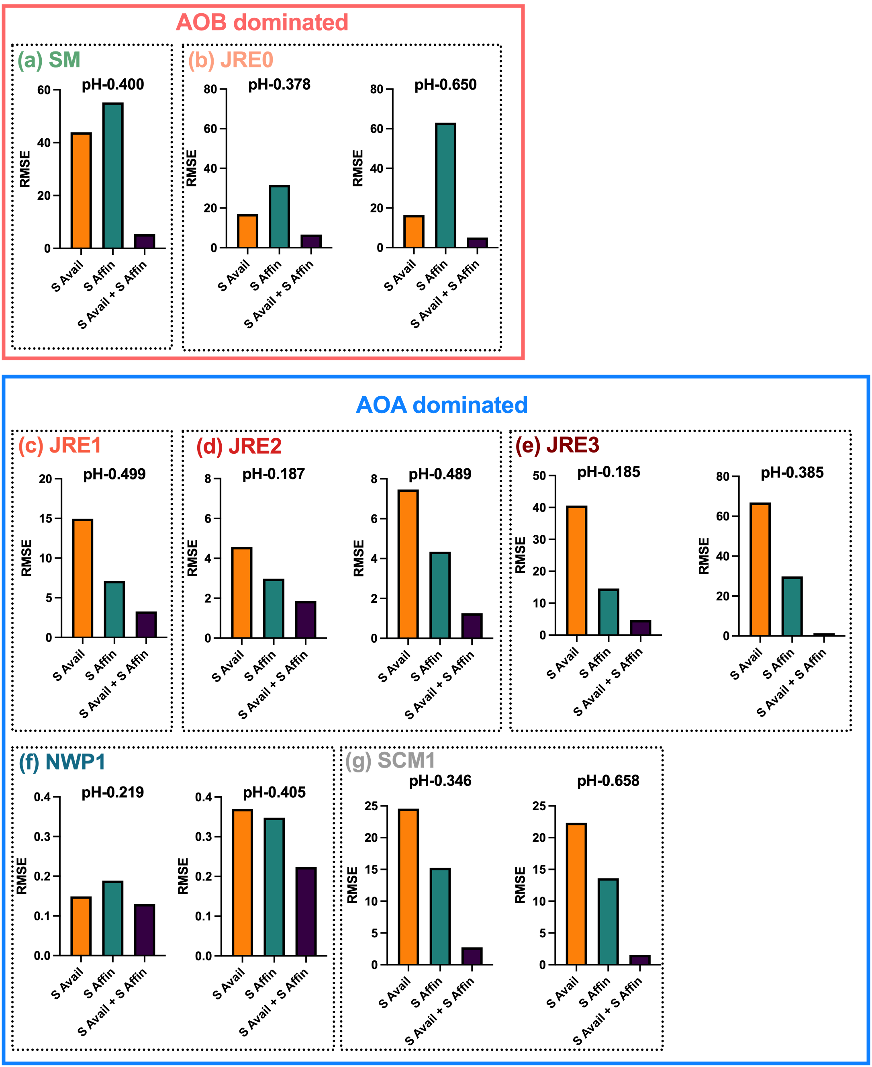
Supplementary Fig. 6 The Root Mean Square Error (RMSE) values for the substrate availability (S Avail) model, substrate affinity (S Affin) model, and the combined model (S Avail + S Affin)
The model incorporating the coupled effects of substrate availability (S Avail) and substrate affinity (S Affin) yielded the lowest root mean square error (RMSE) across all study case

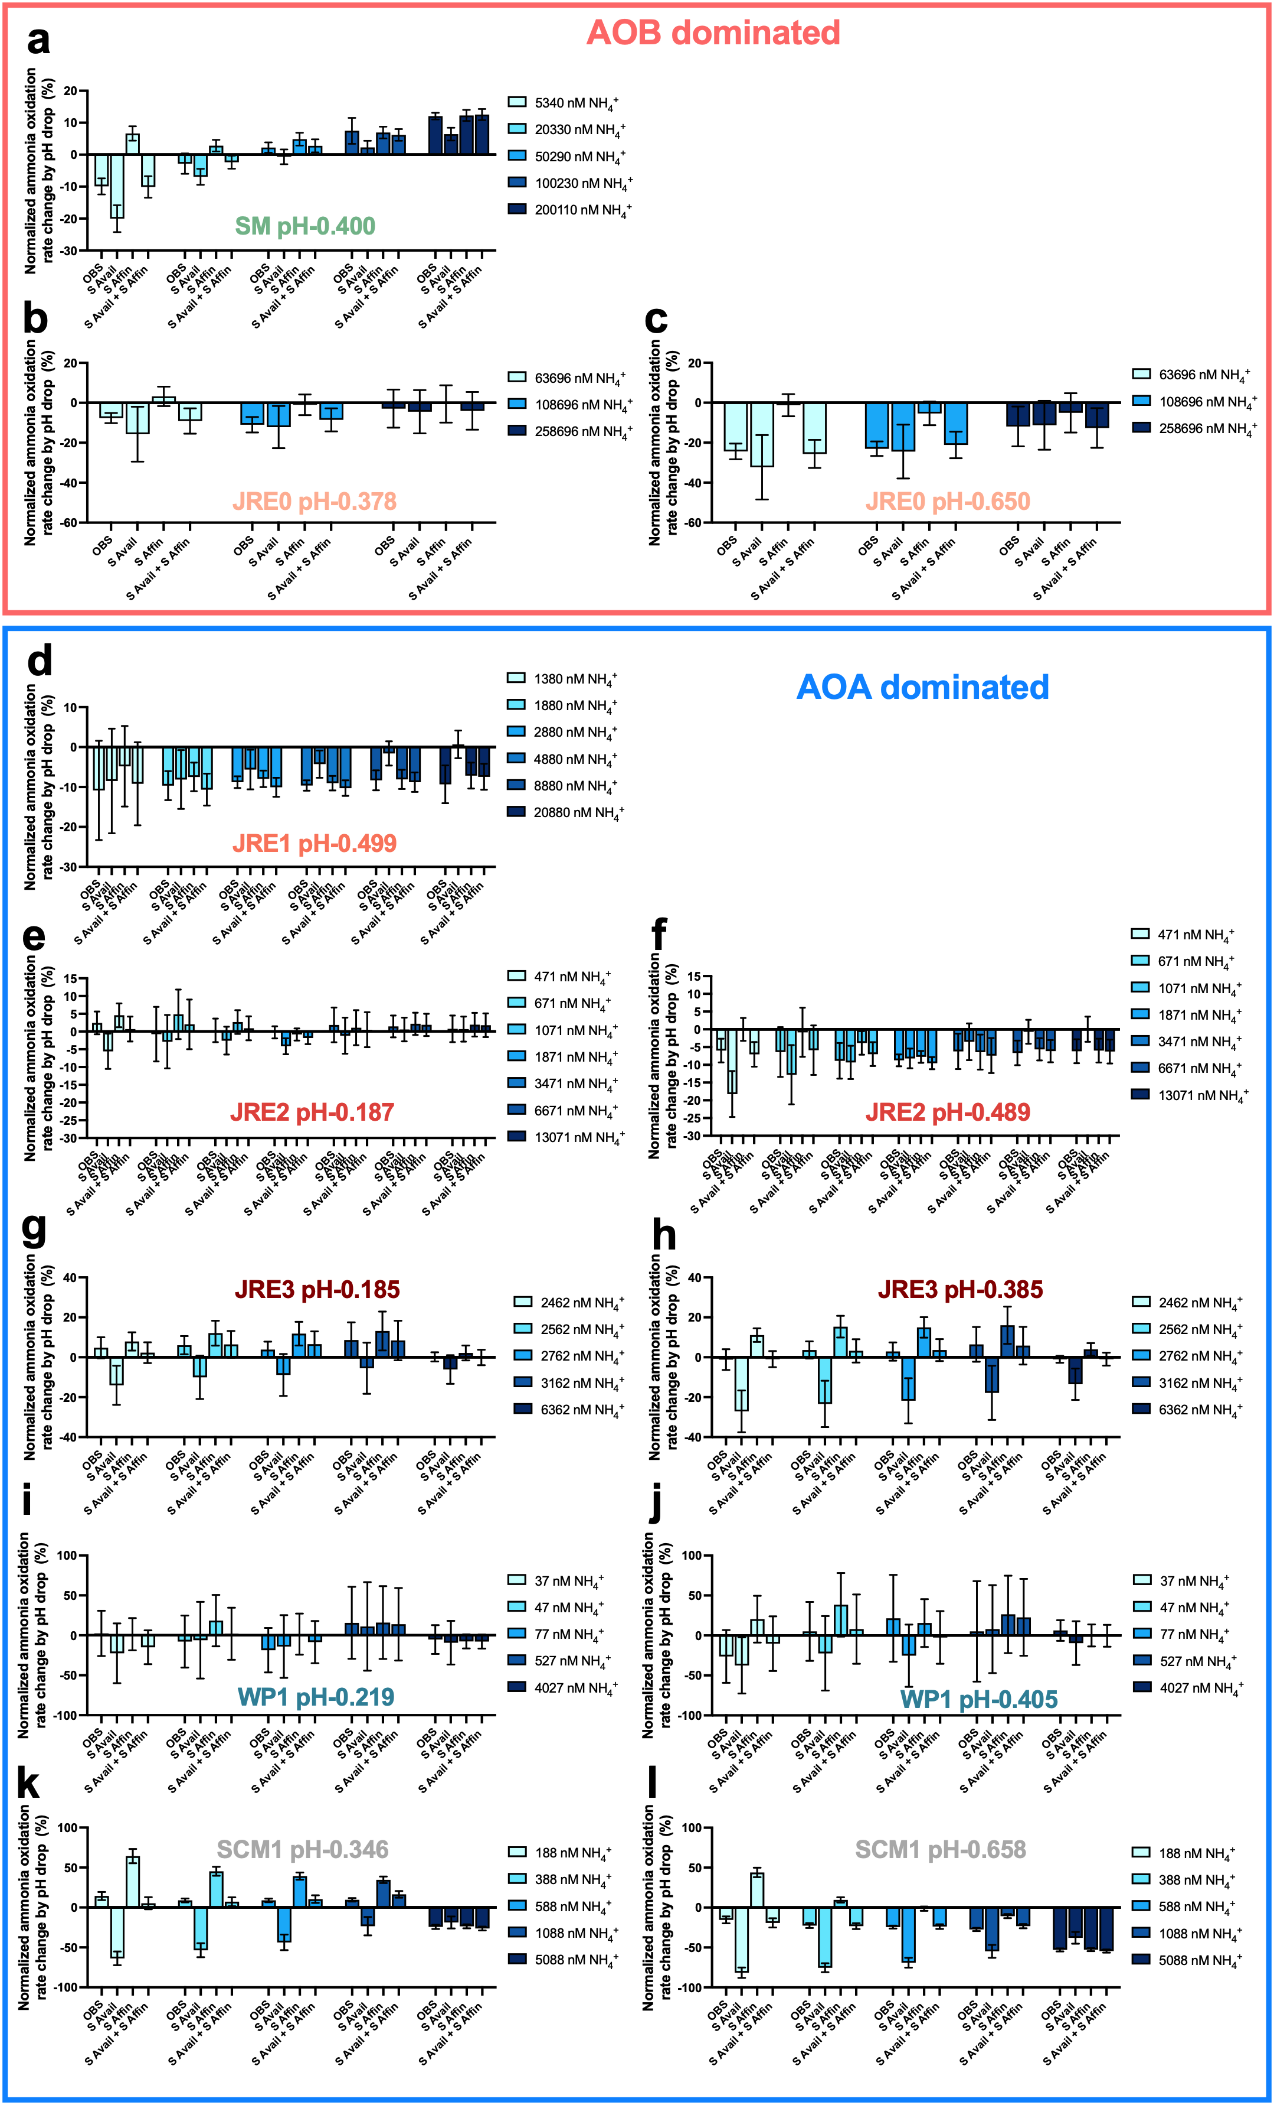

Supplementary Fig. 7 Comparison of the change of ammonia oxidation rate to acidification under different substrate concentration levels, as calculated by substrate availability (S Avail) model, substrate affinity (S Affin) model and the combined model (S Avail + S Affin), with the measured values. All the ammonia oxidation rates (except SM) are normalized to the rate at in situ pH. Due to the inability to perform in-situ pH substrate kinetics fitting at the SM, the result of pH-0.400 at the SM station is the change between two pH downregulated groups (pH-0.419 and pH-0.819).
The observed results were best fit when both substrate availability and substrate affinity were considered across different substrate levels

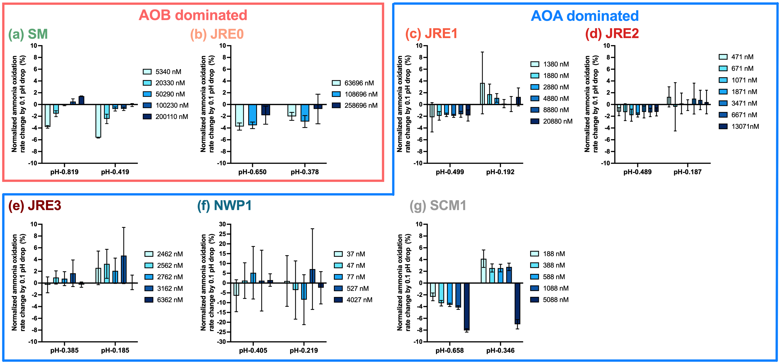
Supplementary Fig. 8 Changes in normalized ammonia oxidation rates to acidification under different substrate concentration levels. The x-axis represents the units of pH drop, while the y-axis shows the change in the normalized ammonia oxidation rate per 0.1 units decrease in pH. Error bars indicate the propagated errors from various rate measurements. In each subgraph, the darker shades of blue correspond to higher substrate concentration levels.

In AOB-dominated systems, the rate decreased as pH dropped, but substrate addition mitigated the diminishing effect of acidification. In contrast, in AOA-dominated systems, the rate increased slightly with mild drops in pH, but decreased with further reductions in pH, and the substrate mitigation effect was not significant.

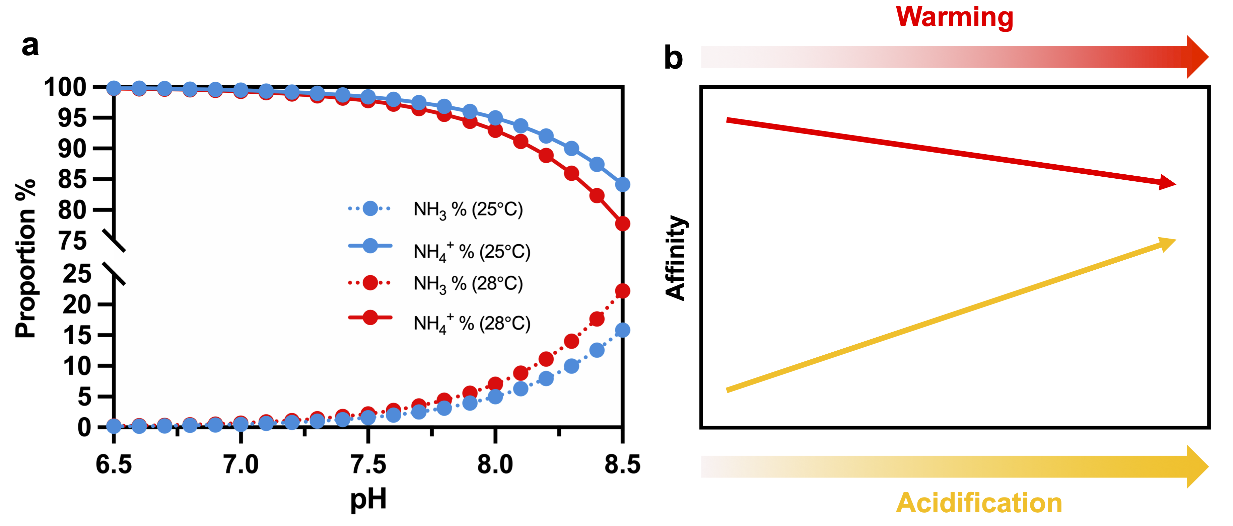
Supplementary Fig. 9 Changes in the NH₃/NH₄⁺ equilibrium (a) and substrate affinity for ammonia oxidation (b) under warming and acidification scenarios
As pH decreases, the concentration of the substrate (NH₃) required for ammonia oxidation gradually decreases, while substrate affinity increases. Conversely, rising temperatures increase NH₃ concentration but reduce substrate affinity.

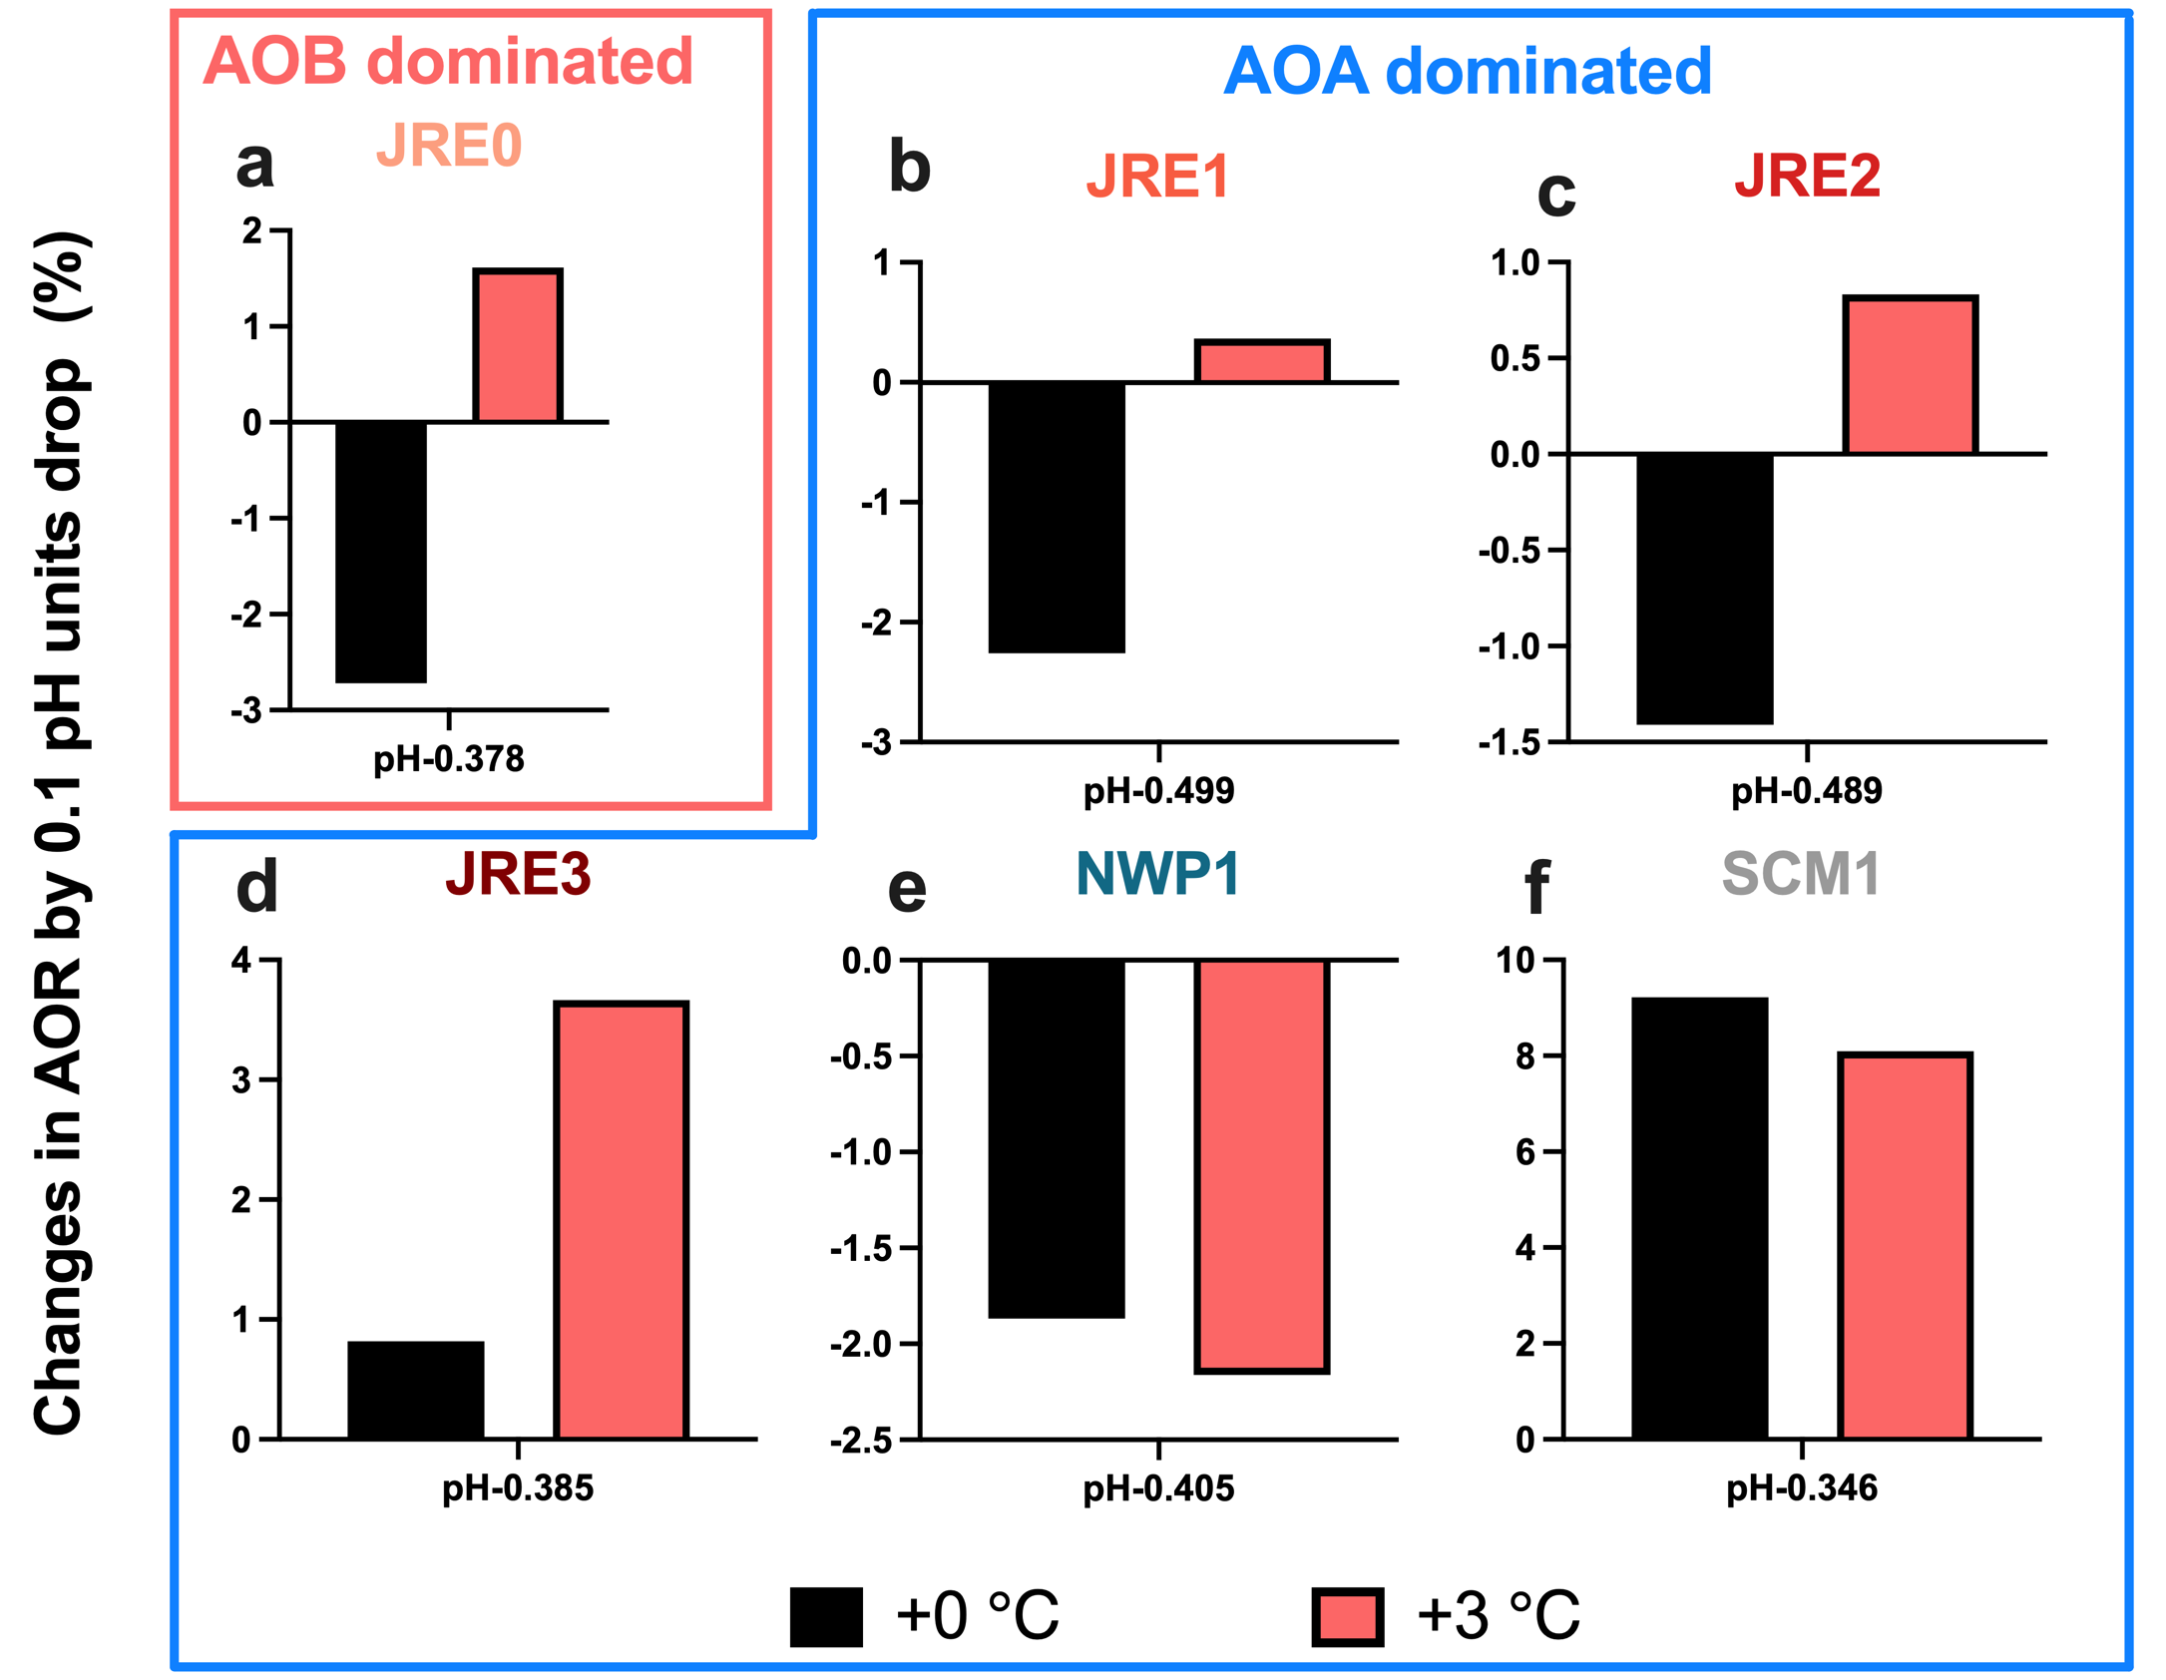
Supplementary Fig. 10 Prediction of changes in AO rates by 0.1 pH units drop under warming scenarios by temperature-pH coupled model. We present the treatment group with a pH drop range of 0.3–0.5. Since SM cannot be fitted in-situ, it is excluded from the temperature-pH coupled model fitting.

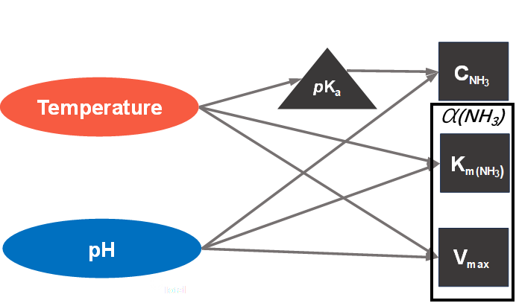
Supplementary Fig. 11 Conceptual diagram of the temperature-pH coupled model for ammonia oxidation.

