SUPPLEMENTARY INFORMATION

Title: Assessing The Performance of Multimodal Large Language Models in Diagnosing and Staging Diabetic Retinopathy: An External Validation Study of Large Language Model

Author list: Chuin-Hen Liew, Ee Xion Tan, Nur Izzati Mohd Salim, Nur Ainaa Najwa Razali, Abdul Hadi Sharifudin, Sin Yee Teo, Sangeetha Subramaniam, Qi Zhe Ngoo, Saravanan Muthaiyah, Kalaiarasi Sonai Muthu

Supplementary Table 1. Formulas for Calculating Performance Metrics Used in the Study
Supplementary Table 2: Performance of Large Language Models for Staging Mild NPDR
Supplementary Table 3: Performance of Large Language Models for Staging Moderate NPDR
Supplementary Table 4: Performance of Large Language Models for Staging Severe NPDR
Supplementary Table 5: Performance of Large Language Models for Staging Proliferative DR
Supplementary Table 6: Result Table of Subgroup Analysis Based on Ethnicity for Evaluating the Performance Of GPT-4 In Diagnosing the Presence of Diabetic Retinopathy.

Supplementary Materials

Supplementary Table 1: Formulas for Calculating Performance Metrics Used in the Study
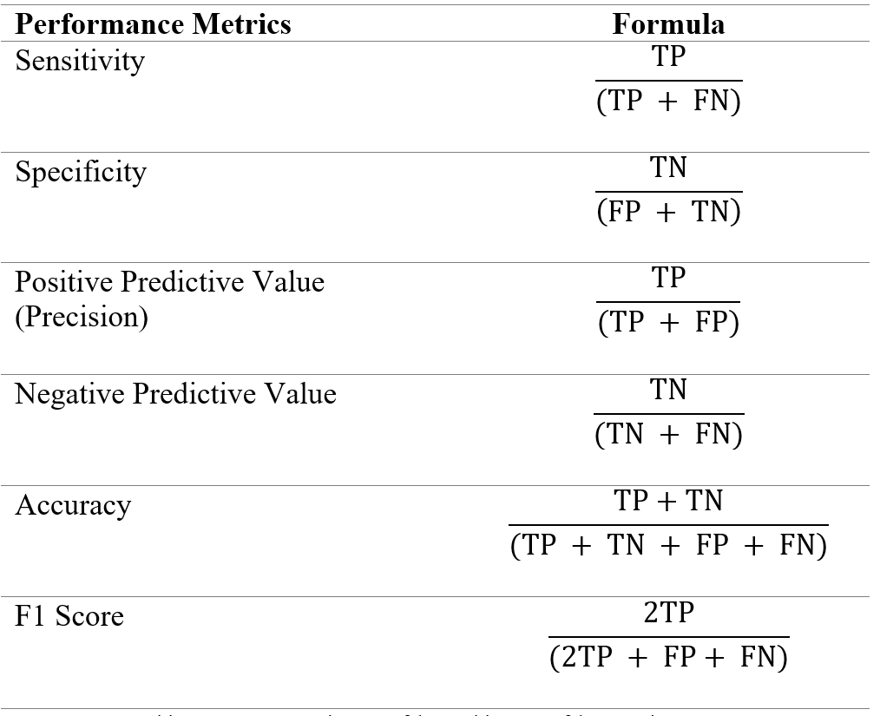
Note: TP= true positive, TN= true negative, FP= false positive, FN= false negative

Supplementary Table 2: Performance of Large Language Models for Staging Mild NPDR
 | Open AI’s GPT-4 | Google Gemini 1.5 | Claude 3 Haiku | Mistral’s AI
AUROC | 0.509 | 0.47 | 0.521 | 0.488
Sensitivity | 0.091 | 0.546 | 0.091 | 0.364
Specificity | 0.927 | 0.398 | 0.952 | 0.612
PPV | 0.118 | 0.088 | 0.167 | 0.091
NPV | 0.905 | 0.891 | 0.907 | 0.9
Accuracy | 0.847 | 0.412 | 0.868 | 0.588
F1 | 0.103 | 0.152 | 0.118 | 0.146
Note: NPDR= non-proliferative diabetic retinopathy, AUROC= area under the receiver operating characteristic curve, PPV= positive predictive value, NPV= negative predictive value

Supplementary Table 3: Performance of Large Language Models for Staging Moderate NPDR
 | Open AI’s GPT-4 | Google Gemini 1.5 | Claude 3 Haiku | Mistral’s AI
AUROC | 0.722 | 0.809 | 0.468 | 0.483
Sensitivity | 0.792 | 0.833 | 0.750 | 0.583
Specificity | 0.652 | 0.784 | 0.186 | 0.382
PPV | 0.211 | 0.313 | 0.098 | 0.1
NPV | 0.964 | 0.976 | 0.864 | 0.886
Accuracy | 0.667 | 0.790 | 0.246 | 0.404
F1 | 0.333 | 0.455 | 0.173 | 0.171
Note: NPDR= non-proliferative diabetic retinopathy, AUROC= area under the receiver operating characteristic curve, PPV= positive predictive value, NPV= negative predictive value

Supplementary Table 4: Performance of Large Language Models for Staging Severe NPDR
 | Open AI’s GPT-4 | Google Gemini 1.5 | Claude 3 Haiku | Mistral’s AI
AUROC | 0.556 | 0.501 | 0.521 | 0.500
Sensitivity | 0.143 | 0.071 | 0.071 | 0
Specificity | 0.970 | 0.930 | 0.970 | 1
PPV | 0.400 | 0.130 | 0.250 | 0
NPV | 0.890 | 0.877 | 0.8820 | 0.877
Accuracy | 0.868 | 0.825 | 0.860 | 0.877
F1 | 0.211 | 0.091 | 0.111 | 0
Note: NPDR= non-proliferative diabetic retinopathy, AUROC= area under the receiver operating characteristic curve, PPV= positive predictive value, NPV= negative predictive value

Supplementary Table 5: Performance of Large Language Models for Staging Proliferative DR
 | Open AI’s GPT-4 | Google Gemini 1.5 | Claude 3 Haiku | Mistral’s AI
AUROC | 0.526 | 0.500 | 0.469 | 0.500
Sensitivity | 0.063 | 0 | 0 | 0
Specificity | 0.990 | 1 | 0.939 | 1
PPV | 0.500 | 0 | 0 | 0
NPV | 0.866 | 0.860 | 0.852 | 0.860
Accuracy | 0.860 | 0.860 | 0.807 | 0.8560
F1 | 0.111 | 0 | 0 | 0
Note: DR= diabetic retinopathy, AUROC= area under the receiver operating characteristic curve, PPV= positive predictive value, NPV= negative predictive value

Supplementary Table 6: Result Table of Subgroup Analysis Based on Ethnicity for Evaluating the Performance Of GPT-4 In Diagnosing the Presence of Diabetic Retinopathy.
Evaluation Metric | Malay | Chinese | Indian
AUROC | 0.82 | 0.74 | 0.76
Sensitivity | 0.80 | 0.83 | 0.90
Specificity | 0.85 | 0.65 | 0.63
PPV | 0.86 | 0.59 | 0.86
NPV | 0.79 | 0.87 | 0.71
Accuracy | 0.82 | 0.72 | 0.82
F1 score | 0.83 | 0.69 | 0.88
Note: AUROC= area under the Receiver operating characteristic curve, PPV= positive predictive value, NPV= negative predictive value.

