Supplementary Information
Valley Selectivity Manipulation via Interfacial Magnon-Exciton Interactions in TMD/CrSBr Antiferromagnetic van der Waals Heterostructures
Xilin Zhang¹, Yaojie Zhu², Ruixue Bai¹, Runcheng Mao¹, Zuowei Yan¹, Xiaoshan Du¹, Rui Zhou², Yisen Tang², Heng Li³, Zdenek Sofer³, Hui Ma^{*2} & Chongyun Jiang^{*1}
¹ College of Electronic Information and Optical Engineering, Nankai University, Tianjin 300350, China.
² School of Physical Science and Technology, Tiangong University, Tianjin 300387, China.
³ Department of Inorganic Chemistry, University of Chemistry and Technology Prague, Technická 5, 166 28 Praha 6, Czech Republic.
*Email: jiang.chongyun@nankai.edu.cn;
*Email: mahui@tiangong.edu.cn.

Supplementary Note 1: Optical microscope images of three heterostructure samples.
Supplementary Note 2: Reduction of exciton emission caused by charge transfer in HS.
Supplementary Note 3: Exclusion of possible mechanisms contributing to the blueshift of X* and T*, as well as the emergence of M*.
Supplementary Note 4: Assignment of emission peaks in WSe₂/SiO₂ and WSe₂/CrSBr (Sample 3).
Supplementary Note 5: Exciton VP in MoSe₂/SiO₂ and MoSe₂/CrSBr (Sample 1) with σ⁺ excitation.
Supplementary Note 6: Exclusion of VP enhancement from other possible mechanisms.
Supplementary Note 7: Interfacial magnon-exciton interaction in the WSe₂/CrSBr heterostructure.
Supplementary Note 8: Theoretical modeling of V-shaped variation of VP with magnetic field.

Supplementary Note 1: Optical microscope images of three heterostructure samples.
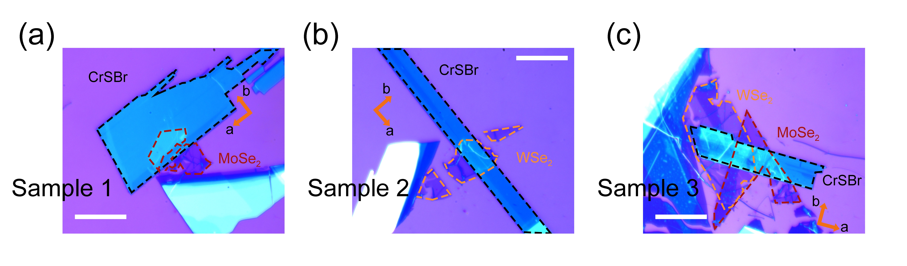
Figure S1. Optical microscope image of MoSe₂/CrSBr (a), WSe₂/CrSBr (b), WSe₂/CrSBr and MoSe₂/CrSBr (c) heterostructures, scale bar: 10 μm. The crystal axes of CrSBr are labeled in the figure.
Sample 1 refers to the MoSe₂/CrSBr sample mentioned in the main text, while Sample 2 and 3 are additional WSe₂/CrSBr samples. In the following text, we use X* or X to refer to excitonic states in HS or ML TMD, and M* to refer to complexes in the heterostructure.

Supplementary Note 2: Reduction of exciton emission caused by charge transfer in HS.
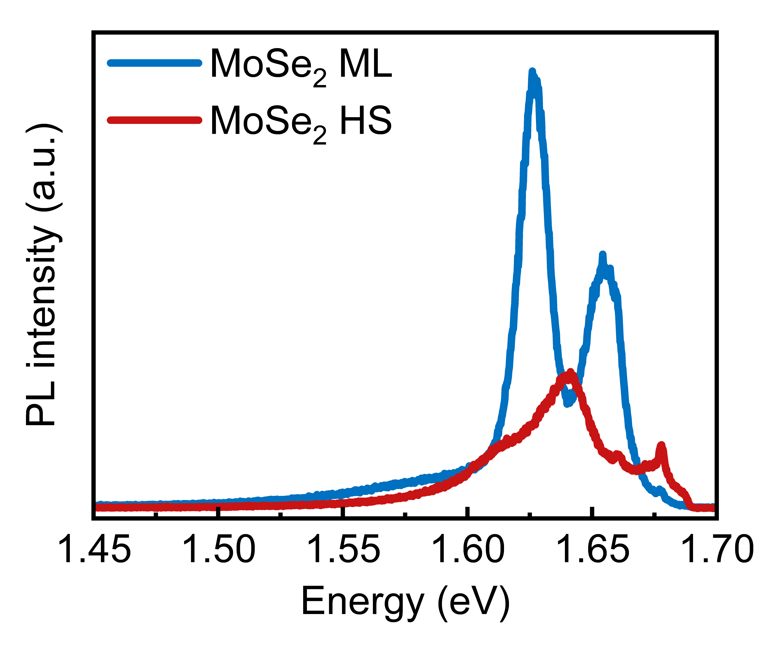
Figure S2. PL spectra of MoSe₂/SiO₂ and MoSe₂/CrSBr (Sample 1) with the excitation wavelength of 715 nm.
Under the same excitation power and exposure time, the emission intensity of excitonic states in MoSe₂/CrSBr is significantly reduced in contrast to that in MoSe₂/SiO₂ due to charge transfer.

Supplementary Note 3: Exclusion of possible mechanisms contributing to the blueshift of X* and T*, as well as the emergence of M*.
The contact between ML MoSe₂ and CrSBr, along with laser irradiation, may lead to the following effects: interlayer charge transfer, a magnetic exchange field (MEF) induced by magnetic proximity effect (MPE) of CrSBr, and interlayer particle interactions. First, we can exclude the doping effect induced by the interlayer charge transfer as the source of the blueshift energy of X* and T*, and the emergence of M*. Doping has been demonstrated to have essentially no effect on the exciton peak energy in the MoSe₂ monolayer¹⁻⁴ and incredibly resulted in the creation of new peak M* with tens of meV shift away from the excitonic states. Furthermore, the type-III band alignment prevents the interlayer transfer of photogenerated carriers under laser irradiation⁵, allowing us to disregard the impact of photogenerated carrier transfer between MoSe₂ and CrSBr. Next, the in-plane magnetization of CrSBr cannot result in so large blueshift energy of X* and T* and the appearance of M*. In-plane magnetic field enable dark excitons to brighten in ML MoSe₂, with the reported blueshift energy of ~ 1.4 meV relative to bright excitons⁶. Even under an in-plane magnetic field of 30T, the energy shift between the bright excitons and brightened dark excitons is only ~ 3 meV⁶, insufficient to account for the ~ 16 meV blueshift. Thus, in-plane MEF also cannot be the origin of the blueshift for X* and T*, or responsible for the occurrence of M*.

Supplementary Note 4: Assignment of emission peaks in WSe₂/SiO₂ and WSe₂/CrSBr (Sample 3).
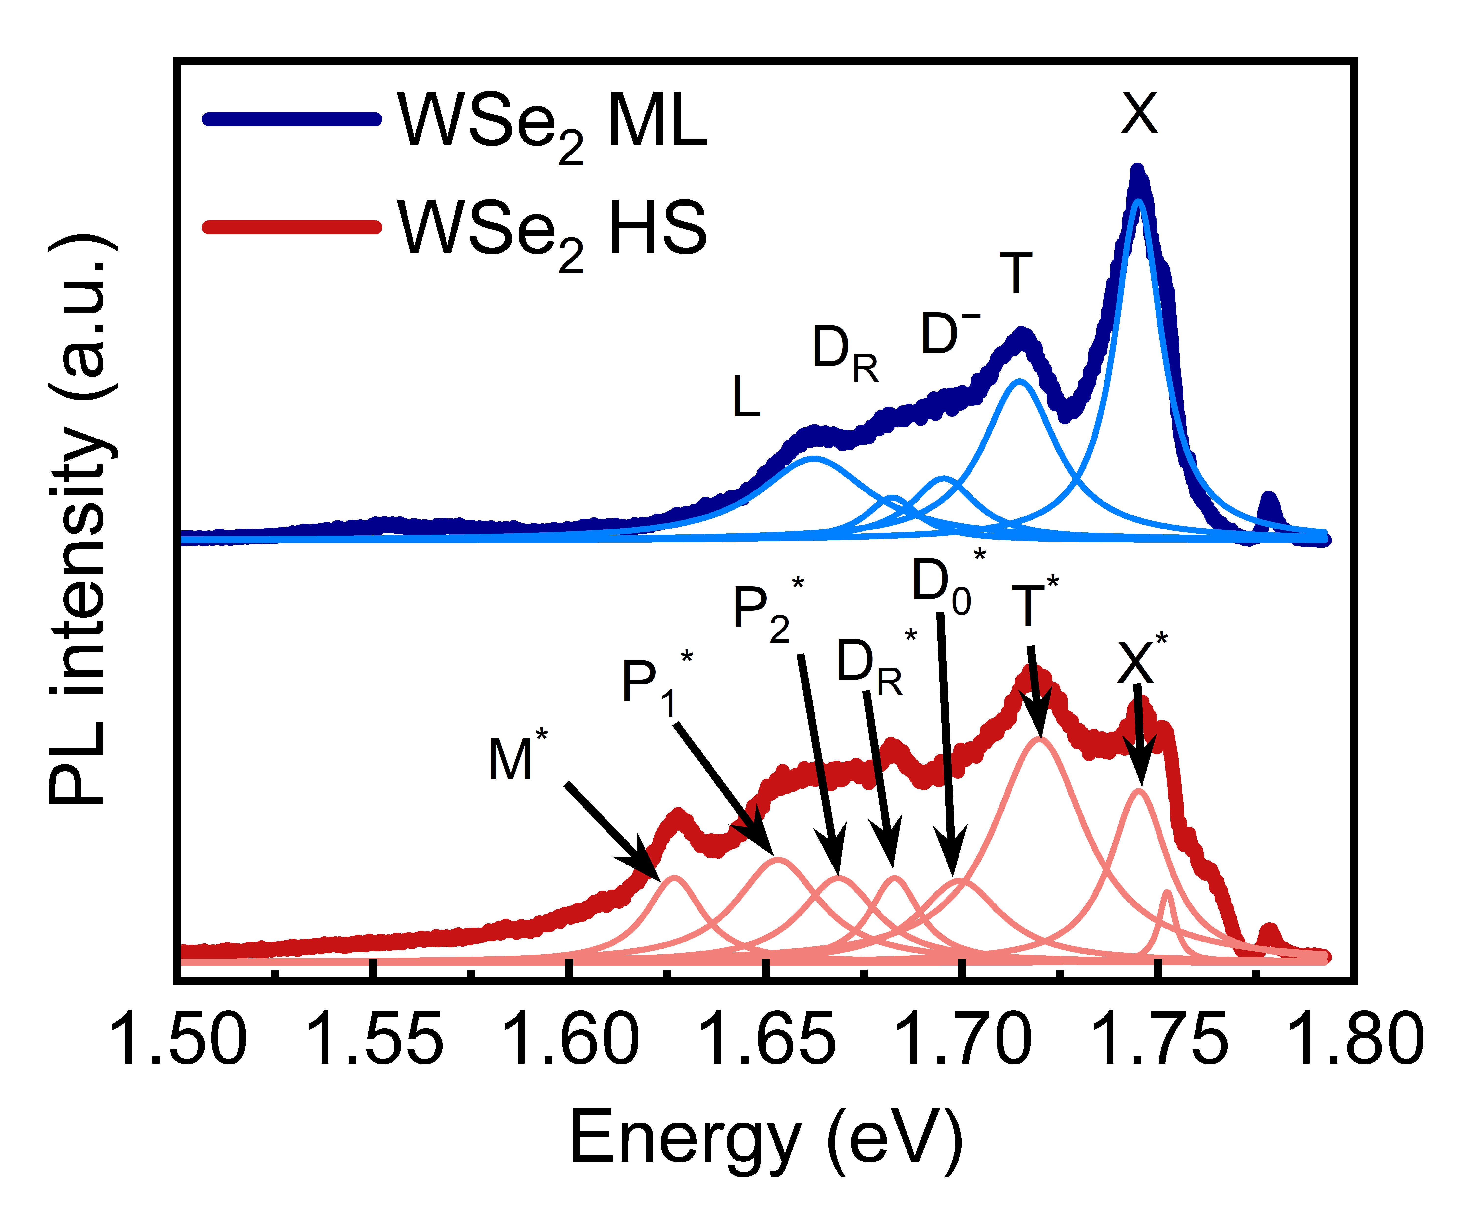
Figure S3. PL spectra and fitting results of WSe₂/SiO₂ and WSe₂/CrSBr (Sample 3), measured at 15 K using continuous-wave excitation of 670 nm. The emission peaks in WSe₂/SiO₂ and WSe₂/CrSBr are marked in the figure.
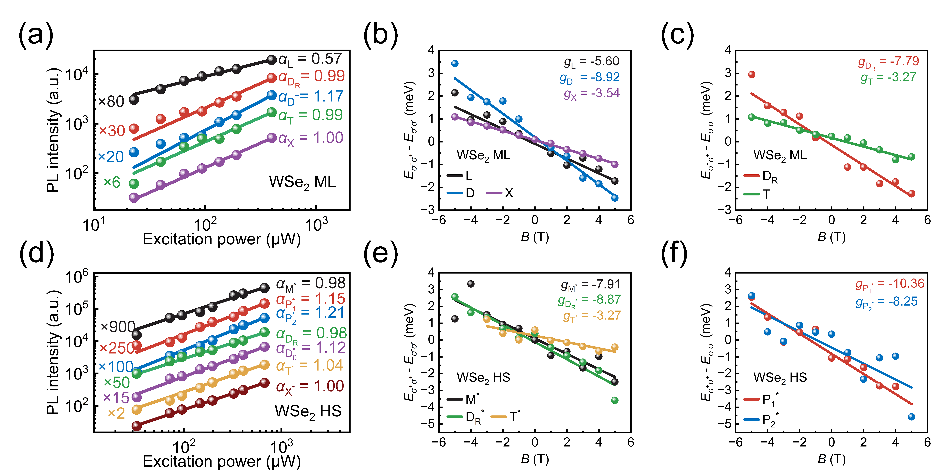
Figure S4. Excitation power dependence and g-factor of excitonic states and complexes in WSe₂/SiO₂ and WSe₂/CrSBr (Sample 3). (a, d) Excitation power dependence of the integrated PL intensity of excitonic states in WSe₂/SiO₂ (a) and WSe₂/CrSBr (d). Solid curves show I ∝ P^{α} fitting, along with their α value. (b-c, e-f) Valley splitting of excitonic states in WSe₂/SiO₂ (b-c) and excitonic states and complexes in WSe₂/CrSBr (e-f). E_{σ⁺σ⁺(σ⁻σ⁻)} represents co-polarized PL peak energy under σ⁺ (σ⁻) excitation. The solid lines represent linear fits results.
Table S1. Peak energy, α value and g-factor of excitonic states and complexes in WSe₂/SiO₂ and WSe₂/CrSBr (Sample 3).
WSe₂/SiO₂ (Sample 3)
Peak |  |  | L | D_{R} | D⁻ | T | X
Peak energy (eV) |  |  | 1.663 | 1.684 | 1.696 | 1.715 | 1.745
α value |  |  | 0.57 | 0.99 | 1.17 | 0.99 | 1.00
g-factor |  |  | -5.60 | -7.79 | -8.92 | -3.27 | -3.54
WSe₂/CrSBr (Sample 3)
Peak | M* | P₁* | P₂* | D_{R}* | D₀* | T* | X*
Peak energy (eV) | 1.627 | 1.654 | 1.668 | 1.683 | 1.701 | 1.718 | 1.744
α value | 0.98 | 1.15 | 1.21 | 0.98 | 1.12 | 1.04 | 1.00
g-factor | -7.91 | -10.36 | -8.25 | -8.87 |  | -3.27

The emission peaks in WSe₂/SiO₂ and WSe₂/CrSBr are fitted and shown in Figure S3, while Figure S4 presents their α value and g-factors. These results are summarized in Table S1. All peaks except for peak L produce linear dependence of PL intensity on power excitation, which excludes the possibility that they are biexcitons, localized excitons, or moiré excitons. In ML WSe₂, the g-factor for intravalley dark exciton recombination is ~ -8, whereas the g-factor for intervalley dark exciton recombination is ~ -12^{3,4}. For WSe₂/SiO₂, L is identified as a localized state due to the sublinear dependence of its intensity on excitation power. Referring to previous studies^{3,4}, in ML WSe₂, the emission energy of positive trion and negative trion is ~ 20 meV and ~ 28 meV lower than that of excitons, respectively. Based on this, we infer that our WSe₂/SiO₂ sample is likely n-doped, and we assign T as negative trion. Furthermore, the g-factor of D_{R} is close to -8, and its emission energy is ~61 meV lower than X⁴. Thus, we assign D_{R} as the Γ₅ phonon replica of the dark exciton. Since in ML WSe₂, the emission energies of negative dark trion and dark exciton are ~ 54 meV and ~ 40 meV lower than that of exciton, corresponding to 1.691 eV and 1.705 eV, respectively, we suggest that D⁻ (1.696 eV) is more likely to be a negative dark trion, while D₀ cannot be distinguished from D⁻ due to its weak intensity. The energy of D₀ is expected to be 1.705 eV, which is ~ 21 meV higher than its phonon replica D_{R}, corresponding to the energy of Γ₅ phonon⁴.
We assign M* in the WSe₂/CrSBr as the complex of D₀ in ML WSe₂ and magnon in CrSBr, based on experimental evidence that the g-factor of M* is similar to that of D₀, and the energy difference between the M* and D₀ emission (~78 meV) is comparable to the energy of two magnons (~90 meV)^{7,8}. The slight energy deviation may be related to nonlinear effects of magnons⁹ (e.g., second harmonic generation), strain¹⁰, substrate, or magnon-exciton scattering. Additionally, we assign D₀* as a dark exciton because its energy in WSe₂/CrSBr is closer to that of D₀ in WSe₂/SiO₂. The transition from D⁻ to D₀* may be associated with p-doping induced by interlayer charge transfer. The energy difference between M* and D₀* is ~ 74 meV, which does not match the phonon energy in ML WSe₂, indicating that M* is not a phonon replica. Furthermore, the energy differences between P₁* and P₂* with respect to D₀* are ~ 47 meV¹¹ and ~ 33 meV⁴, respectively, which we assign to phonon replicas of the intervalley and intravalley negative dark trion, respectively.

Supplementary Note 5: Exciton VP in MoSe₂/SiO₂ and MoSe₂/CrSBr (Sample 1) with σ⁺ excitation.
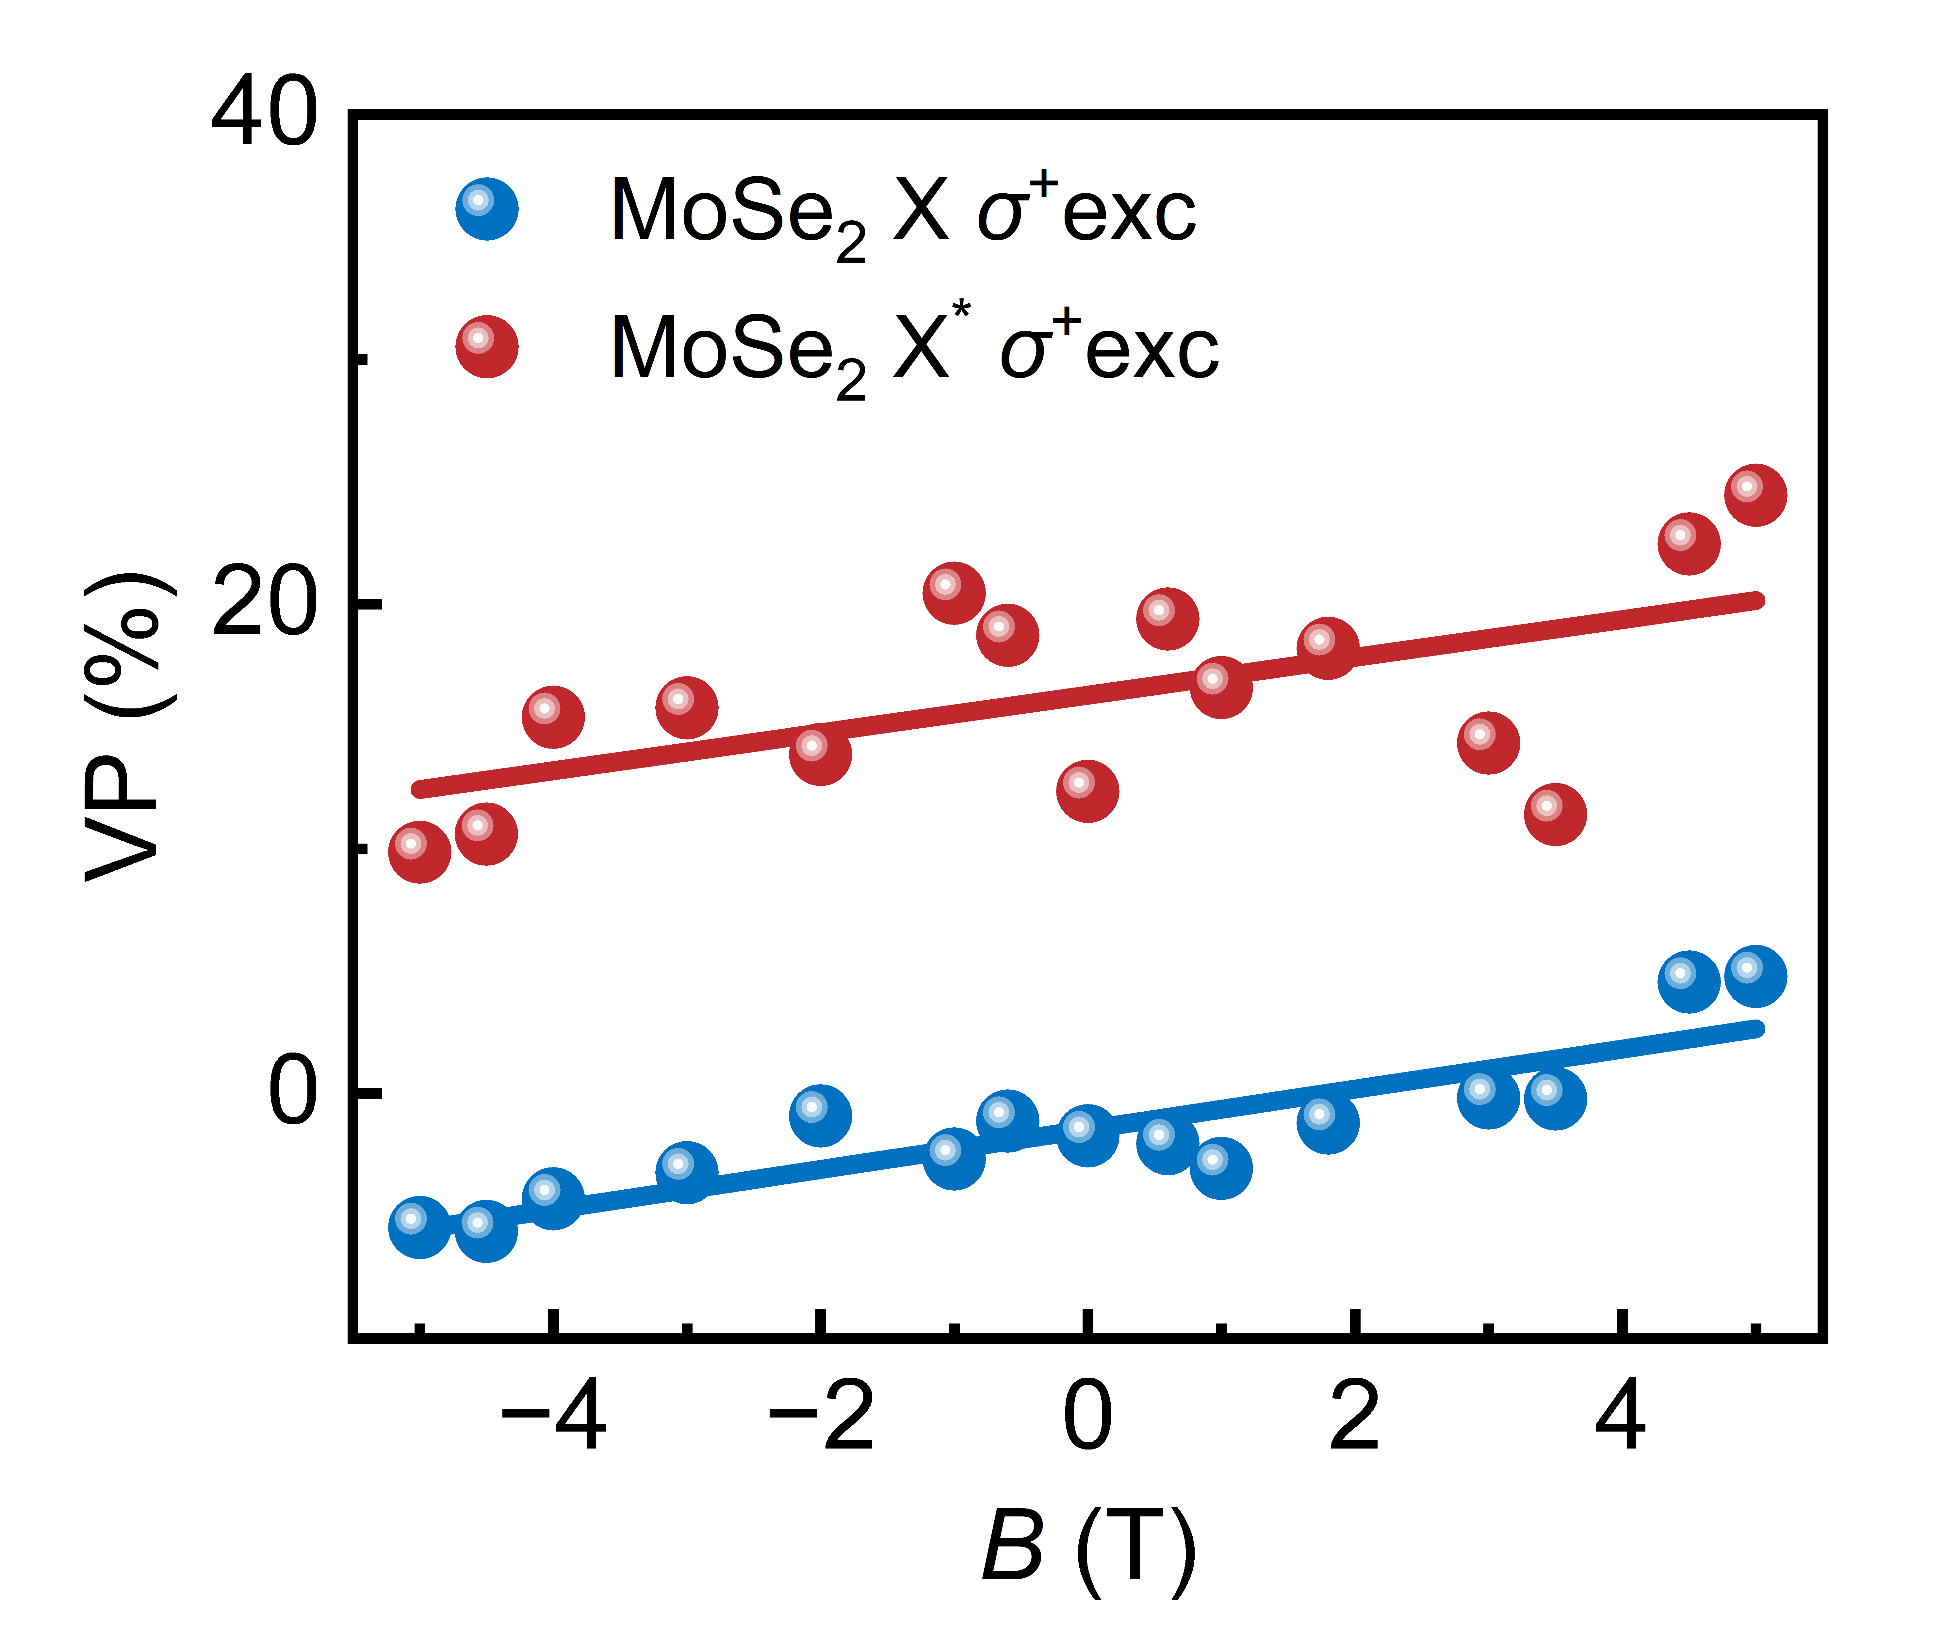
Figure S5. Exciton VP in MoSe₂/SiO₂ and MoSe₂/CrSBr (Sample 1) as a function out-of-plane magnetic field under σ⁺ excitation. The solid lines represent linear fits results.
As shown in Figure S5, the exciton VP in MoSe₂/CrSBr at 0 T increases by ~ 16% compared to MoSe₂/SiO₂, excluding intervalley charge transfer as the origin of the VP enhancement (see Supplementary Note 6). Besides, VP of X and X* show obviously linear variations with the magnetic field, with X and X* showing similar rates of change, which is consistent with the main text.

Supplementary Note 6: Exclusion of VP enhancement from other possible mechanisms.
1. Out-of-plane MEF from MPE. Since CrSBr flake features an antiferromagnet with an in-plane magnetic order, this mechanism can be ruled out to introduce the VP enhancement.
2. In-plane MEF from MPE. The spin orientation of excitons in the K (-K) valley of ML TMD is out-of-plane, and an in-plane magnetic field is expected to induce Hanle precession^{12,13}, reducing the VP, which contrary to our result. On the other hand, previous reports have shown that this mechanism primarily affects the VP of resident carriers¹³, whereas the VP of short-lived excitons in ML TMD remains unaffected in an in-plane magnetic field up to 9T¹². In any case, an in-plane magnetic field cannot be a mechanism for increasing VP.
3. Intervalley charge transfer possibly induced by phonons. Before recombination, photoexcited electrons in the K valley might be scattered by phonons to the -K valley, where they can either bound with holes to form excitons in the -K valley or bound with excitons in the K valley to form trions³. This would reduce the VP of excitons while increasing the VP of trions, which contradicts our experimental results that that the VP of both X* and T* are enhanced (see Figure S5).
4. Improved on-resonance-excitation condition by the blueshift energy. An enhanced on-resonance excitation condition is made possible by the blueshift energy, which likely leads to an increase in VP since it may reduce the gap between the emission and the excitation. Thus, we conducted the polarized PL experiment in MoSe₂/SiO₂ with an excitation wavelength of 721 nm (excitation energy ~1.720 eV, ~14 meV lower than the excitation of 715 nm) and found that the VP is ~0% (see Figure S6). Thus, this potential mechanism is excluded.
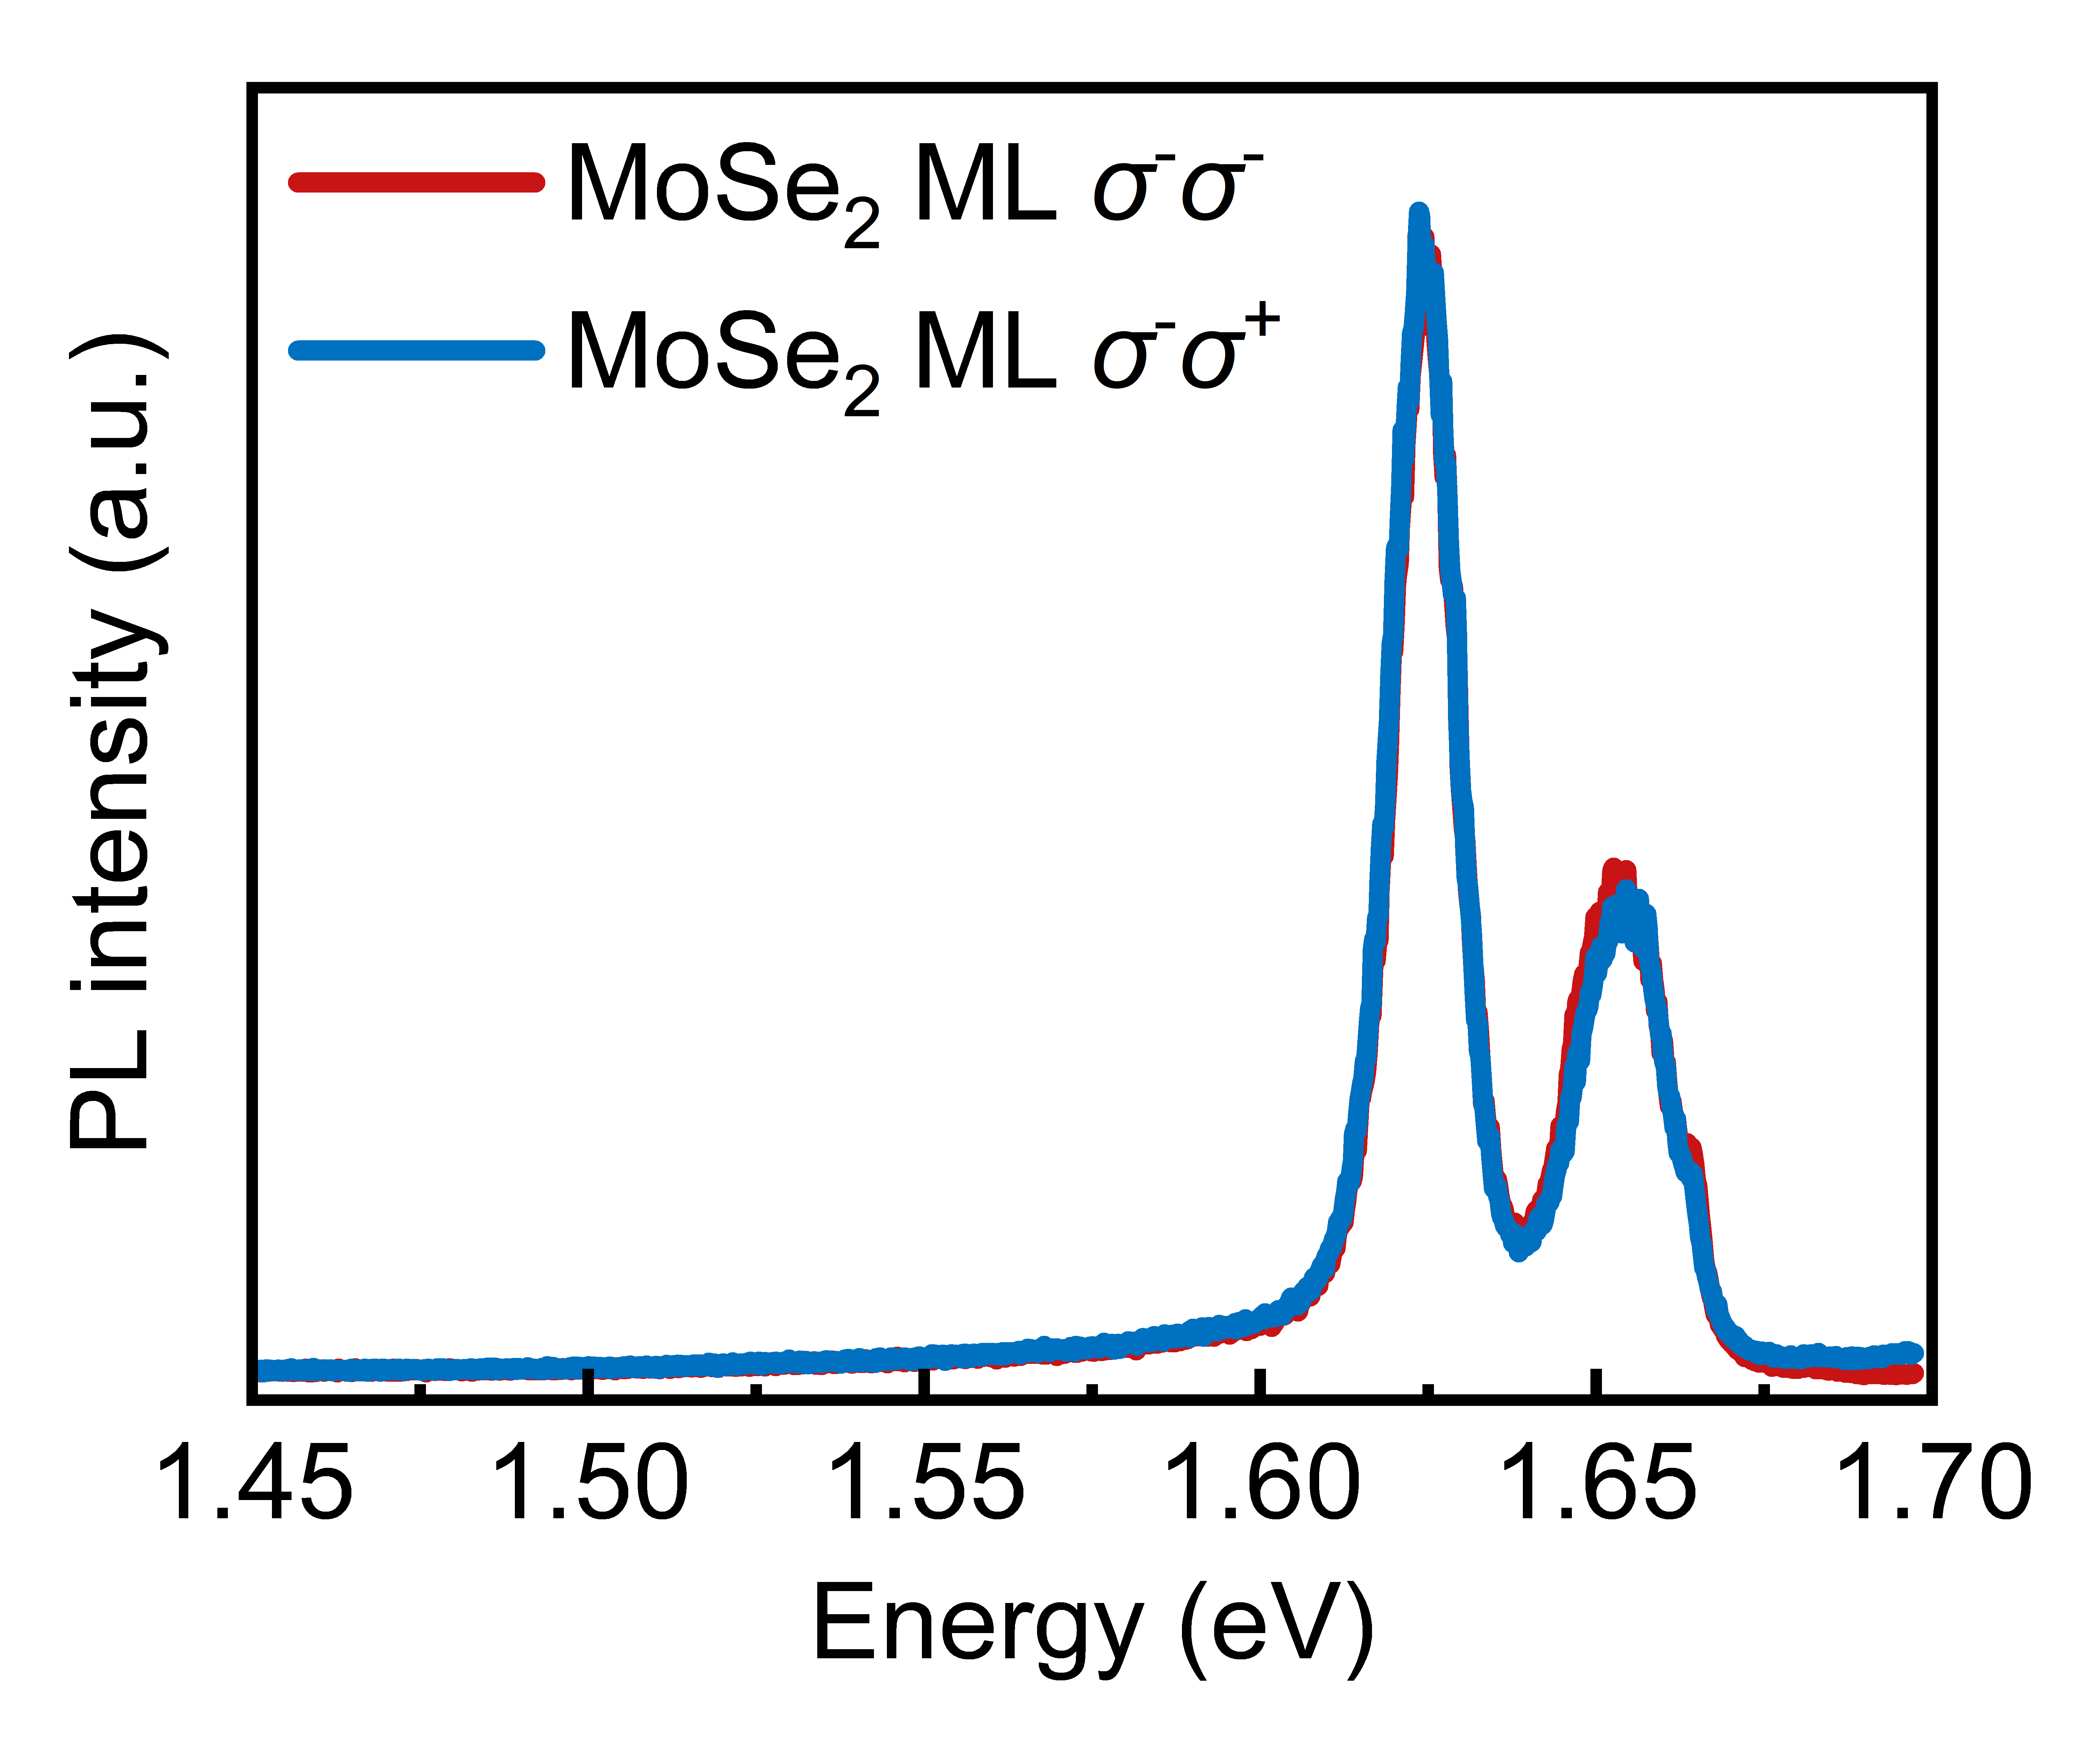
Figure S6. The PL spectra of MoSe₂/SiO₂ (Sample 1) excited at 721 nm. σ⁻σ⁻(σ⁻σ⁺) represents co-and cross-polarization under σ⁻ excitation.

Supplementary Note 7: Interfacial magnon-exciton interactions in the WSe₂/CrSBr heterostructure.
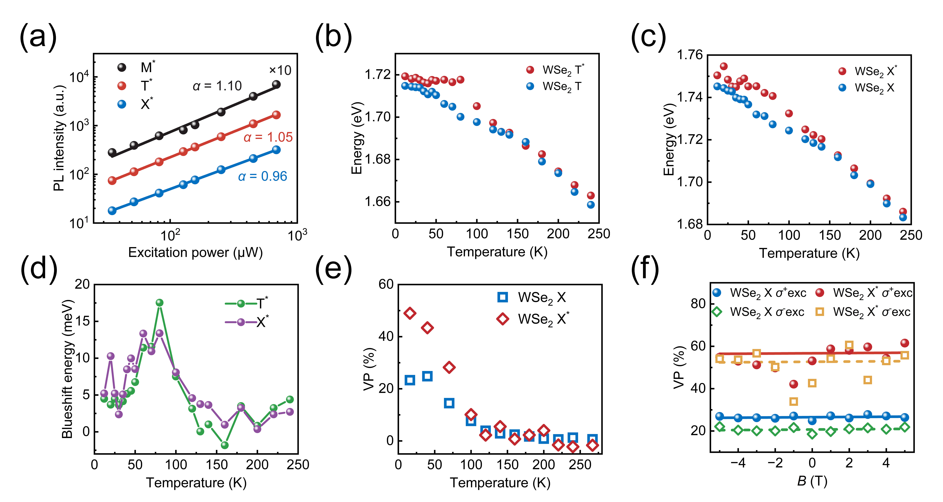
Figure S7. Excitonic and valley properties of excitonic states in WSe₂/CrSBr (Sample 2). (a) Excitation power dependence of the integrated PL intensity of M*, T*, and X* in WSe₂/CrSBr. Solid curves are fitted with I ∝ P^{α}. Temperature dependence of trion (b) and exciton (c) peak energy in WSe₂/SiO₂ and WSe₂/CrSBr. (d) Temperature dependence of energy blueshift between X* (T*) and X (T). (e) Temperature dependence of VP for X and X*. (f) VP of excitons (X, X*) as a function of out-of-plane magnetic field under σ⁺ (solid symbols) and σ⁻ excitation (empty symbols) in WSe₂/SiO₂ and WSe₂/CrSBr. Solid and dashed lines are linear fitting results.
As shown in Figure S7a, the emission intensity of M*, T*, and X* in the WSe₂/CrSBr exhibits linear dependence on the excitation power. The temperature dependence of the trion and exciton emission energy in WSe₂/SiO₂ and WSe₂/CrSBr are shown in Figures S7b and S7c, respectively. We observe a significant blueshift of the excitonic states in WSe₂/CrSBr compared to that in WSe₂/SiO₂ below T_{N}. The blueshift energy are extracted and shown in Figure S7d. It exhibits a maximum at 70 K and keeps a constant (~ 2.5 meV) when the temperature is higher than the Néel temperature of CrSBr, which is attributes to the variation of dielectric environment. This result is in accordance with that observed in MoSe₂/CrSBr. Figure S7e shows the temperature dependence of valley polarization in WSe₂/SiO₂ and WSe₂/CrSBr. Enhanced VP is observed unless the temperature surpasses ~120 K, consistent with the results in MoSe₂/CrSBr. Figure S7f displays the exciton valley polarization in WSe₂/SiO₂ and WSe₂/CrSBr under different magnetic fields. At 0 T, the exciton VP of WSe₂/SiO₂ and WSe₂/CrSBr under σ⁺ (σ⁻) excitation are ~ 26.5% (20.7%) and 56.7% (52.7%), respectively, showing enhanced VP in the heterostructure. In addition, the VP of X and X* exhibits the same rate of change (~0%/T) with the magnetic field, which is consistent with the main text.
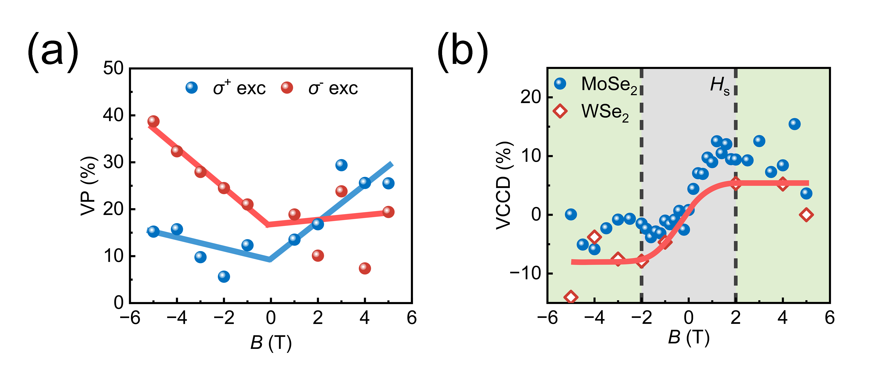
Figure S8. Valley properties of exciton-magnon complexes (M*) in WSe₂/CrSBr (Sample 3). (a) VP of M* dependence on out-of-plane magnetic field under σ⁺ and σ⁻ excitation. The solid lines represent guide lines. (b) VCCD of M* in WSe₂/CrSBr (Sample 3) and MoSe₂/CrSBr (Sample 3) dependence on out-of-plane magnetic field. Dashed black lines indicate ±H_{s}, and the solid red line is the guide line.
In WSe₂/CrSBr, M* exhibits an asymmetric V-shaped dependence of VP on the magnetic field and an S-shaped dependence of VCCD on the magnetic field, consistent with the results in MoSe₂/CrSBr.

Supplementary Note 8: Theoretical modeling of V-shaped variation of VP with magnetic field.
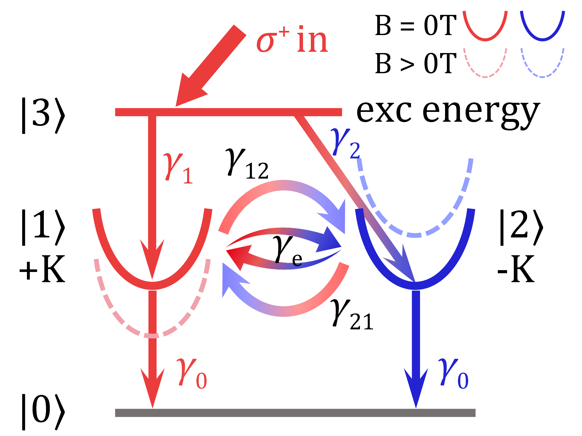
Figure S9. Schematic diagram of exciton decay dynamics with a four-level system under σ⁺ excitation. Scattering driven by electron-hole exchange interaction and Zeeman effect are involved.
We establish a model to explain the VP in the presence of an out-of-plane magnetic field by describing the exciton decay dynamics in ML TMD. As shown in Figure S9, we consider a four-level system, where state |0⟩ represents the ground state, states |1⟩ and |2⟩ correspond to excitonic states in the K and -K valleys, respectively, and state |3⟩ represents the excitation energy level. γ₀ is the exciton decay rate, γ₁ and γ₂ are the valley conservation and valley flipping rates, respectively, γ_{e} is the exchange-driven intervalley scattering rate, and γ₁₂ and γ₂₁ are the Zeeman-driven intervalley scattering rates.
For σ⁺ excitation, assuming that photogenerated carriers are only produced in the K valley, we can write the rate equation for the population in K and -K valley:
$\frac{dN_{1}}{dt}=N_{3}γ_{1}+N_{2}\left(γ_{21}+γ_{e}\right)-{N_{1}\left(γ_{12}+γ_{e}\right)-N}_{1}γ_{0}$
$\frac{dN_{2}}{dt}=N_{3}γ_{2}-N_{2}\left(γ_{21}+γ_{e}\right)+{N_{1}\left(γ_{12}+γ_{e}\right)-N}_{2}γ_{0}$, (S1)
where N_{i} is the population of the i-th state. The VP of K valley can be written as follows:
$P_{c}=\frac{N_{1}-N_{2}}{N_{1}+N_{2}}=P_{0}∙\frac{γ_{0}}{γ_{0}+γ_{12}+γ_{21}+{2γ}_{e}}+\frac{γ_{21}-γ_{12}}{γ_{0}+γ_{12}+γ_{21}+{2γ}_{e}}$, (S2)
where P_{c} is the VP of K valley, and P₀ = (γ₁-γ₂)/(γ₁+γ₂) is the initial VP of the system.
At zero magnetic field, γ₁₂ = γ₂₁ = γ_{l}, P_{c} can be simplified to:
$P_{c}=P_{0}∙\frac{1}{1+2(r_{0}+r_{0}^{'})}=P_{0}∙\frac{1}{1+2(τ_{0}/τ_{\text{v}})}$, (S3)
where τ₀ = 1/γ₀ is the exciton decay time, and τv = 1/(γ_{l} + γe) is the intervalley relaxation time. The parameters r₀ = γ_{l}/γ₀ and r₀' = γ_{e}(B=0)/γ₀ represent the ratio of the Zeeman-driven and e-h exchange-driven valley depolarization rate to the exciton decay rate at zero field, respectively. When P₀ remains constant, the VP at zero field depends on the competition between exciton recombination (τ₀) and intervalley scattering (τ_{v}), i.e., the τ₀/τ_{v} term or the r₀ + r₀' term.
When an out-of-plane magnetic field is applied, γ₁₂, γ₂₁, and γ_{e} take the following forms^{14,15}:
$γ_{12}=r_{0}γ_{0}exp⁡(+β)$
$γ_{21}=r_{0}γ_{0}exp⁡(-β)$
$γ_{e}=r_{0}^{'}γ_{0}\frac{1}{1+{(\frac{∆E}{Γ})}^{2}}$, (S4)
where ΔE = E_{σ⁺σ⁺} - E_{σ⁻σ⁻} = gμ_{B}B is valley Zeeman splitting, g is the g-factor, β = ΔE/(2k_{B}T), k_{B} is the Boltzmann constant, T is temperature, and Γ is the width parameter of exchange interaction. γ_{e} can be negligible when ΔE is much larger than Γ. Therefore, Eq. (S2) can be modified as:
$P_{c}=\frac{P_{0}-2r_{0}∙sinh⁡(β)}{1+2r_{0}∙cosh⁡(β)+2r_{0}^{'}∙\frac{1}{1+{(\frac{∆E}{Γ})}^{2}}}$. (S5)
We assume that P₀ is independent of the magnetic field. By the model fitting to Figure 4b with Eq. (S5), we obtained P₀ = 0.2012, g = -8.75, T = 15 K, r₀ = 0.02, r₀' = 0.85, and Γ = 1.5 meV. The relative smaller r₀ and larger r₀' at 0 T indicate that the valley depolarization mechanism is dominated by the electron-hole exchange interactions.

REFERENCES
1 Le, C. T. et al. Negative Valley Polarization of the Intralayer Exciton via One-Step Growth of H-Type Heterobilayer WS₂/MoS₂. ACS Nano 17, 2629-2638 (2023).
2 Jiang, Y., Chen, S., Zheng, W., Zheng, B. & Pan, A. Interlayer exciton formation, relaxation, and transport in TMD van der Waals heterostructures. Light: Science & Applications 10, 72 (2021).
3 He, M. et al. Valley phonons and exciton complexes in a monolayer semiconductor. Nature Communications 11, 618 (2020).
4 Yang, M. et al. Relaxation and darkening of excitonic complexes in electrostatically doped monolayer WSe₂: Roles of exciton-electron and trion-electron interactions. Physical Review B 105, 085302 (2022).
5 Lee, J. et al. Modulation of Junction Modes in SnSe₂/MoTe₂ Broken-Gap van der Waals Heterostructure for Multifunctional Devices. Nano Letters 20, 2370-2377 (2020).
6 Robert, C. et al. Measurement of the spin-forbidden dark excitons in MoS₂ and MoSe₂ monolayers. Nature Communications 11, 4037 (2020).
7 Scheie, A. et al. Spin Waves and Magnetic Exchange Hamiltonian in CrSBr. Advanced Science 9, 2202467 (2022).
8 Pawbake, A. et al. Magneto-Optical Sensing of the Pressure Driven Magnetic Ground States in Bulk CrSBr. Nano Letters 23, 9587-9593 (2023).
9 Diederich, G. M. et al. Exciton Dressing by Extreme Nonlinear Magnons in a Layered Semiconductor. Preprint at https://arxiv.org/abs/2411.14943 (2024).
10 Esteras, D. L., Rybakov, A., Ruiz, A. M. & Baldoví, J. J. Magnon Straintronics in the 2D van der Waals Ferromagnet CrSBr from First-Principles. Nano Letters 22, 8771-8778 (2022).
11 Li, Z. et al. Phonon-exciton Interactions in WSe₂ under a quantizing magnetic field. Nature Communications 11, 3104 (2020).
12 Sallen, G. et al. Robust optical emission polarization in MoS₂ monolayers through selective valley excitation. Physical Review B 86, 081301 (2012).
13 Yang, L. et al. Long-lived nanosecond spin relaxation and spin coherence of electrons in monolayer MoS₂ and WS₂. Nature Physics 11, 830-834 (2015).
14 Neumann, A. et al. Opto-valleytronic imaging of atomically thin semiconductors. Nature Nanotechnology 12, 329-334 (2017).
15 Surrente, A. et al. Intervalley Scattering of Interlayer Excitons in a MoS₂/MoSe₂/MoS₂ Heterostructure in High Magnetic Field. Nano Letters 18, 3994-4000 (2018).

