Supplementary Information:
Towards a Food Secure Future under Changing Climate in Ghana: The Role of Opportunity Crops
Dilys S. MacCarthy^{1*}, Samuel G. Adiku², Roberto Valdivia³, Bright S. Freduah¹, Kevin Karl^{4,5}, Gershom O. Wesley¹, Jose R. Guarin^{4,5,6}, Meijian Yang^{4,5}, Comfort Freeman⁷, Justina S. Owusu⁸, Andres A. Castellano^{5,6}, Joseph K. Clottey⁹, Stephen Narh¹, Alex C. Ruane⁵, Jonas Jägermeyr^{4,5,10}, Erik Mencos Contreras^{4,5}, Kingsley K. Amoaku¹¹, Cynthia E. Rosenzweig⁵
¹Soil and Irrigation Research Centre, School of Agriculture, College of Basic and Applied Sciences, University of Ghana, Kpong, Ghana
²Department of Soil Science, School of Agriculture, College of Basic and Applied Sciences, University of Ghana, Legon, Accra, Ghana
³Department of Applied Economics, Oregon State University, Corvallis, 97331, OR, USA
⁴Columbia Climate School, Columbia University, New York, NY 10025 USA
⁵NASA Goddard Institute for Space Studies, New York, NY 10025 USA
⁶Autonomic Integra, Bethesda, MD 20817 USA
⁷Department of Agricultural Extension, School of Agriculture, College of Basic and Applied Sciences, University of Ghana, Legon, Accra, Ghana
⁸Department of Food Science and Nutrition, School of Biological Sciences, College of Basic and Applied Sciences, University of Ghana, Legon, Accra, Ghana
⁹International Centre for Evaluation and Development, Sakumono, Ghana
¹⁰ Potsdam Institute for Climate Impact Research (PIK), Member of the Leibniz Association, 14412, Potsdam, Germany
¹¹Ministry of Food and Agriculture, Department of Crops Services, Accra, Ghana
*Corresponding author: Dilys S. MacCarthy (dmaccarthy@ug.edu.gh)
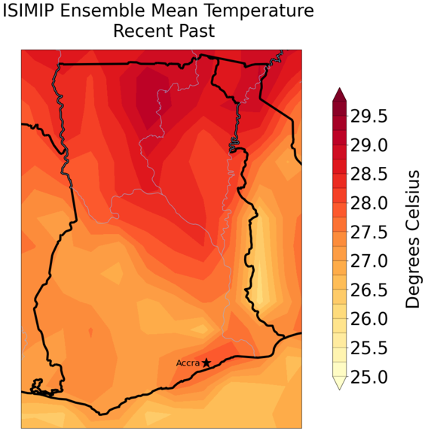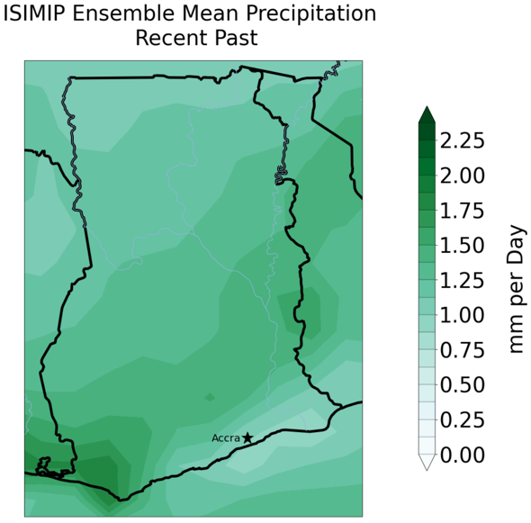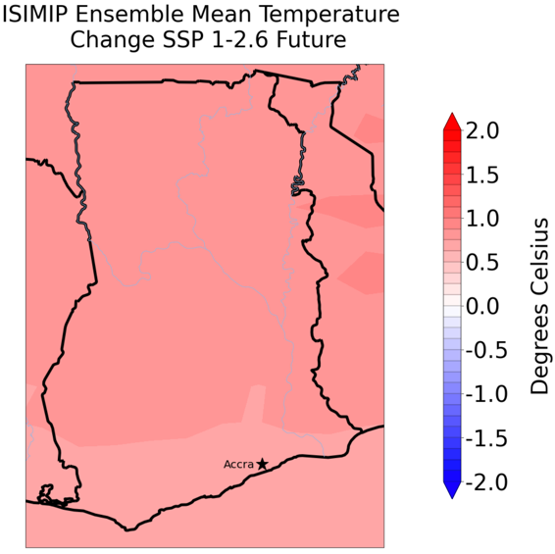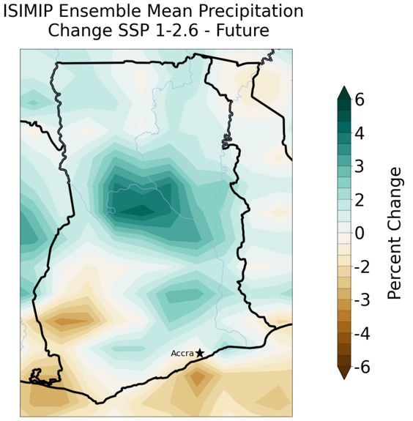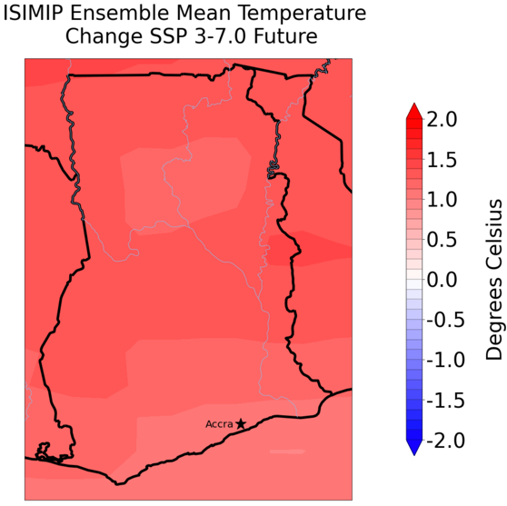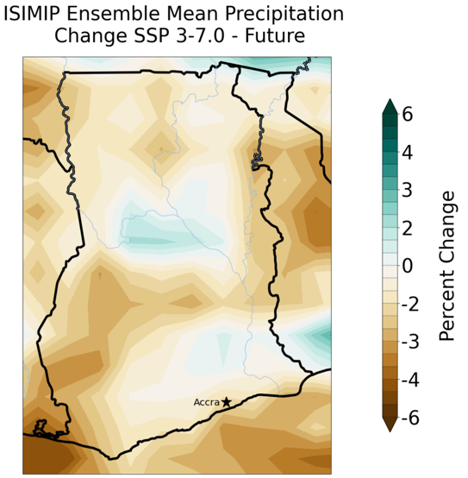
Figure S1 | Ghana climate. Mean temperature (left) and daily rainfall amount (right) under the recent past (1990-2019) and the Inter-Sectoral Impact Model Intercomparison Project (ISMIP) ensembled future projected changes (2035-2064) for Ghana under low (SSP1-2.6) and high (SSP3-7.0) emission scenarios.

Table S1 | Cultivar and species parameters. List of cultivar and species parameters used in calibrating and evaluating SIMPLE in Ghana. T_{sum}: Cumulative temperature requirement from sowing to maturity (°C d). HI: Harvest index. I_{50A}: Cumulative temperature requirement for leaf area development to intercept 50% of radiation (°C d). I_{50B}: Cumulative temperature for maturity to reach 50% radiation interception due to leaf senescence (°C d). T_{base}: Base temperature for phenology development and growth (°C). T_{opt}: Optimal temperature for biomass growth (°C). RUE: Radiation use eﬃciency (above ground only and without respiration) (g MJ⁻¹ m⁻²). I_{50maxH}: The maximum daily reduction in I_{50B} due to heat stress (°C d). I_{50maxW}: The maximum daily reduction in I_{50B} due to drought stress (°C d). T_{max}: Threshold temperature to start accelerating senescence from heat stress (°C). T_{extreme}: The extreme temperature threshold when RUE becomes 0 due to heat stress (°C). S_{CO2}: Relative increase in RUE per ppm elevated CO₂ above 350 ppm. S_{water}: Sensitivity of RUE to drought stress.
Crop type | Species | Cultivar parameters |  |  |  |  | Species parameters
Crop type | Species | T_{sum} | HI | I_{50A} | I_{50B} |  | T_{base} | T_{opt} | RUE | I_{50maxH} | I_{50maxW} | T_{max} | T_{ext} | S_{CO2} | S_{Water}
Cereals | Maize | 1550 | 0.25¹* | 600 | 250 |  | 8 | 28 | 2.00 | 100 | 12 | 34 | 50 | 0.01 | 1.5
Cereals | Fonio | 1320² | 0.24³ | 700 | 400 |  | 10 | 33⁴ | 1.90⁴ | 100 | 12 | 46⁴ | 50 | 0.03 | 0.9
Cereals | Sorghum | 2000 | 0.19⁵* | 570 | 450 |  | 10⁶ | 32⁷ | 1.30⁸ | 100 | 12 | 38⁶ | 50 | 0.03 | 1.4
Legumes | Soybean | 2250 | 0.28 | 490 | 370 |  | 6⁹ | 22 | 0.86¹⁰ | 120 | 20 | 34 | 45 | 0.07 | 0.9
Legumes | Cowpea | 1800 | 0.50 | 700 | 600 |  | 3 | 30 | 1.00 | 100 | 20 | 36 | 45 | 0.14 | 0.8
Legumes | Bambara groundnut | 2500¹¹ | 0.20¹² | 680 | 540 |  | 6 | 30¹³ | 1.10¹⁴ | 100 | 20 | 35 | 50¹⁵ | 0.07 | 1.5
Roots/Tubers | Cassava | 5400 | 0.65 | 650 | 300 |  | 12 | 28 | 1.10 | 100 | 15 | 38 | 50 | 0.07 | 1.0
Roots/Tubers | Cocoyam | 2550¹⁶ | 0.53 | 650 | 450 |  | 10¹⁷ | 21¹⁷ | 1.20 | 50 | 30 | 35 | 45 | 0.10 | 0.7
Roots/Tubers | Sweet potato | 1200 | 0.60¹⁸ | 500 | 300 |  | 15¹⁸ | 22 | 1.61¹⁹ | 50 | 30 | 35¹⁸ | 45 | 0.10 | 0.6
Roots/Tubers | Yams | 3600 | 0.75 | 650 | 540 |  | 12 | 28 | 1.20 | 100 | 15 | 38 | 50 | 0.07 | 1.2
Note: the * after the citation means the reference doesn’t necessarily provide the number but a direction to adjust the number based on other analogous crops.

Table S2 | Crop calendar. Planting windows of various crops in Ghana from the literature.

Agro Ecological Zone | Planting Window from literature | Window used for SIMPLE | Crops simulated using the window
Guinea & Sudan Savanah | June 1 - July 15²⁰ | 21-Jun | Soybean, Bambara groundnut, Cowpea
Transition | March 20 to April 30²⁰ | 10-Apr | Soybean, Bambara groundnut, Cowpea
Deciduous, Rainforest & Coastal savannah | April 15 to May 15²⁰ | 01-May | Soybean, Bambara groundnut, Cowpea
Guinea & Sudan Savanah | End May to Early July²¹ | 01-Jun | Maize, Fonio, Sorghum
Transition | Mid-March to end April²¹ | 01-Apr | Maize, Fonio, Sorghum
Deciduous, Rainforest & Coastal savannah | Early March to end April²¹ | 01-Apr | Maize, Fonio, Sorghum
Guinea & Sudan Savanah | Mid June - Mid August²² | 20-Jun | Cassava, Cocoyam, Sweet potato
Transition | April to end May²³ | 15-Apr | Cassava, Cocoyam, Sweet potato
Deciduous, Rainforest & Coastal savannah | April to end May²² | 15-Apr | Cassava, Cocoyam, Sweet potato

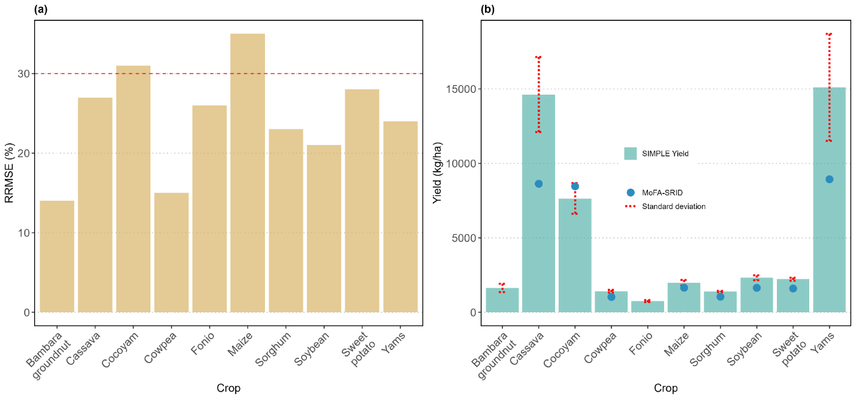
Figure S2 | Model evaluation using MoFA-SRID and Ghana FAO yields. (a) SIMPLE Model performance in simulating observed yields (national yield from FAOSTAT²⁴ and from the Statistics, Research and Information Directorate of the Ministry of Food and Agriculture (SRID-MoFA) over the baseline period (2000 – 2019) and (b) Average simulated historical yield from SIMPLE (bars) based on the ensemble of four GCMs and average national yield data (FAOSTAT and SRID-MoFA; blue circles) for the historical period (1990 – 2019). Error bars indicate the standard deviation of the mean of simulated yields. Baseline yields of bambara groundnut and fonio for model evaluation were from Burkina Faso national yield statistics.

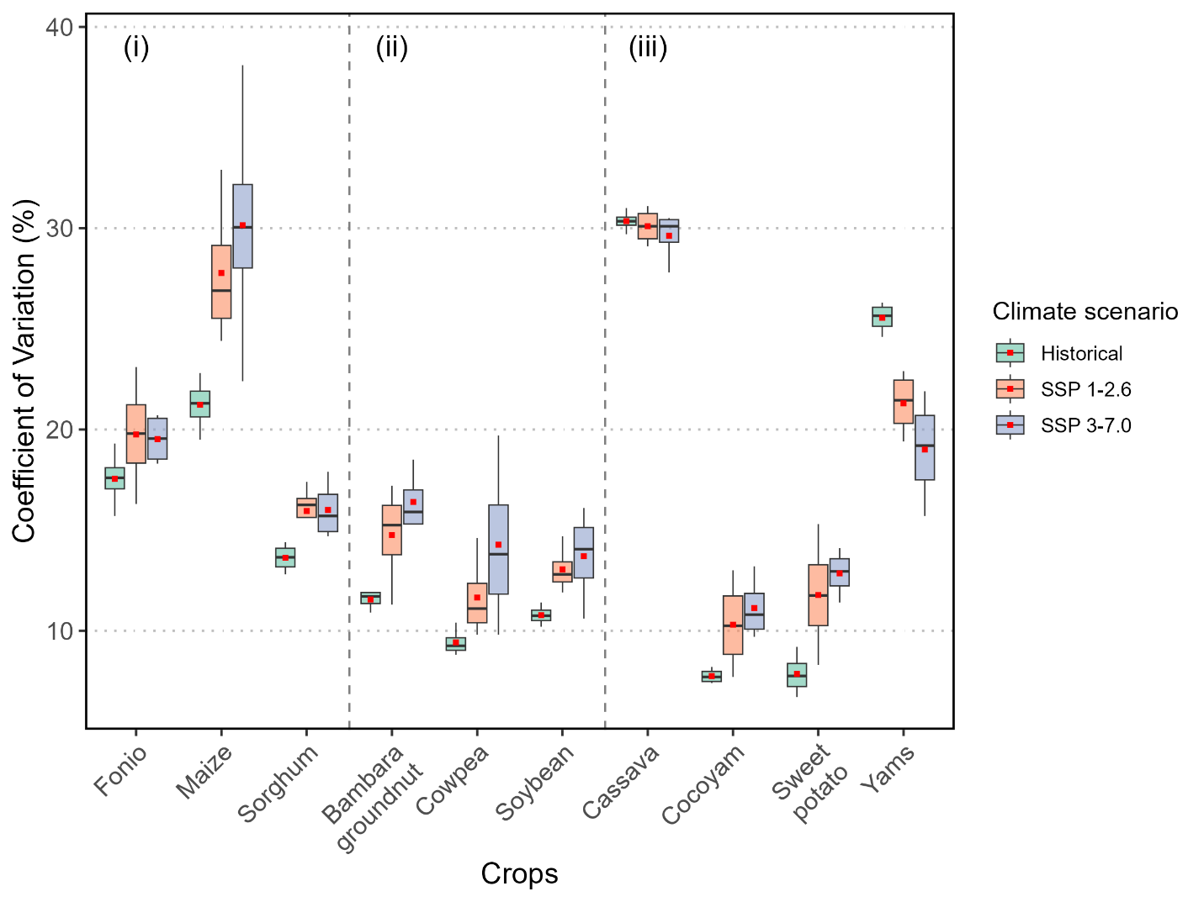
Figure S3 | Spatial yield variability under historical and future climate. Coefficient of variation (CV) in simulated yield for the 10 crops examined in Ghana classified as (i) cereals, (ii) legumes, and (iii) roots and tubers. Each box contains CVs from the four GCMs (GFDL-ESM4, IPSL-CM6A-LR, MPI-ESM1-2-HR and MRI-ESM2-0).

Table S3 | Climate change impact on yields of crops in Navrongo, Northern Ghana using DSSAT. Values are averaged across 4 GCMs
Crop | Climate scenario | Av. grain yield (kg/ha) | Max. grain yield (kg/ha) | Min. grain yield (kg/ha) | cv (%) | Yield change (%)
Maize | Historical | 1196 | 3148 | 342 | 52 | -
Maize | SSP 1-2.6 | 1117 | 2802 | 330 | 51 | -6.0
Maize | SSP 3-7.0 | 1046 | 2534 | 312 | 49 | -11.6
Sorghum | Historical | 632 | 1252 | 335 | 45 | -
Sorghum | SSP 1-2.6 | 625 | 1208 | 345 | 42 | 0.4
Sorghum | SSP 3-7.0 | 602 | 1134 | 342 | 41 | -3.0
Cowpea | Historical | 737 | 1319 | 436 | 33 | -
Cowpea | SSP 1-2.6 | 891 | 1496 | 546 | 30 | 22.3
Cowpea | SSP 3-7.0 | 920 | 1514 | 562 | 28 | 27.5
Peanut | Historical | 859 | 1671 | 414 | 47 | -
Peanut | SSP 1-2.6 | 929 | 1735 | 487 | 42 | 11.0
Peanut | SSP 3-7.0 | 954 | 1731 | 507 | 40 | 14.9

Table S4 | Cost of nutritionally adequate food basket (NAFB) based on 4 different scenarios
 |  | Nutritional Adequate Food basket*
 |  | NAFB1 (no cowpeas) |  | NAFB2 |  | NAFB3 |  | NABF4
Food Group | Food item | Total Weight | Cost | Total Weight | Cost | Total Weight | Cost | Total Weight | Cost
Grain | Maize, white | 61 | 0.11 | 68 | 0.06 | 121 | 0.10 | 310 | 0.26
Grain | Millet, pearl, whole grain, raw | 546 | 0.78 | 185 | 0.23 | 42 | 0.05 | 441 | 0.56
Grain | Oat, dried | 31 | 0.21
Grain | Sorghum, whole grain, raw |  |  | 1098 | 1.05 | 1202 | 1.15 | 1073 | 1.03
Legumes, Nuts& Seeds | Groundnut, red, shelled, dried, raw |  |  | 168 | 0.39 | 111 | 0.26 | 87 | 0.21
Legumes, Nuts& Seeds | Groundnut paste | 1 | 0.01
Legumes, Nuts& Seeds | Groundnut dried | 68 | 0.30
Legumes, Nuts& Seeds | Soyabean flour | 568 | 1.07
Legumes, Nuts& Seeds | Melon seeds (Neri) |  |  | 45 | 0.07 | 120 | 0.20 | 121 | 0.20
Legumes, Nuts& Seeds | Cowpea, dried, raw |  |  | 32 | 0.07 | 32 | 0.07 | 70 | 0.14
Fish | Fish, anchovy, dried |  |  | 65 | 0.42 | 65 | 0.42 | 191 | 1.24
Vegetables and their products | Cowpea Leaves |  |  | 1047 | 0.00 | 1093 | 0.00
Vegetables and their products | Eggplant, raw |  |  | 309 | 0.36 | 182 | 0.21 | 324 | 0.40
Vegetables and their products | Leaf, amaranth, raw |  |  |  |  | 1369 | 0.00 | 163 | 0.53
Vegetables and their products | Cocoyam leaves | 59 | 0.06
Vegetables and their products | Leaf, baobab, raw |  |  | 3009 | 0.00 | 817 | 0.00
Vegetables and their products | Okra, dried, grounded | 112 | 0.61
Vegetables and their products | Leaf, jute, raw (Ayoyo) |  |  |  |  | 124 | 0.00 | 128 | 0.45
Fruit | Mango, deep orange flesh |  |  | 125 | 0.06 | 1103 | 0.00 | 136 | 0.07
Animal and Vegetable oil and fats | Oil, groundnut |  |  | 38 | 0.21 | 30 | 0.16 | 10 | 0.05
Animal and Vegetable oil and fats | Vegetable oil | 6 | 0.02
Animal and Vegetable oil and fats | Oil, palm, red |  |  | 11 | 0.06 | 16 | 0.09 | 18 | 0.10
Root and Tubers | Cassava, flour, gari, yellow | 726 | 0.92
Nuts, seeds and their product | Coconut, whole, immature kernel, fresh | 297 | 0.11
Products from slaughtered animals | Beef liver | 14 | 0.11
Miscellaneous | Salt, Iodized | 17 | 0.03
 | Total cost per household per day |  | 4.35 |  | 2.99 |  | 2.72 |  | 5.23
 | NAFB Total cost per person per year (Ghc) |  | 397 |  | 273 |  | 248 |  | 477
Estimation of the NAFB is based on a household of 4 people with the following assumptions regarding composition and age: 1 Female (8-9 years), 1 Male (5-6 years), 1 Man (30-59 years) and 1 Woman (18-29 years). Total weight is in grams (g/day) and cost is in Ghc. Blank cells in the table indicate that the food item is not used in the respective NAFB. Zero values in the cost columns indicate that the food item can be obtained without cost, for example as a byproduct from crops (e.g., crop leaves) or grown in or around the farm (e.g., mango trees).

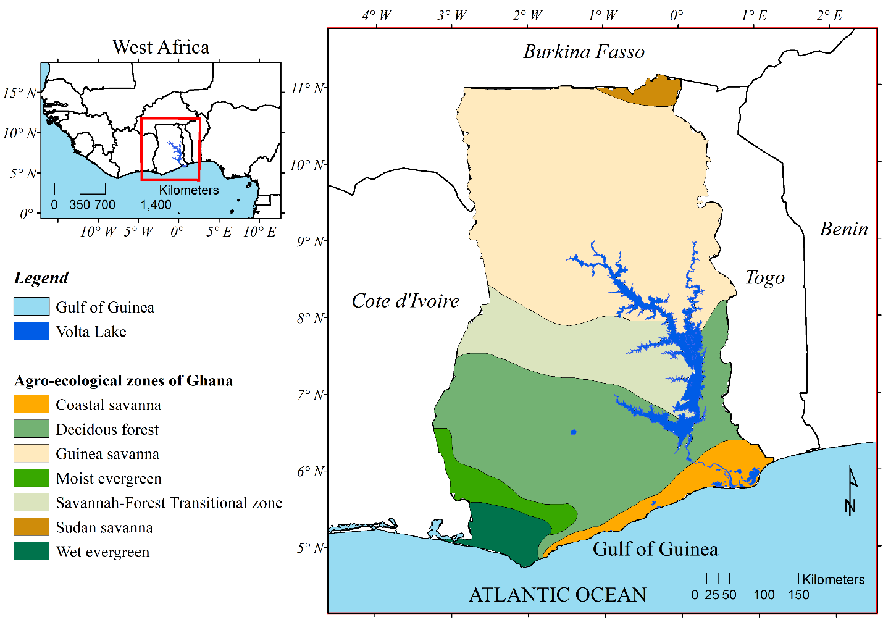
Figure S4 | AEZs of Ghana. Study location illustrating the major agro-ecological zones.

References
1. Amegashie, K. B. Response of maize grain and stover yields to tillage and different soil fertility management practices in the semi-deciduous forest zone of Ghana. (2015).
2. Gueye, M. et al. Effect of planting date on growth and grain yield of fonio millet (Digitaria exilis Stapf) in the Southeast of Senegal. Int. J. Bio. Chem. Sci 9, 581 (2015). https://doi.org/10.4314/ijbcs.v9i2.1
3. Ibrahim Bio Yerima, A. R. et al. Agromorphological Characterization Revealed Three Phenotypic Groups in a Region-Wide Germplasm of Fonio (Digitaria exilis (Kippist) Stapf) from West Africa. Agronomy 10, 1653 (2020). https://doi.org/10.3390/agronomy10111653
4. Dodds, P. E. Development of a crop model to examine crop management and climate change in Senegal. (University of Leeds) 2010).
5. Gómez-Dans, J. L. et al. Location, biophysical and agronomic parameters for croplands in northern Ghana. Earth System Science Data 14, 5387–5410 (2022). https://doi.org/10.5194/essd-14-5387-2022
6. Gerik, T., Bean, B. & Vanderlip, R. Sorghum growth and development. (2024).
7. Djanaguiraman, M., Prasad, P. V. V. & Seppanen, M. Selenium protects sorghum leaves from oxidative damage under high temperature stress by enhancing antioxidant defense system. Plant Physiology and Biochemistry 48, 999–1007 (2010). https://doi.org/10.1016/j.plaphy.2010.09.009
8. Muchow, R. C. & Sinclair, T. R. Nitrogen Response of Leaf Photosynthesis and Canopy Radiation Use Efficiency in Field-Grown Maize and Sorghum. Crop Science 34, (1994). https://doi.org/10.2135/cropsci1994.0011183x003400030022x
9. Pereira-Flores, M. E., Justino, F. B., Pereira-Flores, M. E. & Justino, F. B. Yield Components and Biomass Partition in Soybean: Climate Change Vision. in Soybean - Biomass, Yield and Productivity (IntechOpen) (2019). https://doi.org/10.5772/intechopen.81627
10. Muchow, R. C., Robertson, M. J. & Pengelly, B. C. Radiation-use efficiency of soybean, mugbean and cowpea under different environmental conditions. Field Crops Research 32, 1–16 (1993). https://doi.org/10.1016/0378-4290(93)90017-h
11. Majola, N. G., Gerrano, A. S. & Shimelis, H. Bambara Groundnut (Vigna subterranea [L.] Verdc.) Production, Utilisation and Genetic Improvement in Sub-Saharan Africa. Agronomy 11, 1345 (2021). https://doi.org/10.3390/agronomy11071345
12. Mabhaudhi, T. & Modi, A. T. Growth, phenological and yield responses of a bambara groundnut (Vigna subterranea (L.) Verdc.) landrace to imposed water stress under field conditions. South African Journal of Plant and Soil 30, 69–79 (2013). https://doi.org/10.1080/02571862.2013.790492
13. Hasan, M., Uddin, M. K., Mohamed, M. T. M. & Zuan, A. T. K. Nitrogen and phosphorus management for Bambara groundnut (Vigna subterranea) production-A review. Legume Research (2018). https://doi.org/10.18805/lr-379
14. FAO Agricultural Information Management Series. https://www.fao.org/4/y0494e/Y0494e05.htm (Accessed on 18-10-2023)
15. Soni, M. L. et al. Variability in heat tolerance in Bambara groundnut (Vigna subterranea (L.) Verdc.). Ind J Plant Physiol. 20, 92–96 (2015).DOI:10.1007/s40502-015-0137-8
16. Cocoyam farming complete guidlines:complete information about cocoyam - AGRIFARMBLOG. (2020) https://agrifarmblog.com/cocoyam-farming-complete-guidlinescomplete-information-about-cocoyam/ .
17. Gelleh, I. D., Henry, O. U., Babalogbon, B. A. & Silas, M. Y. Land Suitability Analysis For The Production Of Cocoyam Inbenue State,Nigeria. Earth Sciences Malaysia (ESMY) 2, 25–30 (2018).DOI: 10.26480/esmy.02.2018.25.30
18. Rankine, D. R. et al. Parameterizing the FAO AquaCrop Model for Rainfed and Irrigated Field-Grown Sweet Potato. Agronomy Journal 107, 375–387 (2015). https://doi.org/10.2134/agronj14.0287
19. Arina, I. N et al. Radiation Dynamics of Sweetpotato (Ipomoea batatas (L.) Lam) in Response to Different Cropping Systems with a legume crop. 287 - 299 (2020) https://scialert.net/abstract/?doi=ajps.2020.287.299 doi:10.3923/ajps.2020.287.299.
20. Adzoyi, F. X. Extension Handbook for Soya, Cowpea and Groundnut Production in Northern Ghana (2015).
21. Adzoyi, F. X. Community Extension Agent Handbook for Maize Production, Northern Ghana. Revised Edition, 2015. (2015).
22. FAO Crop Calendar. https://cropcalendar.apps.fao.org/#/home?id=GH&crops=0076. (Accessed on 01-03-2024)
23. AfricaagMedia. Ghana: Cassava. https://www.agricinafrica.com/2023/01/ghana-cassava.html. (Accessed on 01-03-2024)
24. Food and Agriculture Organization of the United Nations. FAOSTAT. https://www.fao.org/faostat/en/#data/QCL. (Accessed on 01-03-2024)

