Supplementary Table 1
The environmental variables used in this study.
Variable | Description
bio1 | Mean annual air temperature in ℃.
bio2 | Mean diurnal air temperature range in ℃. That is, the difference between the mean of monthly maximum and minimum temperatures.
bio3 | Isothermality: The ratio of the diurnal variation to the annual temperature range, expressed as percentage.
bio4 | Temperature seasonality: The standard deviation of monthly mean or seasonal temperatures.
bio5 | Max temperature of warmest month.
bio6 | Min temperature of coldest month.
bio7 | Temperature annual range: The difference between the maximum temperature  of the warmest month and the minimum temperature of the coldest month (bio5-bio6).
bio8 | Mean temperature of wettest quarter: The average temperature during the wettest three-month period.
bio9 | Mean Temperature of driest quarter: The average temperature during  the driest three-month period.
bio10 | Mean Temperature of warmest quarter: The average temperature during the warmest three-month period.
bio11 | Mean Temperature of coldest quarter: The average temperature during the coldest three-month period.
bio12 | Annual Precipitation: The total precipitation over the course of a year.
bio13 | Precipitation amount of wettest Month: The total precipitation during the  wettest month of the year.
bio14 | Precipitation of Driest Month: The total precipitation during the driest month of the year.
bio15 | Precipitation Seasonality: The coefficient of variation of monthly or  seasonal precipitation.
bio16 | Precipitation of Wettest Quarter: The total precipitation during the wettest three-month period.
bio17 | Precipitation of Driest Quarter: The total precipitation during the driest three-month period.
bio18 | Precipitation of Warmest Quarter: The total precipitation during the warmest three-month period.
bio19 | Precipitation of Coldest Quarter: The total precipitation during the coldest three-month period.
Elev  Slope | Topographic elevation (m).  Slope (degrees).
Soil | Dominant reference soil groups.
Dist_water  NDVI | Distance to nearest water body (m).  Mean annual normalized difference vegetation index

Supplementary Figure 1.
The environmental variables with acceptable levels of multicollinearity included in the predictive model of Bu. africanus and Bi. pfeifferi.
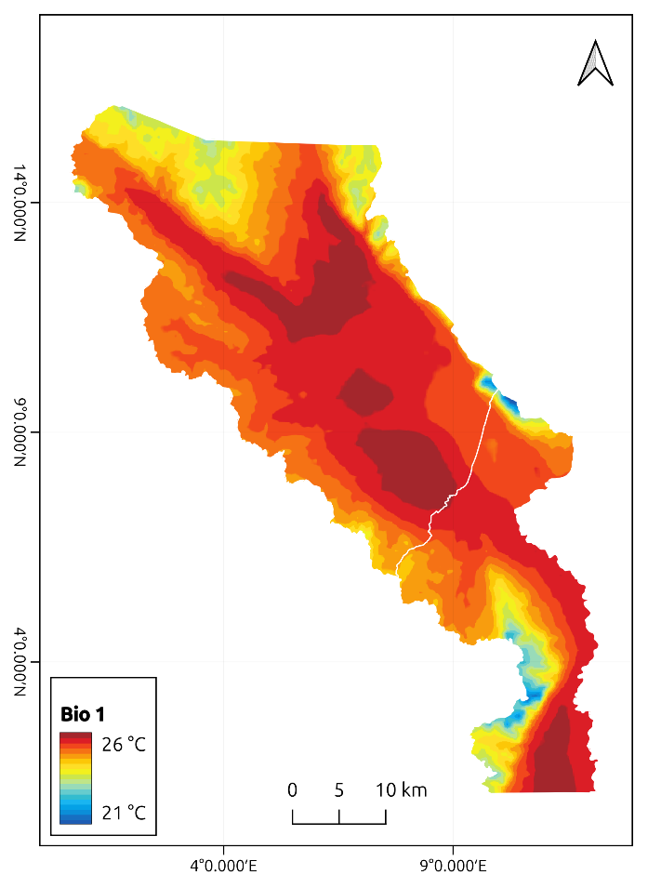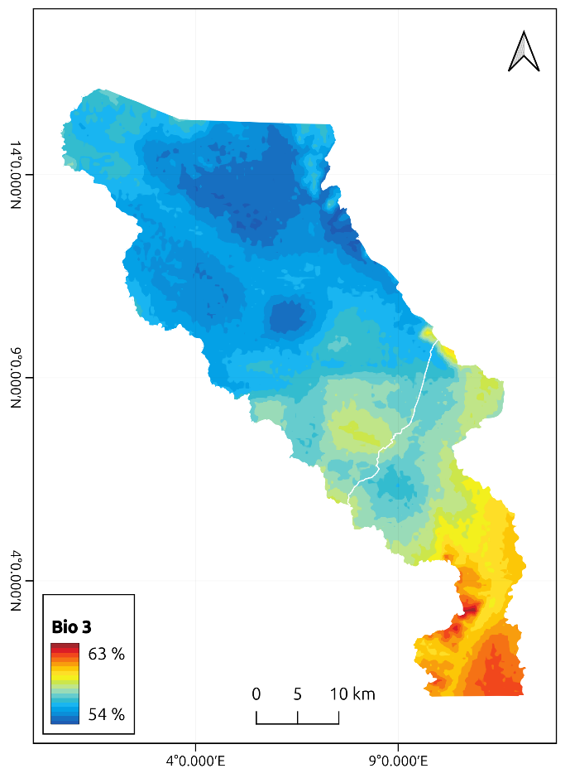
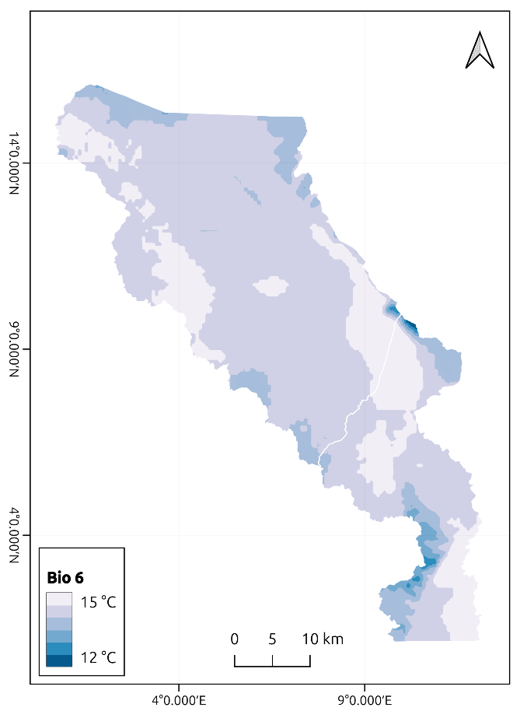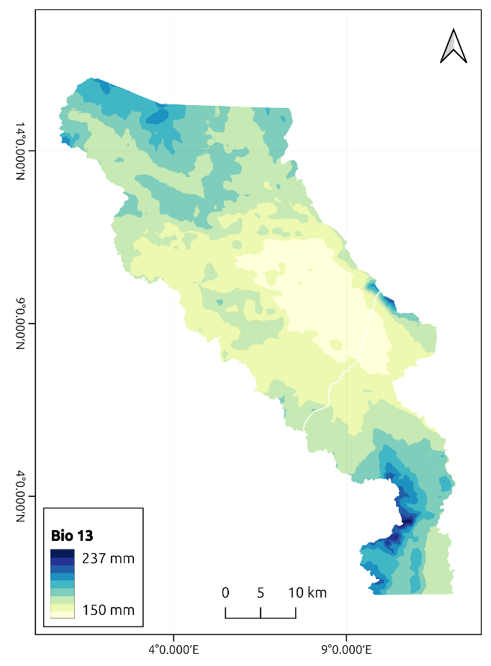
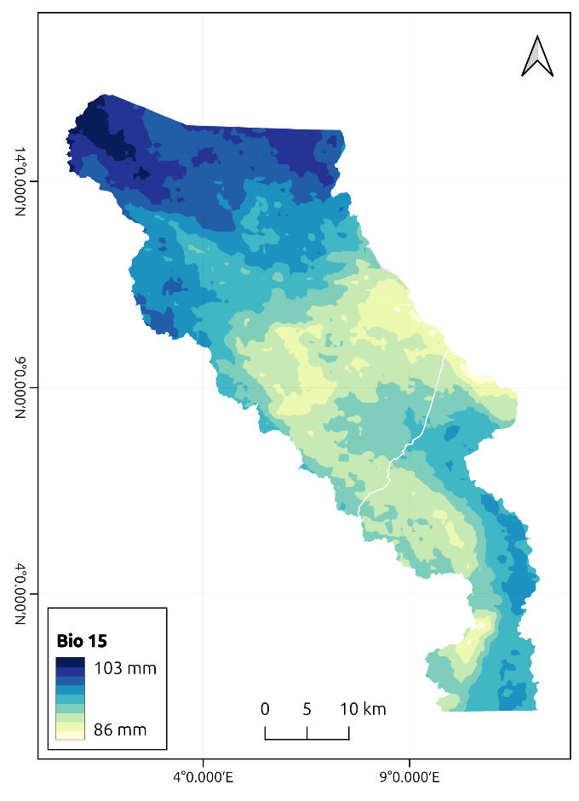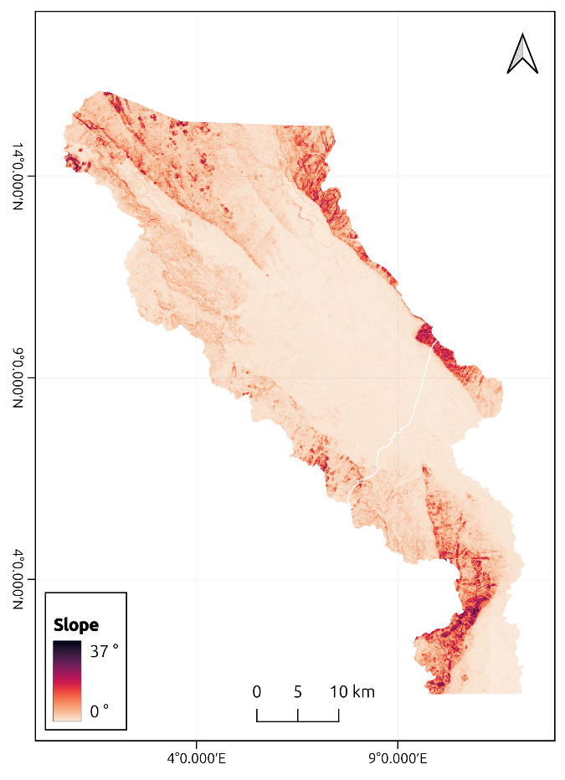
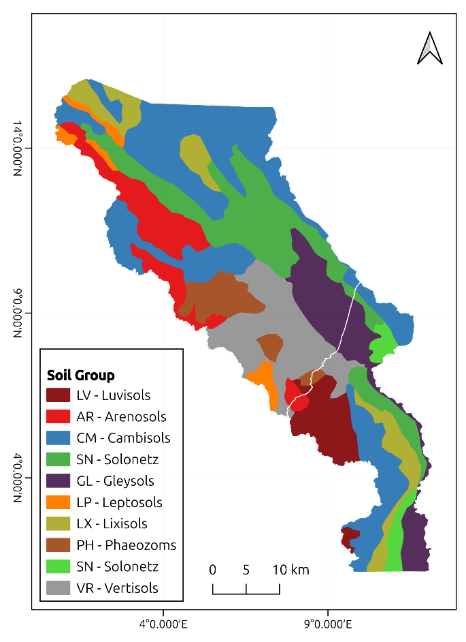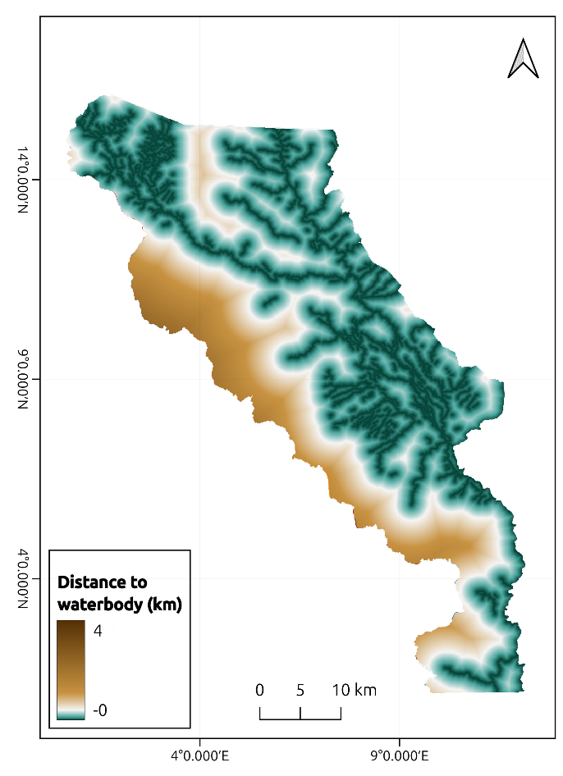
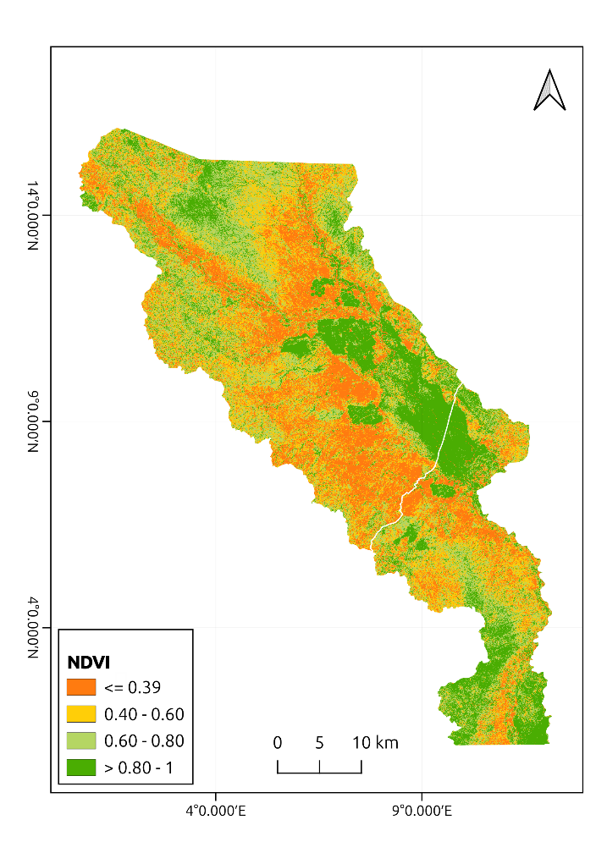

Supplementary Figure 2
ROCs for the predictive models. The AUC values varied between training and test sets, reflecting differences in the models' ability to generalize to unseen data.

B. africanus model
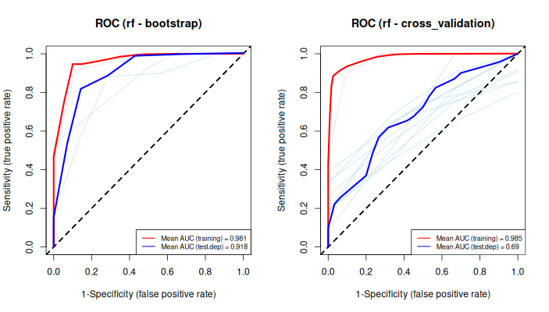
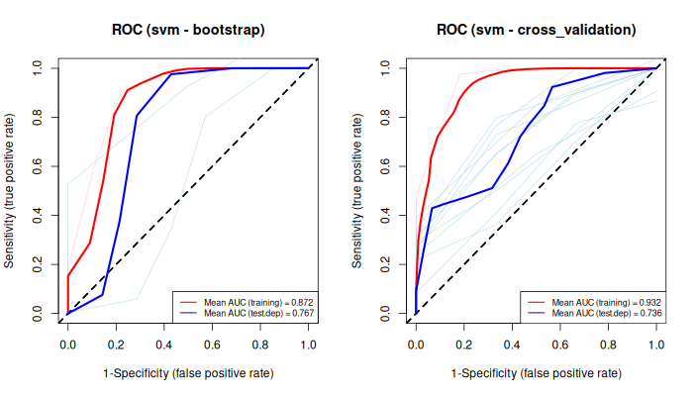
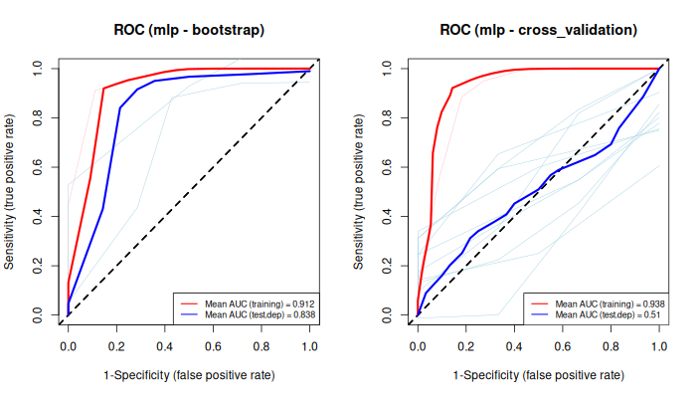

B. pfeifferi model


