DoseTAIlor: A Web-Based Platform for Personalised Tacrolimus Dose Optimisation Across Multi-Centre Populations Using Interpretable AI
Youssef Abdalla¹, Laura Gongas², Brais Muñiz Castro³, Luis Ramudo Cela⁴, Francisco Suárez⁵, Mine Orlu¹, Luis Margusino-Framiñán⁴*, Abdul W. Basit^{1,6}*, David Shorthouse¹*, Alvaro Goyanes^{1,6,7}

¹Department of Pharmaceutics, UCL School of Pharmacy, University College London, London, UK
² Department of Computer Science, University College London, London, UK
³ IRLab, CITIC Research Center, University of A Coruña
⁴Pharmacy Service, Research Group of Hospital Pharmacy, Biomedical Research Institute A Coruña, A Coruña University Hospital, Sergas, University of A Coruña
⁵ Digestive Service, A Coruña University Hospital, Spain, Biomedical Research Institute A Coruña, A Coruña University Hospital, Sergas, University of A Coruña
⁶FABRX Artificial Intelligence, Carretera de Escairón, 14, Currelos (O Saviñao), Spain
⁷Departamento de Farmacología, Farmacia y Tecnología Farmacéutica, I+D Farma (GI-1645), Facultad de Farmacia, Instituto de Materiales and Health Research Institute of Santiago de Compostela (IDIS), Universidade de Santiago de Compostela, Santiago de Compostela, Spain

 | MIMIC-IV Data (%)  N=1,666 | CHUAC Data (%)  N=108
Gender
Female | 36.03 | 29.59
Male | 63.97 | 70.41
Race
Asian | 5.71 | 0.00
Black | 16.29 | 0.00
Latin | 8.97 | 0.00
White | 63.99 | 100.00
Other | 5.05 | 0.00
Care setting
Home | 43.65 | 30.83
Hospital | 50.34 | 44.17
ICU | 6.01 | 25.00

Table S1: Patient demographic information, presented as percentages for different categorical variables.

 | MIMIC-IV Data  N=77,723 | CHUAC Data  N=2,025
Age (years) | 56.44 (12.05) | 59.17 (7.79)
Height (cm) | 170.12 (10.21) | 167.08 (8.66)
Weight (kg) | 78.92 (18.92) | 77.42 (16.50)
Hematocrit (%) | 31.95 (6.40) | 33.15 (5.90)
Hemoglobin (g/dL) | 10.37 (2.09) | 11.14 (2.02)
Renal Function
Creatinine (mg/dL) | 1.83 (1.50) | 1.08 (0.85)
Sodium (mEq/L) | 138.40 (3.78) | 139.98 (3.51)
Potassium (mEq/L) | 4.45 (0.61) | 4.44 (1.35)
Hepatic Function
AST (IU/L) | 43.82 (202.44) | 81.24 (253.73)
ALT (IU/L) | 49.60 (132.67) | 161.41 (346.76)
Albumin (g/dL) | 3.74 (0.70) | 3.49 (0.63)
Bilirubin (mg/dL) | 1.22 (3.59) | 3.55 (5.62)
Tacrolimus
TAC Level (ng/mL) | 7.95 (3.73) | 7.99 (4.29)
Dose (mg) | 2.36 (2.00) | 6.80 (4.49)
Level-Dose time difference (days) | 46.78 (82.16) | 23.36 (31.58)
Treatment Duration (days) | 607.13 (921.02) | 128.81 (168.57)

Table S2: Continuous variables for patients, presented as mean (standard deviation).

 | MIMIC-IV Data (%)  N=77,723 | CHUAC Data (%)  N=2,025
Formulation
Accord | 9.75 | 0.00
Adoport | 58.11 | 0.00
Advagraf | 0.00 | 1.52
American Health | 0.37 | 0.00
Dr Reddy's | 2.80 | 0.00
Envarsus | 0.28 | 38.42
Prograf | 28.69 | 23.47
Solution | 0.00 | 36.59
Route
Oral | 98.70 | 100.00
Sublingual | 1.30 | 0.00
Frequency
Once daily | 13.15 | 75.12
Twice daily | 86.79 | 24.88
Three times daily | 0.06 | 0.00
Four times daily | 0.01 | 0.00

Table S3: Tacrolimus administration information, presented as percentages for different categorical variables.

 | MIMIC-IV Data (%)  N=77,723 | CHUAC Data (%)  N=2,025
P-gp inducers
Yes | 0.17 | 0.00
No | 99.83 | 100.00
P-gp inhibitors
Yes | 9.08 | 0.05
No | 90.92 | 99.95
CYP3A4/5 inducers
Yes | 1.01 | 86.19
No | 98.99 | 13.81
CYP3A4/5 inhibitors
Yes | 16.27 | 1.10
No | 83.73 | 98.90

Table S4: Concomitant drug information, presented as percentages of patients taking medications which are P-glycoprotein (P-gp) or Cytochrome P450 3A4/5 (CYP3A4/5) inhibitors or inducers.

Metric | MIMIC-IV data | CHUAC Data
KS Complement | 0.85 | 0.87
TV Complement | 0.85 | 0.48
KL Divergence | 0.83 | 0.67
Table S5: Evaluation of synthetic data quality using three metrics: the Kolmogorov-Smirnov statistic (KS Test) for continuous columns, the Total Variation Distance test (TV Test) for discrete columns - both ranging from 0 to 1, with 1 indicating perfect similarity - and the Kullback-Leibler (KL) divergence, which measures the divergence between two probability distributions; a lower score indicates greater similarity.

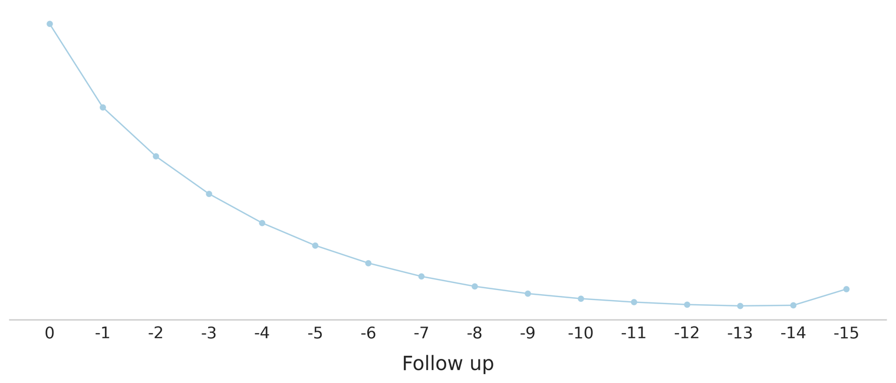
Figure S1: Time-step feature attention for TimeLSTM, with the x-axis representing the follow-ups, starting from 0 (the prediction time) across the entire time window analysed by the model.

 | Tested on real MIMIC-IV data |  | Tested on real CHUAC Data
 | RMSE | MAE | RMSE | MAE
Single-Domain Learning – trained on synthetic and real MIMIC-IV data
LASSO | 3.02(0.11) | 2.33(0.04) | 3.70 | 2.81
Ridge | 3.02(0.11) | 2.13(0.05) | 3.71 | 2.82
ElasticNet | 3.18(0.09) | 2.33(0.04) | 3.83 | 2.95
XGBoost | 3.02(0.10) | 2.23(0.05) | 3.70 | 2.75
LightGBM | 3.02(0.10) | 2.12(0.04) | 3.70 | 2.74
Extra Trees | 3.03(0.10) | 2.14(0.04) | 3.70 | 2.69
TabNet | 3.03(0.03) | 2.14(0.03) | 3.64 | 2.60
Single-Domain Learning - trained on synthetic and real CHUAC data
LASSO | 3.18 | 2.16 | 3.57(0.20) | 2.74(0.08)
Ridge | 4.67 | 2.96 | 3.58(0.20) | 2.73(0.08)
ElasticNet | 3.38 | 2.35 | 3.74(0.22) | 2.92(0.09)
XGBoost | 3.19 | 2.19 | 3.66(0.29) | 2.48(0.28)
LightGBM | 3.16 | 2.20 | 3.69(0.27) | 2.61(0.18)
Extra Trees | 3.05 | 2.08 | 3.66(0.31) | 2.52(0.18)
TabNet | 3.66 | 2.78 | 10.46(1.27) | 8.49(1.46)
Pooled Learning – trained on both datasets (synthetic and real data)
LASSO | 3.02(0.11) | 2.11(0.05) | 3.62(0.20) | 2.73(0.16)
Ridge | 3.02(0.11) | 2.11(0.05) | 3.59(0.22) | 2.64(0.20)
ElasticNet | 3.17(0.09) | 2.31(0.03) | 3.83(0.23) | 2.94(0.018)
XGBoost | 3.26(0.53) | 2.34(0.50) | 3.99(0.54) | 2.95(0.54)
LightGBM | 3.02(0.10) | 2.11(0.05) | 3.67(0.30) | 2.68(0.19)
Extra Trees | 3.43(0.31) | 2.53(0.28) | 4.02(0.31) | 2.93(0.21)
TabNet | 3.36(0.32) | 2.36(0.27) | 4.12(0.39) | 2.90(0.29)
Table S6: Model performance when trained on synthetic and real data combined. Presented as mean (standard deviation).

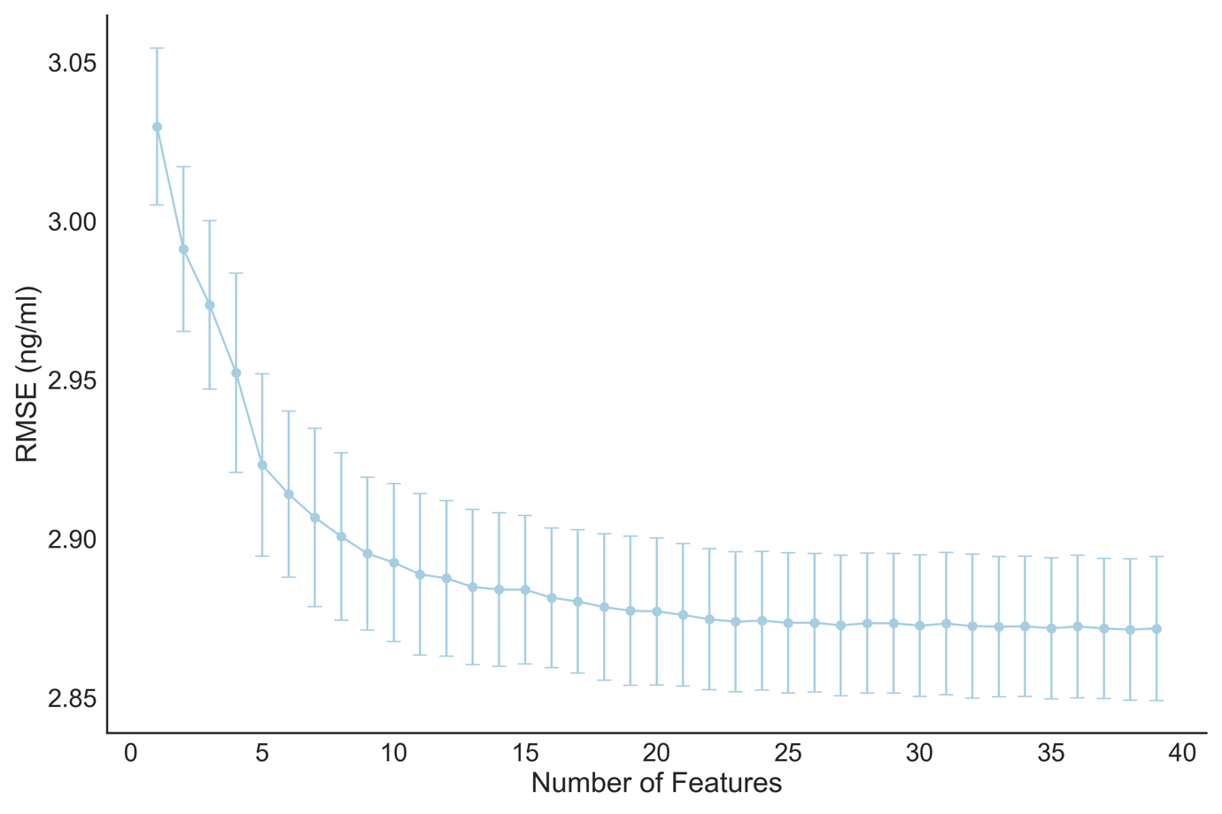
Figure S2: RMSE with a reduced number of features in XGBoost following recursive feature elimination.

 | MIMIC-IV data |  | CHUAC Data
 | RMSE | MAE | RMSE | MAE
Single Domain – MIMIC-IV | 2.89(0.10) | 1.98(0.04) | 4.05 | 3.11
Single Domain – CHUAC | 3.20 | 2.15 | 3.18(0.13) | 2.49(0.16)
Pooled Learning | 2.90(0.10) | 1.90(0.02) | 3.42(0.23) | 2.20(0.06)
Table S7: XGBoost performance measured using nested cross-validation, following removal of labs and formulation information.

 | Hyperparameter | Search Space
LASSO | alpha | [1e⁻⁴, 1]
Ridge | alpha | [1e⁻⁴, 1]
ElasticNet | l1_ratio | [0, 1]
XGBoost | n_estimators | [100, 3000]
XGBoost | max_depth | [1, 20]
XGBoost | learning_rate | [0.0001, 0.5]
XGBoost | min_child_weight | [1, 30]
XGBoost | subsample | [0, 1]
XGBoost | colsample_bytree | [0, 1]
LightGBM | max_depth | [1, 20]
LightGBM | num_leaves | [2, 1000]
LightGBM | min_data_in_leaf | [100, 10000]
LightGBM | feature_fraction | [0, 1]
LightGBM | bagging_fraction | [0, 1]
LightGBM | learning_rate | [0.0001, 0.5]
Extra Trees | n_estimators | [100, 3000]
Extra Trees | max_features | [0, 1]
Extra Trees | min_samples_leaf | [0, 1]
Extra Trees | max_depth | [1, 20]
TabNet | n_d | [8, 64]
TabNet | n_a | [8, 64]
TabNet | n_steps | [3, 10]
TabNet | gamma | [1, 2]
TabNet | lambda_sparse | [1e⁻⁶, 1e⁻³]
TabNet | momentum | [0.01, 0.4]
TabNet | learning_rate | [1e⁻⁵, 1e⁻¹]
TabNet | scheduler_gamma | [0.1, 0.9]
TabNet | virtual_batch_size | [128, 2048]
LSTM | window_size | [3, 20]
LSTM | hidden_size | [16, 128]
LSTM | num_layers | [2, 5]
LSTM | learning_rate | [1e⁻⁵, 1e⁻¹]
LSTM | dropout | [0, 0.5]
LSTM | Attention | [True, False]
Table S8: Model hyperparameter search space.

