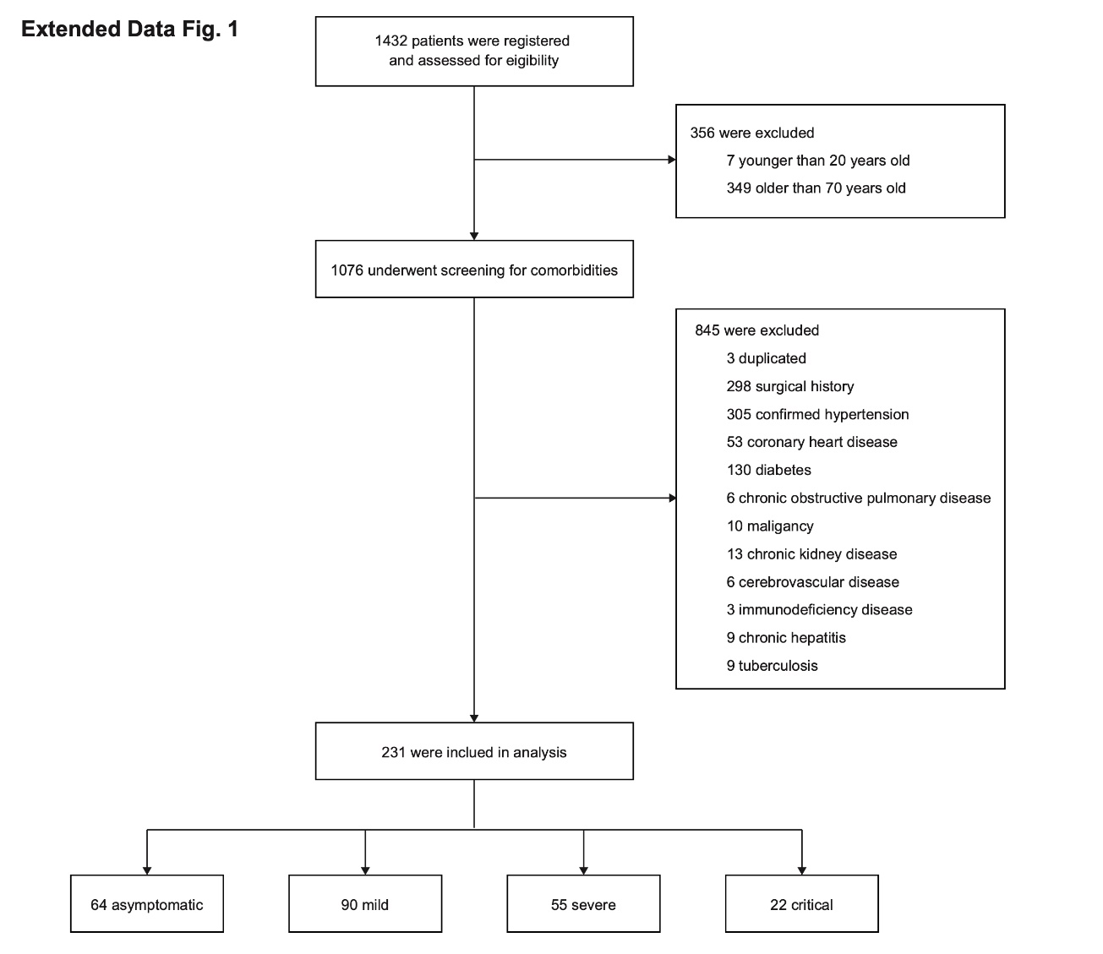
Extended Data Fig. 1 | Study design for multi-omics analysis
All the COVID-19 patients (n=1432) enrolled in the study were screened to exclude ones with any complications, operating history, or aged younger than 19 or older than 70. After filtration, 231 patients were enrolled and grouped as asymptomatic (n=64), mild (n=90), severe (n=55) and critical (n=22). Then, sample DNAs, RNAs, total serum proteins, and lipids were isolated and performed WGS, RNA-seq and LC-MS analyses, respectively, and a multi-omics integration analysis was carried out.
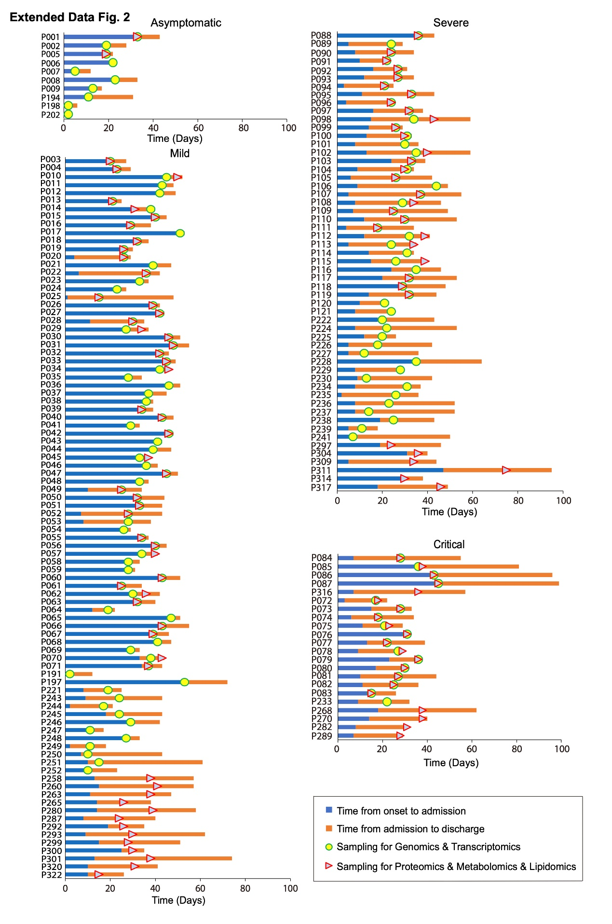
Extended Data Fig. 2 | Clinical characteristics of enrolled patients
Summary of clinical characteristics of hospitalized COVID-19 patients, including asymptomatic (n=10), mild (n=90), severe (n=55) and critical (n=22). For asymptomatic patients, only 10 had been hospitalized, and the others were diagnosed at the fever clinic and isolated at home. Patients’ ID were labeled in Y-axis. More details of all the patients were shown in Supplementary Table 1.
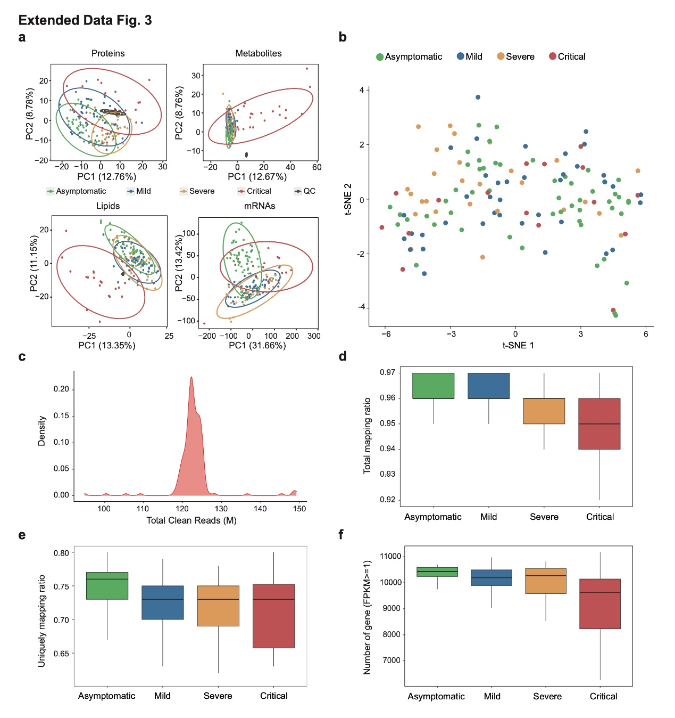
Extended Data Fig. 3 | Quality controls for data generation
(a) Principal component analysis of proteomics, metabolomics, lipidomics and transcriptomics. The quality control samples (QCs) clustered together and all dots mixed together showing good technical reproducibility. Each dot represents a sample colored by disease groups. Gray dots are QCs. For metabolomics, proteomics and lipids, QCs were mixed together with all the samples in the study. Transcriptomic experiment didn’t contain QC. (b) 2D visualization of all multi-omics analytes using t-distributed stochastic neighbor embedding (tSNE) algorithm. Each dot represents a single sample. (c) Density plot of total clean reads for all samples. (d) Boxplot of total mapping ratio across four disease groups. (e) Uniquely mapping ratio. (f) Boxplot of detected gene numbers (FPKM ≥ 1) across four disease groups.

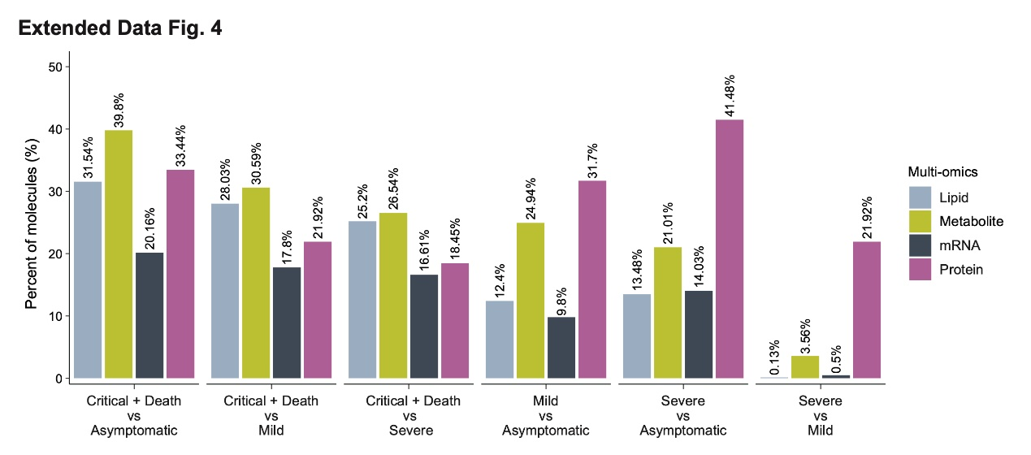
Extended Data Fig. 4 | Bar graph representing the proportion of analytes across molecule types significantly differential expression between any two disease status
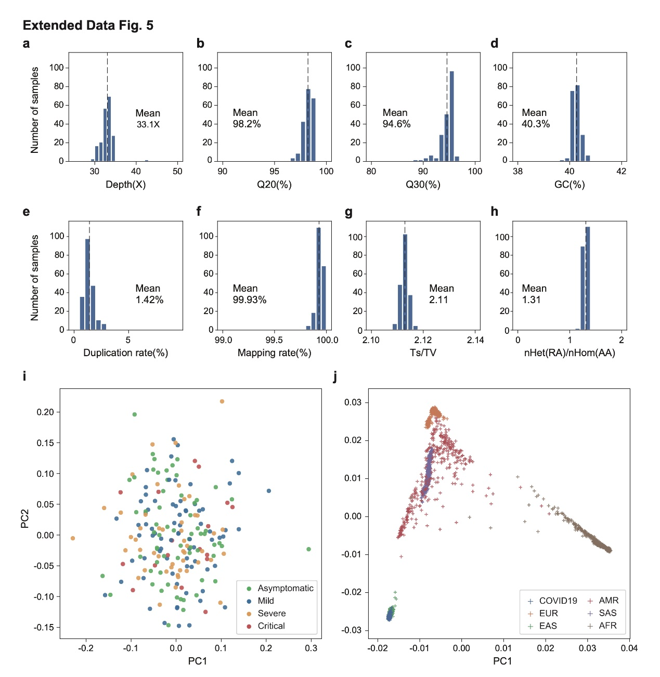
Extended Data Fig. 5 | Quality control of 203 sequenced genomes and PCA
(a-f) Quality control matrix for genome sequencing and mapping. (g-h) Ratio of transitions to transversions (Ts/Tv) and ratio of heterozygous sites to non-reference homozygous sites for each patient. (i) Principal component analysis based on genotype of 203 unrelated individuals, showing PC1 vs PC2. (j) PCA together with 2504 individuals from 1000 genome project, all of the 203 COVID-19 patients were grouped within the East Asian population.
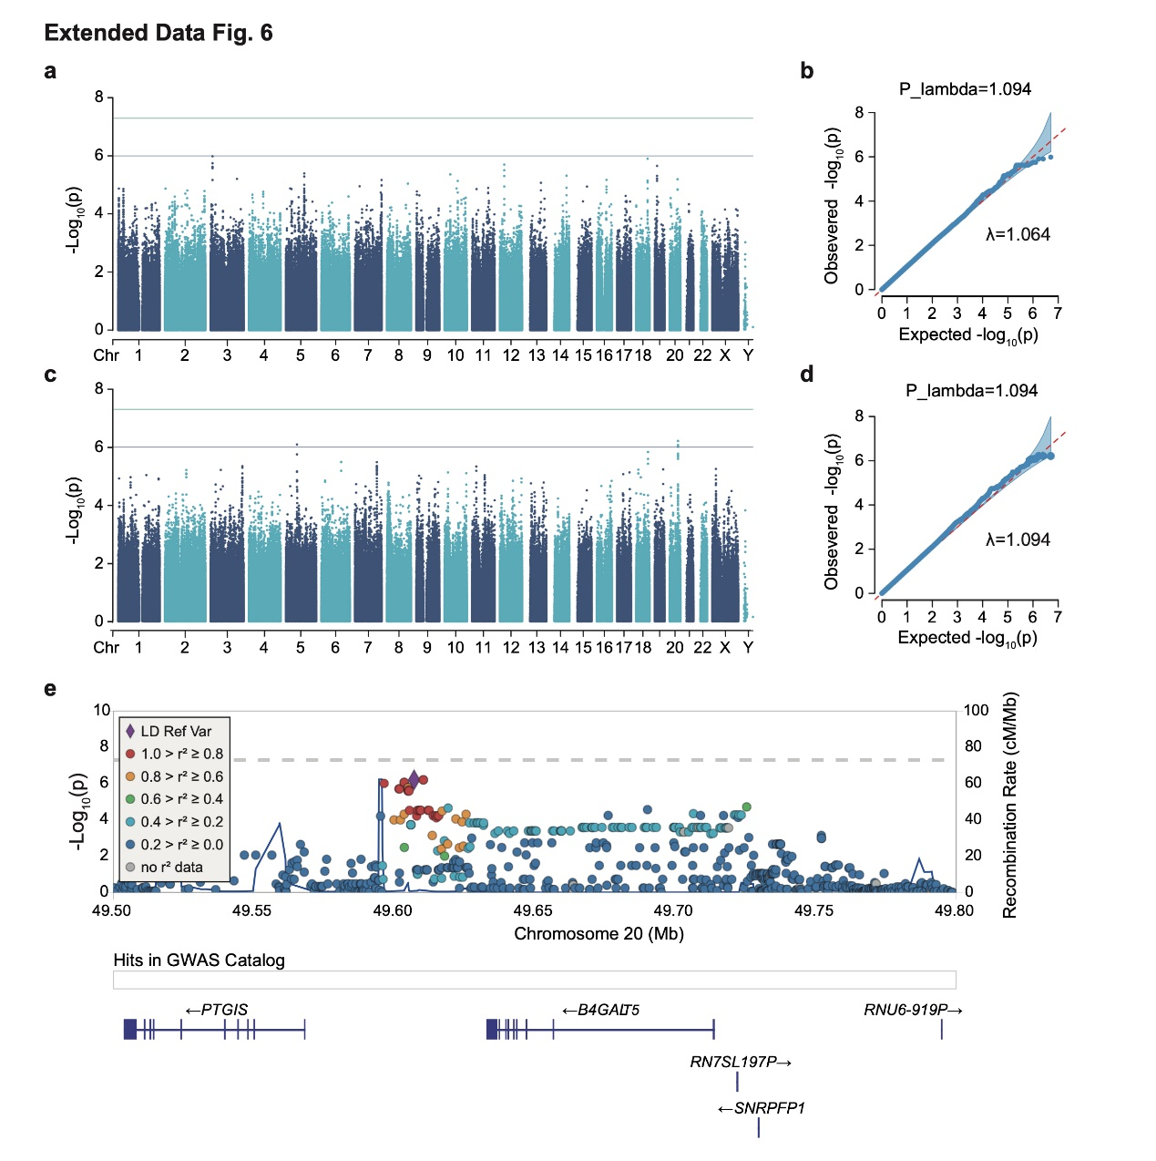
Extended Data Fig. 6 | Results of association study
Single variant association test for common variants (MAF > 0.05). (a) Manhattan plot and (b) QQ-plot for generalized severe group (severe and critical n = 65) versus (asymptomatic and mild n = 138). (c) Manhattan plot and (d) QQ-plot for asymptomatic group (n = 63) versus other groups with symptoms (n = 140). (e) Locus zoom for genomic region flanking the suggestive signal associated with the absence of symptoms: showing chr20:49.5M-49.8M.
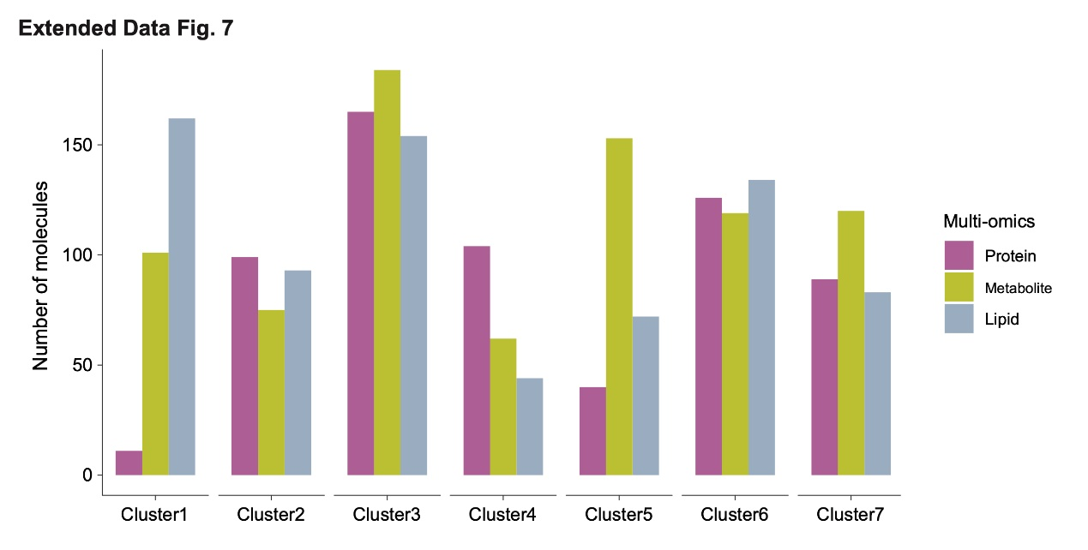
Extended Data Fig. 7 | Cluster composition in proteins and metabolites as well as lipids
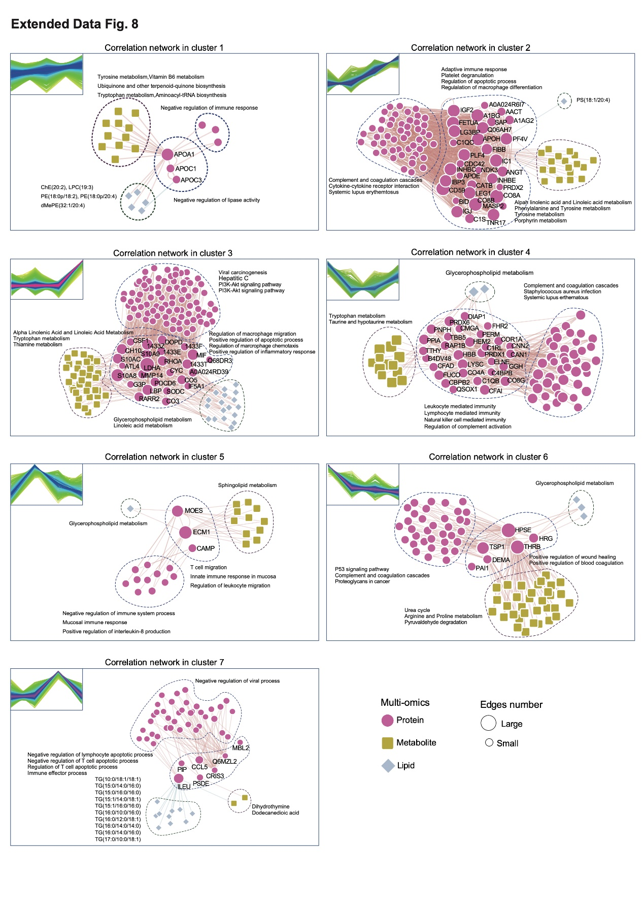
Extended Data Fig. 8 | Integrative multi-omics analysis of circulating analytes
Pairwise spearman correlation networks of multi-omics measures belonging to representing clusters as defined in Fig. 3a. Nodes were color-coded by molecule type and the size represent the network degree of the molecule. Enriched GO terms for proteins in each cluster were showed.

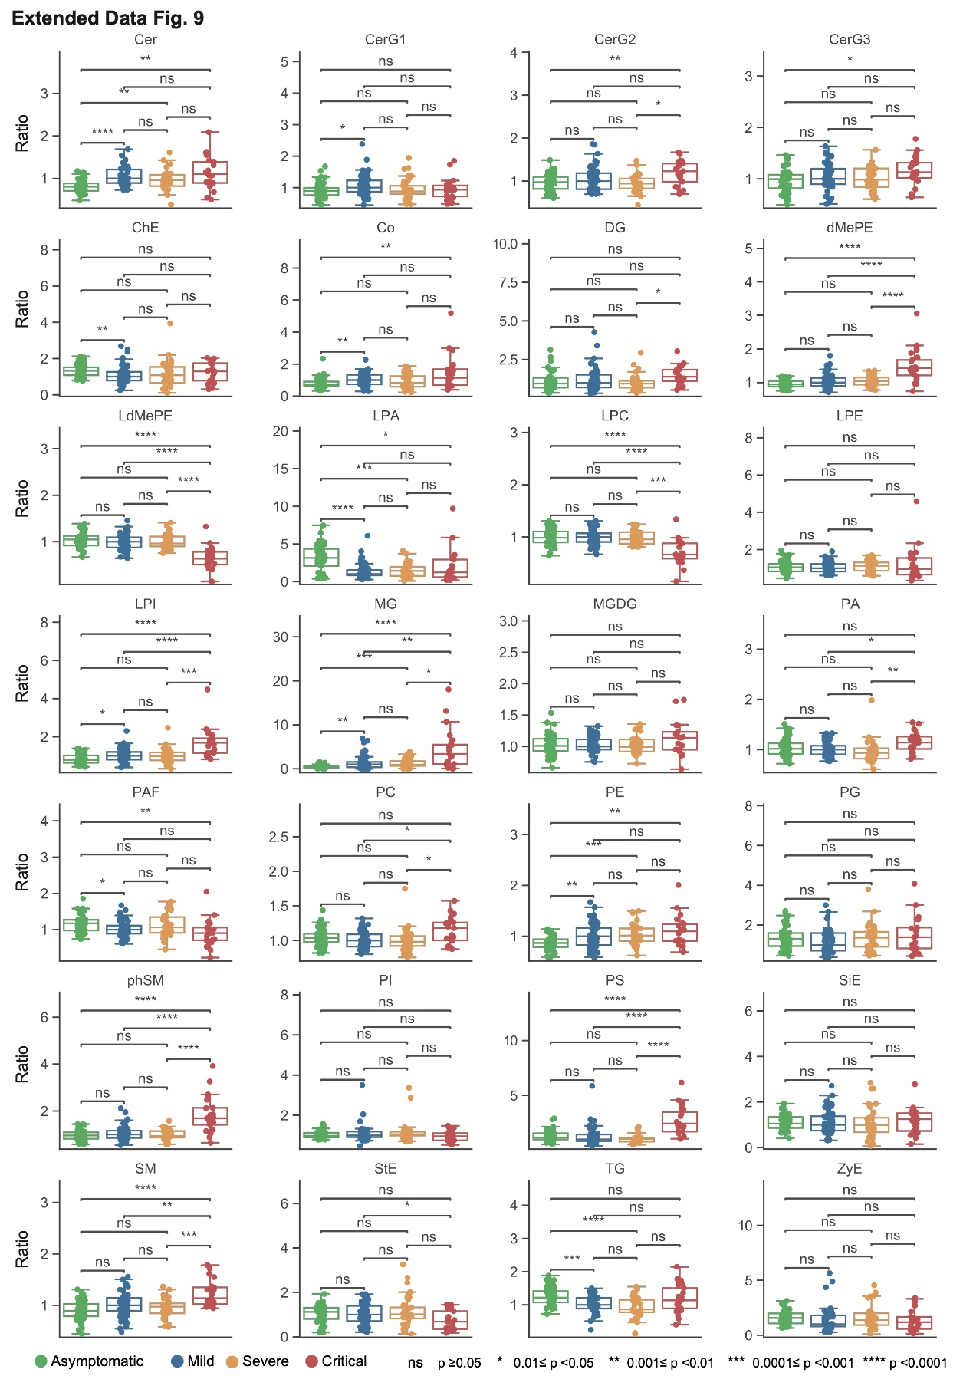
Extended Data Fig. 9 | Relative levels of lipid complex class in COVID-19 patients with different disease severities

