Supplementary information for
SOT-MRAM-Enabled Noise-tolerant and Resource-saving Probabilistic Binary Neural Network
Puyang Huang^{1,2#}, Yu Gu^{1,#}, Chenyi Fu^{3,#}, Tianhao Chen^{3,#}, Shan Yao¹, Zhenghang Zhi¹, Jiaqi Lu³, Yonqi Hu¹, Hongchao Zhang³, Shiyang Lu³, Yumeng Yang¹, Tianxiao Nie³, Shouzhong Peng^{3,*}, Weisheng Zhao³, Kang L. Wang^{2,*}, and Xufeng Kou^{1,*}

¹School of Information Science and Technology, ShanghaiTech University, Shanghai 201210, China.
² Department of Electrical and Computer Engineering, University of California, Los Angeles, CA 90095, USA.
³ School of Integrated Circuit Science and Engineering, Beihang University, Beijing 100191, China.
*Correspondence to: shouzhong.peng@buaa.edu.cn; wang@ee.ucla.edu; kouxf@shanghaitech.edu.cn.

Supplementary Information

Section 1. SOT-driven field-free magnetization switching in i-SOT-MRAM.
Section 2. Statistical analysis of switching probability in reference to probabilistic weights and sampling cycles.
Section 3. Comparison between SOT-MRAM-generated probabilistic weights and their software-generated counterparts.
Section 4. Variations in probabilistic weights under different write pulse widths.
Section 5. Thermometer encoding algorithm in PBNN.
Section 6. Operating principle of the SOT-PBNN hardware system.

Section 1. SOT-driven field-free magnetization switching in the i-SOT-MRAM
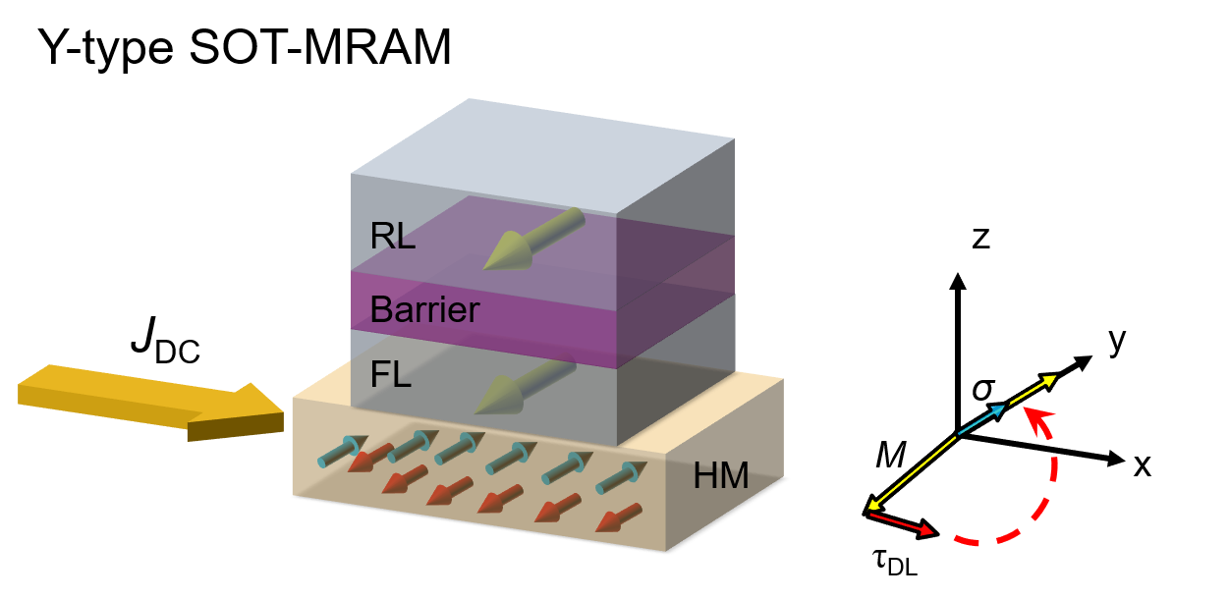
Figure S1. SOT-driven field-free magnetization switching in i-SOT-MRAM. Schematic of the SOT mechanism in the y-type SOT-MRAM structure. The red and blue arrows in the bottom HM layer represent the spin polarization directions.

To achieve deterministic SOT-driven switching without the assistant of the external magnetic field, we utilize a type-y SOT-MRAM structure (Figure S1), in which the in-plane magnetic moment (m) of the free layer (FL) is aligned along the y-direction, perpendicular to the input DC current (J_{DC}) channel along the x-axis¹. In this configuration, the spin polarization (𝜎) generated by the spin Hall effect in the heavy metal (HM) layer aligns either parallel or antiparallel to m. During the incubation time, thermal perturbations cause m to deviate from the easy axis, enabling spin polarization to trigger the generation of damping-like torque. The corresponding damping-like torque is defined as $τ_{DL}=J_{HM}∙m×(σ×m)$, where J_{HM} is the charge current component conducting through the HM channel. As a result, when the charge current conducts along the +x-axis, the magnetic moment of the free layer is expected driven by the spin-orbit torque from its initial −y state to the opposite +y direction (Fig. S1), thereafter achieving a deterministic current-induced magnetization switching.

Section 2. Statistical analysis of switching probability in reference to probabilistic weights and sampling cycles
Figure S2. Statistical distributions of the switching probability of SOT-MRAM device. (a) Normal distributions of the eight intermediate probabilistic weight states. (b) The mean value (purple) and the standard deviation (orange) of switching probability P_{SW} versus the sampling cycles. The red lines are the fitted normal distribution curves.

The statistical results of the 8 intermediate probabilistic weight states generated from the V_{write}-modulated probabilistic switching curve (Fig. 3b) are shown in Fig. S2a. It is seen that all states exhibit a normal distribution feature, and their corresponding P_{SW} values can be clearly distinguished from each other. In order to quantify the relationship between sampling cycles and the fluctuation of P_{SW}, we further conducted a statistical analysis of the mean value and standard deviation for the V_{write} = 1.4 V case under different sampling cycles. As displayed in Fig. S2b, the mean value of P_{SW} remains almost constant around 55%~56% across all sampling cycles. Meanwhile, consistent with Fig. 3c, the standard deviation of P_{SW} monotonically decreases with the sampling cycle N, and it becomes insignificant (σ < 3%) when N ≥ 100.

Section 3. Comparison between SOT-MRAM-generated probabilistic weights and their software-generated counterparts
Figure S3. Comparison between SOT-MRAM-generated probabilistic weights and their software-generated counterparts. Solid symbols represent the standard deviation values, while hollow symbols are the mean values of the switching probability for the V_{write} = 1.4 V case under different sampling cycles.

Figure S3 compares the probabilistic weights generated by the SOT-MRAM device (Figs. 3b-c) and software under different sampling cycles. Here, the software-generated probabilistic weights are based on Python's random number generator, which produces pseudo-random numbers through embedded algorithm (i.e., random()).
It is clear that both the experimental data (i.e., by setting V_{write} = 1.4 V and the pulse width of 20 ns) and the simulation results manage to produce the desired switching probability of P_{SW} ~ 55.8%, and their corresponding standard deviation values follow the same evolution trend with N, thus underscoring the high precision and controllability of P_{SW} in the SOT-MRAM device.

Section 4. Variations in probabilistic weights under different write pulse widths
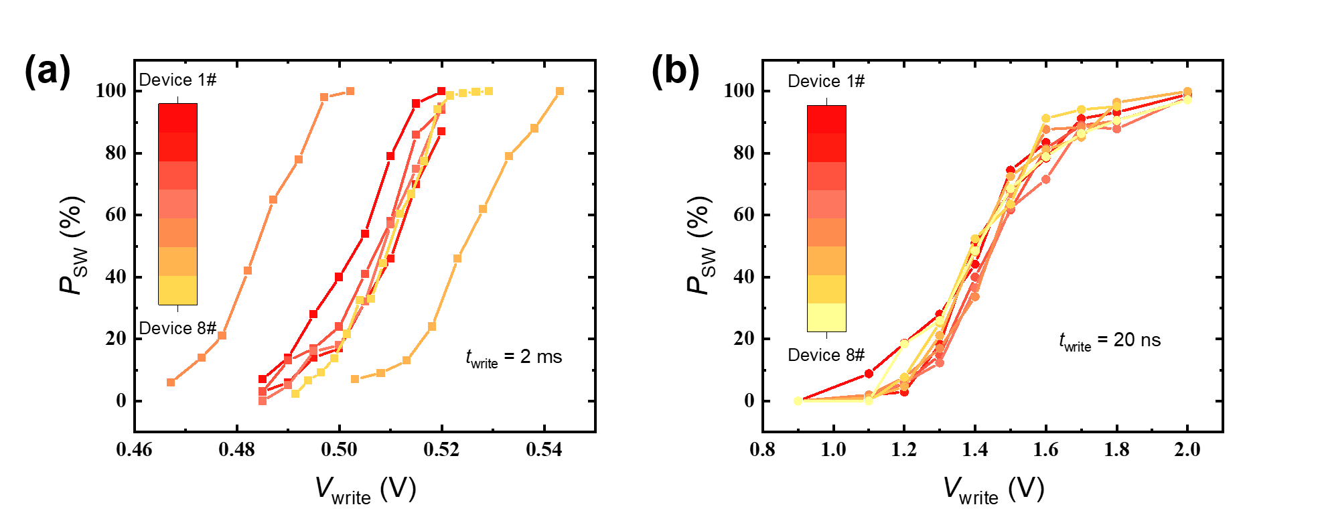
Figure S4. Probability switching curves of eight i-SOT-MRAM devices under two different write voltage pulse width of (a) 2 ms and (b) 20 ns.

The device-to-device variation in the switching probability P_{SW} is the main contributor to the write noise in the PBNN system. In this regard, we have investigated the P_{SW}−V_{write} curves of the 8 randomly selected SOT-MRAM devices used in the main text. As visualized in Fig. S4a, it is seen that a significant weight deviation is observed among the eight devices when has pulse width of the input write voltage is set as 2 ms. Given that such a long pulse width generates more Joule heating, the enhanced thermal fluctuations would dominate the switching process and increases stochasticity². Consequently, the resulting P_{SW} exhibits greater device-to-device variations. In contrast, once the write pulse width is reduced to 20 ns, the diminished thermal energy acts merely as a minor perturbation on determining the switching probability, therefore leading to a consistent S-shape P_{SW}−V_{write} curves among the eight SOT-MRAM devices (Fig. S4b). Besides, it is also noted that the shorter write pulse width not only helps reduce device-to-device variation, but also enables high-speed, energy-efficient operation in the proposed SOT-PBNN system.

Section 5. Thermometer encoding algorithm in PBNN

Figure S5. Main algorithm diagram for the thermometer encoding technique. With a resolution of 8, the input data is encoded into a 32-bit binary sequence.

Compared to standard fixed-point representation, the thermometer encoding (TE) is a binarization technique that takes a unique approach to representing values by activating a series of binary bits³. In particular, the TE method requires a resolution r and a total sequence length l. The encoded sequence consists of n consecutive “1”s followed by l – n consecutive “0”s, arranged from right to left. In this context, such a pattern provides a clear visual representation of magnitude, where the number n of consecutive 1 directly indicates the encoded value between r × n − 1 to r × (n + 1) − 1. For example, as shown in Fig. S5, to encode the value 133 with a resolution of 8, we find n such that 8n − 1 < 133 ≤ 8n + 7. This process results in an encoded value of 16 bits of 0 followed by 16 bits of 1, effectively representing 133 in the TE format.

S6. Operating principle of the SOT-PBNN hardware system
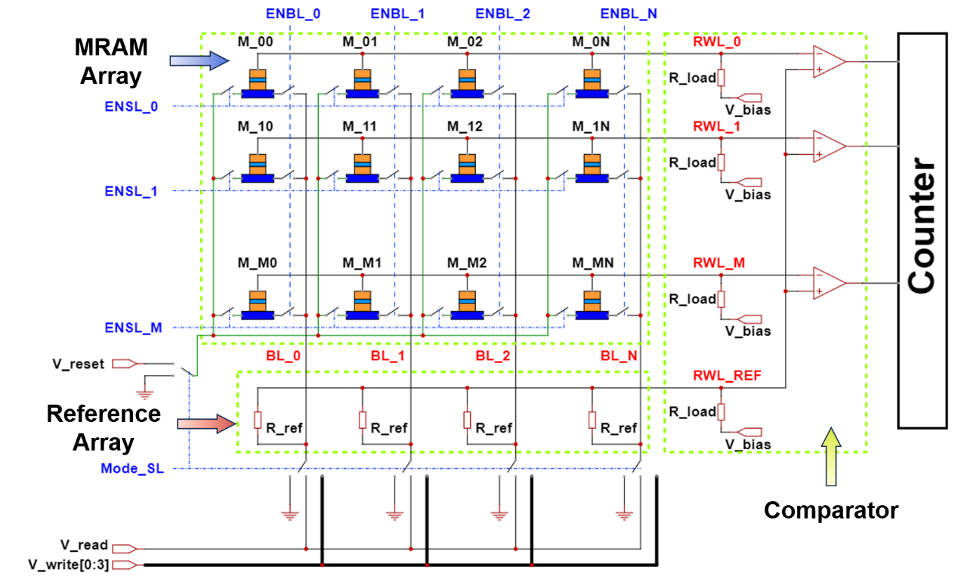
Figure S6. Schematics of the SOT-MRAM-based PBNN diagram. The green rectangles are the main blocks, including the SOT-MRAM array unit, Reference array unit, and the Comparator circuit. The blue lines are the control signals, while the input pins are connected to the voltage sources.

The basic probabilistic matrix-vector multiplication (PMVM) and binarization operations of the proposed SOT-PBNN system are illustrated in Fig. S6. In this architecture, the row devices are selected through ENSL_i signals (i = 0 to M), while column devices are selected by ENBL_j signals (j = 0 to N). In the meantime, the write and read voltages, which are derived from a digital-to-analog converter (DAC) based on weight and input information as shown in Fig. 5a, are applied to BL_j. For the PMVM operation, all SOT-MRAMs are programmed to either the parallel (P) or anti-parallel (AP) state according to their assigned probabilistic weights. The Mode_SL signal selects V_read for the bitlines (BLs), while ENSL_i sets the left pin of all MRAMs to floating. Consequently, this configuration allows currents to flow through the magnetic tunnel junctions (MTJs) and accumulate at the read wordlines (RWL_i). Afterwards, the accumulated current from the PMVM operation is converted into a voltage signal using a load resistance R_{load}​. This voltage signal is then binarized against a reference voltage before being propagated to the next network layer. Given the binary nature of the PBNN, the reference resistance is defined as:
$R_{ref}=\frac{1}{G_{ref}}=\frac{2}{G_{P}+G_{AP}}=\frac{2R_{P}R_{AP}}{R_{P}+R_{AP}}$
where R_{P​} and R_{AP​} represent the resistances in the P and AP states, respectively. Therefore, R_{ref} would serve as the baseline to distinguish between the P and AP states. The accumulated currents from both the MRAM Array and Reference Array are converted into voltage signals. Subsequently, the binarization process is achieved by comparing the summed output current along each row of the SOT-MRAM array with the reference current at the same read voltage. Finally, the Counter records the binarization results for each iteration and transfers them back to the Computer for activation processing.

References
1 Fukami, S., Anekawa, T., Zhang, C. & Ohno, H. A spin–orbit torque switching scheme with collinear magnetic easy axis and current configuration. Nature Nanotechnology 11, 621-625 (2016).
2 Wang, W. et al. Heat-Assisted Magnetization Switching in Flexible Spin–Orbit Torque Devices. Nano Letters 24, 2003-2010 (2024).
3 Buckman, J., Roy, A., Raffel, C. & Goodfellow, I. in International conference on learning representations.

