Supplementary Material

Supplementary Figures and Tables

Supplementary Figures

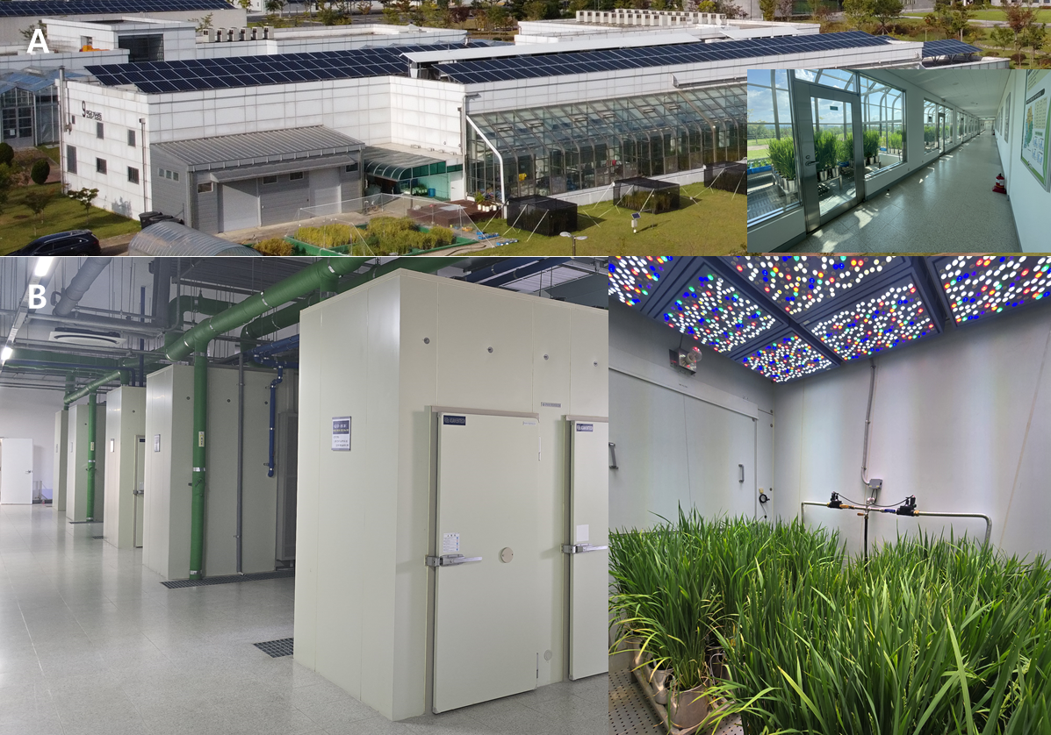
Supplementary Figure 1. Controlled environment facility at the national institute of crop science (A), and lighting chamber where light intensity, temperature, and humidity can be artificially controlled (B).

Supplementary Figure 2. Architecture of a ‘Saenuri’ rice plant following tiller removal (left), and an untreated control (right) at 14 daysafter treatment.
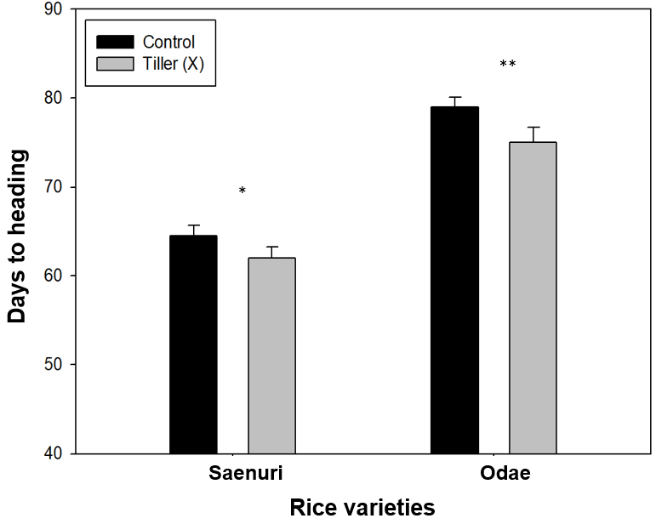
Supplementary Figure 3. Number of growing days from sowing to heading stage in the two rice cultivars for control and tiller removal treatments. Tiller X refers to tiller removal treatment. Error lines represent SD. *P < 0.05 and **P < 0.01 indicate significant difference between treatments (n = 12). Days to heading data collected from 15 biological replicates for each treatment (n=15).

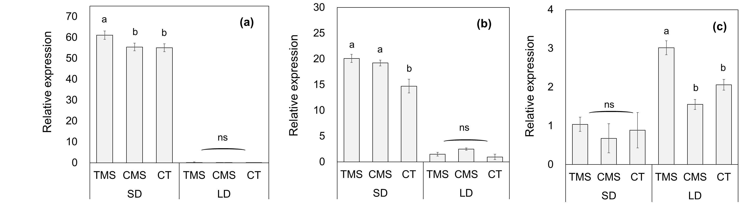
Supplementary Figure 4. Changes in (a) RFT1, (b) Ehd1, and (c) Ghd7 mean relative expression levels in ‘Saenuri’ rice plants for the tiller removal treatment under contrasting daylength conditions, at 7 days after treatment. Relative expression levels were compared with those before treatment (standard). TMS: tiller removal main-stem. CMS: control rice plant-main stem. CT: control rice plant tiller. SD: short day. LD: long day. Values represent the mean of three biological replicates (n=3), each analyzed in triplicate technical replicates. Letters above bars indicate significant differences (P < 0.05) according to Duncan’s multiple range test. Error lines represent SE (n=9).

Supplementary Tables
Table S1. List of primer sequences of Oryza sativa used for qRT-PCR.
S. No. | Genes | Primer sequence 5′-3′
1 | OsUBQ5-F  OsUBQ5-R | CCCTTGCCGACTATAACATCC  CAACACAACCATGACACGATG
2 | Hd3a-F  Hd3a-R | GCTCACTATCATCATCCAGCATG  CCTTGCTCAGCTATTTAATTGCAT
3 | RFT1-F  RFT1-R | TCCGAGCCCAAGCAACCCTAAC  AGTTCCTGGTGCTGAAGTTCTG
4 | MFT1-F  MFT1-R | TCAACGAGCTCTTCGCTCTG  ATGTACGGCACCACCACATC
5 | Ehd1-F  Ehd1-R | CGACAAAACACAAGACCACCCT  CCTGTTTGTCTGAATCCCATCG
6 | Ghd7-F  Ghd7-R | AGAGGAAGAAGAGGTGCTAC  GACATAGGTGGATGGCGGTG

Table S2. Changes in rice plant growth and development traits after tiller removal.
Variety | Treatment | Panicle length  (cm) | Panicle number  (ea) | Grain number per panicle  (ea) | 1000-Grain weight (g)
Saenuri | Control | 21.3 ± (1.4) | 25.3 ± (2.1) | 109.3 ± (6.5) | 23.4 ± (0.4)
Saenuri | Tiller X | 23.1 ± (1.0) | 1.0 ± (0.0) | 121.2 ± (7.9) | 25.8 ± (1.1)
Saenuri | T-test | P<0.05 | P<0.001 | P<0.05 | P<0.01
Odae | Control | 17.5 ± (1.7) | 21.3 ± (2.6) | 102.6 ± (5.2) | 25.4 ± (0.8)
Odae | Tiller X | 22.5 ± (1.9) | 1.0 ± (0.0) | 141.7 ± (10.3) | 31.2 ± (1.3)
 | T-test | P<0.01 | P<0.001 | P<0.01 | P<0.001
Student’s t-test was used to calculate P values. Tiller X refers to the tiller removal treatment. Values in parentheses are standard deviations. Growth data collected from 15 biological replicates for each treatment (n=15).

Table S3. Analysis of variance (ANOVA) for growth duration, stem length, and panicle length caused by tiller removal under contrasting daylength conditions.
Factor | Analysis of variance (ANOVA)
Factor | Variety  (V) |  | Daylength  (D) |  | Tiller  (R) | Interactions
 |  |  |  |  |  | V*D |  | V*R | D*R | V*D*R
Growth duration | *** | *** |  | ns |  |  | *** | *** | *** |  | ***
Stem  length | *** | *** |  | *** |  |  | ** | ns | *** |  | *
Panicle  length | * | *** |  | *** |  |  | *** | ns | *** |  | ***
ns: non-significant (P ≥ 0.05), *, **, ***: significant at P < 0.05, 0.01, and 0.001.

