Supplementary Material for
“C. elegans monitor energy status to trigger innate immune responses via AMPK pathway against bacterial pathogens ”

Shouyong Ju^{#, 1}, Hanqiao Chen^{#, 1}, Shaoying Wang¹, Jian Lin¹, Raffi V Aroian², Donghai Peng^{*, 1}, Ming Sun^{*, 1}

1. State Key Laboratory of Agricultural Microbiology, College of Life Science and Technology, Huazhong Agricultural University, Wuhan, China.
2. Program in Molecular Medicine, University of Massachusetts Medical School Worcester, Worcester, USA.

# These authors contributed equally to this work.
*To whom correspondence: Tel: 86-27-87283455; Fax: 86-27-87280670; E-mail: m98sun@ mail.hzau.edu.cn & donghaipeng@mail.hzau.edu.cn

Supplementary Figures:
Figure S1. Nematocidal Bt strains cause energy disturbance in C. elegans. C. elegans N2 were fed with nematocidal B. thuringiensis BMB171/Cry5Ca, BMB171/Cry21Aa, BMB171/Cry6Aa, and a non-nematocidal B. thuringiensis BMB171/Cry1Ac. The AMP/ATP ratio were then analyzed by LC-MS/MS. The mean and SD of three independent replicates are shown. Values differences were calculated by one-way ANOVA. Triple asterisks (∗∗∗) are set at p< 0.001, two asterisks (∗∗) are set at p< 0.01. a single asterisk (∗) is set at p<0.05.

Figure S2. BMB171 / Cry5Ba infection reduces the mitochondrial membrane potential (ΔΨm) of C. elegans. C. elegans N2 and bre-5 were fed BMB171 / pHT304 and BMB171 / Cry5Ba respectively. Mdivi were used to inhibit mitochondrial MF and FCCP was used as a positive control to reduce mitochondrial membrane potential. Treated animals were incubated in TMRE and observed microscopically. The scan bars represent 100 μm.

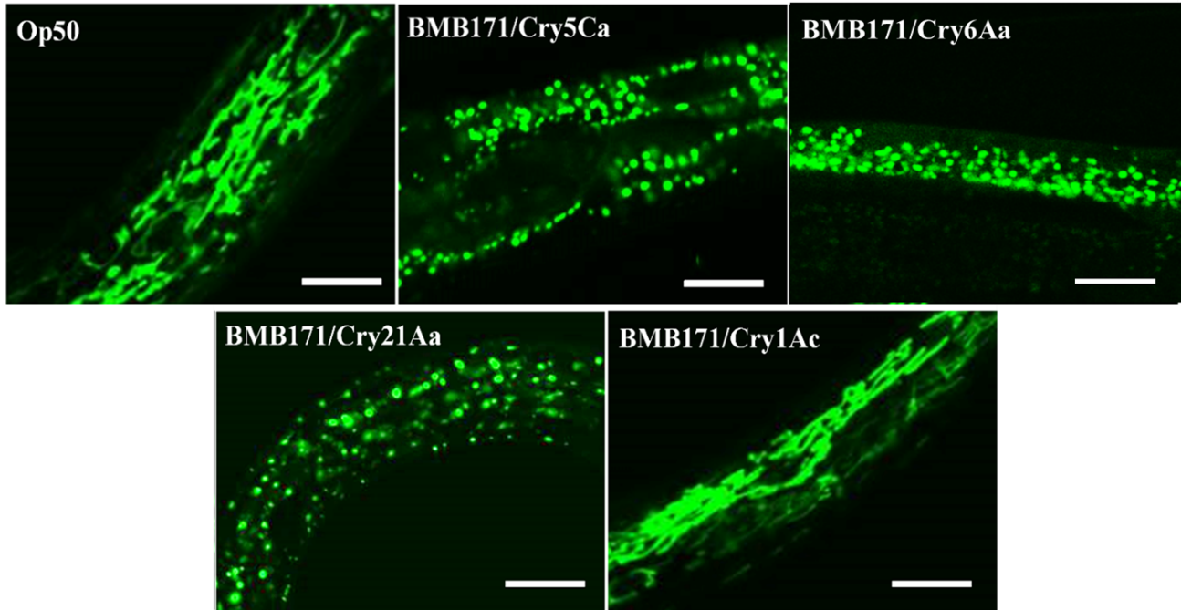

Figure S3. Nematocidal Bt strains that produce Cry5-like Cry proteins cause MF phenomenon in C. elegans. The transgenic C. elegans SJ4143(zcIs17 [P_{ges-1}::GFP^{mt}]) were fed with nematocidal B. thuringiensis BMB171/Cry5Ca, BMB171/Cry21Aa, BMB171/Cry6Aa, and a Non-nematocidal B. thuringiensis BMB171/Cry1Ac. The mitochondria morphologies of transgenic C. elegans were observed after 4 h of treatment. More than 60 worms were observed for each treatment and the representative images are shown. These strains are the recombinant B. thuringiensis which producing Cry5Ca, Cry21Aa, Cry6Aa, and Cry1Ac proteins in the acrystalliferous B. thuringiensis strain BMB171 respectively. The E. coli strain OP50 was used as negative control. The scan bars represent 20 μm.
Figure S4. Analysis of the percentage of worms that showed MF phenotype after treatment with different strains. More than 60 worms were observed for each treatment. The mean and SD of three independent replicates are shown. Values differences were calculated by one-way ANOVA. ∗∗∗p< 0.001 versus control (OP50).

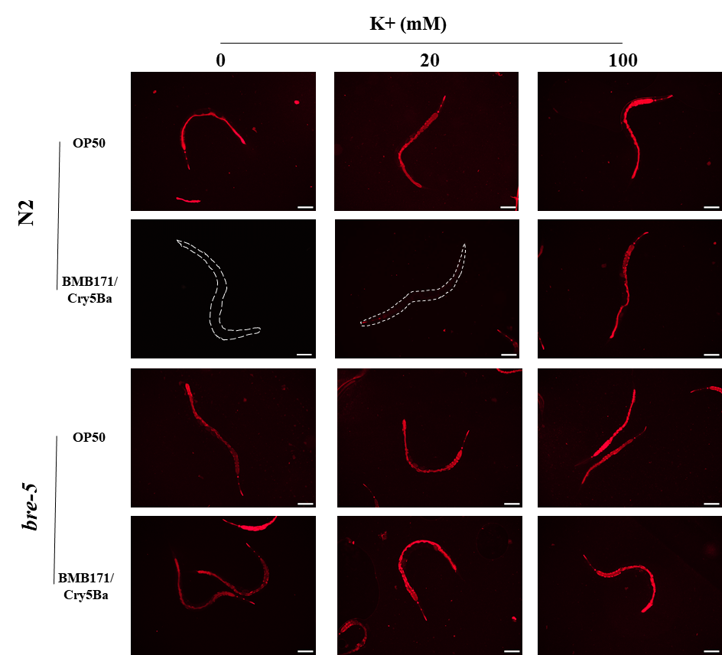
Figure S5. Visual observation the potassium concentration during BMB171/Cry5Ba infection. C. elegans N2 and bre-5 (ye17) were fed with OP50 or BMB171/Cry5Ba during different potassium environment. Fluorescence microscopy was used to monitor potassium concentration by measuring cytoplasmic fluorescence using the APG-2 AM. The representative images of worms treated by each strain are shown. Scale bar, 100 μm.

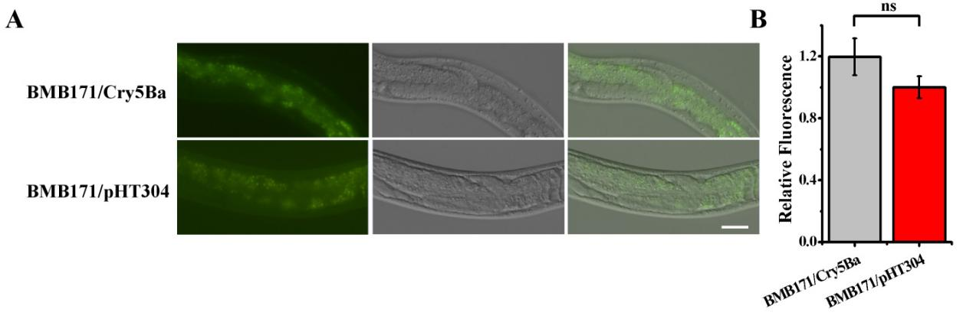
Figure S6. Visual observation the cytoplasm calcium concentration after BMB171/Cry5Ba infection in C. elegans. Fluorescence microscopy was used to monitor calcium concentration by measuring cytoplasmic fluorescence using the calcium indicator Fluo-4 AM. The below part shows the quantification of the fluorescence levels. These results are the mean ± SD of three independent experiments. Scale bar, 0.02 mm.

Figure S7. The transcription levels of aak-2 after Bt infection. QRT-PCR to detect the transcription levels of aak-2 of wild type N2 worms when fed with BMB171/Cry5Ba and BMB171/pHT304. Values differences were calculated by one-way ANOVA. One asterisk (∗) is set at p<0.05. Two asterisks (∗∗) are set at p<0.01.

Figure S8. The plates assay revealed aak-2 mutant aak-2 (gt33) worms are more sensitive to BMB171/Cry5B infection. The growth assay of the wild type N2 and mutant worms after BMB171/Cry5Ba infection. A total of 100-200 L1-staged worms were exposed to each dose of BMB171/Cry5Ba in plates for 3 days. The experiment was performed at least three independent replicates and the representative worms are shown for each dose. Scale bar, 0.02 mm.
Figure S9. A mortality assay revealed aak-2 RNAi worms are more hypersensitive to BMB171/Cry5B infection. The survival rate of the wild type worm N2 with empty vector and aak-2 RNAi worms exposed to BMB171/Cry5Ba at different times were recorded. A total of 30~50 L4 stage synchronized worms were scored for survival per replicate. The mean and SD of three independent replicates are shown. p<0.01 relative to N2 control with empty vector (pL4440).
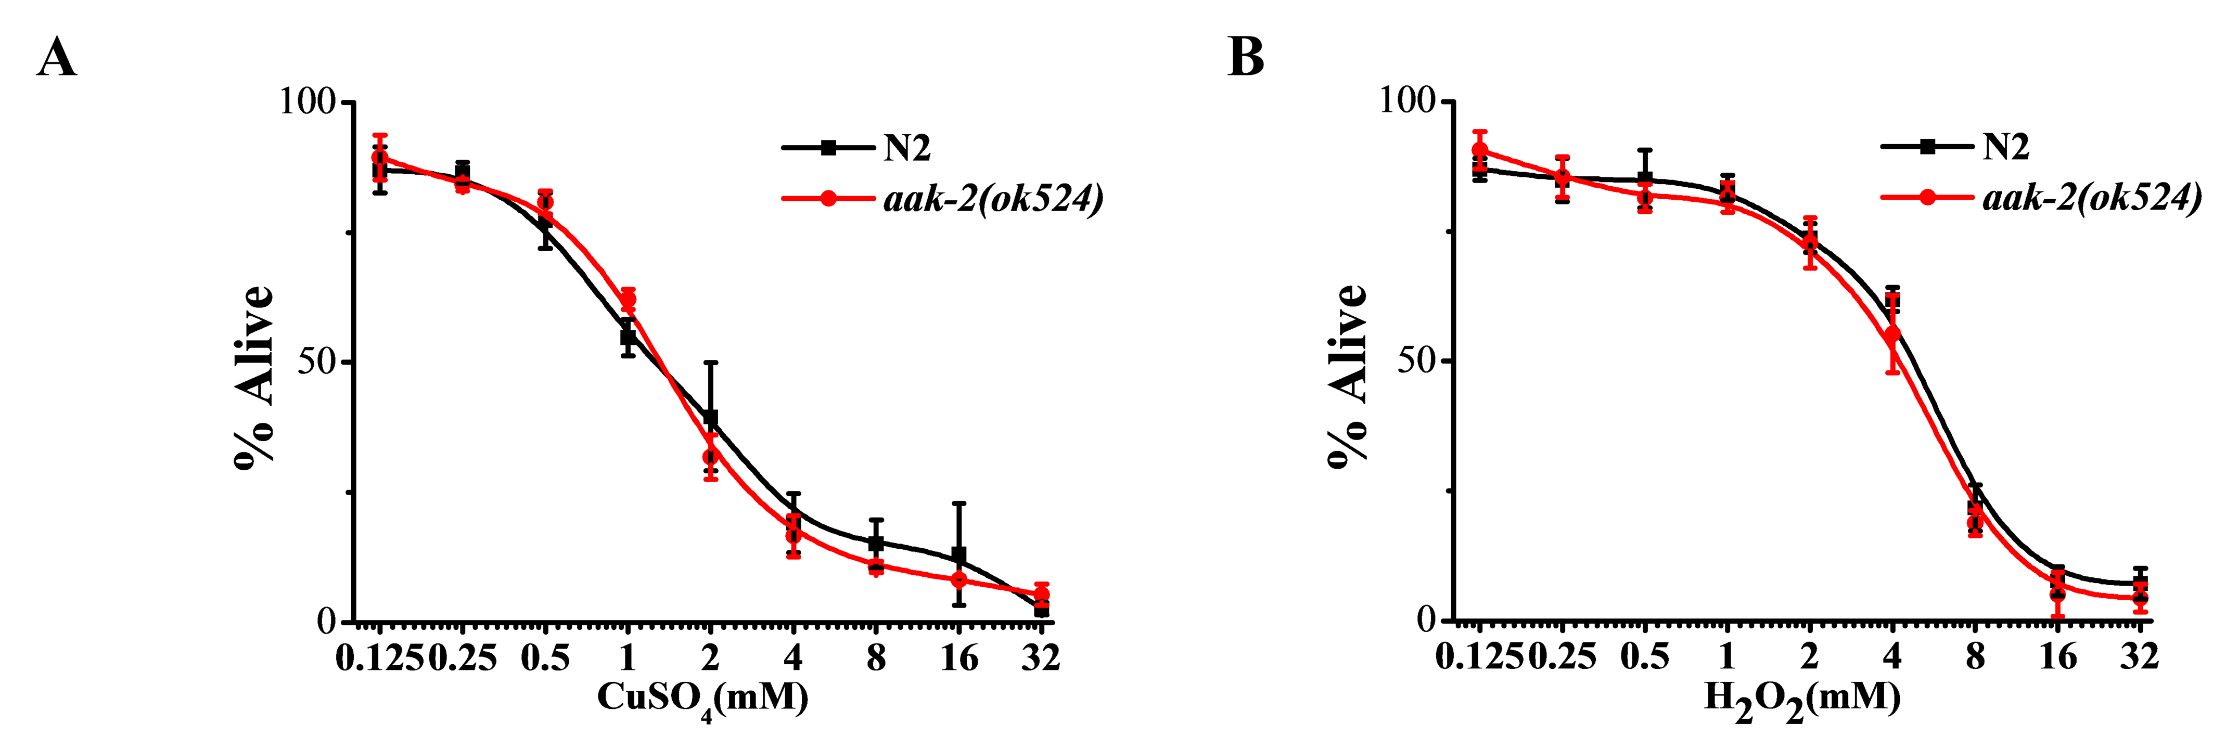
Figure S110. A dose-dependent mortality assay revealed aak-2 mutants are not hypersensitive to chemical toxins insult compared to wild-type N2. (A) The survival assay of the wild worm N2 and null allele aak-2 mutant aak-2 (ok524) in different doses of heavy metal CuSO₄. (B) The survival assay of the wild worm N2 and null allele aak-2 mutant aak-2 (ok524) in different doses of oxidative stress agent H₂O₂. A total of 20~30 L4 stage synchronized worms were scored for mortality per replicate. The mortality was determined after 3 days for Bt strains or CuSO₄ exposure, and 4 h for H₂O₂ exposure. Data present the mean and SD of three independent experiments. No significant difference was relative to N2 control.

Figure S11. Mortality assay revealed epidermal- (A) or muscular-specific (B) aak-2 RNAi had no effect on worm’s sensitivity to Bt infection. The survival assay of the wild worm N2 and RNAi worms exposed to BMB171/Cry5Ba at different times were recorded. A total of 20~30 L4 stage synchronized worms were scored for mortality per replicate. Data present the mean and SD of three independent experiments. No significant difference was relative to empty vector controls.

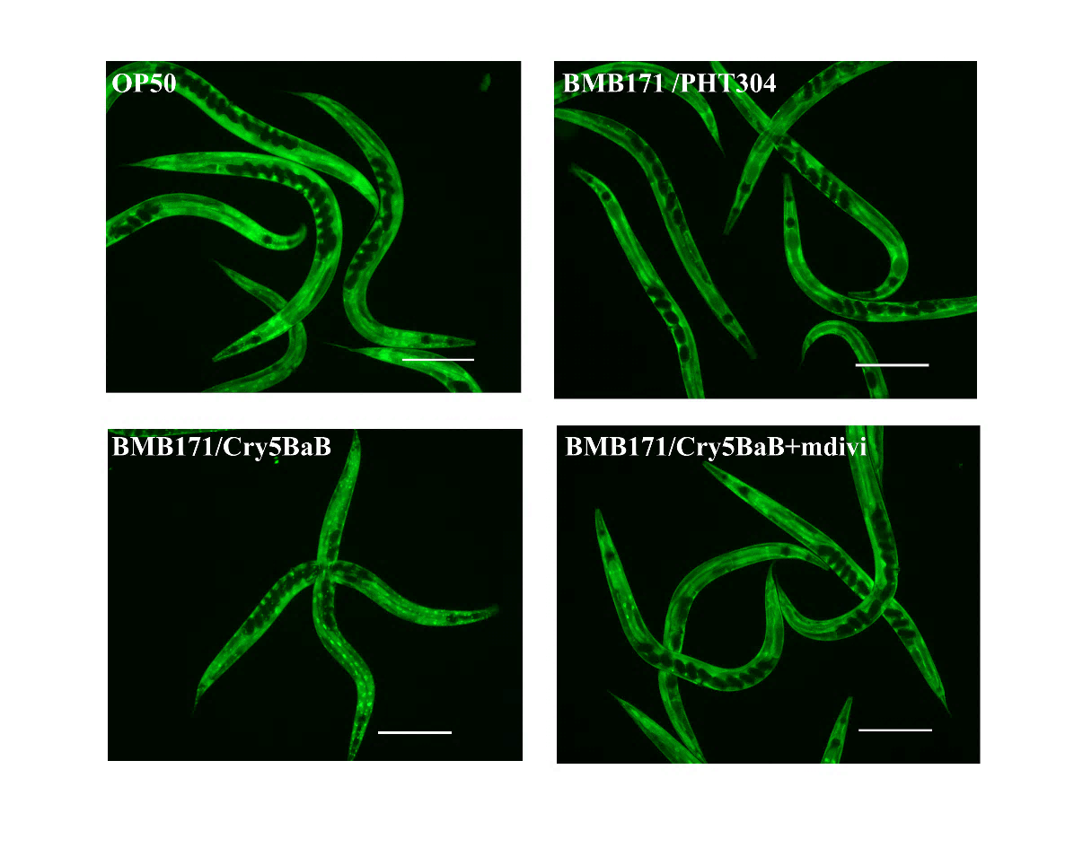
Figure S12. Mdivi-1 can significantly suppress DAF-16 nuclear translocation. DAF-16 translocation was observed using the transgenic worms TJ356(Isdaf-16::gfp) as a reporter. The transgenic worms were fed with OP50, BMB171/Cry5Ba, BMB171/pHT304 or BMB171/Cry5Ba mixed mdivi for 2 h, respectively. The DAF-16::GFP expression pattern was observed using fluorescent microscope (Olympus BX31, Japan) at 40×magnification. Each experiment repeated at least three times and the representative images for each treatment are shown. Scale bar, 20 µm.

Figure S13. The innate immunity p38 MAPK pathway was triggered via AMPK when C. elegans fed with BMB171/Cry5Ba. (A) The alive rates of the wild worm N2, null allele aak-2 mutant aak-2 (ok524), aak-2(ok524)/RNAi-daf-16 (reduced the transcription levels of daf-16 gene in aak-2 mutant aak-2 (ok524)), null allele daf-16 mutant daf-16(mu86) and daf-16(mu86)/RNAi-aak-2 (reduced the transcription levels of aak-2 gene in daf-16 mutant daf-16(mu86)) when fed with BMB171/Cry5Ba for 12 hours. (B) The transcription levels of MAPK genes pmk-1, tir-1, nsy-1, sek-1, kgb-1 and jun-1 of wild type N2 worms and null allele aak-2 mutant aak-2 (ok524) when fed with BMB171/Cry5Ba and BMB171/pHT304. (C) The PMK-1 expression of transgene worms PRJ112 [pmk1::gfp] fed with BMB171/Cry5Ba and BMB171/pHT304 were observed using fluorescent microscope; when gene aak-2 was silenced by RNA interference (RNAi) technique in transgene worms PRJ112 [pmk1::gfp], the PMK-1 expression of the PRJ112 [pmk-1::gfp] worms fed with BMB171/Cry5Ba and BMB171/pHT304. The numbers of worms n≥60. The scale bar is 0.02 mm.

Supplementary Tables:
Table S1. Transcriptome analysis of C. elegans after infection of Bt strains. This table was submitted directly as an Excel file (designated Table S1) because it contains a large amount of data that cannot be easily shown in a Word file.

Table S2. Enrichment pathway analyses of C. elegans after infection of Bt strains. This table was submitted directly as an Excel file (designated Table S1) because it contains a large amount of data that cannot be easily shown in a Word file.

Table S3. Transcriptome analysis of the genes of responsed to nematocidal Bt infection. This table was submitted directly as an Excel file (designated Table S1) because it contains a large amount of data that cannot be easily shown in a Word file.

Table S4. Strains and plasmids used in this study.
Strains or plasmids | Characteristics | Source or reference
Bacillus thuringiensis
BMB171 | No plasmid mutant, acrystalliferous Bt strain | ¹
BMB171/pHT304 | Derivative of BMB171 containing empty plasmid pHT304 as a control. | Our laboratory
BMB171/Cry5Ba | Derivative of BMB171 containing cry5Ba gene for producing Cry5Ba. | ²
BMB171/Cry5Ca | Derivative strain of BMB171 containing cry5Ca gene expressing Cry5Ca protein. | ³
BMB171/Cry6Aa | Derivative strain of BMB171 containing cry6Aa gene expressing Cry6Aa protein. | ²
BMB171/Cry21Aa | Derivative strain of BMB171 containing cry21A gene expressing Cry21A protein. | ⁴
BMB171/Cry1Ac | Derivative of BMB171 containing cry1Ac gene for producing Cry1Ac. | ⁵
Escherichia coli
OP50 | An uracil auxotroph strain whose growth is limited on Nematode Growth Medium (NGM) plates | Caenorhabditis Genetics Center
HT115 | An RNAi feeding strain with tetracycline resistance used for nematode interference experiments. | Professor Wu Zhengxin
HT115/pL440 | E. coli HT115 containing empty plasmid pL440. | This study
HT115/bre-5 | E. coli HT115 cloned target gene of bre-5 as a RNAi strain. | This study
HT115/aak-2 | E. coli HT115 cloned target gene of aak-2 as a RNAi strain. | This study
HT115/daf-16 | E. coli HT115 cloned target gene of daf-16 as a RNAi strain. | This study
Caenorhabditis elegans strains
N2 | wild type strains | Caenorhabditis Genetics Center
HY498 | bre-5(ye17), which was deleted the membrane receptor of Cry5Ba, showing resistance to Cry5Ba. | Caenorhabditis Genetics Center
SJ4143 | zcIs17(P_{ges-1}::GFP^{mt}), which stably expressed GFP in mitochondria matrix of intestinal cells. | Caenorhabditis Genetics Center
tm1944 | aak-1(tm1944), which was the null alleles mutant of AMPK subunit α1. | Caenorhabditis Genetics Center
RB754 | aak-2(ok524), which was the null alleles mutant of AMPK subunit α2. | Caenorhabditis Genetics Center
tm2658 | aakb-1(tm2658), which was the null alleles mutant of AMPK subunit β1. | Caenorhabditis Genetics Center
tm5269 | aakg-4(tm5269), which was the null alleles mutant of AMPK subunit γ1. | Caenorhabditis Genetics Center
TG38 | aak-2(gt33), which was the null allele mutant of aak-2. | Caenorhabditis Genetics Center
CF1038 | daf-16(mu86), which was the null allele mutant of daf-16. | Caenorhabditis Genetics Center
PRJ112 | mutEx70(pmk1::gfp), which expressed GFP by fusing GFP on PMK, working as PMK-1 reporter worm. | Caenorhabditis Genetics Center
TJ356 | zIs356(Isdaf-16:: gfp), which expressed GFP by fusing GFP on Daf-16, working as Daf-16 reporter worm. | Caenorhabditis Genetics Center
CF1553 | muIs84(sod-3::GFP), which expressed GFP by fusing GFP on Sod-3, working as Sod-3 reporter worm. | Caenorhabditis Genetics Center
RT311 | pwIs69(P_{vha-6}::GFP::RAB-11), which stably expressed GFP in apical recycling endosome. | Caenorhabditis Genetics Center
- | aak-2(ok524) (P_{vha-6}::aak-2), which was a rescued worm that stably expressed aak-2 in the intestine. | This study
- | aak-2(ok524) (P_{myo-3}::aak-2), which was a rescued worm that stably expressed aak-2 in the muscle. | This study
- | aak-2(ok524) (P_{rab-3}::aak-2), which was a rescued worm that stably expressed aak-2 in the neuron. | This study
 | aak-2(ok524) (P_{aak-2}::aak-2), which was the native rescued worm that stably expressed aak-2. | This study
Plasmid
pHT304 | E. coil to B. thuringiensis shuttle vector with 4 copies per cell, Amp^{r}, Erm^{r}, 6.6 kb. | ⁶
pL440 | Vector used for the expression of dsRNA for RNAi in nematodes. | Andrew Fire (Addgene plasmid # 1654)
pPD49.26 | Vector for overexpression of cloned tissue-specific promoter. | Andrew Fire (Addgene plasmid # 1686)

Table S5. Primer sequences used in this study.
Primers | Sequence (5'→3') | Functions
mtDNA Forward | GTTTATGCTGCTGTAGCGTG | To quantify the content of mtDNA.
mtDNA Reverse | CTGTTAAAGCAAGTGGACGAG | To quantify the content of mtDNA.
ama-1 Forward | TGGAACTCTGGAGTCACACC | To quantify the content of genomic DNA.
ama-1 Reverse | CATCCTCCTTCATTGAACGG | To quantify the content of genomic DNA.
Pvha-6 Forward | CCCAAGCTTTCGACGGCCCGGGCTGGTAAAG | To amplify the upstream of the vha-6 promoter.
Pvha-6 Reverse | CGCGGATCCTTTGGCGGAGGGACTCAGATGG | To amplify the downstream of the vha-6 promoter.
Pmyo-3 Forward | CCCAAGCTTGGGCTGCAGGTCGGCTATAATA | To amplify the upstream of the myo-3 promoter.
Pmyo-3 Reverse | CGCGGATCCTCTAGATGGATCTAGTGGTCGT | To amplify the downstream of the myo-3 promoter.
Prab-3 Forward | CCCAAGCTTAGTCTTTTAAACAAAAACCCAAA | To amplify the upstream of the rab-3 promoter.
Prab-3 Reverse | CGCGGATCCTGTGAAATCCGATAGGCAAG | To amplify the downstream of the rab-3 promoter.
Paak-2 Forward | CCCAAGCTTTAAGGTTTCCGACACGCTCG | To amplify the upstream of the aak-2 promoter.
Paak-2 Reverse | CGCGGATCCTGAAACAGTATATGCGTTTTAT | To amplify the downstream of the aak-2 promoter.
F-aak-2 Forward | GGATCCATGTTTTCTCATCAAGATCG | To amplify the upstream of the full-length of aak-2.
F-aak-2 Reverse | TTAACGAGCCAGTGTTCCAATC | To amplify the downstream of the full-length of aak-2.
U-aak-2 Forward | AGTCATTTTGTATGCACTTCT | To amplify the upstream including the 3-UTR of aak-2 by overlap PCR.
U-aak-2 Reverse | GGATCCTGGATCTTTCTGAATTTGTTTT | To amplify the downstream including the 3-UTR of aak-2 by overlap PCR.
tba-1 Forward | TCAACATGCCATCGCCGCC | To analysis the transcription of tab-1 mRNA in C. elegans.
tba-1 Reverse | TCCAAGCGAGCCAGGCTTCAG | To analysis the transcription of tab-1 mRNA in C. elegans.
lys-7 Forward | AGGTTCCCCCGATTGTTGAC | To analysis the transcription of lys-7 mRNA in C. elegans.
lys-7 Reverse | GCTGGGTTGTATGCACGAAC | To analysis the transcription of lys-7 mRNA in C. elegans.
F32A5.4 Forward | CAGAGCGAGTTGGCCACTTA | To analysis the transcription of F32A5.4 mRNA in C. elegans.
F32A5.4 Reverse | CATTTTGCAGCCACCACACA | To analysis the transcription of F32A5.4 mRNA in C. elegans.
tre-4 Forward | GGCCAACACTTTGCATTGGT | To analysis the transcription of tre-4 mRNA in C. elegans.
tre-4 Reverse | GGTCGTCCTCGTCGTTTTCT | To analysis the transcription of tre-4 mRNA in C. elegans.
sod-3 Forward | AAATGTCCGCCCAGACTATG | To analysis the transcription of sod-3 mRNA in C. elegans.
sod-3 Reverse | TGGCAAATCTCTCGCTGA | To analysis the transcription of sod-3 mRNA in C. elegans.
clec-166 Forward | GCGCTAATCCAGAGGTCTCC | To analysis the transcription of clec-166 mRNA in C. elegans
clec-166 Reverse | CCCGTATTCGCTACTGGACC | To analysis the transcription of clec-166 mRNA in C. elegans
thn-2 Forward | GAGGCTTCCAACTTACGGCT | To analysis the transcription of thn-2 mRNA in C. elegans
thn-2 Reverse | CAAGGGATGCTGGTGGAACT | To analysis the transcription of thn-2 mRNA in C. elegans
D1086.3 Forward | TGCAGGGATGGCAGAAGTTT | To analysis the transcription of D1086.3 mRNA in C. elegans
D1086.3 Reverse | GGAATGGGTACTCAACCGGA | To analysis the transcription of D1086.3 mRNA in C. elegans
ttr-44 Forward | TCCAGAAAACGCCGTCATCA | To analysis the transcription of ttr-44 mRNA in C. elegans
ttr-44 Reverse | TGAGTAAGCAGTGGCAAAAGG | To analysis the transcription of ttr-44 mRNA in C. elegans
pmk-1 Forward | TGCCCGTCGTACATATCGTG | To analysis the transcription of pmk-1 mRNA in C. elegans
pmk-1 Reverse | GGTCATCGTTGAGTCGCTGA | To analysis the transcription of pmk-1 mRNA in C. elegans
tir-1 Forward | TCCACTTGGACGAACTGACG | To analysis the transcription of tir-1 mRNA in C. elegans
tir-1 Reverse | GCTGGCTGAGTAGGACAAGG | To analysis the transcription of tir-1 mRNA in C. elegans
nsy-1 Forward | TGCTTGCGTGTAGAACTTTTCA | To analysis the transcription of nsy-1 mRNA in C. elegans
nsy-1 Reverse | TGATGATTCGGATGTGTGTGAGT | To analysis the transcription of nsy-1 mRNA in C. elegans
sek-1 Forward | GACACTGTTTGGCGACGATG | To analysis the transcription of sek-1 mRNA in C. elegans
sek-1 Reverse | ATTCCGTCCACGTTGCTGAT | To analysis the transcription of sek-1 mRNA in C. elegans
kgb-1 Forward | ATGGAAGTGGATCTGCCGGT | To analysis the transcription of kgb-1 mRNA in C. elegans
kgb-1 Reverse | AGGTCATCGGCCATTACGAC | To analysis the transcription of kgb-1 mRNA in C. elegans
jun-1 Forward | CAAAAAGGATCGGCGACAGG | To analysis the transcription of jun-1 mRNA in C. elegans
jun-1 Reverse | AGATGCCGGTGTGATTGGAC | To analysis the transcription of jun-1 mRNA in C. elegans

Supporting References:
1 He, J. et al. Complete genome sequence of Bacillus thuringiensis mutant strain BMB171. Journal of bacteriology 192, 4074-4075, doi:10.1128/JB.00562-10 (2010).
2 Guo, S. et al. New strategy for isolating novel nematicidal crystal protein genes from Bacillus thuringiensis strain YBT-1518. Applied and environmental microbiology 74, 6997-7001, doi:10.1128/AEM.01346-08 (2008).
3 Geng, C. et al. Dissimilar Crystal Proteins Cry5Ca1 and Cry5Da1 Synergistically Act against Meloidogyne incognita and Delay Cry5Ba-Based Nematode Resistance. Appl. Environ. Microbiol. 83, doi:UNSP e03505.10.1128/AEM.03505-16 (2017).
4 Wan, L. et al. Bacillus thuringiensis targets the host intestinal epithelial junctions for successful infection of Caenorhabditis elegans. Environ Microbiol 21, 1086-1098, doi:10.1111/1462-2920.14528 (2019).
5 Fang, S. et al. Bacillus thuringiensis bel protein enhances the toxicity of Cry1Ac protein to Helicoverpa armigera larvae by degrading insect intestinal mucin. Applied and environmental microbiology 75, 5237-5243, doi:10.1128/AEM.00532-09 (2009).
6 Arantes, O. & Lereclus, D. Construction of cloning vectors for Bacillus thuringiensis. Gene 108, 115-119 (1991).

