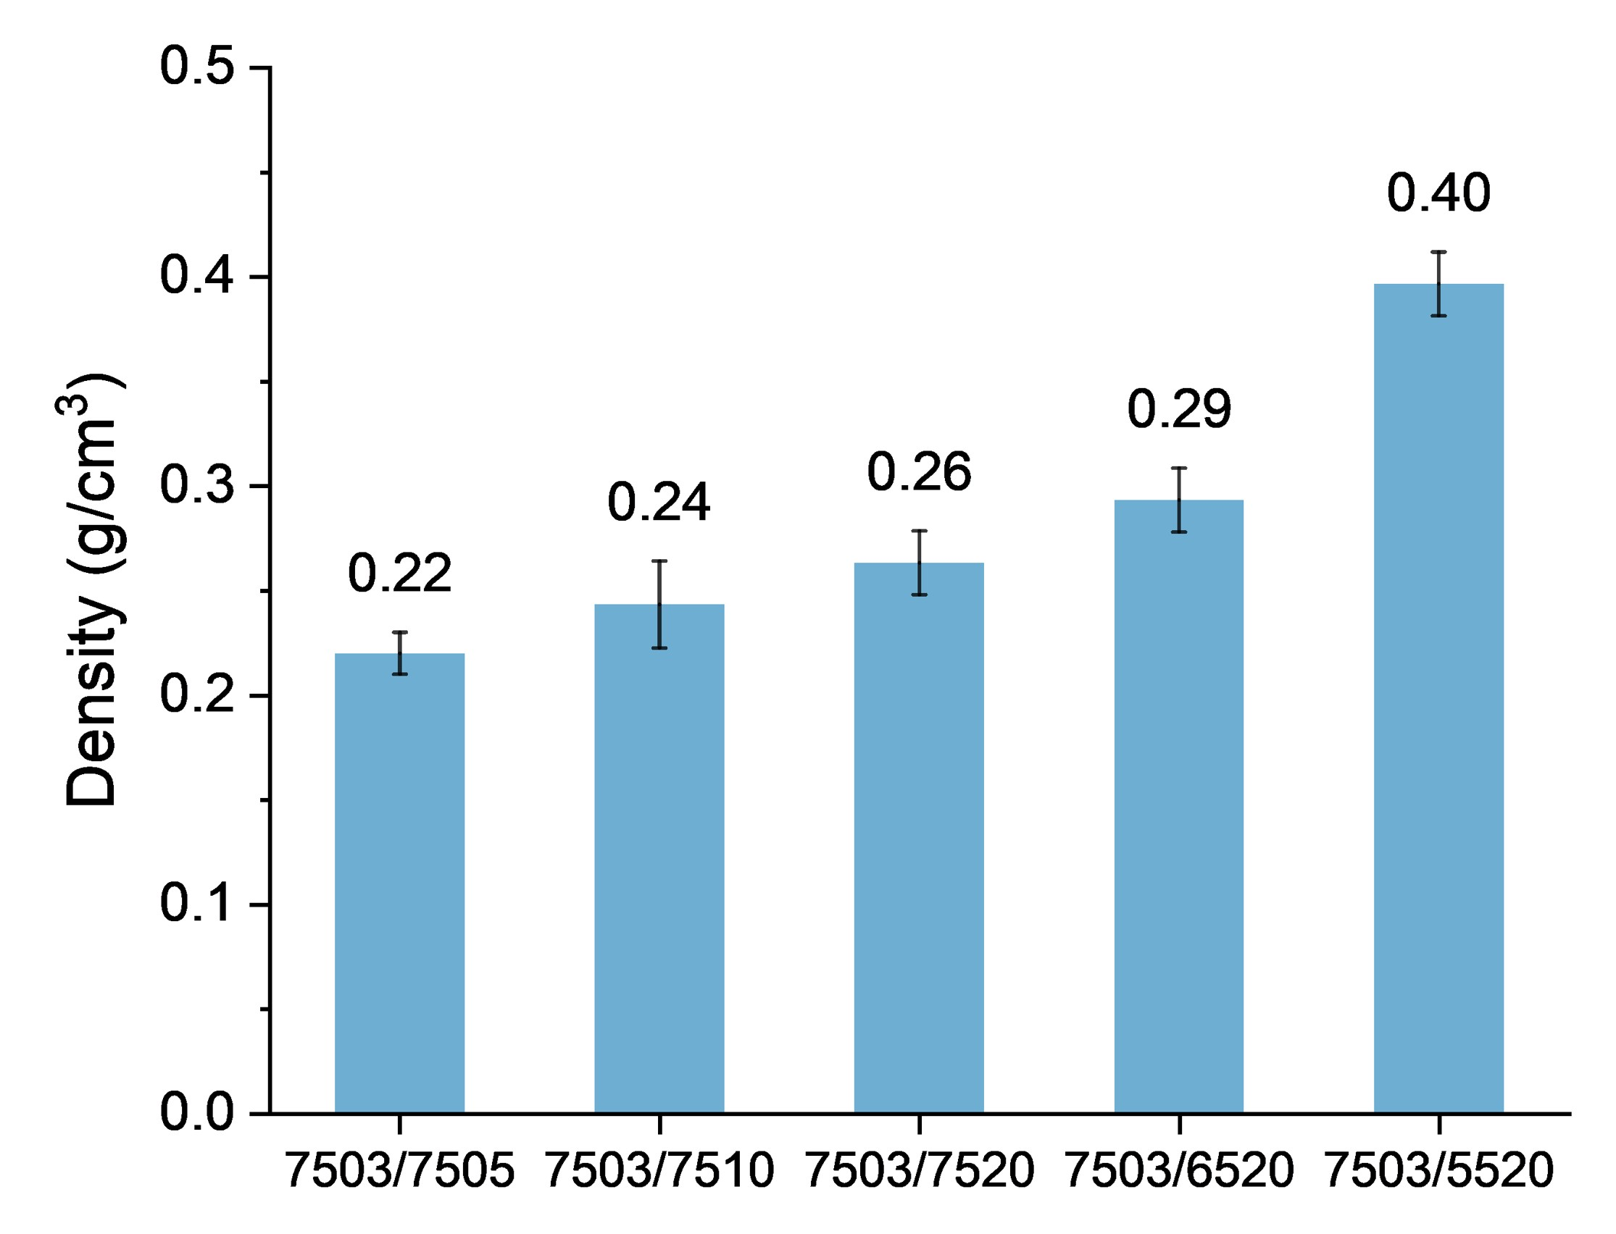
Extended Data Fig. 1 | Lightweight asymmetric porous composites. Density of asymmetric porous composites from different double-layer emulsions.

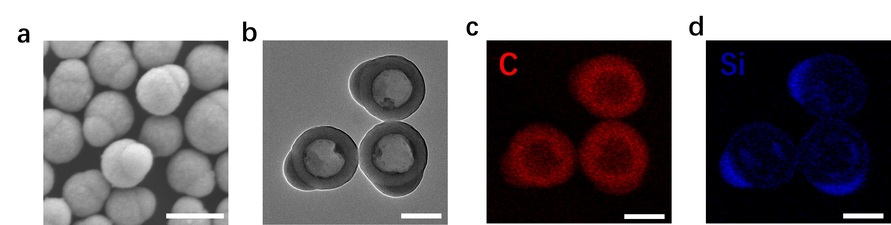
Extended Fig. 2 | Morphology and composition of Janus particles. a, SEM image of JPs with snowman-like morphology. b, TEM image of JPs with hollow hydrophobic polystyrene belly and solid hydrophilic silica head. c-d, EDS mapping image of JPs showing the C element distribution (c) and Si element distribution (d). Scale bars: 250 nm.

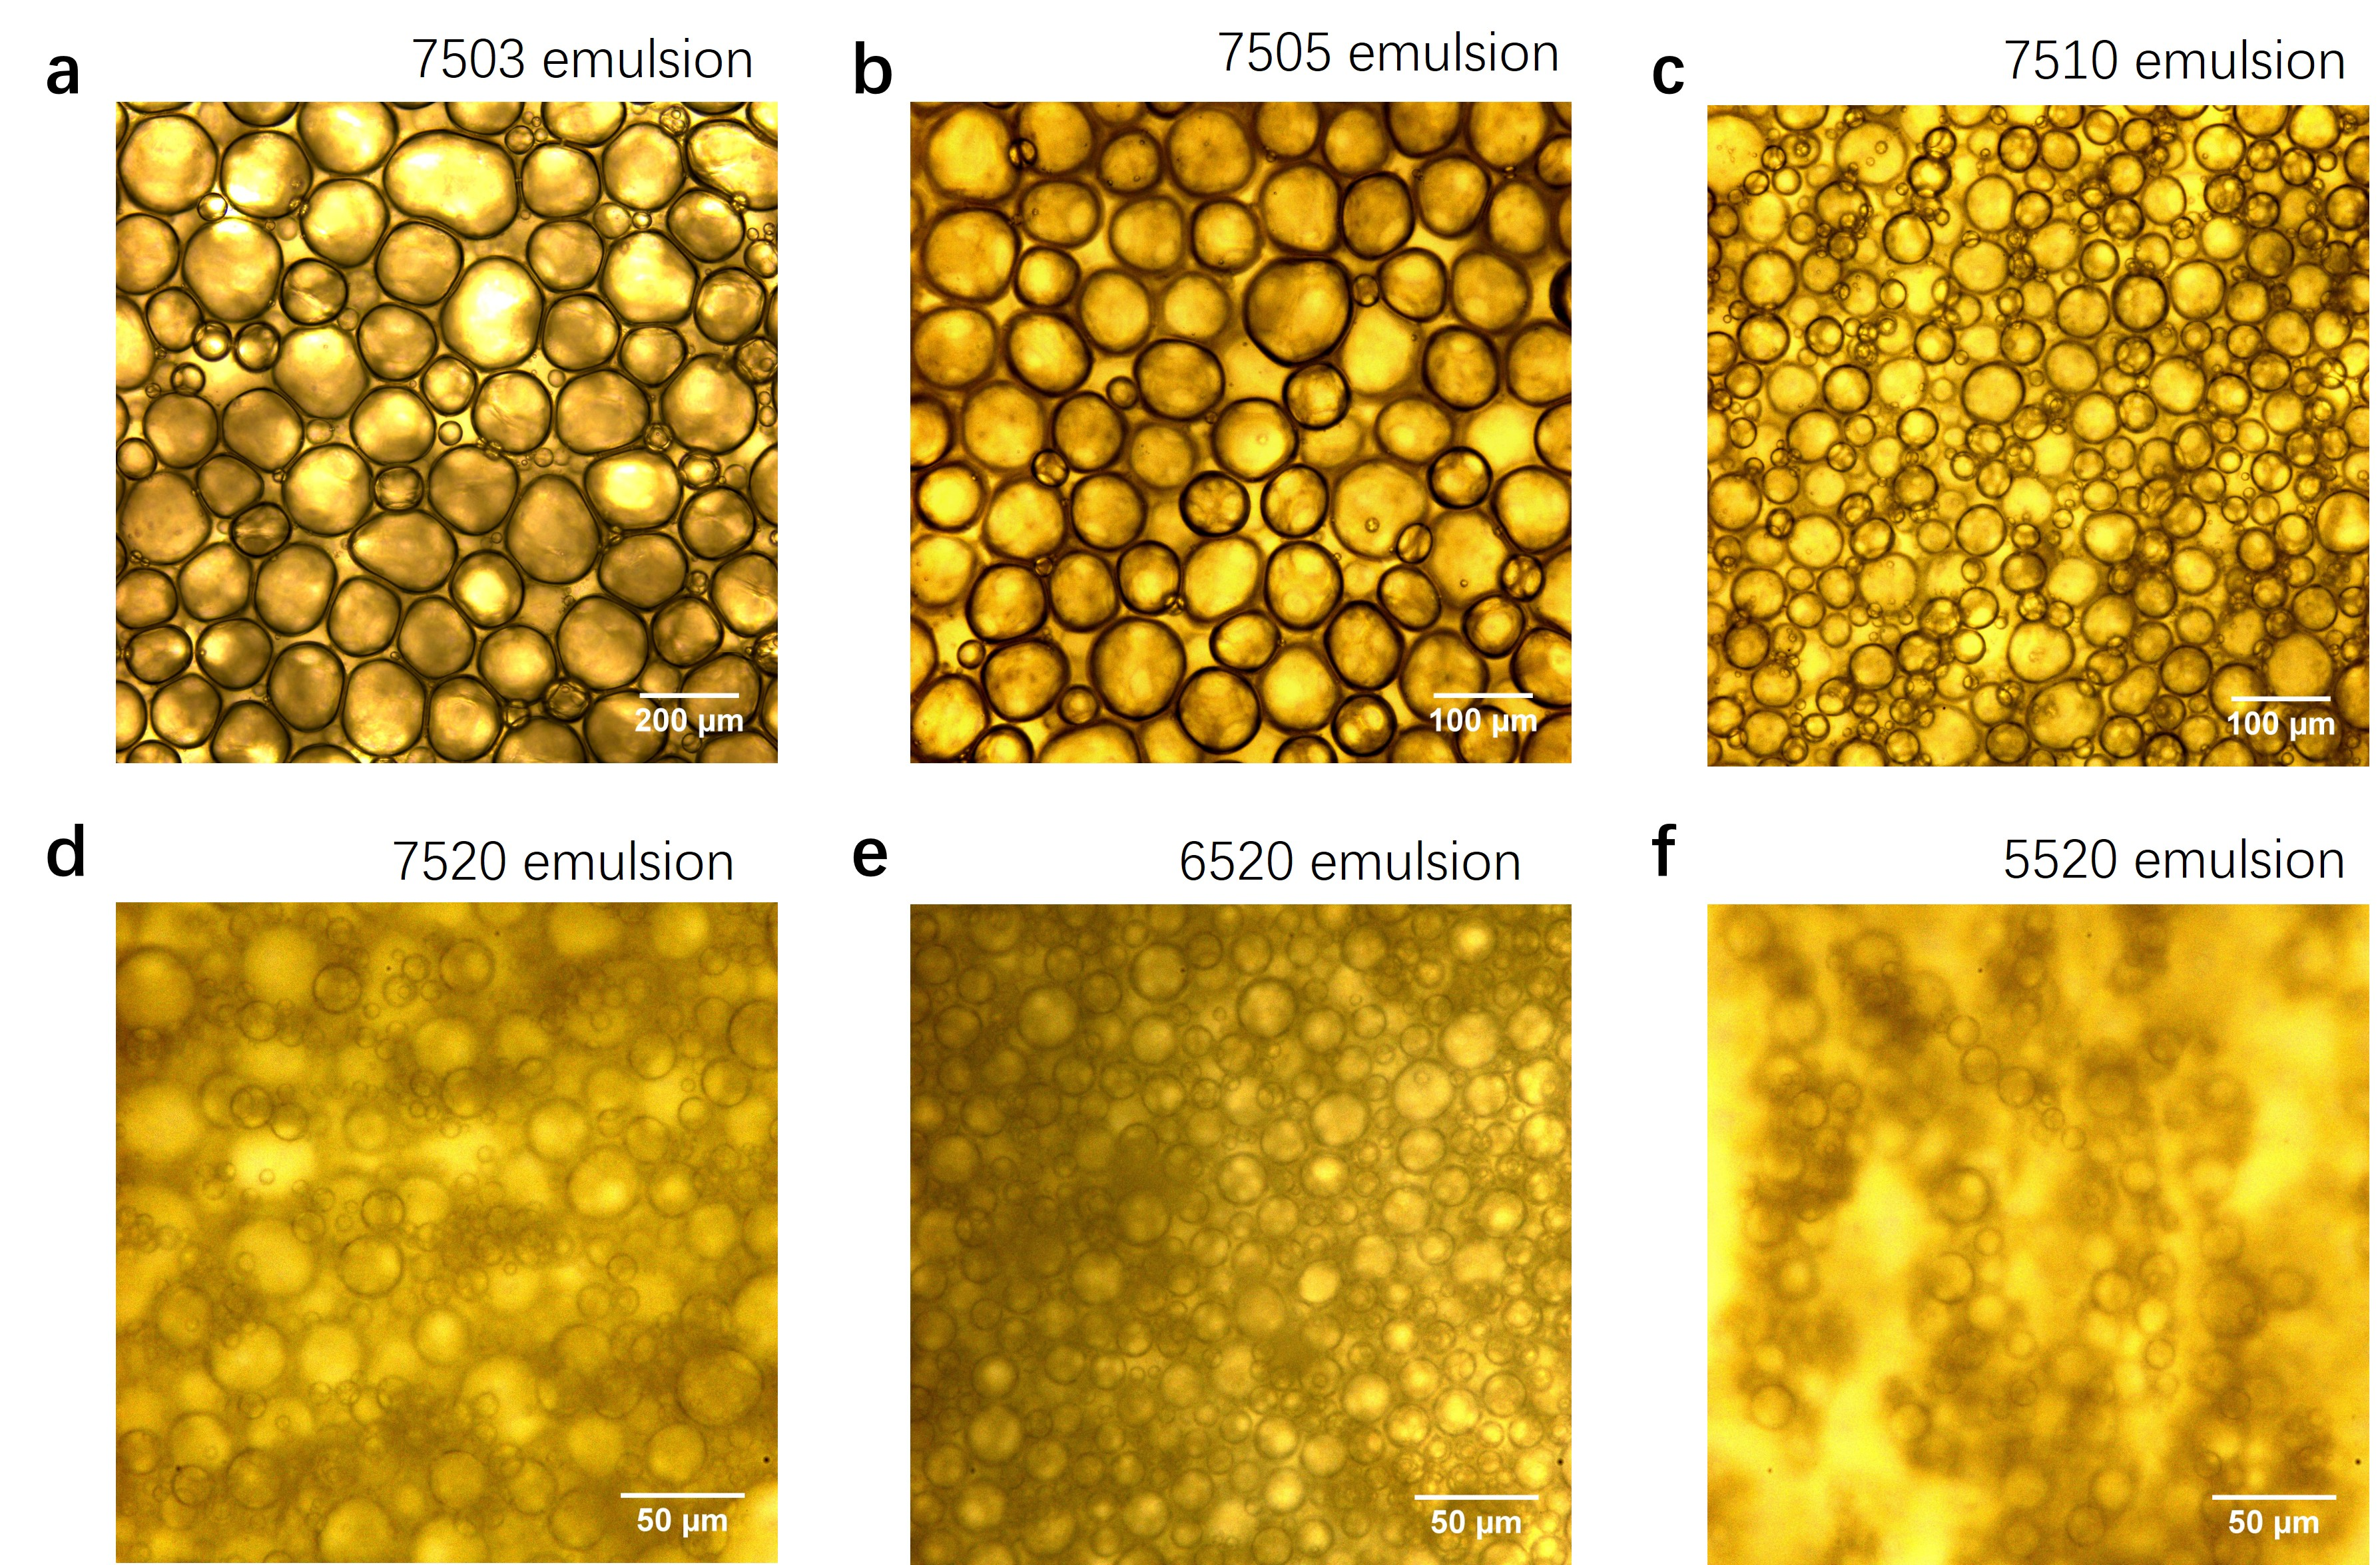
Extended Data Fig. 3 | Optical microscope images of emulsions with different internal phase volume fractions and different JPs dosages just after emulsification. a, 7503 emulsions with the internal phase volume fraction of 75 vol% and the JPs dosages of 3 wt%. b, 7505 emulsions. c, 7510 emulsions. d, 7520 emulsions. e, 6520 emulsions. f, 5520 emulsions.
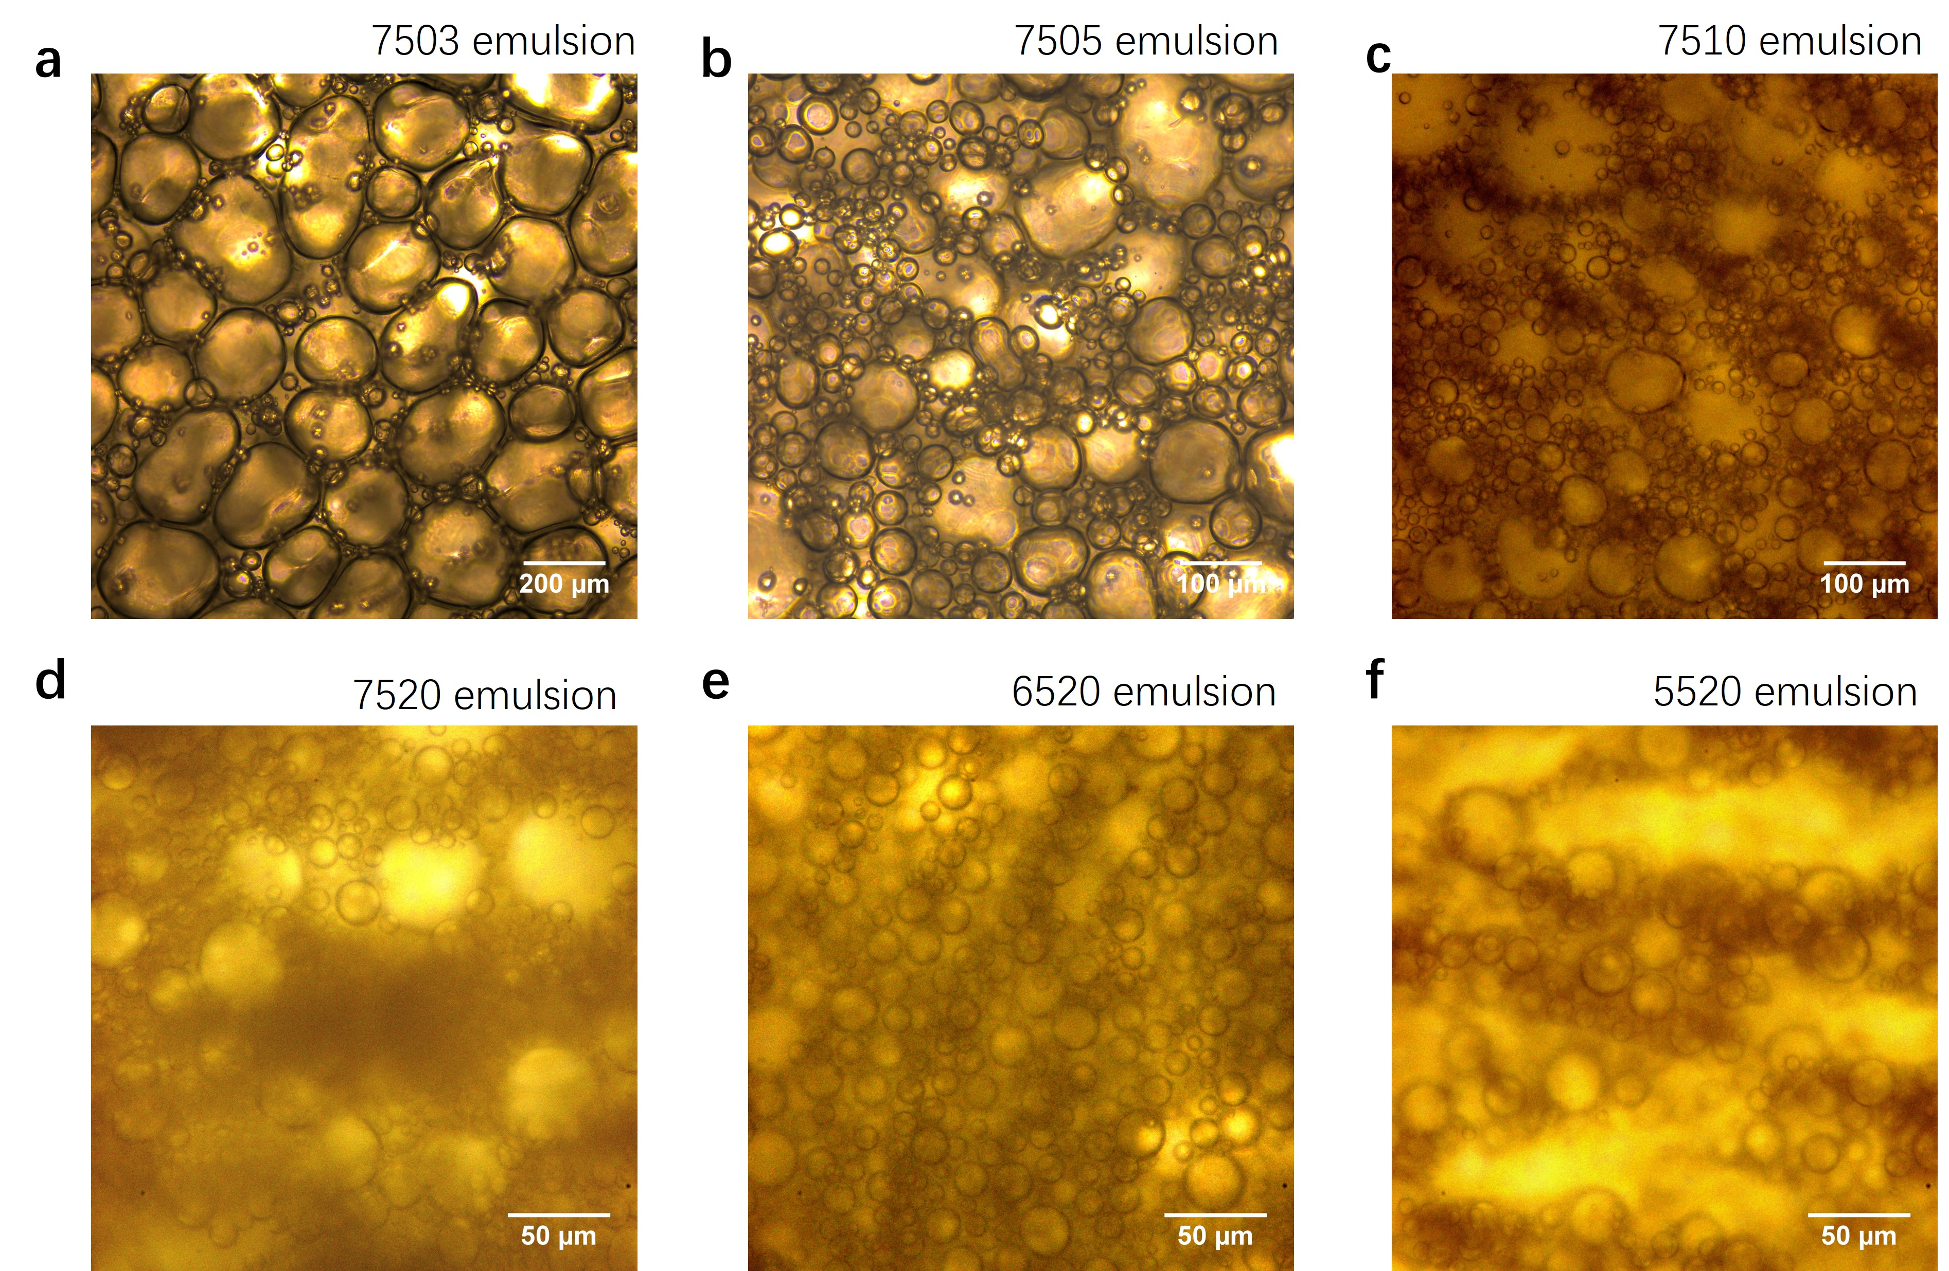
Extended Data Fig. 4 | Optical microscope images of emulsions with different internal water volume fractions and different JPs dosages 10 days after emulsification. a, 7503 emulsions. b, 7505 emulsions. c, 7510 emulsions. d, 7520 emulsions. e, 6520 emulsions. f, 5520 emulsions.
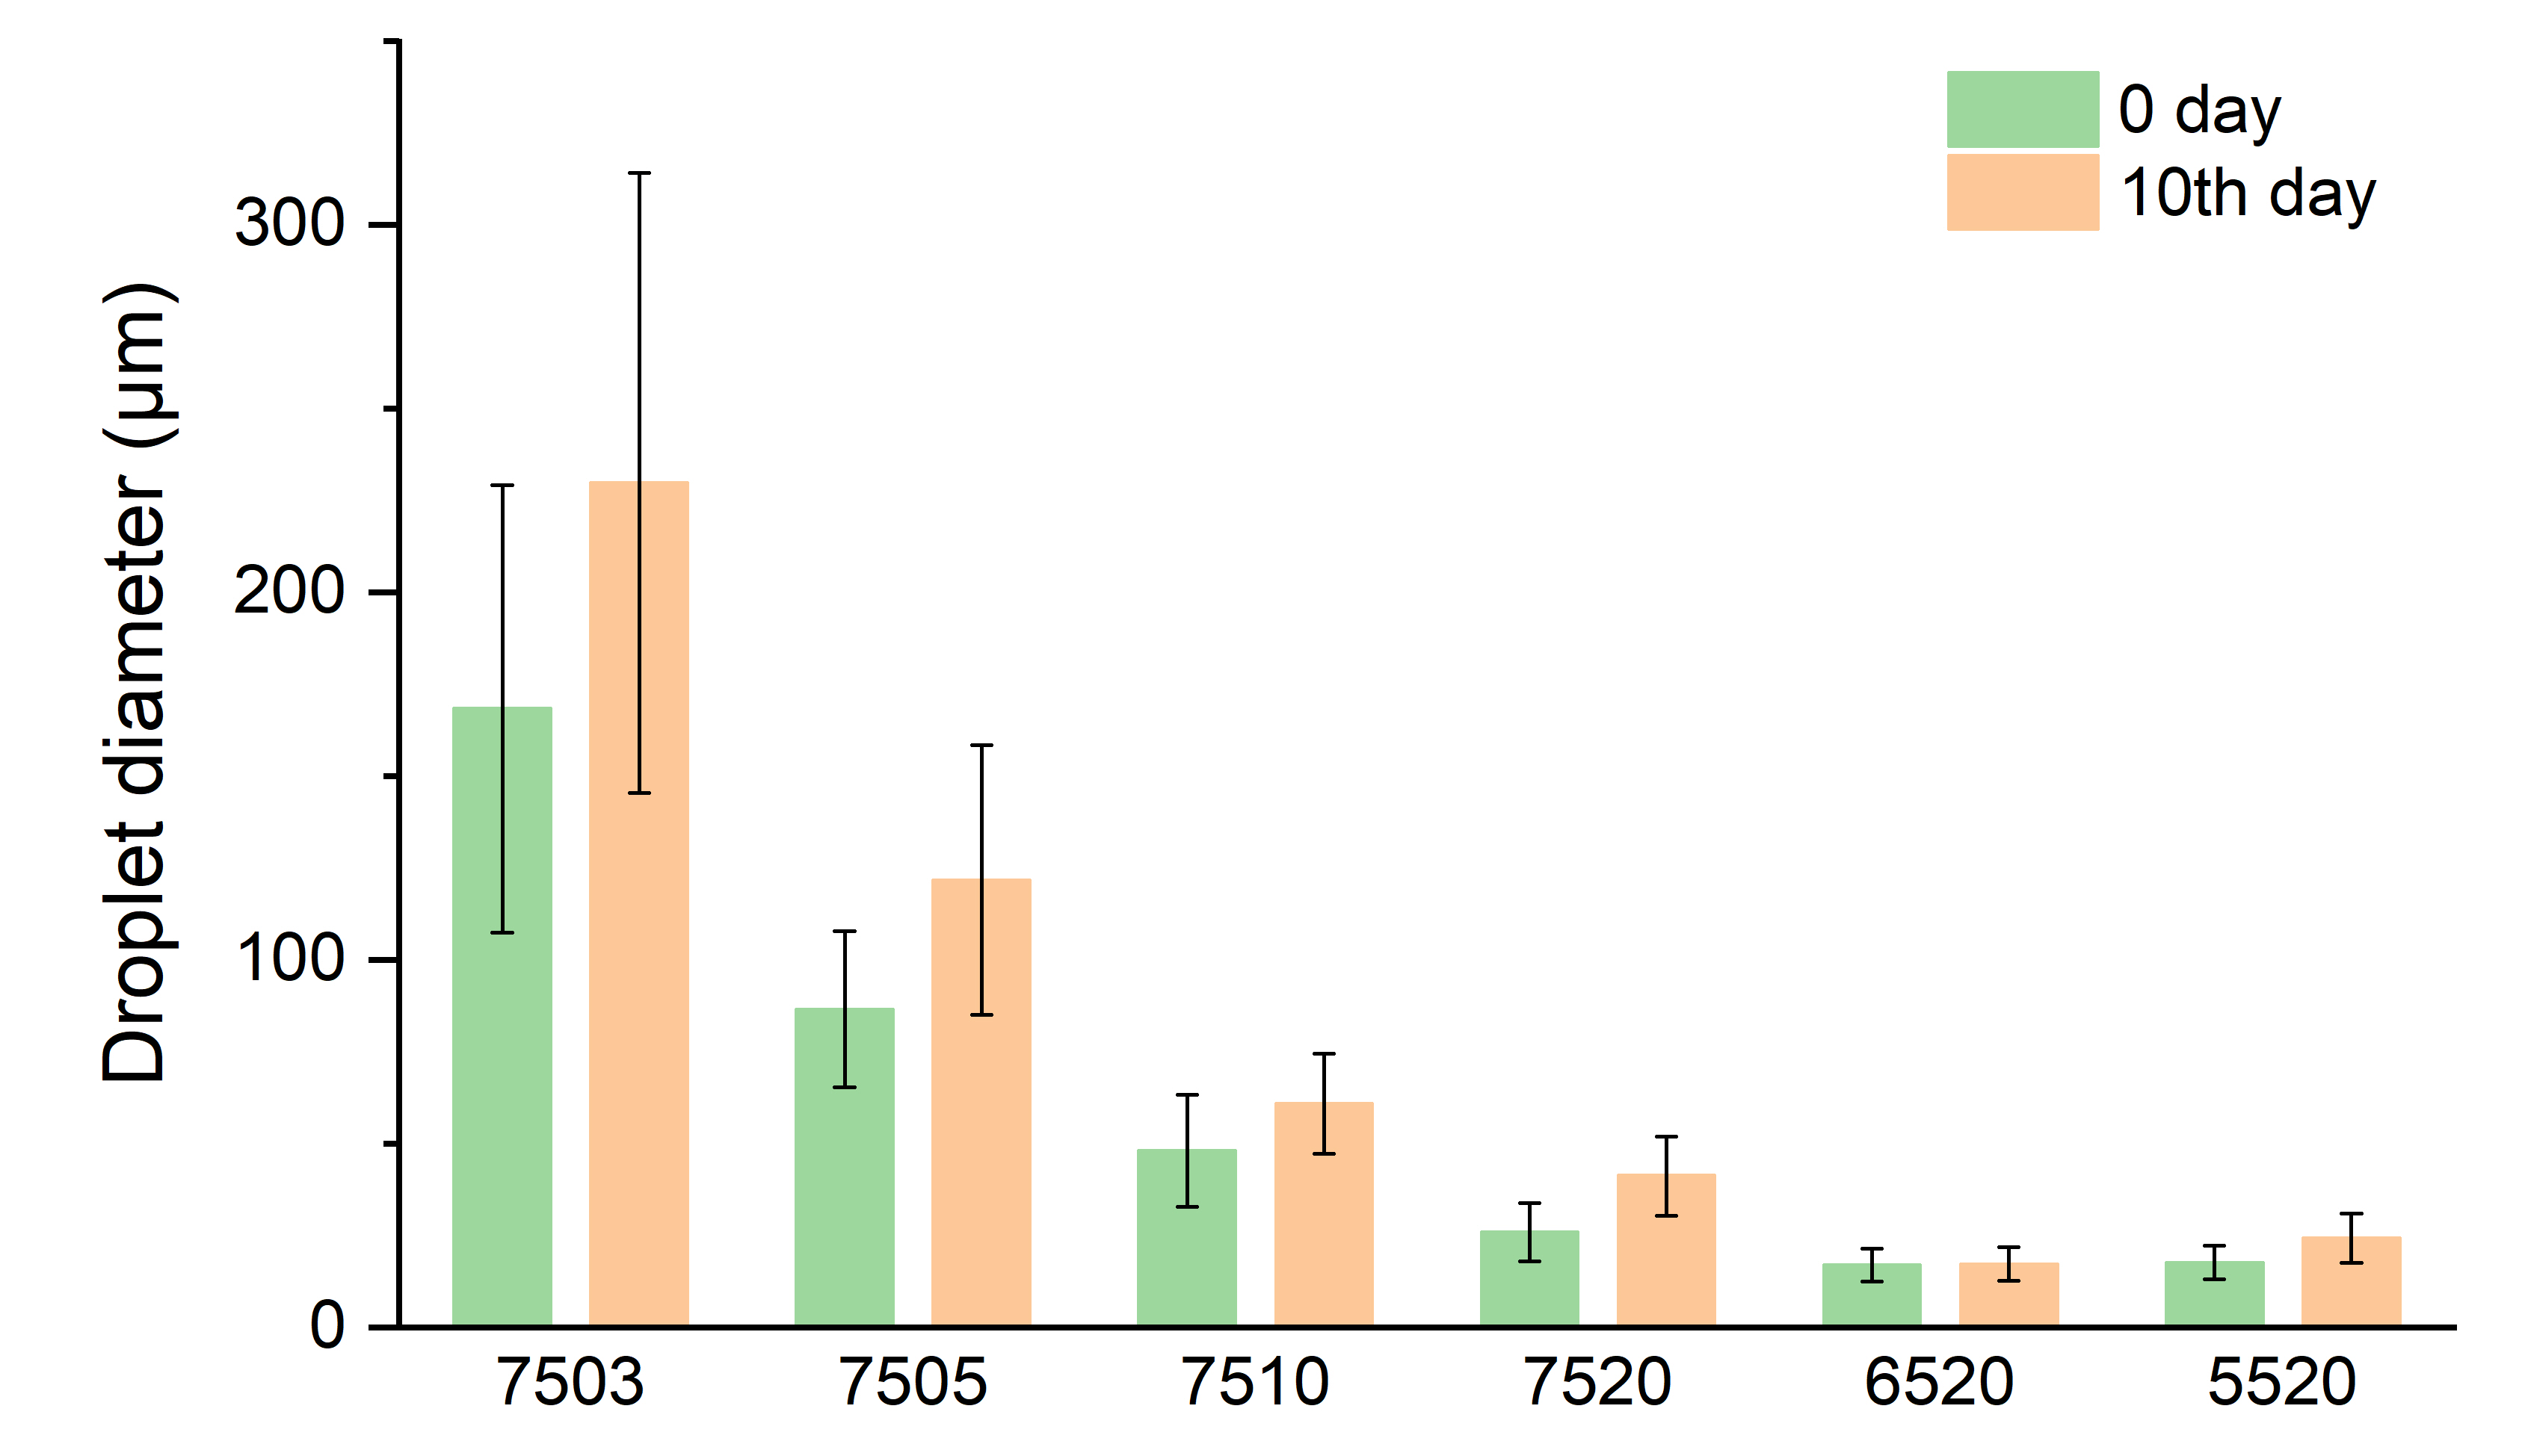
Extended Data Fig. 5 | Emulsions stability analysis. The size of emulsion droplets stabilized by JPs just after emulsification (green bars) and 10 days later (orange bars).
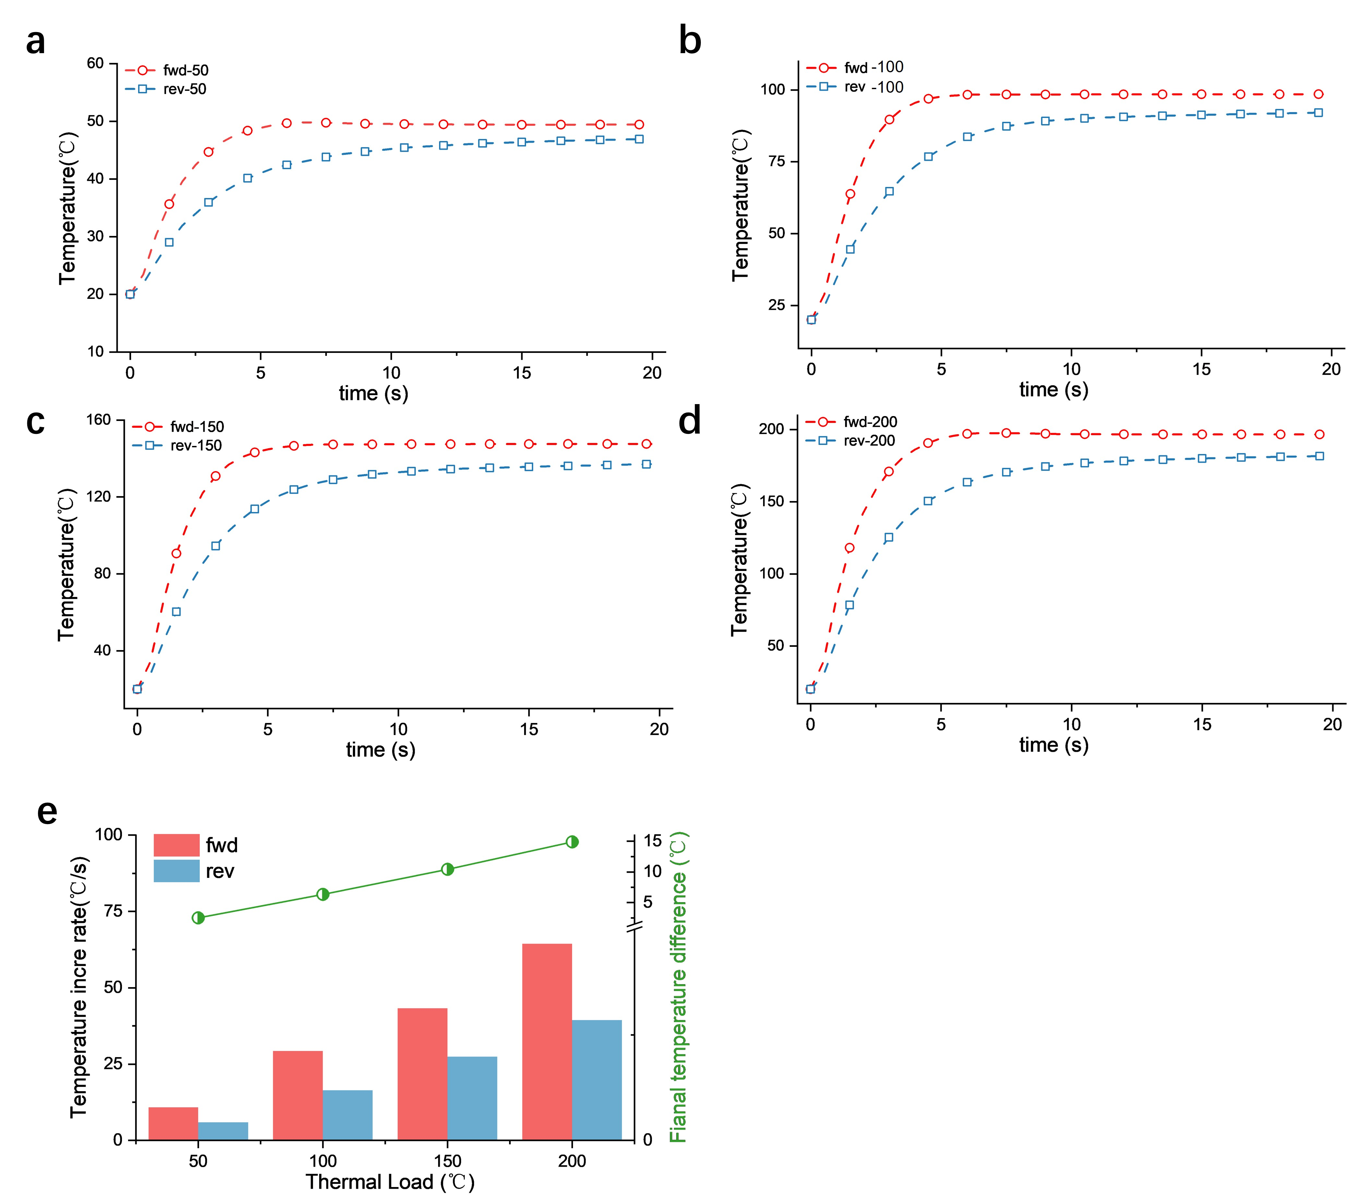
Extended Data Fig. 6 | Simulation results under different thermal loads as heating source. a-d, Temperature of the end surface of JAPCs during heating in simulation with different temperatures of heat source. 50 ℃(a); 100 ℃ (b);150 ℃ (c); 200 ℃ (d). e, Temperature shielding property of JAPCs under different thermal loads.

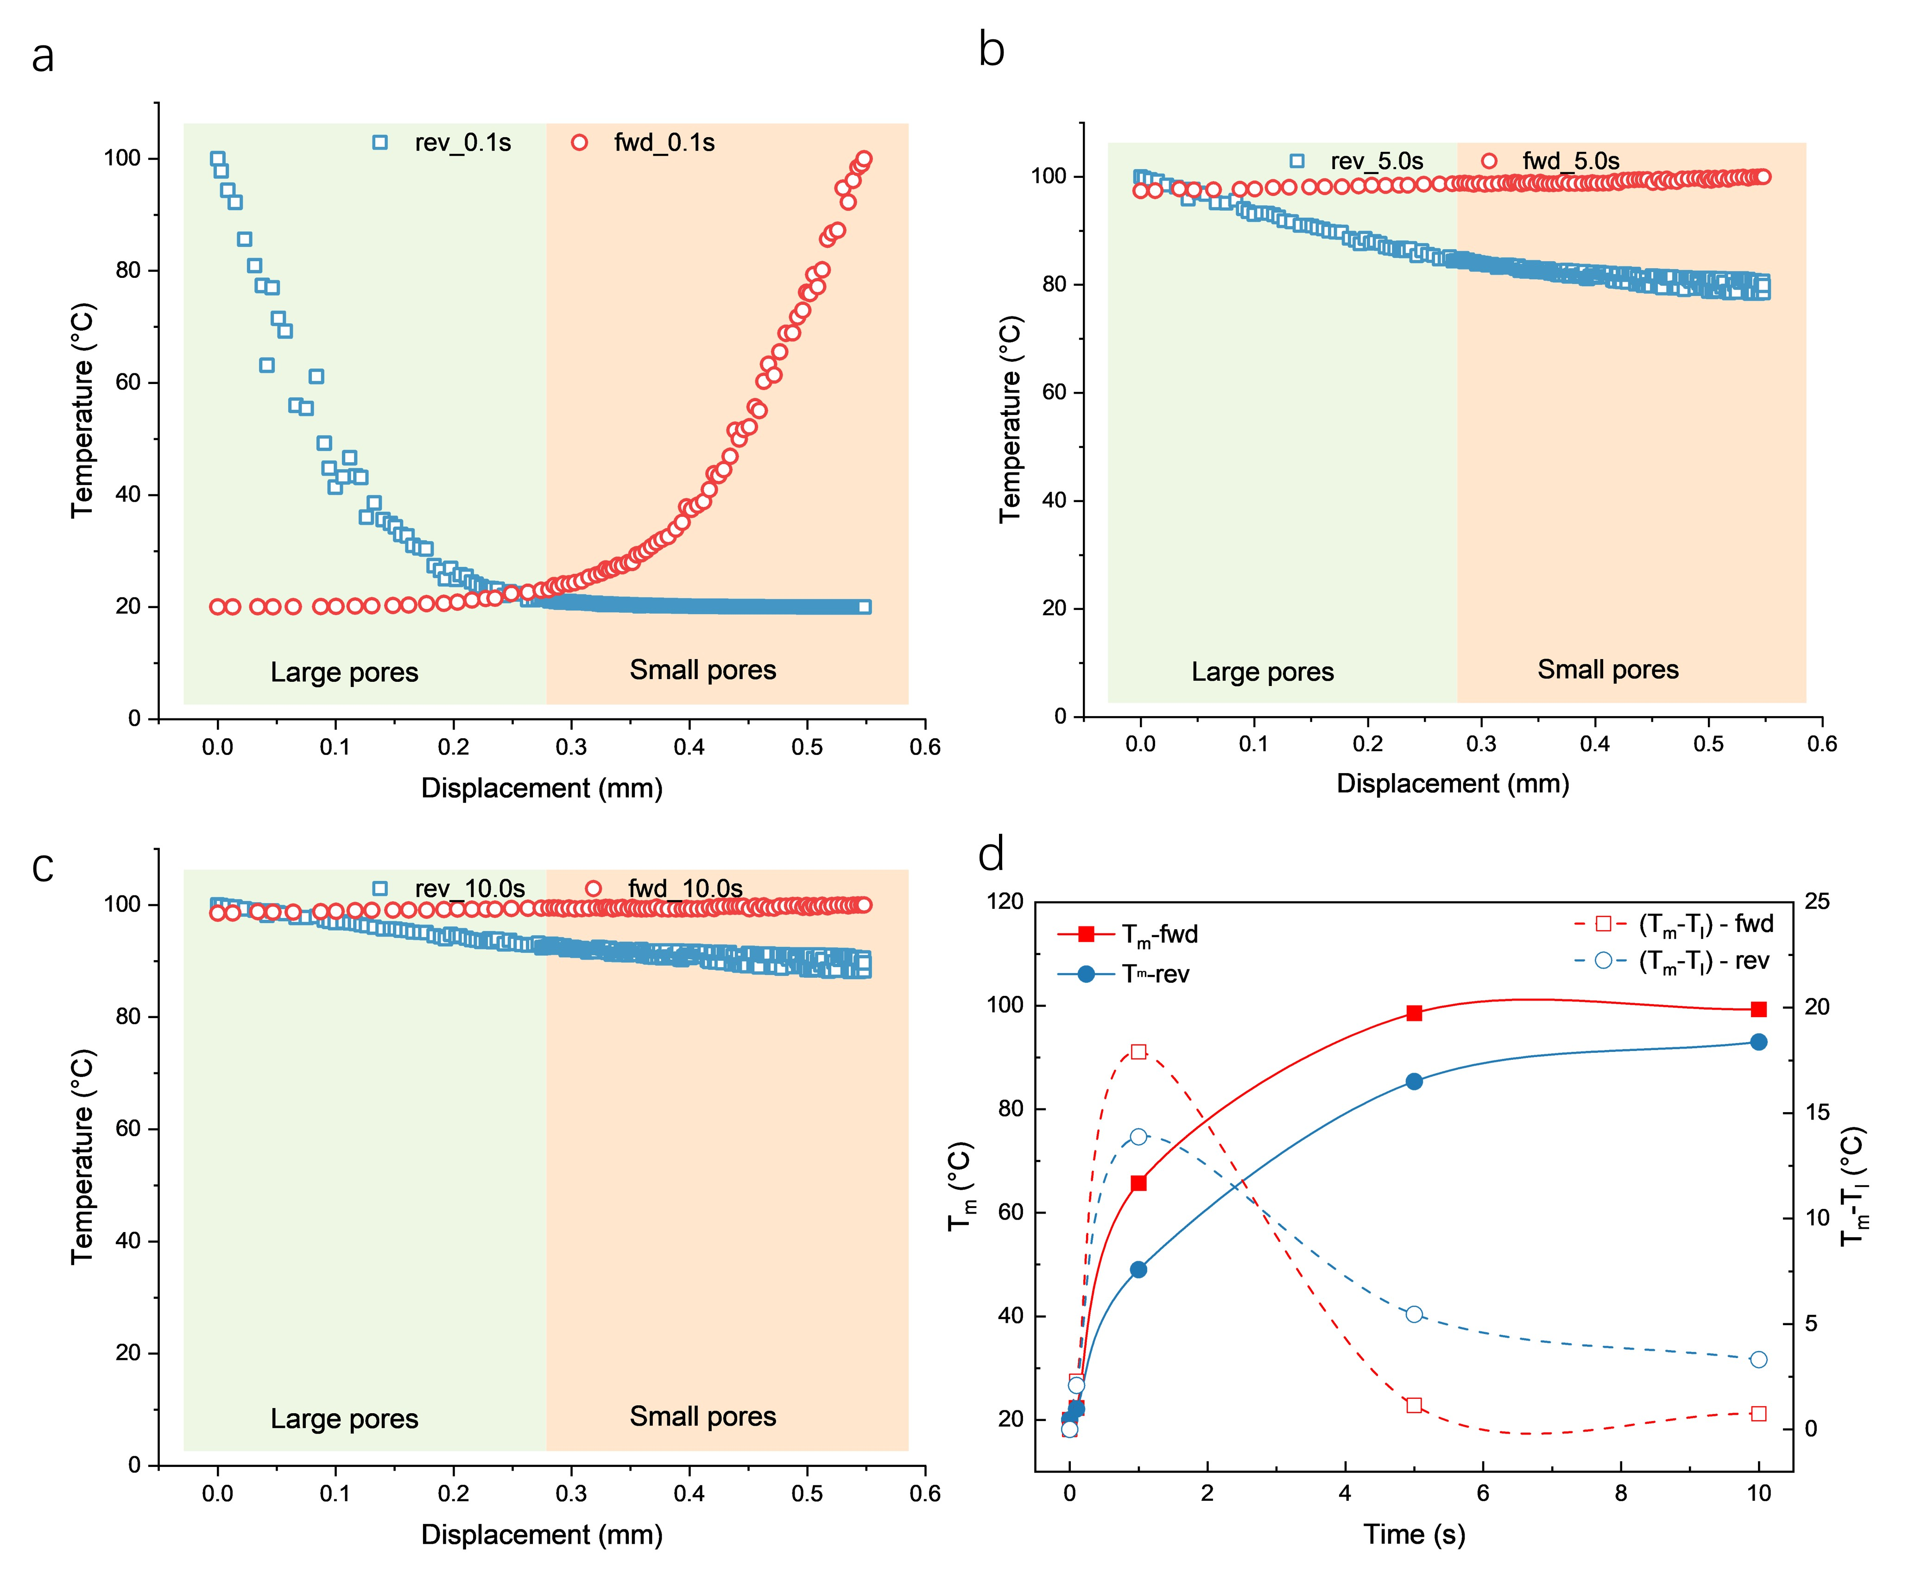
Extended Data Fig. 7 | Simulation results of temperature gradient inside JAPCs. a-c, the Temperature distribution inside JAPCs at different times after heating obtained from simulation. At 0.1 s (a); At 5.0 s (b); At 10 s (c); e, The imaginary interfacial temperature (T_{m}) and the temperature difference between the imaginary interfacial area and low-temperature end (T_{l}) after different heating times.

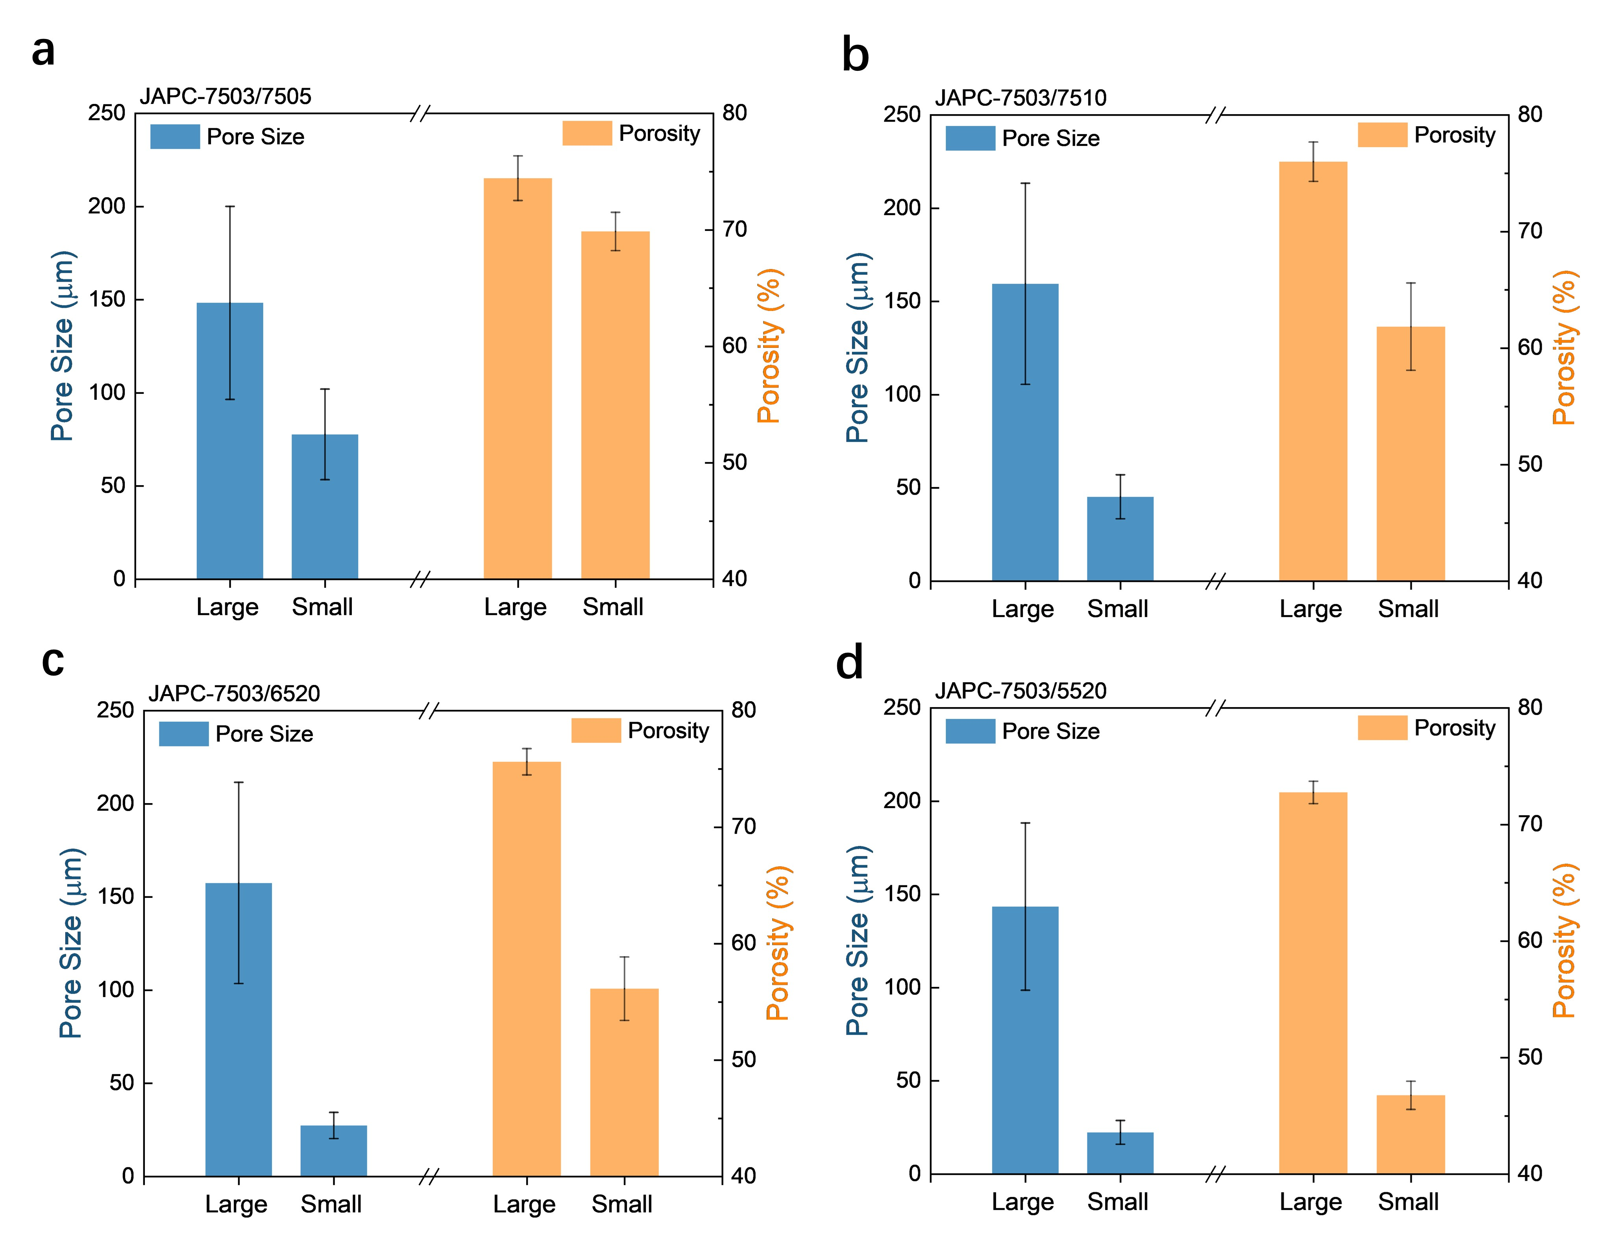
Extended Data Fig. 8 | Statistical analysis of porosity and pore size of separate inner parts of different JAPCs. a, JAPC-7503/7505; b, JAPC-7503/7510; c, JAPC-7503/6520; d, JAPC-7503/5520.

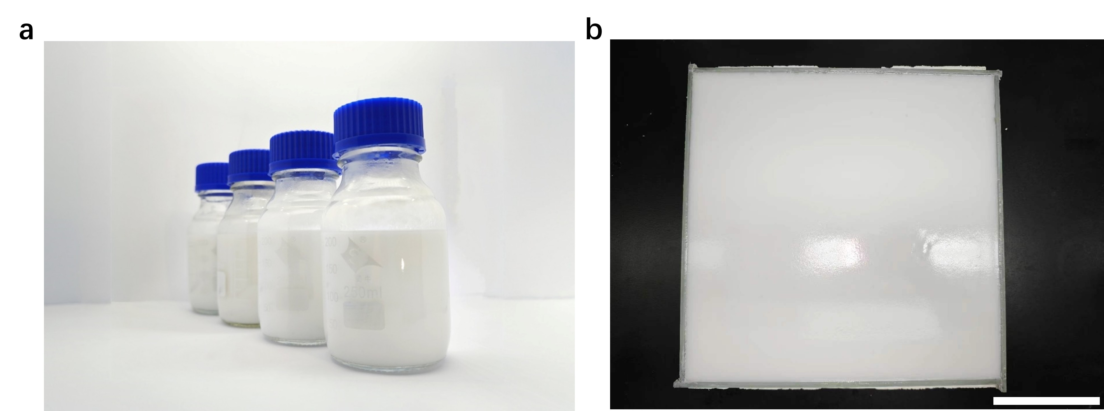
Extended Data Fig. 9 | The scale-up preparation of emulsions and porous composites. a, The JPs stabilized emulsions packaged in 250 mL glass bottles. b, Emulsions poured into the large-area glass mold. Scale bar: 10 cm.

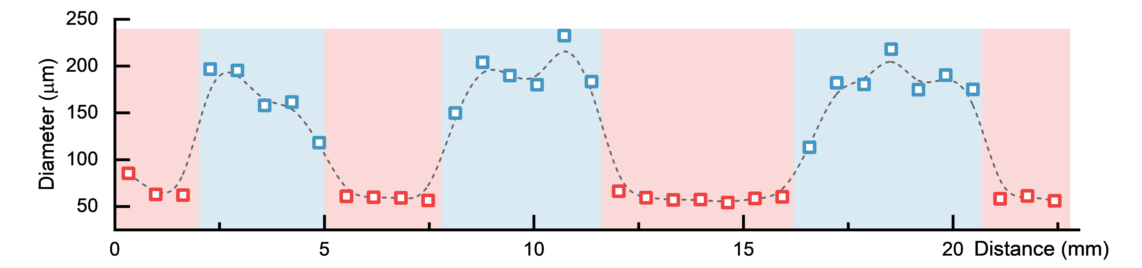
Extended Data Fig. 10 | Structure analysis of alternating multilayer porous composites. The pore size variation along the direction of layers stacking.

