- SUPPLEMENTAL INFORMATION
- Title: Elevated Micro- and Nanoplastics Detected in Preterm Human Placentae
- Authors: Michael D. Jochum, Ph.D.^{1,#}, Marcus A. Garcia, Pharm.D.^{2,#}, Alexandra L. Hammerquist, M.D. ¹, Jacquelyne C. Howell, B.S. ¹, Myla C. Stanford, B.S. ¹, Rui Liu², Marian Olewine, B.S.², Eliane El Hayek, Ph.D.², Emily Phan, B.S.², Lori A. Showalter, M.S.¹, Cynthia Shope, M.S.¹, Melissa A. Suter, Ph.D.¹, Matthew J. Campen, Ph.D.², Kjersti M. Aagaard, M.D., Ph.D.^{3, 4, 5}, Enrico R. Barrozo, Ph.D.^{1,*}
- Affiliations
¹Department of Obstetrics and Gynecology, Baylor College of Medicine and Texas Children’s Hospital, Houston, TX, USA.
²Department of Pharmaceutical Sciences, University of New Mexico, Albuquerque, NM, USA.
³Oregon National Primate Research Center, Beaverton, OR, USA.
⁴HCA Healthcare and HCA Healthcare Research Institute Nashville, TN and HCA Texas Maternal Fetal Medicine, Houston, TX, USA.
⁵Maternal Fetal Care Center, Division of Fetal Medicine and Surgery, Boston Children’s Hospital, Harvard Medical School, Boston, MA, USA.
#Contributed equally
*Corresponding Author
Enrico R. Barrozo, Ph.D.
Assistant Professor
Department of Obstetrics and Gynecology
Baylor College of Medicine and Texas Children’s Hospital
1 Baylor Plaza, Houston, TX 77030
Enrico.Barrozo@bcm.edu.

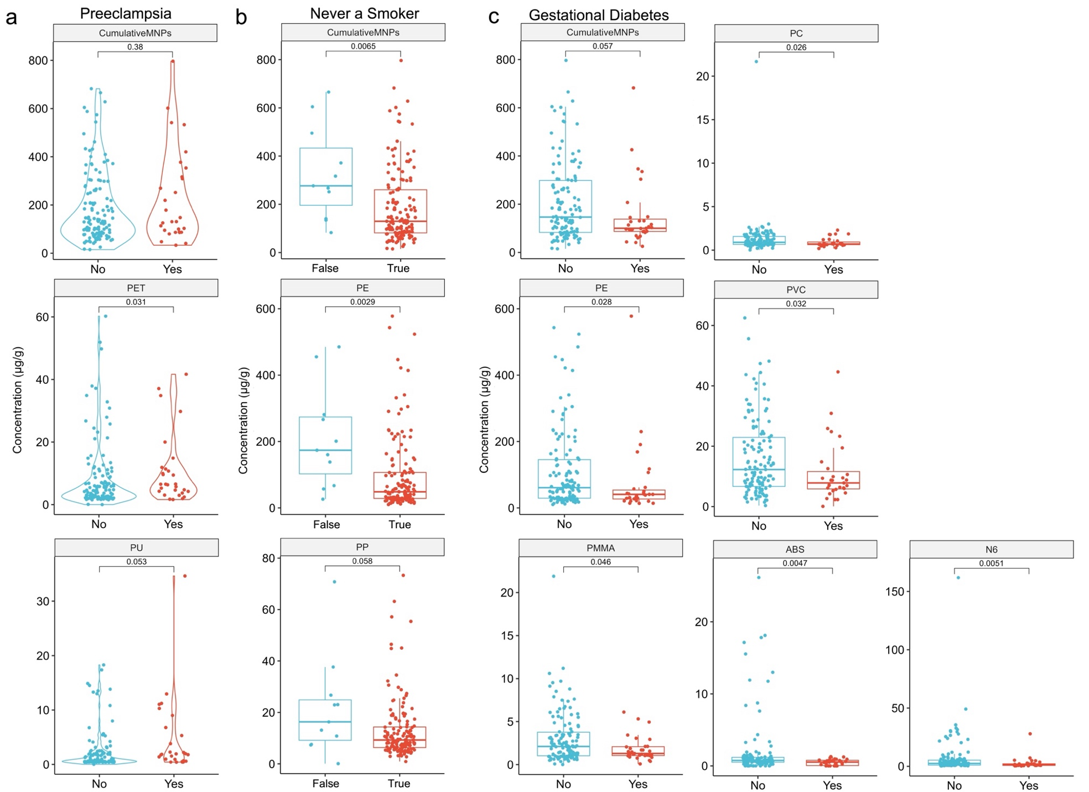
Fig. S1: Specific MNPs were significantly different when stratified by preeclampsia, smoking history, and gestational diabetes, related to Fig. 2. a, Violin or box plots with individual subjects ' data comparing preterm and term concentrations of cumulative or specific MNPs stratified by a, Preeclampsia, yes (n=29), b, Never a Smoker, true (n=147), or c, Gestational Diabetes, yes (n=31). Significance was determined by Wilcoxon tests, with significance defined as p<0.05.
Table S1 [Uploaded separately as .xlsx file]. Table S1a: Coded MNP and clinical metadata, related to Tables 1-2 and Figs. 1-4. Table S1b: Raw Extracted Ion Chromatogram Spectrum of the 12 polymers MNPs analyzed and the Pyrolysis-Gas Chromatography/Mass Spectrometry parameters for analysis, related to Table 2 and Figs. 1-4. Table S1c: Spearman’s correlation analysis with Benjamini-Hochberg multiple corrections, related to Fig. 2a. Table S1d: Unadjusted and adjusted regression models for PTB and MNPs. The unadjusted model excludes covariates, while the adjusted model includes maternal, fetal, and labor-related covariates. Columns show coefficients, standard errors, z-values, p-values, significance (p<0.05, *p<0.01, **p<0.001), AORs, and 95% CIs. Undefined or infinite CIs are marked as NA., related to Fig. 4.

