Supplemental Material for:
Merely Increasing Action Options Increases Charitable Donation

Erika Weisz and Mina Cikara
Department of Psychology
Harvard University

Contents:
- Demographic information
- Sample items and stimuli descriptions
- Self-report measures
- Pairwise comparisons for 1a, 1b, 2 and 3
- Supplemental figures
- Regression tables
- Supplemental experiment: Experiment 1b
- Allocation decisions in Single Agency Condition in Experiment 4

- Demographic information

 | Experiment
Race | 1a | 1b | 2 | 3 | 4 | 5
American Indian or Alaska Native | 0.82% | 0.54% | 0.99% | 0.28% | 0.42% | 0.73%
East Asian | 4.35% | 4.07% | 4.52% | 5.50% | 4.48% | 3.56%
Black or African American | 9.16% | 8.86% | 8.77% | 11.28% | 13.33% | 17.05%
Native Hawaiian or other Pacific Islander | 0.36% | 0.36% | 0.27% | 0.18% | 0.42% | 0.10%
Caucasian American | 71.80% | 71.79% | 70.98% | 69.63% | 68.54% | 65.06%
South Asian | 1.72% | 1.90% | 1.72% | 2.20% | 1.15% | 1.67%
Hispanic American | 6.17% | 5.79% | 6.96% | 6.15% | 6.46% | 7.43%
Native American | 1.63% | 2.98% | 2.35% | 0.73% | 2.19% | 1.88%
Arab | 0.36% | 0.36% | 0.54% | 0.46% | 0.00% | 0.21%
Other | 2.36% | 1.99% | 1.90% | 2.11% | 1.77% | 1.46%
Prefer not to answer | 1.27% | 1.36% | 0.99% | 1.47% | 1.25% | 0.84%

- Sample items and stimuli descriptions

Sample item with partition label:
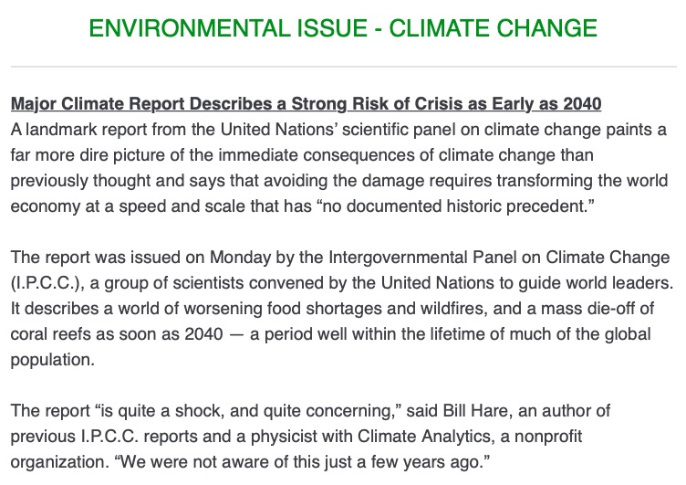

Sample item without partition label:

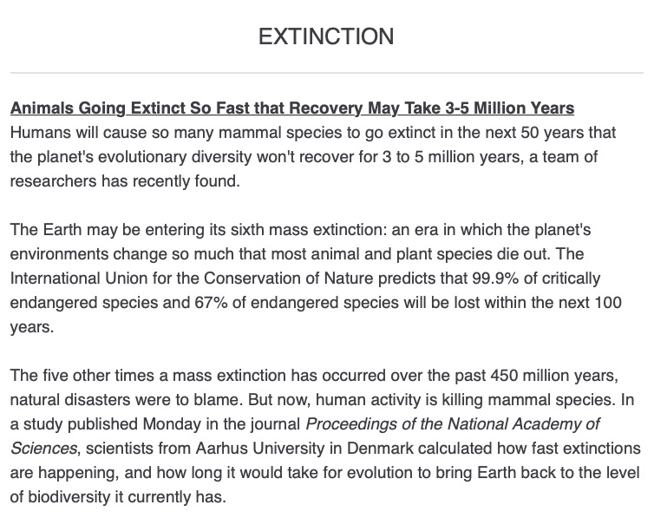

Humanitarian Issues
Famine
Yemen In 'Clear And Present Danger' Of Massive Famine After Years Of Violence
The United Nations' humanitarian chief warned a month ago that war-torn Yemen was on the brink of a "massive loss of life" — a famine-fueled catastrophe that may spell the complete collapse of an already failing country.
Since then, he says the dire situation has only gotten worse. "The toll is unbearably high," Mark Lowcock, humanitarian chief of the United Nations, told the U.N. Security Council on Tuesday. "The immune systems of millions of people on survival support for years on end are now are literally collapsing, making them — especially children and the elderly — more likely to succumb to malnutrition, cholera and other diseases."
Several years of violent conflict created these food shortages, which have rendered a large portion of the population reliant on external aid for survival. The scale of violence threatens to overwhelm relief efforts, leaving some of the most vulnerable people without food.
Lowcock directed his urgent pleas to "all stakeholders to do everything possible to avert catastrophe." That includes not only an end to the violence, but also increased funding for humanitarian efforts and better protection of the food supply. A failure to follow those steps, Lowcock said, would be "the death knell for countless innocent civilians, most of them women and children."
"There is now a clear and present danger of an imminent and great big famine engulfing Yemen," he added, "much bigger than anything any professional in this field has seen during their working lives."

Opioid Crisis
Opioid crisis straining foster system as kids pried from homes
Across the U.S., soaring use of opioids has forced tens of thousands of children from their homes, creating a generation of kids abandoned by addicted parents, orphaned because of fatal overdoses or torn from fractured families by authorities fearful of leaving them in drug-addled chaos.
"This isn't a trickle. This isn't a wave. It's a tsunami," Judge Marilyn Moores said of a child welfare system grappling with an unprecedented crush of parental drug cases. From her first full year on the bench in 2006 through last year, the number of filings for children in need of services more than tripled in Marion County, driven largely by cases involving opioids.
Foster care agencies are receiving 30 to 40 percent more referrals than they had been accustomed to, creating a "crisis state," as one agency's president puts it. Foster parent training sessions, once held monthly, are now weekly; advertising to attract new families has been ramped up.
Behind each of those cases is a child subjected to the realities of life amid addiction — of barren fridges, unwelcome visitors and parents who couldn't be roused awake. The crisis is so severe — with a 32 percent spike in drug-related cases from 2012 to 2016 — it reversed a trend that had the foster care system shrinking in size over the preceding decade.
There is no simple assessment of the impact of all of this on kids. At one extreme, there are infants born healthy who wind up in safe and loving foster homes until their birth parents get clean. At the other are children whose parents' addictions have led to their own, who find themselves hopping from foster family to foster family, living in a group home or a strange town.

Family Separation
Trump administration weighs new family-separation effort at border
The White House is actively considering plans that could again separate parents and children at the U.S.-Mexico border, hoping to reverse soaring numbers of families attempting to cross illegally into the United States, according to several administration officials with direct knowledge of the effort.
One option under consideration is for the government to detain asylum-seeking families together for up to 20 days, then give parents a choice — stay in family detention with their child for months or years as their immigration case proceeds, or allow children to be taken to a government shelter so other relatives or guardians can seek custody.
That option — called “binary choice” — is one of several under consideration amid the president’s frustration over border security. Trump has been unable to fulfill key promises to build a border wall and end what he calls “catch and release,” a process that began under past administrations in which most detained families are quickly freed to await immigration hearings. The number of migrant family members arrested and charged with illegally crossing the border jumped 38 percent in August and is now at a record level, according to Department of Homeland Security (DHS) officials.
While some inside the White House and DHS are concerned about the “optics” and political blowback of renewed separations, White House adviser Stephen Miller and others are determined to act, according to officials briefed on the deliberations. There have been several high-level meetings in the White House in recent weeks about the issue. The “binary choice” option is seen as one that could be tried out fairly quickly.

Political Violence
Humanitarian Aid Has Become a Political Weapon
Food has become weaponized in Venezuela. So have syringes, antibiotics and other medical equipment.

In this impoverished country, millions go hungry every day and others are unable to get needed care because of severe shortages of medical supplies. In short, food and medicine have become invaluable commodities in the battle over Venezuela’s political soul.

Juan Guaidó, the U.S.-backed opposition leader who declared himself interim president of the country last month in an effort to oust embattled President Nicolás Maduro, tweeted recently that more than $100 million worth of aid had been collected for the country. But only a sliver — 85,000 rations — has been delivered to ailing Venezuelans, while millions in aid sits just across the border in Colombia. On Thursday, billionaire Richard Branson, founder of the Virgin Group, announced he had organized a concert in Cucuta, Colombia — just over the border from Venezuela — to urge delivery of the aid.

Venezuela has been left deeply impoverished by decades of policies that led to crippling corruption and mismanagement, first under leftist firebrand Hugo Chávez, who died in 2013, and more recently under his successor, Maduro. In recent years, hyperinflation made basic goods unaffordable, causing an economic crisis that has prompted millions of Venezuelans to flee. Many of those who stayed behind are unable to afford essential food and medicine.

In Venezuela and elsewhere, times of political crisis and conflict often make food and medicine an easy target.

“Those in power are controlling who will eat and how often they will eat,” said Shannon Scribner, associate director of humanitarian programs and policy at Oxfam America.

Prison Conditions (Excluded from Experiment 2, no corresponding university-approved charity)

Jail without heat reflects wider neglect in federal prisons
The sound of inmates banging on the windows of their freezing cells to protest the lack of heat, captured by reporters in America’s biggest media market, helped draw national attention to conditions at a federal jail in Brooklyn.

But defense lawyers, prisoner advocates and union officials say the crisis should serve as a warning that shoddy maintenance and substandard conditions plague not just the Brooklyn Metropolitan Detention Center, but many of the 122 lockups across the country run by the Federal Bureau of Prisons.

“This is chronic,” said Eric Young, president of the American Federation of Government Employees' Council of Prison Locals, which represents federal prison workers. "Many of those facilities are in disrepair. This requires a great deal of attention and often goes neglected.”

At the high-rise Houston Federal Detention Center, for example, malfunctioning elevators bring operations in the seven-story building to a halt at least once a month and force staff to put inmates on lockdown, said Reynaldo Osorio, a correctional counselor and president of the local union chapter.
Balky air conditioning systems often leave the jail hot and humid during the summer, he said.

Betsy Ginsberg, director of the Civil Rights Clinic at Cardozo Law School, said that the federal prison system is often held up as "a shining example" of modern corrections — "but it's not."

She said the most troubling part of the Brooklyn situation was the "lack of attention and lack of humanity" that allowed the problems to go on for several days. She said that was a symptom of a historic lack of public scrutiny.

"That's worse than neglect," Ginsberg said. "It's not just not paying attention. They chose not to take the appropriate steps."

Environmental Issues

Climate Change
Major Climate Report Describes a Strong Risk of Crisis as Early as 2040
A landmark report from the United Nations’ scientific panel on climate change paints a far more dire picture of the immediate consequences of climate change than previously thought and says that avoiding the damage requires transforming the world economy at a speed and scale that has “no documented historic precedent.”
The report was issued on Monday by the Intergovernmental Panel on Climate Change (I.P.C.C.), a group of scientists convened by the United Nations to guide world leaders. It describes a world of worsening food shortages and wildfires, and a mass die-off of coral reefs as soon as 2040 — a period well within the lifetime of much of the global population.
The report “is quite a shock, and quite concerning,” said Bill Hare, an author of previous I.P.C.C. reports and a physicist with Climate Analytics, a nonprofit organization. “We were not aware of this just a few years ago.”
The authors found that if greenhouse gas emissions continue at the current rate, the atmosphere will warm up by as much as 2.7 degrees Fahrenheit (1.5 degrees Celsius) above preindustrial levels by 2040, inundating coastlines and intensifying droughts and poverty. Previous work had focused on estimating the damage if average temperatures were to rise by a larger number, 3.6 degrees Fahrenheit (2 degrees Celsius), because that was the threshold scientists previously considered for the most severe effects of climate change.
Avoiding the most serious damage requires transforming the world economy within just a few years, said the authors, who estimate that the damage would cost trillions of dollars. But while they conclude that it is technically possible to achieve the rapid changes required to avoid 2.7 degrees of warming, they concede that it may be politically unlikely.

Extinction
Animals Going Extinct So Fast that Recovery May Take 3-5 Million Years
Humans will cause so many mammal species to go extinct in the next 50 years that the planet's evolutionary diversity won't recover for 3 to 5 million years, a team of researchers has recently found.
The Earth may be entering its sixth mass extinction: an era in which the planet's environments change so much that most animal and plant species die out. The International Union for the Conservation of Nature predicts that 99.9% of critically endangered species and 67% of endangered species will be lost within the next 100 years.
The five other times a mass extinction has occurred over the past 450 million years, natural disasters were to blame. But now, human activity is killing mammal species. In a study published Monday in the journal Proceedings of the National Academy of Sciences, scientists from Aarhus University in Denmark calculated how fast extinctions are happening, and how long it would take for evolution to bring Earth back to the level of biodiversity it currently has.
"We now live in a world that is becoming increasingly impoverished of large wild mammalian species," said Jens-Christian Svenning, an Aarhus University professor who researches megafauna. "The few remaining giants, such as rhinos and elephants, are in danger of being wiped out very rapidly."
The scientists concluded that in a best-case scenario, nature will need 3-5 million years to get back to the level of biodiversity we have on Earth today. Returning to the state Earth's animal kingdom was in before modern humans evolved would take 5-7 million years.

Deforestation
Scientists say halting deforestation 'just as urgent' as reducing emissions
The role of forests in combating climate change risks being overlooked by the world’s governments, according to a group of scientists that has warned halting deforestation is “just as urgent” as eliminating the use of fossil fuels.
Trees and other vegetation currently absorb around a quarter of the CO2 humans are adding to the atmosphere, softening the potential impact of climate change.
While the world won’t lose all of its trees, large tracts of tropical forests, which hold a vast amount of carbon, are still being lost in the Amazon, central Africa and Indonesia. Warming temperatures are also fueling huge fires in forests in higher latitudes, as witnessed this summer when much of northern Sweden was aflame.
“The forest piece of the conversation is often lost and I don’t think the IPCC report will highlight it enough,” said Deborah Lawrence, a professor of environmental sciences at the University of Virginia and a signatory of the statement. “We almost take forests as a given but we lose forest every year, which means we are diminishing them as a carbon sink."
“Deforestation has been massively reduced in the Amazon, but that hasn’t happened elsewhere. As countries get more peaceful in Africa we could lose more tropical forests, which really worries me.”
“We will have a hotter, drier world without these forests,” Lawrence said. “There needs to be an international price on carbon to fund the protection of forests. And countries with tropical forests should maintain large chunks of forests to stabilize rainfall for agriculture and keep a predictable regional climate.”

Rising Sea Levels
Hole under glacier could trigger catastrophic rise in global sea levels
Scientists have discovered an enormous void under an Antarctic glacier, sparking concern that the ice sheet is melting faster than anyone had realized — and spotlighting the dire threat posed by rising seas to coastal cities around the world, including New York City and Miami.

The cavity under Thwaites Glacier in West Antarctica is about six miles long and 1,000 feet deep — representing the loss of 14 billion tons of ice.

It was discovered after an analysis of data collected by Italian and German satellites, as well as NASA’s Operation IceBridge, a program in which aircraft equipped with ice-penetrating radar fly over polar regions to study the terrain.

The discovery is described in a paper published Jan. 30 in the journal Science Advances. The researchers expected to see significant loss of ice, but the scale of the void came as a shock.

“The size of the cavity is surprising, and as it melts, it’s causing the glacier to retreat,” said Pietro Milillo, a radar scientist at NASA’s Jet Propulsion Laboratory in Pasadena, California, and the paper’s lead author. He said the ice shelf encompassing the Florida-sized glacier is retreating at a rate in excess of 650 feet per year, and that most of the melting that led to the void occurred during the past three years.

If the loss of ice becomes so severe that the glacier collapses — something computer models predict could happen in 50 to 100 years — sea levels would rise by two feet. That’s enough to inundate coastal cities across the globe.

“It’s completely plausible,” Scambos said, adding that "Thwaites has a really perfect storm going for it” — a reference to the fact that parts of the glacier lie below sea level and are thus especially vulnerable to melting by seawater.

Wildfires (Excluded from Experiment 2, no corresponding university-approved charity)
Wildfires in California pose crisis for human health and air quality, experts say
The peril that California’s new era of catastrophic wildfires poses to people and the air we breathe is so great it amounts to a public health crisis, defying even the federal index long used to measure air pollution, leading scientists and regulators said in Santa Rosa.

Officials once thought the North Bay wildfires of 2017, which took 40 lives and leveled nearly 6,200 homes, were “an anomaly,” Jack Broadbent, head of the Bay Area Air Quality Management District, said. Broadbent included the comment in his opening remarks at the two-day conference that focused on fire-related health and air quality impacts.

“Now we understand ... this is the new normal,” he said, repeating the phrase former Gov. Jerry Brown used last August, months before the Camp fire in Butte County set a new benchmark for the state, becoming the worst inferno on record.

Altogether in the past two years, California wildfires have killed 146 people, destroyed nearly 24,000 homes and scorched more than 3 million acres, according to Cal Fire, the state firefighting agency.

The disasters fueled by a warming planet have confronted health researchers and environmental regulators with a new set of challenges. They include how to measure air quality that has been so poor at times during recent fire seasons that pollution levels were off the chart of the federal government’s longstanding index.

The index is an average of long-term pollution measurements that can mask one-hour spikes of much fouler air. John Balmes, a professor at UC Berkeley’s School of Public Health, said the index is “not designed for wildfire smoke.”

Smoke from the deadly Camp fire last November impacted 8 million people in 20 counties, Broadbent said.

Wildfire smoke is a formidable health threat that Balmes said is “pretty much like cigarette smoke, minus the nicotine.

- Self-report measures

All measures administered on 0 (not at all) to 100 (extremely) scale.

Distressed: After reading about these issues, how distressed do you feel overall? That is, how much anxiety, sorrow, or pain are you experiencing after reading about these issues?

Compassion: After reading about these issues, how much compassion do you feel for those affected? That is, how much sympathetic concern do you feel for the suffering and misfortune of those affected?

Efficacious: After reading about these issues, how efficacious do you feel about them? That is, how confident are you in your ability to help address these issues?

Important: After reading about these issues, how important do you think they are?

Motivated: After reading about these issues, how motivated are you to help those affected?

- Pairwise comparisons: Experiments 1a, 1b, 2 and 3

Experiment 1a
Hypothetical donations

labeled,multiple - unlabeled,multiple
t(1096.09) = 1.81, p = .27, 95% CI [-1.21, 7.01]

labeled,multiple - labeled,single
t(1097.80) = 5.45, p < .001, 95% CI [4.59, 12.81]

labeled,multiple - unlabeled,single
t(1095.98) = 5.06, p < .001, 95% CI [3.98, 12.21]

unlabeled,multiple - labeled,single
t(1096.15) = 3.62, p = .002, 95% CI [1.68, 9.92]

unlabeled,multiple - unlabeled,single
t(1084.45) = 3.23, p = .007, 95% CI [1.06, 9.34]

labeled,single - unlabeled,single
t(1092.56) = -.37, p = .98, 95% CI [-4.74, 3.53]

Experiment 1b
Hypothetical donations

labeled,multiple - unlabeled,multiple
t(1098.13) = .89, p = .81, 95% CI [-2.71, 5.58]

labeled,multiple - labeled,single
t(1097.46) = 2.33, p = .093, 95% CI [-.40, 7.87]

labeled,multiple - unlabeled,single
t(1095.63) = 3.58, p = .002, 95% CI [1.63, 9.92]

unlabeled,multiple - labeled,single
t(1099.48) = 1.42, p = .48, 95% CI [-1.86, 6.46]

unlabeled,multiple - unlabeled,single
t(1099.34) = 2.68, p = .038, 95% CI [.17, 8.51]

labeled,single - unlabeled,single
t(1094.92) = 1.26, p = .59, 95% CI [-2.11, 6.19]

Experiment 2
Actual donations

labeled,multiple - unlabeled,multiple
t(1099.09) = .40, p = .98, 95% CI [-3.78, 5.18]

labeled,multiple - labeled,single
t(1100.76) = 2.74, p = .032, 95% CI [.29, 9.31]

labeled,multiple - unlabeled,single
t(1100.78) = 2.29, p = .10, 95% CI [-.49, 8.47]

unlabeled,multiple - labeled,single
t(1097.55) = 2.34, p = .091, 95% CI [-.42, 8.62]

unlabeled,multiple - unlabeled,single
t(1100.75) = 1.89, p = .23, 95% CI [-1.19, 7.77]

labeled,single - unlabeled,single
t(1100.62) = -.46, p = .97, 95% CI [-5.30, 3.68]

Experiment 3
Hypothetical donations

multiple,keepFirst - single,keepFirst
t(1084.99) = 2.99, p = .015, 95% CI [.68, 9.08]

multiple,keepFirst - multiple,keepLast
t(1083.97) = -2.19, p = .13, 95% CI [-7.74, .62]

multiple,keepFirst - single,keepLast
t(1082.15) = 1.32, p = .55, 95% CI [-2.04, 6.33]

single,keepFirst - multiple,keepLast
t(1085.61) = -5.18, p < .001, 95% CI [-12.63, -4.25]

single,keepFirst - single,keepLast
t(1083.33) = -1.68, p = .33, 95% CI [-6.92, 1.45]

multiple,keepLast - single,keepLast
t(1085.00) = 3.51, p = .003, 95% CI [1.52, 9.89]

- Supplemental figures
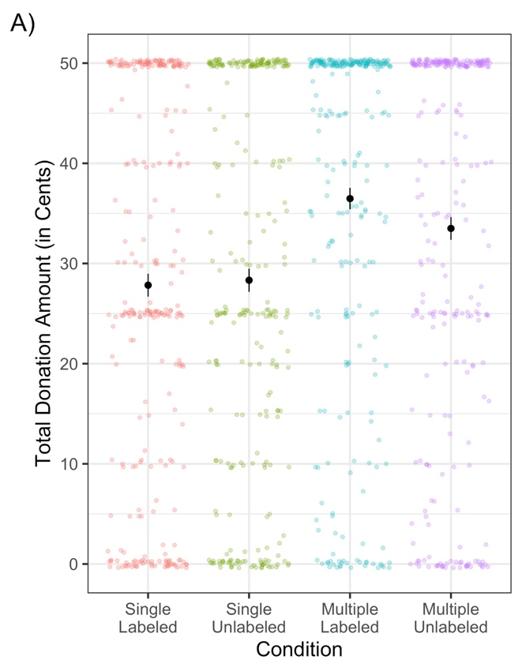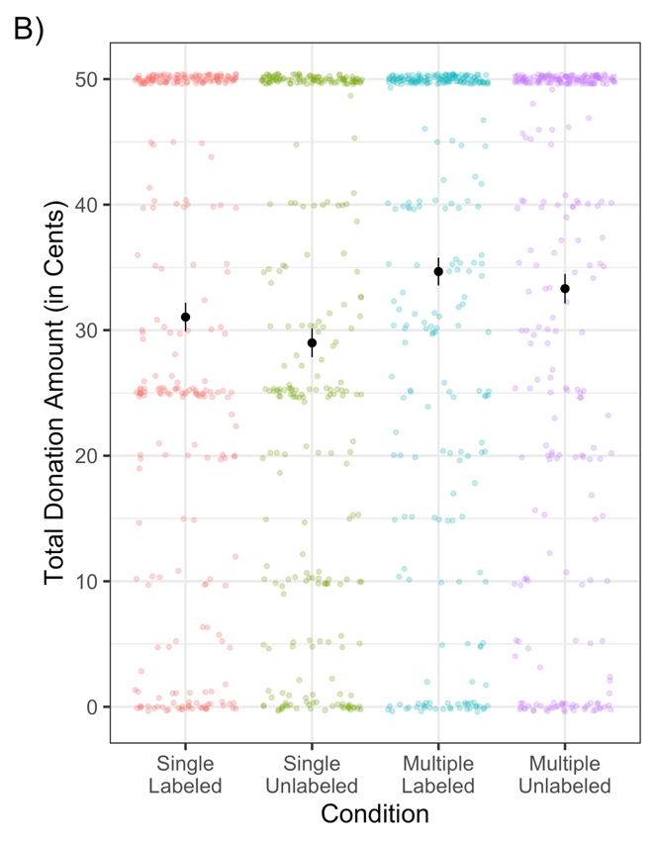
Figure S1. Total amount of money participants would donate by condition in (A) Experiment 1a and (B) Experiment 1b. Condition is displayed on the x-axis, donations in cents is displayed on the y axis. Error bars reflect +/- 1 standard error.

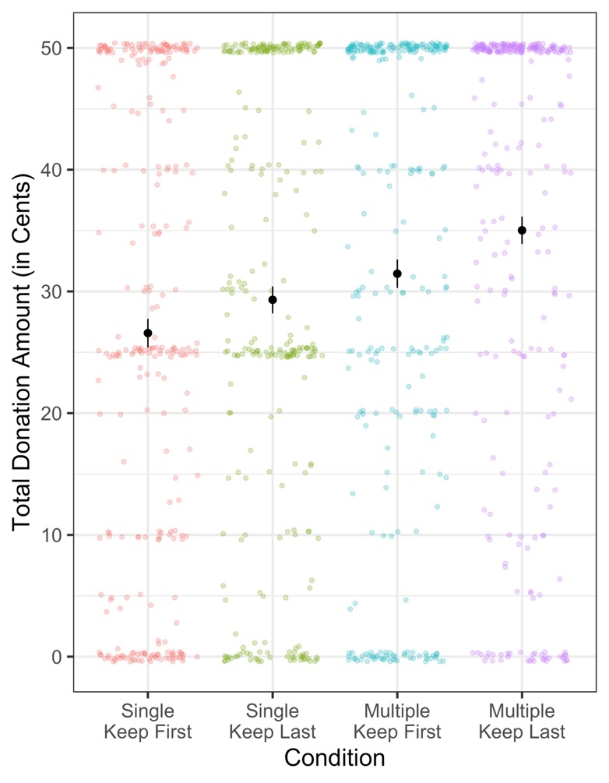
Figure S2. Total amount of money participants would donate by condition in Experiment 3. Condition is displayed on the x-axis, donations in cents is displayed on the y axis. Error bars reflect +/- 1 standard error.

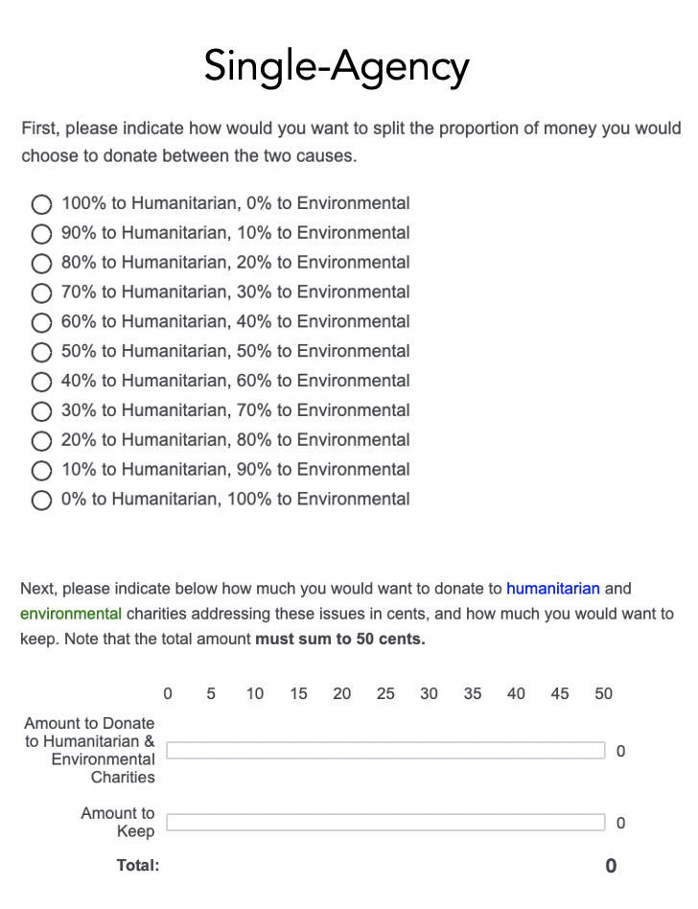
Figure S3. Single-Agency request page from Experiment 4. As in previous experiments, participants always had to indicate how much they wanted to keep to ensure self-interest was equally salient across all conditions.

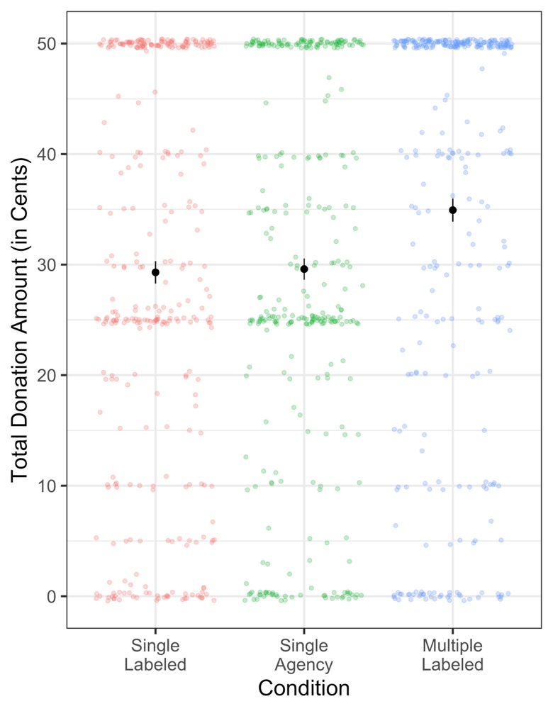
Figure S4. Total amount of money participants would donate by condition in Experiment 4. Condition is displayed on the x-axis, donations in cents is displayed on the y axis. Error bars reflect +/- 1 standard error.

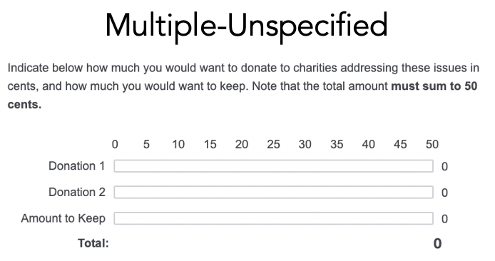
Figure S5. Multiple-Unspecified request page from Experiment 5. As in previous experiments, participants always had to indicate how much they wanted to keep to ensure self-interest was equally salient across all conditions.

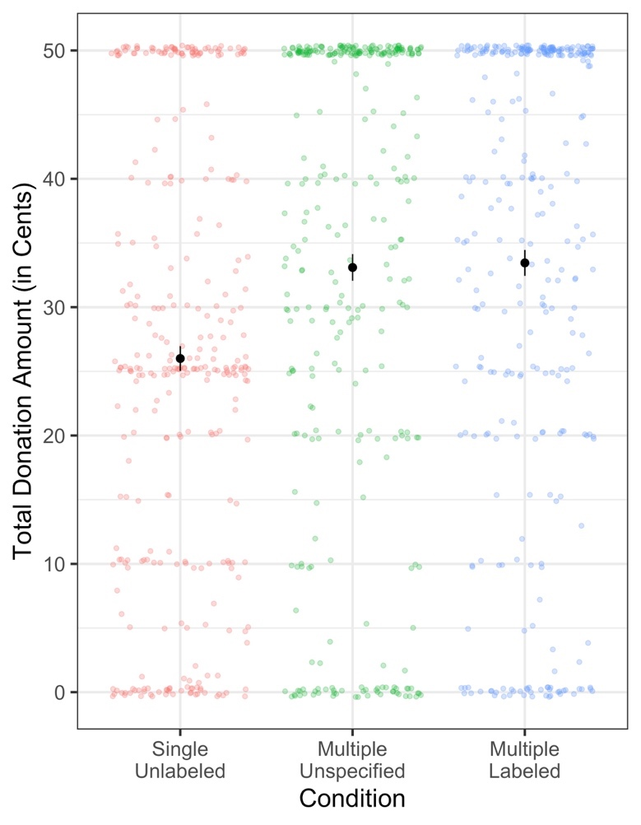
Figure S6. Total amount of money participants would donate by condition in Experiment 5. Condition is displayed on the x-axis, donations in cents is displayed on the y axis. Error bars reflect +/- 1 standard error.

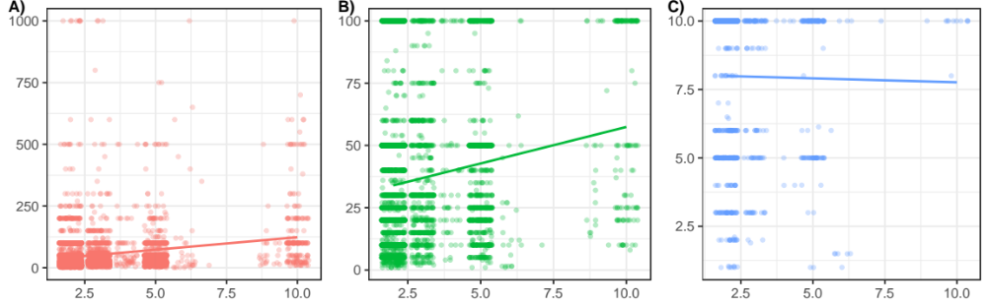Figure S7. Relationship between the number of entities on donation form (shown on the x axis) and donation amount (shown on Y axis, in dollars), for (A) all multiple bid donations; (B) multiple bid donations $100 and under, and (C) multiple bid donations $10 and under.

- Regression tables

 | Total Donation Amount
Predictors | Estimates | CI | p
Intercept | 28.14 | 26.11 – 30.16 | <0.001
Multiple | 6.46 | 4.48 – 8.44 | <0.001
Labeled | 0.33 | -1.66 – 2.31 | 0.748
Motivation | 0.15 | 0.09 – 0.20 | <0.001
Importance | 0.07 | 0.00 – 0.13 | 0.037
Distress | 0.04 | -0.01 – 0.09 | 0.098
Efficacy | -0.02 | -0.06 – 0.03 | 0.437
Compassion | 0.17 | 0.11 – 0.23 | <0.001
Random Effects
σ² | 280.34
τ₀₀ _{humIssue} | 0.00
τ₀₀ _{envIssue} | 1.49
N _{humIssue} | 5
N _{envIssue} | 5
Observations | 1103
Marginal R² / Conditional R² | 0.232 / NA

Table S1A. Experiment 1a: Coefficients from linear mixed effects model including dummy coded donation manipulations, self-reported affect variables, with random effects for each issue category. Regression tables were created using the sjPlot package for R (Lüdecke, 2019).

 | Total Donation Amount
Predictors | Estimates | CI | p
Intercept | 28.87 | 26.43 – 31.32 | <0.001
Multiple | 4.63 | 2.64 – 6.61 | <0.001
Labeled | 1.64 | -0.34 – 3.61 | 0.105
Motivation | 0.12 | 0.06 – 0.17 | <0.001
Importance | 0.14 | 0.08 – 0.21 | <0.001
Distress | 0.02 | -0.02 – 0.07 | 0.341
Efficacy | -0.02 | -0.07 – 0.02 | 0.331
Compassion | 0.17 | 0.10 – 0.23 | <0.001
Random Effects
σ² | 280.79
τ₀₀ _{humIssue} | 0.00
τ₀₀ _{envIssue} | 3.94
N _{humIssue} | 5
N _{envIssue} | 5
Observations | 1106
Marginal R² / Conditional R² | 0.229 / NA

Table S1B. Experiment 1b: Coefficients from linear mixed effects model including dummy coded donation manipulations, self-reported affect variables, with random effects for each issue category.

 | Total Donation Amount
Predictors | Estimates | CI | p
Intercept | 25.44 | 23.12 – 27.75 | <0.001
Multiple | 4.38 | 2.13 – 6.63 | <0.001
Labeled | 0.27 | -1.98 – 2.52 | 0.813
Motivation | 0.06 | -0.01 – 0.13 | 0.072
Importance | 0.12 | 0.05 – 0.20 | 0.001
Distress | 0.09 | 0.04 – 0.15 | 0.001
Efficacy | -0.01 | -0.06 – 0.04 | 0.622
Compassion | 0.11 | 0.03 – 0.18 | 0.005
Random Effects
σ² | 361.69
τ₀₀ _{humIssue} | 1.65
τ₀₀ _{envIssue} | 0.00
N _{humIssue} | 4
N _{envIssue} | 4
Observations | 1106
Marginal R² / Conditional R² | 0.148 / NA

Table S2. Experiment 2: Coefficients from linear mixed effects model including dummy coded donation manipulations, self-reported affect variables, with random effects for each issue category.

 | Total Donation Amount
Predictors | Estimates | CI | p
Intercept | 26.61 | 24.86 – 28.37 | <0.001
Multiple | 5.25 | 3.23 – 7.27 | <0.001
Keep Last | 2.71 | 0.69 – 4.73 | 0.008
Motivation | 0.13 | 0.08 – 0.19 | <0.001
Importance | 0.13 | 0.06 – 0.19 | <0.001
Distress | 0.07 | 0.03 – 0.12 | 0.002
Efficacy | -0.00 | -0.05 – 0.04 | 0.910
Compassion | 0.09 | 0.03 – 0.16 | 0.006
Random Effects
σ² | 288.74
τ₀₀ _{humIssue} | 0.00
τ₀₀ _{envIssue} | 0.00
N _{humIssue} | 5
N _{envIssue} | 5
Observations | 1090
Marginal R² / Conditional R² | 0.216 / NA

Table S3. Experiment 3: Coefficients from linear mixed effects model including dummy coded donation manipulations, self-reported affect variables, with random effects for each issue category.

- Supplemental experiment: Experiment 1b

Experiment 1a demonstrated that donations were significantly higher for multiple than single bid donation requests. There was an additional descriptive advantage of simultaneously invoking partition dependence, but this difference did not reach statistical significance in Experiment 1a. One possible explanation for this null finding is that category information was not salient enough at the time of donation. In Experiment 1b, we therefore examined whether partitioning would render a significant effect on donation if labels were provided after reading the article segments instead of before and during.
Method
Participants. The final sample consisted of 1106 participants (55.2% female; age: M = 36.70, SD = 12.03) who were recruited through Amazon Mechanical Turk. All responses were included in analysis.
Procedure. As in Experiment 1a, we told participants that they would read two article segments describing current issues, make ratings about their feelings, and indicate how much money they would want to donate to charities addressing the issues described in the articles. Participants completed the same article pledge described in Experiment 1a and read two article segments each describing an issue (one humanitarian and one environmental issue). Article segments were randomly selected from the same set used in Experiment 1a, such that each participant saw one humanitarian and one environmental article segment presented in random order. After reading the two articles, participants were shown a screen summarizing the articles they had read. For approximately half of the participants, the summaries were partitioned into two categories (e.g., “You just read about two different issues, one humanitarian issue and one environmental issue:”). Then the one-word descriptions of the issues were displayed in a 2 x 2 table under the corresponding category label. The other participants saw summary screens that did not include category labels (e.g., “You just read about two different issues:”). The one-word issue description of the two articles were presented in a 1 x 2 table without category labels. After reading the two article segments, participants were asked to make ratings on the same dimensions described in Experiment 1a, all on a scale from 0 (not at all) to 100 (extremely), all presented in a random order.
Donation request. As in Experiment 1a, participants were randomly assigned to one of four donation conditions: a Single-Labeled condition (n = 278), a Multiple-Labeled condition (n = 279), a Single-Unlabeled condition (n = 274), and a Multiple-Unlabeled condition (n = 275). Donation questions for these four conditions were the same as those described in Experiment 1a.
Results
We analyzed the data in exactly the same way was Experiment 1a. Replicating Experiment 1a, we observed a statistically significant main effect for multiple bid donation question structure, F(1, 1099.72) = 12.56, p < .001, see Figure S1B, but not for partition category labels, F(1, 1096.92) = 2.32, p = .13. The interaction of these effects was not significant either, F(1, 1096.05) = 0.07, p = .79. On average, participants in the multiple bid conditions (M = 33.99 ¢, SD = 18.99 ¢) gave nearly $0.04 more than participants in the single bid conditions (M = 30.03 ¢, SD = 19.03 ¢), t(1104.00) = 3.47, p < .001, 95% CI [1.73, 6.21], d = .21. Also consistent with our hypotheses, we did not observe a significant difference in the proportion of participants who donated in the multiple bid condition (86%) versus the single bid condition (87%), χ²(1, N = 1106) = .258, p = 0.61.

As in Experiment 1a, we also tested whether the effect of multiple bids remained after accounting for participants’ self-reported affect. Replicating Experiment 1a, motivation, issue importance, and compassion were statistically significant predictors of the amount of money participants would be willing to donate, but the multiple bid manipulation remained significant (see Table S1B).
We next examined whether these effects could be accounted for by a 1/n heuristic account by examining the proportion of participants who split donations evenly among the number of boxes on the page (25¢ per box in the single bid condition, 16-17¢ per box in the multiple bid condition). Of participants in the single bid condition, only 13.9% allocated 25¢ per box. Only four participants in the multiple bid condition (0.72%) gave any configuration of 16¢, 17¢ and 17¢, as would have been predicted by a 1/n heuristic account.
We also examined whether donations in the multiple bid conditions were driven by concerns about fairness, or equal distribution across the two issues. Only 24.5% of participants donated the same amount to each issue. On average people gave 17.55 (SD = 14.41) cents to humanitarian issues and 16.45 (SD = 13.76) cents to environmental issues, t(1106.00) = 1.30, p = .19, 95% CI [-.56, 2.76], d = .08.
As in Experiment 1a, presenting donation request as single bid or multiple bids significantly affected the amount of money participants indicated they would donate, even when controlling for variables related to affect. Partitioning still did not appear to affect hypothetical donation amount, even when labels were presented closer to the donation question.

- Allocation decisions in Single Agency condition in Experiment 4

Allocation Description | Percentage
0% to Humanitarian, 100% to Environmental | 7.86%
10% to Humanitarian, 90% to Environmental | 2.50%
20% to Humanitarian, 80% to Environmental | 4.64%
30% to Humanitarian, 70% to Environmental | 7.14%
40% to Humanitarian, 60% to Environmental | 4.29%
50% to Humanitarian, 50% to Environmental | 45.36%
60% to Humanitarian, 40% to Environmental | 3.21%
70% to Humanitarian, 30% to Environmental | 8.21%
80% to Humanitarian, 20% to Environmental | 7.14%
90% to Humanitarian, 10% to Environmental | 2.14%
100% to Humanitarian, 0% to Environmental | 7.50%
Sum | 100.00%

Table S4. Descriptions of allocation options in the Single-Agency condition in Experiment 4 (n = 280, excluding participants who would not donate anything), and percentage of participants who chose each option. As in previous experiments, participants always had to indicate how much they wanted to keep to ensure self-interest was equally salient across all conditions.

