Supplementary Materials:

Table S1. Summary of puma FIV_{pco} sequences used in this study, population level host genetic diversity estimates, and study area characteristics.

Population | # FIV_{pco} sequences | Males | Females | Dom. clade | Dom. clade: male | Dom clade: female | Host genetic diversity* | Geographic size of areas sampled (km²) | Hunting mortality+ | Other human mediated mortality+
Treatment | 27 | 14 | 13 | 15 | 9 | 6 | 1.93 | 11889
No hunting | 16 | 9 | 7 | 11 | 8 | 3 |  |  | 0 | 3
Hunting | 11 | 5 | 6 | 5 | 2 | 3 |  |  | 35 | 2
Stable | 24 | 8 | 16 | 17 | 6 | 10 | 1.89 | 11958 | 3 | 13
*: allelic richness from Trumbo et al. 2019. +: Mortality estimates of adult and sub-adult individuals (2, 3). Dom.clade. Sequences that grouped with the dominant clade in each region (see Fountain-Jones et al. 2021)

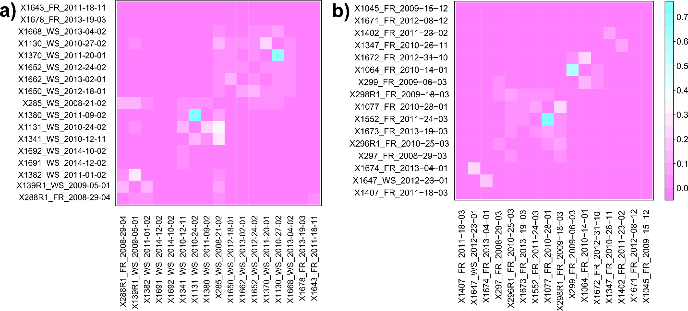
Figure S1. Probabilities of transmission between pairs of individuals in (a) the treatment region and (b) the stable region.

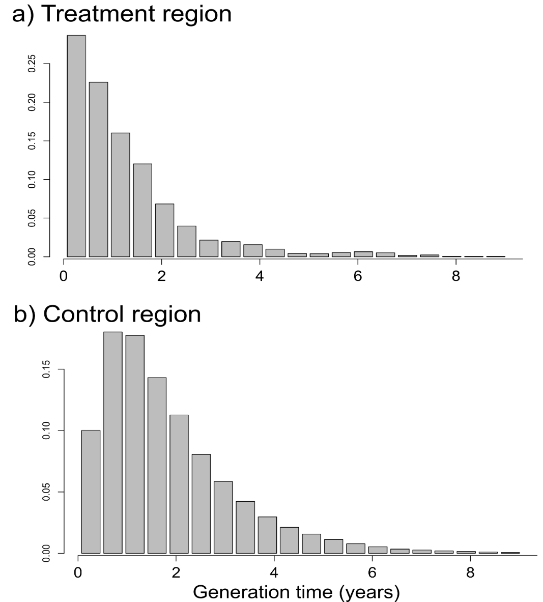

Figure S2. Realized generation time distributions (time from infection to onward transmission) from (a) the treatment and (b) stable regions. In both regions, onward transmission events for FIV_{pco} were most likely in the first two years after infection.
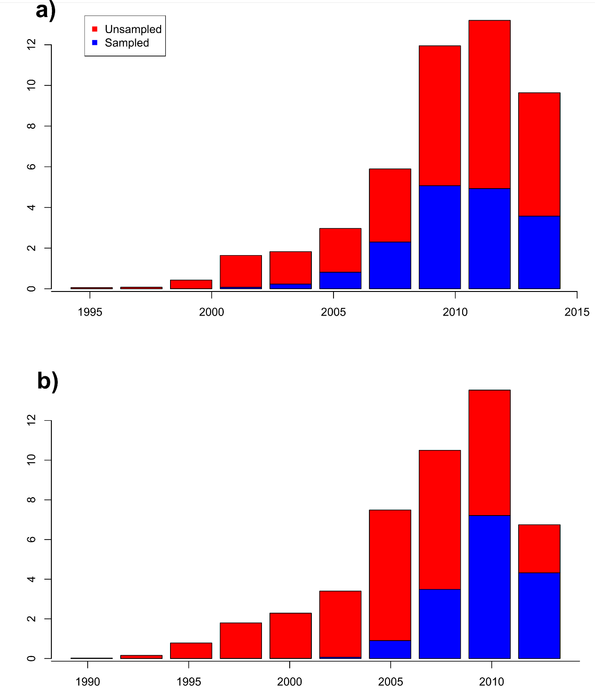
Figure S3. Estimated number of unsampled vs. sampled cases for (a) the treatment region and (b) the stable region.

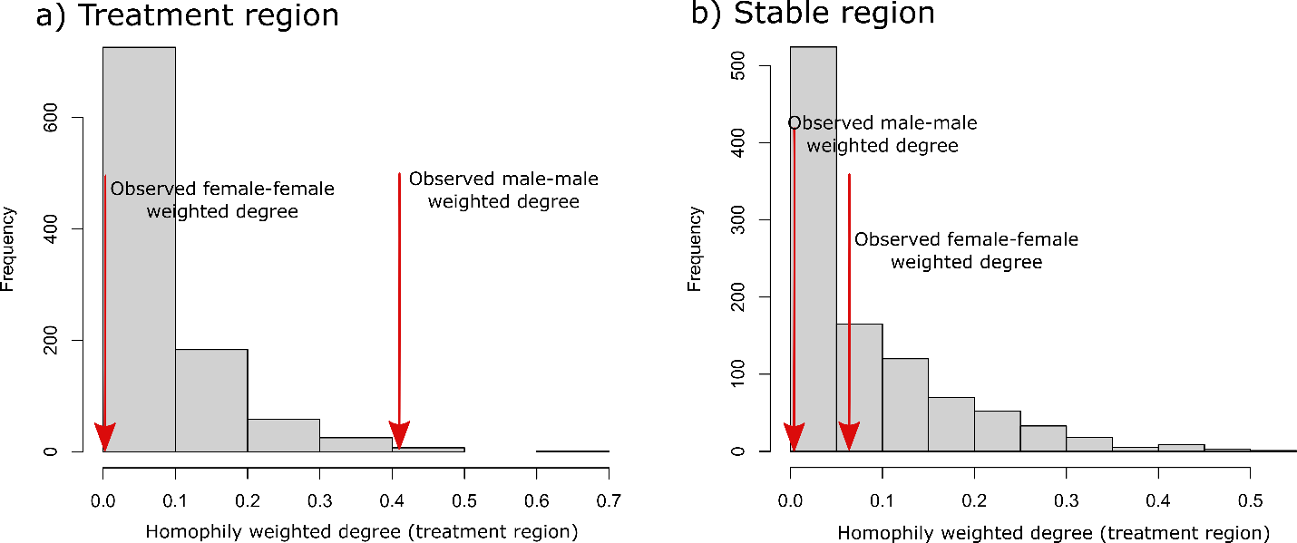 Figure S4. Histograms showing the expected homophily weighted degree distribution from our simulated networks by sex (i.e., just including edges from males-males) compared to observed values from (a) and (b) the stable region (see Methods -simulation modelling for details).

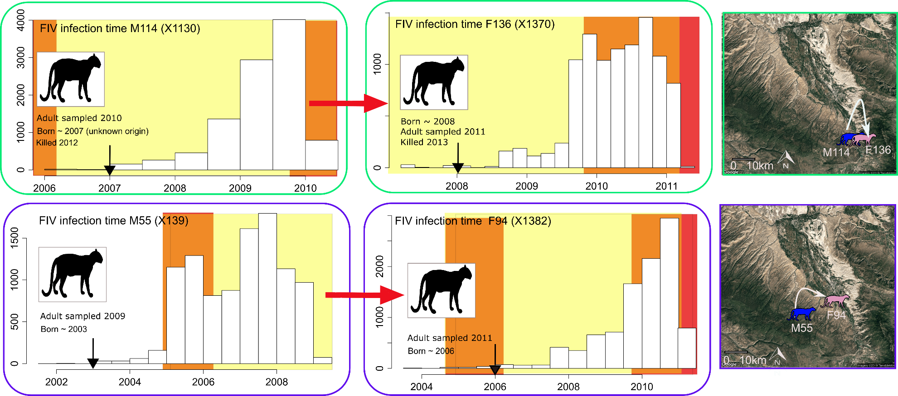
Figure S5. Time distributions for individuals involved in a putative transmission chain with the likely direction (red arrows) and the spatial context on each transmission event (See Fig. 2 for other putative transmission events in the treatment region). Red: Hunting period. Light yellow: hunting pressure relieved, orange: lag periods (see main text), red: hunting pressure resumed. White arrows in the maps indicate the likely transmission direction. Birth, death and sampling date is provided under each photo and estimated birth year is indicated by the black arrow. Color of the boxes reflects transmission chain identity. M114 and F136 were partners with overlapping home ranges that likely sired offspring. M55 and F94 also had overlapping home ranges, and M55 was likely the sire of F94’s kittens; the pair consorted on 15 April 2010 and kittens were born on 15 July 2010. In addition, M55 associated with this family when the kittens were nurslings (K. Logan observation).
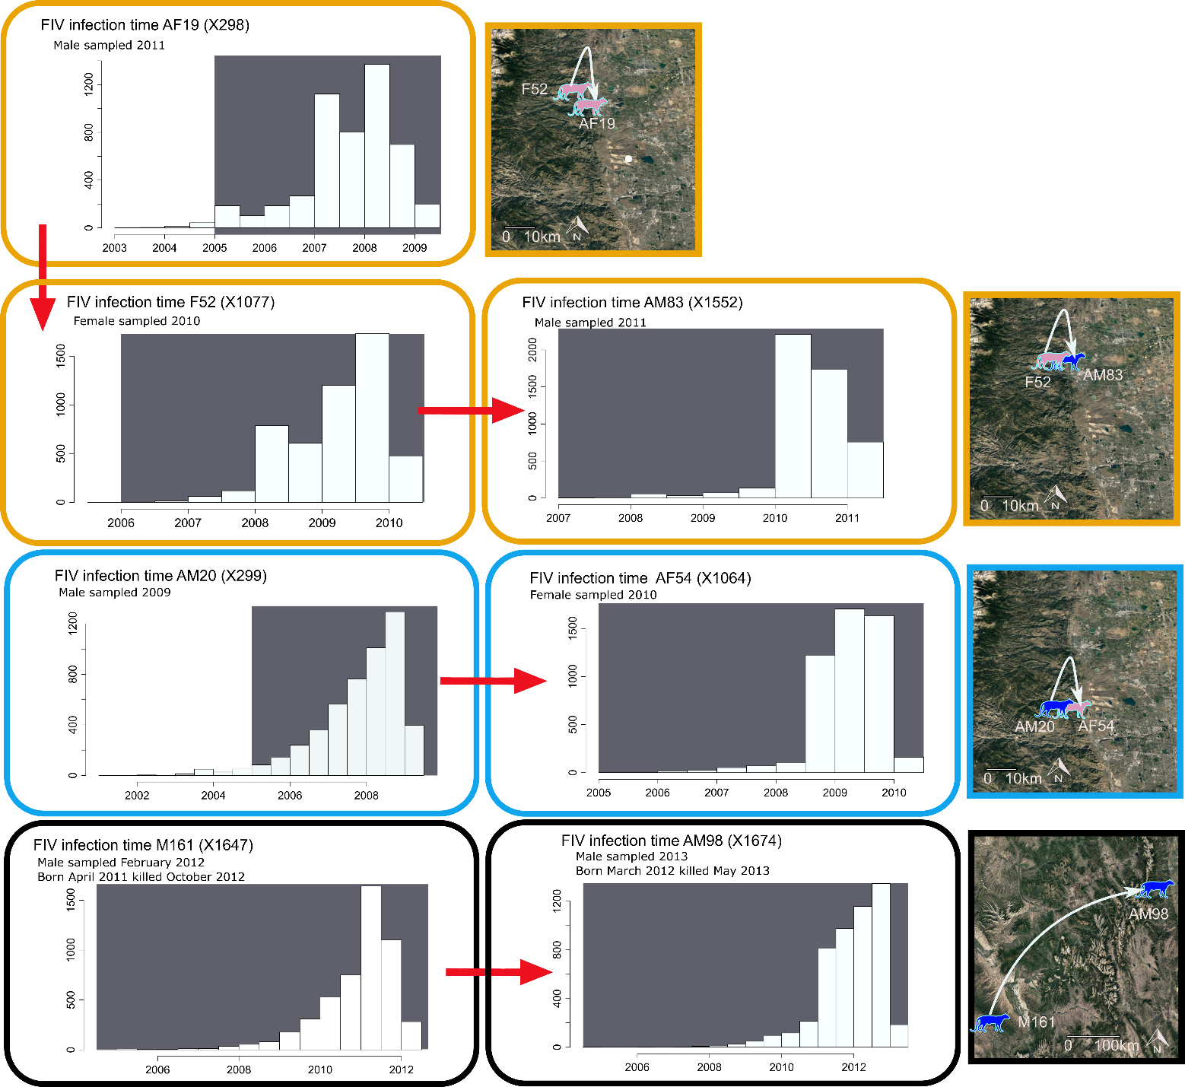
Figure S6. Infection time distributions in the stable region for individuals involved in a putative transmission chain with the likely direction (red arrows) and the spatial context on each transmission event. Color of the boxes reflects transmission chain identity and grey boxes indicates sampling period. Sex, sampling date, birth date and death date of each individual are provided in each box when known.

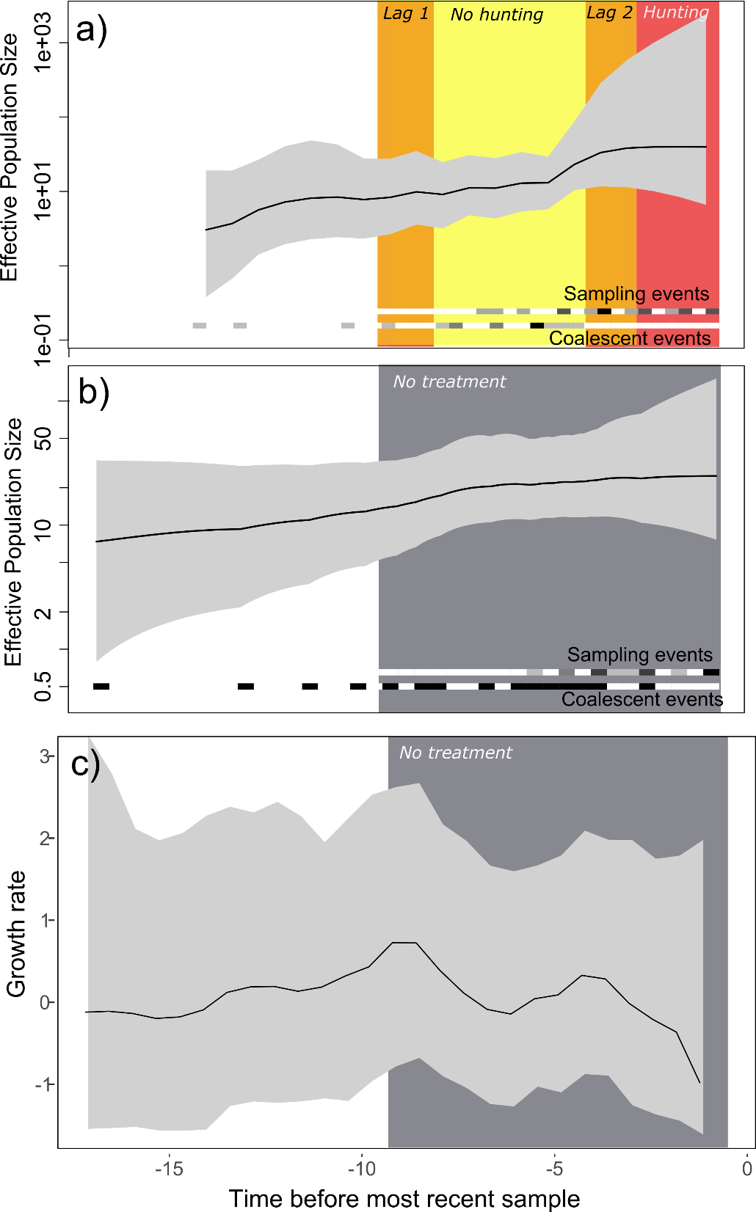
Figure S7. Skyline plots showing the effective population size through time of dominant FIV_{pco} lineages in the (a) treatment and (b) stable regions. a) Light yellow: hunting pressure relieved, orange: lag periods (see main text), red: hunting period. c) skygrowth plot from the management stable region showing FIV_{pco} growth rate through time (see Fig. 3b in the main text for the corresponding plot from the treatment region).

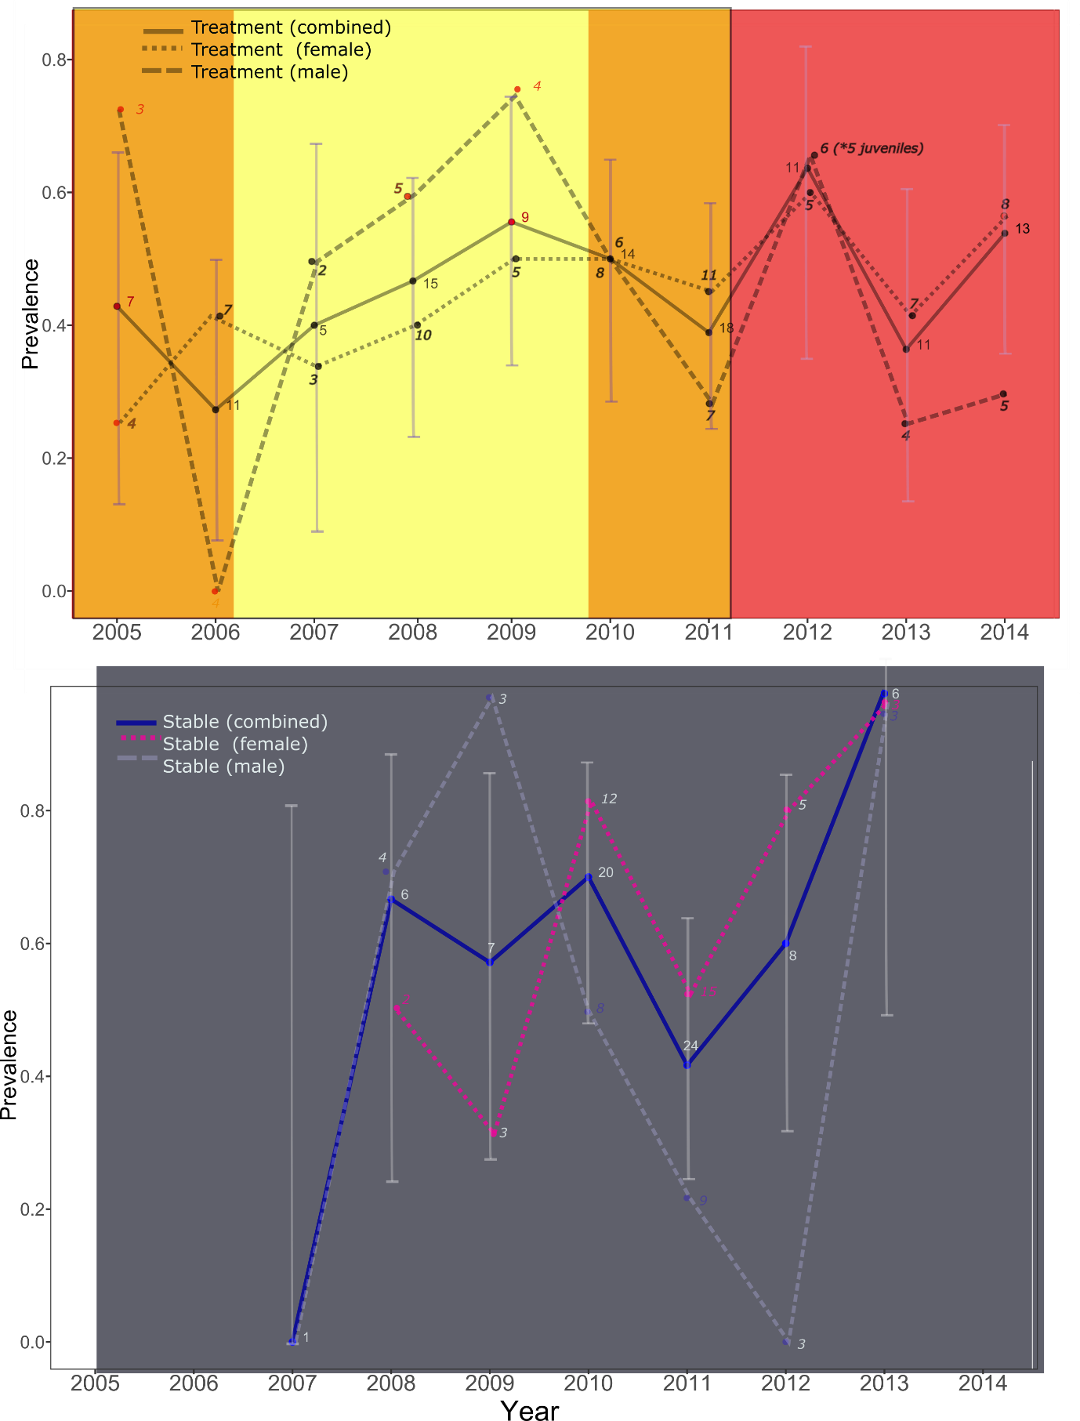
Figure S8. FIV_{pco} prevalence through time for the treatment (top panel) and stable (bottom panel) regions. Numbers next to the points indicate how many samples were screened using qPCR each year. Confidence intervals were calculated using a binomial distribution and are only shown for total population estimates rather than for each sex (to aid interpretation).
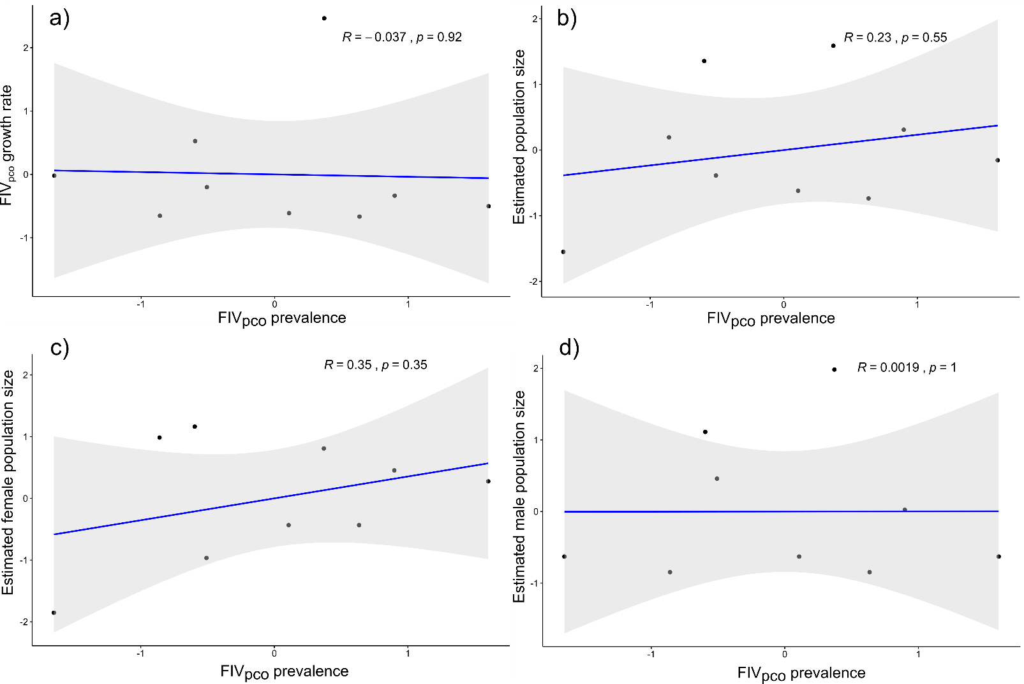
Fig. S9. There were only weak relationships between FIV_{pco} prevalence and (a) FIV growth rate, (b) estimated puma population size, (c) female and (d) male population sizes in the treatment region. All data are scaled. Similar data was not available for the stable region. R: R^{2.}.
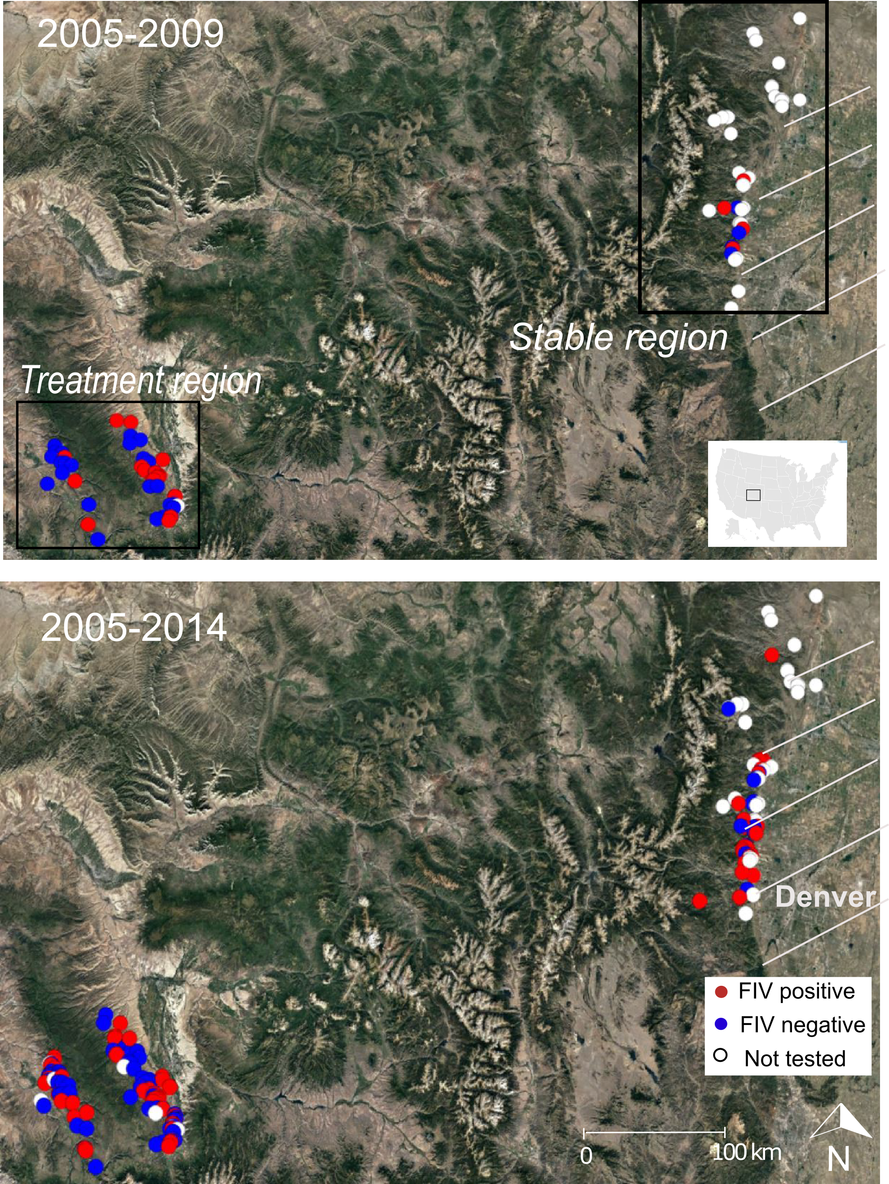
Figure S10. Map of our study regions showing the location of all individuals sampled in 2005-2009 (no hunting in the treatment region, top panel) and the complete sample set (2005-2014 including the years when hunting was resumed in the treatment region). White diagonal lines show the broad extent of the Denver metropolitan area. Maps courtesy of Google Earth.
References
1. Logan, K. & Runge, J. (in press) Effects of hunting on a puma population in Colorado. Wildlife Monographs.
2. Moss, W.E, Alldredge, M.W., Pauli, J.N (2016) Quantifying risk and resource use for a large carnivore in an expanding urban-wildland interface. Journal of Applied Ecology, 53, 371–378
3. Trumbo, T, Logan, K, Gagne, E., Kozakiewicz, C., Kraberger, S., Fountain-Jones, N.M., Craft, M., Carver, S., Ernest, H., Crooks, K., VandWoude, S., Funk, C.W. (2019) Urbanization impacts apex predator gene flow but not genetic diversity across an urban-rural divide. Molecular Ecology. 28, 4926–4940.

