Supplement to: Low-dose testosterone administration and estrogen synthase availability in the female brain

Spearman correlations | Post-treatment Thalamus BP_{ND} | Post-treatment Hypothalamus BP_{ND} | Post-treatment Amygdala BP_{ND}
Post-treatment T | ρ = 0.0, p = 1.0 | ρ = 0.2, p = 0.5 | ρ = -0.6, p = 0.1

Table S1. Association between the post-treatment peripheral testosterone levels and the post-treatment estrogen synthase availability. Spearman rho (ρ) and p values are presented, illustrating the relationship between the serum testosterone concentrations (T) and the [¹¹C]cetrozole binding (BP_{ND}) following one-week of transdermal testosterone treatment.

Spearman correlations | Change in Thalamus BP_{ND} | Change in Hypothalamus BP_{ND} | Change in Amygdala BP_{ND}
Change in T | ρ = -0.2, p = 0.6 | ρ = 0.6, p = 0.1 | ρ = -0.1, p = 0.7

Table S2. Association between the pre- to post-treatment change in peripheral testosterone levels and the change in estrogen synthase availability. Spearman rho (ρ) and p values are presented, illustrating the relationship between the change in serum testosterone concentrations (T) and the change in [¹¹C]cetrozole binding (BP_{ND}) from the pre-treatment to the post-treatment scanning session.

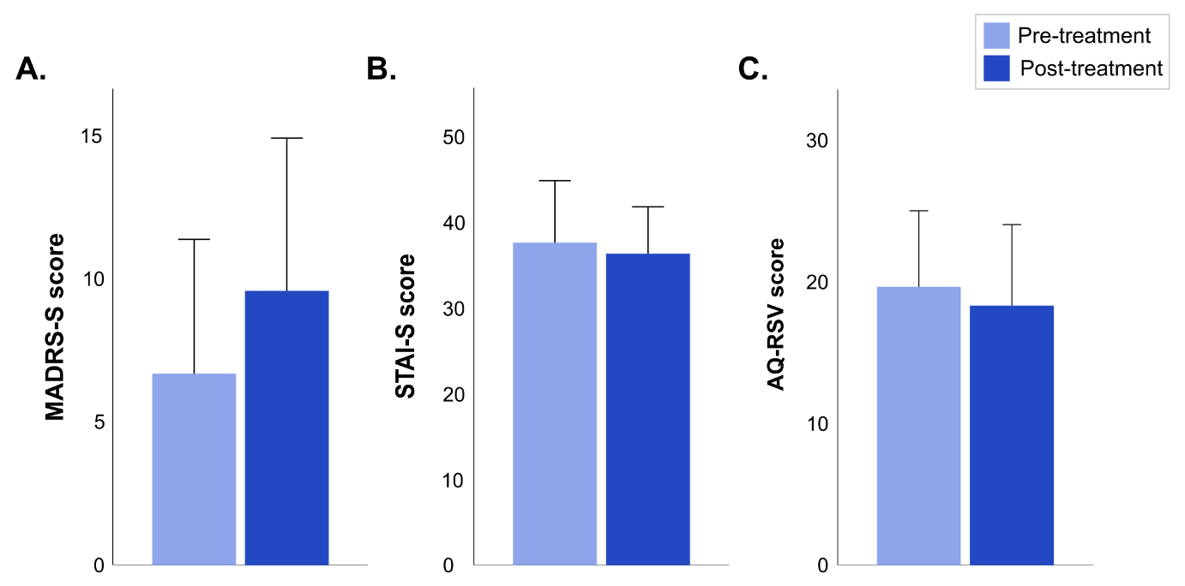
Figure S1. Effect of low-dose testosterone administration on psychometrics. Bar graphs of A. MADRS-S, B. STAI-S and C. AQ-RSV scores collected during scanning sessions, before (pre-treatment) and after one-week of transdermal testosterone treatment (post-treatment). The error bars represent 2x standard error of the mean.

