Fig. S1.
Practical Application Scenarios of the AI System (A) Doctor evaluates the patient's health status and provides guidance for their rehabilitation exercises. (B) The doctor formulates an initial weight-bearing training plan and inputs it into the intelligent rehabilitation walker. (C) The patient performs weight-bearing training according to the plan provided by the doctor, while the ecological AI rehabilitation system within the walker dynamically optimizes the rehabilitation plan based on the patient's historical data.

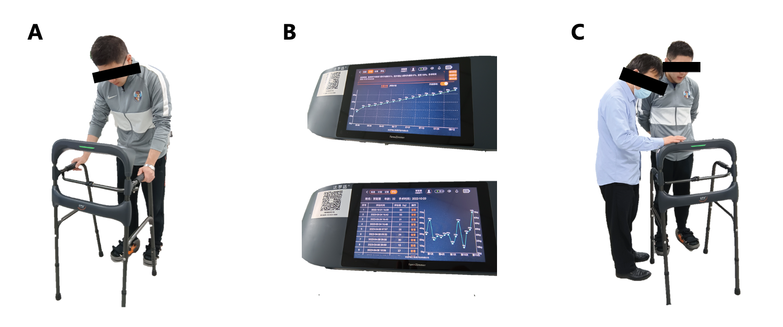

Fig. S2.
Prediction results of TensorFusion Network (TFN). (Left) Comparison plot of predicted values for patients (recovery time and initial load), ordered from smallest to largest based on actual values. The bar chart represents the recovery time suggested by doctors, while the scatter plot represents the predicted values by the model. (Right) Scatter plot demonstrating the correlation between actual values and predicted values. The diagonal line represents perfect prediction, where actual values are equal to predicted values.
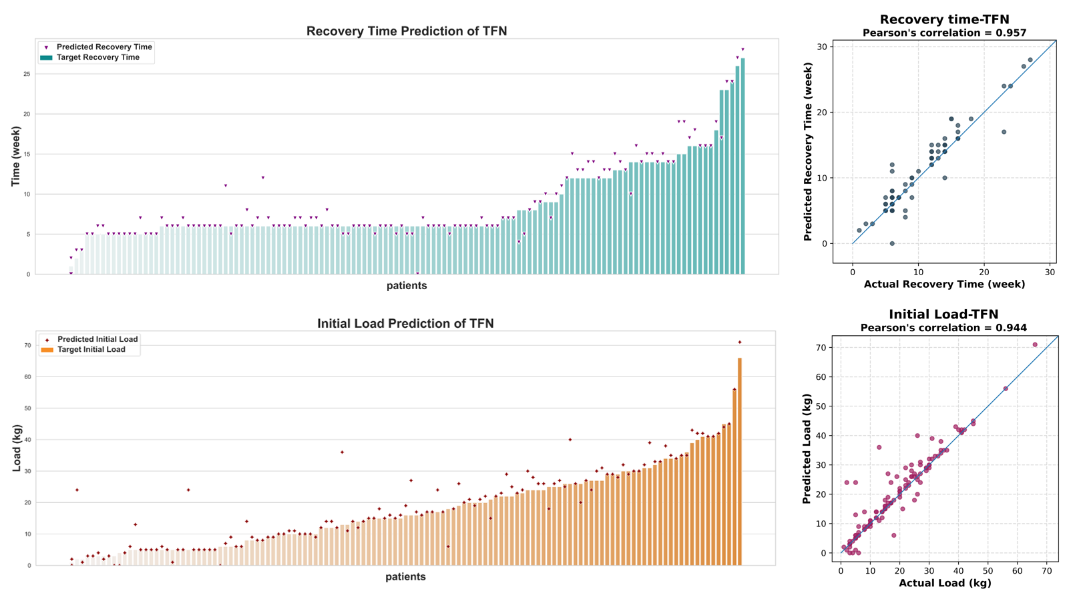

Fig. S3.
Prediction results of AutoFusion. (Left) Comparison plot of predicted values for patients (recovery time and initial load), ordered from smallest to largest based on actual values. The bar chart represents the recovery time suggested by doctors, while the scatter plot represents the predicted values by the model. (Right) Scatter plot demonstrating the correlation between actual values and predicted values. The diagonal line represents perfect prediction, where actual values are equal to predicted values.

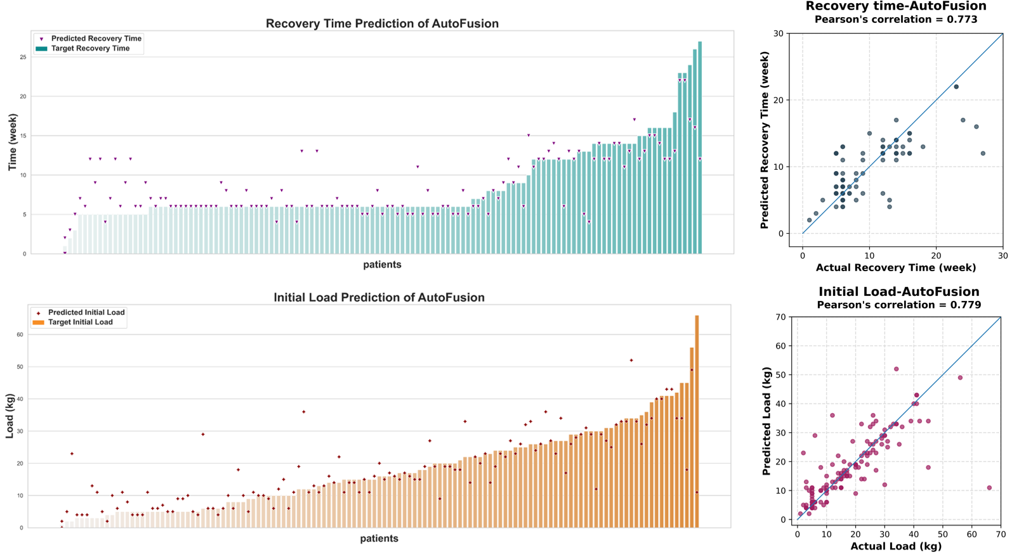

Fig. S4.
Prediction results of LMF. (Left) Comparison plot of predicted values for patients (recovery time and initial load), ordered from smallest to largest based on actual values. The bar chart represents the recovery time suggested by doctors, while the scatter plot represents the predicted values by the model. (Right) Scatter plot demonstrating the correlation between actual values and predicted values. The diagonal line represents perfect prediction, where actual values are equal to predicted values.

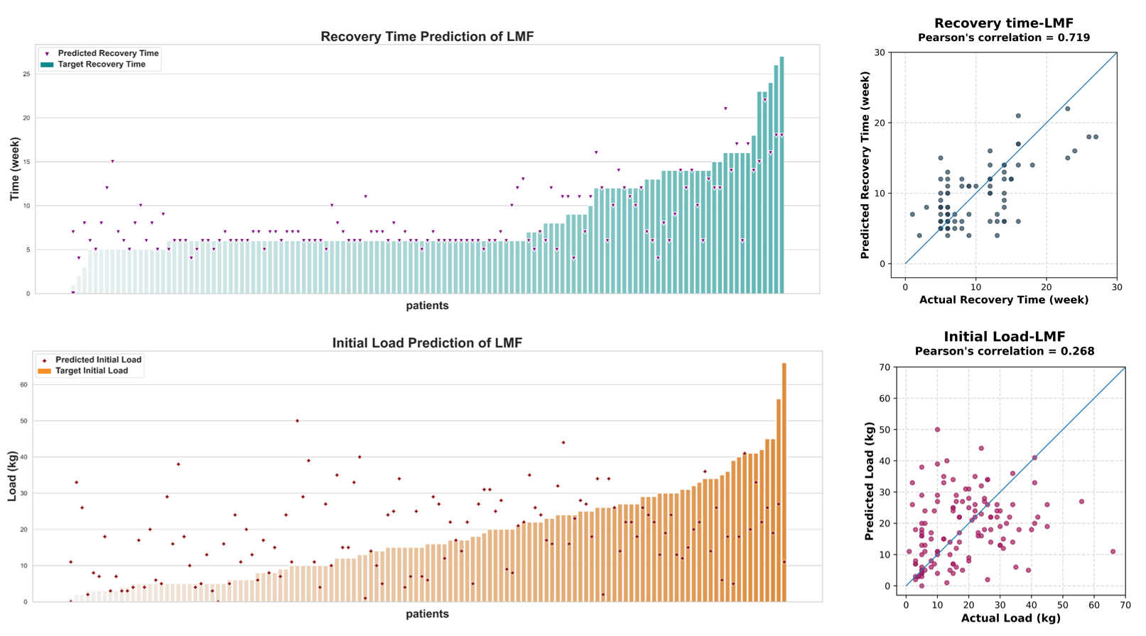

Fig. S5.
Prediction results of feature concatenation. (Left) Comparison plot of predicted values for patients (recovery time and initial load), ordered from smallest to largest based on actual values. The bar chart represents the recovery time suggested by doctors, while the scatter plot represents the predicted values by the model. (Right) Scatter plot demonstrating the correlation between actual values and predicted values. The diagonal line represents perfect prediction, where actual values are equal to predicted values.
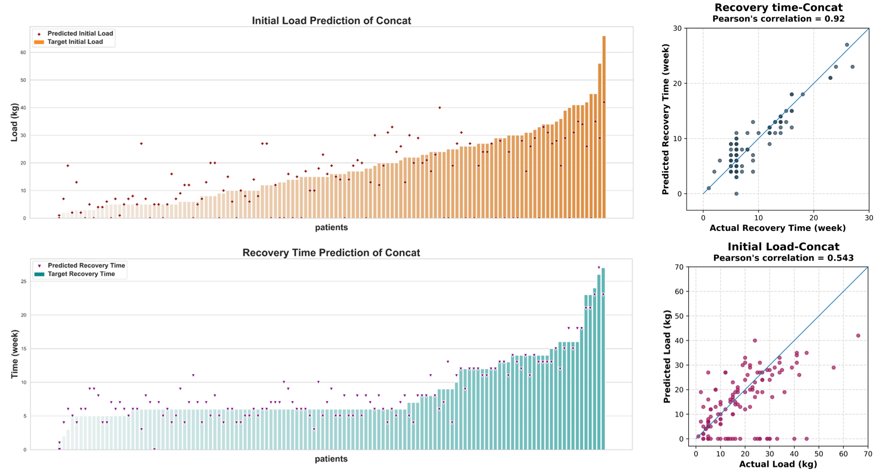

Fig. S6.
Prediction results of Unimodal method (clinical information). (Left) Comparison plot of predicted values for patients (recovery time and initial load), ordered from smallest to largest based on actual values. The bar chart represents the recovery time suggested by doctors, while the scatter plot represents the predicted values by the model. (Right) Scatter plot demonstrating the correlation between actual values and predicted values. The diagonal line represents perfect prediction, where actual values are equal to predicted values.
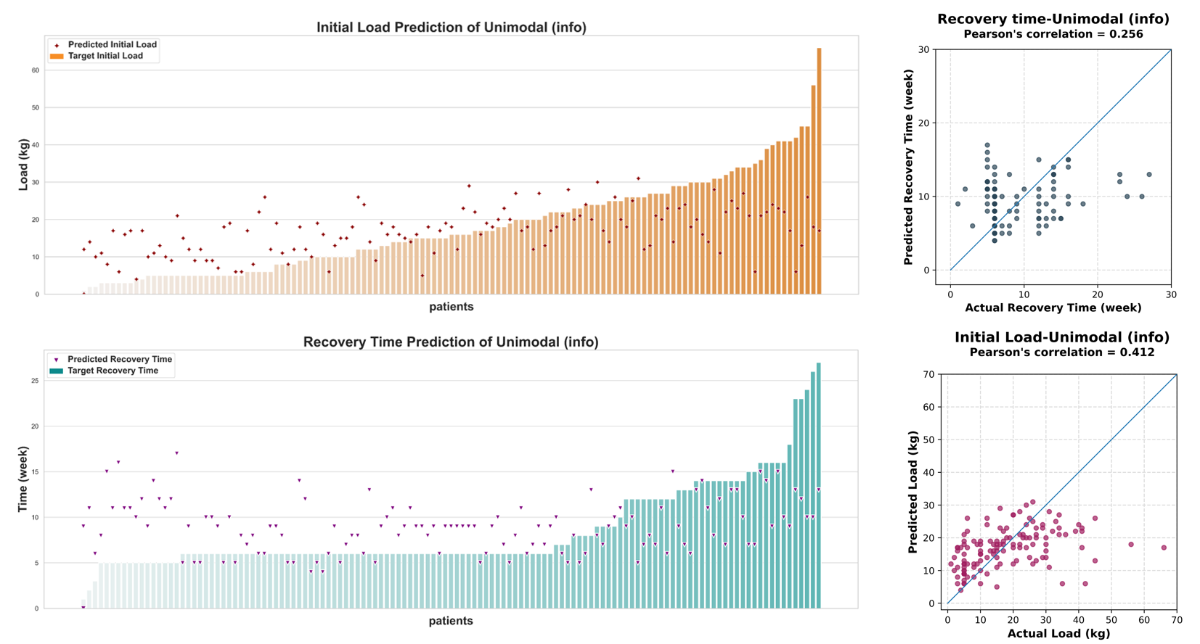

Fig. S7.
SHAP honeycomb diagram of clinical data prediction (A) Summary plot of clinical features on initial load prediction. (B) Summary plot of clinical features on initial load prediction.
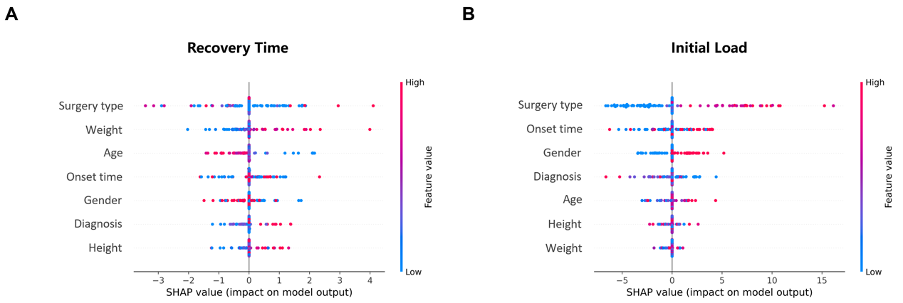

Fig. S8.
The process of data filtering.
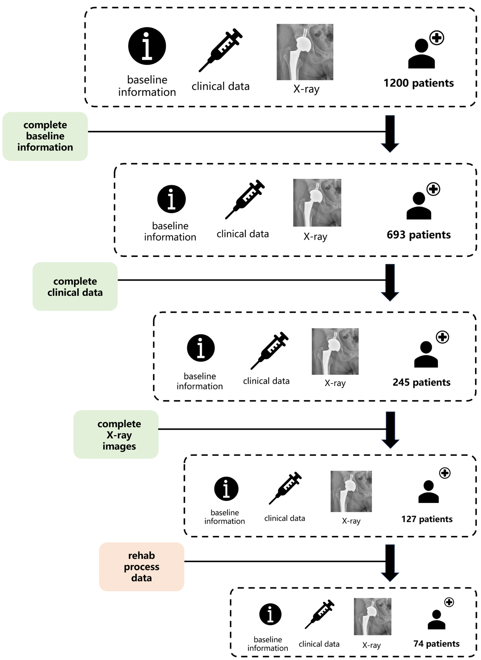

Table S1.
The demographic statistics of patients with full-dimensional clinical and rehabilitation data.
Dataset | Variable | Distribution
Shanghai Sixth People's Hospital | Sample size N | 91
Shanghai Sixth People's Hospital | Age, (<30:30~60:>60) | 0.1: 0.65: 0.25
Shanghai Sixth People's Hospital | Sex, N female (%) | 45.0%
Shanghai Sixth People's Hospital | BMI, mean$±$SD | 24.33$±$3.43
Shanghai Sixth People's Hospital | Diseased part (Hip: Femur: Knee: Ankle) | 0.67：0.12：0.20：0
Ruijin Hospital, Shanghai Jiaotong University School of Medicine | Sample size N | 6
 | Age, (<30:30~60:>60) | 0: 0.16: 0.83
 | Sex, N female (%) | 83.3%
 | BMI, mean$±$SD | 25.03$±$6.02
 | Diseased part (Hip: Femur: Knee: Ankle) | 0.66：0.33：0：0
Shanghai Changzheng Hospital | Sample size N | 7
Shanghai Changzheng Hospital | Age, (<30:30~60:>60) | 0.28: 0.57: 0.14
Shanghai Changzheng Hospital | Sex, N female (%) | 71.4%
Shanghai Changzheng Hospital | BMI, mean$±$SD | 23.46$±$2.21
Shanghai Changzheng Hospital | Diseased part (Hip: Femur: Knee: Ankle) | 0.14: 0: 0.14: 0.714
Others | Sample size N | 18
Others | Age, (<30:30~60:>60) | 0.44：0.55：0
Others | Sex, N female (%) | 66.7%
Others | BMI, mean$±$SD | 22.45$±$3.27
Others | Diseased part (Hip: Femur: Knee: Ankle) | 0.61: 0.11: 0: 0.28

Table S2.
The hospital list of the rest multi-center data source.
Num | Hospital
1 | Shanghai Eighth People's Hospital
2 | Shanghai Guanghua Hospital
3 | Huashan Hospital
4 | East Campus of Huashan Hospital
5 | West Campus of Huashan Hospital
6 | Shanghai Nineth People's Hospital
7 | North Campus of Shanghai Nineth People's Hospital
8 | Shanghai Zhongshan Hospital
9 | Shanghai Sixth People's Hospital (Hengyun)
10 | East Campus of Shanghai Sixth People's Hospital
11 | Minhang District Central Hospital
12 | Pudong People's Hospital
13 | Punan Hospital
14 | Putuo District Central Hospital
15 | Shanghai Rendong Hospital
16 | Shanghai Tenth People's Hospital
17 | Shanghai Fourth People's Hospital
18 | Shanghai Songjiang Hospital
19 | Shanghai Tongji Hospital
20 | Shanghai Xinhua Hospital
21 | Yangpu District Central Hospital
22 | Zhabei District Central Hospital

