Extended Data Figures 1−15.

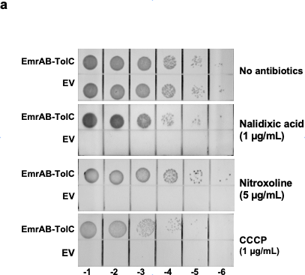

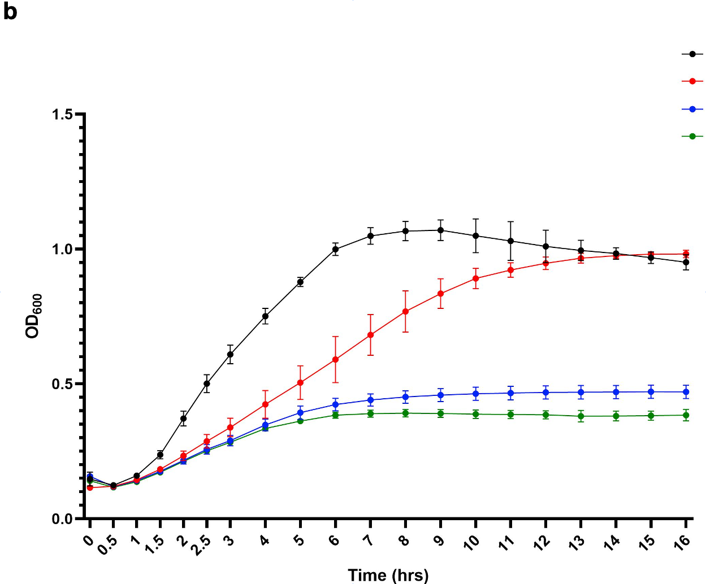

Extended Data Fig. 1 | Drug efflux activity of EmrAB-TolC tripartite pumps confers antibiotic resistance. a, Survival assays of cells expressing the wild-type EmrAB-TolC pump. The E. coli C43(DE3) ΔacrAB cells expressing EmrAB-TolC from plasmids were grown in LB medium at OD₆₀₀ of 0.5, then 10-fold serially diluted (Column -1 to -6) and plated on LB agar containing 60 µM IPTG in the presence of drugs. Cell growth was monitored after culture at 37°C overnight. “EV” represents the empty vector containing the negative control. b, Growth tests of cells expressing engineered EmrAB-TolC tripartite pumps in liquid culture. The growth of E. coli C43(DE3) ΔacrAB expressing wild-type EmrAB-TolC (black), engineered pump-EA (red), engineered pump-FA (blue), or the empty vector (green) in the presence of 0.8 µg/ml nitroxoline and 30 µM IPTG are shown. OD measurements are presented as the means of triplicate measurements ± standard error of the mean (SEM). Error bars represent the SEM.
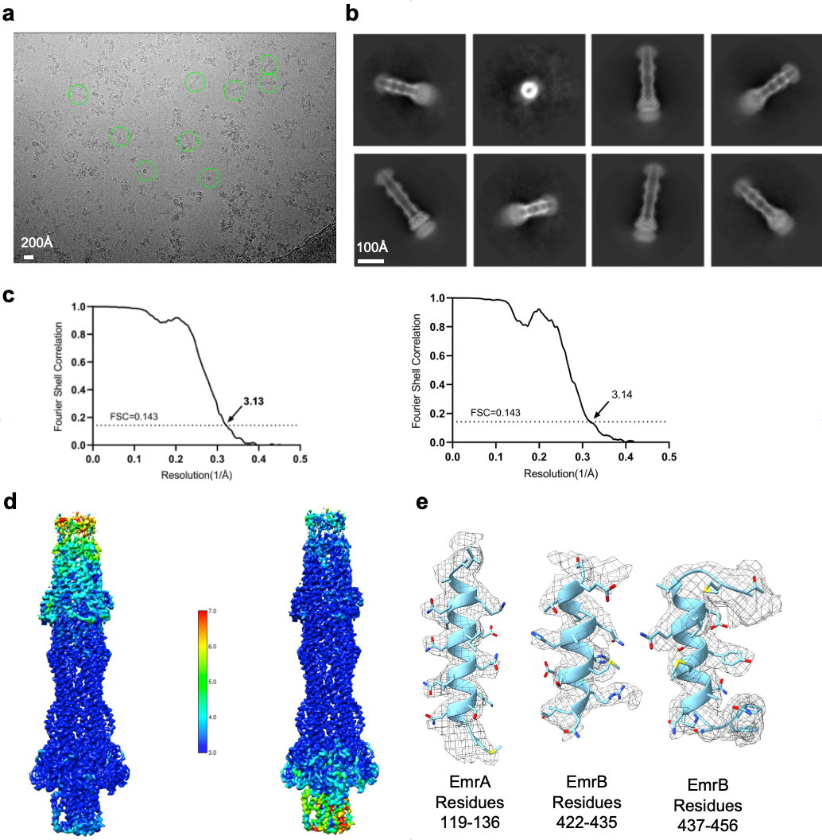

Extended Data Fig. 2 | Cryo-EM image of EmrAB‐TolC pump-EA. a, Representative cryo-EM image of the EmrAB‐TolC complex. The image has been corrected for drift (scale bar 200 Å). b, Typical two-dimensional class averages of the particles (scale bar 100 Å). c, Gold‐standard Fourier shell correlation indicating the resolution of the two maps. FSC plots were generated between reconstructions from random halves of the data for EmrAB-TolC pump-EA with local refinement focused on EmrAB sections (map-1, left) and focused on the α-helical hairpin domains of EmrA and TolC sections (map-2, right). Resolutions are estimated at FSC = 0.143 (black dashed line). d, Local resolution estimation via ResMap of the EmrAB-TolC pump-EA focused on EmrAB sections (map-1, left) and focused on the α-helical hairpin domains of the EmrA and TolC sections (map-2, right). All units are in Angstrom (Å). (E) Cryo-EM map corresponding to segments of EmrA and EmrB (map threshold = 0.15).

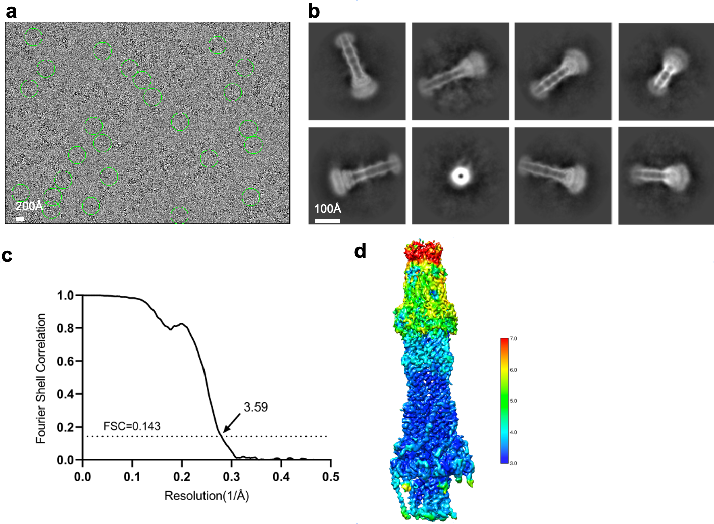

Extended Data Fig. 3 | Cryo-EM image of EmrAB‐TolC pump-FA. a, Representative cryo-EM image of the EmrAB‐TolC complex. The image has been corrected for drift (scale bar 200 Å). b, Typical two-dimensional class averages of the particles (scale bar 100 Å). c, Gold‐standard Fourier shell correlation indicating the resolution of the map. FSC plots were generated between reconstructions from random halves of the data for the EmrAB-TolC pump-FA with local refinement focused on EmrAB sections. Resolution is estimated at FSC = 0.143 (black dashed line). d, Local resolution estimation via ResMap of the pump-FA. All units are in Angstrom (Å).

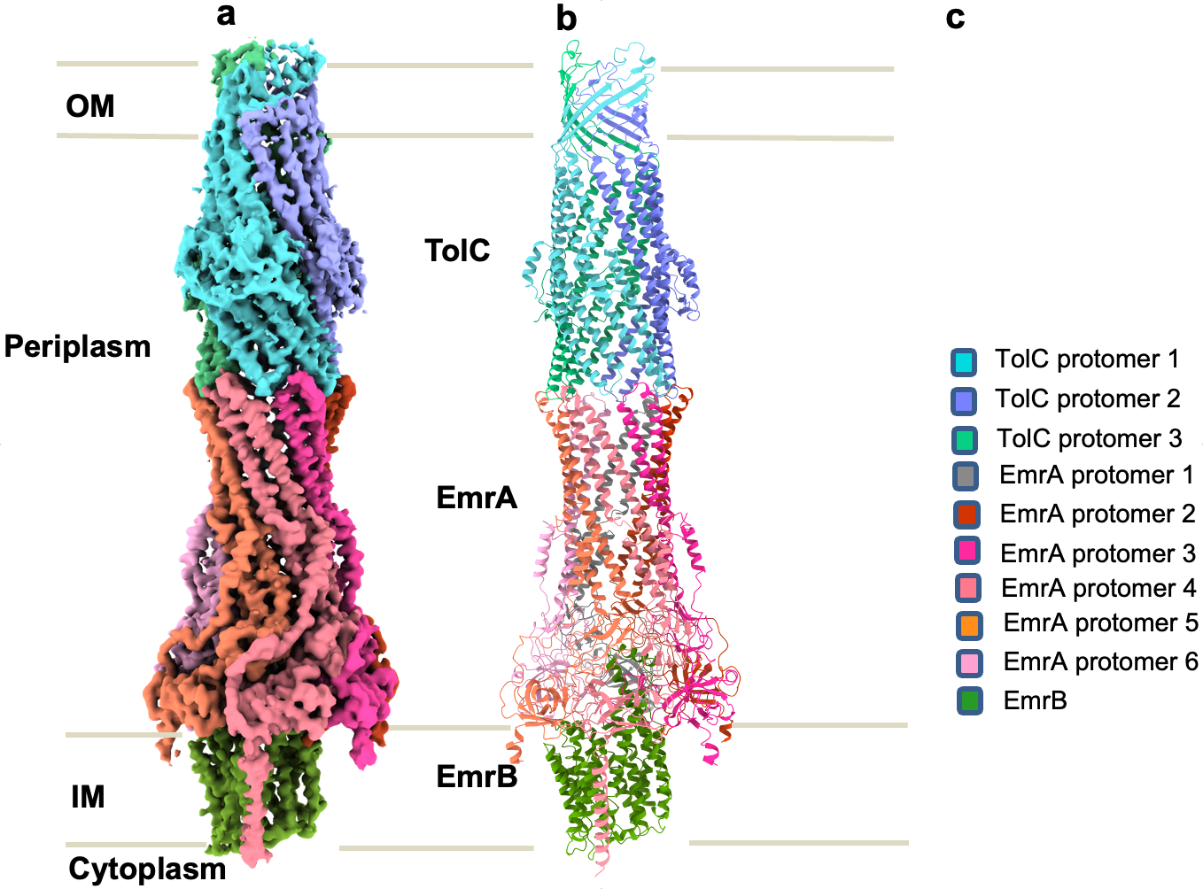

Extended Data Fig. 4 | Structure of EmrAB-TolC pump-FA. a, Map of pump-FA. The protomers are color-coded as in c. b, Ribbon representation of the pump color-coded as in c. The structure of EmrAB-TolC pump-FA is similar to that of pump-EA, with both having a 3:6:1 TolC:EmrA:EmrB protomer ratio. The map of the N-terminal TM helix of EmrA protomer 4 spans the entire inner membrane (IM), while the densities of the other five N-terminal TM helices are approximately two-thirds shorter.

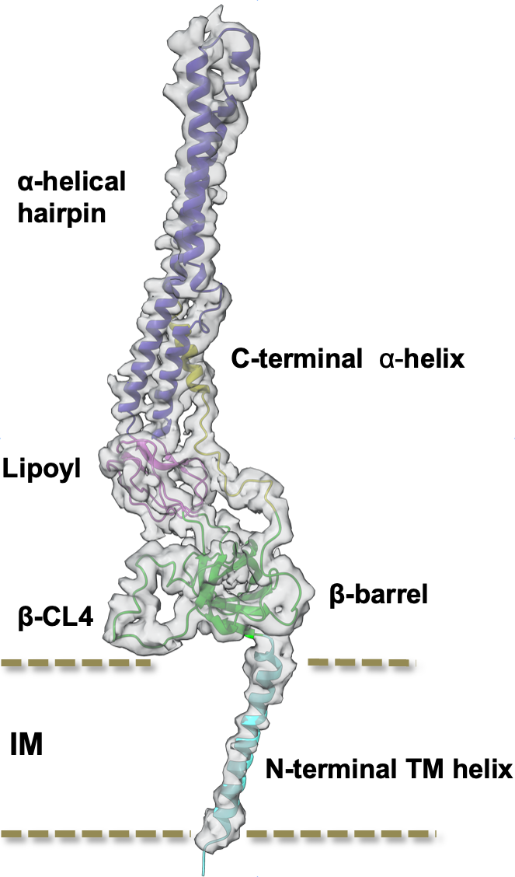

Extended Data Fig. 5 | Cryo-EM map of EmrA protomer 4 with the fitted model, segmented from the map of pump-FA. Domains and subdomains are color-coded as in Fig. 2a. The map of the N-terminal TM helix of EmrA protomer 4 spans the entire IM.

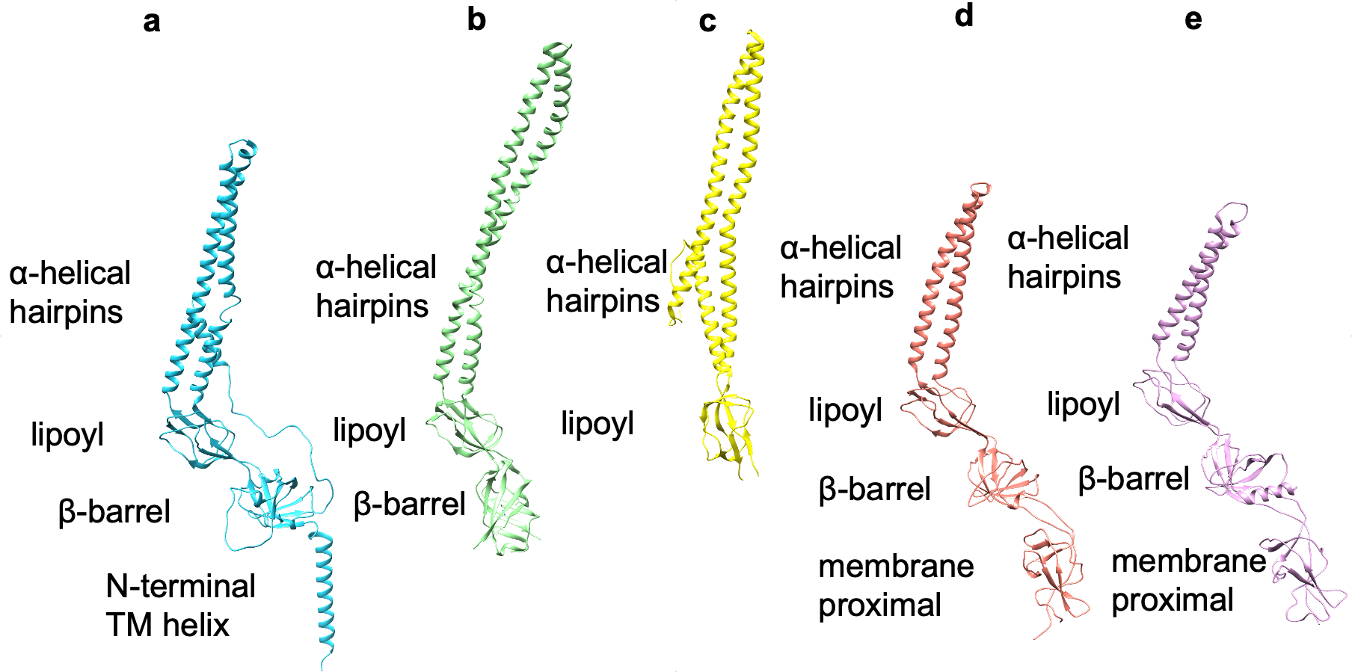

Extended Data Fig. 6 | Structural comparison of EmrA, aaEmrA, HlyD, MacA and AcrA. EmrA a and its homologue aaEmrA (PDB code: 4TKO) b and HlyD (PDB code: 5C21) c lack the membrane-proximal domains present in MacA (PDB code: 5NIK) d and AcrA (PDB code: 5V5S) e, which mediate interactions with periplasmic extensions of the inner membrane transporters MacB and AcrB, respectively.

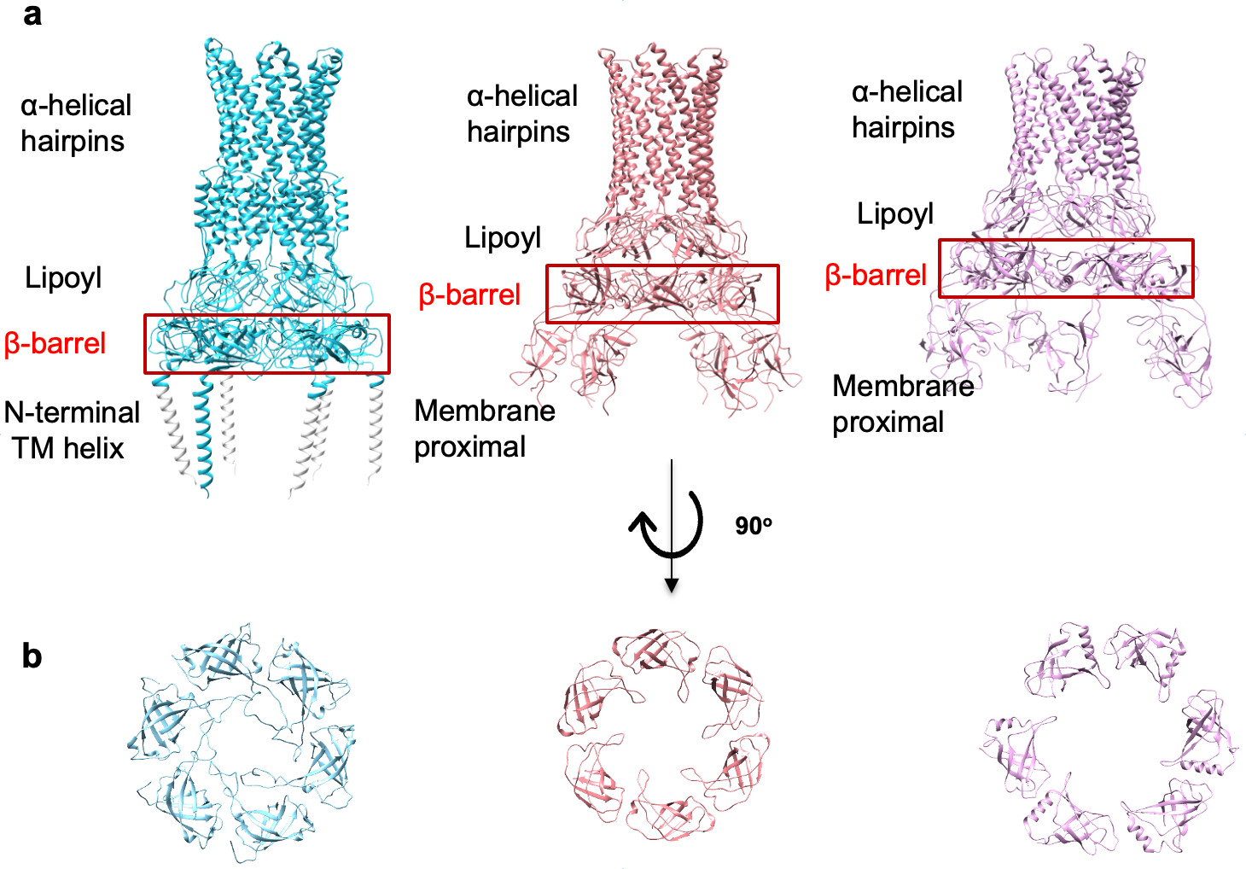

Extended Data Fig. 7 | Structural comparison of EmrA, MacA, and AcrA hexamers. a, Side-by-side comparison of EmrA (left), MacA (PDB code: 5NIK; middle), and AcrA (PDB code: 5V5S; right) hexamers. b, Comparison of the β-barrel domains of EmrA (left), MacA (middle), and AcrA (right) hexamers. The conserved β-CLs of EmrA adopt various conformations, while the equivalent parts of MacA and AcrA are short and adopt similar conformations.

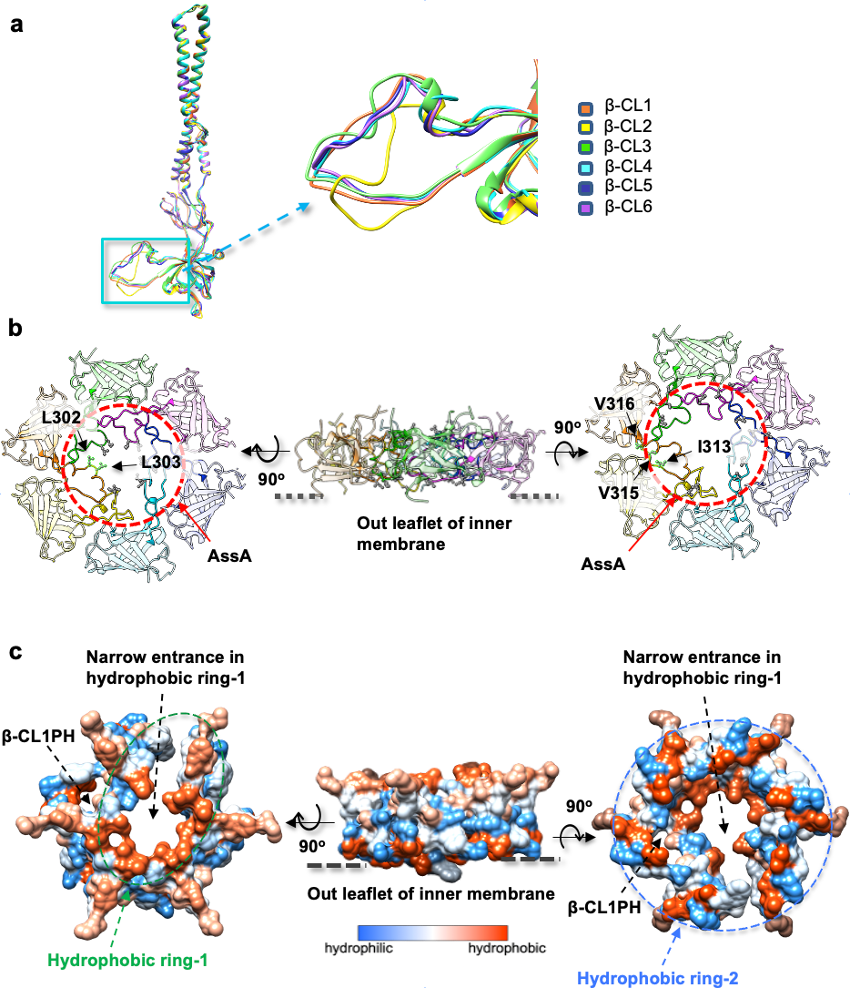

Extended Data Fig. 8 | Structural characteristics of β-CL and AssA subdomain. a, Superposition of six protomers of EmrA (left) and enlargement of the boxed region (middle) showing various conformations of β-CL1 to β-CL6. β-CLs are color-coded accordingly (right). b, The IM distal and proximal sides (left and right, viewed perpendicular to the membrane) and side view (middle, viewed parallel to the membrane) of EmrA β-barrel domains showing the AssA subdomain and two hydrophobic rings. c, Surface representations of AssA (with the same views as in B). Residues are coloured based on hydrophobicity.

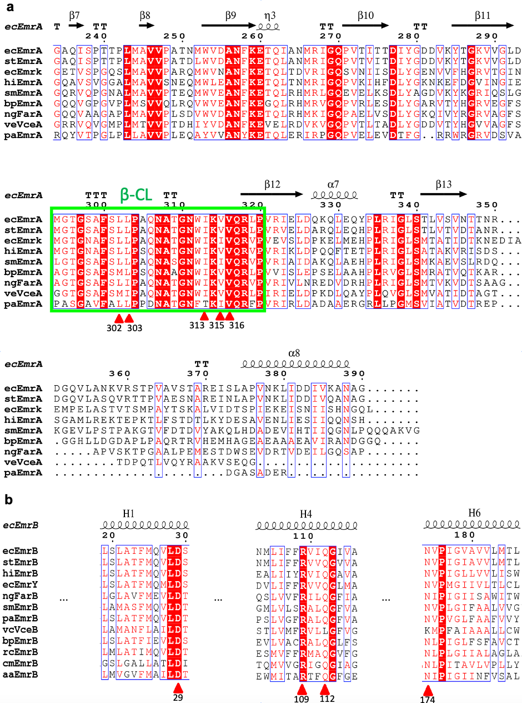
Extended Data Fig. 9 | Sequence alignments of EmrA and EmrB with their homologues, respectively. a, The residues L302, L303, I313, V315 and V316 in the β-CL (green box) of β-barrel domain are conserved among EmrA homologues. The sequences used were from Escherichia coli (ecEmrA, P27303; ecEmrK, P52599), Salmonella Typhimurium (stEmrA, E8XK58), Haemophilus influenza (hiEmrA, P44928), Stenotrophomonas maltophilia (smEmrA, A0A7V8FFT6), Burkholderia pseudomallei (bpEmrA, Q3JLM5), Neisseria gonorrhoeae (ngFarA, Q9RQ30), Vibrio cholerae (vcVceA, O51918), Pseudomonas aeruginosa (paEmrA, A0A3M5E5C8), with corresponding UniProt codes. b, The residues D29, R109, Q112 and N174 are conserved among EmrB homologues. The sequences used were from Escherichia coli (ecEmrB, P0AEJ0; ertEmrY, P52600), Aquifex aeolicus (aaEmrB, O67160), Vibrio cholerae (vcVceB, A0A5C9SY76), Stenotrophomonas maltophilia (smEmrB, A0A0D0JC09), Rhodobacter capsulatus (rcEmrB, D5ASL8), Salmonella Typhimurium (stEmrB, A0A731QJR1), Pseudomonas aeruginosa (paEmrB, A0A0N7HJZ5), Cupriavidus metallidurans (cmEmrB, A0A132HJX6), Burkholderia pseudomallei (bpEmrB, Q3JSY6), Haemophilus influenza (hiEmrB, A0A377IYF3) and Neisseria gonorrhoeae (ngFarB, Q9RQ29), with corresponding UniProt codes. Alignments were performed over the whole sequences, but for clarity, only the relevant regions are shown. Residues that are strictly conserved are highlighted with white text on a red background, while highly conserved residues are highlighted with red text on a white background. The secondary structure is marked above.

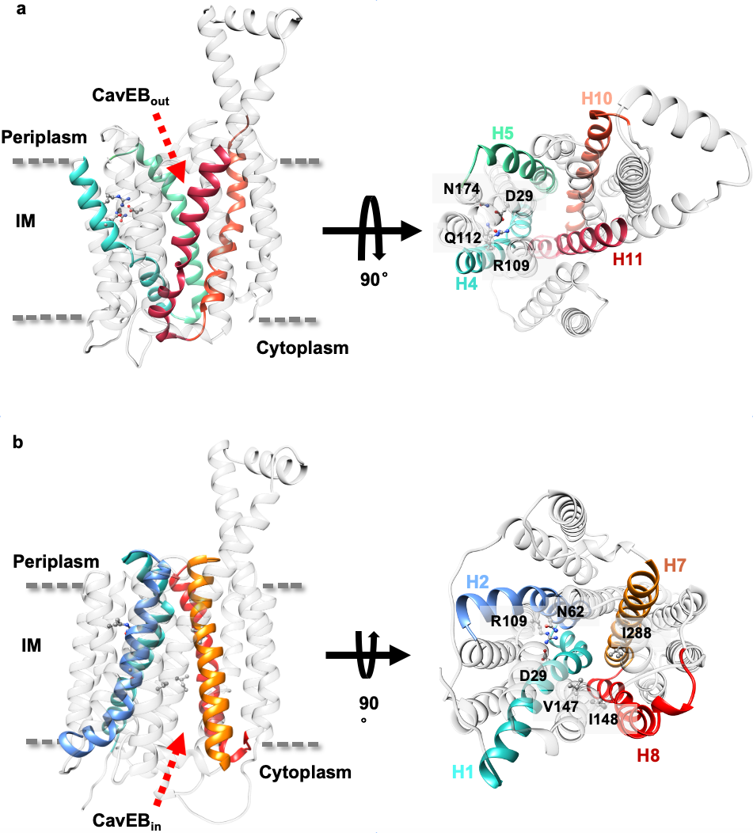

Extended Data Fig. 10 | The central aqueous cavities and gating helices of EmrB. a, Side and periplasmic views of the EmrB structure in the outward-open state showing cavity CavEB_{out}. Interactions of side chains between helices H4 and H5 in the EBN domain, and H10 and H11 in the EBC domain form a cytoplasmic gate. b, Side and cytoplasmic views of the homology model of EmrB in the inward-open state showing cavity CavEB_{in}. Interactions of side chains between helices H1 and H2 in the EBN domain, and H7 and H8 in the EBC domain form a periplasmic gate.

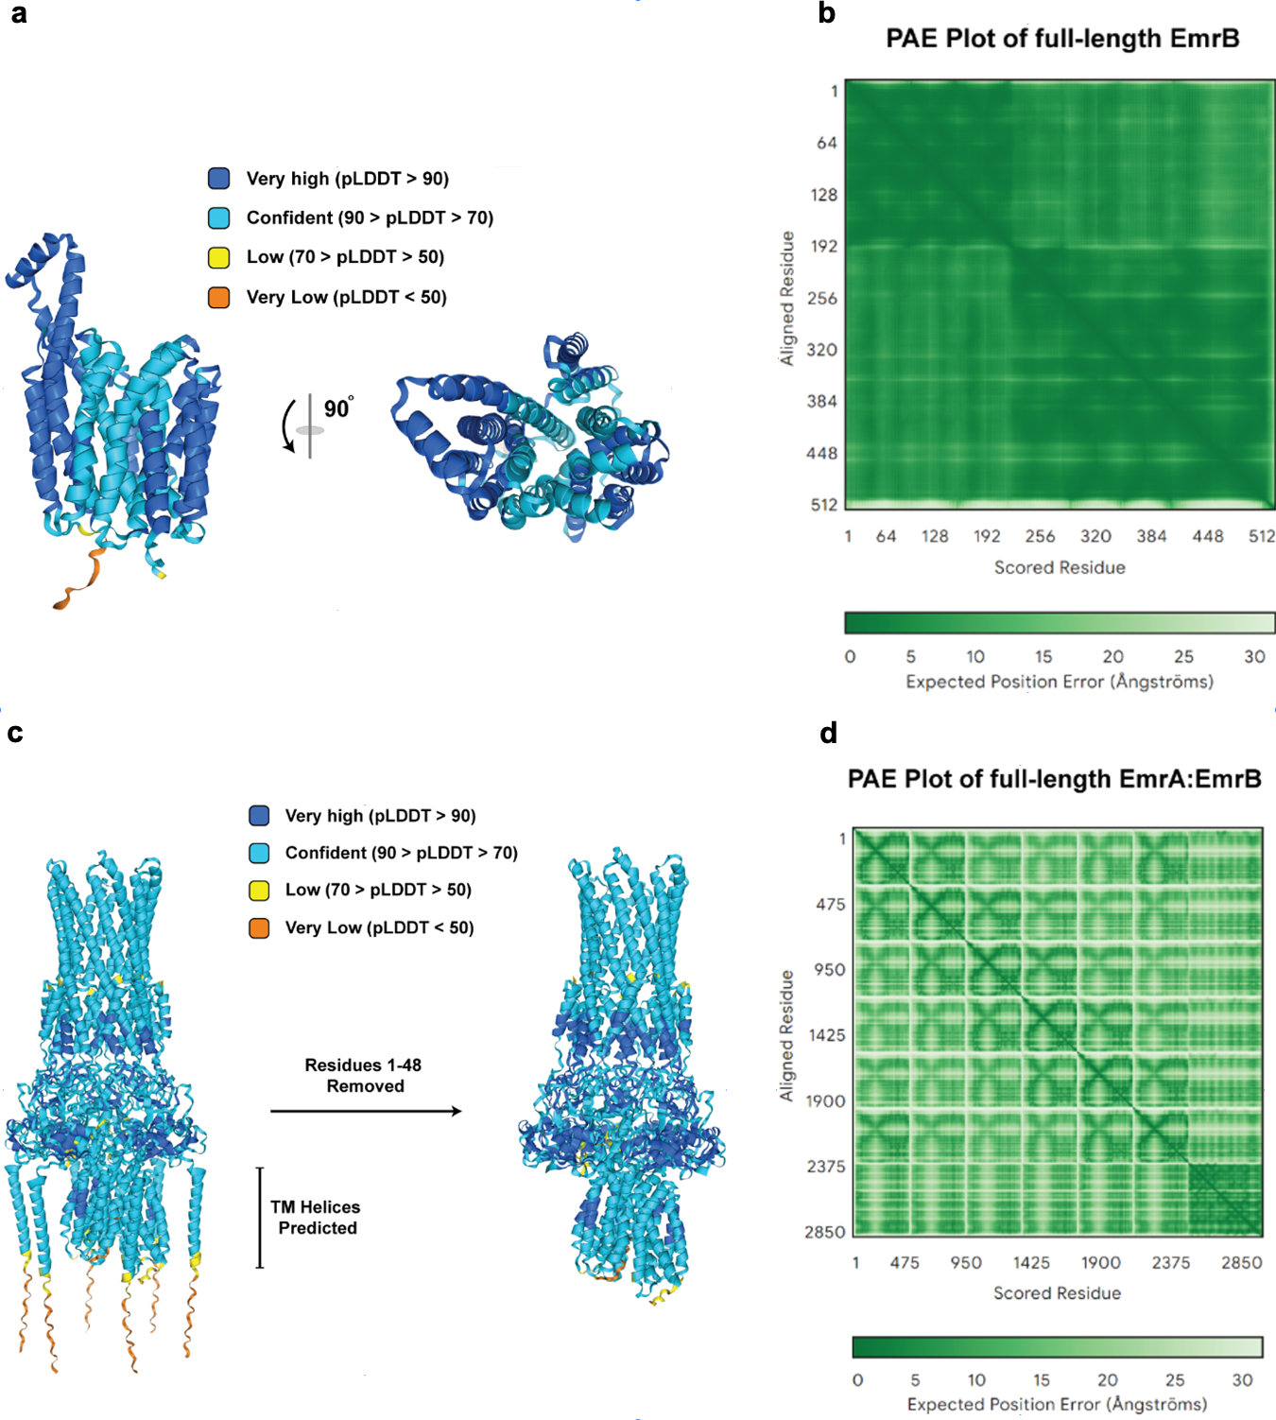

Extended Data Fig. 11 | AlphaFold3 Predictions of EmrB and EmrA:EmrB. a, AlphaFold3 predicts EmrB in its outward-open state with high confidence, as demonstrated by the high per-residue confidence throughout the structure. b, The predicted aligned error (PAE) plot demonstrates global confidence in the EmrB prediction. c, EmrB is predicted in its inward-open state with high confidence when predicted with six molecules of EmrA. The transmembrane helices of EmrA are omitted for easier visualization. d, The predicted aligned error (PAE) plot of full-length EmrA:EmrB demonstrates global confidence in the position of individual monomers, as supported by the low-expected position error throughout.

a b

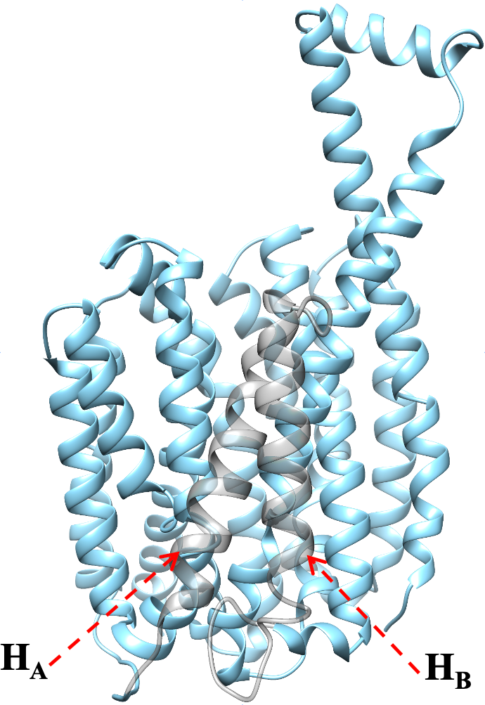

c d

Extended Data Fig. 12 | Comparison of EmrB and MfdA. a, Ribbon representation of EmrB. With helices H_{A} and H_{B} indicated and coloured grey. b, Ribbon representation of outward-open MfdA (PDB code: 6GV1). c, Superposition of EmrB and MfdA. The degree of outward opening in EmrB is less than that of MfdA. d, Superposition of the EBN of EmrB and the N-domain of MfdA. The EBN structure of EmrB is similar to the N-domain of the MfdA, which facilitates the identification of residues in EmrB involved in drug resistance.

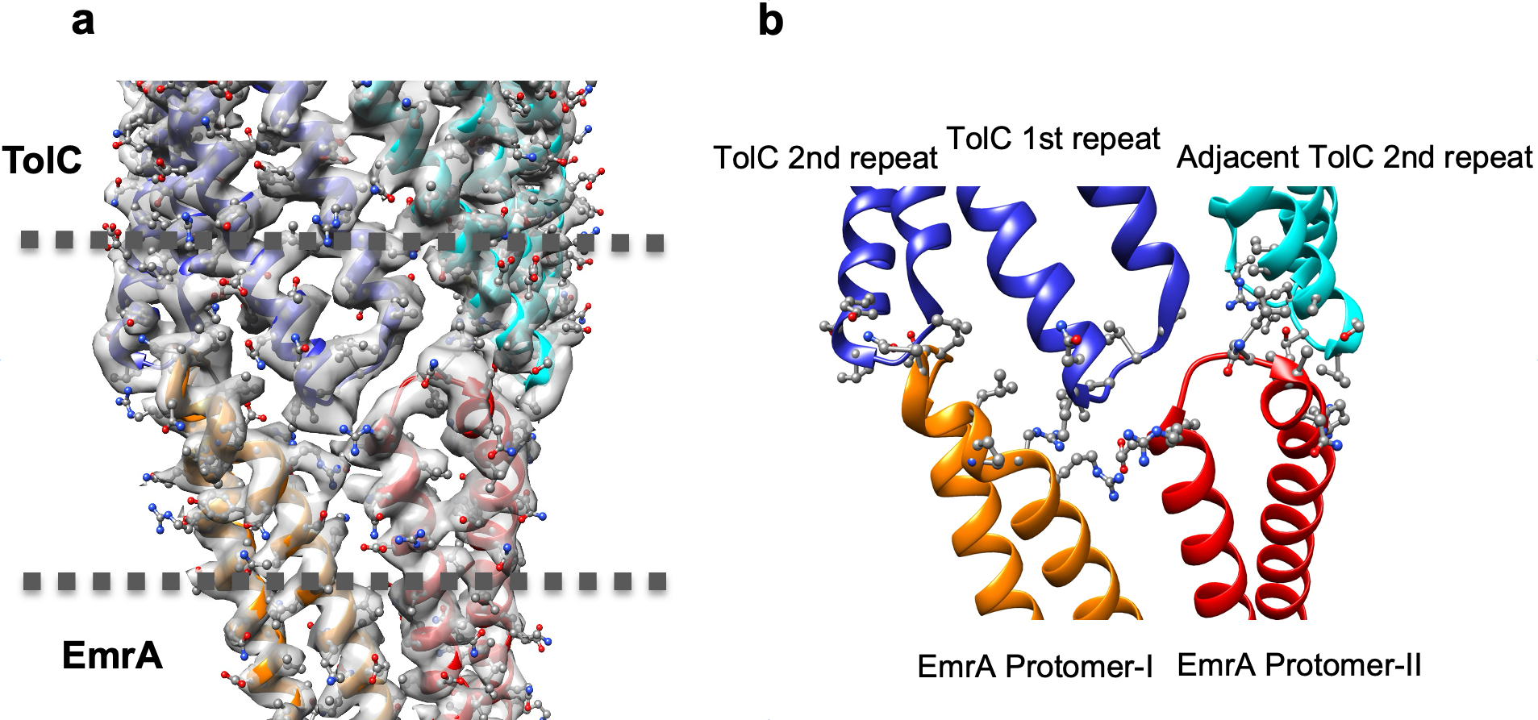

Extended Data Fig. 13 | Interfacial contacts between EmrA and TolC. a, Portions of the cryo-EM map of the pump, combined with the fitted model, showing tip‐to‐tip interactions between a TolC protomer (blue) and two α‐helical hairpins of EmrA (red and orange). The side chains of the residues are shown in ball-and-stick representation. b, Closer view of the area between the dashed lines in a showing the interaction interfaces between EmrA and TolC. The side chains of the residues participating in these contacts are highlighted in ball-and-stick representation.

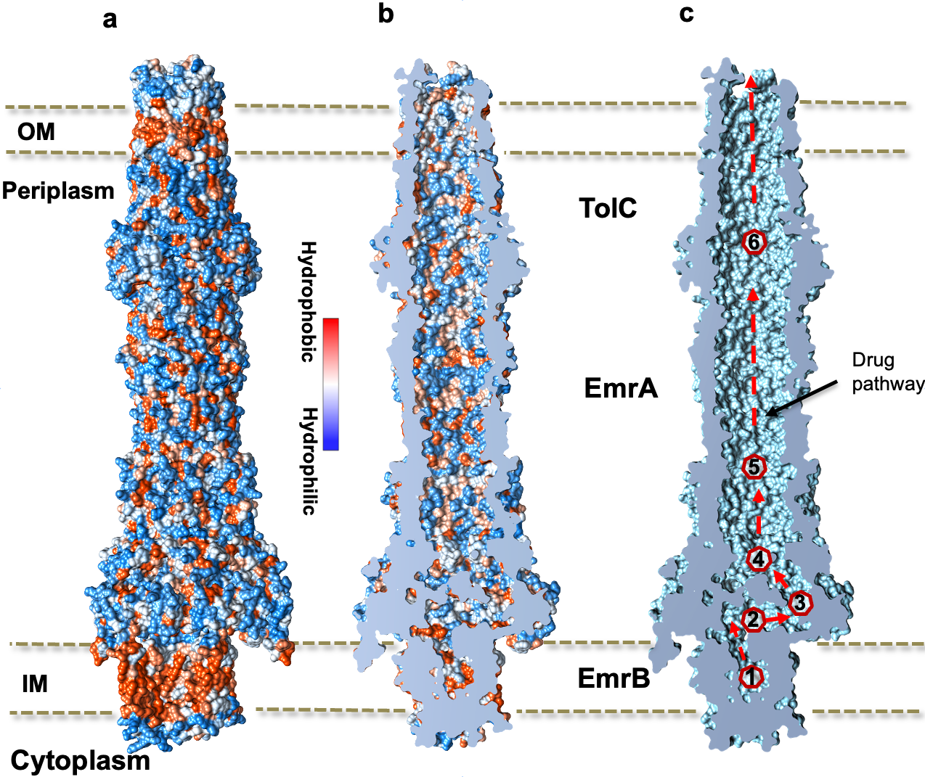

Extended Data Fig. 14 | Drug transport pathway of EmrAB-TolC. a, b, Surface representation and sliced view of EmrAB-TolC. Residues are colored based on hydrophobicity. The surface of CavEB_{out} is more hydrophobic than the other parts of the channel. c, Sliced surface representation of EmrAB-TolC. The entire transport pathway comprises [1] CavEB_{out}, [2] CavEA_{out}, [3] β-CL1PH, [4] CavLP, [5] NanoHP, and [6] NanoTC, which form a sealed channel.

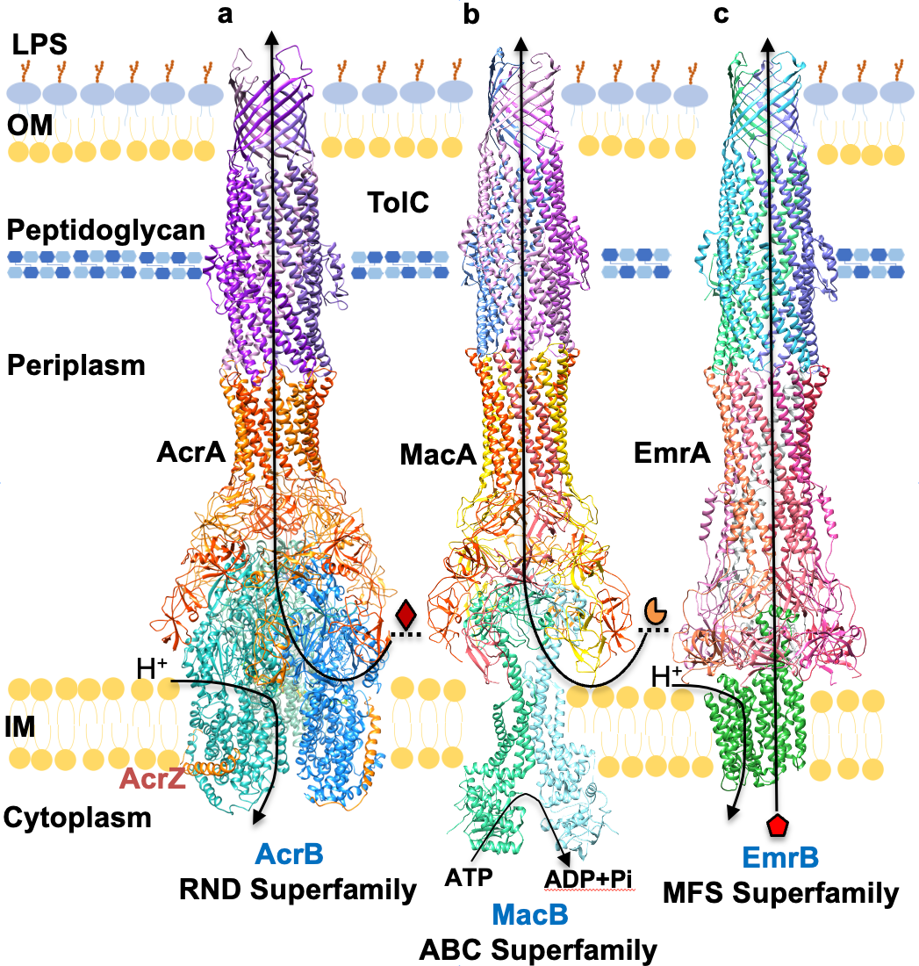

Extended Data Fig. 15 | Schematic diagrams of representative structures of tripartite multidrug efflux pumps. The cell envelope of Gram-negative bacteria is made up of two layers of phospholipids: the inner membrane (IM) and the outer membrane (OM). The OM is distinct as it has an asymmetric structure, with a layer of lipopolysaccharide (LPS) in the outer leaflet. These two membranes are separated by the periplasm, a gel-like space that contains a thin layer of peptidoglycan. Three classes of tripartite efflux pumps are known to span this cell envelope: RND types exemplified by AcrAB-TolC (a) (PDB code: 5O66), ABC types represented by MacAB-TolC (b) (PDB code: 5NIK), and MFS types such as EmrAB-TolC (c). The RND-type AcrAB-TolC and the ABC-type MacAB-TolC pumps utilize a two-step mechanism to recognize substrates at the outer leaflet of the IM and periplasm and efflux them to the cell exterior. By contrast, the MFS-type EmrAB-TolC pump employs a one-step mechanism to directly transport substrates from the inner leaflet of the IM and cytoplasm to the cell exterior.

Extended Data Table 1.

Primers used to generate the constructs
Primer Name | Primer Sequence (5′−3′)
Petduet_F | TCCAGATCAGCCAAAGGCGTCATGCCCATGGTATATCTCCTTCTTAAAG
Petduet_R | GCCTCGAGCACCACCACCACCACCACCACCACCACCACTGAGCG
brilpet-F | GGCATGACGCCTTTGGCTGATCTGGAAGACAATTGGGAAACTCTGAACGAC
bril-link-R | AGGGTGCTCCTGGCCCTCTCCAGGTACTTCTGAATGTATGCATTCCGGGTGGTC
emrB-link-F | AGGGCCAGGAGCACCCTGATGGTCATTATGACGATTGCGCTGTCACTGGC
emrBGS-R | CATGGAGCCGCCACCCCCAGCAAACCACACCAGCCCCAGCAG
emrAGS-F | GGGGGTGGCGGCTCCATGAGCGCAAATGCGGAGACTCAAACC
emrApet-R | TGGTGGTGCTCGAGGCCAGCGTTAGCTTTTACGATATCGTCGATC
TolCinf_F | AAGGAGATATACATATGAAGAAATTGCTCCCCATTCTTATCGGCC
TolCFLAGXhoI_R | GAGCTCGAGTCACTTATCGTCGTCATCCTTGTAATCGTTACGGAAAGGGTTATGACCGTTACTGGT
TolCFLAG_inf_R | TTGAGATCTGCCATATGTCACTTATCGTCGTCATCCTTGTAATCGTTACG
emrAinsert_F | CTTTAATAAGGAGATATACCATGGATGAACAAAAACAGAGGGTTTAC
emrAinsert_R | AAAAGCTAACGCTGGCTAAGGATCCGAATTCGAGCTCGGCGC
ΔemrAinsert_F | TTTAATAAGGAGATATACCCACTTCGAAGAAACCGATGACGCATACGTG
acrAs_F | TTTAATAAGGAGATATACCATGAACAAAAACAGAGGGTTTACGCCTCTG
acrAs_R | GTTTCTTCGAAGTGTTTGTCGTCACATCCTGTTAGGGCTAAGCTGC
﻿EmrAB_F | AAGGAGATATACCATGGGCATGAGCGCAAATGCGGAGACTCAAACCCCGC
EmrAB_R | GCATTATGCGGCCGCTCATTAGTGCGCACCGCCTCCGCCGC
Petduet_V_F | TGAGCGGCCGCATAATGCTTAAGTCGA
Petduet_V_R | GCCCATGGTATATCTCCTTCTTAAAGTTAAACAAAATTATTTCTAGAG
emrB_{D29N}_F | CGACATTCATGCAGGTGCTGAACTCCACCATTGCTAACGTGGCGA
emrB_{D29N}_R | TCGCCACGTTAGCAATGGTGGAGTTCAGCACCTGCATGAATGTCG
emrB_{N62A}_F | TAATCACTTCTTTCGGGGTGGCGGCAGCCATCTCGATCCCGCTTACCGGC
emrB_{N62A}_R | GCCGGTAAGCGGGATCGAGATGGCTGCCGCCACCCCGAAAGAAGTGATTA
emrB_{R109A}_F | AGCAGCCTGAATATGCTGATCTTCTTCGCGGTGATTCAGGGGATTGTCGCCG
emrB_{R109A}_R | CGGCGACAATCCCCTGAATCACCGCGAAGAAGATCAGCATATTCAGGCTGCT
emrB_{V147A}_F | GCGCTGGCGTTGTGGTCGATGACGGCGATTGTCGCGCCAATTTGCGGCCCGA
emrB_{V147A}_R | TCGGGCCGCAAATTGGCGCGACAATCGCCGTCATCGACCACAACGCCAGCGC
emrB_{V148A}_F | CTGGCGTTGTGGTCGATGACGGTGGCGGTCGCGCCAATTTGCGGCCCG
emrB_{V148A}_R | CGGGCCGCAAATTGGCGCGACCGCCACCGTCATCGACCACAACGCCAG
emrB_{I288A}_F | CGTATATGCTCTACTTCGGCGCTGCGGTTCTGCTGCCGCAGTTGTTGCA
emrB_{I288A}_R | TGCAACAACTGCGGCAGCAGAACCGCAGCGCCGAAGTAGAGCATATACG
emrA_{L302Q/L303Q}_F | CTGGATATGGGCACAGGTAGCGCGTTCTCACAGCAACCAGCGCAAAATGCGACCGGTAACTGGATC
emrA_{L302Q/L303Q}_R | GATCCAGTTACCGGTCGCATTTTGCGCTGGTTGCTGTGAGAACGCGCTACCTGTGCCCATATCCAG
emrA_{I313Q/V315T/V316T} _F | CTTCCAGCGCAAAATGCGACCGGTAACTGGCAGAAAACGACTCAGCGTCTGCCTGTGCGTATCGAACTGGAC
emrA_{I313Q/V315T/V316T} _R | GTCCAGTTCGATACGCACAGGCAGACGCTGAGTCGTTTTCTGCCAGTTACCGGTCGCATTTTGCGCTGGAAG

Extended Data Table 2.

Data collection, processing, and model building
 | EmrAB-TolC pump-EA  PDB ID: 8ZAL  EMDB ID: EMD-39879 |  | EmrAB-TolC pump-FA  PDB ID: 8ZAR  EMDB ID: EMD-39885
Data collection and processing
Magnification | 45,871.6 |  | 47,169.9
Voltage (kV) | 300 |  | 300
Electron exposure (e⁻/Å²) | 60 |  | 56.6
Defocus range (µm) | -1, -2.5 |  | -1, -2.5
Pixel size (Å) | 1.09 |  | 1.06
Symmetry imposed | C1 |  | C1
Initial particle images (no.) | 816,894 |  | 762,142
Final particle images (no.) | 19,180 |  | 18,440
Map resolution (Å, FSC = 0.143) |  | 3.13 | 3.59
Particle box size | 400 |  | 400
Refinement
Model composition
Chains | 10 |  | 10
Atoms | 59223 (Hydrogens: 29683) |  | 59993 (Hydrogens: 30115)
Protein residues | 3841 |  | 3880
Bonds (RMSD)
Bond lengths (Å) | 0.003 (0) |  | 0.005 (0)
Bond angles (°) | 0.528 (0) |  | 0.956 (0)
Validation
MolProbity score  Clash score | 1.19  2.73 |  | 1.23  2.90
Ramachandran plot
Favored (%) | 97.33 |  | 97.15
Allowed (%) | 2.64 |  | 2.80
Outliers (%) | 0.03 |  | 0.05

