Hyperpolarized [1-¹³C]pyruvate NMR spectroscopy reveals transition of tumor energy metabolism in tiny multicellular spheroids

Supplementary Material

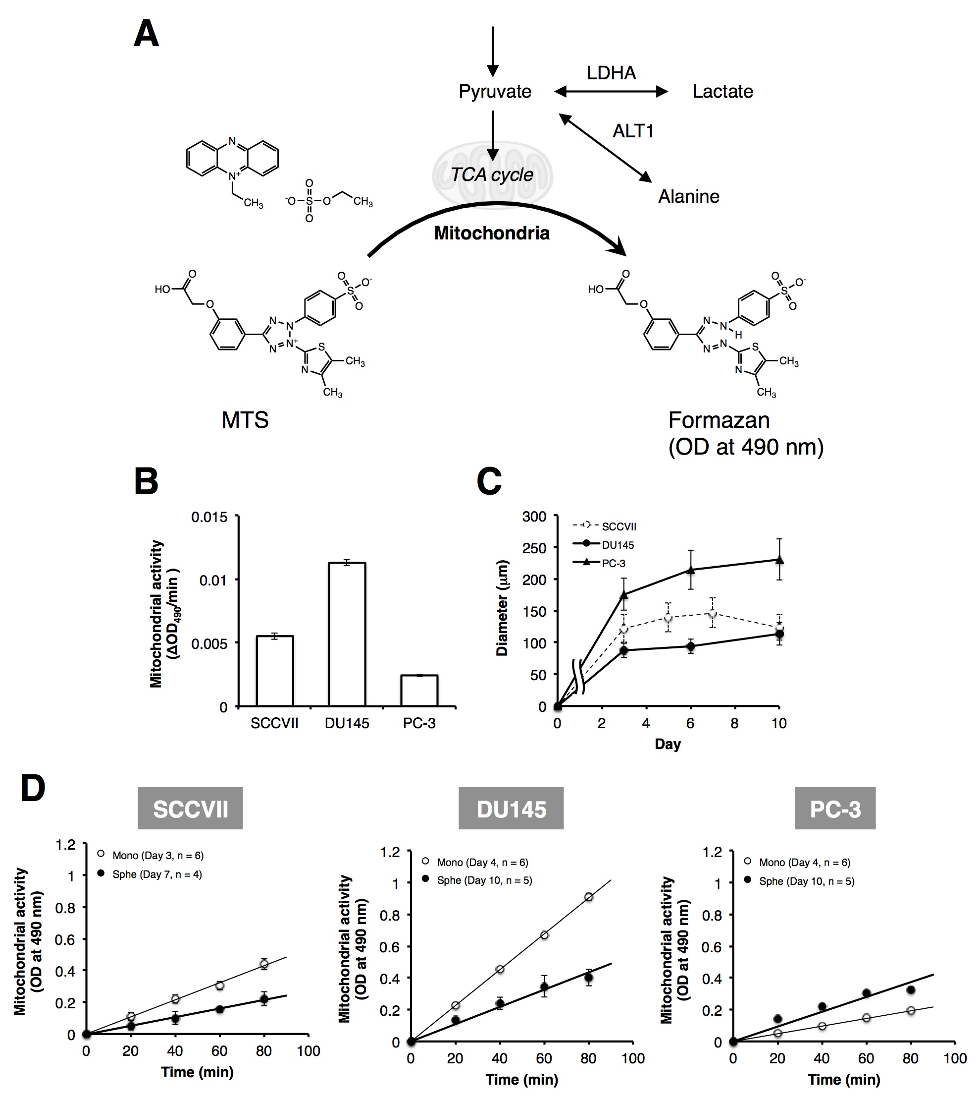
Figure S1. Measurement of the mitochondrial activity. A, Schematic representation of the conversion of MTS (Promega) to formazan. B, Mitochondrial activity (ΔOD₄₉₀/min) of each cell line. Data are presented as means ± SE (n = 6). C, Growth kinetics of spheroids. Spheroid size is shown in diameter (μm). Data are presented as means ± SD (n = 150). D, Monitoring mitochondrial activity in normal vs. spheroidal cultures of each cell type seeded at 5 × 10⁴ cells/ml (100 μl per well in a 96-well plate). Formazan formation in spheroids and standard cell cultures was detected by measuring absorbance at 490 nm every 20 min. Data are presented as means ± SE (n = 4-6).
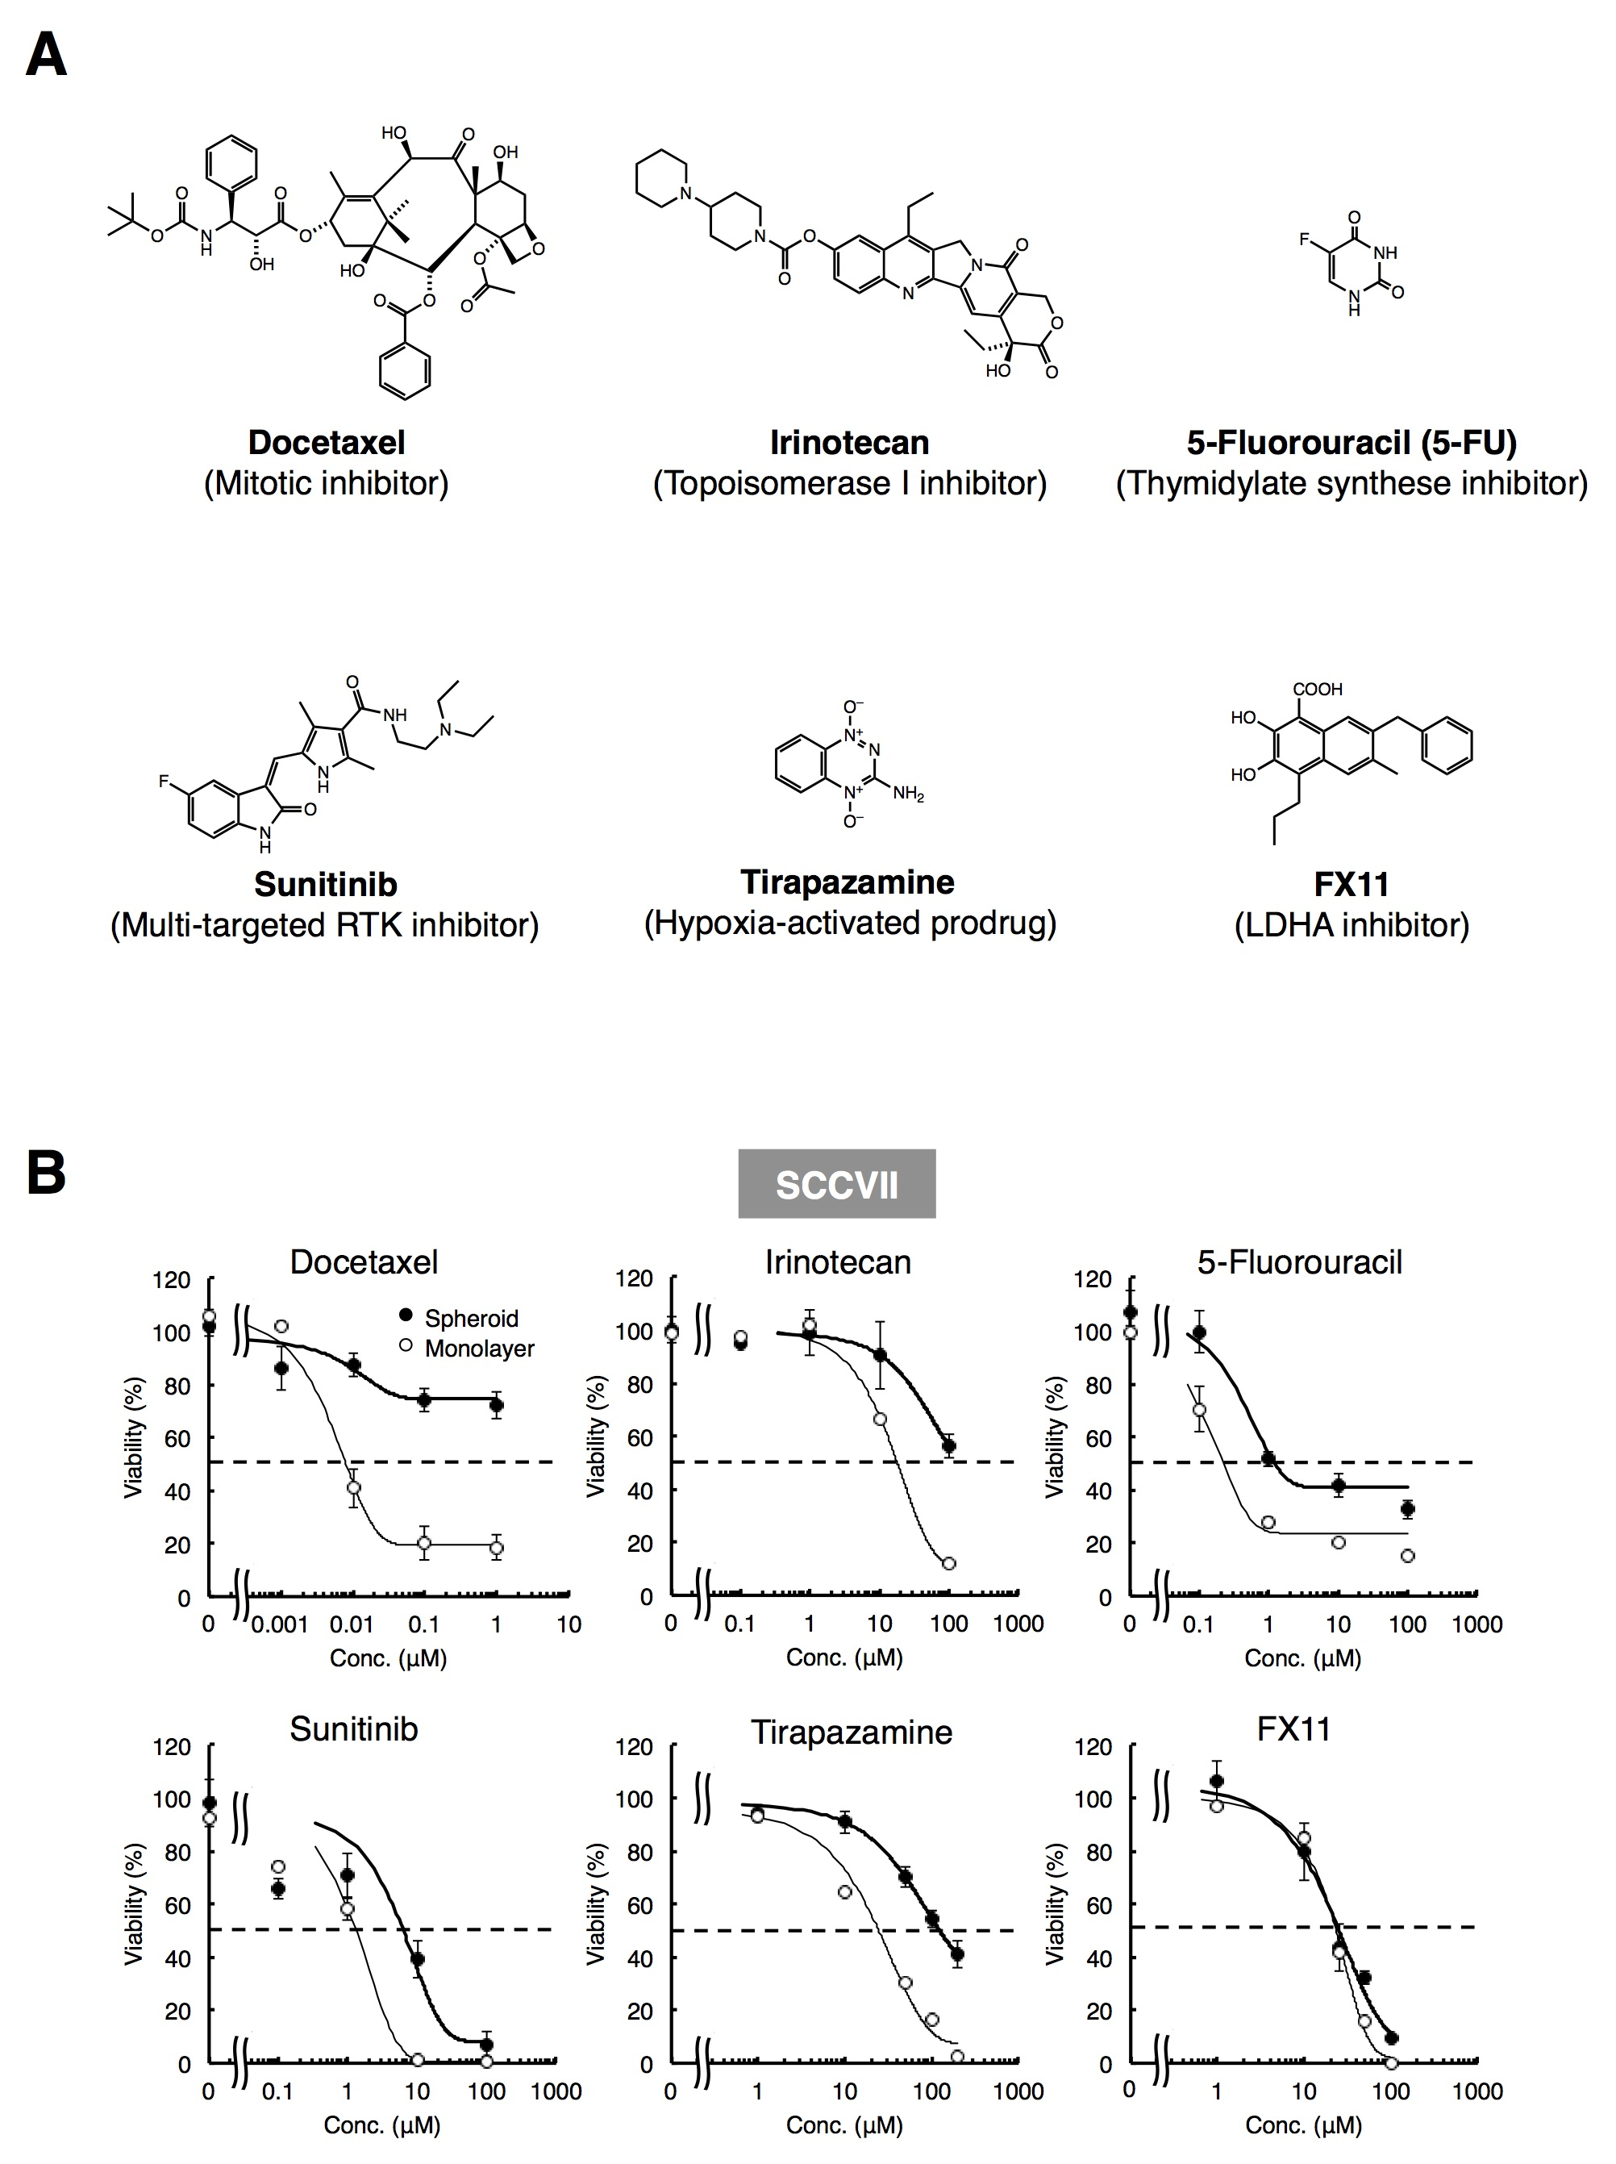

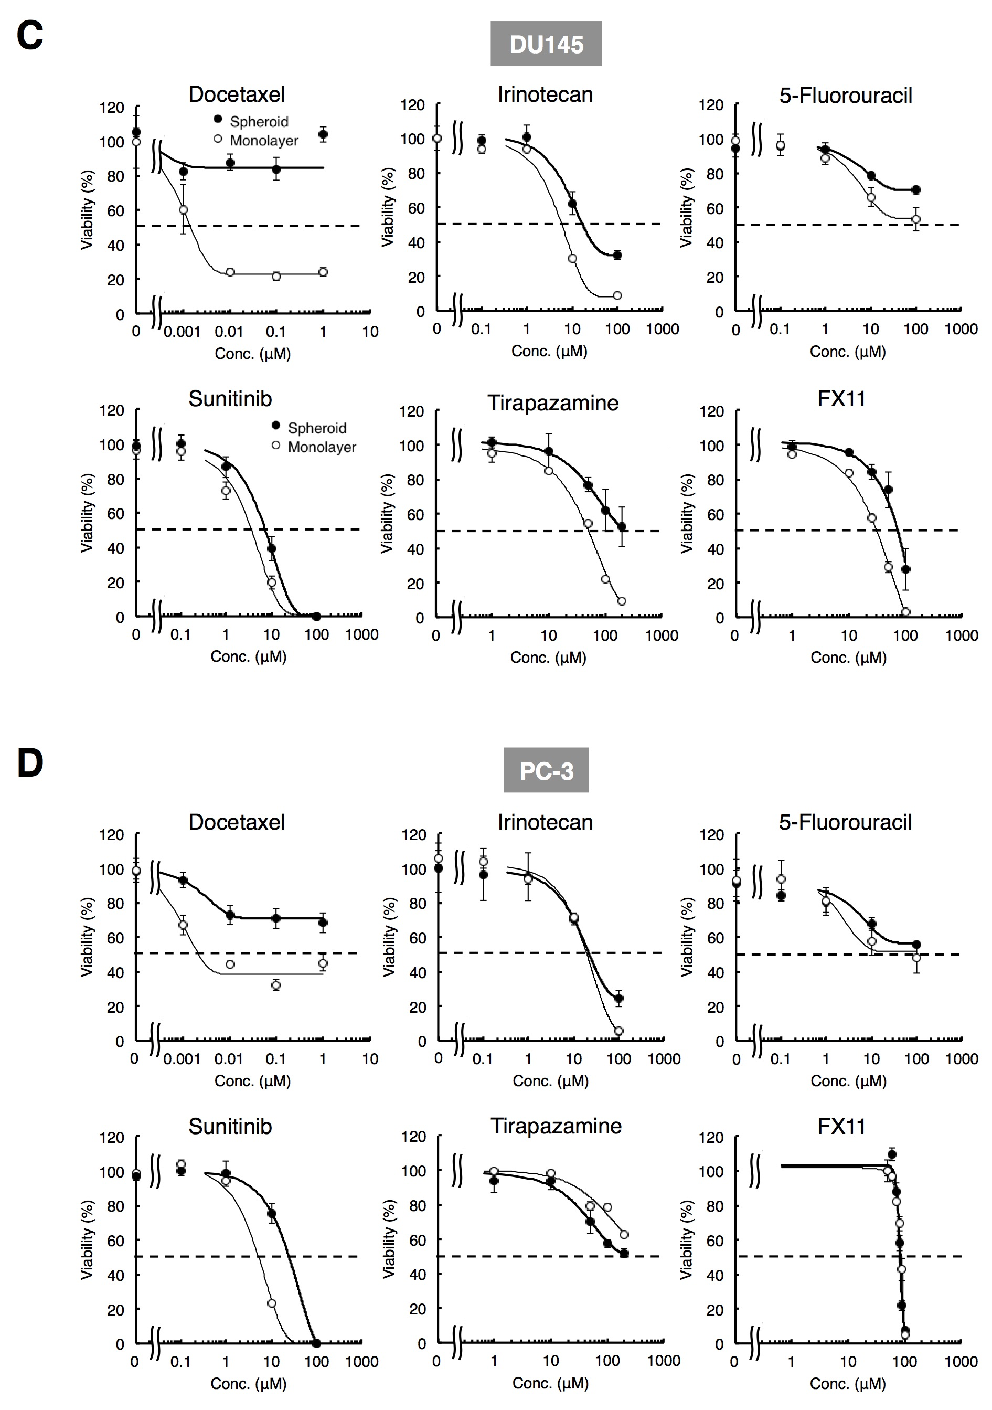

Figure S2. Inhibition of DU145 or PC-3 monolayer cells and spheroids growth under various concentrations of anti-tumor drugs. A, Chemical structure of the anti-tumor drugs used in this study. B-D, Concentration-response curves of monolayer cells (thin line) or spheroids (bold line) cultured in a 96-well plate format. B, SCCVII. C, DU145. D, PC-3. Data are presented as means ± SE (n = 3).
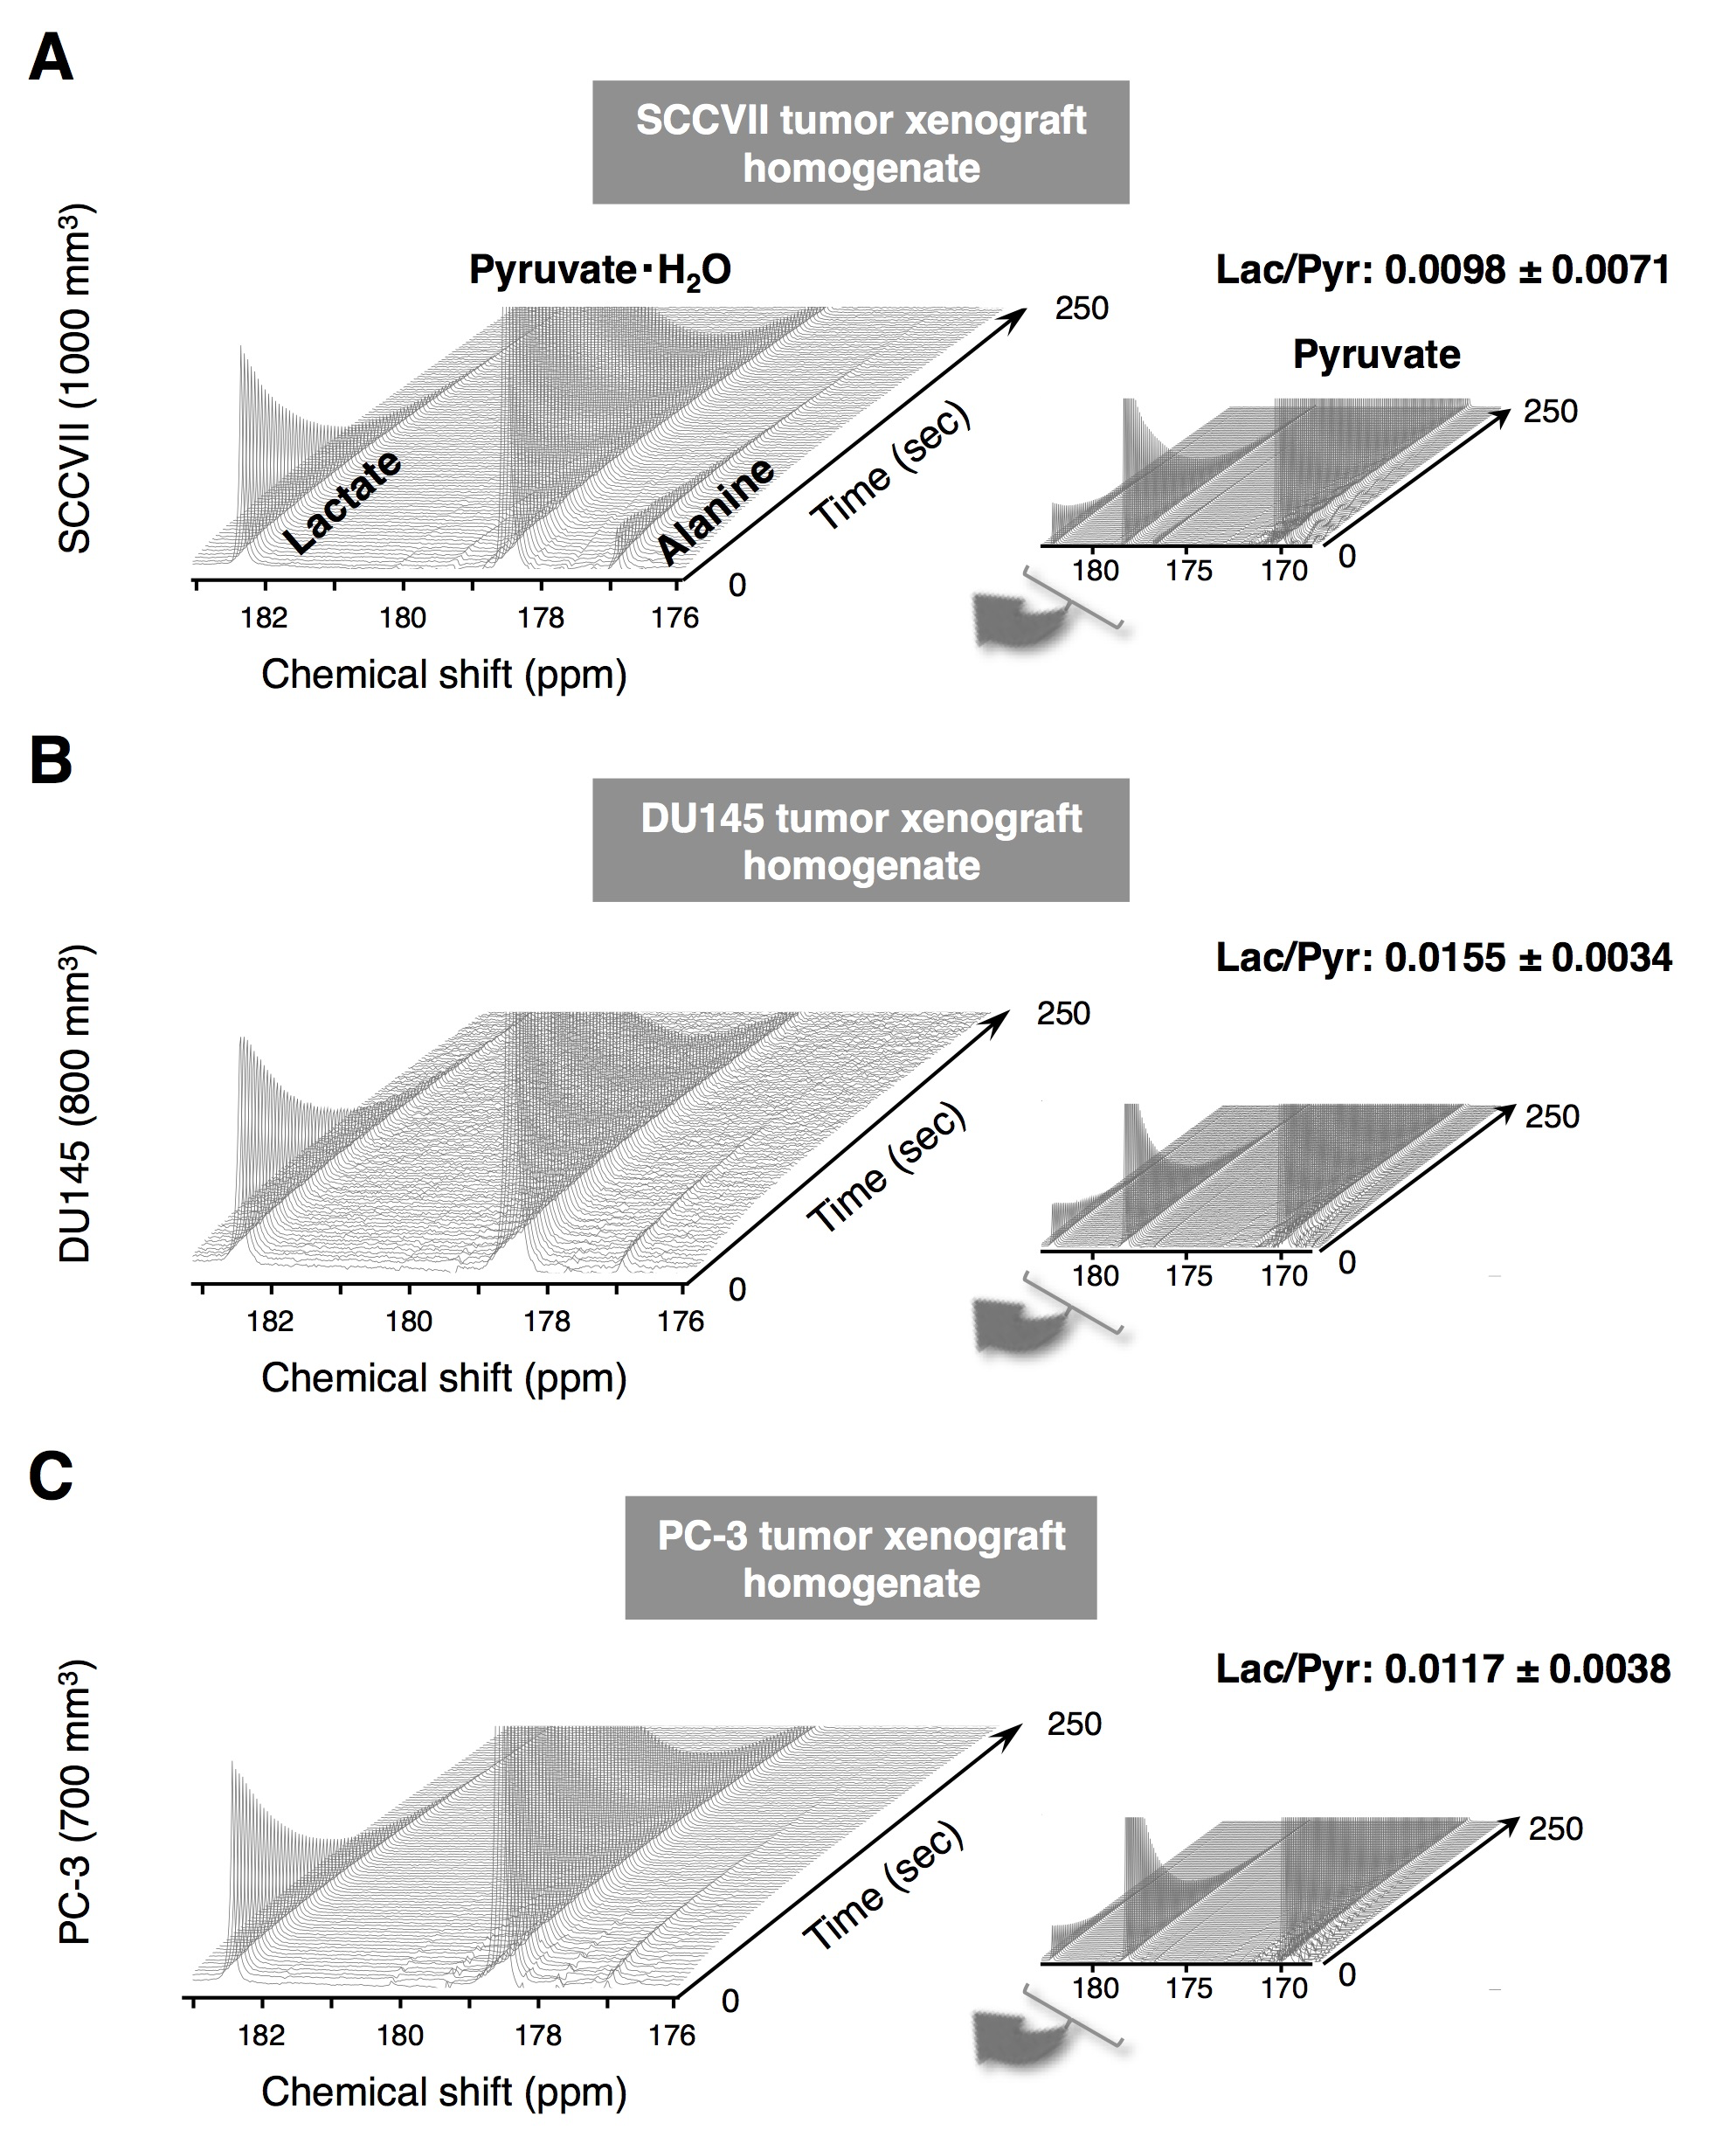

Figure S3 Representative spectra of HP [1-¹³C]pyruvate NMR spectroscopy of biopsy sample homogenates from mice bearing tumor xenografts (ex vivo) (3.35 T HyperSenseTM polarizer, 9.4 T Japan Redox JXI-400Z spectrometer). Exogeneous NADH (final concentration 1 mM) was added to each homogenate and mixed with hyperpolarized [1-¹³C]pyruvate (final concentration 94 mM) (repetition time: 2.5 s; flip angle: 5°). The Lac/Pyr ratio was calculated from 3 to 4 data for each tumor homogenate.

