Appendix A Variable Settings

A.1 Design of main variables
Concerning the existing literature, the independent, dependent, mediating, and control variables of this study are presented in Table A1.
Table A1 Variable description
Variable type | variable name | variable symbol | Variable Definition | References
dependent variable | Level of innovation in climate-friendly technologies | CFTI | Number of climate-friendly patents granted in cities/number of enterprises in cities | Lu et al. (2021), Li & Yang (2018), Nguyen et al. (2023)
dependent variable | Level of innovation in climate-friendly technologies | rCFTI | Number of climate-friendly patent applications in cities/number of businesses in cities | Lu et al. (2021), Li & Yang (2018), Nguyen et al. (2023)
independent variable | Environmental penalties | EPAP | Envadmin/number of businesses in the city, Envadmin is the number of times a business in the city has been penalized by the Department of Environmental Protection. | New in this article
independent variable | Environmental penalties | rEPAP | Values after normalization of Envadmin based on the extreme value normalization approach | New in this article
control variable | Level of economic development | PGDP | Ln (real GDP per capita in cities), base period 2008 | Chen et al., (2023), Chen et al., (2022), Zhang et al. (2022), Chen (2017), Wang& Shen (2016)
control variable | Level of industrial structure | INSR | 1*City's share of primary sector value added + 2*City's share of tertiary sector value added + 3*City's share of secondary sector value added
control variable | Level of foreign direct investment | FDI | FDI in cities/GDP in cities
control variable | Carbon intensity | CO2 | Carbon dioxide emissions from cities/number of enterprises in cities
control variable | Level of financial development | FSIZ | Cities' deposit and loan balances/cities' GDP
control variable | Financial efficiency | FEFF | Loan balances in cities/deposit balances in cities
control variable | Fiscal decentralization | FISD | Municipal revenues/national revenues
control variable | Government technical inputs | SCIP | Fiscal and technical expenditures of cities / GDP of cities
control variable | human capital | HCAP | Number of students enrolled in the city/total population of the city
control variable | Urbanization rate | CITY | Urban population of the city/total population of the city
control variable | Population density | PDEN | Total population of the city/area of the city
control variable | Size of population | POP | Ln (total population of the city)

A.2 Digital economy variable setting
There is a lack of publicly available data on the level of digital economy development at the city level. We constructed the indicator system shown in Table A2, collected data from Shanghai Da Zhi Cai Hui Technology Co., which obtains its data from the State Administration for Market Regulation of China, and used factor analysis to calculate the city's digital economy development index. The KMO and Bartlett's spherical tests are prerequisites for factor analysis. The KMO test showed that KMO= 0.788, which The chi-squared statistic of Bartlett's test was 61937.382, with a p-value of<0.0001. The 11 data items met the prerequisite conditions for factor analysis. Based on the factor analysis method, we measured the i city's digital economy development index decoindex for each city and then calculated the DEQ for each city. For each city and then calculated the DECO according to (decoindex -Min(decoindex))/(Max(decoindex)-Min(decoindex)) * 10 as the proxy variable for the level of digital economy.
Table A2 City Digital Economy Development Index System
Primary Indicator | Secondary Indicator | Original Indicator | References
City Digital Economy Development Index | Digital industrialization | Number of information and communication software and hardware enterprises | Chen et al. (2022a);  Ayres & Williams (2004);  Ma et al. (2019)
City Digital Economy Development Index | Digital industrialization | Number of data centers
City Digital Economy Development Index | Digital industrialization | Number of data element enterprises
City Digital Economy Development Index | Digital industrialization | Number of information and communication support enterprises
City Digital Economy Development Index | Digital industrialization | Number of emerging information and communication majors in colleges and universities
City Digital Economy Development Index | Digital industrialization | Number of colleges and universities offering new information and communication majors
City Digital Economy Development Index | Digital industrialization | Number of traditional information and communication majors in colleges and universities
City Digital Economy Development Index | Digital industrialization | Number of universities offering traditional information and communication majors
City Digital Economy Development Index | Industrial digitalisation | Number of digital primary industry enterprises | Chen et al. (2022a);  D’Souza & Williams (2017);  Rayna (2008)
City Digital Economy Development Index | Industrial digitalisation | Number of industrial enterprises in second place for digitalization
City Digital Economy Development Index | Industrial digitalisation | Number of industrial enterprises in third place for digitalization

A.3 Fintech variable setting
We refer to Chuntao Li et al. (2020) to build EB-level storage, NFC payment, differential privacy technology, big data, third-party payment, multi-party secure computing, distributed computing, equity crowdfunding and financing, Internet finance, machine learning, open banking, brain-like computing, quantitative finance, streaming computing, green computing, in-memory computing, blockchain, AI, cognitive computing, convergence architecture, Business Intelligence, Identity Verification, Deep Learning, Biometrics, Data Visualization, Data Mining, Digital Currency, Investment Decision Aid System, Graph Computing, Image Understanding, Net Connect, Text Mining, Internet of Things, Information Physical Systems, Virtual Reality, Mobile Internet, Mobile Payment, Billion Level Concurrency, Heterogeneous Data, Semantic Search, Speech Recognition, Cloud Computing, Credit Collection, Intelligent Financial Contracts, Smart Customer Service, Intelligent data analysis, intelligent investment, natural language processing, a total of 48 keywords and other keywords, match these keywords with the city, in the Baidu News Advanced Search by year search city + keywords, such as searching for "Tianjin + artificial intelligence". Then, the number of search results for all keywords in the same city is summarized to get the total search volume fintech. referring to Li et al. (2020), FTCH is obtained according to Ln(1+fintech), which is used as a proxy variable for the level of fintech development in the city.

Appendix B Results of Descriptive Statistics
Table B1 reports the descriptive statistics of the variables. As shown in the table, the mean value of the level of CFTI (CFTI) in Chinese cities is 0.2128, the minimum value is 0.0000, and the maximum value reaches 11.2137, with a large gap between the two. It is consistent with the basic national situation of unbalanced development. The mean value of the Environmental Protection Penalty (EPAP) is 0.1222, the minimum value is 0.0000, and the maximum value reaches 1.3165, and the gap between the two is also large, which is also in line with the basic situation of China's unbalanced development.
Table B1 Summary Statistics
Variables | Obs | Mean | Std.Dev. | Min | Max
CFTI | 3,293 | 0.2128 | 0.2297 | 0.0000 | 1.2137
rCFTI | 3,293 | 0.0895 | 0.0844 | 0.0000 | 0.4165
EPAP | 3,293 | 0.1222 | 0.2331 | 0.0000 | 1.3165
rEPAP | 3,293 | 0.2948 | 0.8839 | 0.0000 | 7.9805
FTCH | 3,293 | 2.6436 | 1.4883 | 0.0000 | 7.1405
PGDP | 3,293 | 3.5953 | 0.7324 | 1.2662 | 6.0982
FDI | 3,293 | 0.1819 | 0.1755 | 0.0000 | 1.0918
INDS | 3,293 | 2.2757 | 0.1433 | 1.8312 | 2.6431
CO2 | 3,293 | 0.3801 | 0.3356 | 0.0459 | 2.0639
FSIZ | 3,293 | 0.1855 | 0.7327 | 0.0001 | 4.1574
FEFF | 3,293 | 0.6595 | 0.1784 | 0.2890 | 1.1945
FISD | 3,293 | 0.1553 | 0.3191 | 0.0077 | 2.9433
SCIP | 3,293 | 0.0201 | 0.0891 | 0.0000 | 0.5754
HCAP | 3,293 | 0.1857 | 0.2319 | 0.0000 | 1.1410
CITY | 3,293 | 0.3648 | 0.2386 | 0.0618 | 1.0000
PDEN | 3,293 | 0.0441 | 0.0306 | 0.0011 | 0.1534
POP | 3,293 | 5.9108 | 0.6662 | 2.9226 | 8.1362

Appendix C Results of robust-type test analysis

C.1 Endogenous
Both theoretical analyses and empirical tests show that EPP significantly affect CFTI. Conversely, CFTI is the most important measure to combat climate change (Nguyen et al., 2023). The higher the level of CFTI, the friendlier the firm's environmental behavior and the less EPP may be imposed by the government. In addition, the data on EPP come from Shanghai Da Zhi Cai Hui Data Technology Co., Ltd, whose data comes from administrative organs. Ltd uses web crawler technology to crawl the data. This is bound to introduce measurement errors in EPP, thereby leading to the endogeneity of EPP.
To this end, ivEPAP was used as an instrumental variable by calculating the mean value of EPP in other cities for the same year, following Chen et al. (2022,2023), Faccio et al. (2011), and Laeven & Levine (2007, 2009). Both the EPP strength of other cities and the EPP strength of this city were affected by measurement error. Therefore, ivEPAP is correlated with EPAP, and ivEPAP satisfies the condition of "correlation". On the other hand, EPP in other cities are less likely to affect CFTI in this city, and ivEPAP satisfies the condition of "exogeneity". In addition, the higher the green space per capita (ivEPAP2), the better the environmental quality of the city, the lower the environmental pressure on the government, and the lower the strength of EPP it may impose. Therefore, ivEPAP2 is related to EPAP, and ivEPAP2 satisfies the "relevance" condition. In addition, the CFTI of enterprises is related to their production and operation, and it is difficult to relate to the green space per capita of the city. Therefore, ivEPAP2 can hardly influence the level of CFTI, and ivEPAP2 satisfies the condition of "exogeneity".
Using ivEPAP and ivEPAP2 as instrumental variables, this paper re-estimates equation (1) using the instrumental variable (IV) method. Then, we used weakiv for a weak instrumental variable test. The results show that the chi-square statistic of the AR test is 22.30, p<0.0001; and the chi-square statistic of the Wald test is 9.45, p= 0.0088. Therefore, ivEPAP and ivEPAP2 reject the hypothesis of weak instrumental variables, and ivEPAP and ivEPAP2 are valid instrumental variables.
Using CFTI as the dependent variable and ivEPAP and ivEPAP2 as instrumental variables, we re-estimate equation (1) using the instrumental variable method (IV) and the results are in column (1) of Table C1. From column (1), the coefficient on the quadratic term of EPP is significantly negative at the 1% significance level, and the coefficient on the one-time is significantly positive at the significance level. The conclusion that hypothesis H1 holds is robust to the exclusion of endogeneity.
Table C1 Estimation Results for Robustness Checks
 | (1) | (2) | (3) | (4) | (5)
Variables | CFTI | rCFTI | CFTI | CFTI | CFTI
EPAP | 2.3905*** | 0.0306** |  | 0.0771** | 0.0936***
 | (0.7101) | (0.0138) |  | (0.0344) | (0.0345)
EPAP2 | -1.8620*** | -0.0210* |  | -0.0500* | -0.0651**
 | (0.5577) | (0.0111) |  | (0.0255) | (0.0275)
rEPAP |  |  | 0.0339***
 |  |  | (0.0070)
rEPAP2 |  |  | -0.0033***
 |  |  | (0.0010)
FTCH |  |  |  | 0.0245***
 |  |  |  | (0.0038)
DECO |  |  |  | 0.1208***
 |  |  |  | (0.0225)
City FE | Yes | Yes | Yes | Yes | Yes
Year FE | Yes | Yes | Yes | Yes | Yes
Control | Yes | Yes | Yes | Yes | Yes
Observations | 3,293 | 3,293 | 3,293 | 3,293 | 3,293
R-squared | -0.2391 | 0.4552 | 0.4792 | 0.4885 | -
N | 282 | 282 | 282 | 282 | 282
Note: Instrumental variables pass validity tests. No R-squared under maximum likelihood estimation (MLE).

C.2 Changing the Measurement of the Level of Innovation in Climate-Friendly Technologies
Replacing the dependent variable with rCFTI and using EPAP as the independent variable, equation (1) is re-estimated using FE, and the results are shown in column (2) of Table C1. From column (2), after changing the measure of the level of CFTI, there is an inverted "U"-shaped nonlinear relationship between EPP and the level of prompting CFTI, and the conclusion that hypothesis H1 holds is robust.

C.3 Changing the measurement of EPP
Replacing the independent variable with rEPAP and using CFTI as the dependent variable, equation (1) is re-estimated using FE, and the results are shown in column (3) of Table C1. Column (3) shows that there is an inverse "U" nonlinear relationship between EPP and the level of CFTI, and the conclusion that hypothesis H1 is valid is robust.

C.4 Controlling for mediating variables
The latter analysis shows that both the level of digital economy development and the level of fintech development are favorable to CFTI. We tested the mechanism as a mediating variable and did not include it as a control variable. Here, we control for the level of digital economy development (DECO) and the level of fintech development (FTCH) and re-estimate equation (1) using FE, which results in column (4) of Table C1. From column (4), after controlling for the mediating variables, there is an inverted "U" shaped non-linear relationship between EPP and the level of CFTI, and the conclusion that hypothesis H1 holds is robust.

C.5 Change in estimation methodology
To mitigate the bias generated by the estimation method, we re-estimated equation (1) using the maximum likelihood estimation (MLE) method, and the results are shown in column (5) of Table C1. Column (5) shows that there is an inverse "U" nonlinear relationship between EPP and the level of CFTI, and the conclusion that hypothesis H1 holds is robust.

Appendix D Partial Appendix on Intermediation Effects

D.1 Plot of the relationship between EPP, the level of development of the digital economy, and the level of CFTI
Figure D1 shows the relationship between EPP, the level of development of the digital economy, and the level of CFTI. From Figure D1, there is an inverted "U" non-linear relationship between EPP and the level of digital economy development, while the latter is positively correlated with the level of CFTI.
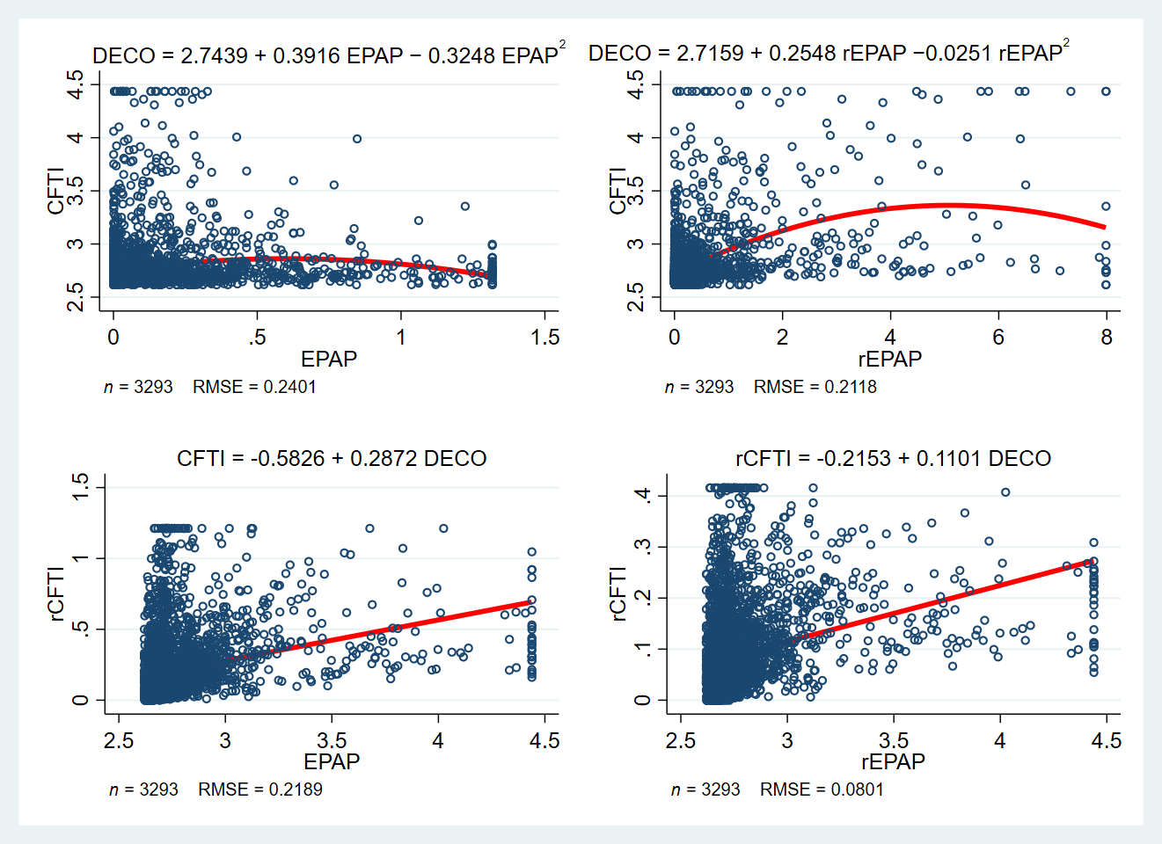
Figure D1 Relationship between EPP, level of digital economy development, and level of CFTI

D.2 Plot of the relationship between EPP, level of fintech development and level of CFTI
Figure D2 shows the relationship between EPP, the level of fintech development and the level of CFTI. From Figure D2, there is an inverted "U" nonlinear relationship between EPP and the level of fintech development, while the latter is positively correlated with the level of CFTI.
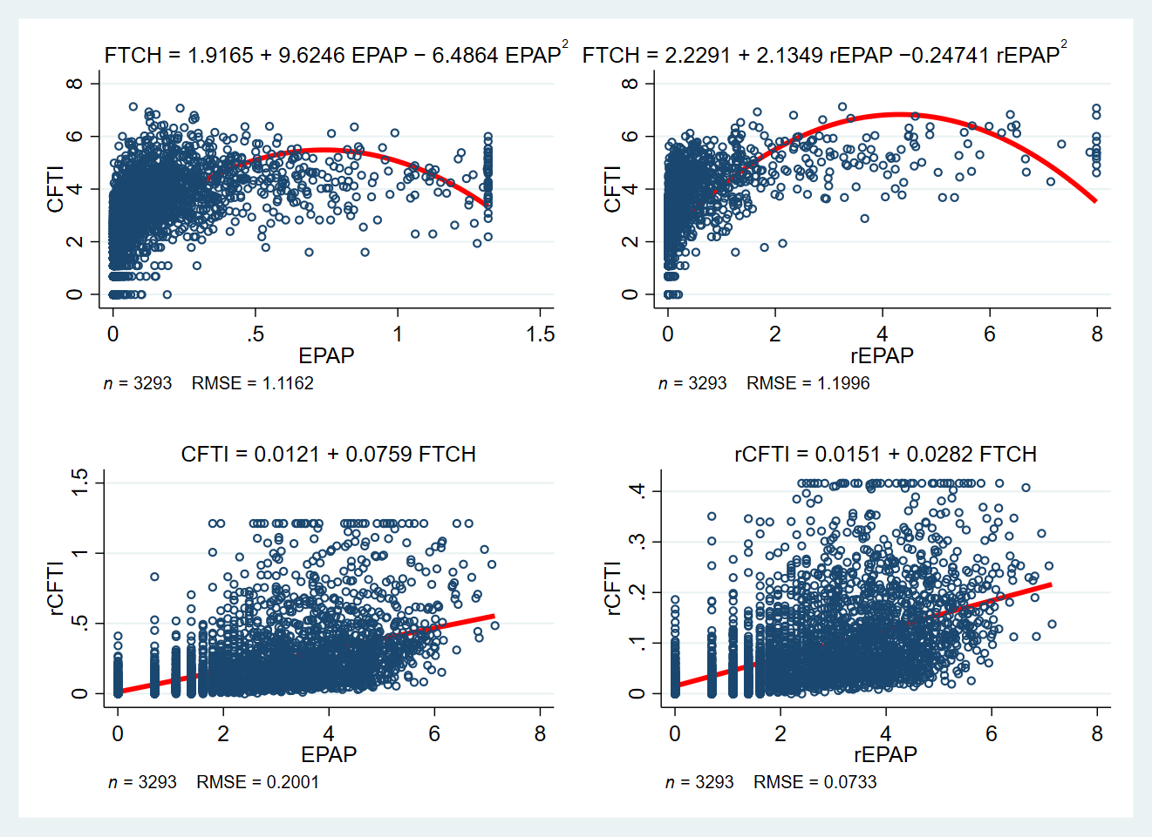
Figure D2 Relationship between EPP, level of fintech development and level of CFTI

