Supplementary information

Global Increase in Tropical Cyclone Rapid Slowdown Events in Offshore Regions

Jian Zhong¹, Chao Wang², Yuqin Wu¹, Yimei Sun¹, Hongyan Li¹

1 China Satellite Maritime Tracking and Control Department, Jiangyin, China;
2 State Key Laboratory of Climate System Prediction and Risk Management/Key Laboratory of Meteorological Disaster, Ministry of Education /Collaborative Innovation Center on Forecast and Evaluation of Meteorological Disasters, Nanjing University of Information Science and Technology, Nanjing, China

*Corresponding author: wangchao@nuist.edu.cn

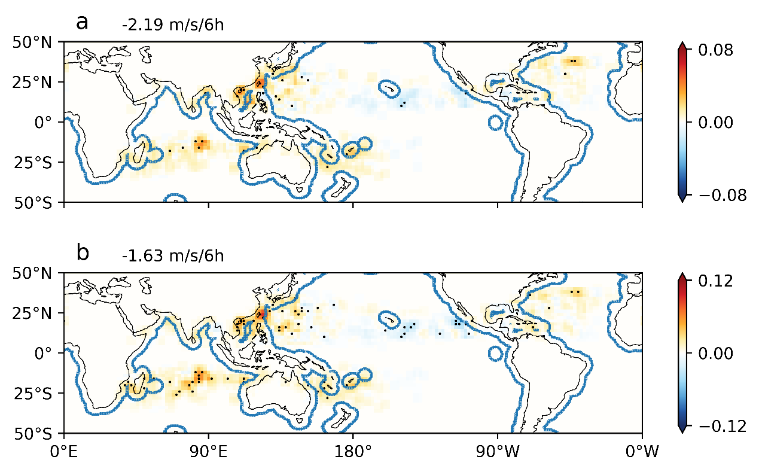
Supplementary Fig. 1 Spatially distribution of the linear trend of annual rapid slowdown (RS) counts. RS is defined as a rapid slowdown of at least (a) -2.19 m/s/6h and (b) -1.63 m/s/6h. The 42-year linear trend is calculated for each 2°×2° latitude-longitude grid, and the unit is count/decade. The black dots show areas 95% confidence for the linear fit is satisfied. The blue lines encompass the regions within 400 km of the coast. Data smoothing using a three-point smoother was performed for better display clarity.

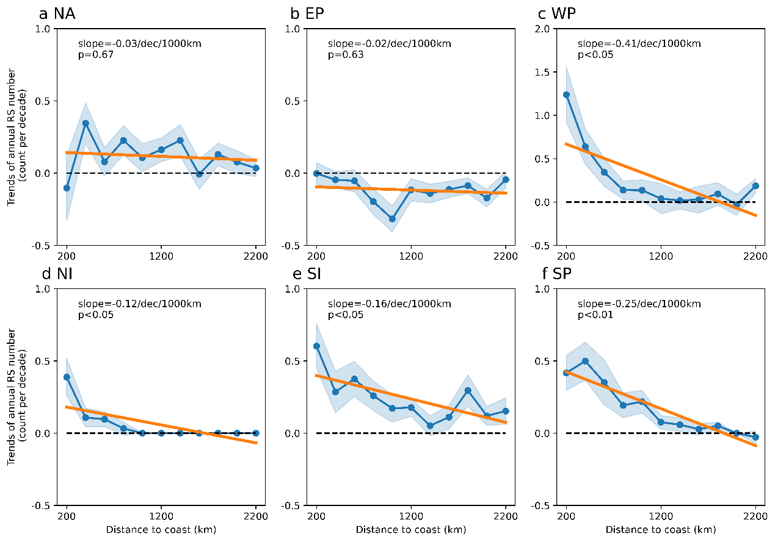
Supplementary Fig. 2 Trends of annual RS counts with different distance to land for the (a) North Atlantic (NA), (b) eastern Pacific (EP), (c) Western Pacific (WP), (d) North Indian Ocean (NI), (e) South Indian Ocean (SI), (f) South Pacific Ocean (SP). RS is defined as a rapid slowdown of at least -2.19 m/s/6h. The x-axis is the distance to land from 0-200km to 2000-2200 km, with a 200-km interval. The blue lines and shadings show linear temporal and a 95% confidence level of the trends, respectively. The orange lines show linear fits of the temporal trends as a function of distance to land. The slopes and p-values of the orange lines are shown on top of each subplot.

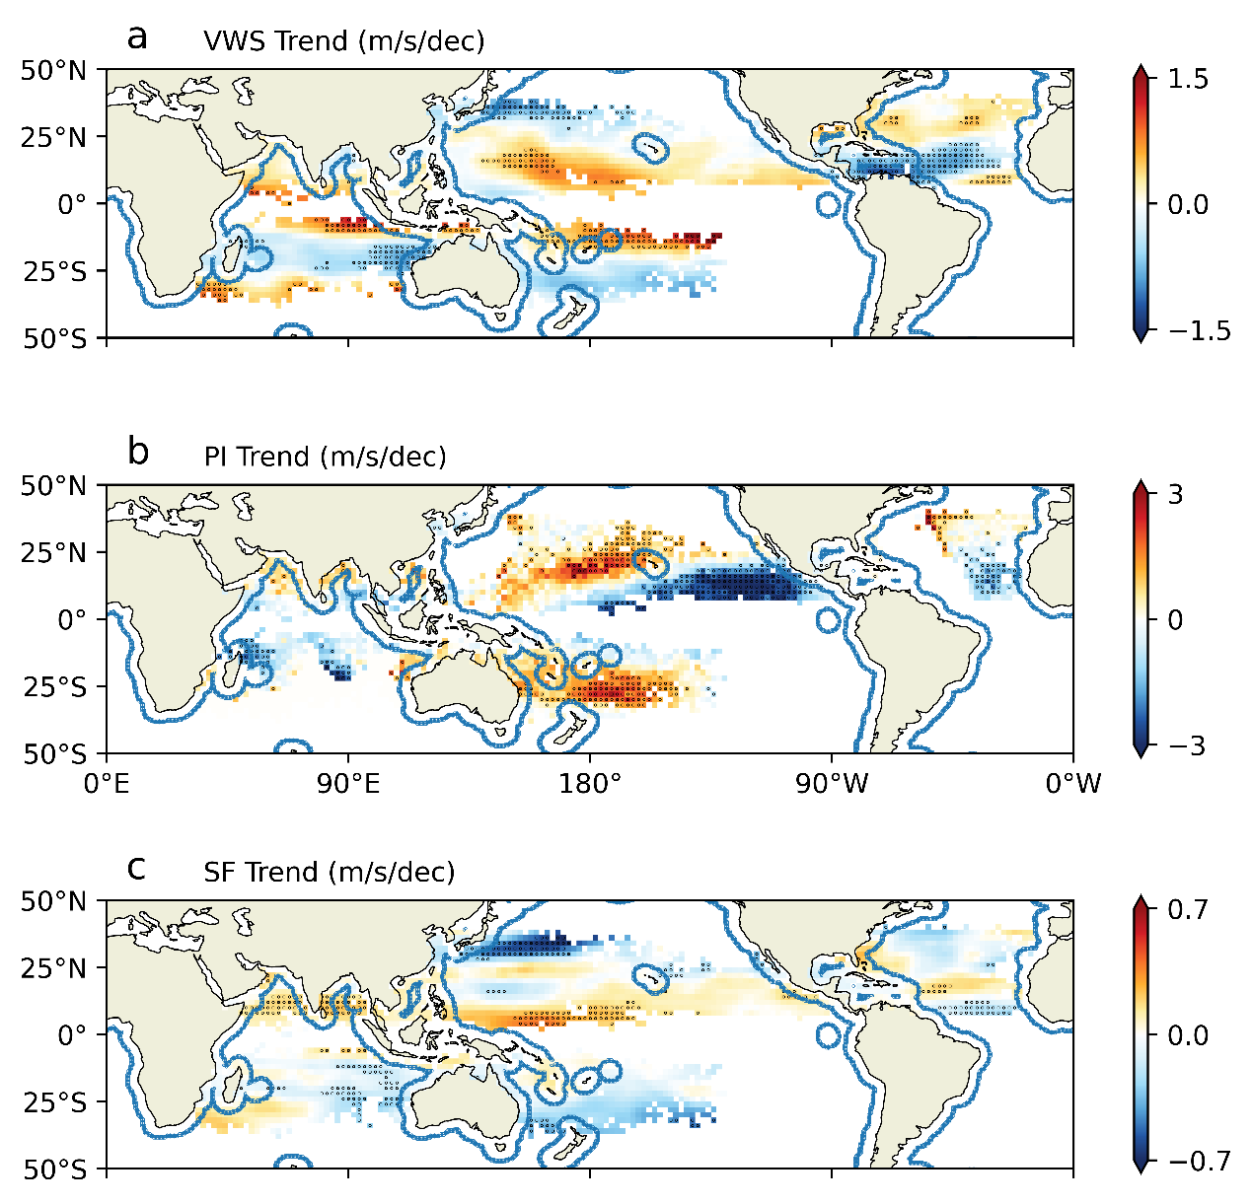
Supplementary Fig. 3 Spatial distribution of linear trend of ambient conditions, including (a) vertical wind shear (VWS) between 200- and 850-hPa, (b) potential intensity (PI), (c) steering flow (SF). The trend is estimated from ERA5 data. The black dots show areas where 95% confidence for the linear fit was satisfied. The blue lines encompass the regions within 400 km from the coast. The trends were calculated for each 2 by 2 longitude-latitude grid, and data smoothing using a three-point smoother was performed for better display clarity.

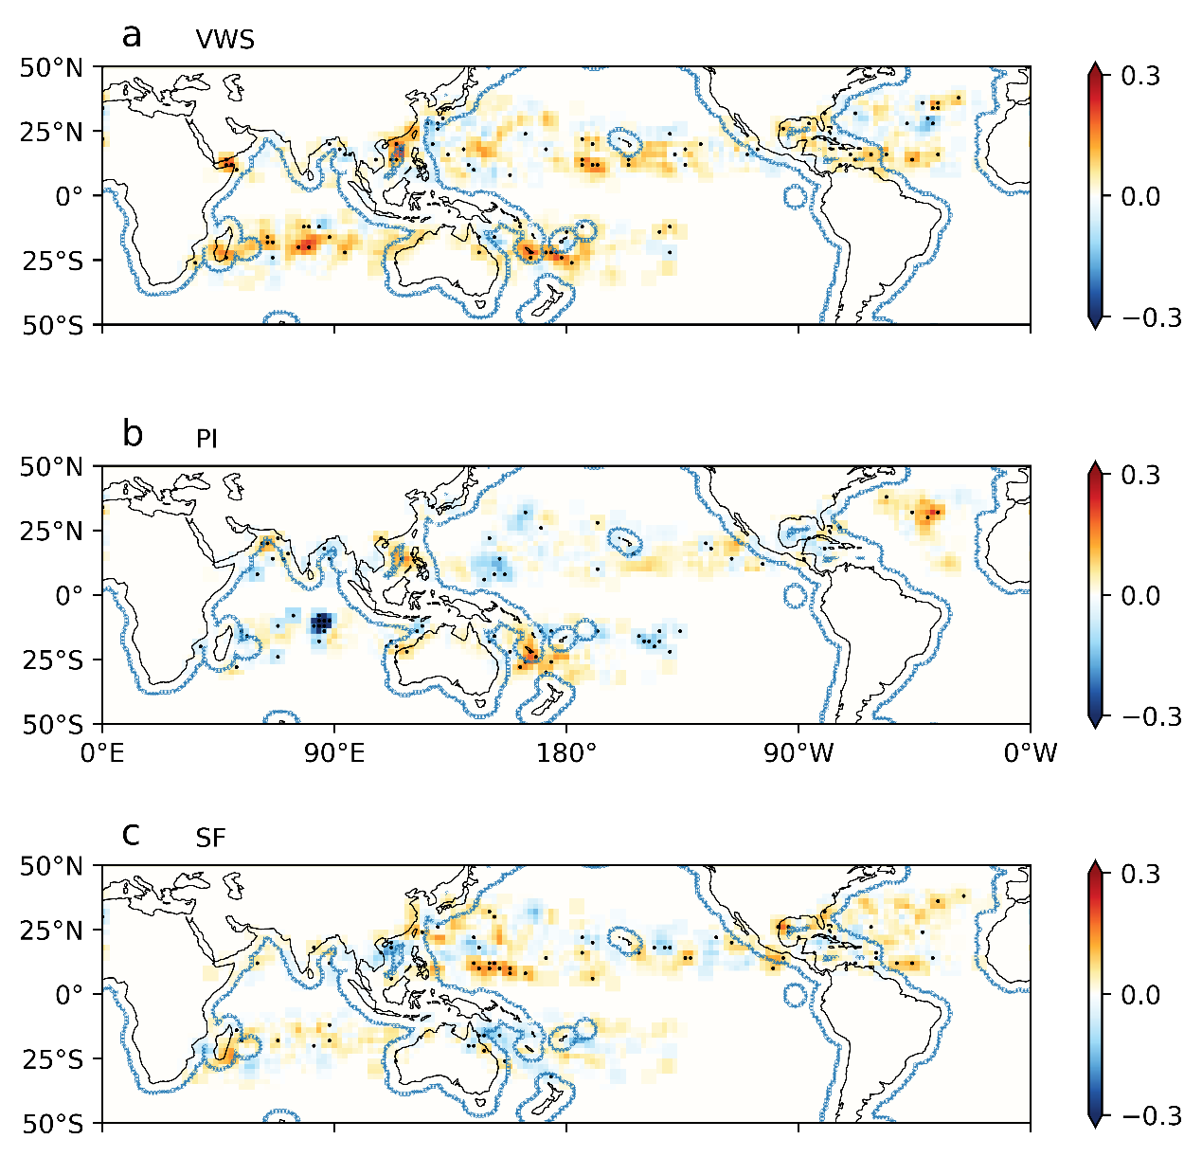
Supplementary Fig. 4 Spatial distribution of correlation between annual mean count of RS and environmental variables, including (a) vertical wind shear (VWS) between 200- and 850-hPa, (b) potential intensity (PI), (c) steering flow (SF). The correlation is estimated from ERA5 data. RS is defined as a slowdown of at least -1.63 m/s/6h for more events and robust analysis. The Black dots show areas where 95% confidence for the linear fit was satisfied. The blue lines encompass the regions within 400 km from the coast. The correlation was calculated for each 2 by 2 longitude-latitude grid, and data smoothing using a three-point smoother was performed for better display clarity.

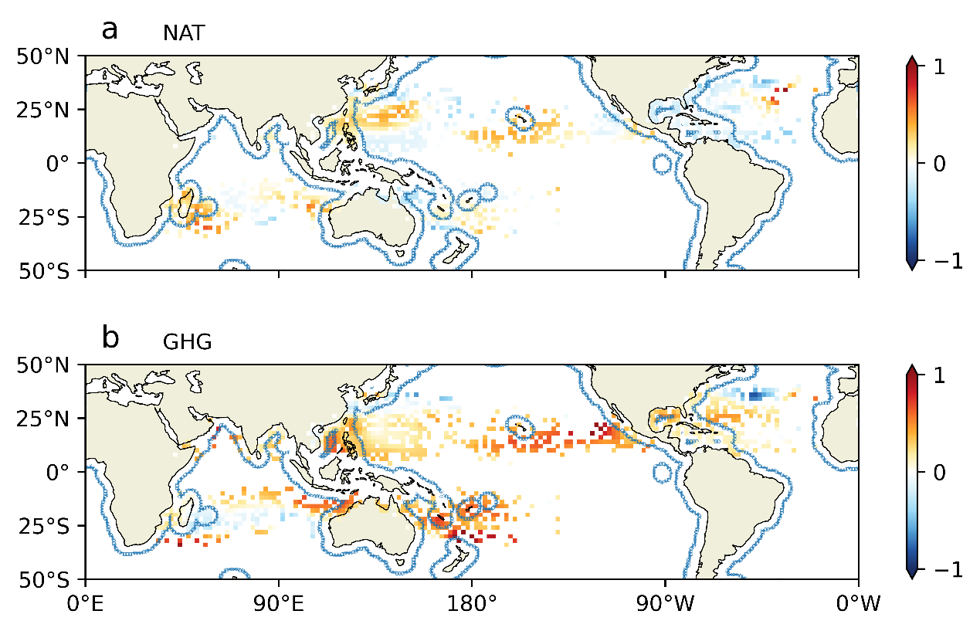

Supplementary Fig. 5 Spatial distribution of the linear trend of PI estimated using the mean of (a) NAT and (b) GHG simulation in CMIP6. The black dots show areas where the 95% confidence interval of the linear fit was satisfied. The blue lines encompass the regions within 400 km from the coast. The trends were calculated for each 2 × 2 longitude-latitude grid, and data smoothing using a three-point smoother was performed for better display clarity.

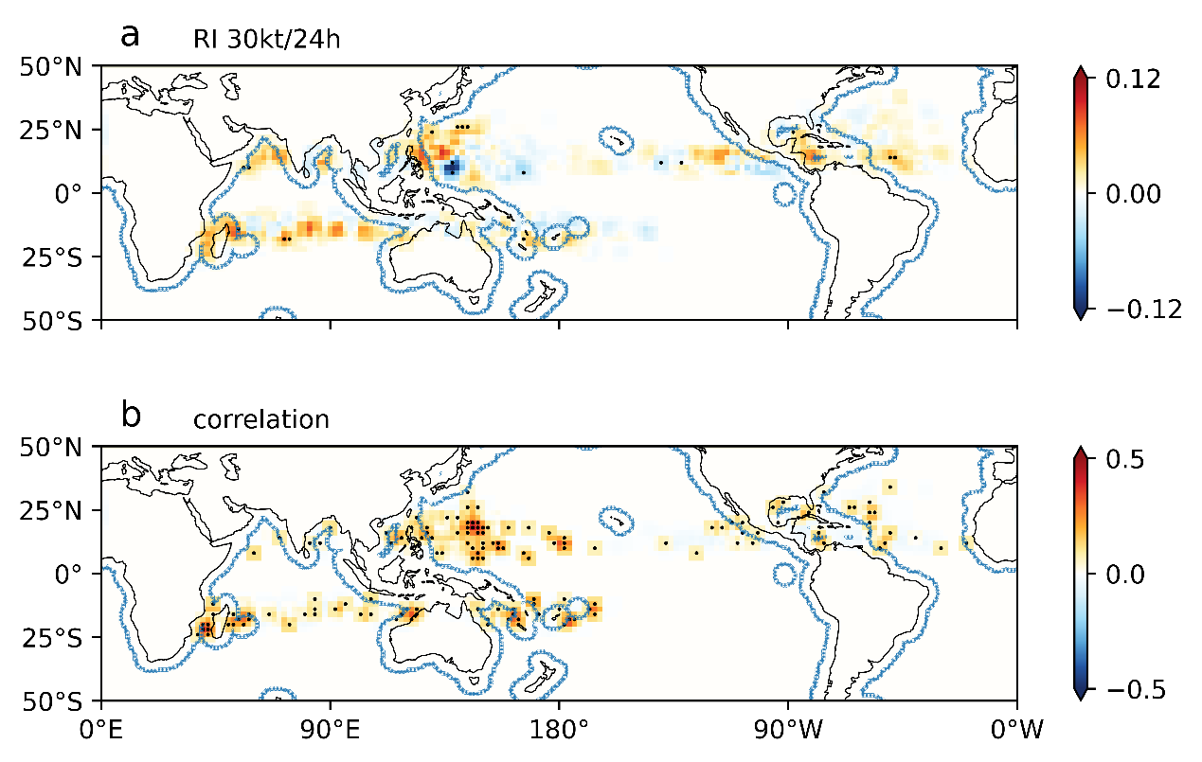
Supplementary Fig. 6 Spatial distribution of a the linear trend of RI, and b the correlation between annual mean count of RS and RI. RI is defined as a rapid intensification of at least 30 kt/24h, and RS is defined as a rapid slowdown of at least -1.63 m/s/6h for more events and robust analysis. The Black dots show areas where 95% confidence for the linear fit was satisfied. The blue lines encompass the regions within 400 km from the coast. The correlation was calculated for each 2 × 2 longitude-latitude grid, and data smoothing using a three-point smoother was performed for better display clarity.

