γ-Glutamyl Transferase-to-Platelet Ratio in Liver Fibrosis: A Comprehensive Meta-Analysis of Diagnostic Accuracy and Cut-Off Points
Ahmed N. Farrag, BPharm ^{1*}, Ahmed M. Kamel, PhD ¹*

¹ Clinical Pharmacy Department, College of Pharmacy, Cairo University, Cairo, 11562, Egypt
* Corresponding authors:
Ahmed N. Farrag, ✉ ahmed.farrag@cu.edu.eg, ORCID ID: 0000-0001-9241-0127
Ahmed M. Kamel, ✉ ahmedm.kamel@pharma.cu.edu.eg , ORCID ID: 0000-0002-3791-5998
Clinical Pharmacy Department, Faculty of Pharmacy, Cairo University, Cairo, 11562, Egypt
Tel.: +011-1203-9434, Fax: +011-202-25320005

Appendix B
1. Search Strategy 3
2. Characteristics of the included studies (n = 33) 4
3. Risk of bias assessment 7
4. Summary of risk of bias assessment 8
5. Pooled sensitivity and Specificity of GPR in diagnosing severe fibrosis (F3) 9
6. Heirerchical Summary Receiver Operating Curve for the different fibrosis staages 11
7. Association between Youden’s index and sensitivity estimates for Cirrhosis 12
8. Determination of thresholds for GPR 13
8.1 Optimal cut-point and performance of GPR in predicting significant fibrosis 14
8.2 Optimal cut-point and performance of GPR in predicting Cirrhosis 16
9. Performance of GPR in diagnosing and excluding significant fibrosis (left graph) and cirrhosis (right graph) using the suggested optimal cut-off thresholds 18
10. References 19

Search Strategy
Advanced Search Queries used in each electronic database was as follows:
PubMed:
- (glutamyl transpeptidase to platelet[Title/Abstract]) OR (glutamyl transferase to platelet[Title/Abstract]) > 85 results
- ((fibrosis[Title/Abstract]) OR (cirrhosis[Title/Abstract])) > 336,033 results
- A+B > 68 results
Scopus:
- TITLE-ABS-KEY (glutamyl AND transpeptidase AND to AND platelet) OR TITLE-ABS-KEY (glutamyl transpeptidase to platelet ratio) → 951 results
- TITLE-ABS-KEY ( fibrosis ) OR TITLE-ABS-KEY ( cirrhosis ) → 526,594 results
- A + B → 224 results

Web Of Sciences:
- AB=("glutamyl transferase to platelet ratio") OR AB=("glutamyl transpeptidase to platelet ratio") → 77 results
- AB=(fibrosis) OR AB=(cirrhosis) → 247,233 results
- A+B → 64 results

Characteristics of the included studies (n = 33)
Table S1. Detailed characteristics and performance for the included studies
Ref | Study | Year | Region | Fibrosis | Cut-off | S_{E} | S_{P} | PPV | NPV | N | M% | Age (Yrs) | Scoring System | Comorbidity
[1] | Purkayastha S. et al | 2023 | India | F2 | 0.28 | 0.76 | 0.65 | 0.71 | 0.70 | 48 | 0.92 | 38 | METAVIR | HBV
 |  |  |  | F3 | 0.32 | 0.86 | 0.71 | 0.42 | 0.92 | 48 | 0.93 | 39 | METAVIR | HBV
[2] | Sannur O. and Erol C. | 2022 | Turkey | F3 | 0.63 | 0.73 | 0.72 | 0.93 | 0.30 | 237 | 0.51 | 49 | ISHAK | HBV
[3] | Wang Z et al | 2022 | China | F2 | 0.55 | 0.57 | 0.75 | 0.67 | 0.66 | 436 | 0.72 | 40 | Sheuer | HBV
 |  |  |  | F3 | 0.87 | 0.63 | 0.83 | 0.43 | 0.92
[4] | Ying P. et al | 2022 | China | F2 | 0.21 | 0.60 | 0.77 | 0.70 | 0.68 | 382 | 0.74 | 39 | METAVIR | HBV
 |  |  |  | F3 | 0.22 | 0.69 | 0.68 | 0.41 | 0.87
 |  |  |  | F4 | 0.27 | 0.86 | 0.66 | 0.18 | 0.98
[5] | Xiang-An Z. et al | 2022 | China | F2 | 0.21 | 0.70 | 0.64 | 0.65 | 0.69 | 184 | 0.52 | 43 | Sheuer | HBV
 |  |  |  | F3 | 0.24 | 0.81 | 0.65 | 0.45 | 0.91
 |  |  |  | F4 | 0.28 | 0.83 | 0.67 | 0.32 | 0.95
[6] | Xingxiang L. et al | 2022 | China | F2 | 0.57 | 0.66 | 0.82 | 0.37 | 0.94 | 180 | 0.58 | 45 | METAVIR | HBV
 |  |  |  | F3 | 0.64 | 0.66 | 0.80 | 0.77 | 0.69
 |  |  |  | F4 | 0.64 | 0.76 | 0.72 | 0.55 | 0.87
[7] | Min-Jun L. et al | 2022 | China | F2 | 0.32 | 0.86 | 0.67 | 0.76 | 0.80 | 211 | 0.81 | 41 | METAVIR | HBV/HCV/Autoimmune/Drug induced/NAFLD
 |  |  |  | F3 | 0.32 | 0.91 | 0.57 | 0.56 | 0.91
 |  |  |  | F4 | 0.56 | 0.75 | 0.62 | 0.21 | 0.95
[8] | Peng, X. et al | 2022 | China | F2 | 0.23 | 0.28 | 0.85 | 0.64 | 0.54 | 227 | 0.42 | 41 | METAVIR | HBV
 |  |  |  | F3 | 0.53 | 0.91 | 0.65 | 0.60 | 0.93
 |  |  |  | F4 | 1.92 | 0.43 | 0.82 | 0.72 | 0.56
[9] | Ekin N. et al | 2022 | Turkey | F2 | 0.24 | 0.52 | 0.86 | 0.40 | 0.91 | 1,454 | 0.66 | 33 | ISHAK | HBV
 |  |  |  | F3 | 0.23 | 0.67 | 0.83 | 0.18 | 0.98
 |  |  |  | F4 | 0.28 | 0.75 | 0.89 | 0.16 | 0.99
[10] | Xiaoqing L. et al | 2022 | China | F2 | 0.32 | 0.71 | 0.57 | 0.77 | 0.49 | 617 | 0.77 | 37 | Sheuer | HBV
 |  |  |  | F2 | 0.43 | 0.64 | 0.71 | 0.82 | 0.49
 |  |  |  | F4 | 0.56 | 0.78 | 0.61 | 0.23 | 0.95
 |  |  |  | F4 | 0.44 | 0.89 | 0.54 | 0.23 | 0.97
[11] | Zongguo Y. et al | 2021 | China | F2 | 0.55 | 0.72 | 0.73 | 0.72 | 0.73 | 1,125 | 0.65 | 37 | Scheuer | HBV, HCV, ALD, NAFLD, AID
[12] | Chen Y. et al | 2020 | China | F2 | 0.32 | 0.72 | 0.65 | 0.83 | 0.50 | 1,005 | 0.82 | 30 | METAVIR | HBV
 |  |  |  | F3 | 0.32 | 0.87 | 0.54 | 0.51 | 0.88
 |  |  |  | F4 | 0.56 | 0.33 | 0.65 | 0.15 | 0.84
[13] | Wang L. et al | 2020 | China | F2 | 0.42 | 0.38 | 0.91 | 0.68 | 0.75 | 370 | 0.67 | 35 | Scheuer | HBV
[14] | Qiang Li. et al | 2020 | China | F2 | 0.32 | 0.36 | 0.97 | 0.89 | 0.69 | 116 | 0.66 | 36 | METAVIR | HBV and NAFLD
 |  |  |  | F3 | 0.32 | 0.56 | 0.96 | 0.80 | 0.89
 |  |  |  | F4 | 0.56 | 0.75 | 0.93 | 0.54 | 0.97
[15] | Lulu Y. et al | 2020 | China | F1 | 0.32 | 0.46 | 0.96 | 1.00 | 0.06 | 239 | 0.79 | 52 | Scheuer | HBV
 |  |  |  | F2 | 0.32 | 0.71 | 0.75 | 0.95 | 0.29
 |  |  |  | F3 | 0.32 | 0.79 | 0.64 | 0.84 | 0.56
 |  |  |  | F4 | 0.56 | 0.78 | 0.69 | 0.73 | 0.75
[16] | Zeng T. et al | 2018 | China | F4 | 0.56 | 0.90 | 0.39 | 0.59 | 0.79 | 76 | 0.22 | 57 | METAVIR | AIH
[17] | Wang W. et al | 2019 | China | F2 | 0.23-0.71 | 0.22 | 0.76 | 0.20 | 0.78 | 127 | 0.73 | 25 | METAVIR | HBV
 |  |  |  | F2 | 0.26-0.56 | 0.50 | 0.82 | 0.53 | 0.80 | 154 | 0.72 | 36 | METAVIR | HBV
 |  |  |  | F2 | 0.27-0.57 | 0.64 | 0.80 | 0.67 | 0.78 | 122 | 0.75 | 45 | METAVIR | HBV
 |  |  |  | F2 | 0.39-0.87 | 0.68 | 0.75 | 0.70 | 0.73 | 102 | 0.71 | 57 | METAVIR | HBV
[18] | Liu D. et al | 2018 | China | F3 | 0.352-0.428 | 0.59 | 0.81 | 0.86 | 0.50 | 1,326 | 0.69 | 36 | Scheuer | HBeAg +
 |  |  |  | F4 | 0.632-0.711 | 0.81 | 0.64 | 0.39 | 0.93
 |  |  |  | F3 | 0.365-0.590 | 0.60 | 0.79 | 0.78 | 0.62 | 1,017 | 0.68 | 43 | Scheuer | HBeAg -
 |  |  |  | F4 | 0.602-0.612 | 0.83 | 0.68 | 0.39 | 0.94
[19] | Zhang G. et al | 2019 | China | F2 | 0.15 | 0.90 | 0.27 | 0.55 | 0.74 | 145 | 0.85 | 38 | METAVIR | HBV and NAFLD
 |  |  |  | F4 | 0.56 | 0.65 | 0.90 | 0.52 | 0.94
[20] | Xu L. et al | 2019 | China | F3 | 0.17 | 0.97 | 0.26 | 0.22 | 0.98 | 711 | 0.47 | 61 | METAVIR | HCV ± HCC
[21] | Wang J. et al | 2019 | China | F2 | 0.43 | 0.59 | 0.72 | 0.84 | 0.40 | 294 | 0.75 | 37 | METAVIR | HBV
[22] | Yu K. et al | 2019 | China | F3 | 0.27 | 0.79 | 0.65 | 0.33 | 0.93 | 160 | 0.74 | 35 | METAVIR | HBV
[23] | Zhang W. et al | 2017 | China | F2 | 0.32 | 0.40 | 0.78 | 0.85 | 0.30 | 1,168 | 0.75 | 36 | METAVIR | HBV
 |  |  |  | F3 | 0.32 | 0.47 | 0.79 | 0.72 | 0.55
 |  |  |  | F4 | 0.56 | 0.36 | 0.85 | 0.46 | 0.78
[24] | Lu X. et al | 2017 | China | F2 | 0.51 | 0.71 | 0.74 | 0.91 | 0.42 | 396 | 0.56 | 40 | METAVIR | HBV
 |  |  |  | F3 | 0.91 | 0.86 | 0.64 | 0.72 | 0.81
 |  |  |  | F4 | 1.15 | 0.79 | 0.64 | 0.50 | 0.87
[25] | Liu D. et al | 2017 | China | F2 | 0.43 | 0.67 | 0.77 | 0.85 | 0.54 | 1,157 | 0.71 | 33 | METAVIR | HBeAg +
 |  |  |  | F2 | 0.32 | 0.74 | 0.67 | 0.82 | 0.57
 |  |  |  | F2 | 0.50 | 0.60 | 0.81 | 0.86 | 0.51
 |  |  |  | F3 | 0.55 | 0.73 | 0.74 | 0.63 | 0.82
 |  |  |  | F3 | 0.32 | 0.88 | 0.56 | 0.55 | 0.89
 |  |  |  | F3 | 0.50 | 0.74 | 0.71 | 0.61 | 0.82
 |  |  |  | F4 | 0.65 | 0.77 | 0.71 | 0.43 | 0.92
 |  |  |  | F4 | 0.56 | 0.79 | 0.67 | 0.40 | 0.92
 |  |  |  | F4 | 0.50 | 0.81 | 0.64 | 0.38 | 0.92
 |  |  |  | F2 | 0.39 | 0.68 | 0.73 | 0.78 | 0.62 | 859 | 0.68 | 43 | METAVIR | HBeAg -
 |  |  |  | F2 | 0.32 | 0.73 | 0.65 | 0.75 | 0.64
 |  |  |  | F2 | 0.50 | 0.60 | 0.78 | 0.79 | 0.59
 |  |  |  | F3 | 0.56 | 0.74 | 0.76 | 0.62 | 0.85
 |  |  |  | F3 | 0.32 | 0.87 | 0.59 | 0.52 | 0.90
 |  |  |  | F3 | 0.50 | 0.76 | 0.72 | 0.59 | 0.85
 |  |  |  | F4 | 0.81 | 0.75 | 0.79 | 0.48 | 0.93
 |  |  |  | F4 | 0.56 | 0.82 | 0.69 | 0.40 | 0.94
 |  |  |  | F4 | 0.50 | 0.85 | 0.66 | 0.39 | 0.94
[26] | Wu X. et al | 2017 | China | F2 | 0.22 | 0.87 | 0.45 | 0.27 | 0.93 | 322 | 0.65 | 39 | Scheuer | HBV
 |  |  |  | F3 | 0.37 | 0.74 | 0.73 | 0.20 | 0.97
[27] | Tianyi R. et al | 2017 | China | F1 | 0.26 | 0.80 | 0.65 | 0.88 | 0.43 | 160 | 0.63 | 39 | METAVIR | HBV
 |  |  |  | F2 | 0.35 | 0.77 | 0.64 | 0.59 | 0.80
 |  |  |  | F3 | 0.38 | 0.76 | 0.60 | 0.48 | 0.86
 |  |  |  | F4 | 0.72 | 0.81 | 0.50 | 0.28 | 0.91
[28] | Qiang L. et al | 2017 | China | F2 | 0.49 | 0.83 | 0.80 | 0.65 | 0.91 | 131 | 0.73 | 39 | METAVIR | HBV
 |  |  |  | F3 | 0.62 | 0.90 | 0.75 | 0.39 | 0.98
 |  |  |  | F4 | 0.74 | 1.00 | 0.81 | 0.30 | 1.00
[29] | Rui H. et al | 2017 | China | F2 | 0.34 | 0.77 | 0.65 | 0.84 | 0.53 | 256 | 0.80 | 38 | METAVIR | HBV
 |  |  |  | F3 | 0.41 | 0.83 | 0.69 | 0.79 | 0.74
 |  |  |  | F4 | 0.64 | 0.72 | 0.71 | 0.54 | 0.84
[30] | Rong-Qi W. et al | 2016 | China | F2 | 0.46 | 0.59 | 0.78 | 0.76 | 0.62 | 312 | 0.73 | 35 | METAVIR | HBV
 |  |  |  | F3 | 0.53 | 0.76 | 0.81 | 0.61 | 0.89
 |  |  |  | F4 | 0.65 | 0.82 | 0.77 | 0.42 | 0.95
[31] | Li Q. et al (a) | 2016 | China | F2 | 0.34 | 0.49 | 0.74 | 0.44 | 0.77 | 401 | 0.63 | 34 | METAVIR | HBV
 |  |  |  | F2 | 0.65 | 0.26 | 0.96 | 0.72 | 0.75
 |  |  |  | F3 | 0.57 | 0.47 | 0.90 | 0.39 | 0.71
 |  |  |  | F3 | 0.89 | 0.33 | 0.95 | 0.49 | 0.72
 |  |  |  | F4 | 0.93 | 0.53 | 0.94 | 0.28 | 0.70
 |  |  |  | F4 | 1.11 | 0.47 | 0.95 | 0.30 | 0.70
[32] | Li Q. et al (b) | 2016 | China | F2 | 0.61 | 0.71 | 0.69 | 0.68 | 0.73 | 372 | 0.69 | 39 | Scheuer | HBV
 |  |  |  | F3 | 0.65 | 0.77 | 0.64 | 0.53 | 0.84
 |  |  |  | F4 | 0.72 | 0.81 | 0.53 | 0.29 | 0.92
[33] | Lemoine M. et al | 2016 | Gambia | F2 | 0.32 | 0.83 | 0.69 | 0.63 | 0.86 | 135 | 0.78 | 34 | METAVIR | HBV
 |  |  |  | F3 | 0.32 | 0.86 | 0.64 | 0.53 | 0.91
 |  |  |  | F4 | 0.56 | 0.85 | 0.76 | 0.39 | 0.97
[33] | Lemoine M. et al | 2016 | France | F2 | 0.32 | 0.73 | 0.49 | 0.56 | 0.67 | 63 | 0.65 | 38 | METAVIR | HBV
 |  |  |  | F3 | 0.32 | 0.80 | 0.44 | 0.31 | 0.88
 |  |  |  | F4 | 0.56 | 1.00 | 0.68 | 0.17 | 1.00
[33] | Lemoine M. et al | 2016 | Senegal | F2 | 0.32 | 0.50 | 0.83 | 0.59 | 0.78 | 80 | 0.84 | 28 | METAVIR | HBV
 |  |  |  | F3 | 0.32 | 0.89 | 0.80 | 0.36 | 0.98

Risk of bias assessment
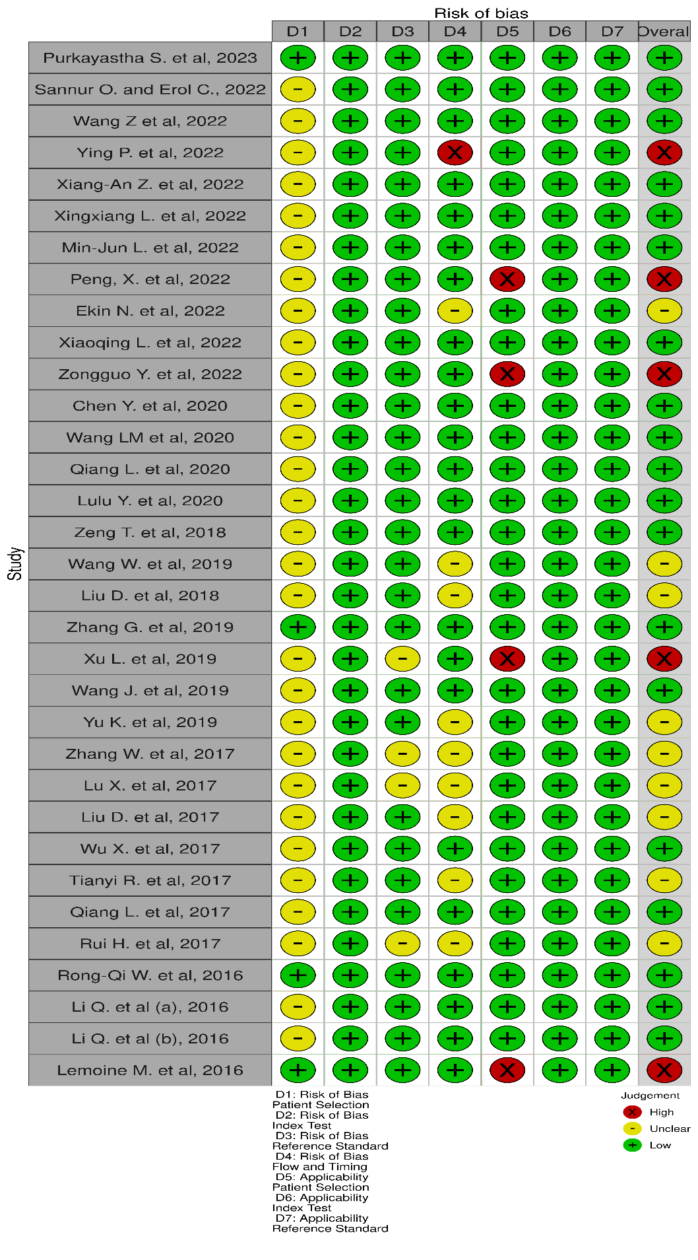
Figure S1: Risk of Bias Traffic Plot

Summary of risk of bias assessment
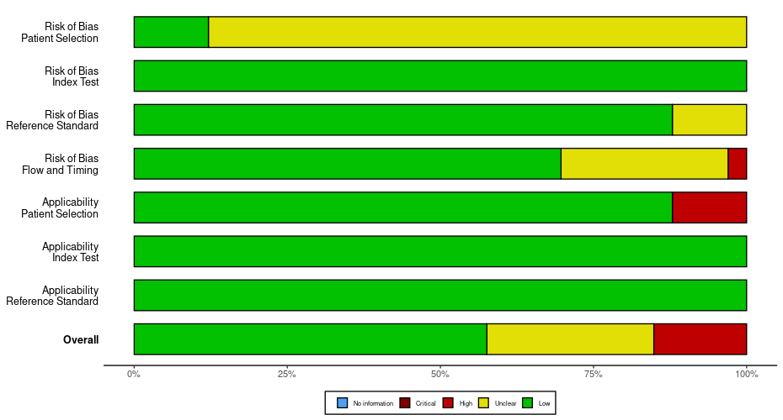
Figure S2. Risk of Bias Summary Plot

Pooled sensitivity and Specificity of GPR in diagnosing severe fibrosis (F3)
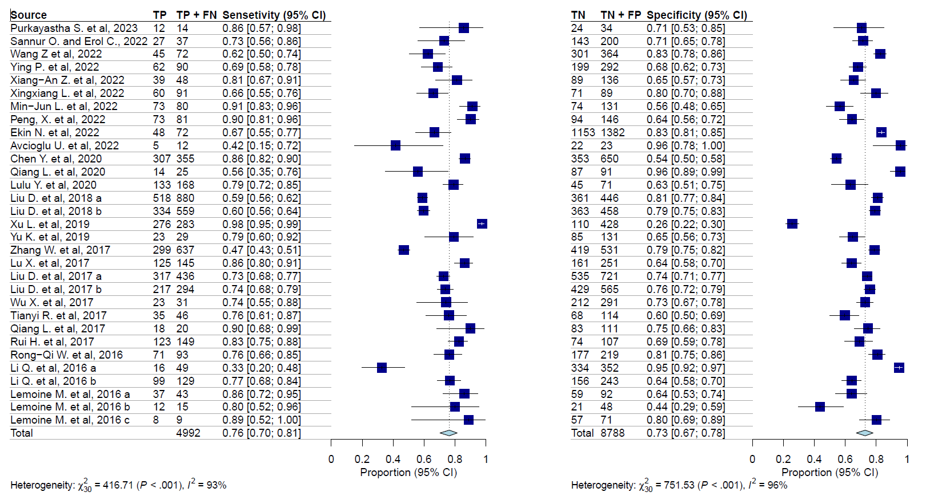
Figure S3. Pooled sensitivity and Specificity of GPR in diagnosing severe fibrosis (F3)

Hierarchical Summary Receiver Operating Curve for the different fibrosis staages
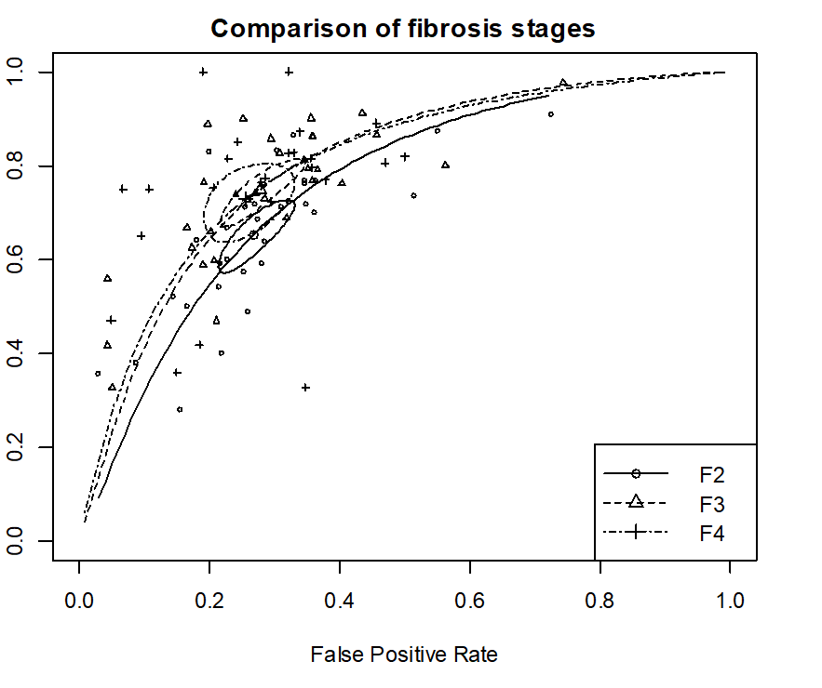
Figure S4. Bivariate summary ROC curves comparing GPR performance in different fibrosis stages

Association between Youden’s index and sensitivity estimates for Cirrhosis
Figure S5. Bubble plot for the association between Youden’s index and pooled sensitivity estimate

Determination of thresholds for GPR
The Reitsma function fits the bivariate model of Reitsma et al. (2005) that Harbord et al. (2007) have shown to be equivalent to the HSROC of Rutter & Gatsonis (2001). We specify the model as a linear mixed model with known random effects variances, like the computational approach by Reitsma et al. (2005). As a default, variance components are estimated by restricted maximum likelihood (REML), but ML estimation is also available. In addition, meta-regression is possible, as is the use of transformations other than the logit, using the approach of Doebler et al. (2012).
A different intercept was included for each study, and a logistic distribution was assumed for the thresholds. The cumulative density function (cdf) was transformed using the quantile function of the logistic distribution and modeled assuming unequal variances.

Optimal cut-point and performance of GPR in predicting significant fibrosis
Forty cut-off points from the included studies were included in the analysis of the various thresholds for significant fibrosis. One study was identified as an outlier (Youden’s index < 0.2) and was excluded ¹⁸. Thus, the analysis included 33 cut-off points.
Figure S6. Results from the linear mixed multiple thresholds model for significant fibrosis after exclusion

Figure S7. Distribution of PPV and NPV
The results were based on an average prevalence of 48% and a standard deviation of 15% for F2 based on the distribution of prevalences in the included studies.

Optimal cut-point and performance of GPR in predicting Cirrhosis
The initial data from 32 cut-off points were used to construct the multiple cut-offs model using the multi-level random effects models. Initial results showed that two studies were outliers and were excluded from further analysis. One study had an extremely low Youden’s index [34], and the other had extremely high cut-off value ⁸. Excluding these two studies resulted in the model that was used to estimate the performance and thresholds for GPR in diagnosing cirrhosis.
Figure S8. Results from the linear mixed multiple thresholds model for significant fibrosis after exclusion

Figure S9. Distribution of PPV and NPV for F4
The results were based on an average prevalence of 16% and a standard deviation of 7.5% for F4 based on the distribution of the included studies.

Performance of GPR in diagnosing and excluding significant fibrosis (left graph) and cirrhosis (right graph) using the suggested optimal cut-off thresholds
Prevalence
Figure S10. Performance of GPR in diagnosing and excluding significant fibrosis (left graph) and cirrhosis (right graph) using the suggested optimal cut-off thresholds
NPV: Negative predictive value, PPV: Positive predictive value

References
[1] Purkayastha S, Jha AK, Kumar R, Dayal VM, Jha SK. Serum Gamma-Glutamyl Transpeptidase-to-Platelet Ratio as a Non-invasive Marker of Liver Fibrosis in Chronic Hepatitis B. Cureus 2023;15:e33744. https://doi.org/10.7759/cureus.33744.
[2] Okdemir S, Cakmak E. A novel non-invasive score for the prediction of advanced fibrosis in patients with chronic hepatitis B. Ann Hepatol 2022;27:100544. https://doi.org/10.1016/j.aohep.2021.100544.
[3] Wang Z, Zhou Y, Yu P, Liu Y, Mei M, Bian Z, et al. Retrospective Evaluation of Non-invasive Assessment Based on Routine Laboratory Markers for Assessing Advanced Liver Fibrosis in Chronic Hepatitis B Patients. Int J Gen Med 2022;15:5159–71. https://doi.org/10.2147/IJGM.S364216.
[4] Pan Y, Yang K, Sun B, Chen J, Tian P. Application of alkaline phosphatase‑to‑platelet ratio as a novel non-invasive index predicts liver fibrosis in patients with chronic hepatitis B. Exp Ther Med 2022;24:619. https://doi.org/10.3892/etm.2022.11556.
[5] Zhao X-A, Wang J, Wei J, Liu J, Chen G, Wang L, et al. Gamma-glutamyl Transpeptidase to Platelet Ratio Predicts Liver Injury in Hepatitis B e Antigen-negative Chronic Hepatitis B Patients With Normal Alanine Aminotransferase. J Clin Transl Hepatol 2022;10:247–53. https://doi.org/10.14218/JCTH.2021.00151.
[6] Liu X, Zhou J, Zhu L, Zhang X, Li F. Diagnostic accuracy of apparent diffusion coefficient values combined with γ-glutamyl transpeptidase-to-platelet ratio parameters for predicting hepatitis B-related fibrosis. Clin Res Hepatol Gastroenterol 2022;46:101968. https://doi.org/10.1016/j.clinre.2022.101968.
[7] Liao M-J, Li J, Dang W, Chen D-B, Qin W-Y, Chen P, et al. Novel index for the prediction of significant liver fibrosis and cirrhosis in chronic hepatitis B patients in China. World J Gastroenterol 2022;28:3503–13. https://doi.org/10.3748/wjg.v28.i27.3503.
[8] Peng X, Tian A, Li J, Mao Y, Jiang N, Li T, et al. Diagnostic Value of FibroTouch and Non-invasive Fibrosis Indexes in Hepatic Fibrosis with Different Aetiologies. Dig Dis Sci 2022;67:2627–36. https://doi.org/10.1007/s10620-021-07049-4.
[9] Ekin N, Ucmak F, Ebik B, Tugba Tuncel E, Kacmaz H, Arpa M, et al. GPR, King’s Score and S-Index are superior to other non-invasive fibrosis markers in predicting the liver fibrosis in chronic Hepatitis B patients. Acta Gastroenterol Belg 2022;85:62–8. https://doi.org/10.51821/85.1.9156.
[10] Liu X, Li H, Wei L, Tang Q, Hu P. Optimized cutoffs of gamma-glutamyl transpeptidase-to-platelet ratio, aspartate aminotransferase-to-platelet ratio index, and fibrosis-4 scoring systems for exclusion of cirrhosis in patients with chronic hepatitis B. Hepatol Commun 2022;6:1664–72. https://doi.org/10.1002/hep4.1938.
[11] Yang Z, Ma X, Zhou X, Huang D, Wang Y, Li X, et al. Predictive performance of eLIFT for liver inflammation and fibrosis in chronic liver diseases. Int J Med Sci 2021;18:3599–608. https://doi.org/10.7150/ijms.62386.
[12] Chen Y-P, Huang L-W, Lin X-Y, Hu X-M, Liang X-E, Jiang R-L. Alanine aminotransferase influencing performances of routine available tests detecting hepatitis B-related cirrhosis. J Viral Hepat 2020;27:826–36. https://doi.org/10.1111/jvh.13293.
[13] Wang L, Li J, Yang K, Zhang H, Wang Q, Lv X, et al. Comparison and evaluation of non-invasive models in predicting liver inflammation and fibrosis of chronic hepatitis B virus-infected patients with high hepatitis B virus DNA and normal or mildly elevated alanine transaminase levels. Medicine (Baltimore) 2020;99:e20548. https://doi.org/10.1097/MD.0000000000020548.
[14] Li Q, Huang C, Xu W, Hu Q, Chen L. Accuracy of FibroScan in analysis of liver fibrosis in patients with concomitant chronic Hepatitis B and non-alcoholic fatty liver disease. Medicine (Baltimore) 2020;99:e20616. https://doi.org/10.1097/MD.0000000000020616.
[15] Yang L, Li J, Ma L, Xiang H, He D, Lu C, et al. Non-invasive assessment of liver fibrosis in chronic hepatitis B carriers with sound touch elastography: study of surgical pathology specimens. Expert Rev Med Devices 2020;17:845–53. https://doi.org/10.1080/17434440.2020.1798226.
[16] Zeng T, Yu J, Tan L, Wu Y, Tian Y, Wu Q, et al. Non-invasive indices for monitoring disease course in Chinese patients with autoimmune hepatitis. Clin Chim ACTA 2018;486:135–41. https://doi.org/10.1016/j.cca.2018.07.030.
[17] Wang W, Zhao X, Li G, Wang L, Chen Y, Ma K, et al. Diagnostic thresholds and performance of non-invasive fibrosis scores are limited by age in patients with chronic hepatitis B. J Med Virol 2019;91:1279–87. https://doi.org/10.1002/jmv.25435.
[18] Liu D, Li J, Lu W, Wang Y, Zhou X, Huang D, et al. Gamma-glutamyl transpeptidase to cholinesterase and platelet ratio in predicting significant liver fibrosis and cirrhosis of chronic hepatitis B. Clin Microbiol Infect Off Publ Eur Soc Clin Microbiol Infect Dis 2019;25:514.e1-514.e8. https://doi.org/10.1016/j.cmi.2018.06.002.
[19] Zhang G-L, Xu S-C, Zeng J, Chen Z, Li Y-P, Zhang T, et al. Optimizing the Use of the Gamma-Glutamyl Transpeptidase-to-Platelet Ratio and Transient Elastography to Identify Liver Cirrhosis in Patients with Chronic Hepatitis B Concurrent with Non-alcoholic Fatty Liver Disease. Dis Markers 2019;2019:2585409. https://doi.org/10.1155/2019/2585409.
[20] Li X, Xu H, Gao P. Fibrosis Index Based on 4 Factors (FIB-4) Predicts Liver Cirrhosis and Hepatocellular Carcinoma in Chronic Hepatitis C Virus (HCV) Patients. Med Sci Monit Int Med J Exp Clin Res 2019;25:7243–50. https://doi.org/10.12659/MSM.918784.
[21] Wang J, Chen Z, Yan X, Yang Y, Liu Y, Chen Y, et al. The Easy Liver Fibrosis Test (eLIFT) for predicting advanced liver fibrosis in patients with chronic hepatitis B. Discov Med 2019;28:149–58.
[22] Yu K, Du Z, Li Q, Cheng Q, Huang C, Shi G, et al. Comparison of non-invasive models for predicting liver damage in chronic hepatitis B patients. Gastroenterol Hepatol 2019;42:281–8. https://doi.org/10.1016/j.gastrohep.2018.12.004.
[23] Zhang W, Sun M, Chen G, An Y, Lv C, Wang Y, et al. Reassessment of gamma-glutamyl transpeptidase to platelet ratio (GPR): a large-sample, dynamic study based on liver biopsy in a Chinese population with chronic hepatitis B virus (HBV) infection. Gut 2018;67:989–91. https://doi.org/10.1136/gutjnl-2017-313896.
[24] Lu X-J, Li X-H, Yuan Z-X, Sun H-Y, Wang X-C, Qi X, et al. Assessment of liver fibrosis with the gamma-glutamyl transpeptidase to platelet ratio: a multicentre validation in patients with HBV infection. Gut 2018;67:1903–4. https://doi.org/10.1136/gutjnl-2017-315299.
[25] Liu D-P, Lu W, Zhang Z-Q, Wang Y-B, Ding R-R, Zhou X-L, et al. Comparative evaluation of GPR versus APRI and FIB-4 in predicting different levels of liver fibrosis of chronic hepatitis B. J Viral Hepat 2018;25:581–9. https://doi.org/10.1111/jvh.12842.
[26] Wu X, Cai B, Su Z, Li Y, Xu J, Deng R, et al. Aspartate transaminase to platelet ratio index and gamma-glutamyl transpeptidase-to-platelet ratio outweigh fibrosis index based on four factors and red cell distribution width-platelet ratio in diagnosing liver fibrosis and inflammation in chronic hepat. J Clin Lab Anal 2018;32:e22341. https://doi.org/10.1002/jcla.22341.
[27] Ren T, Wang H, Wu R, Niu J. Gamma-glutamyl transpeptidase-to-platelet ratio predicts significant liver fibrosis of chronic Hepatitis B patients in China. Gastroenterol Res Pract 2017;2017. https://doi.org/10.1155/2017/7089702.
[28] Li Q, Lu C, Li W, Huang Y, Chen L. The gamma-glutamyl transpeptidase to platelet ratio for non-invasive assessment of liver fibrosis in patients with chronic hepatitis B and non-alcoholic fatty liver disease. Oncotarget 2017;8:28641 – 28649. https://doi.org/10.18632/oncotarget.16162.
[29] Huang R, Wang G, Tian C, Liu Y, Jia B, Wang J, et al. Gamma-glutamyl-transpeptidase to platelet ratio is not superior to APRI, FIB-4 and RPR for diagnosing liver fibrosis in CHB patients in China. Sci Rep 2017;7. https://doi.org/10.1038/s41598-017-09234-w.
[30] Wang R-Q, Zhang Q-S, Zhao S-X, Niu X-M, Du J-H, Du H-J, et al. Gamma-glutamyl transpeptidase to platelet ratio index is a good non-invasive biomarker for predicting liver fibrosis in Chinese chronic hepatitis B patients. J Int Med Res 2016;44:1302–13. https://doi.org/10.1177/0300060516664638.
[31] Li Q, Li W, Huang Y, Chen L. The gamma-glutamyl transpeptidase-to-platelet ratio predicts liver fibrosis and cirrhosis in HBeAg-positive chronic HBV infection patients with high HBV DNA and normal or mildly elevated alanine transaminase levels in China. J Viral Hepat 2016;23:912–9. https://doi.org/10.1111/jvh.12563.
[32] Li Q, Song J, Huang Y, Li X, Zhuo Q, Li W, et al. The Gamma-Glutamyl-Transpeptidase to Platelet Ratio Does not Show Advantages than APRI and Fib-4 in Diagnosing Significant Fibrosis and Cirrhosis in Patients With Chronic Hepatitis B A Retrospective Cohort Study in China. Medicine (Baltimore) 2016;95. https://doi.org/10.1097/MD.0000000000003372.
[33] Lemoine M, Shimakawa Y, Nayagam S, Khalil M, Suso P, Lloyd J, et al. The gamma-glutamyl transpeptidase to platelet ratio (GPR) predicts significant liver fibrosis and cirrhosis in patients with chronic HBV infection in West Africa. Gut 2016;65:1369 – 1376. https://doi.org/10.1136/gutjnl-2015-309260.
[34] Youden WJ. Index for rating diagnostic tests. Cancer 1950;3:32–5. https://doi.org/10.1002/1097-0142(1950)3:1<32::AID-CNCR2820030106>3.0.CO;2-3.

