Investigating the effects of a novel gamified cognitive training on adolescent mental health
Supplementary Materials
Sample Size Calculation
A sample size calculation with Cohen’s f = 0.20 yielded a sample of N = 102 at a power of 90% with a significance threshold of α = .008 to correct for 6 outcomes of interest. While a review of paediatric cognitive control training showed moderate to large effects of training on various clinical outcomes (1), we used the small to moderate effect size listed above to be conservative as some of our outcomes of interest had not previously been tested using affective control training. Assuming an attrition/non-compliance rate of 40% (2), we aimed to recruit N = 144 participants who completed the study faithfully (failed no more than 2 out of 5 attention check items at baseline). Where possible, advertisements and invitations were targeted at individuals residing in Australia and the United Kingdom, although participants from the United States of America and India signed up through social media advertising and were allowed to participate if they met the other eligibility requirements.
Eligibility Criteria
To sign up for the study, participants had to: be aged 13-16 years; have daily access to a device with internet connectivity (e.g., smartphone or tablet), as the experiment was conducted completely online; read English with native fluency, as all assessments and training relied on adequate reading ability; and have no history of traumatic brain injury (TBI), as the training placed significant executive functioning demands, which is often impaired in those with TBI (3).
Participant Exclusions
In total, 253 participants were recruited and completed the baseline questionnaires (Figure S1). Of these, 1 participant withdrew from the study and 12 failed more than 2 attention checks and were excluded from the study for a total of 240 participants recruited and completing baseline questionnaires. One additional participant failed more than 2 attention checks at baseline, but due to experimenter error was still assigned to a training app and completed training, so their baseline data was excluded but their training, post-training and follow-up assessment data was retained.
96 participants were excluded as they were flagged as likely fraudulent based on the following set of criteria (Figure S1): Qualtrics, the platform, which was used for study sign-ups has measures to indicate whether individuals completing the questionnaire are likely to be fraudulent or duplicates of previous participants; participants with duplicate scores higher than 75 or fraud scores higher than 30 on Qualtrics were excluded, as per the platform’s guidelines (4). Additionally, after the experiment’s advertisement had been online for over two weeks and signups had dwindled to only a few each day, experimenters also began to observe “bulk” signups, where multiple participants (10+) signed up within a few minutes of each other, most with high duplicate/fraud scores. However, “fraudulent” participants were still able to complete the study and received remuneration for their participation as we were ethically bound to once they were included in the study. The final sample used for data analyses from those recruited was therefore N = 144 (Table 1). While here we report the analyses with only those participants who appeared legitimate, we additionally repeated all data analyses with “fraudulent” participants included (see Tables S11-14 for output of the pre-registered analyses with the full sample included).
Figure S1
Participant Recruitment, Inclusion and Exclusion
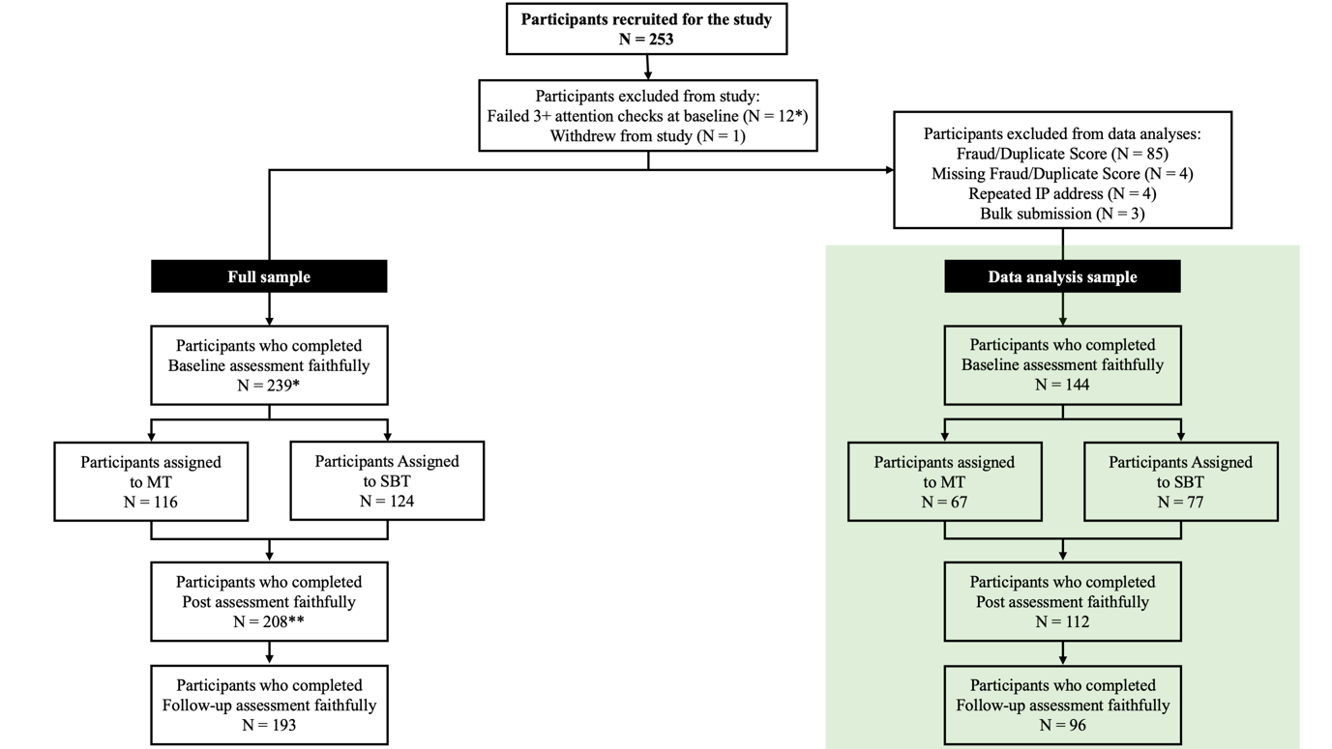
Note. *1 additional participant failed 3+ attention checks at baseline, but due to experimenter error was still assigned to a training group and completed training; this participant was therefore excluded from baseline but retained for training, post-training, and follow-up assessments in the full data sample. **4 participants completed post-training and follow-up measures at the same time; their questionnaire responses were therefore removed from the post-training time point, and the questionnaire responses they completed first were retained and used as follow-up questionnaire responses; their post-training task data was retained and we corrected for time between training completion and post-training task measure completion in the relevant analyses (H2-3); therefore, while N = 208 participants completed post-training task measures, only N = 204 completed post-training questionnaire measures.
Training app randomization procedure
Randomization, performed through computer-generated group assignment (5), was stratified by age and based on block randomization sequence with randomly mixed block sizes (2-6). JF and ABN were assigned to conduct group allocation and baseline assessments and to answer any participant queries, concerns or issues throughout study completion, and were not involved in data analysis. The remaining experimental staff were blinded to group allocation and helped conduct the remaining participant testing.
Measures
Mental Health and Functioning (baseline, post-training, follow-up)
Anxiety symptoms. Symptoms of anxiety were measured with the Generalized Anxiety Disorder 7 Scale (GAD-7; 6). The scale was made up of 7 items assessing how often anxiety symptoms were experienced over the last two weeks on a 4-point Likert scale ranging from 0 (not at all) to 3 (nearly every day). The scale demonstrated good internal consistency in the current sample at all time points (baseline: ω_{T} = .94; post-training: ω_{T} = .94; follow-up: ω_{T} = .96). Item scores were added, with higher scores indicating greater severity of anxiety symptoms.
Depression symptoms. Symptoms of depression were measured with the Patient Health Questionnaire – Adolescent (PHQ-A; 7), a scale made up of 8 items assessing severity of depressive symptoms over the last two weeks. The 9th item, measuring suicidality, was omitted from the present study, as risk could not be managed in the context of an online study. Items were rated from 0 (not at all) to 3 (nearly every day) and were then summed, with higher scores indicating greater severity of depression symptoms. Internal consistency for the PHQ-A was excellent at each timepoint for the current sample (baseline: ω_{T} = .94; post-training: ω_{T} = .95; follow-up: ω_{T} = .96)
Functional impairment. The functional impact of negative feelings on individuals’ functioning was assessed with a modified version of the Child Anxiety Life Interference Scale (CALIS; 8). The scale comprised 9 items measuring to what extent negative feelings upset participants or prevented them from doing a range of activities (e.g., getting on with parents, completing schoolwork, playing sport). Items were rated on a 5-point Likert scale ranging from not at all to a great deal and were then summed such that higher scores indicated greater functional impact of negative feelings. The CALIS showed good internal consistency in the current sample at all time points (baseline: ω_{T} = .90; post-training: ω_{T} = .90; follow-up: ω_{T} = .93).
Mechanisms of Change (baseline, post-training, follow-up)
Emotion regulation. Emotion regulation was measured with the reappraisal subscale of the Emotion Regulation Questionnaire – child and adolescent version (ERQ-CA; 9), a 10-item scale measuring tendency to regulate emotions through cognitive reappraisal (e.g., “I control my feelings about things by changing the way I think about them”) and expressive suppression (e.g., “I control my feelings by not showing them”). Items were rated on a 7-point Likert Scale ranging from 1 (strongly disagree) to 7 (strongly agree). The reappraisal subscale was made up of 6 items, summed such that higher scores indicated greater emotion regulation, and showed good internal consistency at all time points (baseline: ω_{T} = .90; post-training: ω_{T} = .93; follow-up: ω_{T} = .91).
Rumination. Rumination was assessed with the Repetitive Thinking Questionnaire (RTQ-10; 10). The scale was made up of 10 items rated on a 5-point Likert scale ranging from 1 (not true at all) to 5 (very true). Items measured how participants reacted in distressing situations (e.g., “I think about the situation all the time”), and scores were summed such that higher scores indicated greater rumination. The scale showed good internal consistency at all time points (baseline: ω_{T} = .92; post-training: ω_{T} = .93; follow-up: ω_{T} = .93).
Social Sensitivity. Social sensitivity was assessed with the Online and Offline Social Sensitivity Scale (O2S3; 11). The O²S³ assessed social sensitivity in both offline and online contexts through 18 items rated on a 4-point Likert scale ranging from 0 (strongly disagree) to 3 (strongly agree). Scores were summed such that higher scores indicated greater social sensitivity. The scale demonstrated acceptable internal consistency at all time points (baseline: ω_{T} = .90; post-training: ω_{T} = .92; follow-up: ω_{T} = .87).
Social risk concern. Concern for social risk was measured with the Health and Social Risk Questionnaire’s (HSRQ; 12) social subscale. This subscale was made up of 6 items assessing how worried participants would feel performing different actions relating to social activities (e.g., “defend an unpopular opinion that you believe in”). The items were rated on a rating scale ranging from 0 (not worried at all) to 100 (very worried). Social risk concern was indexed as the average of these items, with higher scores indicating greater concern. The scale demonstrated acceptable internal consistency at all time points (baseline: ω_{T} = .78; post-training: ω_{T} = .84; follow-up: ω_{T} = .80).
App Acceptability (post-training)
Participants were first asked how much of the training they had completed on their assigned app: none of it, part of it, most of it, or almost all of it. Those who selected an answer indicating at least partial training completion were then asked to answer whether they believed their assigned app was helpful, easy to use, and whether they liked using it. These three additional questions were rated on 5-point Likert Scales ranging from 0 (not at all) to 4 (very).
Figure S2
Study Procedure Flow Chart
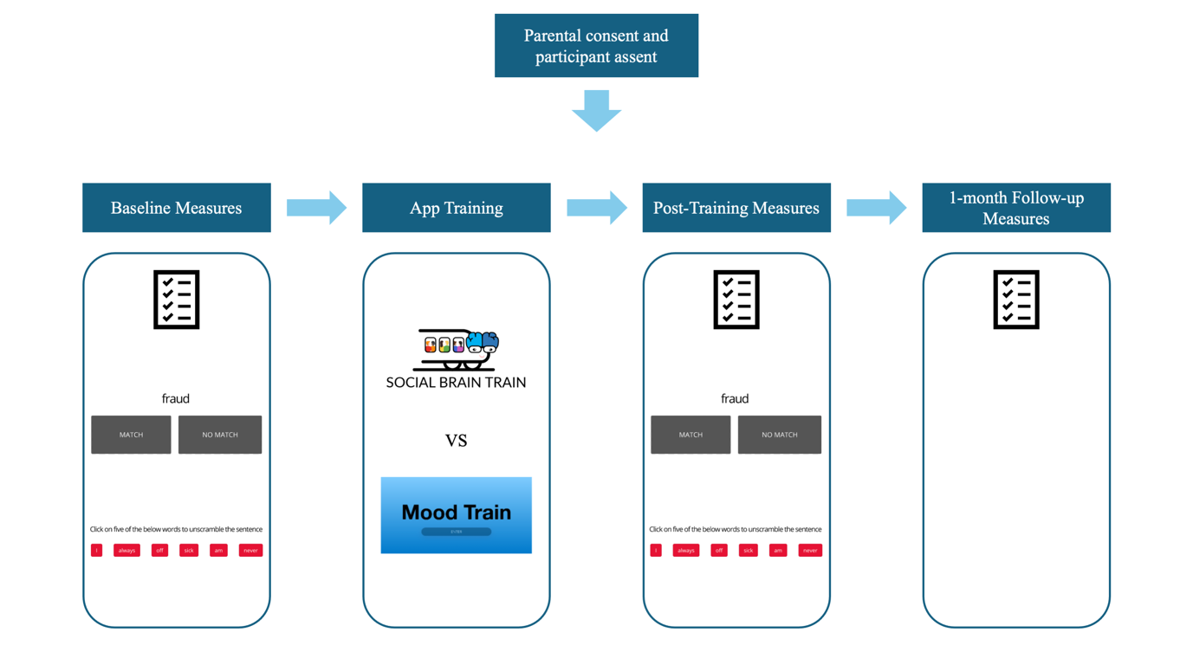
Note. The figure depicts the study procedure. = self-report measures (demographics questionnaire (only at baseline), daily screentime usage, ERQ-CA, RTQ-10, PHQ-A, CALIS; GAD-7, O²S³; HSRQ, training app acceptability (only at follow-up)); 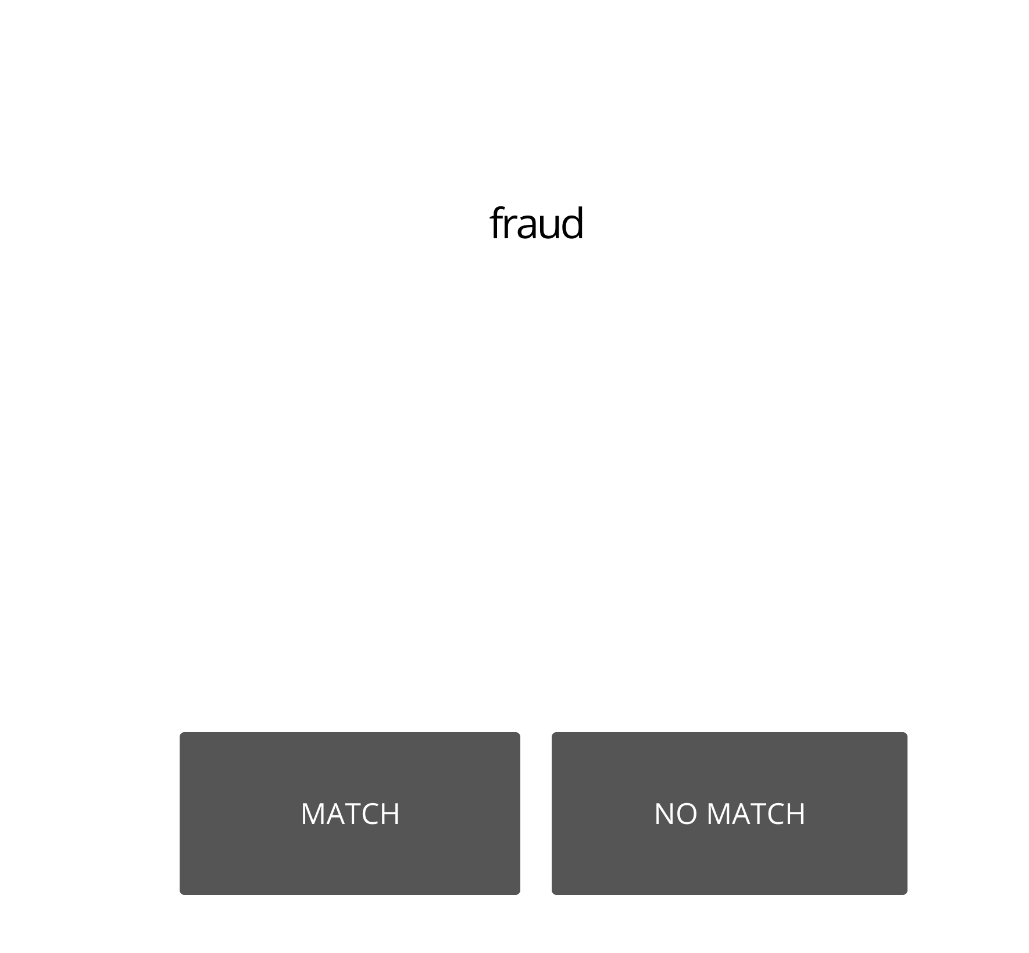 = 2-back task (emotional and neutral conditions); 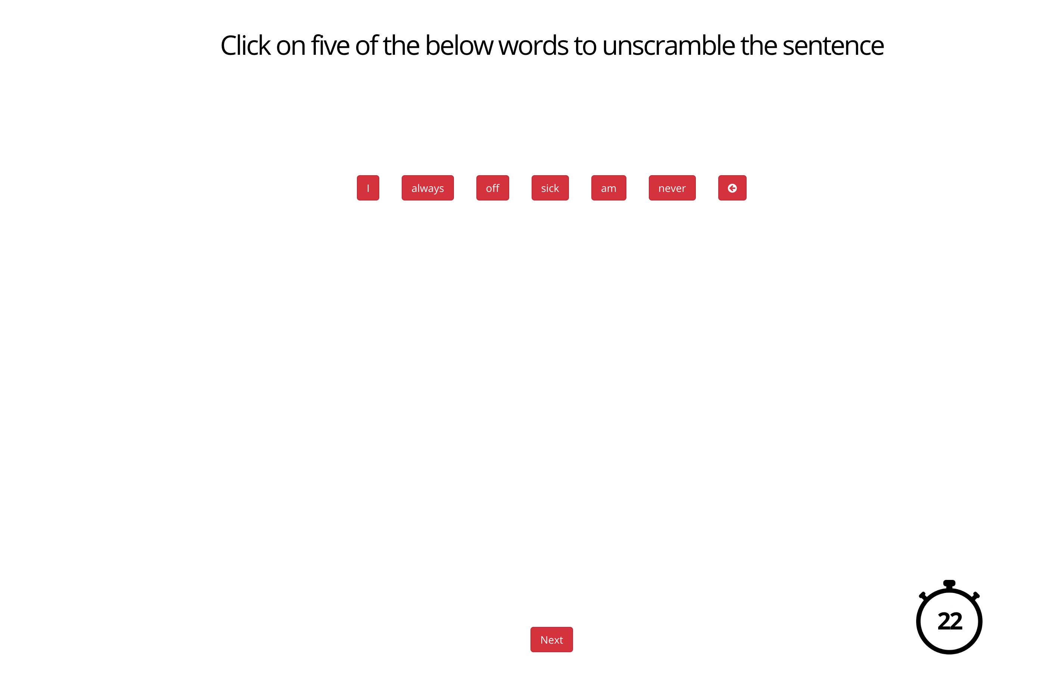 = scrambled sentences task; 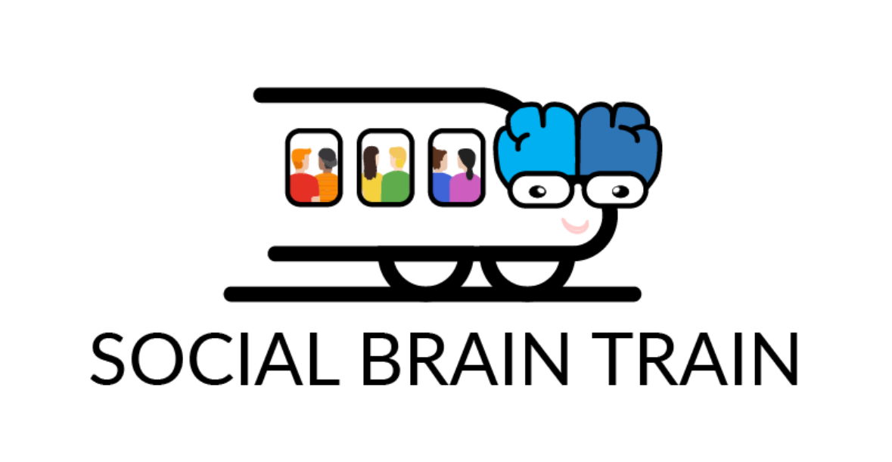= Social Brain Train app training group; 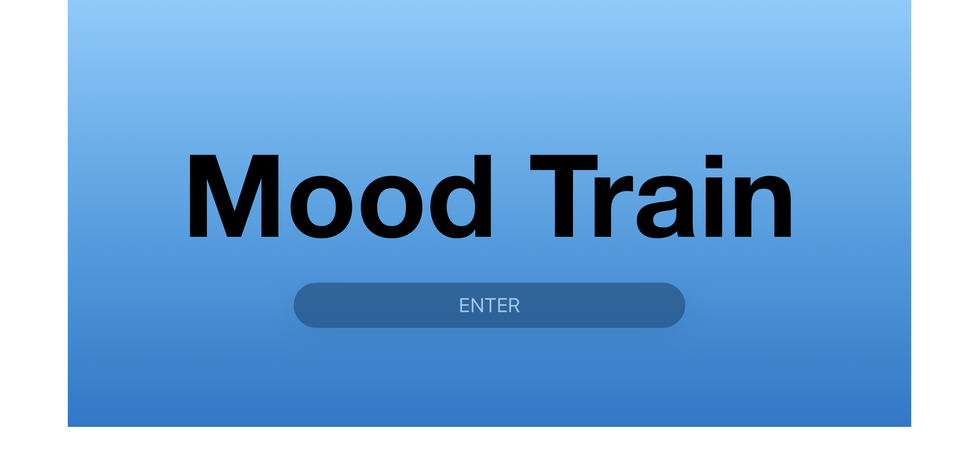= AffeCT app training group.
R Packages
General linear models were conducted using the stats package (13). Linear mixed models were conducted using the lme4 package (14), and their effect sizes were calculated using the MuMIn package (15). Correlations were conducted using the apaTables package (16).
Supplementary Results
Randomisation Checks
There were no significant differences in participant age (F(1, 142) = 0.12, p = .727), gender (χ ²(2, N = 144) = 2.03, p = .361), country (χ ²(3, N = 144) = 2.05, p = .562), ethnicity (χ ²(6, N = 144) = 12.27, p = .056), or SES (F(1, 132) = 0.00, p = .970) across the different training groups. Similarly, there were no significant differences in baseline participant self-rated rumination (F(1, 140) = 0.48, p = .489), depressive symptoms (F(1, 141) = 0.49, p = .487), anxiety symptoms (F(1, 140) = 2.83, p = .095), social sensitivity (F(1, 121) = 3.85, p = .052), or social risk concern (F(1, 142) = 0.65, p = .421) across the training groups, indicating successful randomization of participants.
Table S1
Summary of H2a Analyses
 | Affective control
Predictors | df | F | p | R²m/R²c
 |  |  |  | 0.02/0.32
Time | 107.00 | 0.04 | .845
App usage | 192.77 | 0.22 | .636
Days since training | 106.00 | 0.48 | .488
Time x App usage | 107.00 | 0.84 | .361
Note. Bolded text indicates statistically significant effects. Time indicates time point of measure completion (baseline vs post-training). App usage indicates average time (mins) spent in the assigned training app in total. Days since training indicates time between training completion and post task measure completion. Affective control was operationalised as average RT on correct trials of the emotional 2-back task minus average RT on correct trials of the neutral 2-back task (measured at baseline and post-training).

Table S2
Summary of H2b Analyses
 | Interpretation bias
Predictors | df | F | p | R²m/R²c
 |  |  |  | 0.07/0.69
Time | 105.83 | 3.21 | .076
App usage | 145.60 | 5.25 | .023
Days since training | 105.89 | 4.03 | .047
Time x App usage | 105.30 | 2.19 | .142
Note. Bolded text indicates statistically significant effects. Time indicates time point of measure completion (baseline vs post-training). App usage indicates average time (mins) spent in the assigned training app in total. Days since training indicates time between training completion and post task measure completion. Interpretation bias was operationalised as the proportion of negative grammatically correct sentences in the Scrambled Sentences Task (measured at baseline and post-training).
Table S3
Summary of H2c Analyses
 | Interpretation bias
Predictors | df | F | p | R²m/R²c
 |  |  |  | 0.13/0.72
Time | 103.05 | 0.04 | .848
App usage | 141.05 | 0.34 | .558
Training group | 144.63 | 5.06 | .026
Days since training | 103.89 | 4.51 | .036
Time x App usage | 103.05 | 0.12 | .733
Time x Training group | 103.99 | 1.67 | .199
App usage x Training group | 142.86 | 1.07 | .303
Time x App usage x Training group | 103.49 | 2.66 | .106
Note. Bolded text indicates statistically significant effects. Time indicates time point of measure completion (baseline vs post-training). App usage (mins) indicates average time (mins) spent in the assigned training app in total. Training group indicates app training group (SBT vs AffeCT). Days since training indicates time between training completion and post task measure completion. Interpretation bias was operationalised as the proportion of negative grammatically correct sentences in the Scrambled Sentences Task (measured at baseline and post-training).

Table S4
Summary of exploratory H2a 2-back performance analysis
 | 2-back RT
Predictors | df | F | p | R²m/R²c
 |  |  |  | 0.18/0.70
Time | 325.00 | 21.76 | <.001
App usage | 133.42 | 24.19 | <.001
Days since training | 106.00 | 6.61 | .012
Time x App usage | 325.00 | 0.49 | .485
Note. Bolded text indicates statistically significant effects. Time indicates time point of measure completion (baseline vs post-training). App usage (mins) indicates average time (mins) spent in the assigned training app in total. Days since training indicates time between training completion and post task measure completion. 2-back RT indicates reaction time on correct trials of the untrained 2-back task.

Table S5
Exploratory effects of time (baseline vs post-training) on outcomes of interest
A: Effect of time on emotion regulation
 | Emotion Regulation
Predictors | df |  | F |  | p |  | R²m/R²c
 |  |  |  |  |  |  | 0.00/0.65
Time | 114.84 |  | 0.17 |  | .685
B: Effect of time on rumination
 |  | Rumination
Predictors |  | df |  | F |  | p |  | R²m/R²c
 |  |  |  |  |  |  |  | 0.02/0.61
Time |  | 116.22 |  | 9.06 |  | .003
C: Effect of time on depression
 |  | Depression
Predictors |  | df |  | F |  | p |  | R²m/R²c
 |  |  |  |  |  |  |  | 0.00/0.90
Time |  | 107.99 |  | 0.42 |  | .516
D: Effect of time on anxiety
 |  | Anxiety
Predictors |  | df |  | F |  | p |  | R²m/R²c
 |  |  |  |  |  |  |  | 0.00/0.83
Time |  | 109.08 |  | 0.97 |  | .328
Note. Bolded text indicates statistically significant effects (p < .003). Time indicates time point of measure completion (baseline vs post-training). Emotion Regulation was operationalised as total score on ERQ reappraisal subscale. Rumination was operationalised as total score on the RTQ. Depression was operationalised as total score on PHQ. Anxiety was operationalised as total score on GAD.

Table S6
Exploratory effects of time (baseline vs post-training vs follow-up) on outcomes of interest
A: Effect of time on emotion regulation
 | Emotion Regulation
Predictors | df |  | F |  | p |  | R²m/R²c
 |  |  |  |  |  |  | 0.00/0.61
Time | 211.20 |  | 1.36 |  | .259
B: Effect of time on rumination
 |  | Rumination
Predictors |  | df |  | F |  | p |  | R²m/R²c
 |  |  |  |  |  |  |  | 0.03/0.60
Time |  | 213.12 |  | 12.81 |  | <.001
C: Effect of time on depression
 |  | Depression
Predictors |  | df |  | F |  | p |  | R²m/R²c
 |  |  |  |  |  |  |  | 0.00/0.86
Time |  | 204.07 |  | 0.42 |  | .656
D: Effect of time on anxiety
 |  | Anxiety
Predictors |  | df |  | F |  | p |  | R²m/R²c
 |  |  |  |  |  |  |  | 0.00/0.81
Time |  | 204.94 |  | 0.48 |  | .619
Note. Bolded text indicates statistically significant effects (p < .003). Time indicates time point of measure completion (baseline vs post-training vs follow-up). Emotion Regulation was operationalised as total score on ERQ reappraisal subscale. Rumination was operationalised as total score on the RTQ. Depression was operationalised as total score on PHQ. Anxiety was operationalised as total score on GAD.
Figure S3
Exploratory effect of time (baseline vs post-training vs follow-up) on rumination
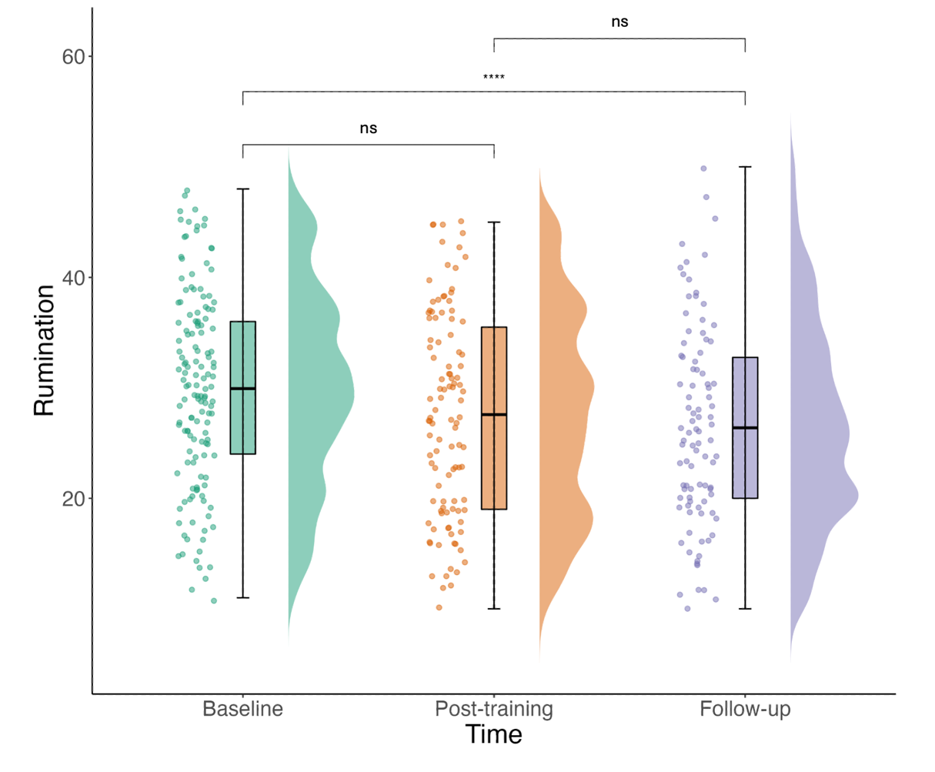
Note. Effect of time (baseline vs pos-training vs follow-up) on self-rated rumination. Rumination was operationalised as total score on the RTQ.

Table S7
Exploratory effects of time (baseline vs post-training) and training group (SBT vs AffeCT) on outcomes of interest
A: Effect of time and training group on emotion regulation
 | Emotion Regulation
Predictors | df | F | p | R²m/R²c
 |  |  |  | 0.02/0.66
Time | 115.94 | 1.42 | .236
Training group | 184.79 | 3.77 | .054
Time x Training group | 114.03 | 3.84 | .053
B: Effect of time and training group on rumination
 | Rumination
Predictors | df | F | p | R²m/R²c
 |  |  |  | 0.02/0.61
Time | 117.94 | 4.48 | .036
Training group | 191.85 | 0.31 | .578
Time x Training group | 115.73 | 0.03 | .860
C: Effect of time and training group on depression
 | Depression
Predictors | df | F | p | R²m/R²c
 |  |  |  | 0.01/0.90
Time | 107.22 | 2.45 | .121
Training group | 153.46 | 0.61 | .435
Time x Training group | 106.97 | 2.26 | .135
D: Effect of time and training group on anxiety
 | Anxiety
Predictors | df | F | p | R²m/R²c
 |  |  |  | 0.01/0.83
Time | 108.86 | 0.01 | .914
Training group | 161.72 | 2.44 | .120
Time x Training group | 108.18 | 0.56 | .455
Note. Bolded text indicates statistically significant effects (p < .003). Time indicates time point of measure completion (baseline vs post-training). Emotion Regulation was operationalised as total score on ERQ reappraisal subscale. Rumination was operationalised as total score on the RTQ. Depression was operationalised as total score on PHQ. Anxiety was operationalised as total score on GAD.

Table S8
Exploratory effects of time (baseline vs post-training vs follow-up) and training group (SBT vs AffeCT) on outcomes of interest
A: Effect of time and training group on emotion regulation
 | Emotion Regulation
Predictors | df | F | p | R²m/R²c
 |  |  |  | 0.00/0.65
Time | 211.26 | 3.85 | .023
Training group | 283.02 | 0.47 | .495
Time x Training group | 209.35 | 3.49 | .032
B: Effect of time and training group on rumination
 | Rumination
Predictors | df | F | p | R²m/R²c
 |  |  |  | 0.04/0.61
Time | 213.93 | 9.79 | <.001
Training group | 288.48 | 3.22 | .074
Time x Training group | 211.50 | 1.14 | .322
C: Effect of time and training group on depression
 | Depression
Predictors | df | F | p | R²m/R²c
 |  |  |  | 0.02/0.86
Time | 202.71 | 1.82 | .164
Training group | 199.86 | 4.43 | .037
Time x Training group | 202.11 | 2.58 | .078
D: Effect of time and training group on anxiety
 | Anxiety
Predictors | df | F | p | R²m/R²c
 |  |  |  | 0.02/0.81
Time | 204.00 | 0.16 | .853
Training group | 218.78 | 2.88 | .091
Time x Training group | 203.16 | 0.62 | .537

Note. Bolded text indicates statistically significant effects (p < .003). Time indicates time point of measure completion (baseline vs post-training vs follow-up). Emotion Regulation was operationalised as total score on ERQ reappraisal subscale. Rumination was operationalised as total score on the RTQ. Depression was operationalised as total score on PHQ. Anxiety was operationalised as total score on GAD.

Table S9
Summary of H3a Analyses
A: H3a Analyses: Emotion Regulation
 | Emotion Regulation
Predictors | df |  | F |  | p |  | R²m/R²c
 |  |  |  |  |  |  | 0.04/0.66
Time | 100.29 |  | 2.29 |  | .133
Training group | 145.31 |  | 3.10 |  | .080
Affective control change | 143.62 |  | 0.47 |  | .494
Days since training | 121.50 |  | 2.60 |  | .109
Time x Training group | 100.05 |  | 3.37 |  | .069
Time x Affective control change | 98.27 |  | 0.60 |  | .442
Training group x Affective control change | 144.08 |  | 0.27 |  | .602
Time x Training group x Affective control change | 98.31 |  | 0.00 |  | .972
B: H3a Analyses: Rumination
 |  | Rumination
Predictors |  | df |  | F |  | p |  | R²m/R²c
 |  |  |  |  |  |  |  | 0.06/0.61
Time |  | 101.10 |  | 5.04 |  | .027
Training group |  | 154.63 |  | 0.04 |  | .848
Affective control change |  | 155.34 |  | 2.03 |  | .156
Days since training |  | 125.81 |  | 0.54 |  | .464
Time x Training group |  | 100.59 |  | 0.02 |  | .898
Time x Affective control change |  | 99.58 |  | 0.22 |  | .640
Training group x Affective control change |  | 154.51 |  | 2.78 |  | .098
Time x Training group x Affective control change |  | 99.88 |  | 0.97 |  | .326
Note. Bolded text indicates statistically significant effects. Time indicates time point of measure completion (baseline vs post-training). Training group indicates app training group (SBT vs AffeCT). Affective control change was operationalised as change in average RT on correct trials of the emotional minus neutral 2-back task (Gorilla) from baseline to post-training. Days since training indicates time between training completion and post task measure completion. Emotion Regulation was operationalised as total score on ERQ reappraisal subscale. Rumination was operationalised as total score on the RTQ.

Table S10
Summary of H3b Analyses
A: H3b Analyses: Affective Control and Depressive Symptoms
 | Depression
Predictors | df | F | p | R²m/R²c
 |  |  |  | 0.04/0.89
Time | 99.30 | 1.01 | .318
Training group | 116.75 | 0.80 | .372
Affective control change | 116.09 | 0.19 | .666
Days since training | 110.18 | 2.51 | .116
Time x Training group | 99.66 | 1.31 | .256
Time x Affective control change | 99.03 | 0.40 | .527
Training group x Affective control change | 116.89 | 0.06 | .810
Time x Training group x Affective control change | 99.27 | 0.82 | .368
B: H3b Analyses: Interpretation Bias and Depressive Symptoms
 | Depression
Predictors | df | F | p | R²m/R²c
 |  |  |  | 0.06/0.89
Time | 97.31 | 0.86 | .355
Training group | 114.52 | 0.02 | .875
Interpretation bias change | 114.37 | 0.13 | .716
Days since training | 108.25 | 3.76 | .055
Time x Training group | 97.28 | 2.04 | .157
Time x Interpretation bias change | 97.26 | 0.44 | .507
Training group x Interpretation bias change | 114.43 | 0.82 | .367
Time x Training group x Interpretation bias change | 97.65 | 0.05 | .821
C: H3b Analyses: Affective Control and Anxiety Symptoms
 | Anxiety
Predictors | df | F | p | R²m/R²c
 |  |  |  | 0.05/0.81
Time | 99.26 | 0.02 | .880
Training group | 126.47 | 1.91 | .170
Affective control change | 125.07 | 0.01 | .904
Days since training | 114.02 | 3.40 | .068
Time x Training group | 99.23 | 0.53 | .468
Time x Affective control change | 98.27 | 0.02 | .887
Training group x Affective control change | 125.69 | 0.02 | .890
Time x Training group x Affective control change | 98.30 | 0.23 | .631
D: H3b Analyses: Interpretation Bias and Anxiety Symptoms
 | Anxiety
 |  |  |  | 0.06/0.82
Time | 97.33 | 0.03 | .853
Training group | 122.89 | 0.52 | .470
Interpretation bias change | 122.47 | 0.34 | .563
Days since training | 111.69 | 4.94 | .028
Time x Training group | 96.83 | 0.00 | .992
Time x Interpretation bias change | 96.79 | 2.25 | .137
Training group x Interpretation bias change | 124.18 | 0.37 | .545
Time x Training group x Interpretation bias change | 97.23 | 0.01 | .936
Note. Bolded text indicates statistically significant effects. Time indicates time point of measure completion (baseline vs post-training). Training group indicates app training group (SBT vs AffeCT). Affective control change was operationalised as change in average RT on correct trials of the emotional minus neutral 2-back task (Gorilla) from baseline to post-training. Interpretation Bias Change was operationalised as change in proportion of negative grammatically correct sentences in the SST from baseline to post-training. Days since training indicates time between training completion and post task measure completion. Depression was operationalised as total score on PHQ. Anxiety was operationalised as total score on GAD.

Table S11
Full sample characteristics (N = 240), means and standard deviations of variables
 | Mean (SD)/N (%)
Age (years) | 14.70 (1.18)
SES | 2.77 (0.33)
Gender
Female | 102 (42.50%)
Male | 136 (56.67%)
Non-binary | 2 (0.83%)
Country
Australia | 114 (47.50%)
United Kingdom | 79 (32.92%)
United States of America | 45 (18.75%)
India | 2 (0.83%)
Ethnicity
Aboriginal or Torres Strait Islander | 2 (0.83%)
Asian | 27 (11.25%)
Black | 29 (12.08%)
Hispanic | 1 (0.42%)
White | 166 (69.17%)
Mixed | 10 (4.17%)
Other | 4 (1.67%)
Prefer not to say | 1 (0.42%)
Education
Current student | 238 (99.17%)
Prefer not to say | 2 (0.83%)
Baseline Measures
Affective Control | -0.86 (203.56)
Interpretation Bias | 0.31 (0.21)
Emotion Regulation | 29.64 (6.33)
Rumination | 32.71 (8.52)
Depression | 6.40 (6.06)
Anxiety | 6.75 (5.73)
Social Sensitivity | 27.77 (9.54)
Social Risk Concern | 44.96 (17.31)
Post Training Measures
Affective Control | 11.29 (162.23)
Interpretation Bias | 0.23 (0.20)
Emotion Regulation | 30.19 (6.25)
Rumination | 31.33 (9.13)
Depression | 5.30 (5.38)
Anxiety | 5.43 (5.33)
Social Sensitivity | 27.47 (10.04)
Social Risk Concern | 43.97 (15.34)
Affective Control Change | -14.62 (211.85)
Interpretation Bias Change | 0.06 (0.19)
1-month Follow-up Measures
Emotion Regulation | 29.45 (6.69)
Rumination | 31.61 (10.05)
Depression | 6.84 (6.80)
Anxiety | 6.87 (6.21)
Social Sensitivity | 28.15 (9.18)
Social Risk Concern | 44.20 (14.30)
SBT Training (n = 124)
SBT app usage | 59.73 (67.24)
SBT app sessions | 6.61 (7.27)
SBT n-back usage | 80.16 (56.61)
SBT max N | 3.29 (1.92)
SBT mean N | 2.01 (1.07)
SBT CBMI usage | 45.15 (53.48)
SBT CBMI RT | 3800.96 (599.38)
SBT CBMI accuracy | 44.63 (34.13)
SBT psychoed usage | 20.77 (25.31)
AffeCT Training (n = 116)
AffeCT app usage | 40.58 (81.82)
AffeCT app sessions | 3.62 (7.08)
AffeCT n-back usage | 102.28 (89.72)
AffeCT max N | 2.94 (2.49)
AffeCT mean N | 1.68 (1.13)
Note. SES = socio-economic status, derived from the average level of parental education for up to 2 parents (1 = primary school; 2 = high school, professional/vocational training; 3 = university). Affective Control = average RT on correct trials of the emotional 2-back task minus average RT on correct trials of the neutral 2-back task. Interpretation Bias = proportion of negative grammatically correct sentences in the Scrambled Sentences Task. Emotion Regulation = total score on ERQ reappraisal subscale. Rumination = total score on RTQ. Depression = total score on PHQ. Anxiety = total score on GAD. Social Sensitivity = total score on O²S³. Social Risk Concern = Average score of HSRQ rating scales. Affective Control Change = change in average RT on correct trials of the emotional minus neutral 2-back task (Gorilla) from baseline to post-training. Interpretation Bias Change = Change in proportion of negative grammatically correct sentences in the SST from baseline to post-training. App usage = average time (mins) spent in the assigned training app in total. App sessions = average number of training sessions completed in the assigned training app in total. N-back usage = amount of time (mins) spent training on the n-back task of the assigned training app. Max N = maximum N reached across all trials of the assigned training app. Mean N = average N reached across all trials of the assigned training app. CBMI usage = total time (mins) spent on CBMI tasks in the SBT app across all SBT app sessions. CBMI RT = average RT (ms) on correct CBMI trials across all SBT app sessions. CBMI accuracy = total correct CBMI trials across all SBT app sessions. Psychoed usage = total time (mins) spent on psychoeducation components in the SBT app across all SBT app sessions.

Table S12
Full Sample Summary of H1 Analyses
A: H1 Analyses: App Usage
 | App Usage
Predictors | df_{regression} | df_{residual} | F | p | R²
Training group | 1 | 238.00 | 3.11 | .079 | 0.01
B: H1 Analyses: N-back Usage (exploratory)
 | N-back Usage
Predictors |  | df | F | p | R²
Training group | 1 | 238.00 | 0.66 | .417 | -0.00
B: H1 Analyses: Session Number (exploratory)
 | Session Number
Predictors |  | df | F | p | R²
Training group | 1 | 238.00 | 10.17 | .002 | 0.04
Note. Bolded text indicates statistically significant effects. Training group indicates app training group (SBT vs AffeCT). App usage indicates average time (mins) spent in the assigned training app in total. N-back usage indicates amount of time (mins) spent training on the n-back task of the assigned training app. App sessions indicates average number of training sessions completed in the assigned training app in total.

Table S13
Full Sample Summary of H2 Analyses
A: H2a Analyses
 | Affective Control
Predictors | df | F | p | R²m/R²c
 |  |  |  | 0.01/0.24
Time | 201.00 | 0.37 | .542
App usage | 379.36 | 0.27 | .602
Days since training | 200.00 | 0.29 | .589
Time x App usage | 201.00 | 0.12 | .725
B: H2b Analyses
 | Interpretation Bias
Predictors | df | F | p | R²m/R²c
 |  |  |  | 0.06/0.57
Time | 199.32 | 8.01 | .005
App usage | 306.28 | 10.94 | .001
Days since training | 199.74 | 1.47 | .227
Time x App usage | 197.93 | 2.23 | .137
C: H2c Analyses
 | Interpretation Bias
Predictors | df | F | p | R²m/R²c
 |  |  |  | 0.08/0.58
Time | 197.21 | 3.26 | .073
App usage | 303.62 | 1.86 | .173
Training group | 307.69 | 1.49 | .223
Days since training | 197.74 | 1.43 | .233
Time x App usage | 195.73 | 0.05 | .825
Time x Training group | 197.31 | 0.08 | .778
App usage x Training group | 305.63 | 1.27 | .262
Time x App usage x Training group | 195.93 | 1.10 | .295
Note. Bolded text indicates statistically significant effects. Time indicates time point of measure completion (baseline vs post-training). App usage indicates average time (mins) spent in the assigned training app in total. Training group indicates app training group (SBT vs AffeCT). Days since training indicates time between training completion and post task measure completion. Affective control was operationalised as average RT on correct trials of the emotional 2-back task minus average RT on correct trials of the neutral 2-back task (measured at baseline and post-training). Interpretation bias was operationalised as the proportion of negative grammatically correct sentences in the Scrambled Sentences Task (measured at baseline and post-training).

Table S14
Full Sample Summary of H3 Analyses
A: H3a Analyses: Emotion Regulation
 | Emotion Regulation
Predictors | df | F | p | R²m/R²c
 |  |  |  | 0.06/0.69
Time | 192.75 | 8.82 | .003
Training group | 271.74 | 3.41 | .066
Affective control change | 269.64 | 1.15 | .284
Days since training | 227.84 | 17.05 | <.001
Time x Training group | 192.47 | 7.20 | .008
Time x Affective control change | 190.68 | 0.10 | .749
Training group x Affective control change | 270.86 | 0.03 | .857
Time x Training group x Affective control change | 190.88 | 0.08 | .781
B: H3a Analyses: Rumination
 | Rumination
Predictors | df | F | p | R²m/R²c
 |  |  |  | 0.07/0.60
Time | 191.63 | 11.75 | .001
Training group | 298.62 | 0.13 | .718
Affective control change | 296.30 | 0.79 | .375
Days since training | 237.26 | 13.81 | <.001
Time x Training group | 191.90 | 1.04 | .310
Time x Affective control change | 189.92 | 0.14 | .711
Training group x Affective control change | 296.38 | 1.41 | .236
Time x Training group x Affective control change | 190.89 | 0.43 | .513
C: H3b Analyses: Affective Control and Depressive Symptoms
 | Depression
Predictors | df | F | p | R²m/R²c
 |  |  |  | 0.02/0.76
Time | 193.10 | 0.38 | .537
Training group | 251.95 | 1.61 | .206
Affective control change | 250.20 | 0.08 | .778
Days since training | 221.49 | 1.02 | .314
Time x Training group | 193.59 | 0.06 | .803
Time x Affective control change | 192.22 | 0.76 | .384
Training group x Affective control change | 251.65 | 0.25 | .616
Time x Training group x Affective control change | 192.69 | 1.13 | .288
D: H3b Analyses: Interpretation Bias and Depressive Symptoms
 | Depression
Predictors | df | F | p | R²m/R²c
 |  |  |  | 0.02/0.76
Time | 188.99 | 0.17 | .680
Training group | 246.53 | 0.46 | .500
Interpretation bias change | 246.96 | 0.00 | .946
Days since training | 217.27 | 1.39 | .239
Time x Training group | 188.80 | 0.05 | .816
Time x Interpretation bias change | 188.74 | 0.06 | .800
Training group x Interpretation bias change | 246.53 | 1.58 | .210
Time x Training group x Interpretation bias change | 189.90 | 0.31 | .576
E: H3b Analyses: Affective Control and Anxiety Symptoms
 | Anxiety
Predictors | df | F | p | R²m/R²c
 |  |  |  | 0.01/0.75
Time | 192.59 | 1.68 | .196
Training group | 253.88 | 0.08 | .779
Affective control change | 251.04 | 0.16 | .686
Days since training | 220.99 | 0.16 | .686
Time x Training group | 192.80 | 0.09 | .765
Time x Affective control change | 191.53 | 0.09 | .759
Training group x Affective control change | 252.40 | 0.37 | .546
Time x Training group x Affective control change | 191.71 | 0.16 | .691
F: H3b Analyses: Interpretation Bias and Anxiety Symptoms
 | Anxiety
 |  |  |  | 0.02/0.75
Time | 188.92 | 0.67 | .413
Training group | 248.31 | 0.00 | .957
Interpretation bias change | 246.69 | 1.78 | .184
Days since training | 216.78 | 0.48 | .488
Time x Training group | 188.48 | 0.18 | .669
Time x Interpretation bias change | 187.88 | 1.73 | .190
Training group x Interpretation bias change | 250.56 | 0.20 | .658
Time x Training group x Interpretation bias change | 188.95 | 0.31 | .576
Note. Bolded text indicates statistically significant effects. Time indicates time point of measure completion (baseline vs post-training). Training group indicates app training group (SBT vs AffeCT). Affective control change was operationalised as change in average RT on correct trials of the emotional minus neutral 2-back task (Gorilla) from baseline to post-training. Interpretation Bias Change was operationalised as change in proportion of negative grammatically correct sentences in the SST from baseline to post-training. Days since training indicates time between training completion and post task measure completion. Emotion Regulation was operationalised as total score on ERQ reappraisal subscale. Rumination was operationalised as total score on the RTQ. Depression was operationalised as total score on PHQ. Anxiety was operationalised as total score on GAD.

References
1. Edwards EJ, Zec D, Campbell M, Hoorelbeke K, Koster EHW, Derakshan N, et al. Cognitive control training for children with anxiety and depression: A systematic review. Journal of Affective Disorders. 2022 Mar 1;300:158–71.
2. Beloe P, Derakshan N. Adaptive working memory training can reduce anxiety and depression vulnerability in adolescents. Dev Sci. 2019/03/31 ed. 2019 Mar 29;e12831.
3. Tsai YC, Liu CJ, Huang HC, Lin JH, Chen PY, Su YK, et al. A Meta-analysis of Dynamic Prevalence of Cognitive Deficits in the Acute, Subacute, and Chronic Phases After Traumatic Brain Injury. Journal of Neuroscience Nursing. 2021 Apr;53(2):63–8.
4. Fraud Detection [Internet]. [cited 2024 Aug 30]. Available from: https://www.qualtrics.com/support/survey-platform/survey-module/survey-checker/fraud-detection/
5. Sealed Envelope Ltd. Create a blocked randomisation list. [Internet]. 2022 [cited 2023 Apr 5]. Available from: https://www.sealedenvelope.com/simple-randomiser/v1/lists
6. Spitzer RL, Kroenke K, Williams JBW, Löwe B. A Brief Measure for Assessing Generalized Anxiety Disorder: The GAD-7. Archives of Internal Medicine. 2006 May 22;166(10):1092–7.
7. Johnson JG, Harris ES, Spitzer RL, Williams JBW. The patient health questionnaire for adolescents: validation of an instrument for the assessment of mental disorders among adolescent primary care patients. J Adolesc Health. 2002 Mar;30(3):196–204.
8. Lyneham HJ, Sburlati ES, Abbott MJ, Rapee RM, Hudson JL, Tolin DF, et al. Psychometric properties of the Child Anxiety Life Interference Scale (CALIS). Journal of Anxiety Disorders. 2013 Oct;27(7):711–9.
9. Gullone E, Taffe J. The Emotion Regulation Questionnaire for Children and Adolescents (ERQ–CA): A psychometric evaluation. Psychological Assessment. 2012;24:409–17.
10. McEvoy PM, Mahoney AEJ, Moulds ML. Are worry, rumination, and post-event processing one and the same?: Development of the repetitive thinking questionnaire. Journal of Anxiety Disorders. 2010 Jun 1;24(5):509–19.
11. Andrews JL, Khin AC, Crayn T, Humphreys K, Schweizer S. Measuring online and offline social rejection sensitivity in the digital age. Psychological Assessment,. 2022;34(8):742–51.
12. Andrews JL, Foulkes LE, Bone JK, Blakemore SJ. Amplified Concern for Social Risk in Adolescence: Development and Validation of a New Measure. Brain Sciences. 2020 Jun;10(6):397.
13. R Core Team. R: A language and environment for statistical computing [Internet]. Vienna, Austria: R Foundation for Statistical Computing; 2022 [cited 2024 Sep 4]. Available from: https://www.R-project.org/
14. Bates D, Mächler M, Bolker B, Walker S. Fitting linear mixed-effects models using lme4. Journal of Statistical Software. 2015;67:1–48.
15. Bartoń K. MuMIn: Multi-Model Inference [Internet]. 2010 [cited 2024 Jul 6]. p. 1.47.5. Available from: https://CRAN.R-project.org/package=MuMIn
16. Stanley D, Stanley MD. Package ‘apaTables.’ 2018;

