Supporting Information
Curved interface-induced Jahn–Teller effect in single-atom catalysts for water purification
Ke Zhu^{1,4}, Ligang Wang^{2,4}, Zhuofeng Hu^{1,4}, Xiaoying Liang¹, Zechao Zhuang³, Xin Li¹, Jiarui Yang³, Rongliang Qiu^{1,}*, Dingsheng Wang^{3,}*, Kai Yan^{1,}*
Affiliations
¹Guangdong Provincial Key Laboratory of Environmental Pollution Control and Remediation Technology, School of Environmental Science and Engineering, Sun Yat-sen University, Guangzhou 510275, China.
²Institute of Molecular Plus, Tianjin University, Tianjin 300072, China.
³Department of Chemistry, Tsinghua University, Beijing 100084, China.
⁴These authors contributed equally: Ke Zhu, Ligang Wang, Zhuofeng Hu.
Corresponding authors
*Prof. Rongliang Qiu, orcid.org/0000-0002-9469-5274
E-mail: eesqrl@mail.sysu.edu.cn
*Prof. Dingsheng Wang, orcid.org/0000-0003-0074-7633
E-mail: wangdingsheng@mail.tsinghua.edu.cn
*Prof. Kai Yan, orcid.org/0000-0001-9001-6337
E-mail: yank9@mail.sysu.edu.cn

Table of Contents

1. Supplementary Methods 1 to 8
2. Supplementary Figures 1 to 23
3. Supplementary Tables 1 to 5
4. Supplementary References

1. Supplementary Methods
1.1 Chemical reagents and materials
Manganese phthalocyanine (MnPc, C₃₂H₁₆MnN₈), p-Nitrophenol (PNP, C₆H₅NO), and peroxymonosulfate (PMS, KHSO₅·0.5KHSO₄·0.5K₂SO₄) were purchased from Sigma-Aldric. Ibuprofen (IBU, C₁₃H₁₈O₂), phenol (P, C₆H₆), bisphenol A (BPA, C₁₅H₁₆O₂), potassium bicarbonate (KHCO₃) were provided by Aladdin Chemical Co., Ltd. Hydrochloric acid (HCl) was purchased from Guangdong Guanghua Sci-Tech Co., Ltd.. Acetaminophen (AP, C₈H₉NO₂), urea (CO(NH₂)₂), aniline (C₆H₅NH₂), furfuryl alcohol (FFA), ethanol (CH₃CH₂OH), 2,2,6,6-tetramethylpiperidine (TEMP), potassium thiocyanate (KSCN), and 5,5-dimethyl-2-pyrrolidone-N-oxyl (DMPO), were purchased from Macklin Co., Shanghai, China. Methanol (MeOH), p-Benzoquinone (p-BQ), and tert-butanol (TBA) were purchased from Guangzhou Chemical Reagent Factory. Polyether sulfone (PES) membranes (50 mm diameter, 0.45 um pore size) were purchased from Hangzhou Special Paper Co., LTD. Ultrapure water (18.25 MΩ/cm) was used for all experiments. All chemicals and reagents were used without further purification.

1.2 Synthesis of carbon precursor (C_{mw})
The waste of Masson pine branches was collected from a certain park in Jiangxi, China. The obtained agricultural and forestry waste was washed with ultrapure water, dried at 120 ºC, and then crushed into powder using a pulverizer. The Masson pine powder was mixed with KHCO₃ in a 1:1 weight ratio and placed in a high-speed ball mill for unidirectional operation for 12 h. A urea solution was added to the mixture and transferred to a hydrothermal reaction vessel, where it was subjected to hydrothermal treatment at 180 ºC for 12 h. After the above mixture was partially dried in a water bath, it was placed in a tube furnace under an N₂ atmosphere and subjected to a three-stage program of temperature ramping and carbonization (120 ºC→ 450 ºC→ 750 ºC). Each stage was activated for 3 h with a heating rate of 5 ºC min⁻¹. After cooling to room temperature, the resulting mixture was subjected to ultrasonic treatment in an HCl solution (1 M) for 1 h. Finally, the sample was washed with water until neutral and dried under vacuum at 80 ºC for 12 h. The resulting material was referred to as C_{mw}.
1.3 The construction method of the Mn-N₄-C@cotton
The Mn-N₄-C catalyst was assembled into cotton using the impregnation-crosslinking assembly method. The cotton was used as substrates. 1.0 mg mL⁻¹ Mn-N₄-C water dispersions with 1wt% ethylenediamine (1000 mL) were used as cotton casting solutions. The suspended solution and cotton were stirred at a speed of 300 rpm for 12 h at room temperature. Subsequently, Ethylenediamine was used as a cross-linker to enhance the stability of the Mn-N₄-C. By using an impregnation-crosslinking method, after completion, the Mn-N₄-C@cotton was dried at ambient atmosphere.

1.4 Analytical methods
The concentration of IBU in the solution was quantified via high-performance liquid chromatography (HPLC) using a Shimadzu LC-20A instrument from Japan, which was equipped with both a UV-vis detector and a Shimadzu-C18 column. The HPLC parameters for determining IBU concentration were as follows: the detection wavelength was set at 220 nm, the column temperature was held at a constant 40 ºC, and the mobile phase comprised a 0.1% formic acid aqueous solution (15%) in combination with acetonitrile (85%). Each injection consisted of 10 μL, and the flow rate was adjusted to 1.0 mL per minute. To gain insight into the electron properties with unpaired electrons within the Mn-N₄-C catalyst, we performed solid-state Electron Paramagnetic Resonance (ESR) tests using a Bruker A300-10/12 instrument from Germany. For the detection of ROS within the Mn-N₄-C/PMS system, a range of quenching agents was utilized: p-BQ, FFA, TBA, and MeOH were employed to quench ·O₂⁻, ¹O₂, ·OH, and·SO₄⁻, respectively. Furthermore, DMPO and TEMP were chosen as spin traps for ESR measurements. Mass spectrometry analysis of the final reaction solution in the Mn-N₄-C/PMS system was carried out to identify IBU degradation intermediates and deduce its degradation pathway. The degradation mechanism of IBU was elucidated, and a comprehensive toxicity evaluation of the intermediates was performed to determine whether the Mn-N₄-C/PMS system has detoxification effects.

1.5 ESR analysis of reactive oxygen species
Radicals (•OH and SO₄⁻) generated in the Mn-N₄-C/PMS systems were qualitatively detected by the electron spin resonance (ESR, A300-10/12, Bruker) experiments, whilst DMPO was used as the trapping agent. 0.1 g L⁻¹ Mn-N₄-C, 0.5 mM PMS, and 20 mM DMPO were mixed in a test tube with 4.0 mL ultrapure water for a 5.0 min reaction. However, O₂⁻ needed to be detected in the methanol system. 0.1 g L⁻¹ Mn-N₄-C, 0.5 mM PMS, and 20 mM DMPO were mixed in a test tube with 4.0 mL methanol for a 5.0 min reaction. The same method was that whilst TEMP was used as the trapping agent. 0.1 g L⁻¹ Mn-N₄-C, 1.0 mM PMS, and 20 mM TEMP were mixed in a test tube with 4.0 mL ultrapure water for a 5.0 min reaction. Finally, each mixed solution was transferred into a capillary tube, which was then inserted into the cavity of the ESR spectrometer. The signals of ESR spectra of DMPO-•OH adduct (derived from the reaction between DMPO and •OH), DMPO-SO₄⁻ adduct (derived from the reaction between DMPO and SO₄⁻), DMPO-O₂⁻ adduct (derived from the reaction between DMPO and O₂⁻) and TEMP-¹O₂ adduct (derived from the reaction between TEMP and ¹O₂) were detected.

1.6 Electrochemical measurement and analysis
All the electrochemical measurements were conducted at room temperature in a standard three-electrode electrochemical cell with the counter electrode (CE, Pt wire with Ф = 1 mm, Shanghai CH Instruments Ins.), reference electrode (RE, Ag/AgCl, Gaoss Union), a catalyst-prepared working electrode, and 500 mM Na₂SO₄ was used as electrolyte. All the electrochemical data were collected via an electrochemical workstation (Shanghai Chenhua, CHI760E).
The catalyst-prepared working electrode: the catalyst (2 mg) ﬁrstly dispersed in a mixed solution containing 0.1 mL of ethanol and 10 μL of naphthol solution with sonicating for 30 min, then the suspension was dropped onto a piece of carbon fiber paper (CFP, TGP-H-060) purchased from Toray Industries, Inc (Japan) (1 cm × 1 cm) (the CFP was soaked for 24 h with 0.05 M HCl solution to remove the surface oxide layer, which was taken out and rinsed with acetone, ethanol and deionized water several times to remove the oil contamination, respectively) and vacuum dried at 60 ℃, 12 h. Finally, the as-formed CFP was used as a working electrodes.
Electrochemical impedance spectroscopy (EIS) measurements were tested with AC voltage of 5 mV amplitude and frequency from 0.1Hz to 10 kHz.
Linear sweep voltammetry (LSV) measurements were carried out was measured as the potential from -1.0~1.0 V (vs. Ag/AgCl) with a scanning rate of 5 mV s⁻¹. (The electrolyte of Mn-N₄-C was a mixture of 500 mM Na₂SO₄ and 0.25 mM PMS). The electrolyte of the Mn-N₄-C/PMS system was a mixture of 500 mM Na₂SO₄ and 0.25 mM PMS.
Tafel measurements were performed with the bias of 0.0 V (vs. Ag/AgCl) with 500 mM Na₂SO₄ as a supporting electrolyte. After the baseline was stable, the open circuit voltage was set to obtain the Tafel curve.

1.7 Method for detecting peroxymonosulfate (PMS) concentration
The concentration of PMS was also tested by the low-concentration iodide method¹: (i) preparation of 10 mM KI stock solution: 0.04 g sodium bicarbonate and 0.166 g potassium iodide were mixed in 100 mL ultrapure water; (ii) sampling: samples (1.0 mL) were withdrawn and then filtrated by the polytetrafluoroethylene microfiltration membrane (0.22 μm); (iii) chromogenic reaction: 0.1 mL filtered sample was mixed with 4.9 mL stock solution for 5 min; (iv) detection: the concentration of PMS was detected using a UV-vis spectrometer at the wavelength of 351 nm using a quartz cuvette.

1.8 The contribution of ROS to the degradation of IBU
This work has proved that O₂⁻ made almost no contribution to the degradation of IBU in the Mn-N₄-C/PMS system. Therefore, we further determined the contribution from •OH, SO₄⁻, and ¹O₂ quantitively according to the literature as follows. The reaction rate constants after adding TBA and MeOH were denoted as k₁, and k₂, respectively, and the initial rate constant without a quenching agent was k. The contributions of •OH, SO₄⁻ and ¹O₂ were calculated according to Eqs. S1-S3, respectively.
λ(•OH) = [(k₀ – k₁)/k] ×100% (S1)
λ(SO₄⁻) = [(k₁ – k₂)/k] ×100% (S2)
λ(¹O₂) = 1 – λ(•OH) – λ(SO₄⁻) (S3)
where λ(•OH), λ(SO₄⁻) and λ(¹O₂) were the contribution of •OH, SO₄⁻ and ¹O₂ to degradation of IBU, respectively.
Supplementary Fig. 1. The curve degree of after PMS adsorbed by M-N₄-C and MnO₂.

Supplementary Fig. 2. XRD patterns spectra of M-N₄-C.

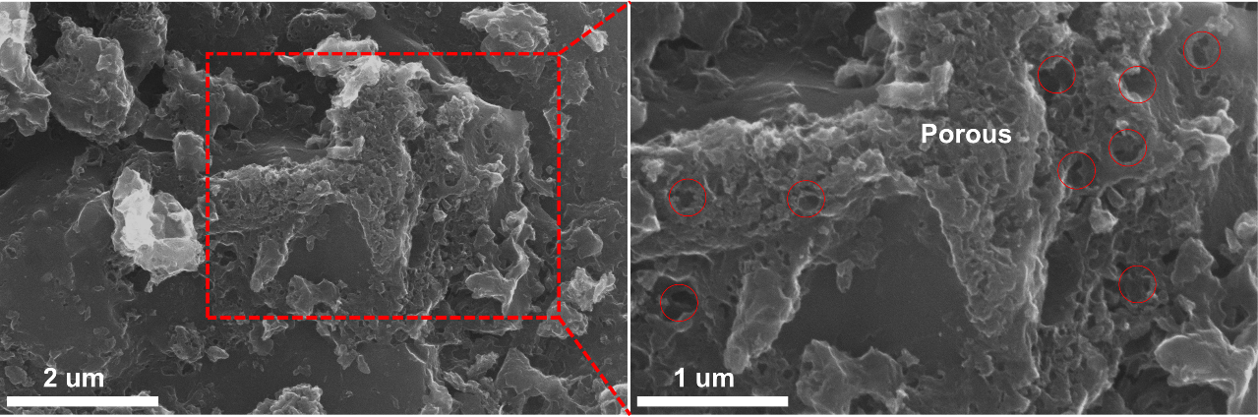
Supplementary Fig. 3. SEM image of Mn-N₄-C.

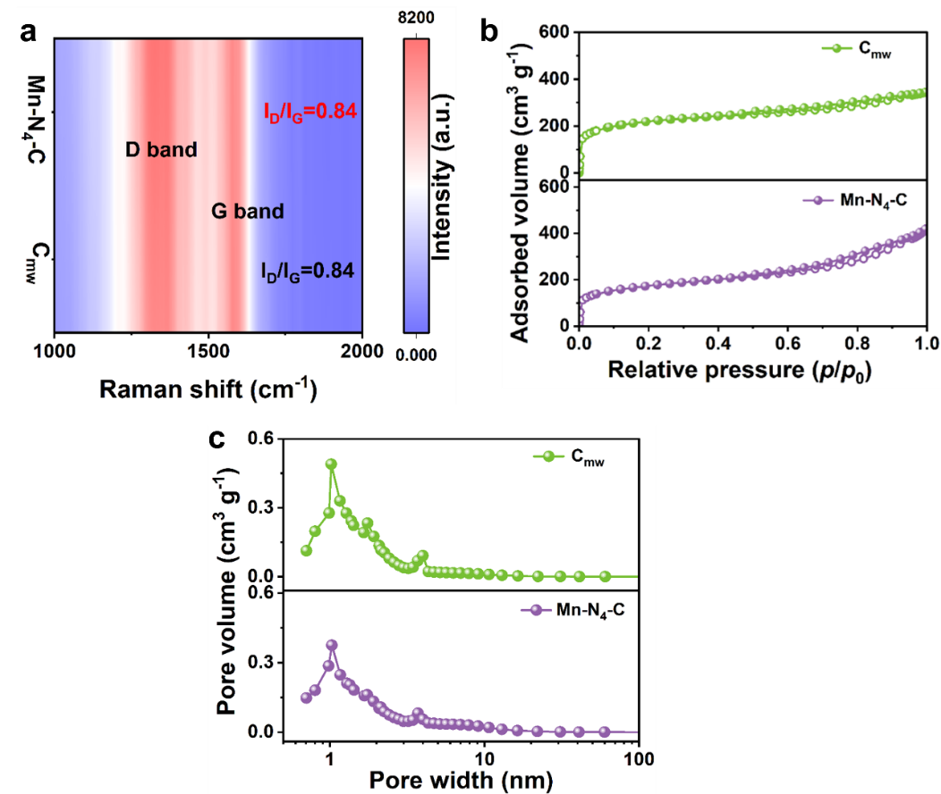
Supplementary Fig. 4. a Raman spectroscopy. b N₂ adsorption/desorption isotherms of C_{mw} and Mn-N₄-C. c The pore size distribution of C_{mw} and Mn-N₄-C.
Note: To investigate the changes in the physical and chemical properties of the material after Mn single atoms were embedded into the C_{mw}, Raman spectroscopy, and pore analysis were conducted. The Raman spectra of the acquired materials displayed two distinct peaks, approximately at ~1340 cm⁻¹ and ~1580 cm⁻¹. These peaks correspond to the D band (sp³) and G band (sp²) characteristics of the carbon material, respectively. The I_{D}/I_{G} values for both samples were calibrated to be 0.84. The similar I_{D}/I_{G} values for both samples indicated that the anchoring of Mn does not significantly affect the crystallinity of the carbon matrix². Furthermore, the pore information of C_{mw} and Mn-N₄-C was obtained from the N₂ adsorption/desorption isotherms. Both materials exhibited type IV isotherms characterized by hysteresis loops, which signify the presence of a mesoporous structure along with a micropore³. Combined with the pore size distribution. Mn-N₄-C possesses a well-defined hierarchical porous structure with abundant micropores, mesopores, and macropores. Mn-N₄-C possesses a substantial surface area, measuring 733.06 m² g⁻¹, along with a significant total pore volume of 0.39 cm³ g⁻¹. These characteristics are advantageous for the exposure of numerous active sites and the enhancement of reactant transport.

Supplementary Fig. 5. a XPS spectra of Mn-N₄-C catalyst. High-resolution b Mn 2p and c N 1s XPS spectra of Mn-N₄-C catalyst. d High-resolution XPS spectrum of C 1s spectra of Mn-N₄-C catalyst.
Note: In the high-resolution XPS spectra of Mn 2p, spin-orbit splitting produces Mn 2p3/2 and Mn 2p1/2. The peaks of Mn 2p3/2 at 641.2 eV, 643.1 eV, and 646.8 eV corresponded to Mn²⁺, Mn³⁺, and specific shakeup satellite peaks, respectively, which is consistent with the XAS results of Mn valence state. Supplementary Fig. 5d showed the C 1s XPS spectra of Mn-N₄-C, which correspond to C=C (284.4 eV), C-N (285.2 eV), C-O (286.3 eV) and C-O (288.4 eV).

Supplementary Fig. 6. a ESR spectra of Mn-N₄-C and C_{mw}. b EIS Nyquist plots of Mn-N₄-C and C_{mw}.
Note: A single peak at about g = 2.004 was observed in the electron paramagnetic resonance (ESR) spectra of the samples, owing to the unpaired electron on the aromatic carbon atom. The much higher peak intensity for Mn-N₄-C suggests the presence of more C-vacancies and defect sites, which are beneficial to improving its catalytic performance. This result can be attributed to the microwave's magnetic field as well as its rapid heating. From the electrochemical impedance spectra (EIS), Mn-N₄-C has a smaller arc radius in the Nyquist plots than C_{mw}, suggesting its lower interfacial charge transfer resistance to accelerating the electron transfer process for surface catalytic reactions.

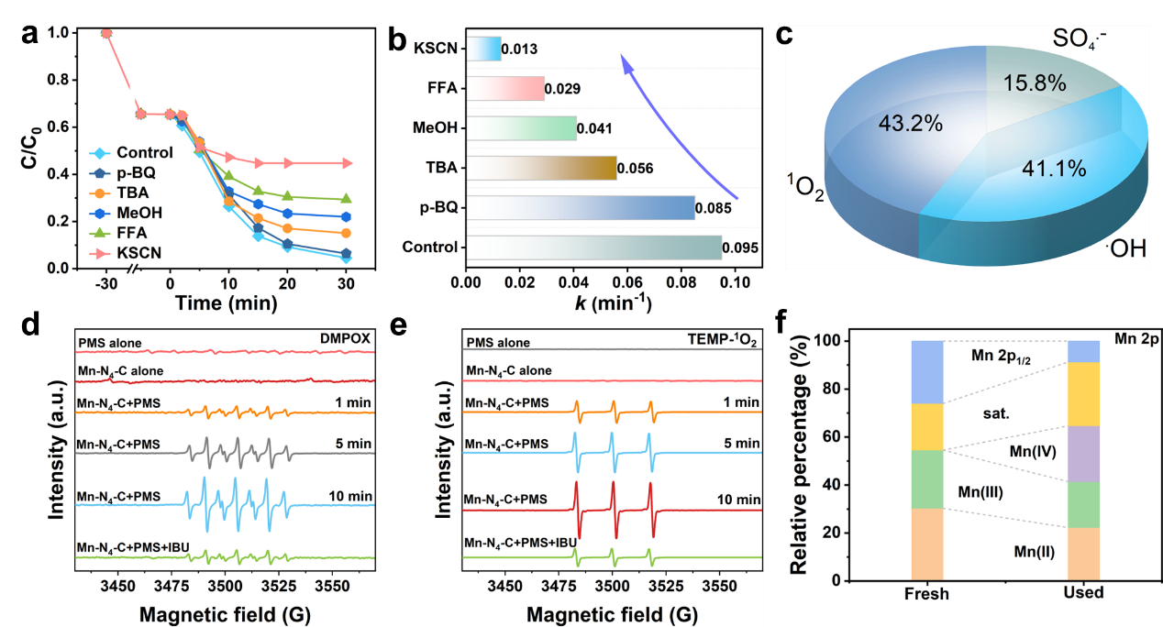
Supplementary Fig. 7. a Effects of sacrificial agents on IBU degradation. b The corresponding k values with different sacrificial agents. c Contributions of major ROS to IBU degradation of Mn-N₄-C/PMS system. d ESR spectra of DMPO-·OH/SO₄^{•-}. e ESR spectra of TEMP-¹O₂. f The percentage of the relative Mn species occupying the total Mn content of Mn-N₄-C before and after the reaction. Reaction conditions: [IBU] = 20 mg L⁻¹, [Catalyst] = 0.1 g L⁻¹, [PMS] = 1.0 mM, pH = 7.0, T = 25 ºC.

Supplementary Fig. 8. Effect of premixing time of Mn-N₄-C with PMS on the degradation of IBU.

Supplementary Fig. 9. a Linear sweep voltammetry (LSV) and b Tafel profiles analysis of various systems. c i-t curve.
Note: Supplementary Fig. 9a showed the LSV of catalysts under a mixture of 500 mM Na₂SO₄ and 1.0 mM PMS. The distinct current increased in the Mn-N₄-C/PMS/IBU system than that of Mn-N₄-C/PMS and Mn-N₄-C, suggesting the strong interaction of both PMS and IBU on the Mn-N₄-C surface. The Tafel scan reflected the low corrosion potential and high corrosion current calculated based on the Tafel slope of Mn-N₄-C (Supplementary Fig. 9b). Therefore, Mn-N₄-C was more prone to corrosion and provided electrons to oxidants in redox reactions. The i-t curve could prove the noticeable current response in the Mn-N₄-C/PMS/IBU system (Supplementary Fig. 9c). When PMS (1 mM) at 150 s was injected, a negative current peak was found, suggesting the formation of surface-confined intermediates on the surface of Mn-N₄-C (Mn-N₄-C/PMS*). After the injection at 250 s, the negative current peak was triggered again, suggesting that the metastable Mn-N₄-C/PMS* complex could accept the electrons from the electron donor of IBU molecules.

Supplementary Fig. 10. Mn-N₄-C before and after the reaction: a N 1s XPS spectra and b percentage of the relative N species occupying the total N content. c C 1s XPS spectra and d the percentage of the relative C species occupying the total C content.

Supplementary Fig. 11. Mn 2p XPS spectra of Mn-N₄-C before and after the reaction.

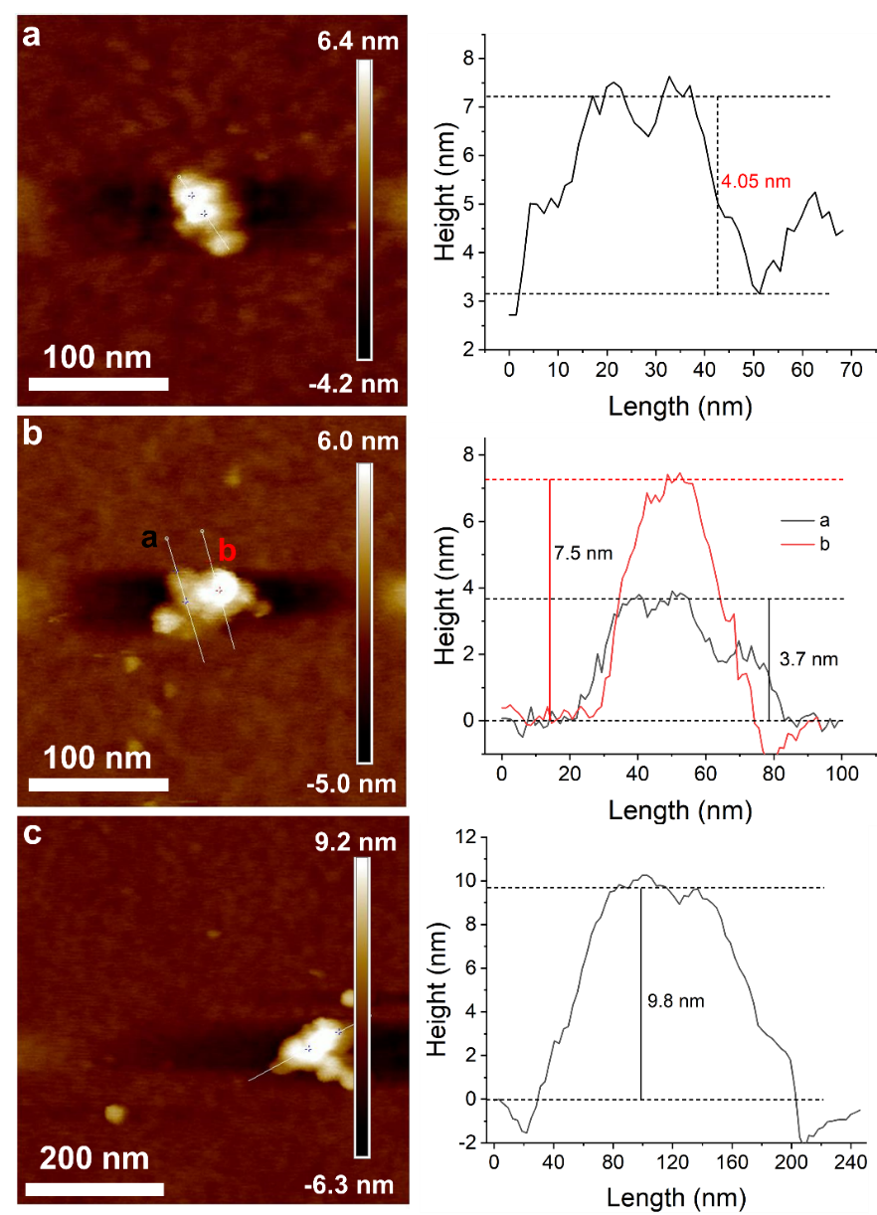
Supplementary Fig. 12. Atomic force microscopy image of catalyst surface roughness: a Mn-N₄-C. b Mn-N₄-C/PMS with 10 min. c Mn-N₄-C/PMS with 30 min.

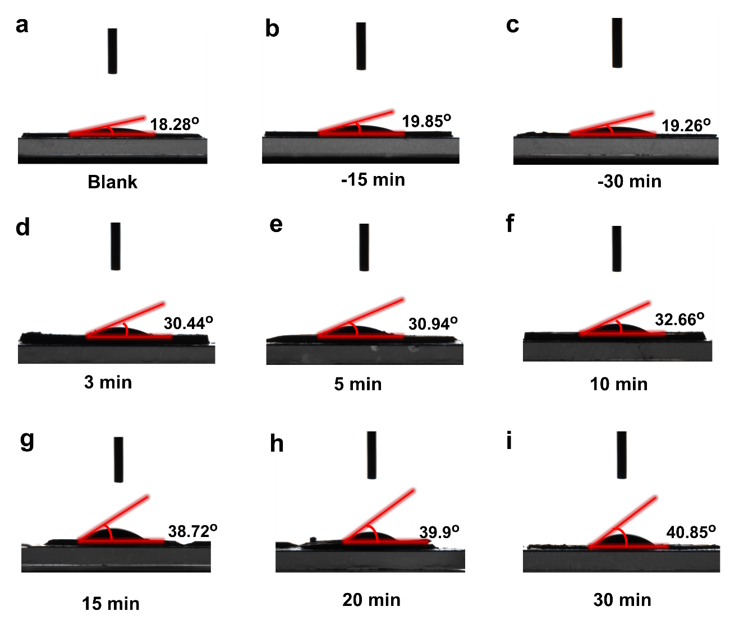
Supplementary Fig. 13. Contact angle of Mn-N₄-C catalyst with different reaction time.

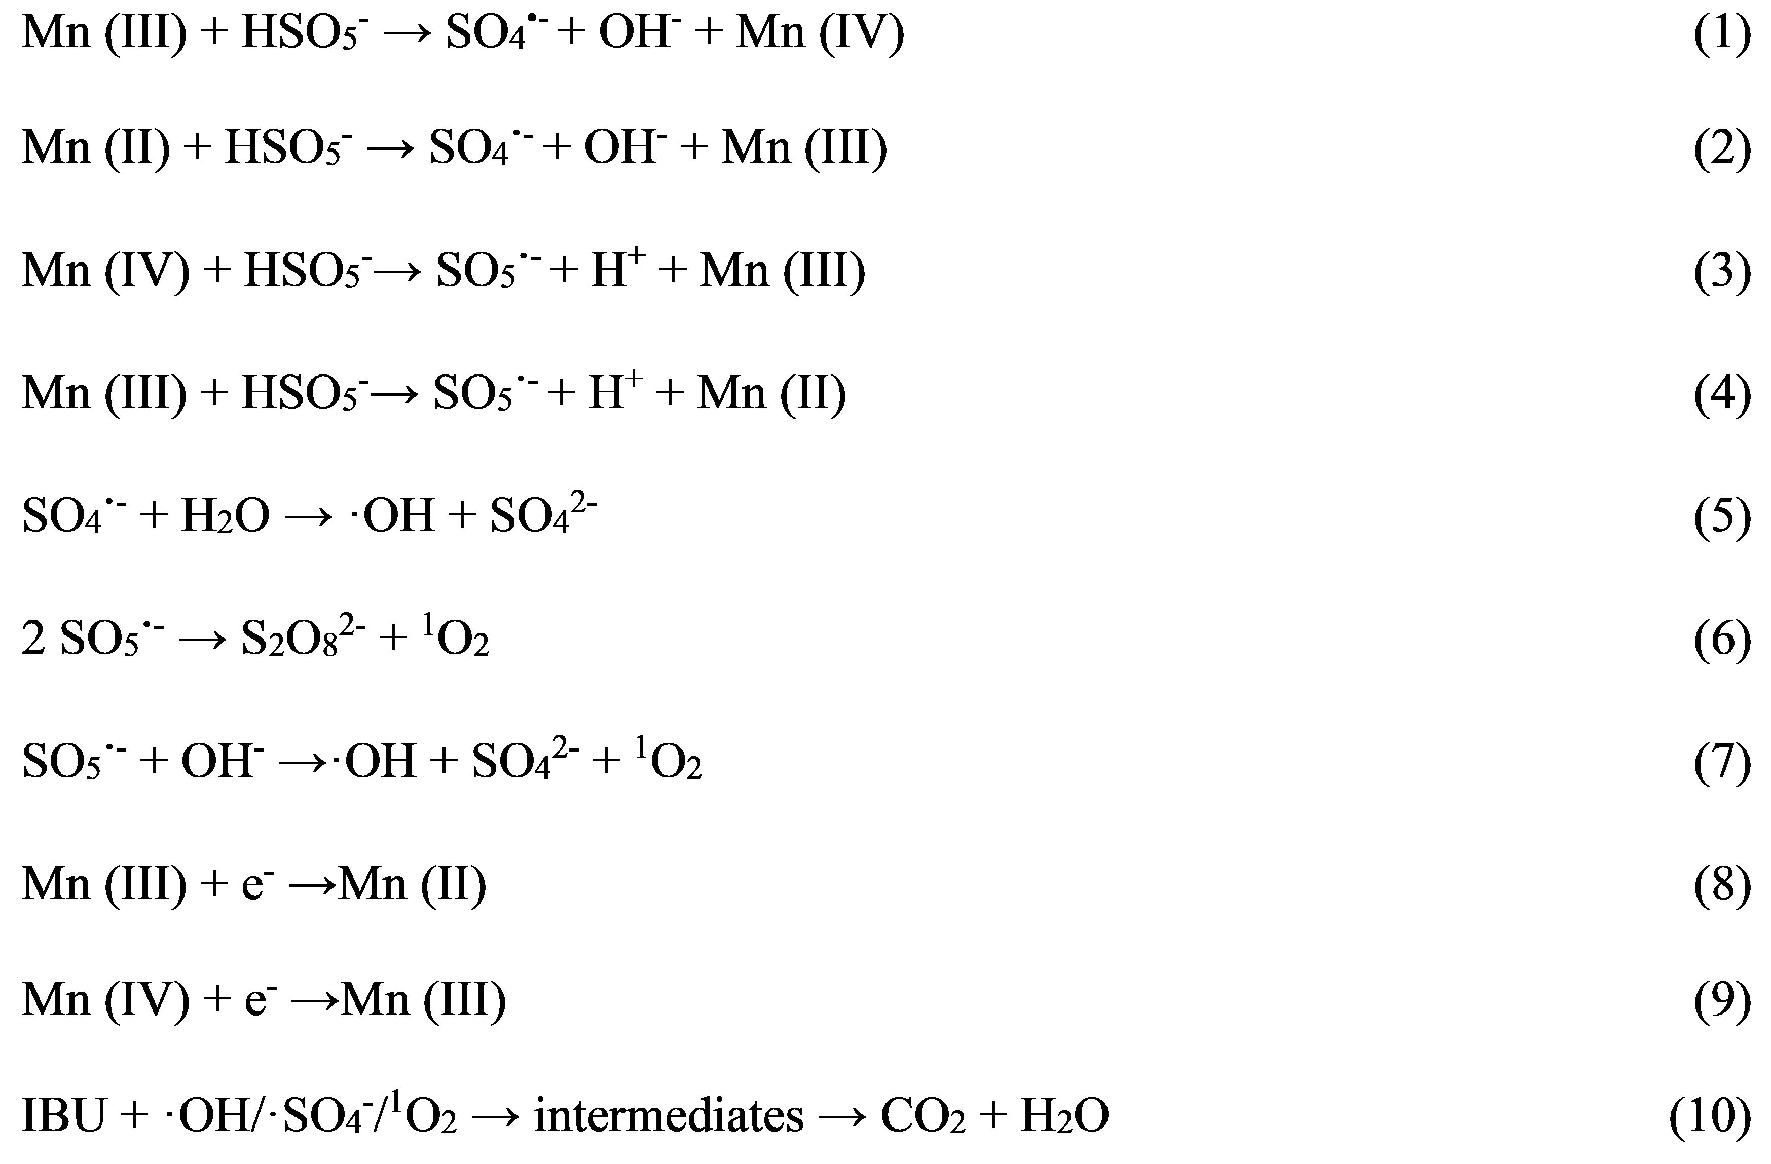
Supplementary Fig. 14. Reaction equation for the generation process of reactive oxygen species.

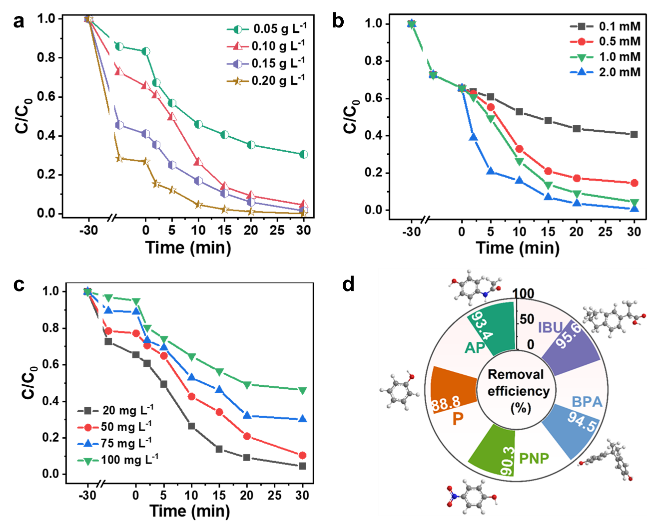
Supplementary Fig. 15. The effects of a catalyst dosage, b PMS concentration and c IBU concentration on IBU removal in the Mn-N₄-C/PMS system. d Universal experiments of pollutants. Reaction conditions: [IUP] = 20 mg L⁻¹, [PMS] = 1.0 mM, pH = 7.0, T = 25ºC.
Note： The organic contaminant IBU, as a representative model compound, was used to evaluate the catalytic performance of the prepared Mn-N₄-C catalyst. Supplementary Fig. 15a showed the impact of varying catalyst quantities on the removal performance of IBU in the Mn-N₄-C/PMS system. As the catalyst dosage ranged from 0.05 to 0.1 g L⁻¹, there was a notable ascent in IBU removal efficiency, rising from 70% to 96%. Beyond the threshold of 0.1 g L⁻¹ for catalyst dosage, IBU removal efficiency displayed a consistent plateau within the range of 96% to 100%. This observation suggests that a catalyst dosage of 0.1 g L⁻¹ is indeed suitable for effective IBU removal. Supplementary Fig. 15b was dedicated to the examination of how varying PMS concentrations impacted the catalytic efficacy in the removal of IBU. Upon adding 0.1, 0.5, 1.0, and 2.0 mM of PMS, IBU in the Mn-N₄-C/PMS system was removed by 59%, 86%, 96%, and 100%, respectively. The removal efficiency of IBU was positively correlated with the PMS dosage. It was widely recognized that PMS can generate ROS to directly attack and degrade IBU. Supplementary Fig. 15c delved into the influence of IBU concentration on removal efficiency. As the IBU concentration escalated from 20 to 100 mg L⁻¹, there was a gradual reduction in removal efficiency, declining from 96% to 53%. This decrease was attributed to the limited generation of ROS by the Mn-N₄-C/PMS system at higher IBU concentrations. Furthermore, the substantial quantity of IBU molecules posed an impediment to the efficiency of mass transfer between Mn-N₄-C and PMS, thereby unfavorable for the expeditious generation of ROS. To explore the universality of this system, catalytic performance studies were extended to other pollutants mentioned. Under the same conditions (Supplementary Fig. 15d), the removal rates of AP, P, PNP, and BPA were 93.4%, 88.8%, 90.3%, and 94.5%, respectively, indicating that Mn-N₄-C catalyst showed good performance in removing various pollutants.

Supplementary Fig. 16. TOC removal and PMS consumption in the Mn-N₄-C/PMS system. Reaction conditions: [IBU] = 20 mg L⁻¹, [Catalyst] = 0.1 g L⁻¹, [PMS] = 1.0 mM, pH = 7.0, T = 25ºC.
Note: Mineralization rate measurement validated the accumulation of by-products during the reaction, which is an important indicator of the effectiveness of organic pollutant removal in the systems. The mineralization rate of the IBU solution in the Mn-N₄-C/PMS system reached 72.3% within 30 min, indicating that this system exhibits excellent removal efficiency for pollutants. Meanwhile, this PMS consumption was as high as 85.6%.

Supplementary Fig. 17. The effects of initial pH on IBU removal in the Mn-N₄-C/PMS system. Reaction conditions: [IBU] = 20 mg L⁻¹, [Catalyst] = 0.1 g L⁻¹, [PMS] = 1.0 mM, T = 25ºC.

Supplementary Fig. 18. The effects of inorganic ion on IBU removal in the Mn-N₄-C/PMS system. Reaction condition: [IBU] = 20 mg L⁻¹, [Catalyst] = 0.1 g L⁻¹, [PMS] = 1.0 mM, pH = 7.0, T = 25ºC.

Supplementary Fig. 19. The effects of water quality on IBU removal in the Mn-N₄-C/PMS system. Reaction conditions: [IBU] = 20 mg L⁻¹, [Catalyst] = 0.1 g L⁻¹, [PMS] = 1.0 mM, pH = 7.0, T = 25ºC.

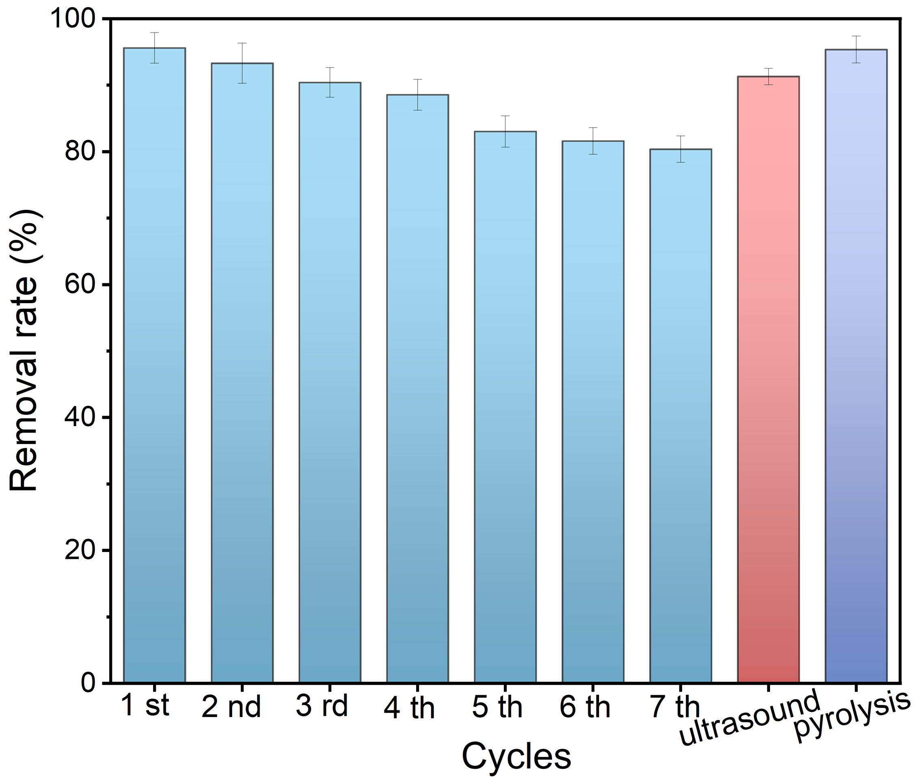
Supplementary Fig. 20. Cycling experiments of Mn-N₄-C for IBU removal. Reaction conditions: [IBU] = 20 mg L⁻¹, [Catalyst] = 0.1 g L⁻¹, [PMS] = 1.0 mM, pH = 7.0, T = 25ºC.

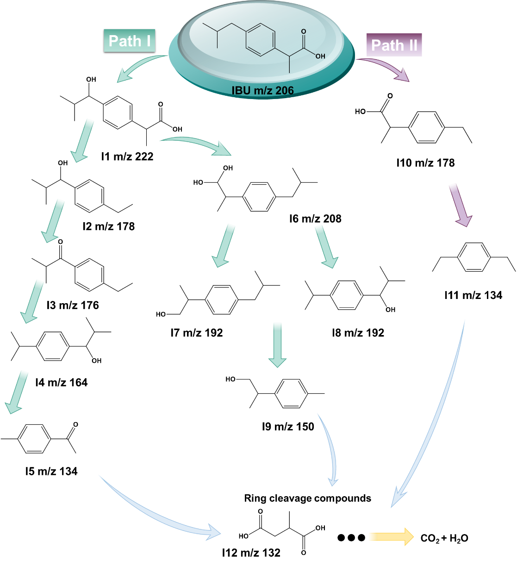
Supplementary Fig. 21. Proposed degradation pathways of IBU in the Mn-N₄-C/PMS system.
Note: To gain insight into the degradation pathway of IBU within the Mn-N₄-C/PMS system, HPLC analysis was conducted on the reaction solution. It was observed that with the progression of the reaction, the signal peak of IBU gradually weakened, and new by-product peaks appeared. This indicated that in the Mn-N₄-C/PMS system, the pollutant IBU was being broken down and transformed into small organic molecules or inorganic components such as CO₂ and H₂O. Next, liquid chromatography-tandem mass spectrometry (LC-MS/MS) was used for qualitative analysis of the intermediate products during the IBU degradation process. The detailed information detected is listed in Supplementary Table 3. Combined with the detection results and relevant literature⁴⁻⁷, two main degradation pathways, hydroxylation, and demethylation, were proposed for IBU removal in the Mn-N₄-C/PMS system (Supplementary Fig. 21). Pathway I: ·OH primarily attacks IBU through electrophilic addition and dehydrogenation, while SO₄^{•-} mainly reacts via an electron transfer mechanism. Under combined attack, IBU is transformed into I1, which is further oxidized to form I2 and I6. Smaller organic compounds may undergo further cleavage, leading to the formation of carboxylic acid (I5). Pathway II: The maximum negative surface potential of IBU molecules is around oxygen atoms (Supplementary Fig. 22), where oxygen-containing functional groups are considered active sites for electrophilic reactions. As ¹O₂ is more susceptible to electrophilic attack, the formation of I10 and I11 may be facilitated by ¹O₂. After the oxidation and ring opening of the aromatic ring (I12), a series of hydroxylation reactions eventually mineralizes the intermediates into CO₂ and H₂O. These results provide insights into the IBU degradation mechanism in the Mn-N₄-C/PMS system, highlighting the effectiveness of the Mn-N₄-C catalyst in promoting the transformation and mineralization of pollutants.

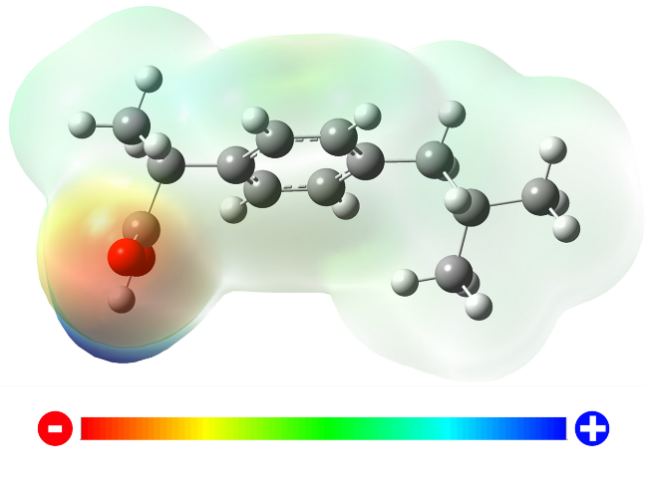
Supplementary Fig. 22. Surface potential distribution of IBU molecules.

Supplementary Fig. 23. Mn leaching concentration and TOC removal rate as filtration time.

Supplementary Table 1 Content of each element in Mn-N₄-C catalysts.
Instrument | ICP-OES | EA
Element | Mn (%) | C (%) | N (%) | O (%) | H (%)
Content | 0.35 | 72.39 | 3.28 | 20.86 | 2.21

Supplementary Table 2 Structural parameters extracted from the Mn K-edge FT-EXAFS fitting.
Sample | Scattering pair | CN | R(Å) | Debye-Waller  (σ²) | ΔE₀  (eV) | R factor
Mn-N₄-C | Mn-N | 4.0 ± 0.3 | 1.96 | 0.003 | -0.4 ± 0.9 | 0.009
S₀² is the drop factor (S₀²=0.76)

Supplementary Table 3 The possible intermediates of IBU in the degradation process by LC-MS/MS.
Number | Formula | m/z | Structure
IBU | C₁₃H₁₈O₂ | 206
I1 | C₁₃H₁₈O₃ | 222
I2 | C₁₂H₁₈O | 178
I3 | C₁₂H₁₆O | 176
I4 | C₁₀H₁₂O₂ | 164
I5 | C₉H₁₀O | 134
I6 | C₁₃H₂₀O₂ | 208
I7 | C₁₃H₂₀O | 192
I8 | C₁₃H₂₀O | 192
I9 | C₁₀H₁₄O | 150
I10 | C₁₂H₁₈O | 178
I11 | C₁₀H₁₄ | 134
I12 | C₅H₈O₄ | 132

Supplementary Table 4 Theoretically calculated data of acute toxicity, developmental toxicity, and mutagenicity of IBU and its degradation intermediates.
Compound | m/z | Acute toxicity  (mg L⁻¹) |  | Developmental Toxicity |  | Mutagenicity
Compound | m/z | Fathead minnow LC₅₀  (96 h) | Daphnia magna LC₅₀  (48 h) | Predicted value | Predicted  result | Predicted value | Predicted result
IBU | 206 | 5.45 | 2.80 | 0.90 | Developmental toxicant | -0.05 | Mutagenicity Negative
I1 | 222 | 10.80 | 4.54 | 0.88 | Developmental toxicant | N/A | N/A
I2 | 178 | 13.32 | 1.92 | 0.82 | Developmental toxicant | 0.05 | Mutagenicity Negative
I3 | 176 | 3.79 | 4.07 | 0.64 | Developmental toxicant | 0.24 | Mutagenicity Negative
I4 | 164 | 10.29 | 1.48 | 0.82 | Developmental toxicant | -0.01 | Mutagenicity Negative
I5 | 134 | 28.00 | 7.57 | 0.67 | Developmental toxicant | 0.12 | Mutagenicity Negative
I6 | 208 | 8.43 | 15.89 | 0.83 | Developmental toxicant | 0.04 | Mutagenicity Negative
I7 | 192 | 3.62 | 2.44 | 0.81 | Developmental toxicant | 0.14 | Mutagenicity Negative
I8 | 192 | 10.29 | 1.48 | 0.82 | Developmental toxicant | -0.01 | Mutagenicity Negative
I9 | 150 | 38.47 | 12.16 | 0.81 | Developmental toxicant | 0.17 | Mutagenicity Negative
I10 | 178 | 11.55 | 17.20 | 0.83 | Developmental toxicant | -0.01 | Mutagenicity Negative
I11 | 134 | 4.60 | 2.26 | 0.41 | Developmental Non-toxicant | N/A | N/A
I12 | 132 | 197.33 | 205.99 | 0.76 | Developmental toxicant | 0.04 | Mutagenicity Negative

Supplementary Table 5 Comparison of the performance of different catalysts for IBU removal.
Catalyst |  |  | Synthesis method | Reaction condition | Removal efficiency | ROS | Refs.
MnCo₂O₄/FCNTs |  | Hydrothermal |  | [Catalyst] = 0.1 g L⁻¹,  [PMS] = 0.01 g L⁻¹,  [IBU] = 10 mg L⁻¹,  pH = 4.7, T = 25ºC | 100%  40 min | SO₄^{•-}, •OH, and ¹O₂ | ⁸
S-MnO₂/NGA |  | Hydrothermal |  | [Catalyst] = 0.1 g L⁻¹,  [PMS] = 2 g L⁻¹,  [IBU] = 20 mg L⁻¹,  pH = 4.7, T = 25ºC | 95.1%  120 min | SO₄^{•-} and •OH | ⁹
Bi₂Fe₄O₉ | Hydrothermal |  |  | [Catalyst] = 0.1 g L⁻¹,  [PMS] =0.5 mM,  [IBU] = 0.025 mM, pH = 7 | 100%  30 min | SO₄^{•-} and •OH | ¹⁰
Co₃O₄-rGO | Hydrothermal |  |  | [Catalyst] = 0.15 g L⁻¹,  [PMS] = 2 mM,  [IBU] = 30 mg L⁻¹, pH = 5 | 98.3%  30 min | SO₄^{•-} | ¹¹
Cu@C SACs | Hydrothermal |  |  | [Catalyst] = 0.1 g L⁻¹,  [PMS] = 0.1 g L⁻¹,  [IBU] = 10 mg L⁻¹, pH = 5 | 91.3%  30 min | SO₄^{•-}, •OH, O₂^{•-}, and ¹O₂ | ¹²
h-Co(OH)₂ | Solvothermal-  hydrothermal |  |  | [Catalyst] = 0.2 g L⁻¹,  [PMS] = 0.2 mM,  [IBU] = 10 μM, pH = 7 | 98.6%  10 min | SO₄^{•-} | ¹³
Co/Fe  @CNFs | Electrospinning and carbonization |  |  | [Catalyst] = 0.2 g L⁻¹,  [PMS] = 10 mM,  [IBU] = 25 μM, T = 20ºC | 100%  60 min | SO₄^{•-} and •OH | ¹⁴
C-ZnFe LDH | Hydrothermal |  |  | [Catalyst] =1 g L⁻¹,  [PMS] = 1 mM,  [IBU] = 5 mg L⁻¹,  pH = 7, T = 25ºC | 75.4%  90 min | SO₄^{•-} | ¹⁵
Mn-N₄-C | Microwave pyrolysis |  |  | [Catalyst] =0.1 g L⁻¹,  [PMS] = 1.0 mM;  [IBU] = 20 mg L⁻¹;  pH = 7, T = 25ºC | 95.6%  30 min | SO₄·⁻, •OH, and ¹O₂ | This work

References
1. Gao, Y. et al. Unraveling the high-activity origin of single-atom iron catalysts for organic pollutant oxidation via peroxymonosulfate activation. Environ. Sci. Technol. 55, 8318-8328 (2021).
2. Zhu, Y. et al. A cocoon silk chemistry strategy to ultrathin N-doped carbon nanosheet with metal single-site catalysts. Nat. Commun. 9, 3861 (2018).
3. Peng, H. et al. Pore and heteroatom engineered carbon foams for supercapacitors. Adv. Energy Mater. 9, 1803665 (2019).
4. Wu, H. et al. Metal-free activation of peroxymonosulfate by boron and nitrogen Co-doped graphene nanotubes for catalytic oxidation of 4-hydroxybenzoic acid. Environ. Funct. Mater. 1, 139-148 (2022).
5. Qian, H. et al. Ingenious control of adsorbed oxygen species to construct dual reaction centers ZnO@FePc photo-Fenton catalyst with high-speed electron transmission channel for PPCPs degradation. Appl. Catal., B 291, 120064 (2021).
6. Peng, F. et al. Kinetics and mechanisms of enhanced degradation of ibuprofen by piezo-catalytic activation of persulfate. Chem. Eng. J. 392, 123818 (2020).
7. Me´ndez-Arriaga, F., Esplugas, S. & Gime´nez, J. Degradation of the emerging contaminant ibuprofen in water by photo-Fenton. Water Res. 44, 589-595 (2010).
8. He, C., Tang, C. & Oh, W.-D. Reinforced degradation of ibuprofen with MnCo₂O₄/FNTs nanocatalyst as peroxymonosulfate activator: Performance and mechanism. J. Environ. Chem. Eng. 10, 107874 (2022).
9. Dong, Q. et al. Self-assembly of 3d MnO₂/N-doped graphene hybrid aerogel for catalytic degradation of water pollutants: Structure-dependent activity. Chem. Eng. J. 369, 1049-1058 (2019).
10. Zhang, Y. et al. Efficient oxidation of ibuprofen by nano-plate Bi₂Fe₄O₉ activated peroxymonosulfate. Sep. Purif. Technol. 319, 124044 (2023).
11. Shen, C., Wang, Y. & Fu, J. Urchin-like Co₃O₄ anchored on reduced graphene oxide with enhanced performance for peroxymonosulfate activation in ibuprofen degradation. J. Environ. Manage. 307, 114572 (2022).
12. Chen, W. et al. Activation of peroxymonosulfate for degrading ibuprofen via single atom Cu anchored by carbon skeleton and chlorine atom: The radical and non-radical pathways. Sci. Total. Environ. 858, 160097 (2023).
13. Ma, M., Chen, L., Zhao, J., Liu, W. & Ji, H. Efficient activation of peroxymonosulfate by hollow cobalt hydroxide for degradation of ibuprofen and theoretical study. Chin. Chem. Lett. 30, 2191-2195 (2019).
14. Zhang, Y. et al. Efficient degradation of ibuprofen by Co/Fe@CNFs catalyst in the presence of peroxymonosulfate and persulfate: Characterization, performance, and mechanism comparison. J. Taiwan Inst. Chem. Eng. 131, 104161 (2022).
15. Naderi, M. & Darvishi Cheshmeh Soltani, R. Hybrid of ZnFe layered double hydroxide/nano-scale carbon for activation of peroxymonosulfate to decompose ibuprofen: Thermodynamic and reaction pathways investigation. Environ. Technol. Innov. 24, 101951 (2021).

