Supplementary material

Table 1-S. ANOVA results for the DF model for H₂O₂ production.
 | Analysis of variance
 | d.f. ª | Sum of square | Mean of square | F-value | p-value
 |  |  |  |  | Pr>F
Model | 10 | 117.03 | 11.7 | 38.36 | 0.0004 | Significant
X1 Time | 1 | 31.45 | 34.45 | 103.1 | 0.0002
X2 Current intensity | 1 | 47.05 | 47.05 | 154.24 | <0.0001
X3 Flow rate | 1 | 7.3 | 7.6 | 23.94 | 0.0045
X4 Electrodes position | 1 | 17.06 | 17.06 | 55.94 | 0.0007
Residual | 5 | 1.53 | 0.31
ª Degree freedom
F Fisher coefficient

Table 2-S. ANOVA results for the DF model for energetic consumption.
 | Analysis of variance
 | d.f. ª | Sum of square | Mean of square | F-value | p-value
 |  |  |  |  | Pr>F
Model | 10 | 35.49 | 3.55 | 45.56 | 0.0003 | Significant
X1 Time | 1 | 9.26 | 9.26 | 118.88 | 0.0001
X2 Current intensity | 1 | 21.05 | 21.05 | 270.23 | <0.0001
X3 Flow rate | 1 | 0.79 | 0.79 | 10.10 | 0.0246
X4 Electrodes position | 1 | 0.88 | 0.88 | 11.24 | 0.0203
Residual | 5 | 0.39 | 0.078
ª Degree freedom
F Fisher coefficient

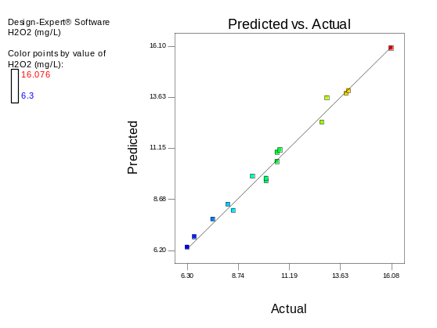  (a) | 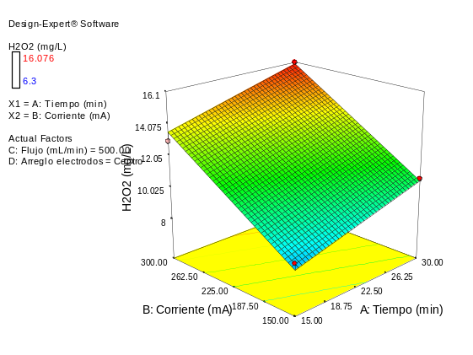  (b)
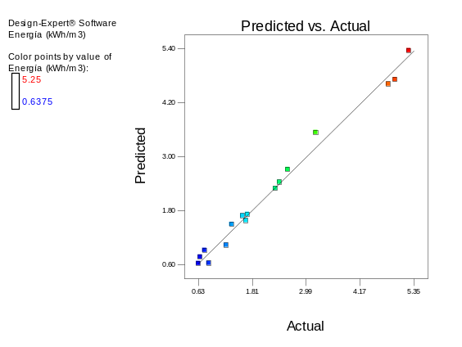  (c) | 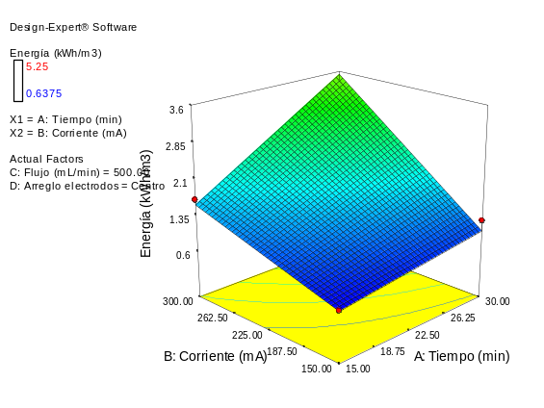  (d)
Fig. 1-S. (a) Actual and predicted H₂O₂ electrogeneraton and (c) energetic consumption. Treatment time and current intensity effects on (b) H₂O₂ electrogeneraton and (d) energetic consumption, response surface and contour diagram.

