Supplementary Information

For manuscript –
Assessing the impact of building footprint dataset choice for health programme planning: a case study of indoor residual spraying (IRS) in Zambia

Appendix A
 | Settlement Class (count of potentially residential building footprints per GRID3 v2.0 settlement extent)
 | A (n = 0) | B (n = 1-5) | C (n = 6-24) | D (n = 25+) | Total
Counts of settlement extents
Ecopia (year 2) | 19,588 | 423,913 | 160,249 | 30,749 | 634,499
Google (v3) | 210,573 | 271,318 | 127,631 | 24,977 | 634,499
Microsoft (Oct. 2023) | 348,627 | 217,171 | 55,719 | 12,982 | 634,499
OSM (Oct. 2023) | 300,276 | 206,096 | 107,797 | 20,330 | 634,499
Counts of potentially residential building footprints within settlement extents
Ecopia (year 2) | 0 | 978,965 | 1,662,155 | 5,438,017 | 8,079,137
Google (v3) | 0 | 702,208 | 1,316,990 | 5,271,951 | 7,291,149
Microsoft (Oct. 2023) | 0 | 501,561 | 564,180 | 2,931,462 | 3,997,203
OSM (Oct. 2023) | 0 | 552,157 | 1,115,177 | 3,267,050 | 4,934,384
Table A.1: Counts of GRID3 settlement extents per class (A-D) and potentially residential building footprints within each settlement extent, for each building footprint dataset nationally.

 | Settlement Class (count of potentially residential building footprints per derived settlement cluster)
 | A (n = 0) | B (n = 1-5) | C (n = 6-24) | D (n = 25+) | Total
Counts of derived settlement clusters
Ecopia (year 2) | 0 | 532,423 | 177,594 | 29,032 | 739,049
Google (v3) | 0 | 497,970 | 127,966 | 22,806 | 648,742
Microsoft (Oct. 2023) | 0 | 383,107 | 56,366 | 12,043 | 451,516
OSM (Oct. 2023) | 0 | 350,556 | 111,138 | 19,202 | 480,896
Counts of potentially residential building footprints within derived settlement clusters
Ecopia (year 2) | 0 | 1,217,022 | 1,800,981 | 5,061,190 | 8,079,193
Google (v3) | 0 | 1,085,408 | 1,288,624 | 4,955,366 | 7,329,398
Microsoft (Oct. 2023) | 0 | 746,859 | 561,901 | 2,774,801 | 4,083,561
OSM (Oct. 2023) | 0 | 821,479 | 1,122,911 | 3,002,920 | 4,947,310
Table A.2: Counts of derived settlement clusters per class (A-D) and potentially residential building footprints within each derived cluster, for each building footprint dataset nationally.
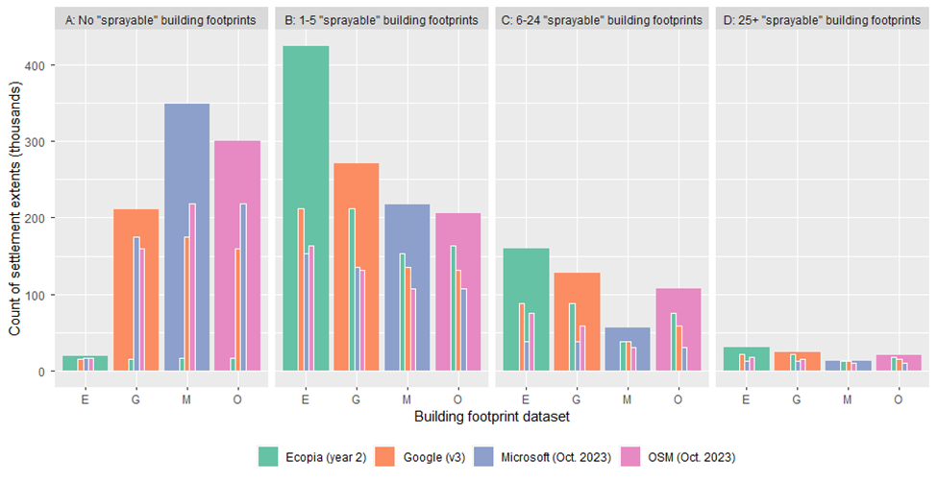
Figure A.1: The wider bars show count of GRID3 v2.0 settlement extents in each class (A-D), for each building footprint dataset, based on the count of potentially residential building footprints per settlement extent. For example, there are 12,982 class D settlement extents, when Microsoft building footprints are used to calculate the number of potentially residential building footprints per settlement extent. Within the wider bars, there are three smaller, nested bars, which represent the subset of settlement extents that are in the same class, when the three other building footprint datasets are separately used as the basis for calculating counts of potentially residential building footprints per settlement extent. For example, of the 12,982 settlement extents classified as class D with Microsoft building footprints, 12,754 are also classified as class D with Ecopia footprints, 12,326 are classified as class D with Google footprints and 10,135 are classified as class D with OSM footprints.
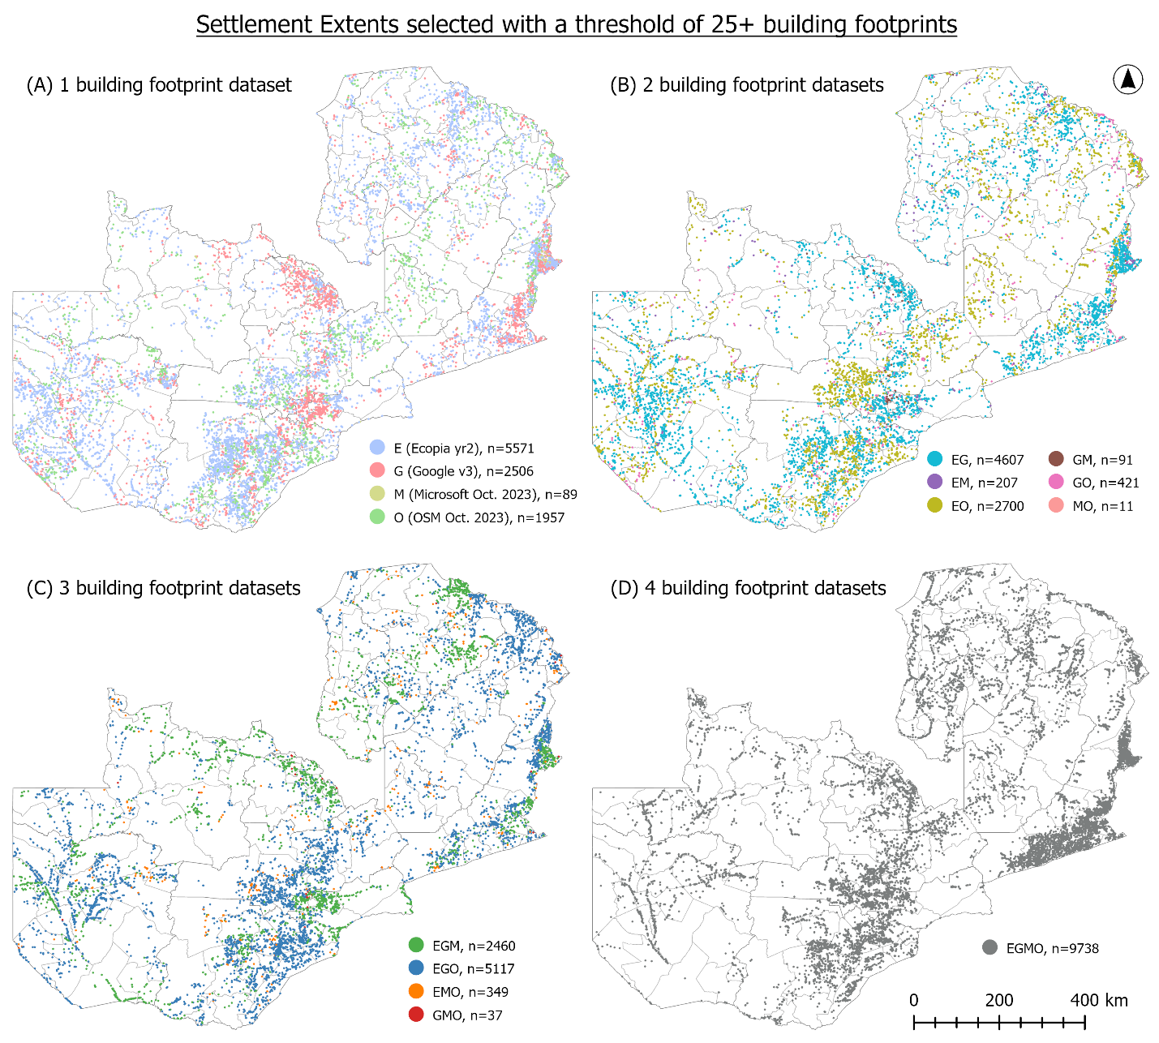
Figure A.2: The location of class D settlement extents (with 25 or more potentially residential building footprints), stratified by the count (A-D) and combination (colour of points) of building footprint datasets (E=Ecopia year 2, G=Google v3, M=Microsoft (Oct. 2023 download) and O=OSM (Oct. 2023 download)). Settlement extents are mapped based on their geometric centroid. The count of settlement extents is summarised in Figure 5.
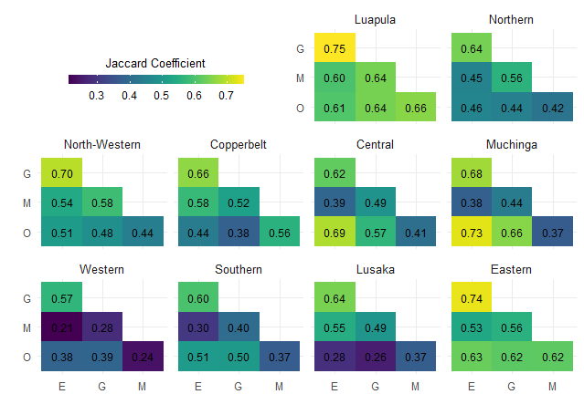
Figure A.3: Jaccard Coefficient values for pairwise comparison of the priority settlement extents selected with a threshold of 25 or more potentially residential building footprints, with different building footprint datasets (E=Ecopia year 2, G=Google v3, M=Microsoft (Oct. 2023 download) and O=OSM (Oct. 2023 download)), summarised for each province. Higher Jaccard coefficient values indicate greater spatial similarity in terms of the settlement extents selected.

Province | Count of class D settlement extents (EGMO) | Count of potentially residential building footprints within subset of class D (EGMO) settlement extents
Province | Count of class D settlement extents (EGMO) | Ecopia (year 2) | Google (v3) | Microsoft (Oct. 2023) | OSM (Oct. 2023) | Mean CV [%] | Median CV [%]
Central | 1,515 | 381,485 | 371,125 | 248,527 | 342,897 | 46.7 | 19.0
Copperbelt | 546 | 696,071 | 827,306 | 542,011 | 413,928 | 299.6 | 26.6
Eastern | 2,651 | 736,852 | 717,235 | 395,036 | 439,896 | 71.3 | 37.3
Luapula | 664 | 371,895 | 357,617 | 227,748 | 235,776 | 117.4 | 31.3
Lusaka | 277 | 710,246 | 897,528 | 575,610 | 474,142 | 590.5 | 30.0
Muchinga | 653 | 168,877 | 158,503 | 87,633 | 154,748 | 60.2 | 21.8
North-Western | 573 | 284,371 | 262,940 | 168,300 | 124,429 | 162.6 | 33.5
Northern | 845 | 285,925 | 257,101 | 157,935 | 180,749 | 82.3 | 28.1
Southern | 1,447 | 420,340 | 386,769 | 233,169 | 284,998 | 65.4 | 20.5
Western | 567 | 200,842 | 179,896 | 96,684 | 127,226 | 89.9 | 25.4
TOTAL: | 9,738 | 4,256,904 | 4,416,020 | 2,732,653 | 2,778,789
Table A.3: For the subset of class D settlement extents that are found with all four building footprint datasets (EGMO), the count of potentially residential building footprints within these settlement extents is shown per province. The mean and median coefficient of variation (CV) in the count of building footprints per settlement extent is also calculated for this subset of class D settlement extents.
Province | Count of class D settlement extents (EGMO) | Count of potentially residential building footprints within subset of class D (EGMO) settlement extents
Province | Count of class D settlement extents (EGMO) | Ecopia (year 2) | Google (v3) | Microsoft (Oct. 2023) | OSM (Oct. 2023) | Mean CV [%] | Median CV [%]
Rural
Central | 1,480 | 196,934 | 174,323 | 115,990 | 181,568 | 28.5 | 18.7
Copperbelt | 491 | 93,476 | 107,125 | 67,165 | 51,946 | 50.1 | 24.6
Eastern | 2,604 | 598,216 | 561,446 | 313,535 | 365,208 | 58.6 | 36.6
Luapula | 596 | 153,245 | 132,615 | 92,678 | 96,798 | 50.9 | 27.6
Lusaka | 206 | 40,532 | 44,247 | 24,975 | 19,774 | 58.4 | 25.1
Muchinga | 642 | 109,364 | 89,107 | 58,712 | 102,139 | 37.3 | 21.8
North-Western | 538 | 113,618 | 85,533 | 61,414 | 87,089 | 57.0 | 32.3
Northern | 807 | 154,629 | 118,786 | 85,485 | 113,225 | 43.1 | 27.4
Southern | 1,399 | 229,067 | 198,376 | 114,296 | 168,511 | 39.1 | 20.3
Western | 532 | 82,803 | 67,225 | 38,531 | 60,326 | 38.5 | 24.0
TOTAL: | 9,295 | 1,771,884 | 1,578,783 | 972,781 | 1,246,584
Urban Cluster
Central | 33 | 72,926 | 76,829 | 46,255 | 64,653 | 469.3 | 61.9
Copperbelt | 48 | 108,978 | 133,654 | 91,361 | 68,606 | 528.7 | 152.2
Eastern | 46 | 91,085 | 100,849 | 50,501 | 50,714 | 522.3 | 71.5
Luapula | 67 | 174,590 | 178,521 | 109,563 | 119,856 | 535.9 | 194.6
Lusaka | 67 | 45,100 | 57,024 | 36,091 | 16,612 | 237.6 | 53.7
Muchinga | 10 | 36,875 | 41,745 | 15,520 | 30,491 | 1,026.9 | 204.1
North-Western | 34 | 78,014 | 71,191 | 42,606 | 31,217 | 707.3 | 245.5
Northern | 37 | 80,765 | 83,489 | 43,019 | 45,892 | 561.8 | 94.9
Southern | 47 | 160,205 | 155,211 | 100,299 | 95,019 | 717.7 | 69.6
Western | 34 | 72,759 | 64,892 | 35,912 | 34,551 | 594.2 | 143.4
TOTAL: | 423 | 921,297 | 963,405 | 571,127 | 557,611
Urban Centre
Central | 2 | 111,625 | 119,973 | 86,282 | 96,676 | 6,557.1 | 6,557.1
Copperbelt | 7 | 493,617 | 586,527 | 383,485 | 293,376 | 16,229.1 | 9,587.9
Eastern | 1 | 47,551 | 54,940 | 31,000 | 23,974 | 12,414.2 | 12,414.2
Luapula | 1 | 44,060 | 46,481 | 25,507 | 19,122 | 11,729.2 | 11,729.2
Lusaka | 4 | 624,614 | 796,257 | 514,544 | 437,756 | 33,904.8 | 5,023.8
Muchinga | 1 | 22,638 | 27,651 | 13,401 | 22,118 | 5,125.8 | 5,125.8
North-Western | 1 | 92,739 | 106,216 | 64,280 | 6,123 | 38,449.1 | 38,449.1
Northern | 1 | 50,531 | 54,826 | 29,431 | 21,632 | 13,933.7 | 13,933.7
Southern | 1 | 31,068 | 33,182 | 18,574 | 21,468 | 6,183.2 | 6,183.2
Western | 1 | 45,280 | 47,779 | 22,241 | 32,349 | 10,297.7 | 10,297.7
TOTAL: | 20 | 1,563,723 | 1,873,832 | 1,188,745 | 974,594
Table A.4: For the subset of class D settlement extents that are found with all four building footprint datasets (EGMO), the count of potentially residential building footprints within these settlement extents is shown per province, with rural/urban stratification. The mean and median coefficient of variation (CV) in the count of building footprints per settlement extent is also calculated for this subset of class D settlement extents. Rural/urban stratification is based on the GRID3 v2.0 settlement extent L1 Degree of Urbanisation attribute.
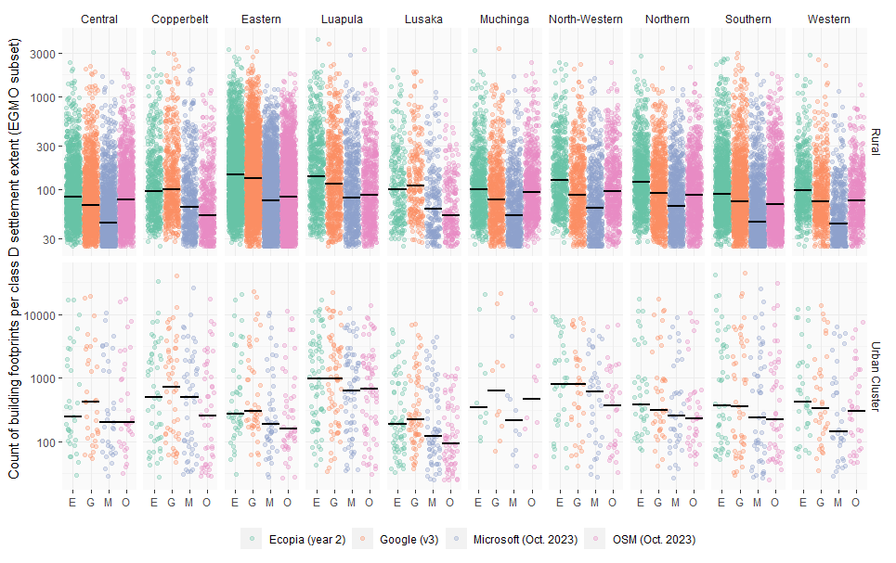
Figure A.4: For the subset of class D settlement extents that are found with all four building footprint datasets (EGMO), the count of potentially residential building footprints per settlement extent is shown with stratification per province and with rural/urban stratification. For each stratum, the median count of building footprints per settlement extent is shown by the horizontal black line. Rural/urban stratification is based on the settlement extent L1 Degree of Urbanisation attribute; given the small number of settlement extents classified as Urban Centres, this stratum has been omitted. Note that the Y-axis for the Rural and Urban strata are different, both of which are on a log10 scale.
Province | The count of class D settlement extents with each building footprint dataset, and the total count of potentially residential building footprints within those class D settlement extents
Province | Ecopia (year 2) |  | Google (v3) |  | Microsoft (Oct. 2023) |  | OSM (Oct. 2023)
 | n sett. exts | n. BF | n sett. exts | n. BF | n sett. exts | n. BF | n sett. exts | n. BF
Rural
Central | 4,233 | 302,610 | 3,185 | 238,636 | 1,684 | 123,690 | 3,769 | 265,944
Copperbelt | 1,338 | 132,328 | 1,562 | 158,682 | 818 | 82,963 | 620 | 56,546
Eastern | 5,612 | 753,697 | 5,201 | 694,542 | 3,057 | 330,935 | 3,894 | 427,138
Luapula | 1,314 | 205,256 | 1,093 | 169,372 | 772 | 101,833 | 834 | 117,310
Lusaka | 1,021 | 98,959 | 1,129 | 105,006 | 558 | 49,450 | 295 | 22,897
Muchinga | 1,808 | 172,273 | 1,469 | 136,935 | 689 | 60,405 | 1,817 | 164,842
North-Western | 1,619 | 197,991 | 1,346 | 147,907 | 877 | 87,700 | 1,017 | 109,510
Northern | 3,053 | 338,873 | 2,142 | 221,720 | 1,373 | 129,879 | 1,632 | 159,625
Southern | 5,680 | 422,561 | 4,063 | 316,769 | 1,682 | 128,149 | 3,769 | 268,822
Western | 4,404 | 275,342 | 3,050 | 188,634 | 921 | 59,648 | 2,178 | 127,751
TOTAL: | 30,082 | 2,899,890 | 24,240 | 2,378,203 | 12,431 | 1,154,652 | 19,825 | 1,720,385
Urban Cluster
Central | 46 | 73,373 | 50 | 77,427 | 39 | 46,456 | 41 | 64,950
Copperbelt | 72 | 111,317 | 94 | 137,929 | 68 | 93,173 | 51 | 68,687
Eastern | 64 | 92,913 | 66 | 102,749 | 53 | 51,104 | 49 | 50,878
Luapula | 75 | 177,355 | 80 | 181,228 | 67 | 109,563 | 71 | 121,369
Lusaka | 128 | 50,849 | 153 | 65,278 | 107 | 40,280 | 70 | 16,723
Muchinga | 20 | 48,471 | 26 | 52,334 | 10 | 15,520 | 25 | 40,530
North-Western | 54 | 90,604 | 56 | 84,056 | 42 | 45,043 | 40 | 32,614
Northern | 60 | 92,236 | 65 | 95,542 | 51 | 49,340 | 39 | 46,047
Southern | 68 | 163,324 | 62 | 157,158 | 54 | 101,376 | 56 | 95,413
Western | 51 | 73,561 | 51 | 65,537 | 35 | 35,991 | 43 | 34,860
TOTAL: | 638 | 974,003 | 703 | 1,019,238 | 526 | 587,846 | 485 | 572,071
Urban Centre
Central | 2 | 111,625 | 2 | 119,973 | 2 | 86,282 | 2 | 96,676
Copperbelt | 13 | 493,824 | 14 | 586,845 | 10 | 383,577 | 7 | 293,376
Eastern | 1 | 47,551 | 1 | 54,940 | 1 | 31,000 | 1 | 23,974
Luapula | 1 | 44,060 | 1 | 46,481 | 1 | 25,507 | 1 | 19,122
Lusaka | 6 | 624,775 | 9 | 796,554 | 6 | 514,671 | 4 | 437,756
Muchinga | 2 | 22,671 | 2 | 27,681 | 1 | 13,401 | 1 | 22,118
North-Western | 1 | 92,739 | 1 | 106,216 | 1 | 64,280 | 1 | 6,123
Northern | 1 | 50,531 | 1 | 54,826 | 1 | 29,431 | 1 | 21,632
Southern | 1 | 31,068 | 1 | 33,182 | 1 | 18,574 | 1 | 21,468
Western | 1 | 45,280 | 2 | 47,812 | 1 | 22,241 | 1 | 32,349
TOTAL: | 29 | 1,564,124 | 34 | 1,874,510 | 25 | 1,188,684 | 20 | 974,594
Table A.5: For each building footprint dataset, the count of class D settlement extents and the total count of potentially residential building footprints within those class D settlement extents. Counts are stratified by province, with rural/urban stratification. Rural/urban stratification is based on the GRID3 v2.0 settlement extent L1 Degree of Urbanisation attribute.

