Sample MRI radiologist report of the lumbar spine with a history of lower back pain
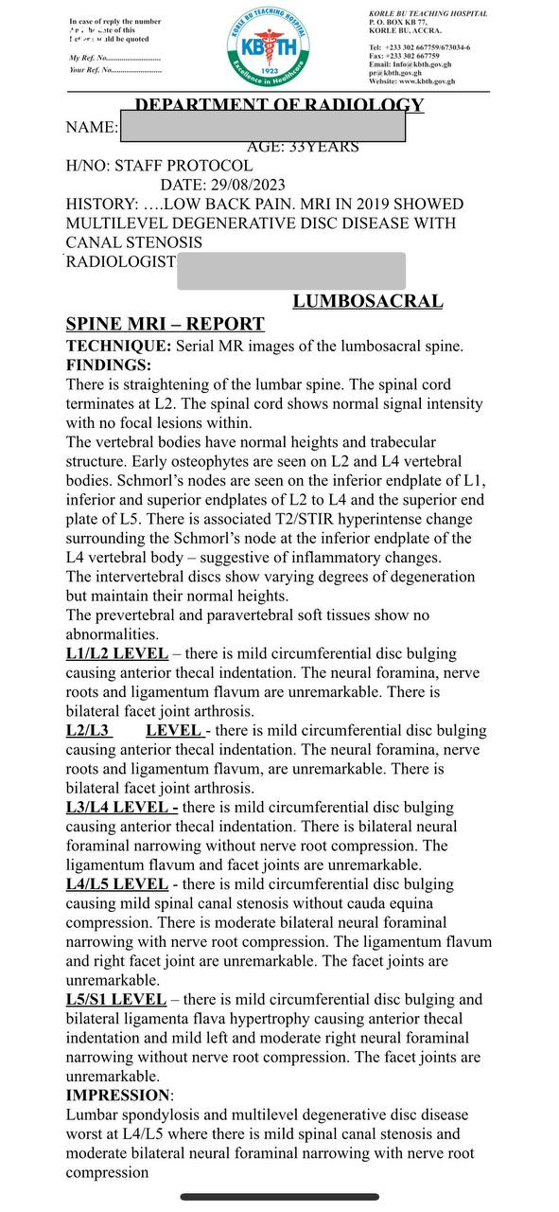

Data collection sheet
Gender | Age | Main findings | Disc space | Pathologies associated | Vertebral body | Pathologies associated | Lordotic curvature | Spinal cord termination

