Supplementary Material
Selective recruitment of beneficial microbes in the rhizosphere of maize affected by microbial inoculants, farming practice, and seasonal variations
Ioannis D. Kampouris^{1*#}, Theresa Kuhl-Nagel^{2#}, Jan Helge Behr², Loreen Sommermann³, Doreen Babin¹, Davide Francioli^{4,5}, Rita Zrenner², Susanne Kublik⁶, Michael Schloter^{6,7}, Uwe Ludewig⁴, Kornelia Smalla¹, Günter Neumann⁴, Rita Grosch^{2#}, Joerg Geistlinger^{3#}
¹Julius Kühn Institute (JKI) - Federal Research Centre for Cultivated Plants, Institute for Epidemiology and Pathogen Diagnostics, Braunschweig, Germany
²Leibniz Institute of Vegetable and Ornamental Crops (IGZ), Plant-Microbe Systems, Großbeeren, Germany
³Department of Agriculture, Ecotrophology and Landscape Development, Anhalt University of Applied Sciences, Bernburg, Germany
⁴Department of Nutritional Crop Physiology, Institute of Crop Science, University of Hohenheim, Stuttgart, Germany
⁵Department of Soil Science and Plant Nutrition, Hochschule Geisenheim University, Geisenheim, Germany
⁶Institute for Comparative Microbiome Analysis, Helmholtz Zentrum München – German Research Center for Environmental Health, Neuherberg, Germany
⁷Technical University of Munich, Chair for Environmental Microbiology, München, Germany
# I. D. Kampouris, T. Kuhl-Nagel, R. Grosch, J. Geistlinger contributed equally to this work
* Correspondence:
Ioannis D. Kampouris; ioannis.kampouris@julius-kuehn.de

Table S1 Genes and primer pairs for gene expression analysis in maize leaves (cv. Benedictio). Housekeeping genes for normalization are highlighted in bold.
Gene | Code | Accession | Forward and  Reverse primers (5’-3’) | Ref
Ubiquitin-conjugating enzyme | ZmUbi | NM_001154750.1 | CAGGTGGGGTATTCTTGGTG  ATGTTCGGGTGGAAAACCTT | 1
Actin | ZmACT | NM_001165684.1 | GGAGCTCGAGAATGCCAAGAGCAG  GACCTCAGGGCATCTGAACCTCTC | 2
Cytosolic ascorbate peroxidase | ZmAPX1 | GRMZM2G316256 | GCTCTGTCTTGCATGGCACTCC  GATGGGCTCTAGCAACCTGACG | 3
Mitogen-activated protein kinase | ZmMPK3 | GRMZM2G017792 | ACAGCGACATGATGACGGAGTA  CCAATCACCTCGGTTATGAG | 3
Nicotianamine synthase | ZmNAS3 | XM_008666956.4 | GGCTCACCAGAAGATGGAGGAG  TCACGCATGTGGTGTAGACACG | 4
Zinc transporter | ZmIRTa | NM_001158638.2 | CTGCAGAGCAGCGTCAGG  AGTACTGTGTCATGTCGTCTC | 5
Oligopeptide transporter | ZmOPT8a | GRMZM2G086258 | GCTACATGAGCATGTCGCAGGCT  TGCCAGCCACAATGGTACCAACAAACTGA | 5
Nitrite reductase | ZmNIR | GRMZM2G079381 | AGGTGGCGGACATCGGCTTC  ACGGCACGGACTTCCTGTAGAC | 6
Nitrate reductase 1 | ZmNR1 | GRMZM2G076723 | TGCTTCTGGTCCGTCGAGGTGG  ACACGTTCACCTTCACCTTGAA | 7
High affinity nitrate transporter | ZmNAR2.2 | GRMZM2G163494 | GCTGGAGGTGACCCTCTGCTACG  TGCCGGGCGATCCTGAACTGG | 7
Phosphate transporter 1;1 | ZmPht1 | GRMZM2G326707 | CGTAGTACGTGTGTGATAGTCTGG  TATTATCACACGTGGACCTCTACC | 8
Phosphate transporter 1;3 | ZmPht3 | GRMZM2G112377 | GCCTTCCGTTACGTCATTGT  AGCACGTCTCTGATCCCATC | 8
Phosphate transporter 1;4 | ZmPht4 | GRMZM2G170208 | ACCGGCTACCCTCACCTACT  CTACCTTCTTGGCGTCCTTG | 8
Phosphate transporter 1;8 | ZmPht8 | GRMZM2G045473 | CCTGGAGGAGATGTTCAGGA  AAGACGGTGAACCAGTAGCC | 8
Endochitinase PR4 | ZmPR4 | NM_001157282.1 | TGATGGATAGATGGCGATTGC  AGAATTGACACCGCCAAACC | 9
Superoxide dismutase | ZmSOD4 | XM_008653632.4 | CACCAACGGCTGCATGTC  ATGCTCCTTGCCAACAGGAT | 9
1-Aminocyclopropane-1-carboxylate synthase | ZmACS6 | NM_001143622.2 | GTGCTCATCACCAACCCTTC  ACGAAGTCCACCAGCATCTC | 2
Defensin-like protein 1 | ZmDef1 | NM_001329491.1 | TGCTGCTCCTCATCGTCGTTGC  TTGCCGCCGCCGTAGCCTTC | 10
Defensin-like protein 2 | ZmDef2 | NM_001153491.2 | AGTCCAGGGCGACCGTGTG  CGAGTGGTGCTGGCTCTTGC | 10
WRKY transcription factor | ZmWRKY106 | GRMZM2G013391 | GCTCGTCACCTACACCTTCG  AGCTTTCGTCCTCCTCTGC | 11
WRKY transcription factor | ZmWRKY17 | GRMZM2G102583 | TTTTTCTTCTTCCGCTGTTCTACTC  TCAGATCGAGGGTCGTCATCT | 11
WRKY transcription factor | ZmWRKY33 | GRMZM2G148087 | GTGGTCCAGACGATGAGCGACAT  GCTGCTCAGCATCTCCAGGGTGT | 11
WRKY transcription factor | ZmWRKY58 | GRMZM2G147880 | AGGAAGTGGAGGAGGCGAACA  GGATGGCTTGCGCTTGC | 11
Ethylene-responsive factor-like protein | ZmERF1 | NM_001111800.2 | ACTTCCCCAGCGACACCTC  TGACCTCGTCGGACACCTGA | 12
Ethylene-responsive transcription factor | ZmEREB58 | NM_001176924.1 | GACGGCGACAAGAAGCGA  CGGTGCCAGGACGACG | 13
MYB transcription factor | ZmMYB30 | GRMZM2G087955 | CTCCTTGTCGTTGTCCCTCT  CTTGCTTGTGCTTGAGGTGT | 14
MYB transcription factor | ZmMYB36 | GRMZM2G139284 | GGTGTTCGAGTACGAGACGA  ACAGGACGGTGGAAGTGG | 14
MYB transcription factor | ZmMYB95 | GRMZM2G139284 | CTCGTCTTCTCTCCGCTACC  TAGTCGACGACAACGAGTGG | 14
References
1 Gorbani et al., 2018; https://doi.org/10.1371/journal.pone.0194592
2 Louis et al., 2015; https://doi.org /10.1104/pp.15.00958
3 Xu et al., 2017; http://dx.doi.org/10.1016/j.plaphy.2017.05.018
4 Zhou et al. 2013; http://www.biomedcentral.com/1471-2164/14/238
5 Kobae et al., 2014; http://dx.doi.org/10.1080/00380768.2014.949854
6 Jiang et al., 2018; https://doi.org/10.1080/23723556.2018.1441633
7 Liseron-Monfils et al., 2013; https://doi.org/10.4161/psb.26056
8 Sawers et al., 2017; https://doi.org/10.1111/nph.14403
9 Gond et al., 2015; http://dx.doi.org/10.1016/j.micres.2014.11.004
10 Liu et a., 2016; https://doi.org/10.1093/jxb/erw226
11 Wei et al., 2012; https://doi.org/10.1093/dnares/dsr048
12 Shi et al., 2016; https://doi.org/10.1007/s11738-016-2146-2
13 Li et al., 2015; https://doi.org/10.1111/tpj.12994
14 Chen et al., 2018; https://doi.org 10.1007/s10535-017-0756-1
15 Campbell, R 2000; https://ncagr.gov/agronomi/saaesd/scsb394.pdf

Table S2 Information on metagenomic sequencing runs (AR: annotated reads)
 |  | 2020 |  |  |  | 2021
 |  | No. of reads | Range |  | [%] | No. of reads | Range |  | [%]
Raw reads (F&R) |  | 755.064.346 | 7.694.159 – 19.737.260 |  | 100 | 720.503.706 | 9.266.032 – 14.941.948 |  | 100
Trimmed reads (Forward & Reverse) using FASTX toolkit5 (50bp, Phredscore 20, No PhiX contamination, paired) |  | 720.371.138 | 7.352.763 – 18.813.545 |  | 95.4 | 693.723.530 | 8.993.359 – 14.472.065 |  | 96.3
Merged reads by PEAR pipeline |  | 344.628.088 | 7.168.494 – 18.104.610 |  | 91.3 | 321.676.174 | 7.885.933 – 13.151.655 |  | 89.3
Merged read length ranges |  |  | 120-165 bp |  |  |  | 119-134 bp
Taxonomy merged reads by MGX pipeline | 2020 |  |  |  |  | 2021
Taxonomy merged reads by MGX pipeline | AR |  |  | AR [%] |  | AR |  | AR [%]
Archaea | 2.762.345 |  |  | 0.8 |  | 2.556.190 |  | 0.8
Bacteria | 152.802.549 |  |  | 44 |  | 156.554.970 |  | 49
Fungi | 124.178 |  |  | 0.04 |  | 202.646 |  | 0.06
Total (also includes other eukaryotes) | 156.817.662 |  |  | 45.5 |  | 160.603.667 |  | 50
Functions merged reads (COG database) | AR |  |  | AR [%] |  | AR |  | AR [%]
Archaea | 1.151.439 |  |  | 0.3 |  | 1.129.602 |  | 0.35
Bacteria | 92.086.588 |  |  | 25.5 |  | 95.164.223 |  | 30
Fungi | 46.384 |  |  | 0.012 |  | 76.561 |  | 0.02
Total (also includes other eukaryotes) | 100.997.321 |  |  | 28 |  | 101.883.650 |  | 31.7

Table S3 Linear model with the factors affecting shoot biomass (SDM) of maize (cv. Benedictio). Log₁₀ transformation was applied to improve fitting under normal distribution. Significant factors are highlighted in bold, n = 64. Shapiro test on residuals using log₁₀-transformed data p = 0.01, n = 64.
Parameter | R² | F | p-value
BMc | 7.20 | 7.461929 | 0.00879
Year | 0.07 | 0.067868 | 0.79558
Tillage | 0.31 | 0.319058 | 0.57480
N-Fertilization intensity | 4.68 | 4.851645 | 0.03245
BMc:Year | 21.93 | 22.73355 | 0.00002
BMc:Tillage | 11.45 | 11.86324 | 0.00120
Year:Tillage | 1.90 | 1.96771 | 0.16713
BMc:N-Fertilization intensity | 0.01 | 0.01319 | 0.90905
Year:N-Fertilization intensity | 0.42 | 0.434849 | 0.51277
Tillage:N-Fertilization intensity | 1.06 | 1.098288 | 0.29989
BMc:Year:Tillage | 0.15 | 0.151103 | 0.69920
BMc:Year:N-Fertilization intensity | 4.06 | 4.211864 | 0.04562
BMc:Tillage:N-Fertilization intensity | 0.11 | 0.111118 | 0.74033
Year:Tillage:N-Fertilization intensity | 0.24 | 0.252669 | 0.61750
BMc:Year:Tillage:N-Fertilization intensity | 0.10 | 0.108665 | 0.74310

Table S4: Macro- and micro-nutrient concentrations in maize shoots (cv. Benedictio) grown under different farming practices (MP: Mouldboard plough tillage, CT: Cultivator tillage, Int: Intensive, Ext: Extensive N-fertilization intensities, Ctrl: control plants) and with BMc (beneficial microorganisms consortium) inoculation in the growing season 2020. The table depicts main and interactions effects of ANOVA tests on the nutrients (*p < 0.05, **p < 0.01, ***p < 0.001, n=64, TILL: Tillage, FERT: N-Fertilization, BMc: Beneficial microorganism consortium). Italicized values depict nutritional deficiency threshold as described by Campbell et al. 2000.
 | C | N | P | K | Mg | Ca | Fe# | Cu | Zn | Mn#
TILL | 0.058 | 0.017* | < 0.001*** | 0.023* | 0.009** | 0.947 | 0.003** | 0.021* | 0.016* | 0.012*
FERT | 0.853 | 0.005** | < 0.001*** | 0.503 | < 0.001*** | 0.055 | 0.929 | 0.003** | 0.551 | 0.164
BMc | 0.034* | 0.157 | 0.121 | 0.562 | 0.151 | 0.938 | 0.008** | 0.060 | 0.848 | 0.815
TILL x FERT | 0.802 | 0.575 | 0.036* | 0.371 | 0.562 | 0.131 | 0.038* | 0.742 | 0.193 | 0.815
TILL x BMc | 0.386 | 0.376 | 0.654 | 0.910 | 0.909 | 0.387 | 0.045* | 0.976 | 0.617 | 0.519
FERT x BMc | 0.295 | 0.622 | 0.400 | 0.427 | 0.004** | 0.468 | 0.572 | 0.142 | 0.834 | 0.664
TILL x FERT x BMc | 0.223 | 0.838 | 0.985 | 0.505 | 0.198 | 0.188 | 0.428 | 0.415 | 0.544 | 0.596

Table S5: Macro- and micro-nutrient concentrations in maize shoots (cv. Benedictio) grown under different farming practices (MP: Mouldboard plough tillage, CT: Cultivator tillage, Int: Intensive, Ext: Extensive N-fertilization intensities, Ctrl: control plants) and with BMc (beneficial microorganisms consortium) inoculation in the growing season 2021. The table depicts main and interactions effects of ANOVA tests on the nutrients (*p < 0.05, **p < 0.01, ***p < 0.001, n=64, TILL: Tillage, FERT: N-Fertilization, BMc: Beneficial microorganism consortium). Italicized values depict nutritional deficiency threshold as described by Campbell et al. 2000.

 | C | N | P | K | Mg | Ca | S# | Fe | Cu | Zn | Mn
TILL | 0.001** | < 0.001*** | 0.118 | 0.018* | 0.002** | < 0.001*** | < 0.001*** | 0.006** | < 0.001*** | < 0.001*** | < 0.001***
FERT | 0.055 | < 0.001*** | 0.010* | 0.063 | < 0.001*** | 0.524 | < 0.001*** | 0.118 | 0.367 | 0.207 | < 0.001***
BMc | 0.985 | 0.772 | 0.198 | 0.700 | 0.802 | 0.645 | 0.042* | 0.298 | 0.073 | 0.133 | 0.666
TILL x FERT | 0.637 | 0.024* | 0.006** | 0.009** | 0.455 | 0.111 | 0.433 | 0.956 | 0.006** | 0.523 | 0.245
TILL x BMc | 0.304 | 0.935 | 0.695 | 0.009** | 0.130 | 0.126 | 0.093 | 0.699 | 0.264 | 0.701 | 0.557
FERT x BMc | 0.408 | 0.018* | 0.454 | 0.803 | 0.346 | 0.335 | 0.470 | 0.230 | 0.037* | 0.798 | 0.531
TILL x FERT x BMc | 0.307 | 0.002** | 0.535 | 0.946 | 0.256 | 0.215 | 0.225 | 0.159 | 0.145 | 0.701 | 0.638

Table S6 Statistics of structural equation model (SEM) with SDM (shoot dry mass) and nutrient concentrations (mg or g kg⁻¹ SDM) based on partial least squares.
Variable1 | Variable2 | Estimate | p-value
SDM | Fe | 2.377422 | 0.017434
SDM | Ca | -1.96555 | 0.049351
SDM | Zn | 2.603525 | 0.009227
SDM | K | 2.531854 | 0.011346
SDM | Cu | -4.17656 | 2.96E-05
Fe | N | 2.803724 | 0.005052
Fe | Ca | 4.851634 | 1.22E-06
Fe | S | 3.302182 | 0.000959
Fe | P | -2.20836 | 0.027219
N | K | 2.206329 | 0.027361
N | Cu | 5.74895 | 8.98E-09
Mg | Ca | 5.248275 | 1.54E-07
Mg | Mn | -10.1431 | 0
Mg | S | 2.307002 | 0.021055
Mg | P | -2.03849 | 0.041501
Mg | Zn | 6.513073 | 7.36E-11
Mg | K | 5.334574 | 9.58E-08
Ca | Mn | 5.36365 | 8.16E-08
Ca | S | -3.5304 | 0.000415
Mn | S | 2.417993 | 0.015606
Mn | P | 4.023389 | 5.74E-05
Mn | K | -9.92839 | 0
Mn | Cu | 3.309991 | 0.000933
P | Zn | 4.234146 | 2.29E-05
P | K | 7.502933 | 6.24E-14
P | Cu | -5.67227 | 1.41E-08
Zn | Cu | 6.491075 | 8.52E-11
K | Cu | 10.42701 | 0

Table S7 Number (No.) of annotated reads (AR, 100%) and sequences identical to the inoculated strains (ABi03, RU47, and OMG16) of the beneficial microorganism consortium in the growing seasons 2020 and 2021.
2020 | AR total | No. of AR mapped onto respective BMc genome (identity 100%, alignment 100%) | Genome
Bacillus atrophaeus | 71.345 | 59.164 | ABi03
Pseudomonas sp. | 23.221 | 17.462 | RU47
Trichoderma harzianum | 1.496 | 474 | OMG16
2021
Bacillus atrophaeus | 125.375 | 106.080 | ABi03
Pseudomonas sp. | 24.221 | 19.479 | RU47
Trichoderma harzianum | 9.133 | 6.695 | OMG16

Table S8 Global PERMANOVA for bacterial communities in the rhizosphere of control or BMc (beneficial microorganism consortium) inoculated maize plants (cv. Benedictio) under intensive or extensive N-fertilization intensity with mouldboard plough or cultivator tillage, including year as a factor (***p < 0.001, **p < 0.01, *p < 0.05).
 | Explained Variance [%] | p-value
Year | 20.93 | 1.00E-05
Tillage | 5.28 | 2.00E-05
N-Fertilization Intensity | 1.65 | 0.07189
BMc | 2.77 | 0.00433
Year:Tillage | 2.17 | 0.0193
Year:N-Fertilization Intensity | 1.26 | 0.21923
Tillage:N-Fertilization Intensity | 1.31 | 0.19293
Year:BMc | 1.40 | 0.14837
Tillage:BMc | 1.99 | 0.03014
N-Fertilization Intensity:BMc | 1.40 | 0.14667
Year:Tillage:N-Fertilization Intensity | 1.45 | 0.12775
Year:Tillage:BMc | 1.60 | 0.08344
Year:N-Fertilization Intensity:BMc | 1.24 | 0.23698
Tillage:N-Fertilization Intensity:BMc | 1.81 | 0.04918
Year:Tillage:N-Fertilization Intensity:BMc | 1.44 | 0.13044

Table S9 Global PERMANOVA for fungal communities in the rhizosphere of control or BMc (beneficial microorganism consortium) inoculated maize plants (cv. Benedictio) under intensive or extensive N-fertilization intensity with mouldboard plough or cultivator tillage, including year as a factor (***p < 0.001, **p < 0.01, *p < 0.05).
 | Expl. Variance (%) | p-value
Year | 19.42 | 1.00E-05
Tillage | 1.90 | 0.00783
N-Fertilization Intensity | 4.24 | 1.00E-05
BMc | 11.49 | 1.00E-05
Year:Tillage | 3.53 | 7.00E-05
Year:N-Fertilization Intensity | 4.40 | 2.00E-05
Tillage:N-Fertilization Intensity | 1.98 | 0.00587
Year:BMc | 13.59 | 1.00E-05
Tillage:BMc | 0.96 | 0.14752
N-Fertilization Intensity:BMc | 0.76 | 0.2851
Year:Tillage:N-Fertilization Intensity | 1.80 | 0.01045
Year:Tillage:BMc | 1.04 | 0.11239
Year:N-Fertilization Intensity:BMc | 0.81 | 0.2515
Tillage:N-Fertilization Intensity:BMc | 1.31 | 0.04695
Year:Tillage:N-Fertilization Intensity:BMc | 1.17 | 0.07544

Table S10 PERMANOVA for bacterial communities in the rhizosphere of control or BMc (beneficial microorganism consortium) inoculated maize plants (cv. Benedictio) under intensive or extensive N-fertilization intensity with mouldboard plough or cultivator tillage in the sampling years 2020 and 2021 (***p < 0.001, **p < 0.01, *p < 0.05).
Factor | Explained Variance [%]
Factor | 2020 | 2021
Tillage practice | 10.0*** | 9.7***
N-fertilization intensity | 3.9* | 3.5*
BMc Inoculation | 5.8*** | 6.8**
Tillage practice ×  N-fertilization intensity | 3.6 | 3.4
Tillage practice × BMc Inoculation | 4.9*** | 4.5**
N-fertilization intensity × BMc Inoculation | 3.7* | 3.1
Tillage practice ×  N-fertilization intensity × BMc Inoculation | 4.6** | 3.7*
Residuals | 63.2 | 65.2

Table S11 PERMANOVA for fungal communities in the rhizosphere of control or BMc (beneficial microorganism consortium) inoculated maize plants (cv. Benedictio) under intensive or extensive N-fertilization intensity with mouldboard plough or cultivator tillage in the sampling years 2020 and 2021 (***p < 0.001, **p <0.01, *p < 0.05).
Factor | Explained Variance [%]
Factor | 2020 | 2021
Tillage practice | 5.9* | 7.1**
N-fertilization intensity | 3.8* | 14.7***
Inoculation | 28.1**** | 32.8****
Tillage practice ×  N-fertilization intensity | 7.3** | 3.2**
Tillage practice × Inoculation | 5.9** | 0.5
N-fertilization intensity × Inoculation | 2.5 | 1.7
Tillage practice ×  N-fertilization intensity × Inoculation | 5.9** | 1.4
Residuals | 40.4 | 38.6

Table S12 Bacterial differentially abundant ASVs to BMc inoculation identified with logistic regression
See Excel file
Table S13 Fungal differentially abundant ASVs to BMc inoculation identified with logistic regression
See Excel file

Table S14 PERMANOVA of bacterial gene abundance from the rhizosphere of control or BMc (beneficial microorganism consortium) inoculated maize plants (cv. Benedictio) under intensive or extensive N-fertilization intensity with mouldboard plough or cultivator tillage in the sampling years 2020 and 2021 (***p < 0.001, **p <0.01, *p <0.05).
Factor | Explained Variance [%]
Factor | 2020 | 2021
Tillage practice | 7.3** | 6.4***
N-fertilization intensity | 4.7* | 3.5
Inoculation | 9.0*** | 10.4***
Tillage practice ×  N-fertilization intensity | 2.9 | 3.5
Tillage practice × Inoculation | 3.4 | 5.7**
N-fertilization intensity × Inoculation | 3.3 | 4.0*
Tillage practice ×  N-fertilization intensity × Inoculation | 5.9** | 3.5
Residuals | 63.6 | 62.9

Table S15 Bacterial and fungal iron-associated ASVs to BMc inoculation identified with linear regression of iron shoot concentrations and log₁₀ transformed relative abundance.
See Excel file

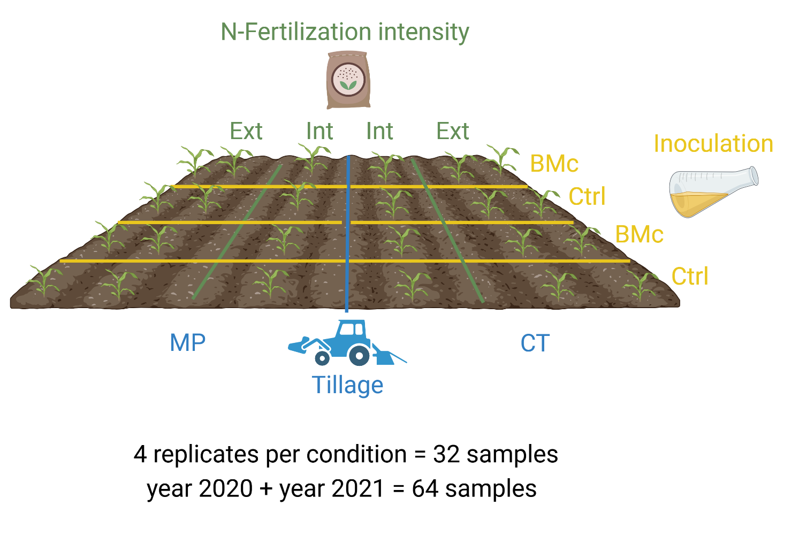
Figure S1 Description of the experimental design and the number of replicates under different farming practices. BMc: beneficial microorganism consortium, C: Control, Ext: Extensive N-fertilization, Int: Intensive N-fertilization. MP: Mouldboard plough, CT: Cultivator. Created with BioRender.com

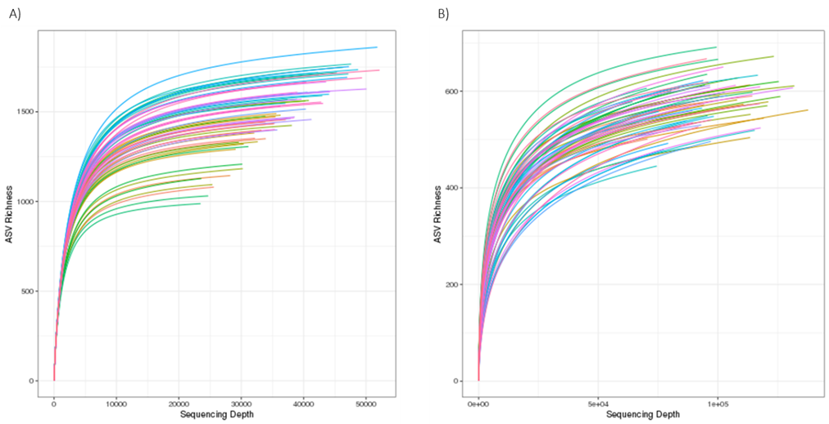
Figure S2. Rarefaction curves of 16S rRNA gene (A) and ITS2 (B) amplicon sequencing data in the growing seasons 2020 and 2021.

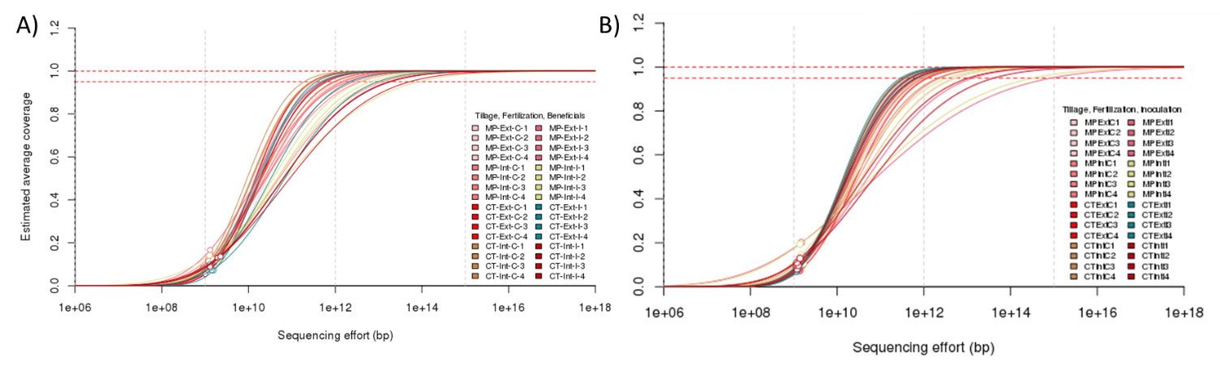Figure S3. Nonpareil-curves for diversity coverage of metagenome sequence reads. A) Coverage 2020: 5.4 - 14.5%, B) Coverage 2021: 5.3 - 16.9%.

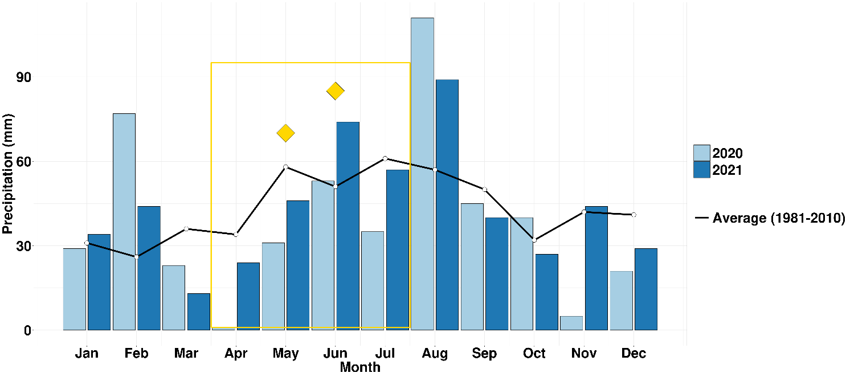
Figure S4. The average monthly precipitation at the LTE (long term experiment) field site in Bernburg, Germany, from 1981 until 2010 and in the experimental years. The yellow box denotes the duration of the field experiments and the stars indicate the dates of inoculation with the beneficial microorganism consortium (BMc).

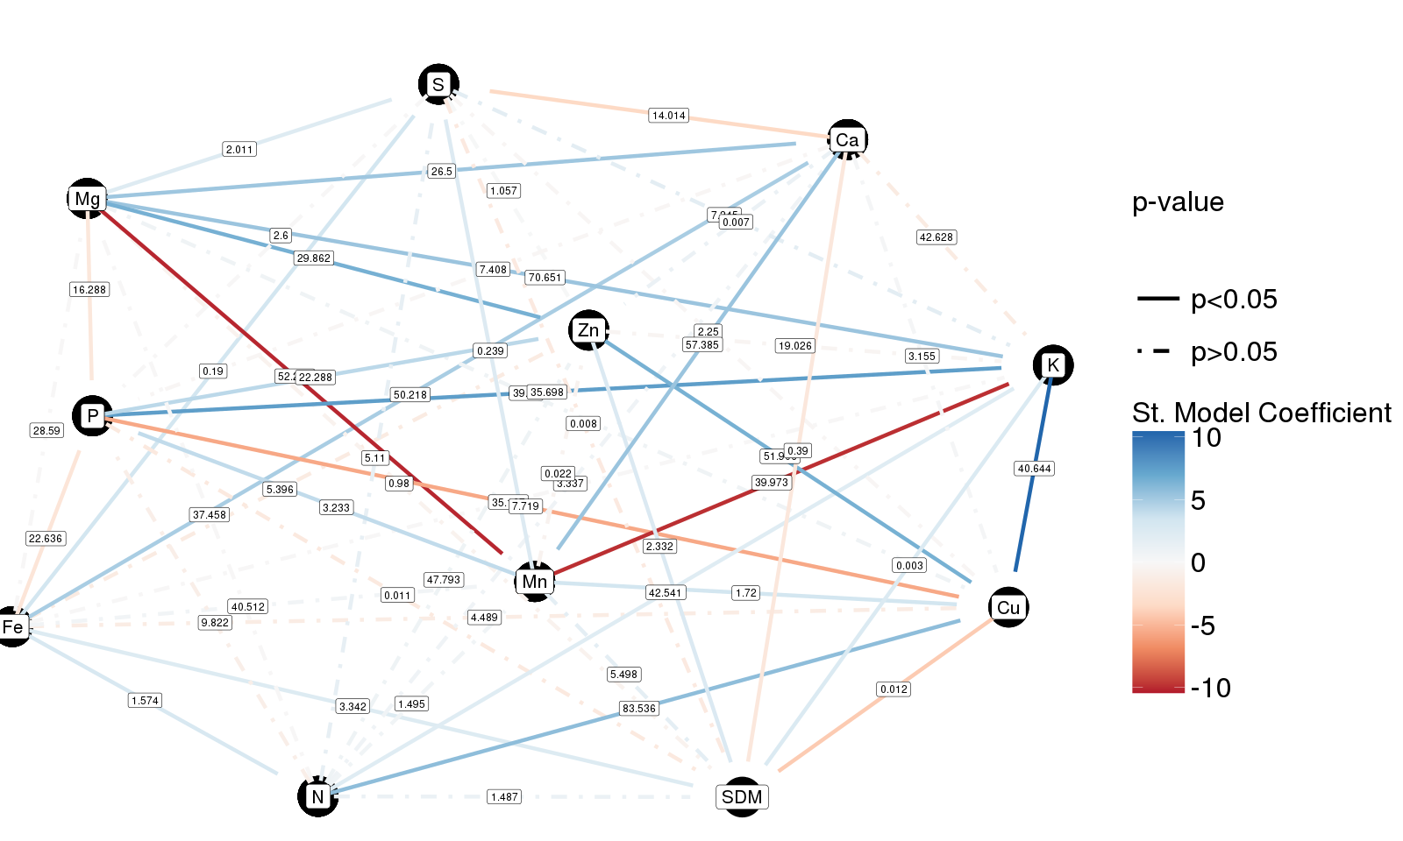
Figure S5. Structural equation model of macro- and micronutrient total mass (mg or g kg⁻¹ plant), and shoot dry mass (SDM, g plant⁻¹) based on partial least squares. The model shows significant relationships with solid lines (p ≤ 0.05), dashed lines are not significant. The structural (St.) model coefficient indicates a positive (blue) or negative (red) correlation (n = 64).

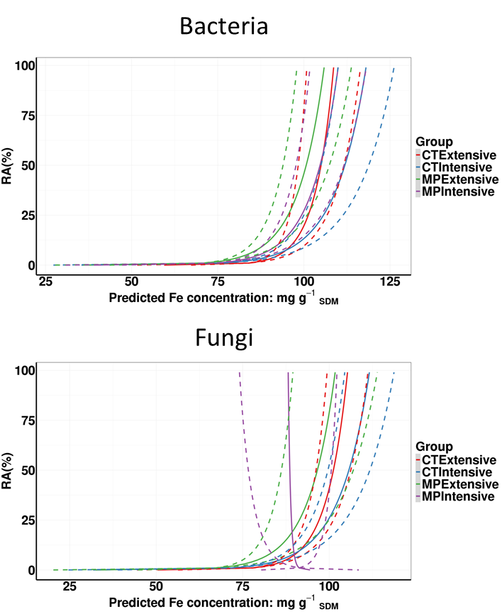
Figure S6. Linear model inferring the iron concentration in shoots through the log₁₀-transformed relative abundance of iron-associated bacterial (A) and fungal (B) ASVs. The model was examined among the different groups of tillage and N-fertilization intensity to identify model coefficients for each group and error-estimates for each coefficient. Solid lines represent the fit and dashed lines the predicted standard error. For all groups (except MP-Intensive in fungi) similar trends of iron-concentration saturation under high abundances of iron-associated ASVs were detected. SDM: shoot dry mass, MP: mouldboard plough tillage, CT: cultivator tillage, RA: Relative abundance.

