Supplemental information
Decoding Gender: A Machine Learning Approach for Classifying Indian Names with Advanced Feature Extraction

Sudeep D Ghate^{1,2}*, Saishma H¹, Dhanush Ghate D³, Adithya M³, Anjusha Alex⁴, Neevan Dsouza⁴, Prakash Patil²

¹ Center for Bioinformatics, NITTE deemed to be University, Mangaluru -575018, India
²Center Research Laboratory, KS Hegde Medical Academy, NITTE deemed to be University, Mangaluru -575018, India
³Department of Computer Science and Engineering, NMAM Institute of Technology, NITTE deemed to be University, Nitte - 574110, India
⁴ Department of Biostatistics, KS Hegde Medical Academy, NITTE deemed to be University, Mangaluru- 575018, India

*Corresponding author
E-mail: sudeep1129@gmail.com

Running title: Name gender classification using CNN and feature engineering

Keywords: Gender classification, Indian names, Machine learning, Feature extraction, Deep learning, Dataset diversity
Figure legends
Fig. S1. Training vs Validation accuracy over Iterations for testing performance of 12 ML models with 10% test dataset: (A) CatBoost, (B) CNN, (C) Decision tree, (D) GRU, (E) KNN, (F) LSTM, (G) Logistic Regression, (H) Logistic Regression with BERT, (I) MLP, (J) Random forest, (K) XGBoost, (L) XGBoost. Each curve represents the performance of the respective model across 30 epochs, highlighting trends and variability in accuracy during training and validation phases.
Fig. S2. Training vs Validation loss over Iterations for testing performance of 12 ML models with 10% test dataset: (A) CatBoost, (B) CNN, (C) Decision tree, (D) GRU, (E) KNN, (F) LSTM, (G) Logistic Regression, (H) Logistic Regression with BERT, (I) MLP, (J) Random forest, (K) XGBoost, (L) XGBoost. Each curve represents the performance of the respective model across 30 epochs, highlighting trends and variability in accuracy during training and validation phases.
Fig. S3. Confusion matrix for testing performance of 12 ML models with 10% test dataset: (A) CatBoost, (B) CNN, (C) Decision tree, (D) GRU, (E) KNN, (F) LSTM, (G) Logistic Regression, (H) Logistic Regression with BERT, (I) MLP, (J) Random forest, (K) XGBoost, (L) XGBoost with The diagonal values indicate correctly classified instances, while off-diagonal values represent misclassifications. The predicted labels are shown on the x-axis, and the actual labels are on the y-axis.
Table S1. Count of names extracted from Indian Electoral Data of Different States and Union Territories
Sl. No. | State/Union territories | Total Names
1 | Andaman and Nicobar Islands | 17948
2 | Andhra Pradesh | 106649
3 | Arunachal Pradesh | 29971
4 | Bihar | 127055
5 | Chhattisgarh | 111003
6 | Delhi | 55558
7 | Goa | 44285
8 | Gujarat | 2304
9 | Haryana | 102417
10 | Himachal Pradesh | 72086
11 | Jharkhand | 103113
12 | Jammu and Kashmir | 28037
13 | Karnataka | 97399
14 | Kerala | 54951
15 | Madhya Pradesh | 94657
16 | Maharashtra | 127295
17 | Manipur | 22528
18 | Meghalaya | 24615
19 | Mizoram | 22436
20 | Nagaland | 26280
21 | Odisha | 24970
22 | Punjab | 2141
23 | Rajasthan | 103336
24 | Sikkim | 72096
25 | Tamil Nadu | 98611
26 | Telangana | 119759
27 | Uttar Pradesh | 168011
28 | Uttarakhand | 79001
29 | West Bengal | 101152

Table S2. Distribution of total names extracted from various websites included in the study
Sl. No. | Website url | Total Names
1 | https://www.bachpan.com | 36872
2 | https://www.behindthename.com | 1300
3 | https://drlogy.com | 7714
4 | https://babynames.extraprepare.com | 59775
5 | https://hindunames.net/ | 7523
6 | https://indianhindunames.com | 7567
7 | https://www.momjunction.com/baby-names/indian | 18028
8 | https://www.mychildnames.com/ | 51113
9 | https://namesabout.com | 54251
10 | https://www.in.pampers.com | 1364
11 | https://quranicnames.com | 4393

Table S3. Distribution of total names generated by the ‘Synthetic Name Generator’ (IndiGen) across Indian States, Union Territories, and Communities
Sl. No. | State/Union Territories/ Communities | Total Names
1 | Andhra pradesh | 100000
2 | Assam | 57700
3 | Bihar | 97450
4 | Chhattisgarh | 120000
5 | Delhi | 71000
6 | Gujarat | 80000
7 | Haryana | 119000
8 | Himachal Pradesh | 68400
9 | Jammu & Kashmir and Ladakh | 100000
10 | Jharkhand | 49000
11 | Karnataka | 110000
12 | Kerala | 120000
13 | Madhya Pradesh | 69000
14 | Maharashtra | 160000
15 | Odisha | 100000
16 | Parsi | 45000
17 | Punjab | 80000
18 | Rajasthan | 120000
19 | Tamil Nadu | 99000
20 | Telangana | 100000
21 | Tribal | 90000
22 | Tripura | 24600
23 | Uttar Pradesh | 110000
24 | Uttarakhand | 70000
25 | West Bengal | 110000

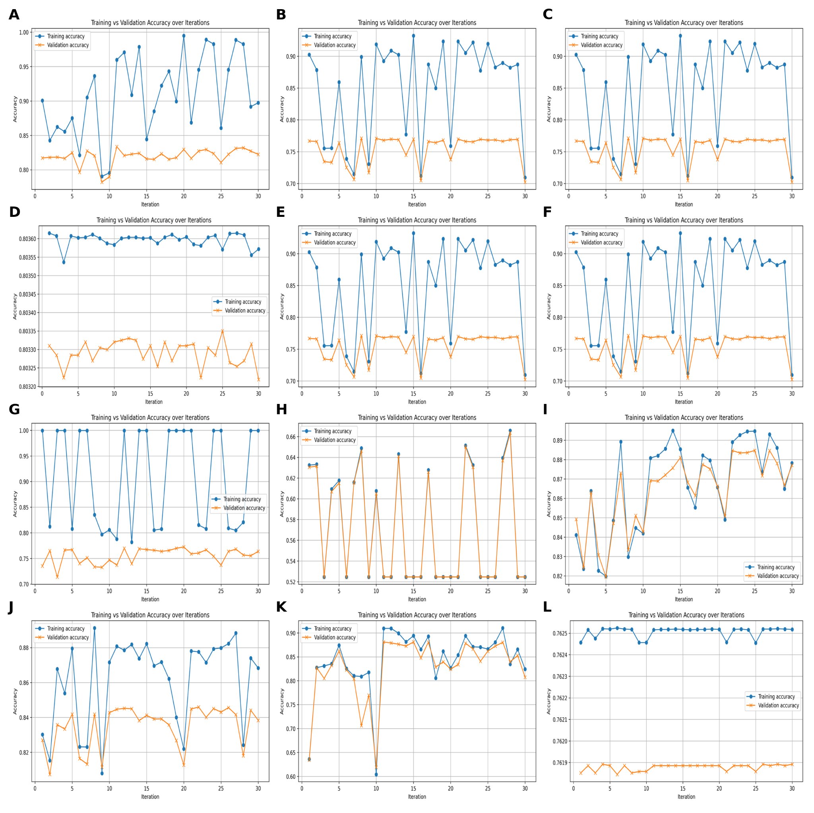

Fig. S1

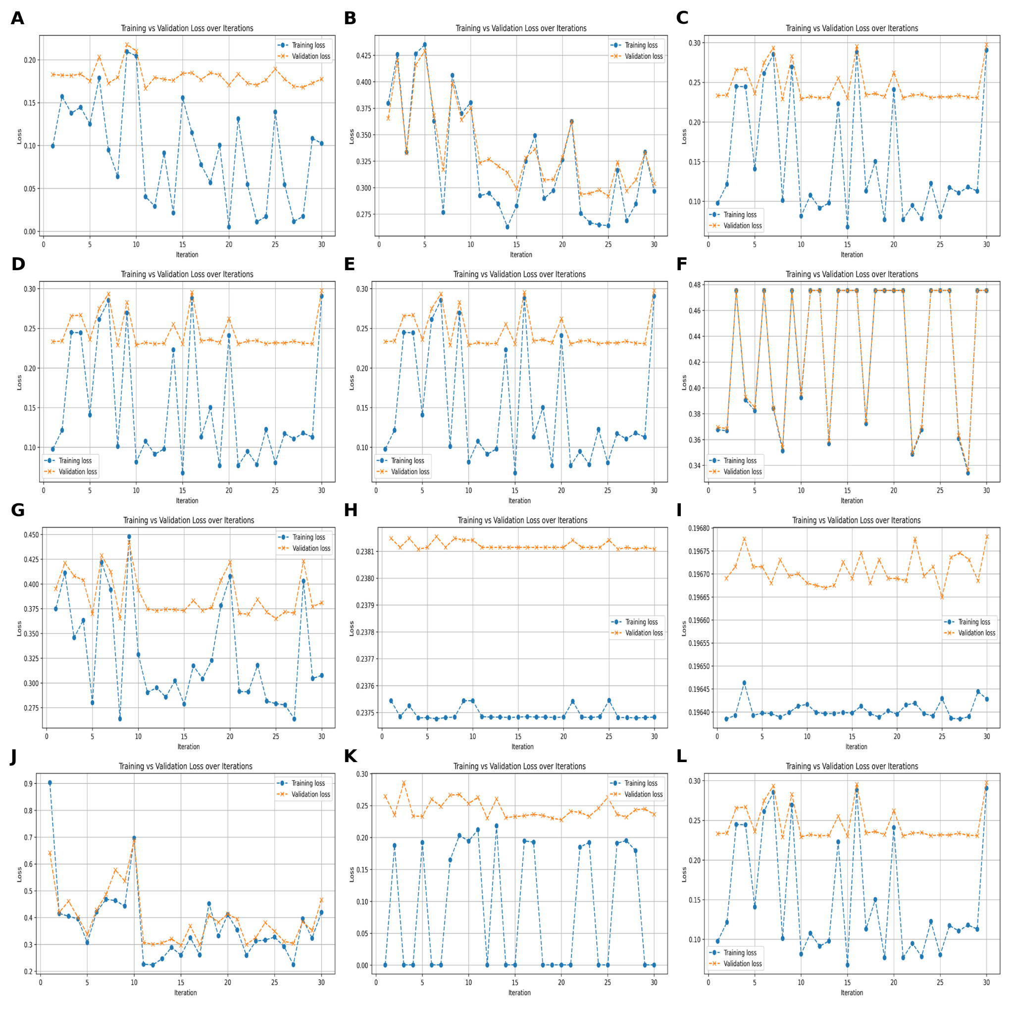

Fig. S2

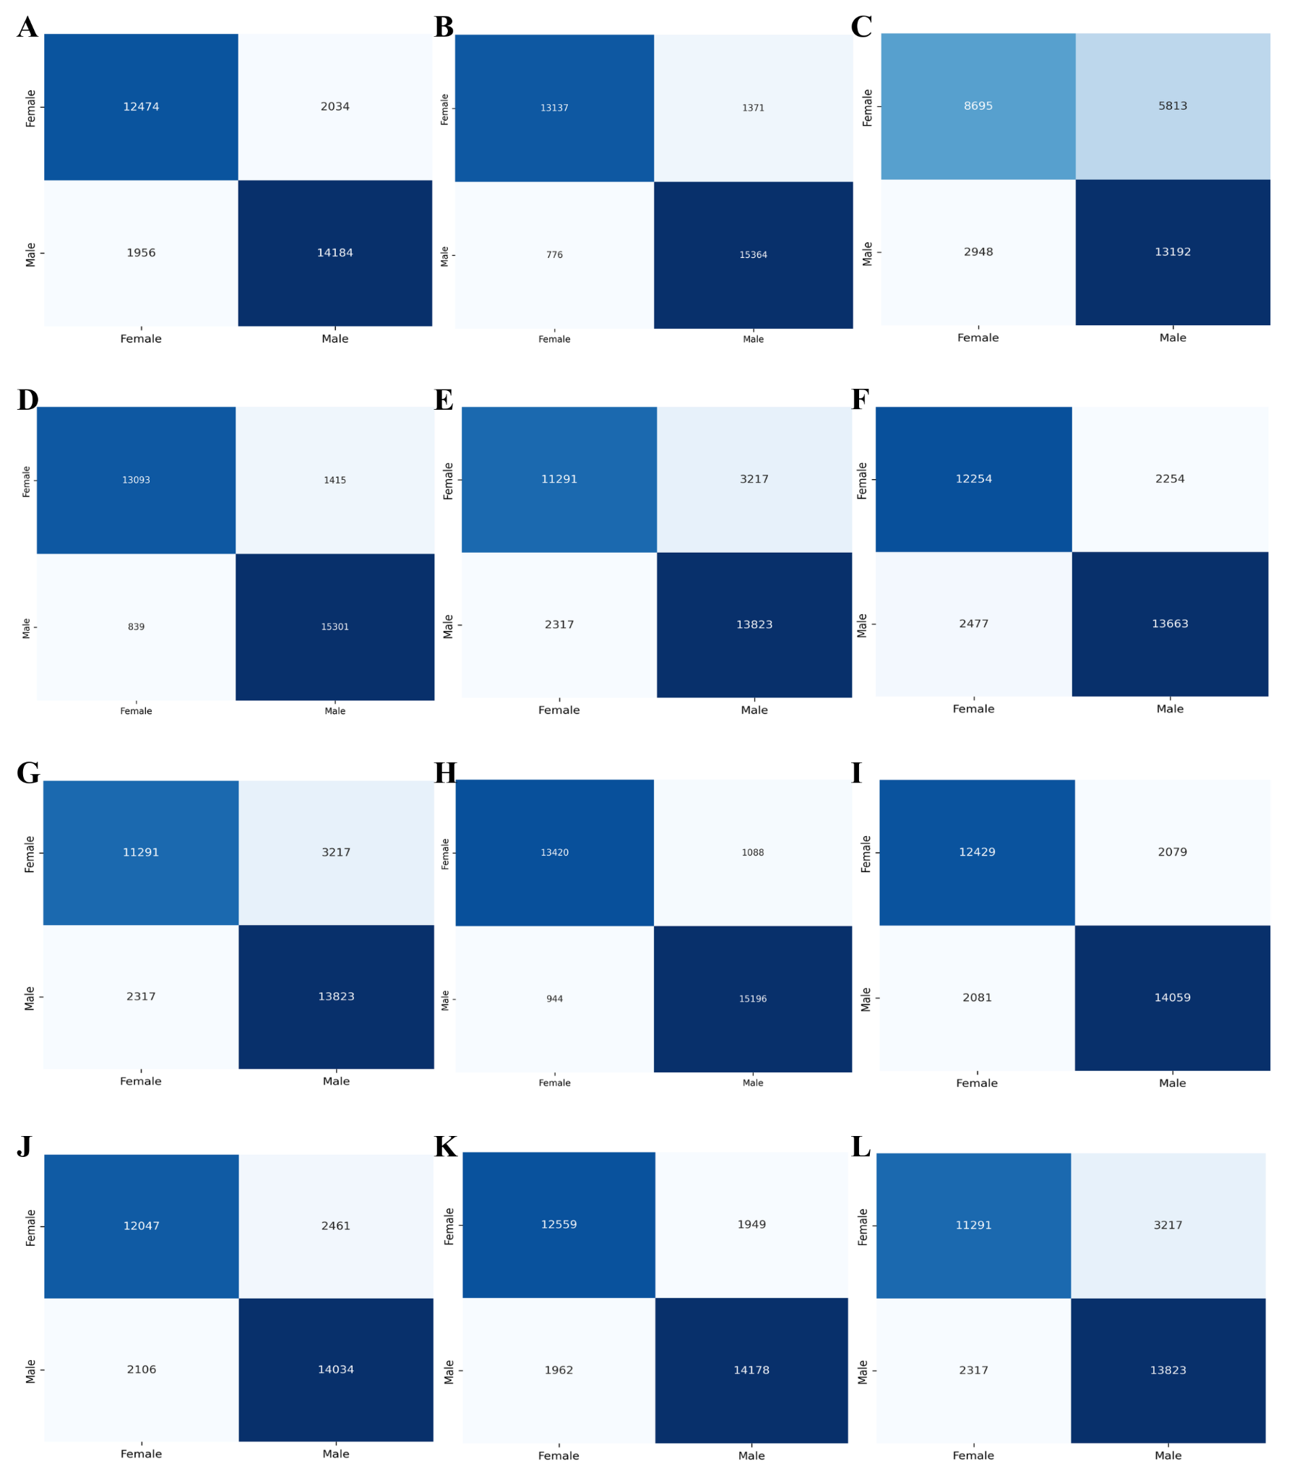

Fig. S3

