Supplementary Information

Photoselective isotope fractionation dynamics in cosmo and atmospheric chemistry

Ksenia Komarova, Natalia A. Gelfand, Francoise Remacle, Raphael D. Levine*, Subrata Chakraborty, Teresa L. Jackson, Oleg Kostko, Mark H. Thiemens*

*Corresponding authors. Email: mthiemens@ucsd.edu, raphy@mail.huji.ac.il

The PDF file includes:

Methods
S1. Experimental methods
S2. Computational methods
The absorption cross section
Shielding of the light beam, the Voigt profile
Computing the isotopic enrichment
Dynamics
The photodissociation cross section
Overview
Figures S1: Schematic diagram of the experimental chamber
S2: The role of the spectral line shape in determining the isotopic enrichment
S3: The role of H₂ shielding
S4: The ALS beam frequency profile
S5: Potential energy curves of${}_{}^{1}{{Σ }_{u}^{+}}$ and ${}_{}^{3}{Π_{u}}$ and their spin-orbit coupling terms
S6: Potential energy curves of ${}_{}^{1}{Π_{u}^{+}}$ and ${}_{}^{3}{Π_{u}}$ and their spin-orbit coupling terms

Tables
S1: Measured isotopic fractionation as a function of energy
S2: Rate constants k for reactions of nitrogen atoms with hydrogen molecules, molecular nitrogen and ammonia
S3: Spectroscopic and kinetic parameters for the ${{}_{}^{1}Σ}_{u}^{+}$ singlet electronic states of
the ¹⁴N₂ isotopomer
S4: Spectroscopic and kinetic parameters for the ${{}_{}^{1}Σ}_{u}^{+}$ singlet electronic states of
the ¹⁴N¹⁵N isotopomer
S5: Spectroscopic and kinetic parameters for the${{}_{}^{1}Π}_{u}^{}$singlet electronic states of
the ¹⁴N₂ isotopomer
S6: Spectroscopic and kinetic parameters for the${{}_{}^{1}Π}_{u}^{}$singlet electronic states of
the ¹⁴N¹⁵N isotopomer
S7: Band-specific natural linewidth types for both isotopomers

Methods
S1 Experimental method
All experiments for molecular nitrogen VUV photolysis were carried out at the Advanced Light Source at the Lawrence Berkely Lab on the chemical dynamics beam line. Each experiment corresponds to a full 8-hour time allocation. The difference in actual photolysis time is due to synchrotron issues and beam shut down. The flow chamber and collection procedures performed as expected. As detailed in (25,26) for the wavelengths of study there is no window that may be used, and all experiments were operated in a windowless flow system. Two large turbopumps, differentially pumped, interface the chamber to the beam line to the synchrotron. The chamber has been described in detail in (25) and shown in Figure S1. The chamber has a dewar lining that allows us to stably maintain the experiments at 80 degrees K. The gas flow, pressure and temperature were stabilized and flowing prior to acquisition of the UV light. In each series of experiments a total blank was run, that is a run with everything as usual but no UV. It was found that there is no nitrogen blank species.

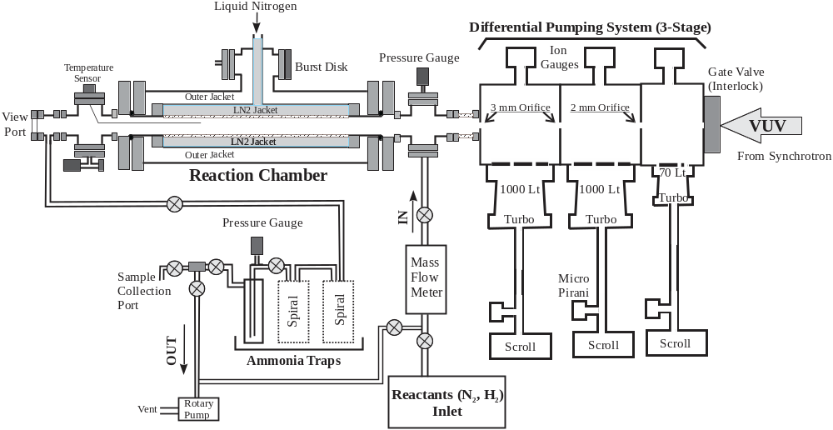
Fig. S1. Schematic diagram of the LN2cooled reaction chamber to perform photolysis experiments at various temperatures. The design of the chamber was similar to a thermos with three coaxial cylinders (with increasing diameters) were welded together creating three compartments made out of stainless steel (SS). The innermost compartment was the reaction chamber, the second compartment was the LN2reservoir, and the third (outermost)compartment was a vacuum chamber (kept under high vacuum using a turbo pump for temperature stabilization by reducing the evaporation rate). The reaction chamber compartment was fabricated with a long SS bellow to increase the surface of the reaction chamber. The chamber was attached through a 2 mm orifice to a three-stage differential pumping system (DPS). The other end of the DPS is connected to the beamline (9.0.2) end station through a gate valve.

The reaction chamber was continually monitored and controlled for pressure, temperature and flow. The flow gas was a 50:50 mixture of N₂:H₂ manually set at a total partial pressure of 250 mtorr (260 mtorr in the last series). The low flow rate of 1.575 sccm (standard cubic centimeters per minute) was controlled by a new mass flow controller manufactured by Alicat Scientific Inc. The experimental wavelengths are given in the Table in the main text. Photolysis of nitrogen occurs in the photocell and as discussed, there is insignificant H₂ photolysis. The product nitrogen atoms react with H₂ to form NH₃ which is trapped immediately and predominantly on the 80 K chamber walls such that there is little NH₃ photodecomposition. Downstream three liquid nitrogen traps ensure complete NH₃ collection. Once light is terminated, the system is isolated from the synchrotron and the 250 mtorr of unreacted N2:H2 flow gas is pumped out of the chamber, still at liquid nitrogen temperature with NH3 trapped on its surface. In about an hour near vacuum of the chamber is reached (19 mtorr), and the chamber is allowed to come to air temperature. This is done by venting the vacuum of the dewar chamber to STP to allow heating of the jacket and with hot air guns to release trapped NH₃ from chamber surface into the 3 chilled traps (80 K). Following collection of NH₃ sample in the cold traps, they are isolated from the reaction chamber, heated with boiling water, and transferred to a clean stainless steel sample tube (40 minutes). The longer time and high temperature are needed to release the otherwise sticky NH₃.
The product NH₃ was transferred in the La Jolla lab to a clean quartz tube containing solid CuO. At 910 degrees, CuO gives off O₂ which converts the sample to N₂ and H₂O. This is a well-known technique and in use by many labs, including ours, for more than 50 years. The product water is cryogenically removed and the pure N₂ collected and transferred to the Finnigan MAT 253 IRMS. As discussed, this procedure was done following this protocol but with no NH₃ to determine the blank. NH₃ of known isotopic composition was done and the error estimated for the micromole size sample is plus or minus 1 per mil. With the sample isotopic composition in the thousand per mil range, this is an insignificant error.
For these experiments a careful assessment of the CuO preparation was carried out. CuO, though 99% pure, has air trapped in the solid CuO and is not all surficial. This then can contribute nitrogen at delta values of approximately 30 per mil, which can significantly lower the isotopic composition given the small sample sizes. It was found in the CuO process that first, there is an optimal amount of CuO. Too much and there is a larger blank and too little may render an incomplete oxidation conversion. It was found that less than one gram (0.090 gram) is ideal for our sized samples. There is a multi-step process to purify and provide the best oxygen pressure at 910 C in the CuO break seal. In the first step, the CuO is slowly heated to 910 C and held for 11 minutes while open to a U trap (80 K) near the pump, to trap impurities such as water and CO₂. The heater is shut off to cool for 30 minutes to take up the oxygen. In the first temperature cut, there is excess oxygen and that is pumped away. A second step is done in the same fashion and the amount of excess oxygen is reduced considerably and no contaminant nitrogen. It is found that a third repeat step provides the optimal oxygen and, upon cooling is taken up by the CuO. In the actual sample analysis following the second heating and cooling and evacuation the sample is admitted to the quartz sample tube and frozen in. The tube is flame break sealed. For complete conversion to nitrogen, a muffle oven is used for carefully timed temperature control of the CuO-NH3 break-seal, that is slowly heated to 910 C (takes about 45 min) and held for 2 hours. Slow cooling (3 C per min) follows to 600 C and hold for 1 hour. The oven is turned off for final overnight cooling and optimal conversion of NH₃ to pure nitrogen and water, which is cryogenically removed when the pure nitrogen is transferred to a sample tube for isotopic analysis. The sample is collected on a sample tube with a molecular sieve after passage through liquid nitrogen to remove any impurities. As discussed, there is no CO or CO₂. The background is measured on the most sensitive scale. In the CuO, there is air Ar and N₂ at relative constant ratios which has been removed in the first two heating cycles. In our samples we detect no excess Ar and consequently no blank nitrogen. There is this no need to apply a correction factor. The measured isotopic fractionation are given in Table S1

Table S1. Measured isotopic fractionation of 14 samples. Energy is in descending scale.
SAMPLE | Beam energy |  |  | δ¹⁵N per mil | nanomoles | beam min
 | eV | nm | cm-1
ALS-24-05N | 14.55 | 85.21 | 117353 | 8049 | 7840 | 514
ALS-22-11N | 14.38 | 86.21 | 116000 | 8300 | 2575 | 479
ALS-24-02N | 14.37 | 86.28 | 115902 | 7916 | 2540 | 122
ALS-23-01N | 14.31 | 86.64 | 115418 | 7861 | 6600 | 433
ALS-23-02N | 14.22 | 87.19 | 114692 | 8775 | 7100 | 480
ALS-23-07N | 14.13 | 87.75 | 113966 | 10500 | 5560 | 442
ALS-22-10N | 14.07 | 88.11 | 113500 | 9576 | 4058 | 481
ALS-23-03N | 14.03 | 88.37 | 113160 | 11211 | 3830 | 475
ALS-22-09N | 13.97 | 88.73 | 112700 | 9747 | 3490 | 420
ALS-23-08N | 13.92 | 89.1 | 112233 | 10880 | 5640 | 503
ALS-23-09N | 13.86 | 89.46 | 111788 | 10669 | 2160 | 451
ALS-23-10N | 13.62 | 91.03 | 109852 | 9482 | 1270 | 480
ALS-24-03N | 13.20 | 93.93 | 106465 | 8208 | 4920 | 503
ALS-24-04N | 12.77 | 97.09 | 102997 | 5782 | 1930 | 518

S2. Computational Method

The absorption cross section
The absorption cross section as a function of frequency is needed in two places. One, as further discussed below, is to determine the absorption of the light along its path in the reaction chamber. The second is to determine the dissociation cross section. There is only one state known to give high fluorescence yield, it is (ν = 0) c′ ${{}_{}^{1}Σ}_{u}^{+}$state at 104323 cm⁻¹. Higher in energy, above 108000 cm⁻¹, with the exception of a few long living states identified in Tables S2 and S3 below, most initial ${{}_{}^{1}Σ}_{u}^{+}$states and all ${{}_{}^{1}Π}_{u}^{}$ states dissociate rapidly enough to compete effectively with spontaneous emission. For all these states we take the quantum yield for dissociation to be unity. Using the potentials of ¹⁴N₂ and ¹⁴N¹⁵N that we generated, the computed absorption cross section, (see^{1,2} and references therein), agrees well with the previously published results³. The time-dependent propagation is not carried for long enough to reliably determine the natural line width. At the lower energies, below 106000 cm⁻¹, we used the high resolution absorption measurements reported ^{4,5} in the research depository of the Australian National University. At higher energies we use the spectra as reported by Dishoeck et al ⁶, https://doi.org/10.1051/0004-6361/201220625 , Appendix B in particular. The key input that we take from the results is the location of the maximum and the area of each rotational peak. We modified one detail, a detail that for us is essential. The spectra as reported, uses a Gaussian line shape. As discussed below, we find that using a Gaussian line shape leads to an excessively large computed isotopic fractionation. Rather we use a Voigt profile,⁷ (https://en.wikipedia.org/wiki/Voigt_profile) of a given area that accounts for both natural and Doppler broadening, see Figure S2. We emphasize this point because it is the use of a Voigt line profile that leads to the computed isotopic branching as reported in the main text. There are variations in the natural widths of different states, see for example Table II of ⁸ columns on the right. As also shown in Figure S2, when we use a Voigt profile, varying the natural width from 0.13 cm⁻¹ to 0.97 cm⁻¹ does not markedly change the computed isotopic ratio.

Fig. S2. (A) Energy profiles of two rotational lines computed for a Lorentzian, a Gaussian and a Voigt functional forms. The three profiles have the same area. The Lorentzian and Gaussian have a FWHM = 0.484 cm⁻¹. In the Voigt profile, we set $σ$ and $Γ$ such that both correspond to a FWHM = 0.484 cm⁻¹. (B) The same rotational lines computed with a Voigt profile for increasing FHWM for $σ$ and $Γ$ as indicated. (C) Computed $δ^{15}N$ enrichment profile, Eq. (8), for the Lorentzian, Gaussian and Voigt profiles shown in panel (A). (D) Computed $δ^{15}N$, Eq. (8) for the three Voigt profiles shown in panel (B).

Table S2.
The rate constants k for reactions of nitrogen atoms with hydrogen molecules H₂, molecular nitrogen N₂ and ammonia NH₃, k is in units of cm³ molecule⁻¹ s⁻¹ at room temperature 298 K.
Note: The experiments of Umemoto et al. and Suzuki et al were carried out near atmospheric pressure while the other data were obtained at a lower pressure.

Reaction | Rate constant | Reference
$${N(}^{2}D)+H_{2}=NH+H$$ | 2.2 × 10⁻¹²  2.3 × 10⁻¹²  2.4 × 10⁻¹²  1.8 × 10⁻¹²  2.3 × 10⁻¹²  3.5 × 10⁻¹²  2.7 × 10⁻¹²  2.1 × 10⁻¹²  1.7 × 10⁻¹²  5 × 10⁻¹² | Herron, 1999  Umemoto et al,1998  Suzuki et al, 1993  Whitefield and Hovis, 1987  Piper et al, 1987  Fell et al, 1981  Black et al, 1975  Husain et al, 1974  Husain et al, 1972  Black et al, 1969
$${N(}^{2}D)+N_{2}=N+ N_{2}$$ | 2.4 × 10⁻¹²  1.3 × 10⁻¹²  1.8 × 10⁻¹²  ≤ 1.8 × 10⁻¹²  1.5 × 10⁻¹²  2.3 × 10⁻¹²  1.6 × 10⁻¹²  ≤ 6 × 10⁻¹² | Suzuki et al, 1993  Sugawara et al, 1980  Slanger and Black, 1976  Black et al, 1975  Husain et al, 1974  Husain et al, 1972  Lin and Kaufman, 1971  Black et al, 1969 7
$${N(}^{2}D)+{NH}_{3}=products$$ | 5 × 10⁻¹¹  1.1 × 10⁻¹⁰ | Schofield, 1979  Black et al, 1969
$${N(}^{2}P)+H_{2}=N+H_{2}$$ | 2 × 10⁻¹⁵  1.4 × 10⁻¹⁴  1.4 × 10⁻¹⁴  ≤ 8 × 10⁻¹⁶  1.9 × 10⁻¹⁵  3.0 × 10⁻¹⁵ | Herron, 1999  Suzuki et al, 1993  Umemoto et al,1985  Young and Dunn, 1975  Husain et al, 1974  Husain et al, 1972
$${N(}^{2}P)+N_{2}=N+N_{2}$$ | ≤ 4 × 10⁻¹⁶  3.3 × 10⁻¹⁷  1 × 10⁻¹⁶  ≤ 3 × 10⁻¹⁶ | Umemoto et al, 1985  Sugawara et al, 1980  Husain et al, 1974  Husain et al, 1972

Table S3.
Calculated vibrational energy levels of the ${{}_{}^{1}Σ}_{u}^{+}$ singlet electronic states and the corresponding experimental (Song, et al. 2016) branching ratio into N(⁴S_{3/2})+N(²P_{J}) channel and computed channel exit lifetime for ¹⁴N₂ isotopomer. The experimental values are taken for the lowest available rotational state excitation. ª estimated value

Energy, cm⁻¹ | Experiment N(⁴S_{3/2})+N(²P_{J}) | Predissociation lifetime, ps
108,778 | 0.000 | 5,324
109,442 | 0.003 | 118
110,144 | 0.307 | 458,839ª
110,476 | 0.057 | 466
110,855 | 0.021 | 172
111,549 | 0.006 | 1,540
112,226 | 0.210 | 154
112,551 | 0.574 | 432
112,903 | 0.818 | 64
113,551 | 0.943 | 28
114,182 | 0.838 | 38
114,538 | 0.013 | 543
114,789 | 0.000 | 453
115,315 | 0.468 | 71
115,747 | 0.633 | 287
116,202 | 0.793 | 1,411

Shielding of the light beam
When the photodissociation light needs to cover a long path length, as in astrochemical observations ⁶ its absorption along the way is a key issue. This was recognized early on by ⁹ with an early application to self-shielding¹⁰. Many small molecules of astrochemical interest have more than one isotopic variant and the fractionation of the isotopes during dissociation is particularly sensitive to shielding of the rarer isotopomers by the more dominant species. A recent experimental test ¹¹ has validated this sensitivity for CO. Additional detailed evidence can be found in ⁶ and¹². The relatively higher abundance of H₂ that strongly absorbs in the far UV requires detailed considerations of shielding in the clouds. ¹³ including the role of over the frequency distribution in the incident radiation field ¹⁴.

Astronomical observations have rather long path lengths and so can operate with the often low concentrations of the absorbing molecules. Earth bound experiments need higher partial pressures to compensate for the far lower physical dimensions so as to generate a measurable yield of products. Experiments in the laboratory have the advantage that one can use light with a relatively narrow width in frequency of the beam. For the interstellar photodissociation of N₂ ¹⁵one needs to integrate over the frequency distribution in the incident radiation field¹⁴.
The relatively low density in the experimental chamber and the long path length requires that we too allow for shielding. We use the standard approach. For a light incident at the wavelength $λ,$ the fraction of the unattenuated light intensity at a path length L is

$\exp\left(-\left(\frac{P}{kT}\right)Lσ_{abs}(λ)\right)$

where P is the pressure so that $P/{kT}$ is the concentration of molecules at the temperature T and ${N≡(P}/{kT)L}$ is the column density. $σ_{abs}\left(λ\right)$ is the cross section for light absorption discussed above. If, as is usually the case, several species can absorb light the exponent in the attenuation factor is the sum of the individual contributions, where each species j contributes according to its partial pressure $P_{j}=x_{j}P$ with $x_{j}$ as its mole fraction. The individual cross section of species j is $σ_{absj}(λ)$

$f\left(L;λ\right)=\exp\left(-\sum_{j}{{\left(\frac{P}{kT}\right)x}_{j} L{ σ}_{absj}}(λ)\right)=\exp\left(-\sum_{j}{N_{j}}σ_{absj}(λ)\right)$

$N_{j}$ is the column density of species j. In terms of this attenuation one defines the fraction of light removed by species j when the light source has the spectral distribution $I_{LS}$($\left(λ;λ_{0}\right)$ centered about the wave length, $λ_{0}$,

$θ_{j}\left(λ_{0}\right)=\frac{\int_{l}{\int_{λ}{ I_{LS}(\left(λ;λ_{0}\right)f\left(l;λ\right)σ_{absj}^{react}\left(λ\right)dλdl}}}{\int_{l}{\int_{λ}{ I_{LS}(\left(λ;λ_{0}\right)f\left(l;λ\right)σ_{absj}^{}\left(λ\right)dλdl}}}$

Where the index ‘react’ labels those bands that enable dissociation to reactive D atoms. The numerator of $θ_{j}\left(λ_{0}\right)$in the fraction when multiplied by the velocity of light is the rate constant for light absorption by species j. For species that dissociates, assuming that all molecules j of that species that absorb light react, it is also the rate constant for photodissociation.
The computation includes the role of the shielding by H₂ that is present at an equal number density to N₂. Over most of the wavelength range of interest the shielding by H₂ is small as shown in Figure S3(B).
A feature that is special to the experimental design as shown in Figure S1 is that there is a distance of about 10 cm in length between the gas inlet that is at room temperature and the liquid nitrogen cooled jacket of the reaction chamber. Since this is the region where the light is most intense we did allow a distance dependent temperature in the entrance region when integrating over the length of the shielding. The resulting change is small (Figure 3(C)), and it can be practically neglected because a higher temperature is equivalent to a shorter path length at a lower temperature.
The role of the shielding is strongly dependent on the beam frequency profile of the UV light provided by the ALS. A profile shown at a frequency where the cross section is high, is presented in Figure S4. Also shown therein are the absorption spectra of the two isotopomers of N₂. Clearly, at the broad frequency range of the beam profile the isotope fractionation is not expected to be due to local differences in the absorption spectra between the two isotopomers but rather is an accumulative effect.

Fig. S3. Computed $δ^{15}N$ enrichment profiles with different shielding effects taken into account. (A) Account of reactivity: black line – all N atoms are included, blue – only reactive N(²D) are included using the branching values reported in Table S2-S4, red – experimental $δ^{15}N$. (B) Effect of H₂ shielding as indicated. (C) Effect of temperature profile for the first 10 cm of the tube. (D) Effect of the partial pressure on the enrichment profile. All computations shown use the cross-sections with band-dependent widths that are reported in Table S6.

Fig. S4. Absorption cross-section of the two isotopomers, ¹⁴N₂ (black lines) and ¹⁴N¹⁵N(red lines), superposed with the beam frequency profile I_{ALS}(ω; ω₀) of the UV light provided by the ALS (shaded blue area).

Computing the isotopic enrichment
Using the beam current defined for each value of the energy (beam current profile in ampere) we compute the number of photons of a given energy. Taking the beam spot size, we can calculate the total number of photons per unit area per second, 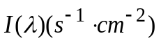:
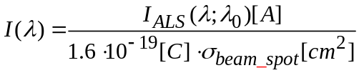
Here 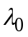 is the central wavelength of the ALS beam light. The units of each term are indicated in explicitly in brackets in Eq.(4) and in the equations below. The change in the number of photons per unit volume along the chamber is estimated as:
$I\left(λ,l\right)=I\left(λ;λ_{0}\right)\exp\left(-\sum_{j}{}σ_{absj}\left(λ\right)lc_{j}\right){}$
$σ_{absj}\left(λ\right)$is the absorption cross-section of the particular molecule j (H₂, ¹⁴N₂, ¹⁴N¹⁵N) at a given temperature, l is a specific length at which the number of photons is computed.
Finally the photodissociation rate constant is
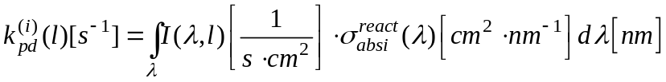
The number of nitrogen atoms produced during the whole duration of the experiment is estimated as follows:
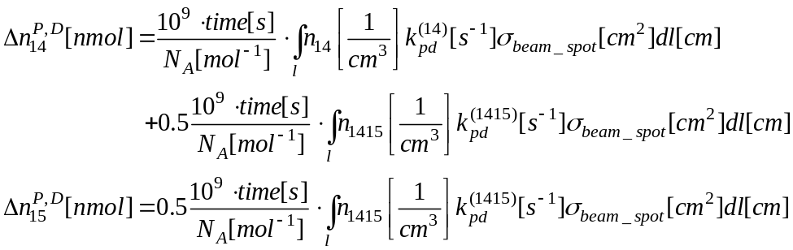
Note, that we assume here no reactivity of the 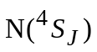 atoms with 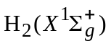. The total duration of the experiment is considered 8 hours. The concentration of molecules is uniform but temperature dependent.
The enrichment profile is computed as follows:
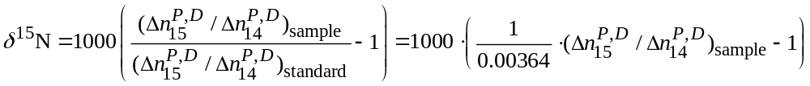

Relative ratio of ¹⁴N₂ : ¹⁴N¹⁵N is 0.99273325 : 0.0072535, which gives

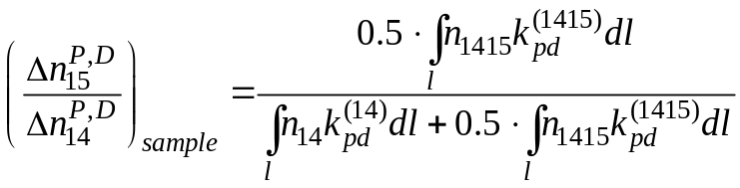
Computer codes for the shielding computation as well as for the isotopic enrichment are available from us upon request.

Dynamics
The VUV photodissociation of N₂ leads to three possible lowest exit channels that differ in their energy threshold and in the electronic states of the dissociated N atoms. These are

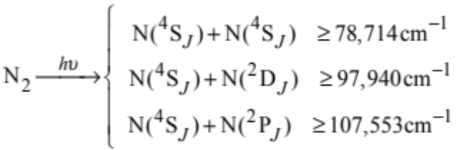
At a given beam the nascent products differ in their kinetic energy but under the experimental conditions as reported above and in ref. ⁸ the translational relaxation will be rather fast. It is realistic therefore to assume that the product atoms have a thermal kinetic energy distribution.
The ground state ${N(}^{4}S)$ atoms are known to be rather non-reactive with the H₂ molecules that are introduced to scavenge the N atoms. A state correlation energy of N atoms in different states with H₂ is figure 6 in ref. ¹⁶ and it attributes this low reactivity to a high energy threshold for the possible reactions. There is both experimental and theoretical evidence that the ${N(}^{2}D)$ atoms are quite reactive with H₂ with a rather low activation energy^{17,18}. The similar reaction rate of ${N(}^{2}P)$ is lower by some two orders of magnitude. These ${N(}^{2}P)$ atoms that are higher in their electronic energy can be effectively quenched down to ${N(}^{2}D)$ atoms in collisions with H₂,¹⁷. The rate constants for the reaction of ${N(}^{2}P)$ and ${N(}^{2}D)$ with H₂ are collected in Table S2. Under the experimental conditions reported in ⁸ an atom survives on the average for about 10 seconds before being swept out of the reaction tube. So, we take it that only the electronically excited ${N(}^{2}D)$atoms have enough time to react with H₂. The primary input that the dynamical computations provide for us is the branching fraction between the ${N(}^{2}P)$ and ${N(}^{2}D)$ atoms as a function of frequency, for either of the two isotopomers of N₂.
Our recent computational study very much confirms the experimental discovery of a very non-statistical character of the photodissociation branching fraction into the lower dissociation exit channels. The electronic structure of N₂ is complex and the electron excited from the ground state will transverse a maze of various electronic states (see Figure 1 in the main text) on the way to exit. The the excitation energies below 117000 cm⁻¹, the singlet states are bound and the dissociation occurs via the states of higher multiplicity, triplets and quintets. The states differ in multiplicity are linked by weak and selective spin-orbit coupling terms. The computed spin-orbit coupling between the excited ${{}_{}^{1}Σ}_{u}^{+}$ and ${{}_{}^{1}Π}_{u}^{}$ singlet and triplet ${{}_{}^{3}Π}_{u}^{}$ states are shown in Figure S5 and Figure S6 respectively. Another key factor which determines the energy-dependence in the dynamics is the intricate shape of potential energy curves of the triplet states. Thus, when the population transfer occurs to the repulsive triplet potential, the dissociation is faster.

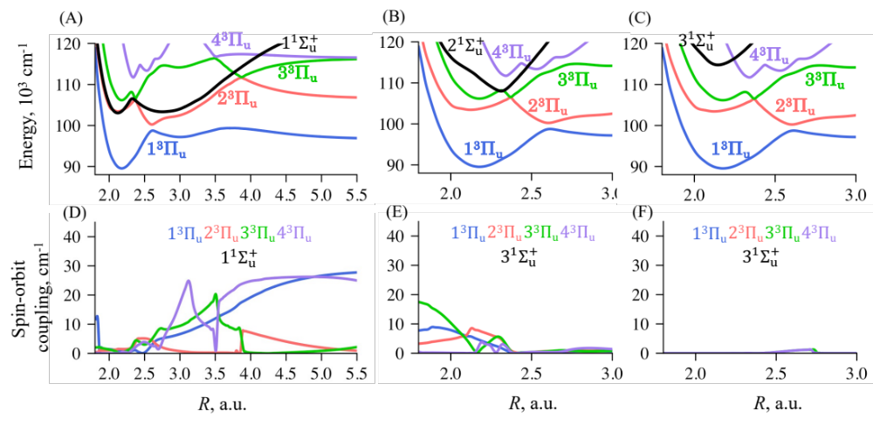

Fig. S5. Potential energy curves of ${}_{}^{1}{Σ_{u}^{+}}$ (in black) and ${}_{}^{3}{Π_{u}}$ (colorcoded in the figure) (A-C) and the absolute values of the spin-orbit coupling terms between them (D-F).

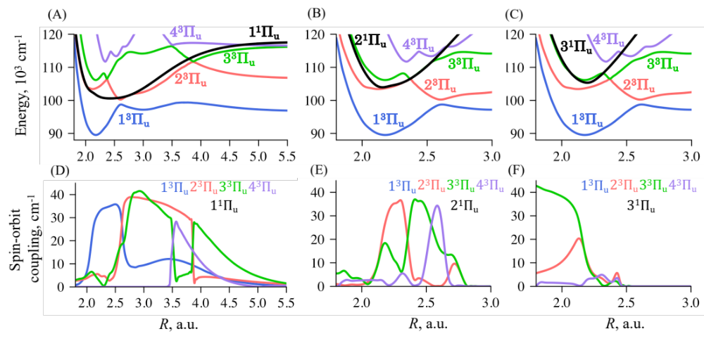

Fig. S6. Potential energy curves of ${}_{}^{1}{Π_{u}}$ (in black) and ${}_{}^{3}{Π_{u}}$ (colorcoded in the figure) (A-C) and the absolute values of the spin-orbit coupling terms between them (D-F).

The photodissociation cross-section
We introduced above reactive ${N(}^{2}D)$ and inactive ${N(}^{2}P)$ atoms. The detailed measurements for each rotational singlet level in ¹⁴N₂ and ¹⁴N¹⁵N were presented in refs. ^{19,20}. Exciting a particular singlet rotational state will lead to either ${N(}^{2}D)$ or ${N(}^{2}P)$ or their mixture. We therefore assume, that such singlet rotational state that produces inactive ${N(}^{2}P)$ atoms will not contribute to the reaction with H₂. Therefore such states should not contribute to the photodissociation cross section as needed to compute the isotopic enrichment, see Figure S3(A), for the changes due to this correction. We use the cross section for producing active ${N(}^{2}D)$ atoms to compare with the experimental results, see Table S2. As can be seen in Figure S3(A) it is the production of inactive ${N(}^{2}P)$ atoms at the higher energy threshold that, for us, accounts for the drop of the isotopic enrichment at the highest energies probed in the experiment.
Applying the nonadiabatic quantum dynamics as discussed in^{1,2}, we can determine the lifetime for the exit through any particular channel for all the considered vibronic states (Tables S4-S7). These lifetimes are typically longer than the lifetime for the transfer from the singlet states to the triplet manifold, the lifetimes that determines the natural linewidth in the absorption spectrum. We used these lifetimes to classify and assign a band-specific linewidth for the transitions above 106000 cm⁻¹, see Table S7.

Overview
Figure S3, panels (A) and (C) in particular, is the summary of the comparison between experiment and simulations. We here emphasize the considerable sensitivity of the computed isotopic enrichment to the width of the spectral lines as illustrated in Figure 2 panels (C) and (D),
Therefore in Figure 3 we use band-specific linewidths with Voigt profile, where the actual width is given in Table S7.

Table S4.
Calculated vibrational energy levels of the ${{}_{}^{1}Σ}_{u}^{+}$ singlet electronic states and the corresponding experimental (Liu, et al. 2021) branching ratio into N(⁴S_{3/2})+N(²P_{J}) channel and computed predissociation lifetime for ¹⁴N¹⁵N isotopomer. The experimental values are taken for the lowest available rotational state excitation. ª estimated value

 | Experiment N(⁴S_{3/2})+N(²P_{J}) | Predissociation lifetime, ps
108,702 | 0.000 | 946
109,358 | 0.006 | 126
110,049 | 0.056 | 104,226ª
110,385 | 0.038 | 582
110,746 | 0.006 | 224
111,431 | 0.003 | 1,899
112,097 | 0.162 | 215
112,428 | 0.258 | 235
112,774 | 0.962 | 87
113,410 | 0.890 | 40
114,031 | 0.931 | 30
114,385 | 0.900 | 989
114,649 | 0.747 | 141
115,186 | 0.966 | 92
115,633 | 0.930 | 167
116,052 | 0.613 | 4,742

Table S5.
Calculated vibrational energy levels of the ${{}_{}^{1}Π}_{u}^{}$ singlet electronic states and the corresponding experimental (Song, et al. 2016) branching ratio into N(⁴S_{3/2})+N(²P_{J}) channel and computed predissociation lifetime for ¹⁴N₂ isotopomer. The experimental values are taken for the lowest available rotational state excitation.

Energy, cm⁻¹ | Experiment N(⁴S_{3/2})+N(²P_{J}) | Predissociation lifetime, ps
108421 | 0.000 | 2
108682 | --- | 190
109162 | 0.000 | 2
109546 | 0.000 | 3
109876 | 0.001 | 41
110571 | 0.000 | 3
110777 | 0.000 | 9
111250 | 0.000 | 60
111424 | 0.000 | 5
111910 | 0.022 | 78
112540 | 0.000 | 179
113167 | 0.864 | 45
113277 | 0.000 | 9
113745 | 0.754 | 163
114294 | 0.104 | 36
114744 | 0.022 | 55
115140 | 0.137 | 7
115328 | 0.016 | 36
115769 | 0.045 | 50

Table S6.
Calculated vibrational energy levels of the ${{}_{}^{1}Π}_{u}^{}$ singlet electronic states and the corresponding experimental (Liu, et al. 2021) branching ratio into N(⁴S_{3/2})+N(²P_{J}) channel and computed predissociation lifetime for ¹⁴N¹⁵N isotopomer. The experimental values are taken for the lowest available rotational state excitation.

Energy, cm⁻¹ | Experiment N(⁴S_{3/2})+N(²P_{J}) | Predissociation lifetime, ps
108312 | 0.000 | 21
108613 | 0.000 | 431
109040 | 0.000 | 67
109489 | 0.013 | 3
109745 | 0.001 | 6
110432 | 0.000 | 137
110677 | --- | 9
111105 | 0.000 | 86
111337 | 0.000 | 6
111759 | 0.002 | 284
112384 | 0.004 | 46
113009 | 0.834 | 91
113156 | 0.004 | 8
113585 | 0.558 | 152
114133 | 0.004 | 45
114590 | 0.033 | 12
114980 | 0.324 | 15
115175 | --- | 237

Table S7.
Band-specific natural linewidth types for rovibronic transitions in 14N2 and 14N15N: narrow (FWHM = 0.13 cm⁻¹), medium (FWHM = 0.484 cm⁻¹) or wide (FWHM = 0.968 cm⁻¹). For the energy range between 100000 – 106000 cm-1 80K absorption profile from ^{4,5}is used.

¹⁴N₂ |  | ¹⁴N¹⁵N
Band energy, cm⁻¹ | Linewidth type | Band energy, cm⁻¹ | Linewidth type
106172.0 – 106556.7 | medium | 106135.9 – 106361.7 | medium
107343.8 – 108391.2 | wide | 106361.7 – 106502.2 | narrow
108391.2 – 108579.5 | narrow | 106502.2 – 107297.7 | medium
108579.5 – 108744.9 | medium | 107343.8 – 108297.3 | wide
108962.9 – 110538.7 | wide | 108297.3 – 108485.3 | medium
110538.7 – 110685.5 | narrow | 108485.3 – 108673.9 | narrow
110685.5 – 110818.0 | wide | 108673.9 – 109713.8 | wide
110818.0 – 111222.4 | medium | 109713.8 – 110168.4 | narrow
111222.4 – 111465.4 | wide | 110168.4 – 110411.7 | medium
111465.4 – 111604.8 | narrow | 110411.7 – 110587.6 | narrow
111604.8 – 111884.6 | wide | 110587.6 – 110719.9 | wide
111884.6 – 112514.1 | medium | 110719.9 – 111074.1 | medium
112514.1 – 113562.1 | wide | 111074.1 – 111376.0 | wide
113562.1 – 113722.2 | medium | 111376.0 – 111485.3 | narrow
113722.2 – 114262.9 | wide | 111485.3 – 112130.5 | medium
114262.9 – 114866.8 | narrow | 112130.5 – 113412.6 | wide
114866.8 – 115397.1 | wide | 113412.6 – 113562.1 | medium
115397.1 – 115867.8 | medium | 113562.1 – 114106.4 | wide
 |  | 114106.4 – 114708.6 | narrow
 |  | 114708.6 – 115290.6 | wide
 |  | 115290.6 – 115605.2 | narrow
 |  | 115605.2 – 115760.5 | medium

References

1 Gelfand, N., Komarova, K., Remacle, F. & Levine, R. D. Nonadiabatic dynamics in a forest of coupled states: Electronic state branching in the VUV photodissociation of N2. J. Chem. Phys 158, 164302 (2023). https://doi.org/10.1063/5.0148798
2 Gelfand, N., Komarova, K., Remacle, F. & Levine, R. D. Nonadiabatic quantum dynamics explores non-monotonic photodissociation branching of N2 into the N(4S) + N(2D) and N(4S) + N(2P) product channels. Physical Chemistry Chemical Physics 26, 3274-3284 (2024). https://doi.org/10.1039/D3CP04854C
3 Spelsberg, D. & Meyer, W. Dipole-allowed excited states of N₂: Potential energy curves, vibrational analysis, and absorption intensities. J. Chem. Phys. 115, 6438-6449 (2001).
4 Lewis, B. R., Gibson, S. T., Zhang, W., Lefebvre-Brion, H. & Robbe, J. M. Predissociation mechanism for the lowest ¹Π_{u} states of N₂. J. Chem. Phys. 122, 144302 (2005). https://doi.org/10.1063/1.1869986
5 Lewis, B. R., Heays, A. N., Gibson, S. T. & Stark, G. N2 Photoabsorption Cross Sections in the Vaccuum Ultraviolet, <http://academics.wellesley.edu/Physics/gstark/N2_ANU_cross_sections/spectroscopic_information.html> (2024).
6 Li, X. et al. Photodissociation of interstellar N₂. A&A 555, A14 (2013).
7 Boyer, W. & Lynas-Gray, A. E. Evaluation of the Voigt function to arbitrary precision. MNRAS 444, 2555-2560 (2014). https://doi.org/10.1093/mnras/stu1606
8 Chakraborty, S., Jackson, T. L., Rude, B., Ahmed, M. & Thiemens, M. H. Nitrogen isotopic fractionations in the low temperature (80 K) vacuum ultraviolet photodissociation of N2. J. Chem. Phys. 145, 114302 (2016). https://doi.org/10.1063/1.4962447
9 Cicerone, R. J. & McCrumb, J. L. Photodissociation of isotopically heavy O 2 as a source of atmospheric O 3. GeoRL 7, 251-254 (1980). https://doi.org/https://doi.org/10.1029/GL007i004p00251
10 Thiemens, M. H. & Heidenreich, J. E. The Mass-Independent Fractionation of Oxygen: A Novel Isotope Effect and Its Possible Cosmochemical Implications. Science 219, 1073-1075 (1983). https://doi.org/10.1126/science.219.4588.1073
11 Farquhar, J., Bao, H. & Thiemens, M. Atmospheric Influence of Earth's Earliest Sulfur Cycle. Science 289, 756-758 (2000). https://doi.org/10.1126/science.289.5480.756
12 Chakraborty, S., Rude, B., Ahmed, M. & Thiemens, M. H. Carbon and oxygen isotopic fractionation in the products of low-temperature VUV photodissociation of carbon monoxide. CP 514, 78-86 (2018). https://doi.org/https://doi.org/10.1016/j.chemphys.2018.05.022
13 Heays, A. N., Bosman, A. D. & van Dishoeck, E. F. Photodissociation and photoionisation of atoms and molecules of astrophysical interest. Astron. Astrophys. 602, A105 (2017).
14 Draine, B. T. Photoelectric heating of interstellar gas. Astrophysical Journal Supplement Series, vol. 36, Apr. 1978, p. 595-619. 36, 595-619 (1978).
15 Heays, A. N. et al. Isotope selective photodissociation of N₂ by the interstellar radiation field and cosmic rays. A&A 562, A61 (2014). https://doi.org/10.1051/0004-6361/201322832
16 Donovan, R. J. & Husain, D. Recent advances in the chemistry of electronically excited atoms. Chem. Rev. 70, 489-516 (1970). https://doi.org/10.1021/cr60266a003
17 Bochenkova, A. V. & Andersen, L. H. Ultrafast dual photoresponse of isolated biological chromophores: link to the photoinduced mode-specific non-adiabatic dynamics in proteins. Faraday Discussions 163, 297-319 (2013). https://doi.org/10.1039/c3fd20150c
18 Balucani, N. Elementary reactions of N atoms with hydrocarbons: first steps towards the formation of prebiotic N-containing molecules in planetary atmospheres. Chem. Soc. Rev. 41, 5473-5483 (2012). https://doi.org/10.1039/C2CS35113G
19 Song, Y. et al. Quantum-state dependence of product branching ratios in vacuum ultraviolet photodissociation of N₂. Astrophys. J. 819, 13 (2016). https://doi.org/10.3847/0004-637x/819/1/23
20 Liu, M. et al. Strong Isotope-dependent Photodissociation Branching Ratios of N2 and Their Potential Implications for the 14N/15N Isotope Fractionation in Titan's Atmosphere. Astrophys. J. 923, 196 (2021). https://doi.org/10.3847/1538-4357/ac2f97

