Appendix 1
A total of 195 publications were excluded for focusing on risk factors related to SU/PSU/SA rather than the determinants of ESO. Initially, these studies were categorized according to the phenomenon investigated (SU/PSU/SA) and the target population (children and/or adolescents). Among them, 82 examined PSU, 79 focused on SA, and 41 explored SU.
Figure 3. Distribution by phenomena investigated.
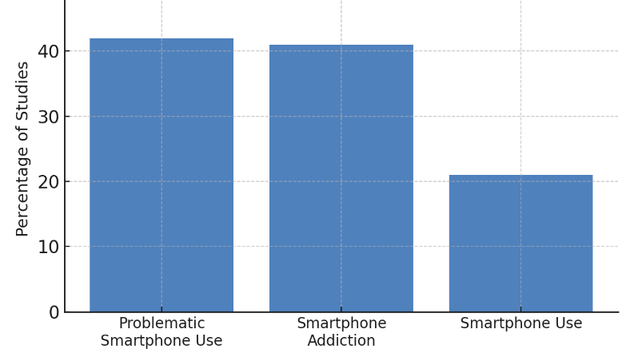
Note: Chart showing the distribution of the 195 excluded studies based on the specific phenomena investigated (PSU, SA, and SU).
In terms of the populations studied, 144 publications focused on adolescents (up to 16 years old), while 64 publications addressed children (between 6 to 12 years old). It should be noted that publications can be found that address both populations.
Figure 4. Distribution by age group.
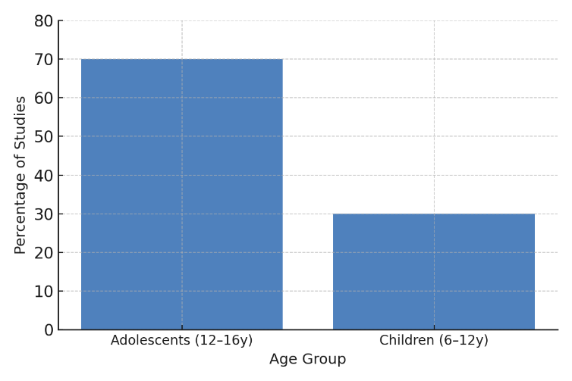
Note: Chart showing the distribution of the 195 excluded studies based on the target population (children vs. adolescents).
Regarding the identified risk factors for SU/PSU/SA, they can be grouped into five main categories: Parental and family-related factors; Psychological and emotional factors; Behavioural and motivational factors; Environmental and contextual factors; Demographic factors. It should be noted that smartphone ownership is identified as a risk factor for SU/PSU/SA and classified under the Parental and family-related factors category, as the decision to provide a smartphone typically lies with the parents or caregivers. This distribution is summarized in Figure 5.
Figure 5. Number and distribution of publications across research categories.

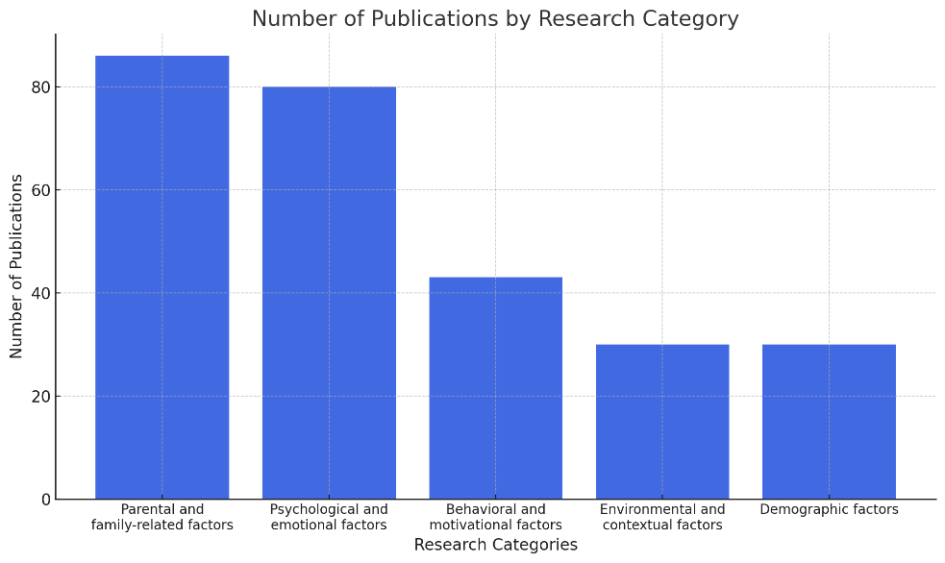
Note: Chart showing the categories used to classify the risk factors for SU/PSU/SA identified in the excluded studies.
Among the identified risk factors, parental and family-related factors emerged as the most frequently discussed category, appearing in 86 publications. These studies explored variables such as parenting style, parental SU/PSU/SA, parental control, parental mediation, parental phubbing, parental motives, parental smartphone knowledge, parent-child communication and relationship, parental support, parental views, parental resilience, parental intention, parental tobacco and alcohol consumption, parental qualification, and the family environment. Smartphone ownership by the child, which was identified as a risk factor in 5 publications and attributed to this category. Additionally, broader family dynamics such as isolation from family and family resilience were also considered. Other less frequently mentioned factors (2 or fewer) related to this category included isolation from family, and trust.
Psychological and emotional factors for SU/PSU/SA were widely addressed in the literature, appearing in 80 publications. These factors included self-control (13), adverse childhood experiences (ACEs) (12), loneliness (11), and depression (7). Emotional traits such as self-esteem (7), peer pressure (7), FoMO (fear of missing out) (6), and social anxiety (4) were also prominent. Broader psychological constructs, including general psychological factors (6), well-being (4), and personality traits (4), further highlighted the intricate emotional and mental health dimensions. Additionally, specific issues related to emotional regulation, such as alexithymia (3), anxiety (3), and stress (3), were noted as relevant influences. Other less frequently mentioned factors (2 or fewer) related to this category included impulsivity, neurobiological traits, ADHD, aggression, mood changes due to the inability to use digital devices, grit, resilience, academic helplessness, gratitude, meaning in life, and body image.
Studies addressing behavioural patterns and motivations highlighted factors that directly influence SU/PSU/SA. This category was addressed in 43 publications. Usage time (17) was a frequently studied variable, often linked to habitual behaviours. Use motivations (6) were explored as key drivers for SU/PSU/SA and other related issues such as digital addiction, problematic Internet use, or excessive screen time. Broader psychosocial traits (9), which encompass social and psychological behaviours, were also considered. Additionally, sleep problems (3) and diet (3) emerged as behavioural factors, reflecting how lifestyle habits and routines intersect with SU patterns. Other less frequently mentioned factors (2 or fewer) related to this category included sensation seeking, mindfulness traits, peer support, peer victimization, bullying victimization, extracurricular activities, leisure activities, playing games, watching videos, use before bedtime, learning apps, book reading, and lack of outdoor play.
Environmental and contextual influences were another prominent area of focus, addressed in 32 publications. The COVID-19 pandemic (10) was identified as a significant situational factor, illustrating how global crises can accelerate SU and its problematic/addictive use. Social and environmental factors such as neighbourhood (3) and academic achievement (3) were also highlighted. Furthermore, socioeconomic status (SES) (5) emerged as a contextual determinant of SU/PSU/SA. Other less frequently mentioned factors (2 or fewer) related to this category included school climate, school type, peer phubbing, academic burnout, academic motivation, narrowing of interests, cumulative ecological risk, health literacy, subjective economic level, and perceived usefulness.
Demographic variables were frequently examined as risk factors for SU/PSU/SA, with 47 publications addressing this category. Age (30) was the most frequently addressed demographic factor, with some studies specifically analysing age at initial use (5) as a risk factor for SU/PSU/SA, although it should be noted that, among the factors identified in the studies detailed in this section, it may be the most closely related to ESO. Gender (24) also appeared consistently, shedding light on differences in usage patterns. Other less frequently mentioned factors (2 or fewer) related to this category included left-behind minor status, one-child status, and other unspecified demographics.
Finally, a total of 9 systematic reviews or meta-analyses were identified among the 195 publications excluded for focusing on risk factors for SU/PSU/SA. Most of these reviews focused on specific factors or populations, with only 5 addressing risk factors from a general perspective. Fauzi et al. (2019) concentrated on adolescents and SA, while Fischer-Grote et al. (2019) examined PSU in children and adolescents but included only 38 publications from alternative databases, such as Google Scholar and PubMed. Similarly, Çelik & Çelik (2023) conducted a meta-synthesis analysing 258 studies on the antecedents and consequences of digital addiction, providing a broad overview of factors associated with addictive behaviours across different digital platforms. However, their methodological approach differs, as it is a meta-synthesis rather than a systematic review. De Freitas et al. (2021) performed a scoping review analysing 67 publications on the prevalence and associated factors of SA in adolescents, with a strong geographical focus on South Korea, which limits the generalizability of their findings to other cultural contexts. On the other hand, Khan et al. (2021) conducted a literature review combined with a conceptual model, identifying influential factors and adverse effects of SA in children, with particular emphasis on parental influence, peer pressure, and emotional consequences such as anxiety and depression.

