Synthesis of Finely Controllable Sizes of Au Nanoparticles on a Silica Template and Their Nanozyme Properties
Bomi Seong,¹ Jaehi Kim,¹ Wooyeon Kim,¹ Sang Hun Lee,² Xuan-Hung Pham,¹* and Bong-Hyun Jun^{1,}*
¹ Department of Bioscience and Biotechnology, Konkuk University, Seoul 143-701, Republic of Korea. e-mail: iambomi33@konkuk.ac.kr (B.S.); susia45@gmail.com (J.K.)
² Department of Chemical and Biological Engineering, Hanbat National University, Daejeon 34158, Korea; sanghunlee@hanbat.ac.kr (S.H.L)
Correspondence should be addressed to Xuan-Hung Pham: phamricky@gmail.com and Bong-Hyun Jun: bjun@konkuk.ac.kr

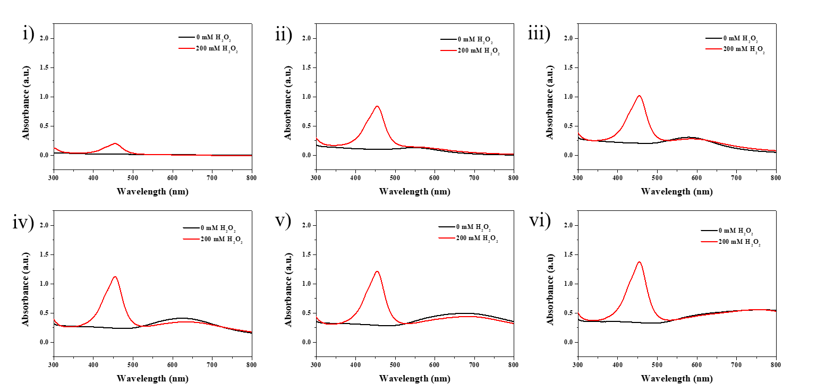

Figure S1. Absorption spectra of 0.1 mM TMB and 200 mM H₂O₂ in the presence SiO₂@Au NPs fabricated in various concentrations of Au³⁺ precursor: (i) 0 μM, (ii) 50 μM, (iii) 100 μM, (iv) 150 μM, (v) 200 μM, and (vi) 300 μM Au³⁺.

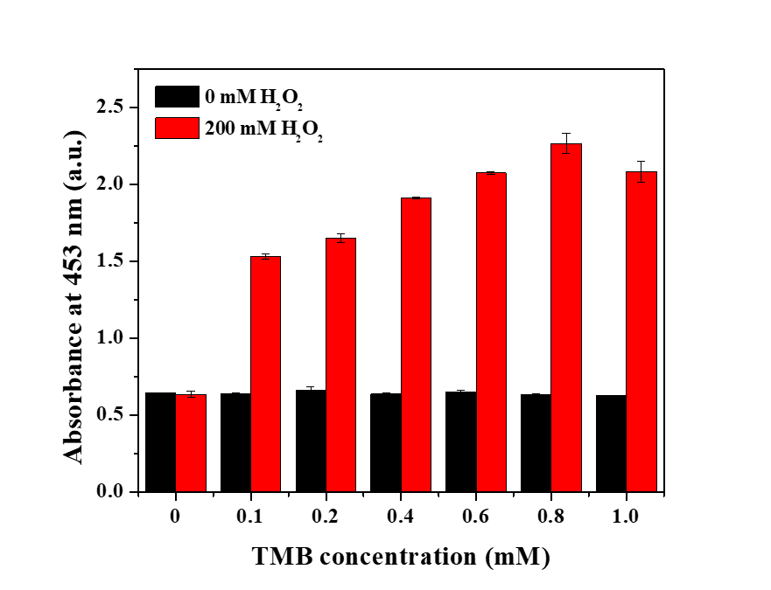
Figure S2. The effects of TMB concentration in the range of 0 to 1.0 mM on the peroxidase-like activity of SiO₂@Au in mixture of TMB and 200 mM H₂O₂.

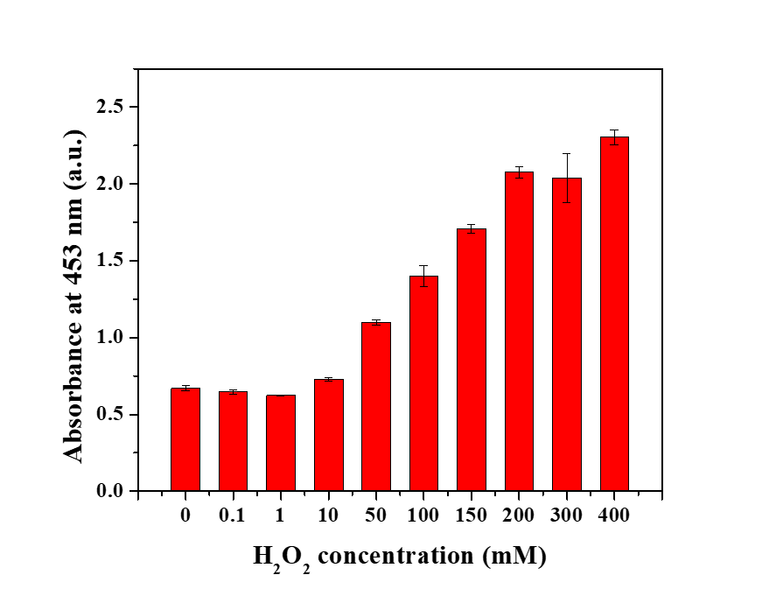
Figure S3. The effects of H₂O₂ concentration in the range of 0 to 400 mM on the peroxidase-like activity of SiO₂@Au in mixture of 0.6 mM TMB and H₂O₂.

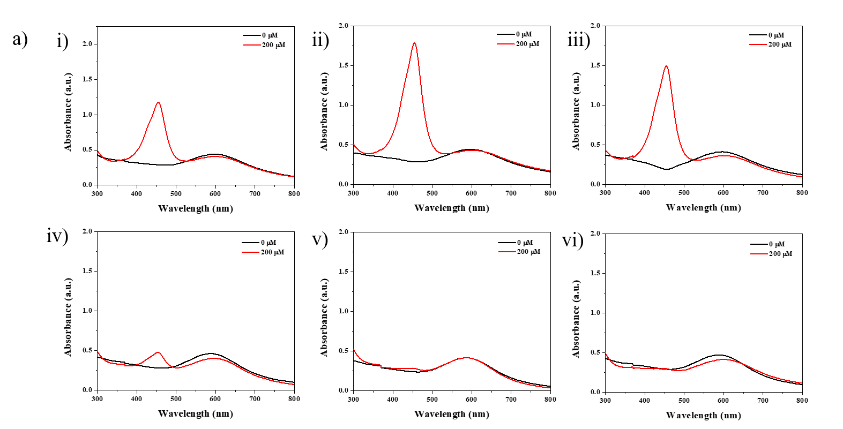
Figure S4. (a) Effect of pH solution on the UV-Vis spectra of 0.6 mM TMB and 200 mM H₂O₂ in the presence of SiO₂@Au at various pH conditions: (i) pH 3.0, (ii) pH 4.0, (iii) pH 5.0, (iv) pH 6.0, (v) pH 7.0, and (vi) pH 8.0

Figure S5. The effects of SiO₂@Au amount in the range of 0 to 50 μg on the peroxidase-like activity of SiO₂@Au in mixture of 0.6 mM TMB and 200 mM H₂O₂.

