Supporting Information for

Widespread and strong impacts of river fragmentation by human barriers on fishes in the Mekong River Basin

Jingrui Sun^{1,2}*, Damiano Baldan³, Martyn C. Lucas⁴, Jie Wang¹, Amaia A. Rodeles⁵, Shams M. Galib⁶, Juan Tao^{1,2}, Mingbo Li¹, Daming He¹, Chengzhi Ding^{1,2}

Affiliations
1. Yunnan Key Laboratory of International Rivers and Transboundary Eco-security, Institute of International Rivers and Eco-security, Yunnan University, Kunming 650091, China
2. Ministry of Education Key Laboratory for Transboundary Eco-Security of Southwest China, Yunnan University, Kunming, 650091, China
3. National Institute of Oceanography and Applied Geophysics – OGS, Trieste, Italy
4. Department of Biosciences, University of Durham, Durham DH1 3LE, UK
5. Centro de Investigación Mariña, Universidade de Vigo, 36310, Vigo, Spain
6. Department of Fisheries, University of Rajshahi, Rajshahi 6205, Bangladesh
*Corresponding author

Figure S1. The main channel barriers in the Mekong Basin.
Figure S2. The fish occurrence records of the Mekong Basin (a) and the cumulative fish species richness in each sub-basin (b).

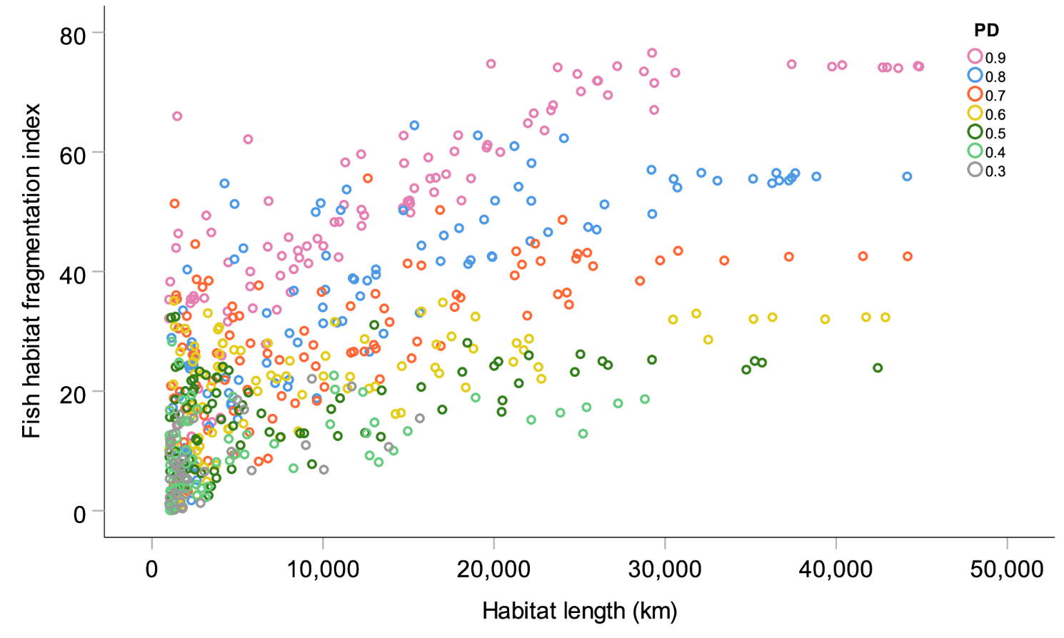
Figure S3. Scatter plot showing the correlation between available fish habitat and fragmentation index (FI). Each point represents a fish species. PD is the dispersal probability of each species.

