Supplementary Table S1. The type and quantity of metabolites detected by ST.
Class. I | Class. II | Class. II count | Class. I count
Alcohol and amines | Alcohols | 43 | 121
Alcohol and amines | Amines | 73 | 121
Alcohol and amines | Polyamines | 5 | 121
Aldehyde, Ketones, Esters | Aldehydes | 2 | 162
Aldehyde, Ketones, Esters | Esters | 59 | 162
Aldehyde, Ketones, Esters | Ketones | 101 | 162
Amino acid and Its metabolites | Amino acid derivatives | 34 | 318
Amino acid and Its metabolites | Amino acids | 8 | 318
Amino acid and Its metabolites | Small Peptide | 248 | 318
Amino acid and Its metabolites | polypeptide | 28 | 318
Benzene and substituted derivatives | Benzene and substituted derivatives | 70 | 74
Benzene and substituted derivatives | Phenolics | 4 | 74
Bile acids | Bile acids | 3 | 3
Carbohydrates and Its metabolites | Carbohydrates and Its metabolites | 4 | 17
Carbohydrates and Its metabolites | Sugar acids | 1 | 17
Carbohydrates and Its metabolites | Sugar derivatives | 4 | 17
Carbohydrates and Its metabolites | Sugars | 8 | 17
CoEnzyme and vitamins | CoEnzyme and vitamins | 5 | 5
FA | CAR | 10 | 64
FA | CE | 4 | 64
FA | FFA | 3 | 64
FA | Others | 36 | 64
FA | Oxidized lipids | 11 | 64
GL | DG | 46 | 76
GL | MG | 6 | 76
GL | TG | 24 | 76
GP | CL | 1 | 168
GP | LPA | 1 | 168
GP | LPC | 8 | 168
GP | LPC_P | 2 | 168
GP | LPE | 3 | 168
GP | PA | 24 | 168
GP | PC | 33 | 168
GP | PC_O | 1 | 168
GP | PC_P | 1 | 168
GP | PE | 47 | 168
GP | PG | 10 | 168
GP | PGP | 8 | 168
GP | PI | 7 | 168
GP | PIP | 12 | 168
GP | PS | 10 | 168
Heterocyclic compounds | Heterocyclic compounds | 12 | 12
Hormones and hormone related compounds | Hormones and hormone related compounds | 29 | 29
Nucleotide and Its metabolites | Nucleotide and Its metabolites | 44 | 44
Organic acid and Its derivatives | Organic acid and Its derivatives | 212 | 230
Organic acid and Its derivatives | Phosphoric acids | 14 | 230
Organic acid and Its derivatives | Sulfonic acids | 4 | 230
SL | Cer | 20 | 34
SL | SL | 1 | 34
SL | SM | 12 | 34
SL | SPH | 1 | 34
ST | CE | 1 | 1
Tryptamines, Cholines, Pigments | Cholines | 2 | 4
Tryptamines, Cholines, Pigments | Pigments | 1 | 4
Tryptamines, Cholines, Pigments | Tryptamines | 1 | 4

Supplementary Table S2. Hallmark Overrepresentation table of all the genes mentioned in the paper.
Cancer Hallmark | Overlap | P value | Hallmark vs. hallmark | Genes
Sustaining Proliferative Signaling | 6/3574 | 0.65063 | 0.58 | PRKAA2; PRKAG1; AKT1; CHKA; SGPL1; SPHK1
Genome Instability | 2/747 | 0.39205 | 0.92 | FH; AKT1
Evading Growth Suppressors | 4/3288 | 0.87354 | 0.42 | PRKAA2; PRKAG1; AKT1; SPHK1
Evading Immune Destruction | 2/749 | 0.39335 | 0.92 | SPHK1; AKT1
Sustained Angiogenesis | 5/796 | 0.01267 | 2.16 | AKT1; SGPL1; PIK3R6; SDHA; SPHK1
Tissue Invasion and Metastasis | 3/2318 | 0.81031 | 0.44 | SPHK1; AKT1; PIK3R6
Tumor-Promoting Inflammation | 1/769 | 0.75882 | 0.45 | AKT1
Resisting Cell Death | 7/1941 | 0.05143 | 1.24 | PRKAA2; PRKAG1; AKT1; SGPL1; PRKAG3; PRKAG2; SPHK1
Reprogramming Energy Metabolism | 13/740 | <1e-6 | 6.04 | PRKAA2; PRKAG1; IDH1; FH; MDH2; AKT1; SDHB; IDH2; PRKAG3; SDHA; DLAT; PRKAG2; ACO1
Replicative Immortality | 2/547 | 0.25841 | 1.26 | SPHK1; AKT1

Supplementary Figure S1

Fig.S1. The Distribution of each Subset in T418.

Supplementary Figure S2

Fig.S2. The Distribution of each Subset in T419.

Supplementary Figure S3

Fig.S3. The Distribution of each Subset in T421.

Supplementary Figure S4

Fig.S4. The Distribution of each Subset in N423.

Supplementary Figure S5

Fig.S5. The Distribution of each Subset in N424.

Supplementary Figure S6

Fig.S6. The Distribution of each Subset in N455.

Supplementary Figure S7

Fig.S7. Correlation between gene expression and Overall Survivor (OS) probability in BC tissues, and gene expression levels between normal tissues and BC tissues.
(A, C, E, G, I) Correlation between the expression of CHKα, CCT2, CCT3, CCT6A, CCT8 and OS probability in BC tissues.
(B, D, F, H, J) The expression levels of CHKα, CCT2, CCT3, CCT6A and CCT8 between normal tissues and BC tissues.

Supplementary Figure S8

Fig.S8. Downregulation of AMPK Pathway in BC Tissues.
(A - H) Distribution of PRKAA2, PRKAG1, PRKAG2, PRKAG3, PIK3R6, GLUL, AKT1 and DLAT in cancerous and adjacent non-cancerous tissues.
(I) Violin plots illustrating the expression levels of genes in cancerous versus adjacent non-cancerous tissues.

Supplementary Figure S9

Fig.S9. Correlation between gene expression and Overall Survivor (OS) probability in BC tissues, and gene expression levels between normal tissues and BC tissues.
(A, C, E, G, I, K, M) Correlation between the expression of ACO1, IDH1, IDH2, SDHA, SDHB, FH, MDH2 and OS probability in BC tissues.
(B, D, F, H, J, L, N) The expression levels of ACO1, IDH1, IDH2, SDHA, SDHB, FH and MDH2 between normal tissues and BC tissues.

Supplementary Figure S10

Fig.S10. Correlation between gene expression and Overall Survivor (OS) probability in BC tissues, and gene expression levels between normal tissues and BC tissues.
(A, C) Correlation between the expression of CERK and SPHK1 and OS probability in BC tissues.
(B, D) The expression levels of CERK and SPHK1 between normal tissues and BC tissues.

Supplementary Figure S11

Fig.S11. Correlation between gene expression and Overall Survivor (OS) probability in BC tissues, and gene expression levels between normal tissues and BC tissues.
(A, C) Correlation between the expression of IDO1, KMO and OS probability in BC tissues.
(B, D) The expression levels of IDO1 and KMO between normal tissues and BC tissues.

Supplementary Figure S12
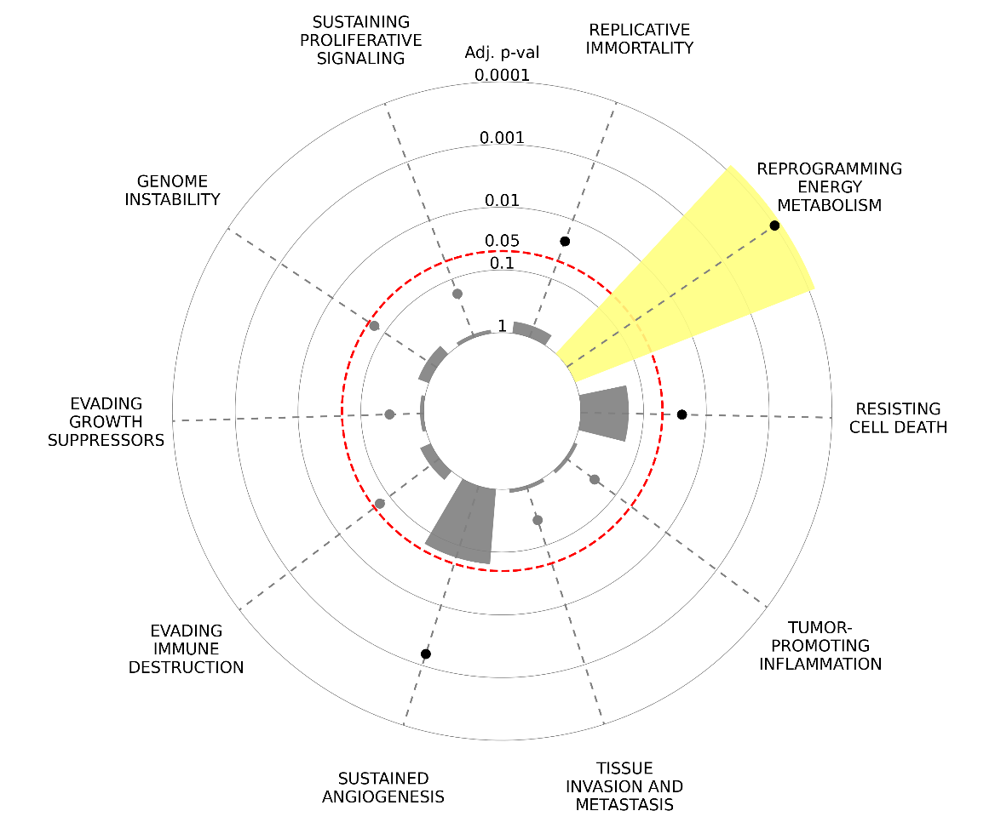

Fig.S12. Hallmark Enrichment Plot of all the genes mentioned in the article.

