Appendix A. Conceptual Model of the Study
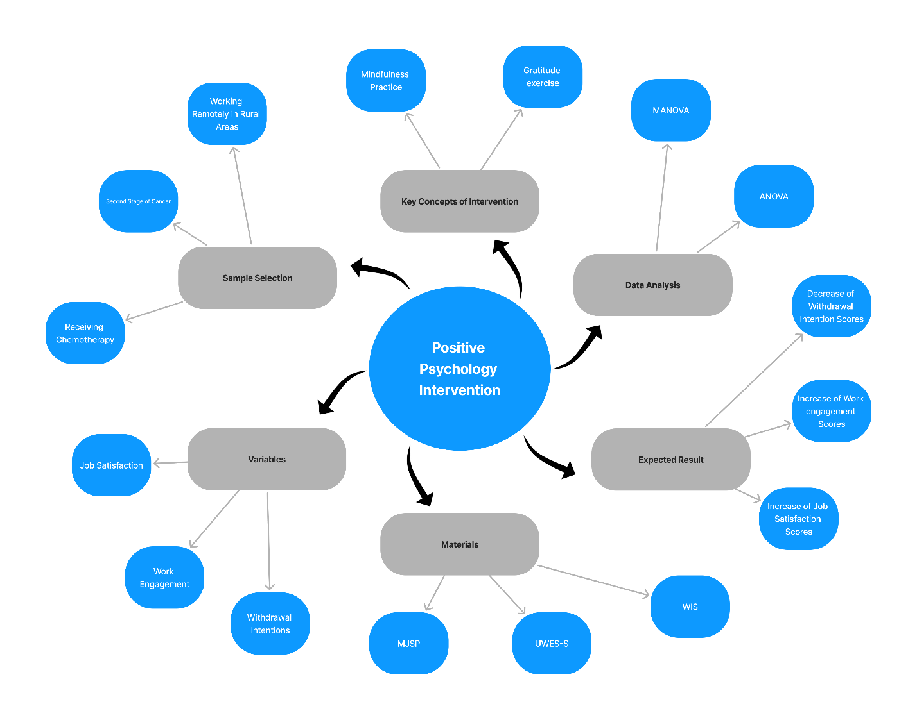
This model explores the impact of positive psychology interventions on job satisfaction, work engagement, and withdrawal intentions among cancer survivors who work remotely in rural areas. The model begins with the selection of a sample of cancer survivors at stage two who are undergoing chemotherapy and are employed remotely in rural communities. The positive psychology interventions, which include mindfulness practices and gratitude exercises, are key concepts in this framework. These interventions are designed to influence three main variables: job satisfaction, work engagement, and withdrawal intentions, which are measured using tools like the Minnesota Job Satisfaction Questionnaire (MJSP), the Utrecht Work Engagement Scale - Student Version (UWES-S), and the Withdrawal Intention Scale (WIS). The data collected is analyzed using statistical methods such as Multivariate Analysis of Variance (MANOVA) and Analysis of Variance (ANOVA). The expected outcomes include an increase in job satisfaction and work engagement scores, along with a decrease in withdrawal intention scores, indicating the effectiveness of these interventions in improving the work-related outcomes of cancer survivors in remote work settings.
Appendix B. Statistical Analysis
The data collected in this study were analyzed using both descriptive and inferential statistics. The statistical software SPSS version 24 was employed for all analyses.

Descriptive Statistics
Descriptive statistics, including means and standard deviations, were computed to summarize the basic characteristics of the data. These statistics provided a clear understanding of the central tendency and variability of the job satisfaction, work engagement, and withdrawal intention scores across the experimental and control groups both before and after the intervention.

Inferential Statistics
Inferential statistics were employed to determine the effectiveness of the positive psychology intervention. The analysis involved several steps:
1. Shapiro-Wilk Test: This test was used to assess the normality of the distribution of the dependent variables. The results indicated whether the distribution of all research variables was normal. The Shapiro-Wilk test statistic is defined as:
$$W=\frac{(\sum_{i=1}^{n}{a_{i}x_{(i)})^{2}}}{\sum_{i=1}^{n}{(X_{i}}-\overline{X})^{2}}$$
where $X_{(i)}$ is the ordered sample values, $\overline{X }is$the sample mean, and $a_{(i)}$is constants generated from the means, variances, and covariances of the order statistics of a sample of the same size from a normal distribution.
2. Levene’s Test: To check the homogeneity of variances, Levene’s test was applied. This test verified whether the variances were equal across groups. The test statistic for Levene's test is:
$$W=\frac{(N-K)}{(K-1)} \frac{\sum_{j=1}^{k}{N_{j}( {\overline{Z}}_{j.}-\overline{Z}..)^{2}}}{\sum_{j=1}^{k}{\sum_{i=1}^{N_{j}}{(}{\overline{Z}}_{ij}- {\overset{̿}{Z}}_{j.})^{2}}}$$
where $Z_{ij}$​ = |$X_{ij}-{\overline{X}}_{j}|$, $X_{ij}$are the sample values, ${\overline{X}}_{j}$​ is the group mean, K is the number of groups, and N is the total number of observations.
3. Covariance Analysis: Analysis of covariance (ANCOVA) was conducted to evaluate the differences in job satisfaction, work engagement, and withdrawal intentions between the experimental and control groups, controlling for pre-test scores. The equation represents the ANCOVA model:
$$Y=β_{0}+β_{1}X+ β_{2}X+ϵ$$
where Y is the dependent variable, X is the independent variable, Z is the covariate, $β_{0}$​ is the intercept, ​$β_{1}$​ and $β_{2}$​ ​ are the coefficients, and $ϵ$ is the error term.
4. Regression Slope Homogeneity Test: This test checked the assumption of homogeneity of regression slopes for the dependent variables. It ensured there was no significant interaction between the group and the pre-test scores, confirming the validity of the ANCOVA. The test involves verifying that the interaction term in the following model is not significant:
$$Y=β_{0}+β_{1}X+ β_{2}X+β_{3}\left(X×Z\right)+ϵ$$
By employing these statistical techniques, the study aimed to provide a rigorous data analysis to understand the impact of the positive psychology intervention on the participants. The use of these tests ensures the robustness and reliability of the findings.

