Annex I:
Table 7: Assessment of assumptions for the study predictors of time to recovery from cataract surgery by categorical covariates at Menelik II Comprehensive Specialized Hospital, 2024
Variables | Category | Rho | Chi2 | P value | VIF
Age in years | <16 Age
Age in years | 16–30 Age | 0.0042 | 0.01 | 0.9356 | 1.53
Age in years | 31–45 Age | -0.0073 | 0.02 | 0.887 | 2.07
Age in years | 46–60 Age | 0.0274 | 0.29 | 0.590 | 5.98
Age in years | >60 Age | 0.0390 | 0.58 | 0.444 | 7.92
Residence | Rural
Residence | Urban | 0.0745 | 2.10 | 0.148 | 2.74
Marital status | Single
Marital status | Married | -0.0818 | 2.96 | 0.085 | 9.54
Marital status | Divorced | 0.0265 | 0.27 | 0.602 | 1.32
Marital status | Widowed | -0.0351 | 0.48 | 0.487 | 1.44
Types of cataract | Age related cataract
Types of cataract | Traumatic cataract | 0.0313 | 0.40 | 0.528 | 1.47
Types of cataract | Congenital cataract | 0.0519 | 1.00 | 0.317 | 1.13
Types of cataract | Secondary cataract | 0.0398 | 0.64 | 0.425 | 1.38
Level of Visual acuity | Low
Level of Visual acuity | Medium | 0.0601 | 0.40 | 0.528 | 1.48
Level of Visual acuity | High | 0.0383 | 0.62 | 0.432 | 1.20
Presences of ocular comorbidities | Yes
Presences of ocular comorbidities | No | 0.0334 | 0.46 | 0.497 | 1.41
Presences of systemic comorbidities | Yes
Presences of systemic comorbidities | No | 0.0662 | 1.70 | 0.192 | 1.36
Types of cataract surgery | Intracapsular Cataract Extraction (ICCE) | 0.0705 | 1.83 | 0.176 | 1.06
Types of cataract surgery | Extracapsular Cataract Extraction (ECCE) | -0.0899 | 3.34 | 0.067 | 1.27
Types of cataract surgery | Small Incision Cataract Extraction (SICE)
Types of cataract surgery | Phacoemulsification (Phaco) | 0.0063 | 0.02 | 0.902 | 1.19
Site of lens inserted | Posterior chamber
Site of lens inserted | Sulcus fixated | 0.0553 | 1.32 | 0.250 | 1.08
Site of lens inserted | Anterior chamber | 0.0367 | 0.54 | 0.461 | 1.07
Presences of intraoperative complication | Yes
Presences of intraoperative complication | No | 0.08037 | 2.44 | 0.118 | 1.13
Surgeon status | Ophthalmologist | -0.0564 | 1.22 | 0.270 | 2.49
Surgeon status | Ophthalmology resident
Presences of postoperative complication | Yes | 0.0032 | 0.00 | 0.950 | 1.18
Presences of postoperative complication | No
Global test |  |  | 23.69 | 0.421 | VIF | 2.28
Table 8: Model selection results for the study data predictors of time to recovery from cataract surgery among cataract patients at Menelik II Comprehensive Specialized Hospital, 2024
Model | Baseline  Hazard | Frailty | Log likelihood | AIC | BIC
Cox regression | Unspecified |  | -1851.51 | 3749.02 | 3843.98
Exponential regression | Exponential |  | -454.87 | 957.74 | 1056.83
Exponential regression | Exponential | Gamma | -454.87 | 959.74 | 1062.96
Gompertz regression | Gompertz |  | -188.26 | 426.53 | 529.76
Univariate frailty | Gompertz | Gamma | -180.97 | 413.94 | 521.29
Univariate frailty | Gompertz | Inverse Gaussian | -180.45 | 412.90 | 520.26
Weibull regression | Weibull |  | -174.73 | 399.47 | 502.69
Univariate frailty | Weibull | Gamma | -174.21 | 400.41 | 507.76
Univariate frailty | Weibull | Inverse Gaussian | -173.09 | 398.19 | 505.55

Figure 3: Kaplan‒Meier estimator survival curve of time to recovery from cataract surgery by categorical covariates at Menelik II Comprehensive Specialized Hospital, 2024
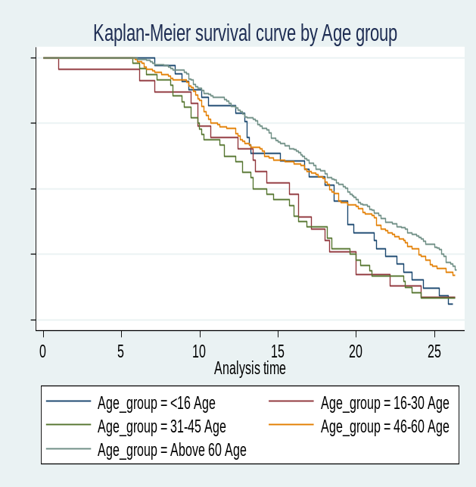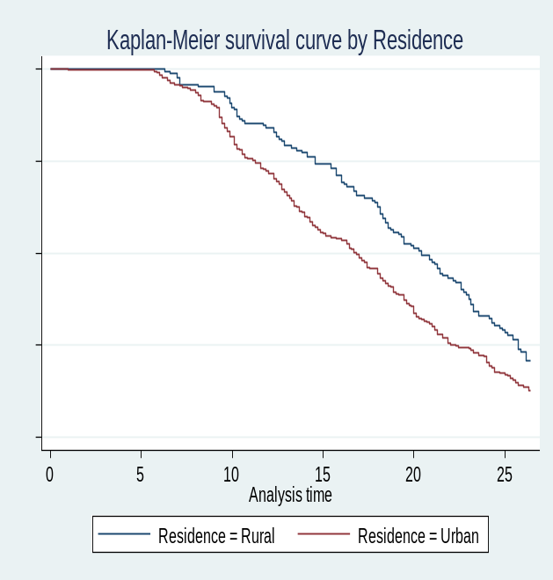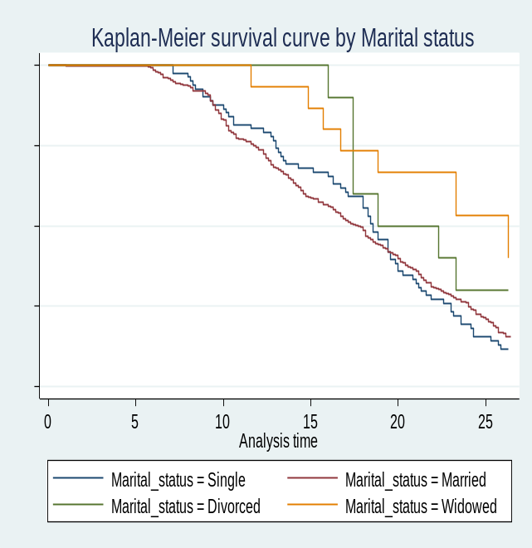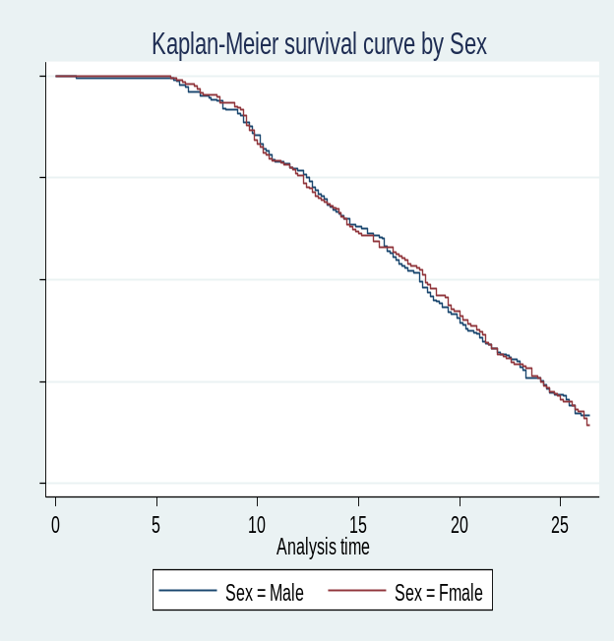

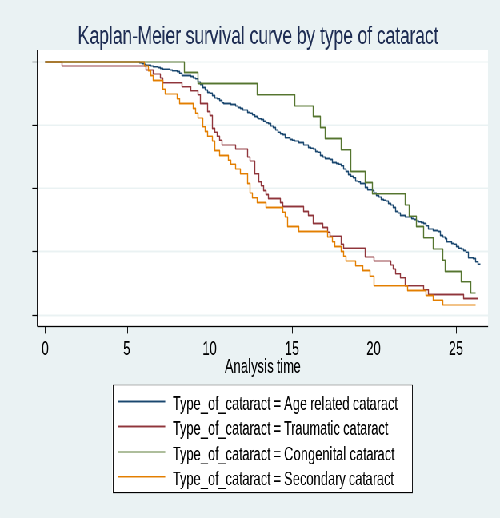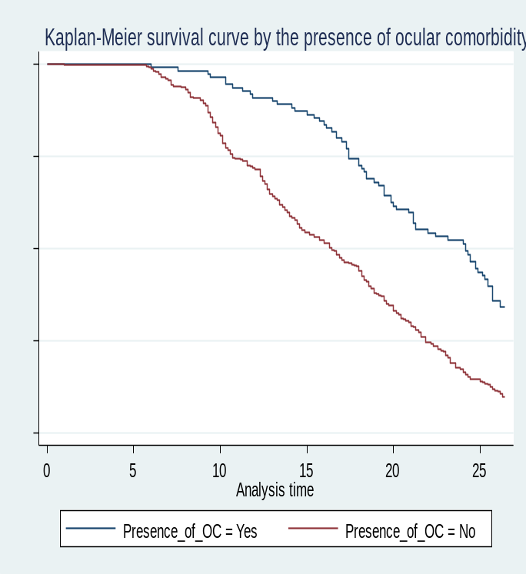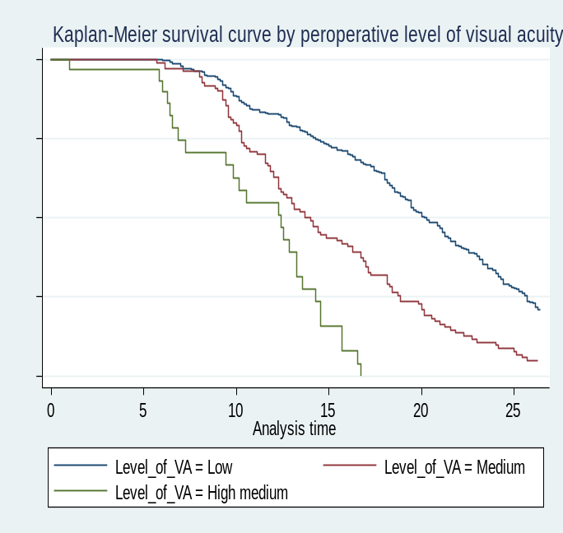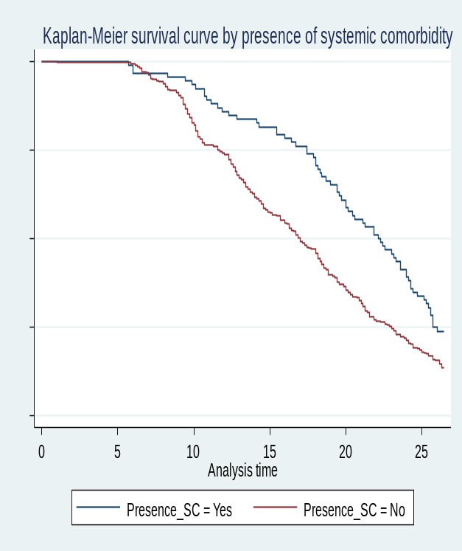

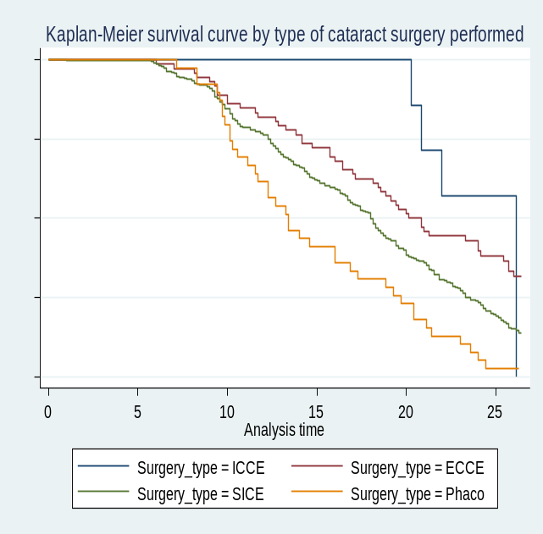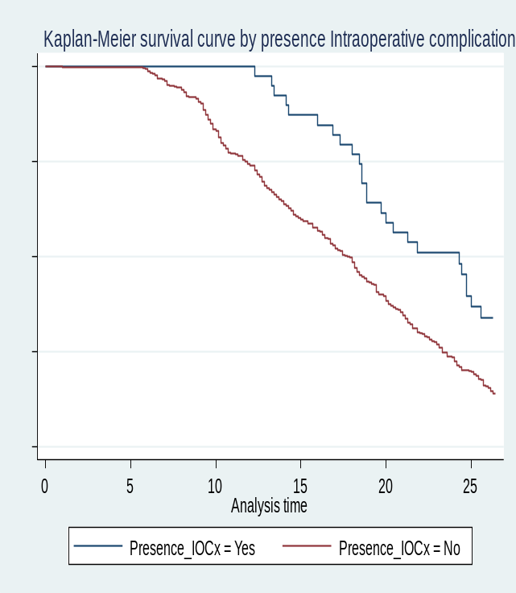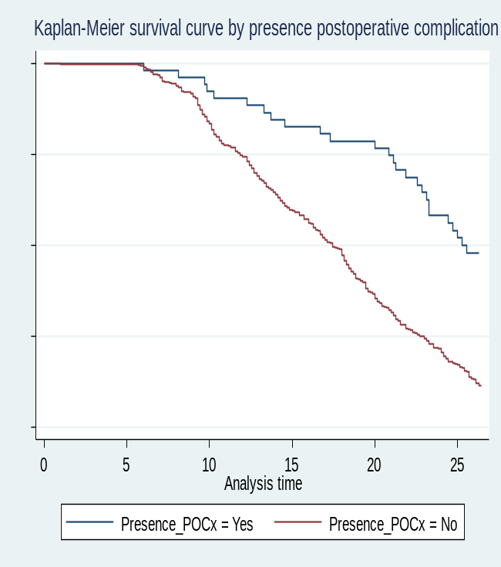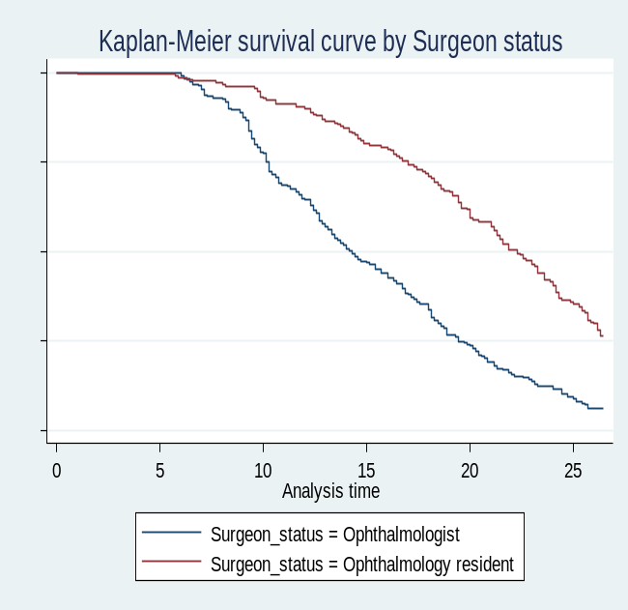

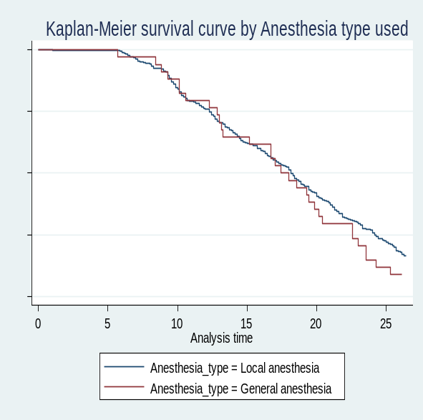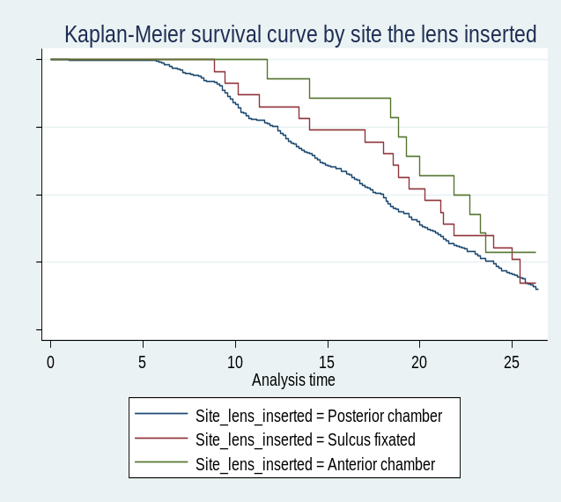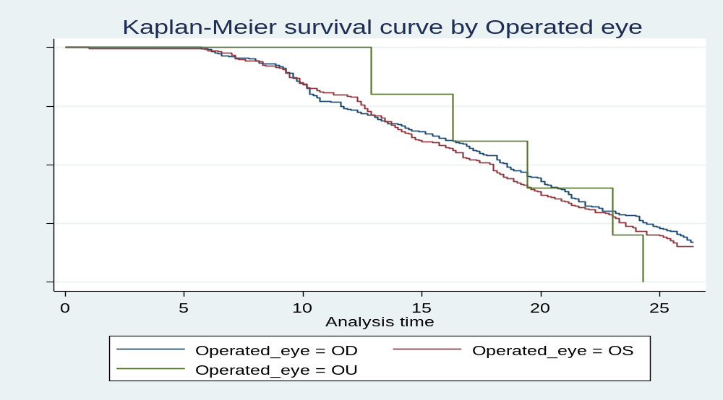

Table 9: Comparison of survival time to recovery from cataract surgery by the log-rank test at Menelik II Comprehensive Specialized Hospital from January 1, 2023, to December 31, 2023
Variables | Category | Median recovery time in week with (95%CI) | Chi-square | P- value of log rank test
Sex | Male | 18.00(16.57-19.14) | <0.001 | 0.998
Sex | Female | 18.29(16.71-19.57) | <0.001 | 0.998
Age in years | <16 Age | 18.57(13.13-19.86) | 19.22 | 0.0007
Age in years | 16–30 Age | 15.71(10.71-18.00) | 19.22 | 0.0007
Age in years | 31–45 Age | 13.43(11.57-16.86) | 19.22 | 0.0007
Age in years | 46–60 Age | 18.29(16.71-20.43) | 19.22 | 0.0007
Age in years | >60 Age | 19.43(17.71-20.86) | 19.22 | 0.0007
Residence | Rural | 20.43(18.57-22.28) | 12.70 | 0.0004
Residence | Urban | 16.85(14.86-18.14) | 12.70 | 0.0004
Marital status | Single | 18.57(17.00-19.57) | 12.03 | 0.0246
Marital status | Married | 17.71(16.29-18.71) | 12.03 | 0.0246
Marital status | Divorced | 18.86(16.00-21.52) | 12.03 | 0.0246
Marital status | Widowed | 26.00(15.71-35.79) | 12.03 | 0.0246
Types of cataract | Age related cataract | 19.57(18.43-20.86) | 53.17 | <0.0001
Types of cataract | Traumatic cataract | 13.29(12.29-16.29) | 53.17 | <0.0001
Types of cataract | Congenital cataract | 19.85(17.00-23.00) | 53.17 | <0.0001
Types of cataract | Secondary cataract | 12.43(10.57-14.71) | 53.17 | <0.0001
Level of Visual acuity | Low | 20.29(19.29-21.29) | 102.62 | <0.0001
Level of Visual acuity | Medium | 13.71(12.29-16.00) | 102.62 | <0.0001
Level of Visual acuity | High | 12.43(7.29-13.29) | 102.62 | <0.0001
Presences of ocular comorbidities | Yes | 24.14(20.86-25.43) | 43.06 | <0.0001
Presences of ocular comorbidities | No | 16.42(14.71-18.00) | 43.06 | <0.0001
Presences of systemic comorbidities | Yes | 22.14(20.00-24.00) | 13.19 | 0.0003
Presences of systemic comorbidities | No | 17.00(15.71-18.14) | 13.19 | 0.0003
Types of cataract surgery | ICCE | 26.00(20.29-31.46) | 26.21 | <0.0001
Types of cataract surgery | ECCE | 20.14(18.14-24.14) | 26.21 | <0.0001
Types of cataract surgery | SICE | 18.00(16.86-18.71) | 26.21 | <0.0001
Types of cataract surgery | Phaco | 13.43(11.14-16.86) | 26.21 | <0.0001
Type of anesthesia | Local anesthesia | 18.14(17.00-19.00) | 1.14 | 0.2849
Type of anesthesia | General anesthesia | 17.43(13.14-20.14) | 1.14 | 0.2849
Site of lens inserted | Posterior chamber | 18.00(16.71-18.57) | 3.18 | 0.2037
Site of lens inserted | Sulcus fixated | 20.29(17.00-24.00) | 3.18 | 0.2037
Site of lens inserted | Anterior chamber | 21.86(18.43- 25.05) | 3.18 | 0.2037
Eye operated | OD | 18.57(17.14-20.00) | 0.93 | 0.6284
Eye operated | OS | 18.00(16.29-18.86) | 0.93 | 0.6284
Eye operated | OU | 19.43(12.86-24.57) | 0.93 | 0.6284
Presences of intraoperative complication | Yes | 24.29(18.86-25.57) | 10.84 | 0.0010
Presences of intraoperative complication | No | 17.71(16.43-18.57) | 10.84 | 0.0010
Surgeon status | Ophthalmologist | 14.29(13.14-16.00) | 81.81 | <0.0001
Surgeon status | Resident | 22.29(21.00-23.57) | 81.81 | <0.0001
Presences of postoperative complication | Yes | 25.29(22.86-27.52) | 30.70 | <0.0001
Presences of postoperative complication | No | 17.43(16.29-18.29) | 30.70 | <0.0001

Note: OD= Oculus Dexter, OS= Oculus Sinister, OU= Oculus Uterque, ICCE= Intracapsular cataract extraction, ECCE= Extracapsular cataract extraction, SICE= Small-incision cataract extraction, Phaco= Phacoemulsification

