Supplementary materials
Binary solvent extraction of intracellular lipids from Rhodotorula toruloides for cell recycling
Jingyi Song ^{1,3}, Rasool Kamal ^{1,2}, Yadong Chu ⁴, Shiyu Liang ^{1,3}, Qitian Huang ^{1,2,4＊}
¹ Dalian Institute of Chemical Physics, Chinese Academy of Sciences, Dalian 116023, PR China
² Northeastern University, College of Life and Health Sciences, Shenyang, 110819, PR China
³ School of Bioengineering, Dalian University of Technology, Dalian 116024, PR China
⁴ Yantai Institute of Coastal Zone Research, CAS, Yantai 264003, PR China.
* Corresponding author.
Dalian Institute of Chemical Physics, CAS, 457 Zhongshan Road, Dalian 116023, PR China. Tel./fax: +86 411 84379211.
E-mail address: qthuang@yic.ac.cn

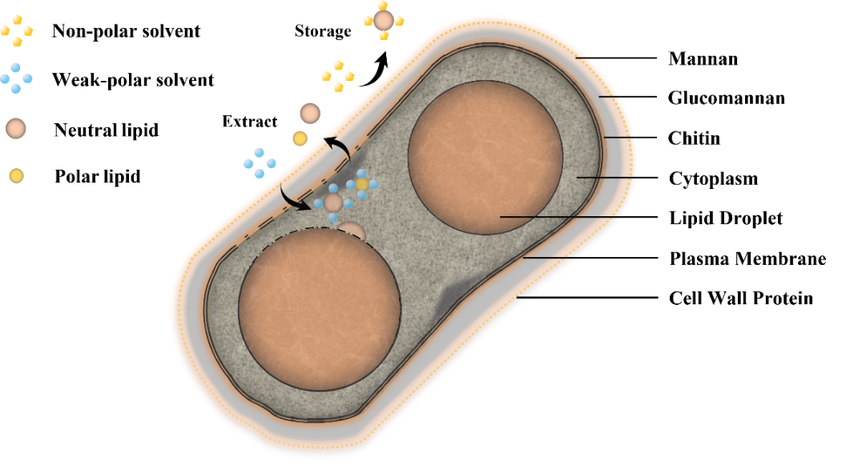
Figure S1. Combined solvent extraction lipid mechanism

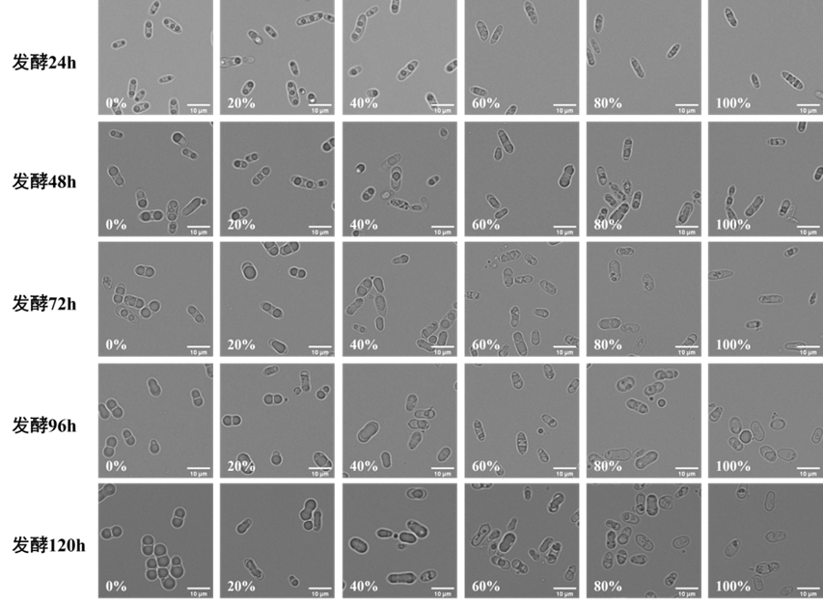
Figure S2 Cell status after extracted with different ratios of binary solvents (microscopic examination of cells after extracted with combined solvents at 0%, 20%, 40%, 60%, 80%, and 100% MTBE content at 48 h and 120 h of fermentation time, respectively)

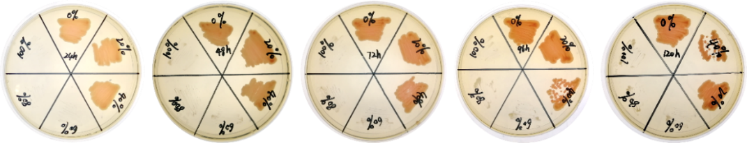
Figure S3 survival of the cells after lipid extraction with MTBE/n-hexane binary solvent (0%, 20%, 40%, 60%, 80%, and 100% MTBE content at 24 h, 48 h, 72 h, 96 h, and 120 h of fermentation time)

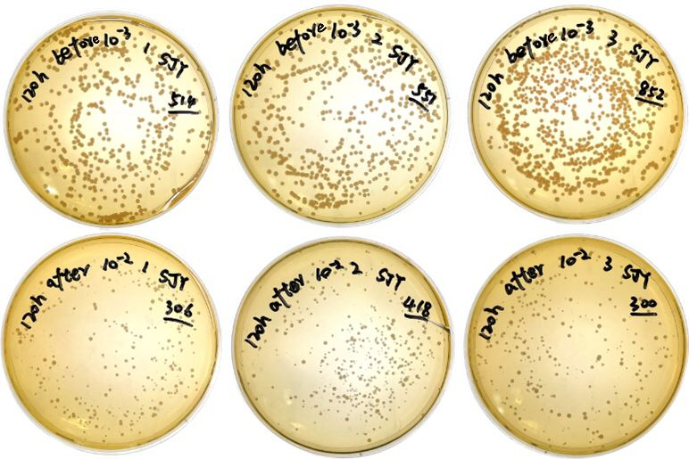
Figure S4. Survival of yeast after lipid extraction

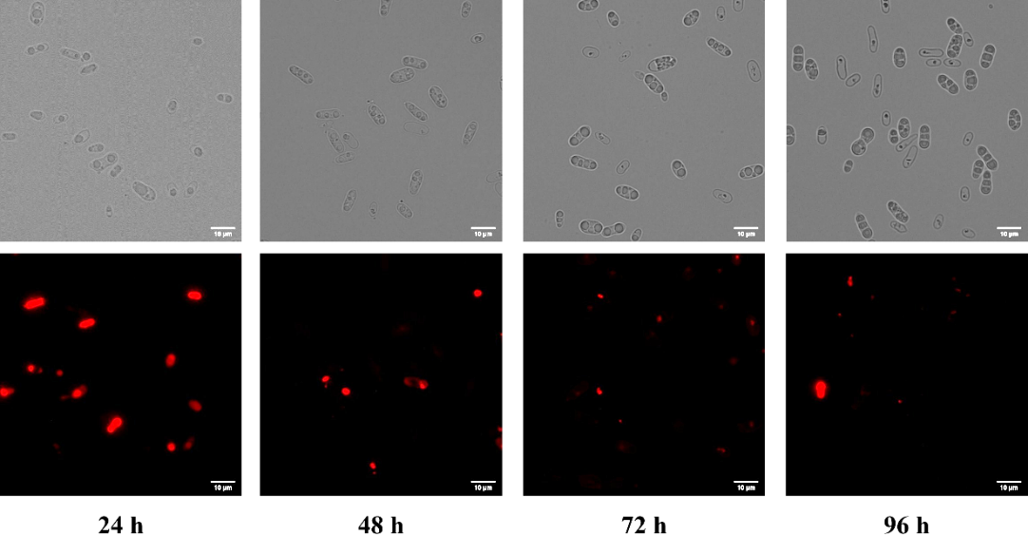
Figure S5. Recovery of circulating fermenting cells (Nl supplementary strategy)

Table S1 Extraction Performance Comparison and Lipid Yield Analysis
Study | Extraction Method | Yield Range | Process Conditions | Microorganism Type
Castejón and Marko, 2022 | Enzyme-based (Saczyme®) with ultrasounds | 25.7% ± 0.5 | 50°C for 1 hour, followed by ultrasound-assisted extraction for 30 minutes at 50°C | Nannochloropsis gaditana
Castejón and Marko, 2022 | Traditional Folch method | 27.3% ± 0.7 | No mention found | Nannochloropsis  gaditana
Castejón, 2022 | Ultrasonic-assisted enzymatic extraction (UAEE) with Saczyme® Yield and ethanol | 25.7% ± 0.5 | No mention found | Nannochloropsis  gaditana
Castejón, 2022 | Traditional Folch  method | 27.3% ± 0.7 | No mention found | Nannochloropsis  gaditana
Gorgich et al., 2020 | Various approaches with less toxic solvents | No mention found | No mention found | Nannochloropsis gaditana  Chlorella zofingiensis,  Phaeodactylum tricornutum,  Arthrospira platensis
Kruger et al., ”Recovery of Fuel-Precursor Lipids” | Acid treatment | >90% recovery | 170°C for 60 min  at 1 wt % H2SO4 and 8 wt % yeast solids | Lipomyces starkeyi
Kruger et al., ”Recovery of Fuel-Precursor Lipids” | High-pressure homogenization | ~80% recovery | No mention found | Lipomyces starkeyi
Kruger et al., ”Recovery of Fuel-Precursor Lipids” | Enzymatic treatment | ~70% recovery | No mention found | Lipomyces starkeyi
Prabakaran and Ravindran, 2011 | Various cell disruption methods | No mention found | No mention found | Freshwater microalgae
Ríos et al., 2013 | One-step lipid extraction- transesterification | No mention found (same as traditional methods) | No mention found | Phaeodactylum tricornutum,  Nannochloropsis gaditana,  Chaetoceros calcitrans
Ríos et al., 2013 | Bligh and Dyer, Soxhlet extraction with n-hexane | No mention found | No mention found | Phaeodactylum tricornutum,  Nannochloropsis gaditana,  Chaetoceros calcitrans
Señoráns et al., 2020 | Pressurized liquid extraction (PLE), Ultrasound- assisted extraction (UAE), Folch, Bligh and Dyer | No significant differences reported | PLE: 100°C and 140°C; UAE: 50°C  for 15-30 min | Isochrysis galbana
Vishwakarma et al., 2023 | Enzymatic pretreatment with biocompatible | 53.33% increase in lipid content | No mention found | Microalgae (species  not specified)
Vishwakarma et al., 2023 | solvent Conventional extraction | 15.77% increase in lipid content | No mention found | Microalgae (species  not specified)
References
Jacob S. Kruger, N. Cleveland, Rou Yi Yeap, Tao Dong, Kelsey J. Ramirez, N. Nagle, A. Lowell, G. Beckham,
J. McMillan, and Mary Biddy. “Recovery of Fuel-Precursor Lipids from Oleaginous Yeast,” 2018.
M. Gorgich, T. Mata, A. Martins, M. Branco-Vieira, and N. Caetano. “Comparison of Different Lipid Extraction Procedures Applied to Three Microalgal Species.” Energy Reports, 2020.
M. Señoráns, N. Castejón, and F. J. Señoráns. “Advanced Extraction of Lipids with DHA from Isochrysis Galbana with Enzymatic Pre-Treatment Combined with Pressurized Liquids and Ultrasound Assisted Extractions.” Molecules, 2020.
N. Castejón. “Eco-Friendly Strategies to Produce Bioactive Lipids from the Omega-3 Rich Microalga Nan- nochloropsis Gaditana.” Proceedings of 2022 AOCS Annual Meeting &Amp; Expo, 2022.
N. Castejón, and D. Marko. “Fatty Acid Composition and Cytotoxic Activity of Lipid Extracts from Nan- nochloropsis Gaditana Produced by Green Technologies.” Molecules, 2022.
P. Prabakaran, and A. D. Ravindran. “A Comparative Study on Effective Cell Disruption Methods for Lipid Extraction from Microalgae.” Letters in Applied Microbiology, 2011.
R. Vishwakarma, S. Dey, Saurabh Samuchiwal, and A. Malik. “A Biphasic Photobioreactor System for Consecutive Extraction of Lipids and Carotenoids from Pre-Hydrolysed Microalgae and Evaluation of Its Biodiesel Potential.” Environmental Research, 2023.
S. Ríos, J. Castañeda, C. Torras, X. Farriol, and J. Salvadó. “Lipid Extraction Methods from Microalgal Biomass Harvested by Two Different Paths: Screening Studies Toward Biodiesel Production.” Bioresource Technology, 2013.

