Supplementary information for

Inhibition of polymeric densification at platinum/ionomer interface via enlarging tetrafluoroethylene spacing in perfluorinated sulfonic-acid ionomer

Won Young Choi^{1,2}, Hyunguk Choi^{1,2}, Young Je Park¹, Seo Won Choi¹, Hyeon E Cho¹,
Nam Jin Lee¹, Young Gi Yoon¹, Sung-Chul Yi^{2***}, Min-Jae Ko²**, Chi-Young Jung^{1,3}*

¹Hydrogen Research & Demonstration Center, Hydrogen Energy Institute, Korea Institute of Energy Research, Jeollabuk-do 56332, Republic of Korea
²Department of Chemical Engineering, Hanyang University, Seoul 04763, Republic of Korea
³Department of Energy Engineering, University of Science and Technology, 217 Gajeong-ro, Yuseong-gu, Daejeon 34113, Republic of Korea

Corresponding authors: Prof. S.-C. Yi***
E-mail: ***scyi@hanyang.ac.kr
Corresponding authors: Prof. M.-J. Ko**
E-mail: **mjko@hanyang.ac.kr
Corresponding authors: Dr. C.-Y. Jung*
E-mail: *cyjung@kier.re.kr
Methods
TEM sample preparation
To analyze the spatial ionomer distribution within the electrode, a cryogenic focused ion beam (cryo-FIB) milling technique was employed to obtain a 100 nm thick sample while minimizing ionomer degradation. Prior to preparation, the electrode was coated with a thin Cr mask to protect it from the unintentional impact of Ga+ ions from the FIB column. Then, the sample was carefully adjusted beneath the scanning electron microscope (SEM) and FIB columns to ensure that the Ga+ beam from the FIB column intersected the sample surface at a vertical angle. Subsequently, the FIB-SEM instrument employs two separate high-energy charged particle beams, one of Ga+ ions and one of electrons, focused on the same area of the sample. The angle between ion and electron beams was 52°. Finally, a 5 × 5 μm² size transmission electron microscope (TEM) sample was prepared, as shown in Supplementary Fig. 11a, b.

Crack evaluation at the electrode surface
A 3D laser scanning confocal microscopy (3D-LSCM) (VK-X1000, Keyence) was utilized to visualize the wide view of the electrode surface with a 20× objective lens. Using multiple analysis applications, it was possible to quantitatively analyze electrode surface cracks by measuring the height, surface area, and volume of the concave patterns. When calculating the crack area, microstructures appearing within 200 nm of the specified reference height were considered rough and were excluded from the analysis (Supplementary Fig. 12 a-c). The quantitative analysis results derived from examining the concave patterns in the 3D-LSCM images, particularly the maximum depth and surface ratio of the cracks.

Electrochemical analysis details
H₂-air iV polarization curve
The single-cell tests were performed under a cell temperature of 80 ℃ in the 100 W polymer electrolyte fuel cell (PEFC) testing station (Greenlight Innovation, G20). All single-cell tests were carried out using a 25 cm² membrane electrode assembly (MEA), except for the limiting current measurement, where the MEA active area was 1 cm². Prior to characterization, the cell was activated by stepwise voltage cycling in a range of 0.8 to 0.3 V with increments of 0.1 V for 5 min with a flow rate of 830/2600 sccm (An/Ca) under ambient pressure. After that, the H₂-Air polarization curve was conducted by following the U.S. Department of Energy (DOE) protocol with stoichiometric ratios of 1.5 and 2.0 in the anode and cathode at RH 100% under 150 kPa_{abs,out} in the galvanostatic mode; the corresponding current density was taken by averaging the values in last 30 seconds. The electrochemical impedance spectra (EIS) were measured using an impedance analyzer (Biologics, HCP-803). The alternating current was set at 10% of the applied direct current within the 20,000 to 0.1 Hz frequency range.

ORR mass activity measurement
Due to the limited but diffusive nature of hydrogen gas within the ionomer, H₂ gas migrates from the anode compartment of the PEFC to the cathode and undergoes oxidation at the cathode [15]. The permeability of hydrogen gas can be electrochemically measured and quantified as a crossover current. The anodic flow of H₂ (260 sccm) and cathodic flow of N₂ (500 sccm) were maintained at a pressure of 150 kPa at cell temperature of 80 °C with the potential range of 0.1 to 0.5 V (vs RHE) at scan rate of 0.2 mVs⁻¹. The crossover current was obtained at 0.3 V. Then, the H₂-O₂ polarization curve was conducted to obtain the mass activity with an anodic flow of 1,000 sccm of H₂ and a cathodic flow of 2,000 sccm of O₂ at 80°C with 100% relative humidity (RH) under a pressure of 150 kP_{abs}. Then, mass activity was extracted at 0.9 V from the H₂-O₂ polarization curve, after correcting for HFR and H₂-crossover current.

Calculation of sulfonate groups coverage onto Pt
The number of sulfonate groups adsorbed onto the Pt surface can be calculated from the integrated charge (q_{dis}) arising from the linear CO displacement. This allows to determine the sulfonate group coverage onto Pt catalysts through CO displacement and CO stripping. Prior to the CO displacement, the cathode was cleaned by cyclic voltammetry (CV) from 0.05 V to 1.0 V at a scan rate of 500 mVs⁻¹ with 200 sccm H₂ and 500 sccm N₂ supplied to the anode and cathode respectively. Then, the potential of 0.4 V_{RHE} was then applied to remove the hydroxyl groups. In this step, the gas supplied to the cathode was changed from N₂ to CO (80 sccm). In this step, a decrease in current was observed, indicating displacement of the adsorbed ionomer. After linear adsorption of CO, the MEA was subsequently purged with nitrogen gas. This was followed by a CO stripping analysis conducted over a voltage range of 0.05 to 1.2 V at a scan rate of 50 mV /s. Furthermore, the process of CO displacement was monitored by recording the current-time curve at an applied potential of 0.1 V against the reference hydrogen electrode (RHE). To calculate the coverage of the sulfonate group, the charge related to CO displacement at 0.4 V versus RHE was doubled and normalized to the CO stripping charge (q_{strip}). The electrochemical surface area (ECSA) of the catalyst layer during the CO stripping process was estimated using an equation with a reference charge (q_{ref}) of 420 μC cm⁻² designated for the CO stripping analysis.

Dry proton accessibility measurement
Subsequently, the ECSA was determined by CV with CO stripping method. In the test, RH was set as 100% and 20% for estimating the ionomer coverage on the Pt/C surface via dry proton accessibility (PDA) test (ECSA_{RH 20} / ECSA_{RH 100}). The cell was purged with 500 sccm N₂ gas until the cell voltage dropped below 0.1 V (vs. RHE), while simultaneously supplying 200 sccm H₂ in the anode. Afterward, the 500 sccm CO gas (1% CO with N₂ balance) was flowed into the cathode while maintaining the cell potential at 0.1 V_{RHE} for 30 min in the CO adsorbing step. The 500 sccm N₂ gas was supplied in the cathode for removing residual CO gas in the catalyst layer over 30 min by holding 0.1 V_{RHE}. The 2 cycles of CV were recorded in a range of 0.05–1.2 V_{RHE} by the flow of 200 sccm H₂ and 40 sccm N₂ in the anode/cathode respectively. The first one was used to determine the absorbed CO peak and the second cycle verified the Pt_{oxide} peak. The CO absorption transfer factor of 420 μCcm_{Pt} ⁻² was used for calculating the ECSA.

Local O₂ transport resistance
Limiting current measurements were conducted to decompose the total mass transport resistance (R^{total}) into pressure-dependent (R^{PD}) and pressure-independent (R^{PI}) resistances as presented in Equation. 1. The tests were conducted at different cell pressures (150, 200, and 300 kPa_{abs, out}) under 100% RH condition. The active area of a 1 cm² electrode was employed to avoid differential cell pressure. During the measurement, the 2,000 sccm of varied O₂ mixture gases (O₂/N₂ balance, O₂ mole fraction; 1.5%, 3%, 7%, and 10%) were fed into the cathode while the 1000 sccm H₂ gas was supplied in the anode. The cell potential range of 0.3 to 0.05 V_{RHE} with a potential step of 0.05 V was applied to keep the oxygen concentration near zero from the Pt surface. Each potential was maintained for 3 min, and the current was recorded for the last 30 s. R^{PD} can be separated by resistance of the flow channel (${\text{R}}^{\text{CH}})$, DM (${\text{R}}^{\text{DM}})$, and MPL (${\text{R}}^{\text{MPL}})$, which are parameters of intermolecular gas diffusion (see Equation. 2). R^{PI} is the parameter of a Knudsen diffusion, which mainly occurs through the interface between the ionomer/catalyst (the local transfer resistance (${\text{R}}^{\text{local}})$ and pores less than 100 nm (${\text{R}}^{\text{pore}}$), as shown in Equation 2:
${\text{R}}^{\text{total}}\text{ = }{\text{R}}^{\text{PD}}\text{ + }{\text{R}}^{\text{PI}}$ $(Eq. 1)$
${\text{R}}^{\text{total}}\text{ = }{\text{R}}^{\text{CH}}\text{ + }{\text{R}}^{\text{DM}}\text{ + }{\text{R}}^{\text{MPL}}\text{ + }{\text{R}}^{\text{local}}$ + ${\text{R}}^{\text{pore}}$ $(Eq. 2)$
The current densities measured at different pressures and oxygen dilution levels can be transformed into a line plot for R^{total} using Eqs. 3 and 4, with the value of R^{PI} obtained from the y-axis intercept (Supplementary Fig.13).
$${\text{R}}^{\text{total}}\text{ = }\frac{4F}{i_{lim}}∙C_{O2} (Eq. 3)$$
$$C_{O2}\text{ = }\frac{P^{in}-P^{out}}{RT}∙x_{dry,O2} (Eq. 4)$$

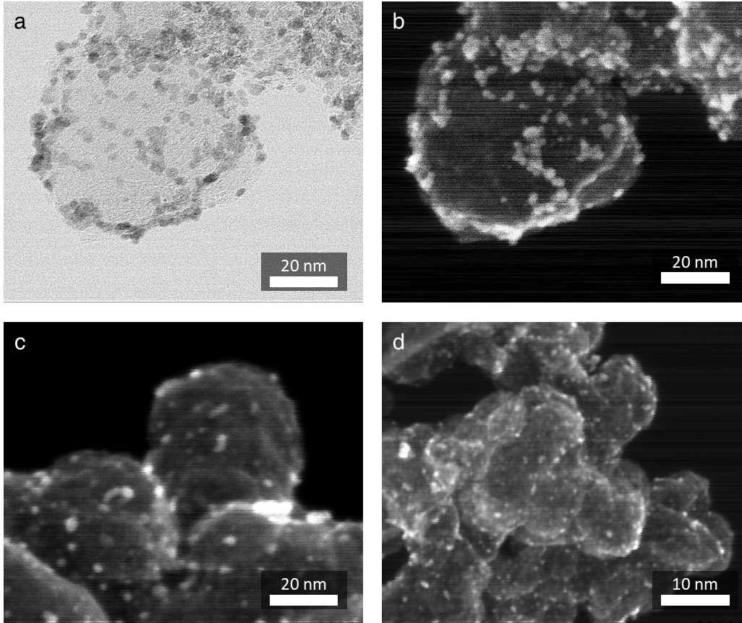
Supplementary Fig. 1 TEM image of the 40 wt% Pt/Vulcan catalyst obtained by HR-TEM | a-b. Catalyst surface obtained by BF images (a) and HADDF images (b) at the identical location (b). c-d. Multiple HADDF images of the catalyst.
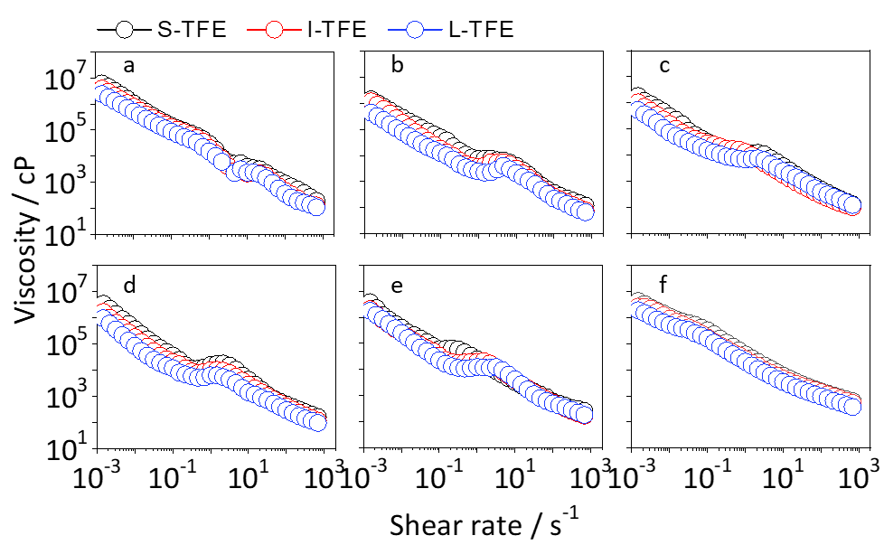Supplementary Fig. 2 Steady-shear measurements of the electrode slurry for S-TFE, I-TFE, and L-TFE spacing ionomer | a-f. Viscosity flow curves with different ionomer concentrations 0.125 (a), 0.25 (b), 0.5 (c), 0.75 (d), 1.0 (e), and 1.25 mmol_{SO3}g_{c}⁻¹ (f) with a shear rate range from 0.001 to 1,000 s⁻¹.
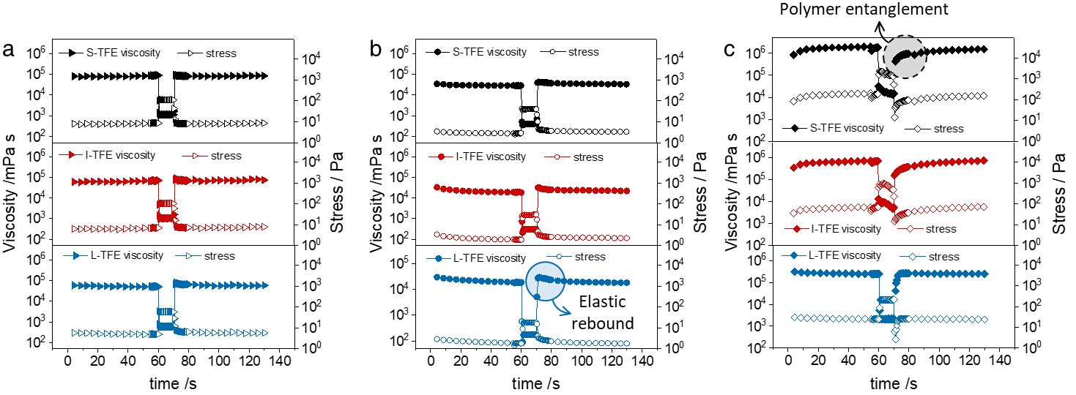
Supplementary Fig. 3 Three-interval thixotropy test (3ITT) results of S-TFE (black), I- TFE (red), and L- TFE (blue) spacing ionomer-based electrode slurry | 3ITT results with ionomer concentrations of 0.125 (a, ▶), 0.75 (b, ●), and 1.25 mmol_{SO3}g_{c}⁻¹ (c, ◆). During the measurements, electrode slurry was sheared at 0.1 s⁻¹ for the initial stage (0 to 60 s), 100 s⁻¹ for the deformation stage (60 to 70 s), and 0.1 s⁻¹ for the reconstruction stage (70 to 120 s).

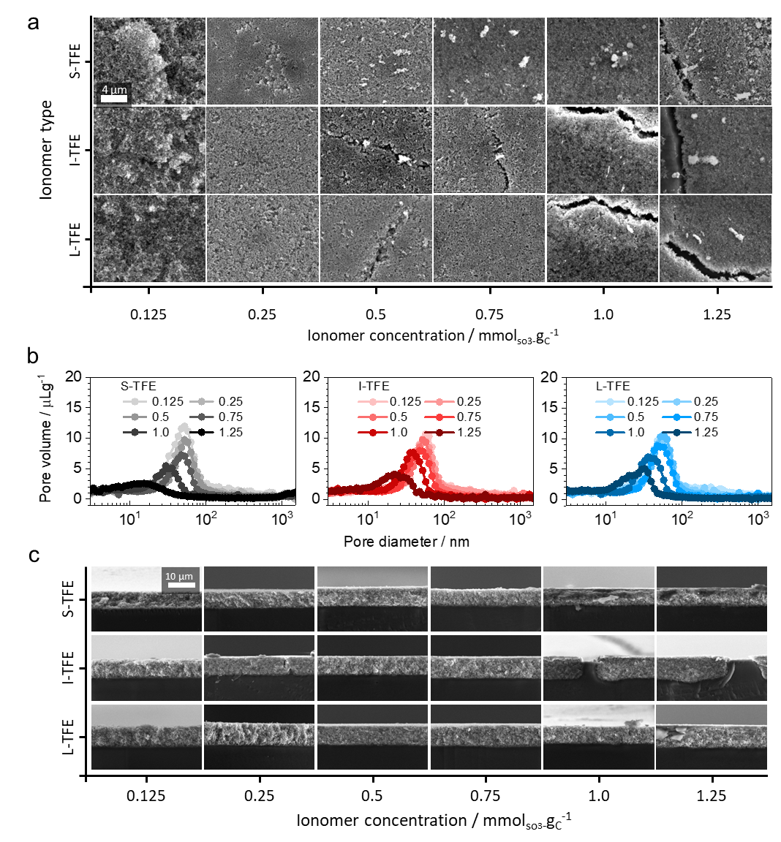
Supplementary Fig. 4 Surface morphologies of electrodes | a. Electrode surface with S-TFE, I-TFE, and L-TFE spacing ionomers at 10k magnification obtained by HR-SEM. b. Porosimetry of MEA measured by MIP. c. Cross-section image of the electrode at 5k magnification.

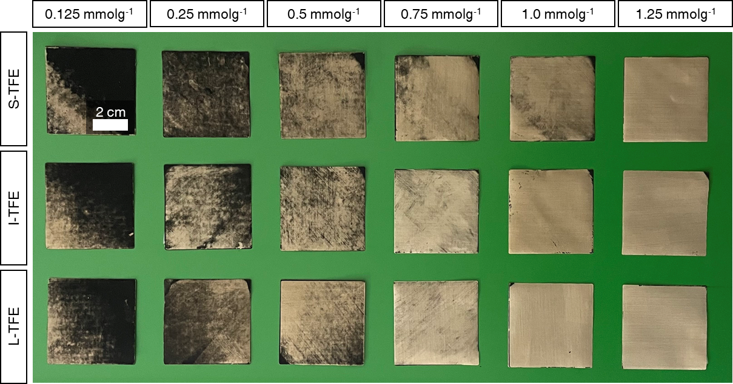
Supplementary Fig. 5 Photographs of the decal substrate peeled off after hot pressing the MEA | 25cm² PTFE-coated glassy fiber fabric sheet was used as the decal substrate, with the dark area representing the residual Pt catalyst.
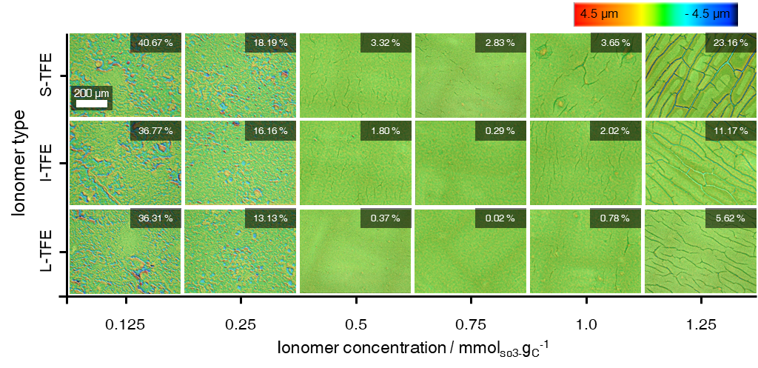
Supplementary Fig. 6 Topological images of the electrode surface | Electrode surfaces (700 µm × 530 µm) including crack fraction for each ionomer type and content, characterized by 3D-LSCM.
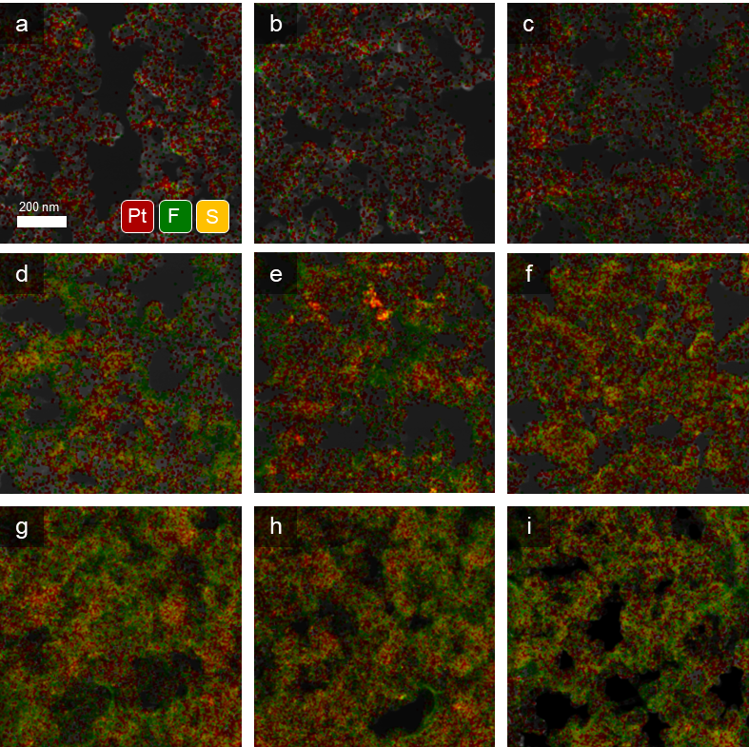
Supplementary Fig. 7 EDS mapping images with elemental maps of F (green), Pt (red), and sulfur (yellow) overlaid on bright field (BF) images from the MEA cross-section obtained from cryo-FIB sampling | a-c. Result of MEA with ionomer contents at 0.125 mmol_{SO3-}g_{C}⁻¹ of S-TFE spacing (a), I- TFE spacing (b) and L- TFE spacing ionomers (c), d-f. MEA with 0.75 mmol_{SO3-}g_{C}⁻¹ of S-TFE spacing (d), I- TFE spacing (e) and L- TFE spacing ionomers (f), and g-i. MEA with 1.25 mmol_{SO3-}g_{C}⁻¹ of S-TFE spacing (g), I- TFE spacing (h) and L- TFE spacing ionomers (i).

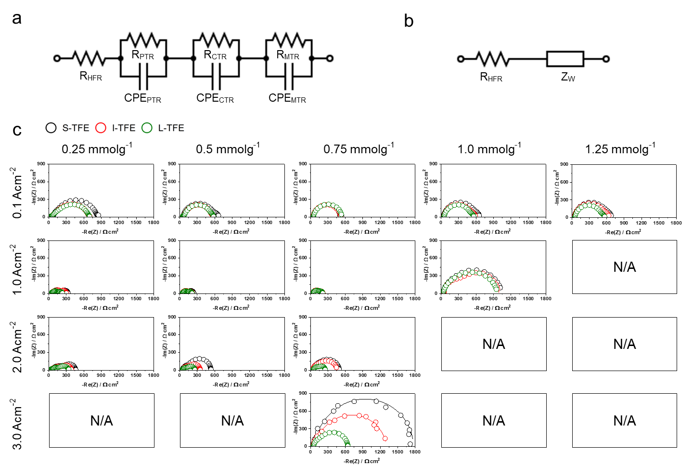
Supplementary Fig. 8 Equivalent circuit model and EIS results | a-b. Equivalent circuit with fueling H₂-air (a) and H₂-N₂ (b) at An/Ca, respectively. c. Nyquist plots curves (circle symbol) and fitted data (solid lines) in H₂-air EIS curves, measured at varying current densities.
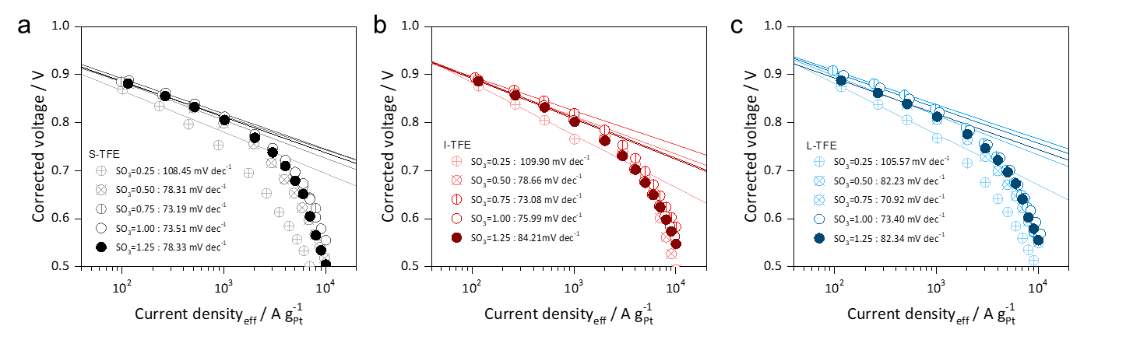
Supplementary Fig. 9 H₂-O₂ polarization curves | a-c. Corrected H₂-O₂ polarization curve (circle symbols) and Tafel slope (solid line) with S-TFE spacing (a), I-TFE spacing (b), and L-TFE spacing MEA(c). Tafel Slope (TS) was obtained between 50 and 500 mA·cm⁻². Cell voltage was corrected by high-frequency resistance (HFR), and the current was corrected by H₂ crossover current.

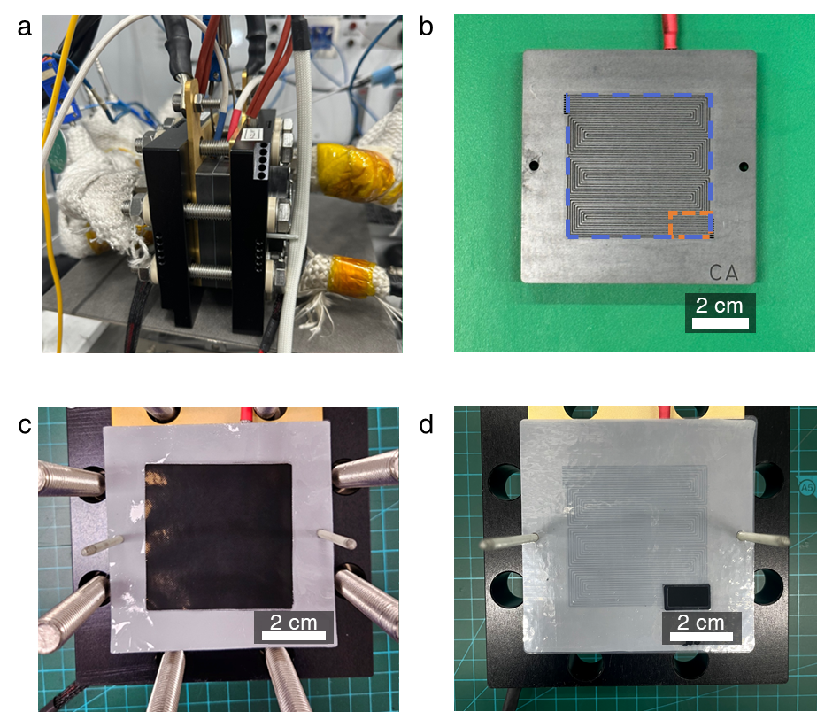
Supplementary Fig. 10 Experimental setup for single cell test | a. Photographic image of a single cell connected to the PEFC testing device. b. Illustration of a graphite flow field with nine channels where blue and orange dashed lines indicate the position of the MEA with an active area of 25 cm² and 1 cm², respectively. c-d. Pictures of the active area of 25 cm² (c) and 1 cm² (c) MEAs on the graphite flow field.
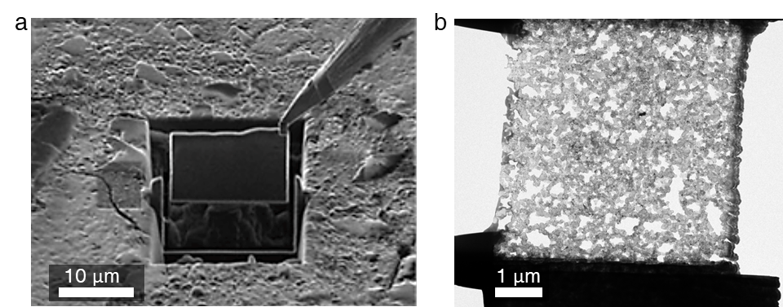
Supplementary Fig. 11 TEM sample preparation using cryo-FIB-SEM | a. Ga-coated electrode sample after ion-milling. b. TEM sample with 100 nm thickness after FIB ion-milling under cryogenic N₂ atmosphere.

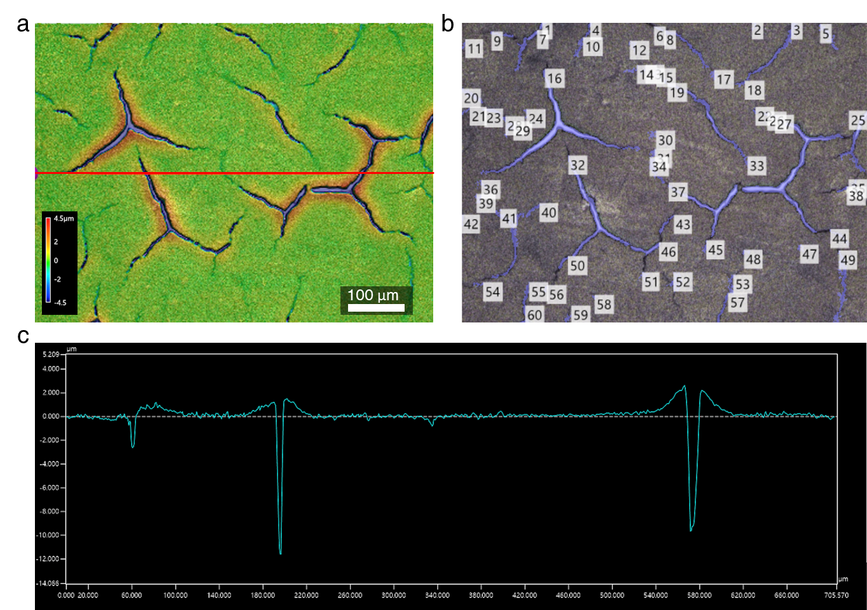Supplementary Fig. 12 Quantifying crack area observed at electrode surface | a-c. Surface morphology obtained from 3D-LSCM (a), crack areas (blue) measured by multi-analysis applications (b), and depth of the crack measured in the through-plane direction (c).

Supplementary Fig. 13 O₂ transport resistance measured by limiting current measurement | Plotted line obtained from the under varying pressures (150, 200, and 300 kPa), which can be separated into R_{pd} and R_{PI} from the total O₂ transport resistance.

MEA |  | Amount of residual Pt  (µgcm⁻²)
Ionomer type | Ionomer con.  (mmol_{SO3}-g_{c}⁻¹) | Amount of residual Pt  (µgcm⁻²)
S-TFE | 0.125 | 19.27
S-TFE | 0.25 | 14.24
S-TFE | 0.5 | 4.76
S-TFE | 0.75 | 0.68
S-TFE | 1.0 | 0.75
S-TFE | 1.25 | 0.02
I-TFE | 0.125 | 12.27
I-TFE | 0.25 | 9.52
I-TFE | 0.5 | 2.63
I-TFE | 0.75 | 0.23
I-TFE | 1.0 | 0.09
I-TFE | 1.25 | 0.09
L:-TFE | 0.125 | 15.4
L:-TFE | 0.25 | 9.63
L:-TFE | 0.5 | 2.88
L:-TFE | 0.75 | 0.16
L:-TFE | 1.0 | 0.15
L:-TFE | 1.25 | 0.03

Supplementary Table 1 The average amount of residual Pt loaded on the decal substrate after MEA manufacturing | The residual Pt was measured using X-ray fluorescence (XRF) analysis, and the average amount was calculated from five different locations on the decal substrate.
MEA |  | Porosity (%)
Ionomer type | Ionomer con.  (mmol_{SO3}-g_{c}⁻¹) | Porosity (%)
S-TFE | 0.125 | 59.9
S-TFE | 0.25 | 57.6
S-TFE | 0.5 | 48.3
S-TFE | 0.75 | 39.9
S-TFE | 1.0 | 32.1
S-TFE | 1.25 | 18.7
I-TFE | 0.125 | 61.1
I-TFE | 0.25 | 55.8
I-TFE | 0.5 | 47.3
I-TFE | 0.75 | 40.7
I-TFE | 1.0 | 37.1
I-TFE | 1.25 | 28.1
L:-TFE | 0.125 | 65.0
L:-TFE | 0.25 | 53.9
L:-TFE | 0.5 | 50.4
L:-TFE | 0.75 | 43.1
L:-TFE | 1.0 | 38.6
L:-TFE | 1.25 | 27.2

Supplementary Table 2 The porosity of as-fabricated electrode with respect to TFE spacing and ionomer concentration | The porosity was estimated using a mercury intrusion porosimeter (MIP) with pore sizes ranging from 3 to 1,000 nm.

Electrode slurry preparation
Sample | Catalyst | Solvent  (w/w) | Solid con.  (g_{carbon}/ml_{sol}) | Ionomer  type | Ionomer con.  (mmol_{SO3-1}g_{c}) | I/C ratio  (g/g)
No.1 | Pt₄₀/Vulcan | H₂O : nPA  (1:1) | 0.1 | - | 0 | 0
No.2 | Pt₄₀/Vulcan | H₂O : nPA  (1:1) | 0.1 | S-TFE | 0.125 | 0.09
No.3 |  |  |  |  | 0.25 | 0.18
No.4 |  |  |  |  | 0.5 | 0.36
No.5 |  |  |  |  | 0.75 | 0.5
No.6 |  |  |  |  | 1.0 | 0.7
No.7 |  |  |  |  | 1.25 | 0.9
No.8 | Pt₄₀/Vulcan | H₂O : nPA  (1:1) | 0.1 | I-TFE | 0.125 | 0.10
No.9 |  |  |  |  | 0.25 | 0.21
No.10 |  |  |  |  | 0.5 | 0.42
No.11 |  |  |  |  | 0.75 | 0.62
No.12 |  |  |  |  | 1.0 | 0.83
No.13 |  |  |  |  | 1.25 | 1.0
No.14 | Pt₄₀/Vulcan | H₂O : nPA  (1:1) | 0.1 | L-TFE | 0.125 | 0.12
No.15 |  |  |  |  | 0.25 | 0.25
No.16 |  |  |  |  | 0.5 | 0.49
No.17 |  |  |  |  | 0.75 | 0.74
No.18 |  |  |  |  | 1.0 | 0.98
No. 19 |  |  |  |  | 1.25 | 1.23

Supplementary Table 3 Electrode slurry specification used for each type of TFE spacing and concentration.

