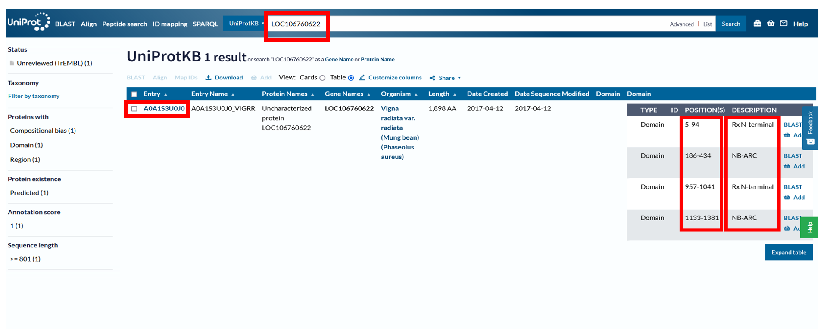
Figure S1 Not Merely Conserved Domains (NMCD) within the same R protein. The presence of NB-ARC and RX_N-terminal domains occurring twice within the same R protein (A0A1S3U0J0) at different positions indicates the occurrence of NMCD (highlighted in red color).

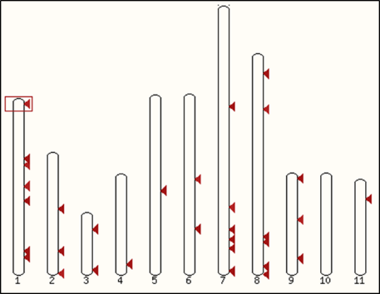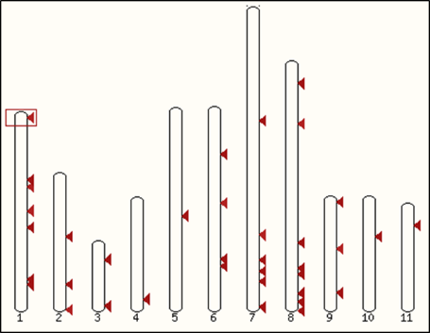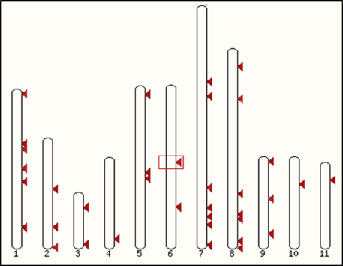
C)
B)
A)
KR350634.1 HQ704838.1 HQ704837.1

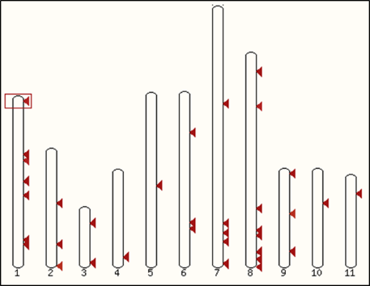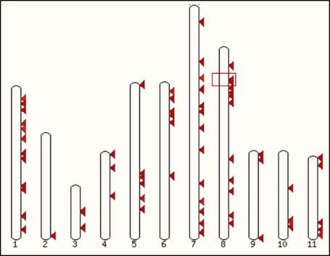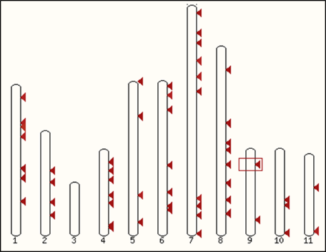
D)
E)
F)
EU258701.1 EU258700.1 EF446378.1
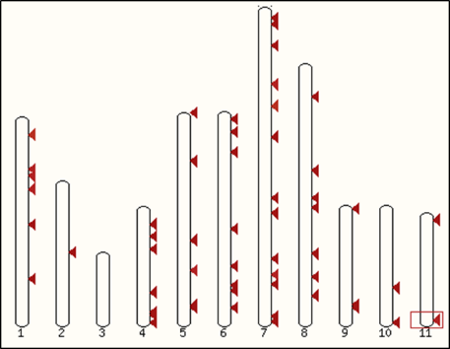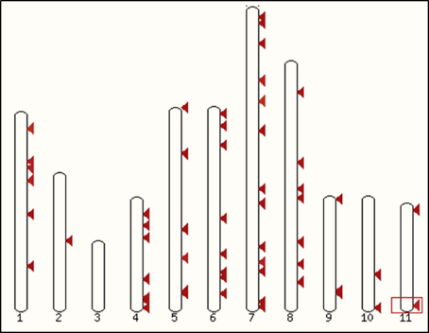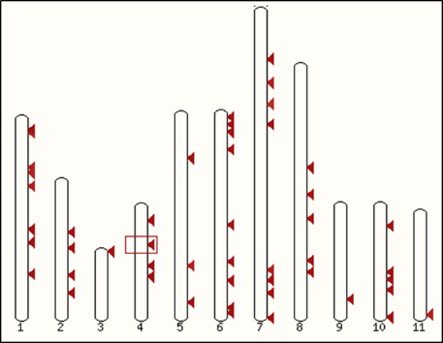
G)
H)
I)
AY301991.1 AY297425.2 XM_014647468.2

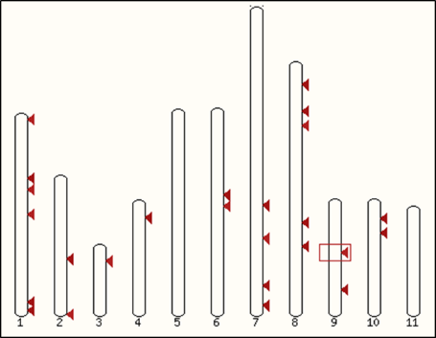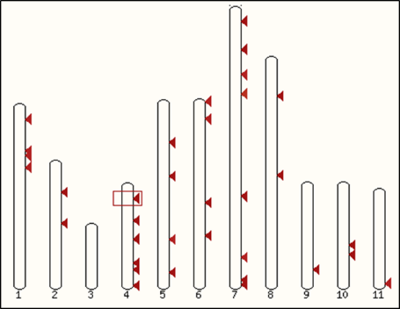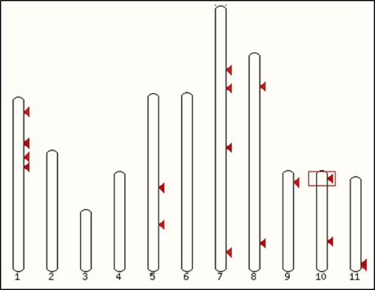
L)
K)
J)
AY301990.1 KF021265.1 KF661551.1
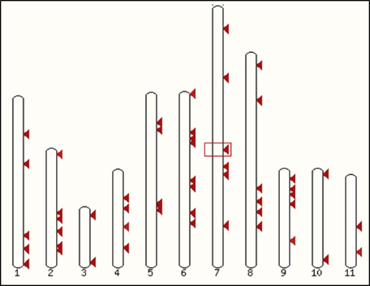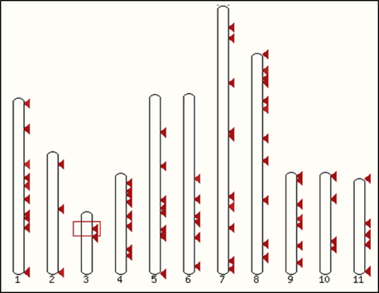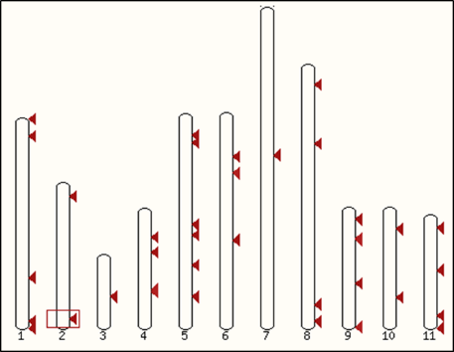
O)
N)
M)
XM_014649096.2 XM_022781464.1 CP039352.1

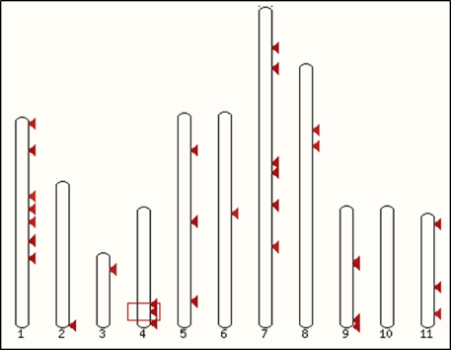
P)
AP015039.1
Figure S2 Identification of redundancy in R genes using High-Scoring Segment Pair (HSP) Blast analysis in the Ensembl Plants database. The figure illustrates the redundancy and chromosomal distribution of collected R genes (Table S1) in the V. radiata genome, highlighting multiple copies of similar regions across different chromosomes (indicated by red arrows). This analysis provides insights into the potential functional redundancy of R genes in the Vigna genome. The distribution of NB-ARC domain-specific R genes (A-P) is shown.

A)
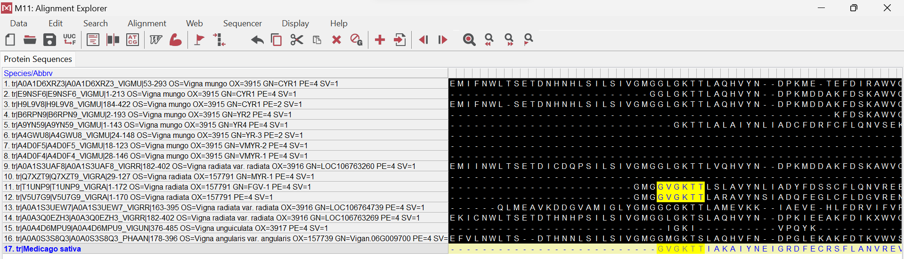

B)
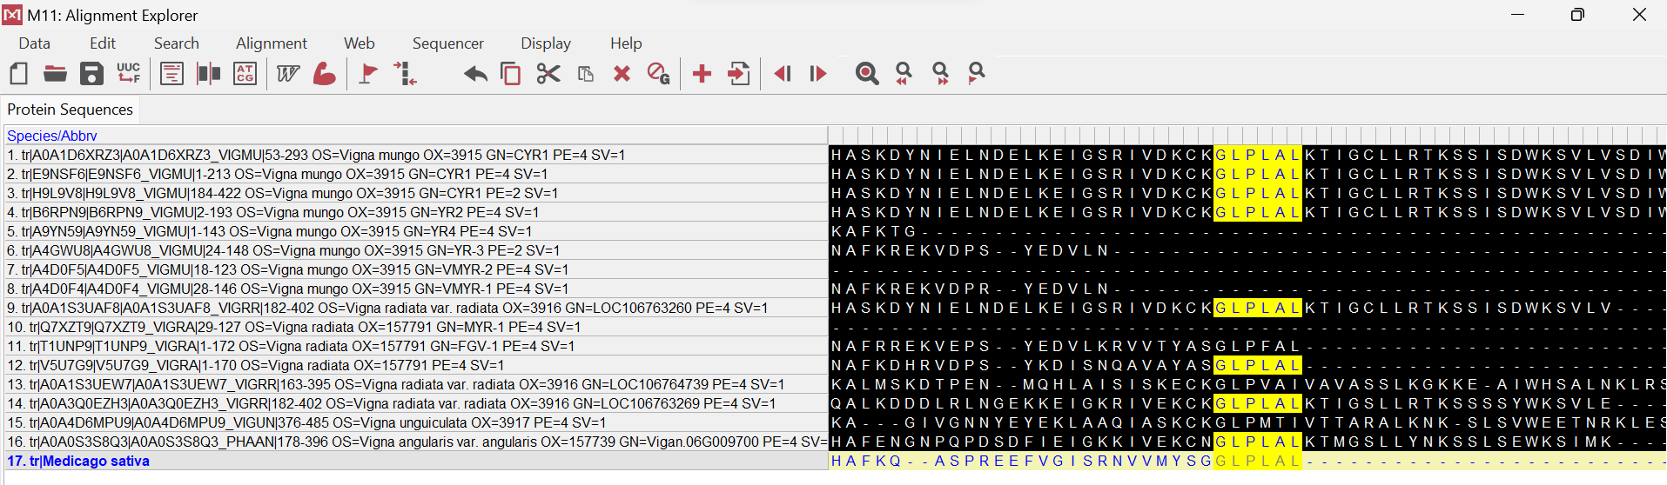
Figure S3 Identification of conserved motifs within R protein domains. MUSCLE alignment was performed on collected accessions to verify the presence of conserved motifs. For the NB-ARC family, the P-Loop motif (A) and the terminal GLPLAL motif (B) are highlighted in yellow.
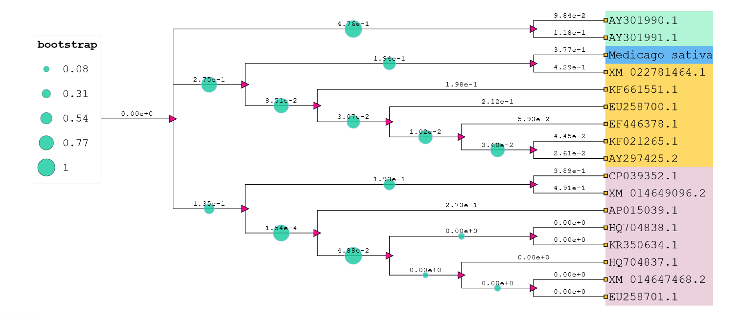
Figure S4 Identification of diversity in conserved domain sequences among functionally similar R proteins. Phylogenetic analysis was performed on the nucleotide sequences of collected NB-ARC domain R protein accessions to visualize evolutionary relationships and clustering patterns. The dendrogram highlights variations among functionally similar R proteins, showing limited sequence similarity within conserved domains across three major clades. Medicago sativa served as the reference group.

A)
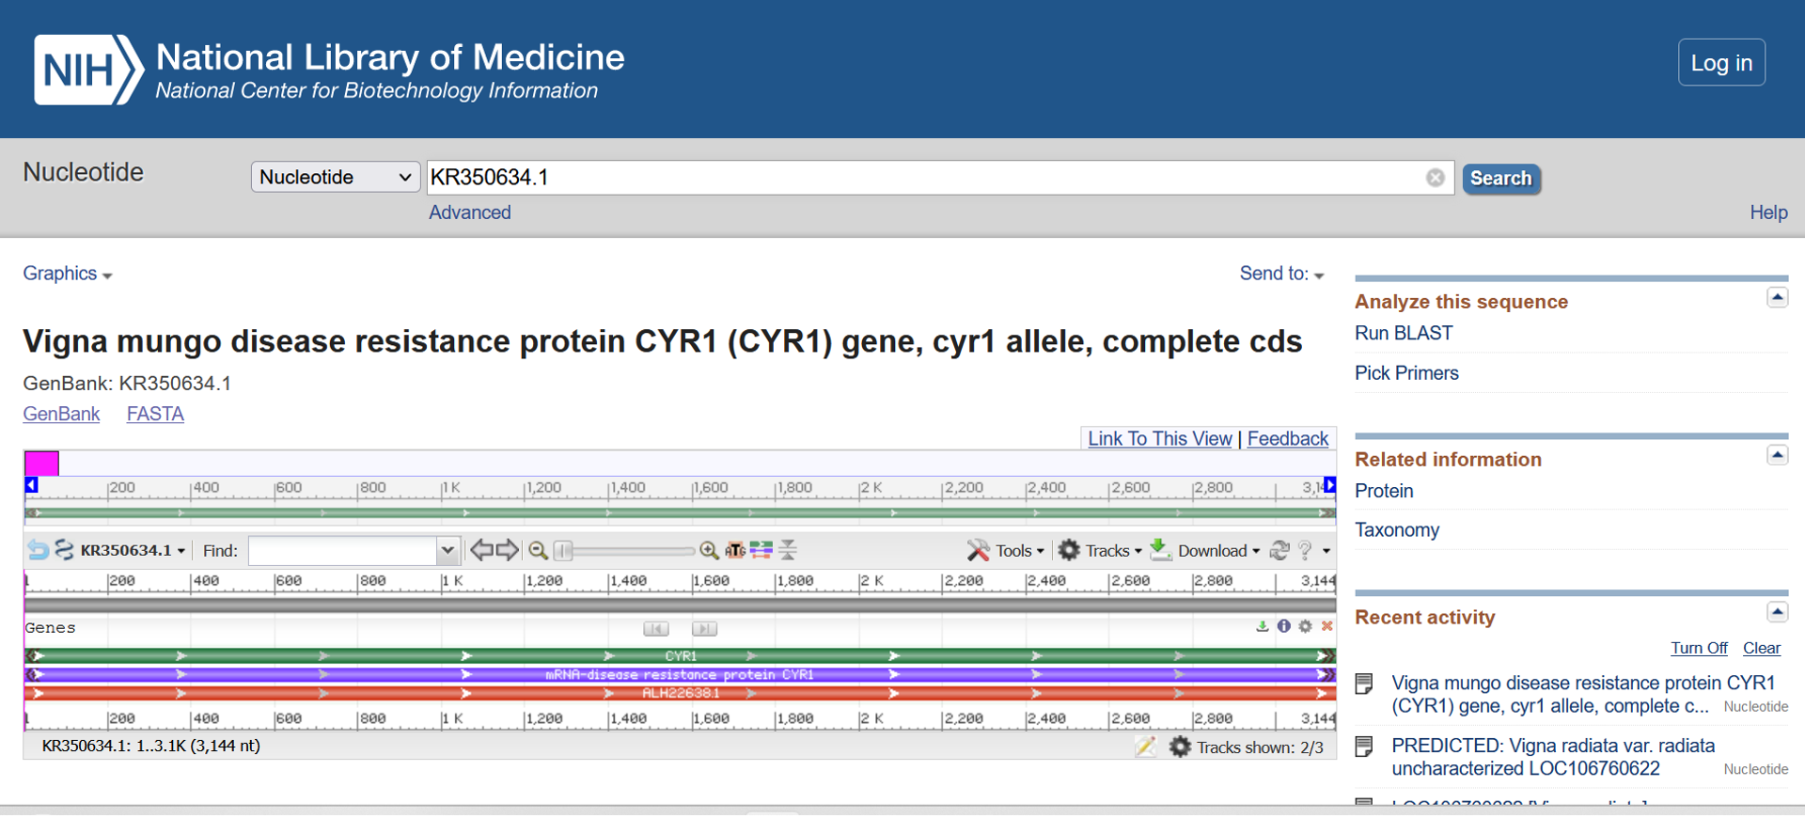

B)
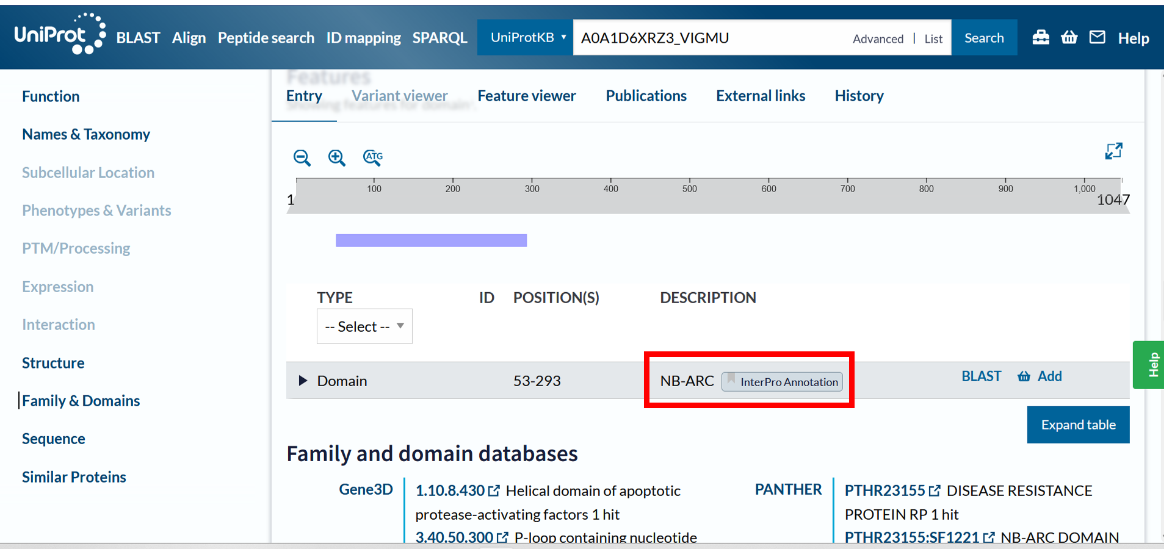
Figure S5 Database selection for identifying specific domains within the R protein. (A) The NCBI database does not provide domain information for the R protein (A0A1D6XRZ3_VIGMU), while (B) the UniProt database shows the domain position for the same R protein.

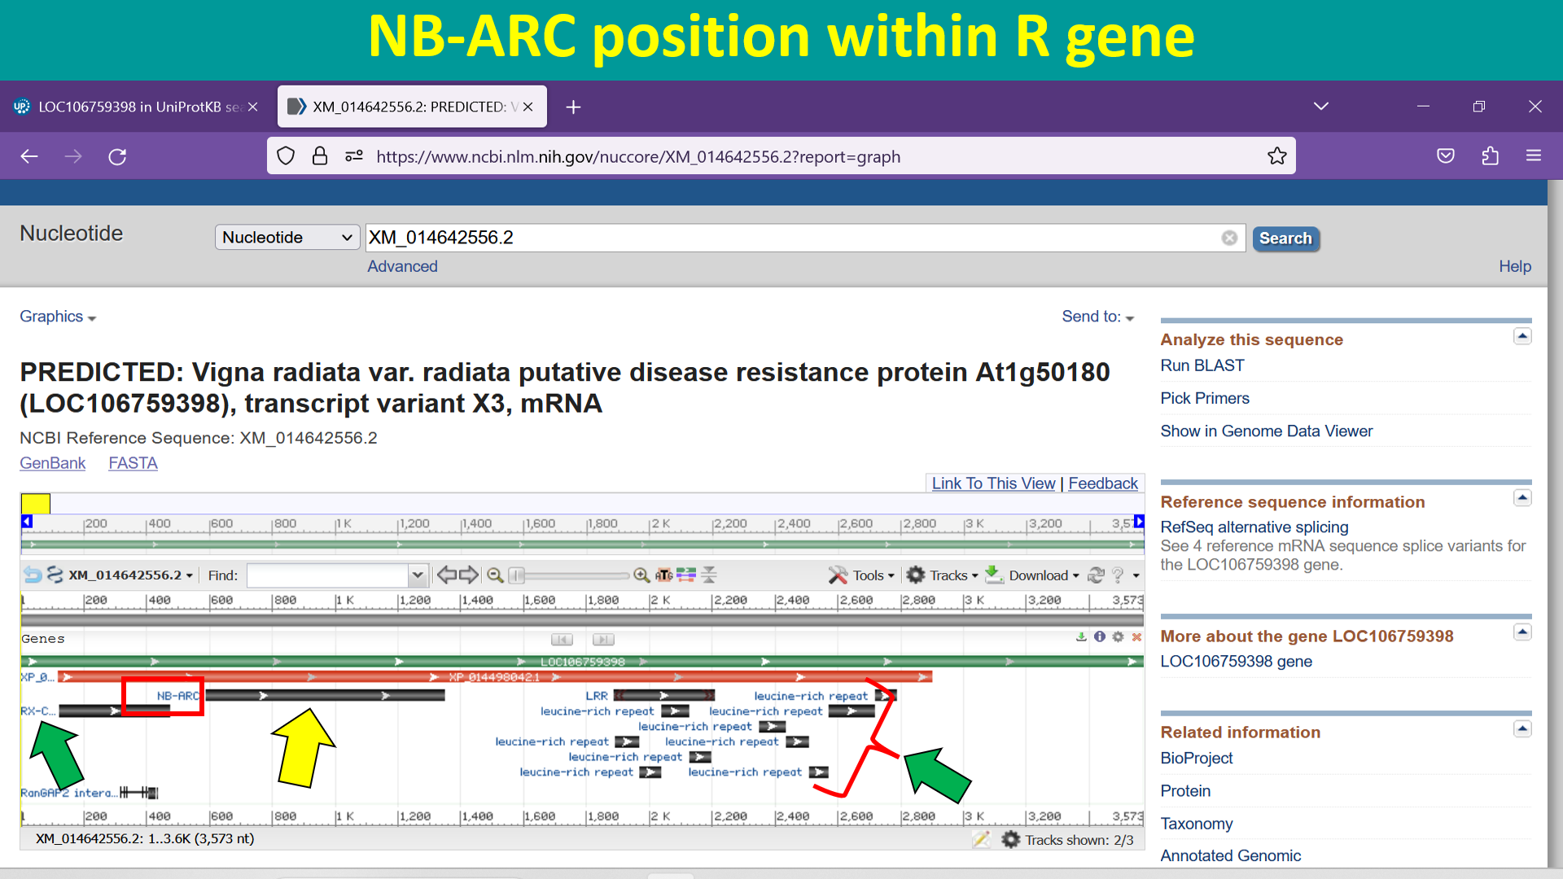
Figure S6 Graphical representation of the R gene (LOC106759398) in the NCBI database. The NB-ARC domain is indicated by the yellow arrow, while other domains are highlighted with the green arrow.

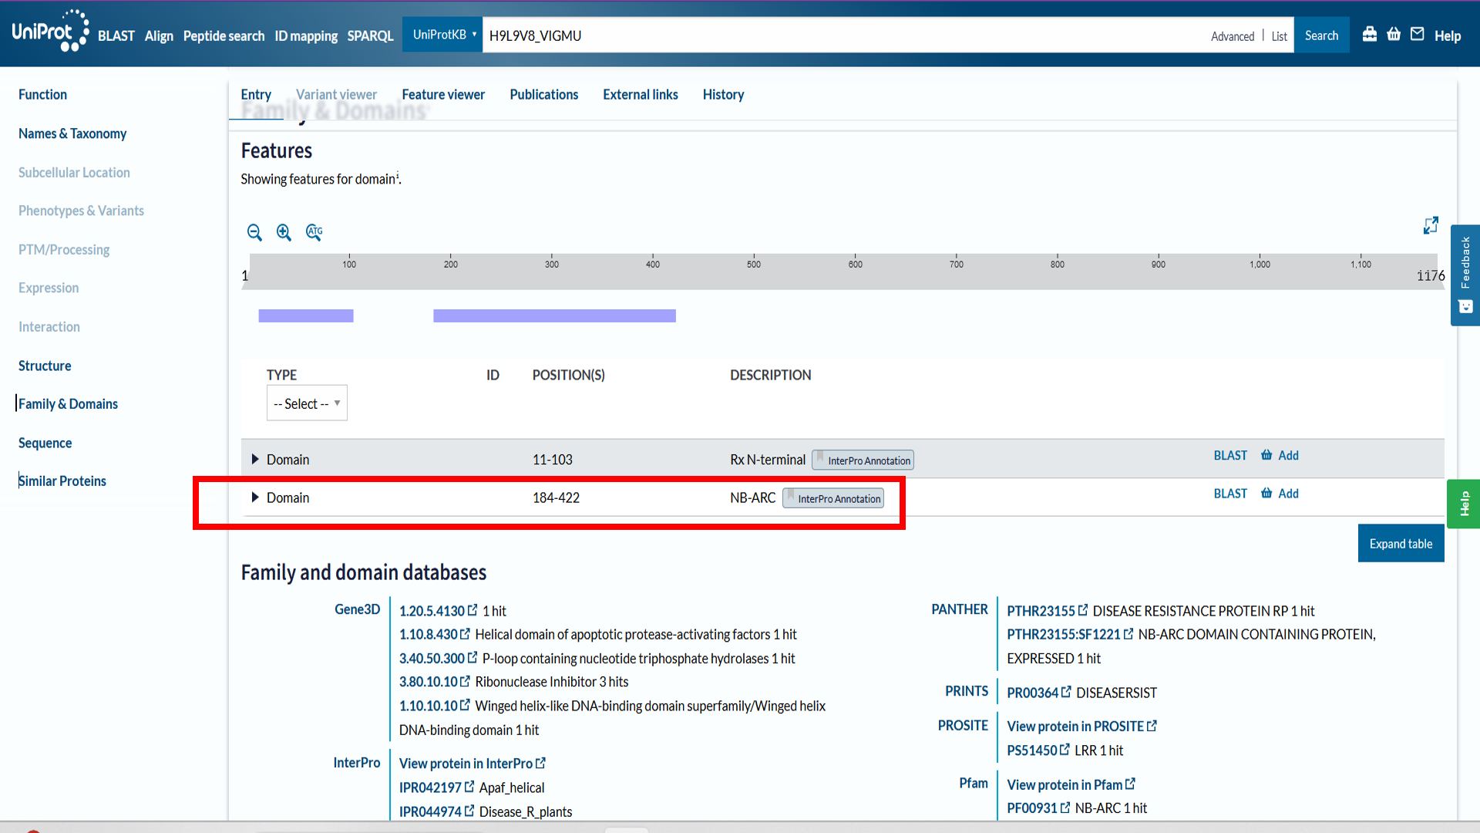
Figure S7 Identification of the NB-ARC domain position within the CYR1 R protein in the UniProtKB database.

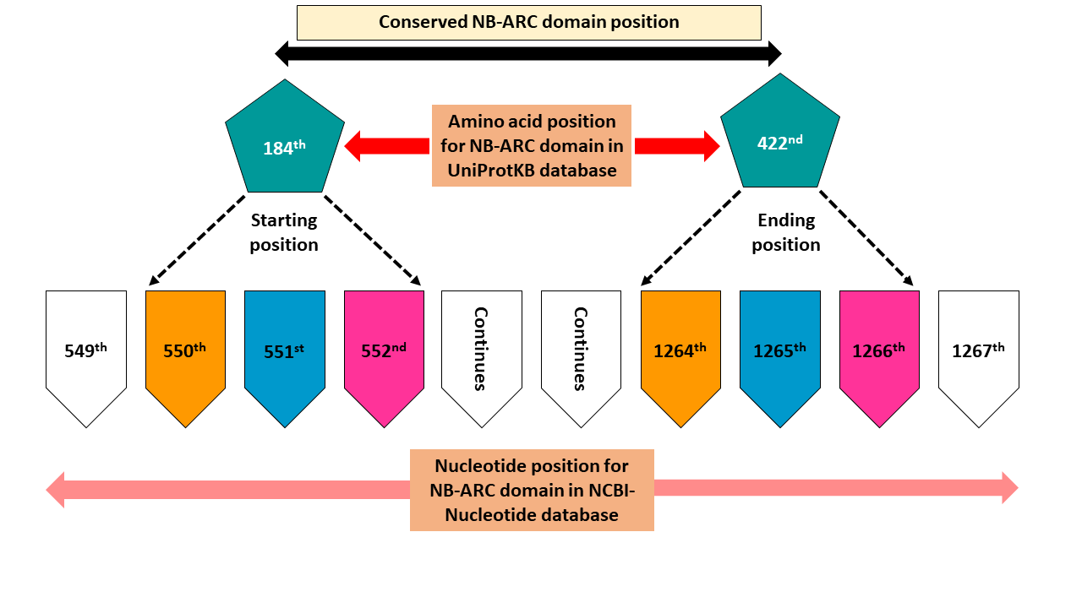
Figure S8 Accurate identification of nucleotide coordinates corresponding to amino acid positions (184 to 422) for the NB-ARC R protein (H9L9V8_VIGMU) from the UniProtKB database.
A)
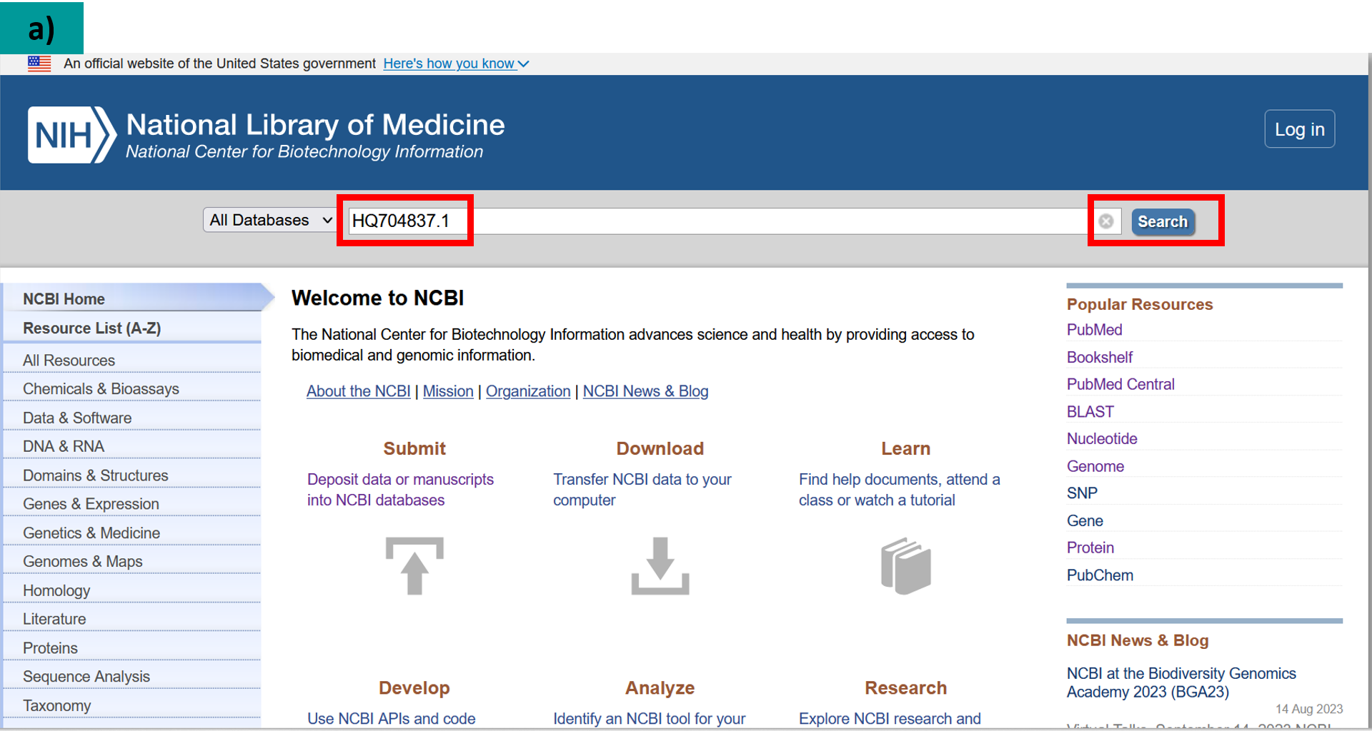

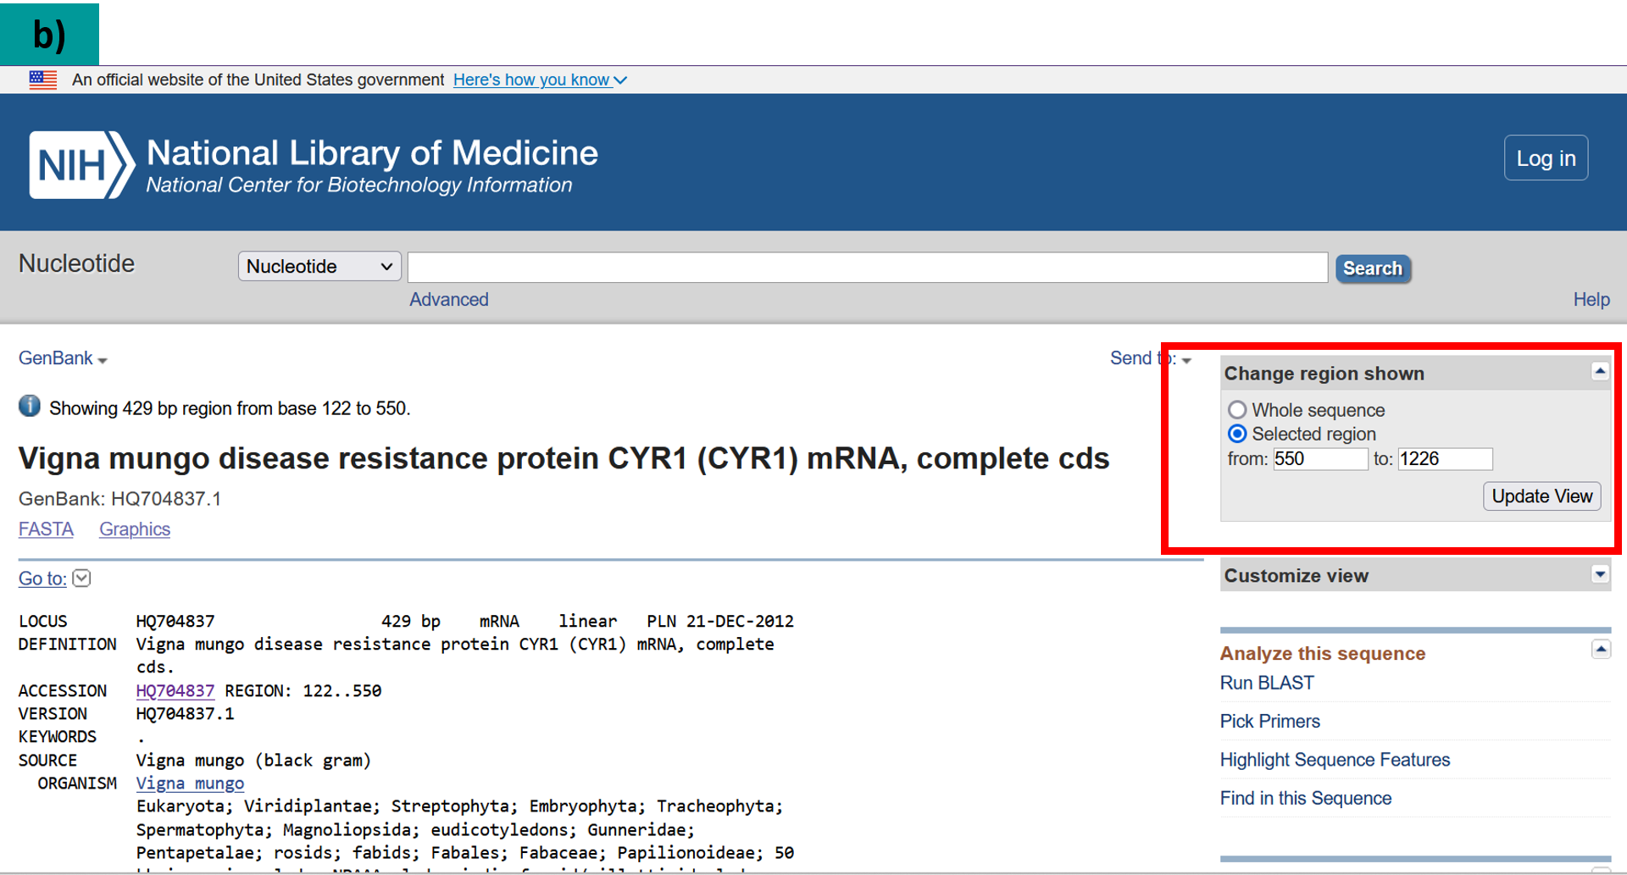
B)

C)
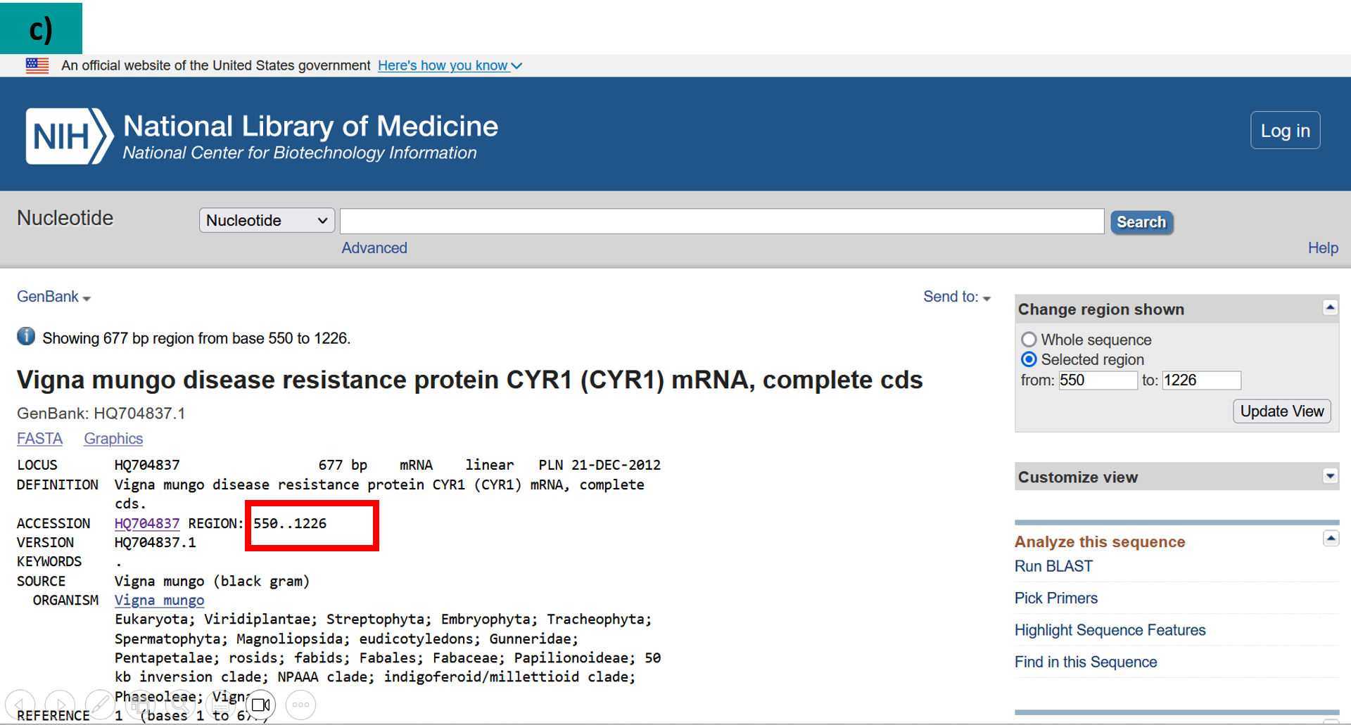
Figure S9 Determining the nucleotide range for the R gene (HQ704837.1) in the NCBI-Nucleotide database. (A) The "Change Region Shown" tool was used, accessed via the top-right menu. (B) Coordinates were set, and (C) the "Update View" function was selected to display the precise nucleotide range.

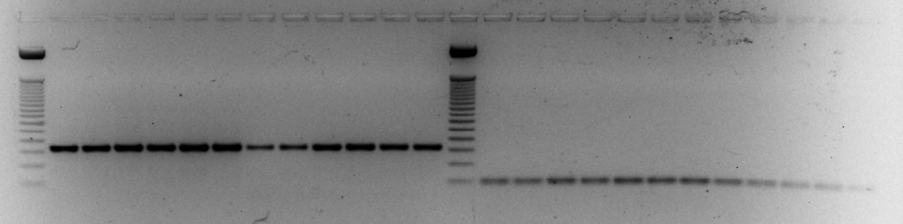
A)
NB-ARC_1
NB-ARC_2
54
55
56
57
58
59
60
61
62
63
64
50bp Ladder
65

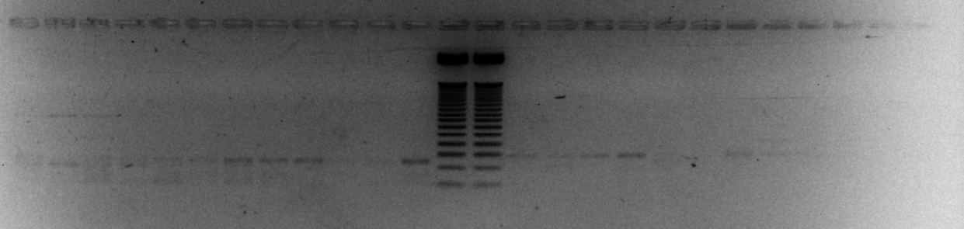
NB-ARC_3
NB-ARC_4
B)

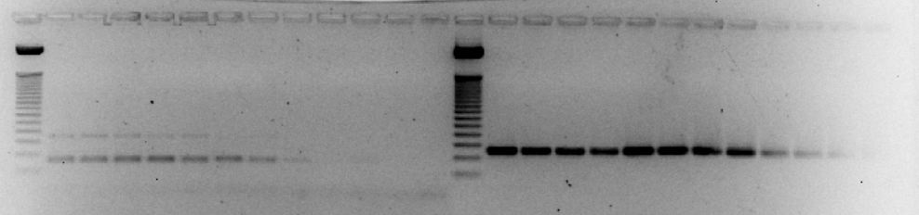
NB-ARC_5
NB-ARC_6
C)

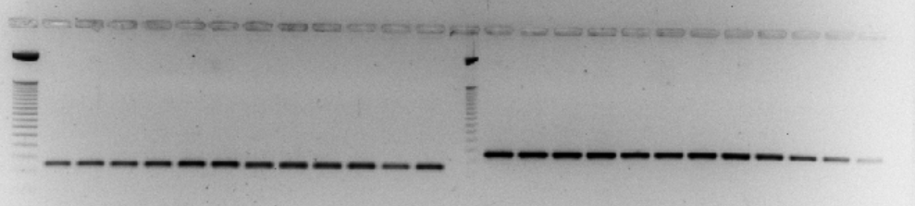
NB-ARC_7
NB-ARC_8
D)

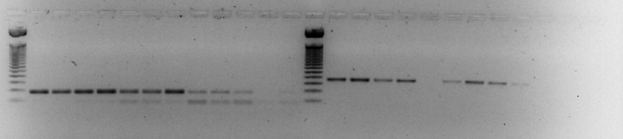
NB-ARC_9
NB-ARC_10
E)

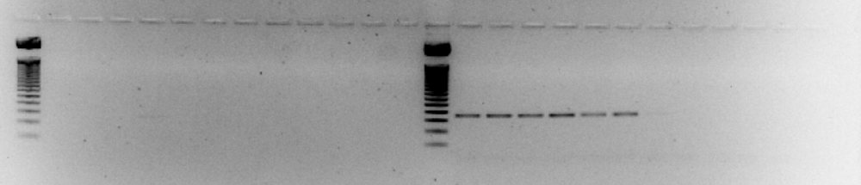
NB-ARC_11
NB-ARC_12
F)

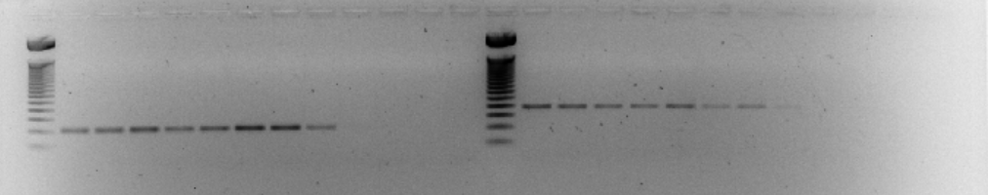
NB-ARC_13
NB-ARC_15
G)

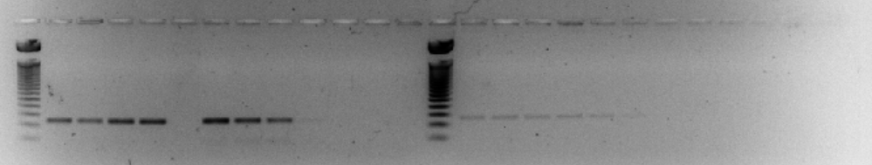
NB-ARC_17
NB-ARC_19
H)

Figure S10 Optimization of designed PDS qPCR primers using gradient PCR (A-H). The yellow arrow highlights the annealing temperature range (54 - 65°C) tested for each primer pair.
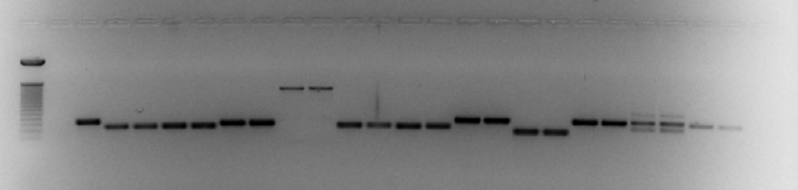
50bp
N1
N2
N3
N4
N5
N6
N7
N8
N9
N10
Mash1-1
N11
N12
E
A)

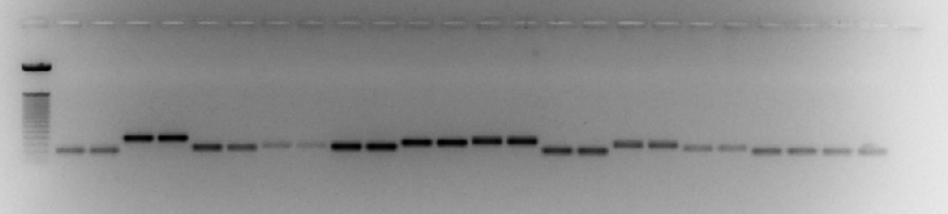
B)
N13
N15
N17
N19
50bp

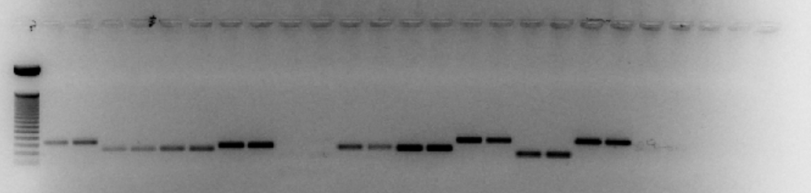
KUG253
50bp
N1
N2
N3
N4
N5
N6
N7
N8
N9
N10
N11
N12
E
C)

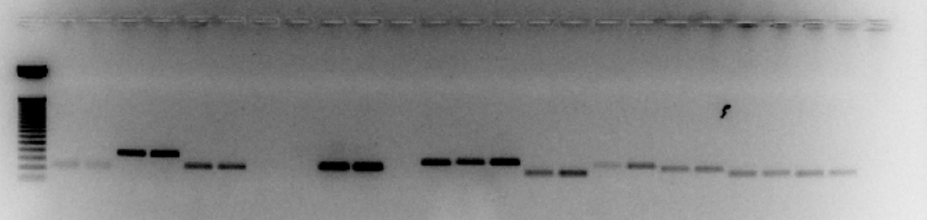
D)
N15
N13
N17
N19
50bp

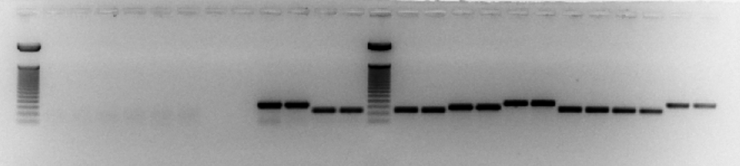
E)
N1
N2
N3
ML818
50bp
N4
N5
N6

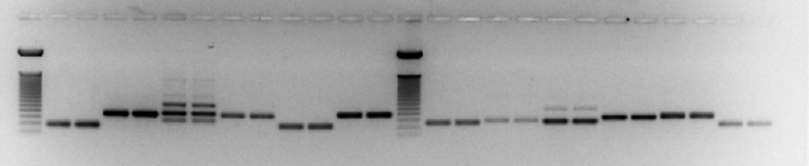
F)
N9
N8
N10
N12
N7
N17
N19
50bp
N11
50bp
N13
N15

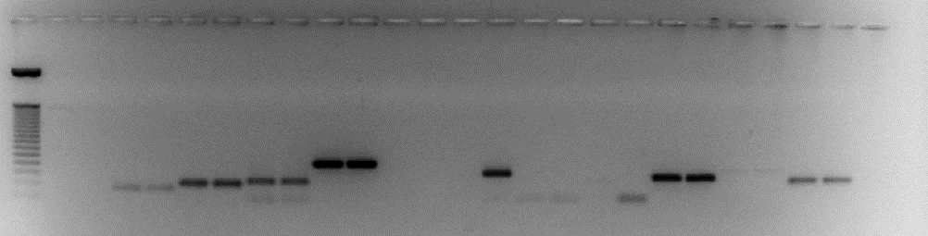
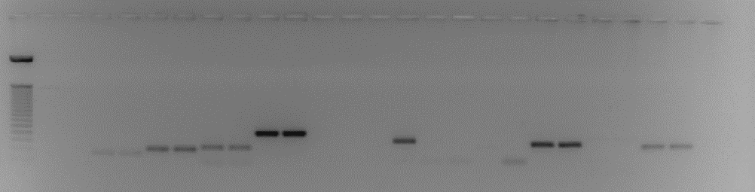
G)
E
SML1082
N1
N2
N3
N4
N5
N6
50bp

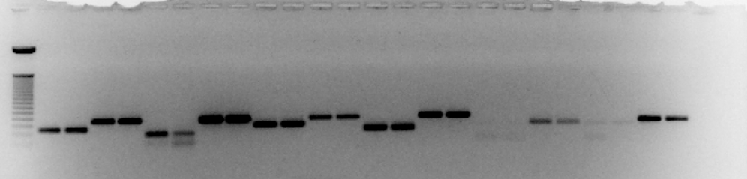
H)
N7
N8
N10
N11
N12
N13
N15
N17
N19
N9
50bp

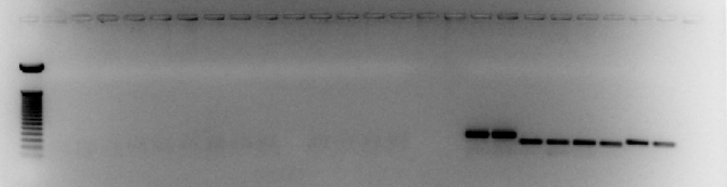
N1
N2
N3
SML1827
E
N4
I)
50bp

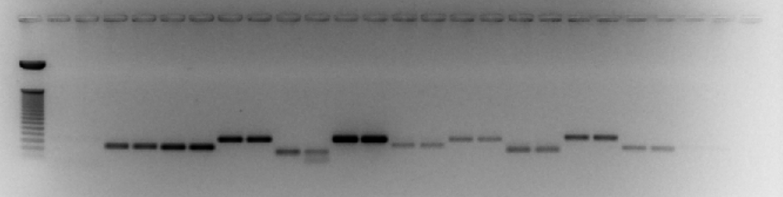
N5
N6
N7
N8
N9
N10
N11
N12
N13
N15
N17
E
N19
50bp
J)

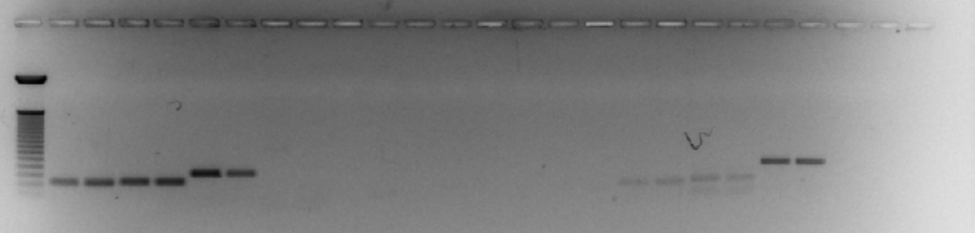
K)
N1
N2
N3
N4
E
RBL35
50bp

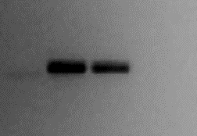
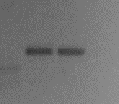

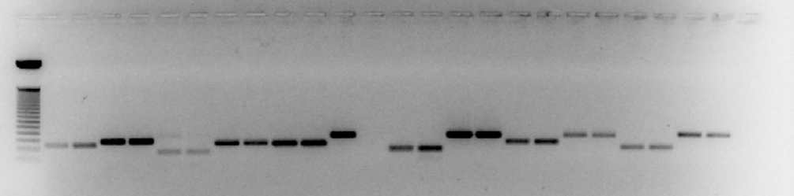
N5
N6
N7
N8
N9
N10
N11
N12
N13
N15
N17
N19
E
50bp
L)

Figure S11 Validation of designed PDS qPCR primers through endpoint PCR (A-L) with an optimized annealing temperature of 57°C, using six different Vigna genotypes (Mash1-1, KUG253, ML818, SML1082, SML1827, RBL35). N = NB-ARC qPCR primers; E = Empty well.

