Additional file 1

Title:
Microbiome profiling reveals distinct microbial compositions of nasal polyps in chronic rhinosinusitis
Short title: Microbiome in chronic rhinosinusitis

Sung-Woo Cho, MD, Dong-Young Kim , MD, PhD, Sungmi Choi, PhD, Hye-Ryun Kang, MD, PhD, and Hana Yi, PhD

Supplementary Figure S1
Comparison of alpha diversity (Shannon index). Swab samples (SW) taken at middle meatus (a) and uncinate tissue samples (UT) (b) were compared according to disease subtype (control, CRSsNP, and CRSwNP). In both SW and UT, no significant differences were found in the Shannon index among disease subtype (P = 0.750, P = 0.308) for SW and UT, respectively, using Kruskal-Wallis test. (c) Tissues from NP and UT of patients with CRSwNP were compared. NP exhibited a significantly decreased Shannon index (P = 0.012 by Wilcoxon signed rank test). Abbreviations– SW: Swab, UT: uncinate tissue, NP: nasal polyp, CRSsNP: chronic rhinosinusitis without nasal polyp, CRSwNP: chronic rhinosinusitis with nasal polyp.

Supplementary Figure S2
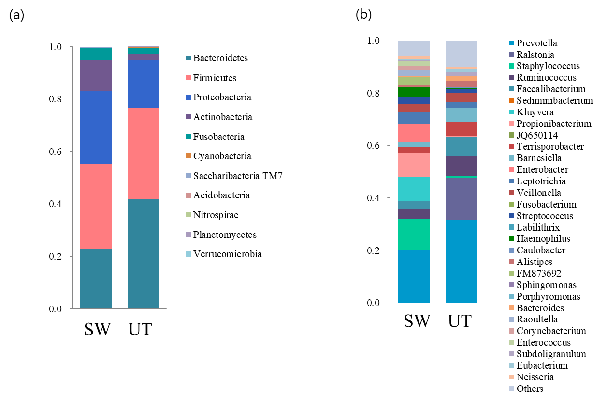Distribution of bacterial taxa across sample types. Samples from different disease subtypes were averaged. (a) Bacteriodetes, Firmicutes, Proteobacteria, Actinobacteria, and Fusobacteria were the five dominant phyla, comprising more than >99% in both swabs and UT regardless of the disease status. (b) At the genus level, the overall profile of the genus composition differed between the swabs and UT. Although, Prevotella was the most common genus in both the swabs and UT, the second and third most abundant bacteria differed between samples types (Staphylococcus and Propionibacterium in swab and Ralstonia and Ruminococcus in UT).

Disease subtype | Tissue type | Genus | Linear regression | Correlation coefficient | Spearman's rho | P-value
CRSwNP | Nasal polyp | Prevotella | -2732.02*RA+18.87 | 0.7119 | -0.771 | 0.025
CRSwNP | Nasal polyp | Finegoldia | 6484.72*RA + 8.64 | 0.6641 | 0.718 | 0.045
CRSwNP | Uncinate tissue | Lachnospira | 2398.59*RA + 8.21 | 0.7366 | 0.745 | 0.034
CRSwNP | Uncinate tissue | Bacteroides | -298.69*RA + 14.97 | 0.6972 | -0.807 | 0.015
CRSwNP | Uncinate tissue | Paraburkholderia | 2780.38*RA + 8.61 | 0.6944 | 0.718 | 0.045
CRSwNP | Uncinate tissue | Agathobacter | 3121.39*RA + 7.96 | 0.6653 | 0.745 | 0.034
CRSsNP | Uncinate tissue | Roseburia | -1548.44*RA + 14.94 | 0.9142 | -0.971 | 0.001
CRSsNP | Uncinate tissue | Lachnoanaerobaculum | -2944.35*RA + 11.8 | 0.8859 | -0.823 | 0.044
CRSsNP | Uncinate tissue | AB185816 | -1177.74*RA + 11.8 | 0.8859 | -0.823 | 0.044
CRSsNP | Uncinate tissue | Rothia | -2349.65*RA + 18.21 | 0.8817 | -0.928 | 0.008
CRSsNP | Uncinate tissue | Streptococcus | -234.27*RA + 14.59 | 0.8713 | -0.899 | 0.015
Supplementary Table S1. Microbiome association with disease severity. Multiple genera associated with disease severity by Lund-Makay CT score were identified. Correlated genera were different between disease subtypes (CRSwNP or CRSsNP) and tissue types (nasal polyp or uncinate tissue).
Abbreviations: CRSwNP, chronic rhinosinusitis with nasal polyp; CRSsNP, chronic rhinosinusitis without nasal polyp; RA, relative abundance

