Supplementary Information

Electrochemical detection of white spot syndrome virus with a silicone rubber disposable electrode composed of graphene quantum dots and gold nanoparticle-embedded polyaniline nanowires

Kenshin Takemura¹, Jun Satoh², Jirayu Boonyakida¹, Sungjo Park³, Ankan Dutta Chowdhury⁴, Enoch Y. Park^{1,4,}

¹ Laboratory of Biotechnology, Department of Bioscience, Graduate School of Science and Technology, Shizuoka University, 836 Ohya, Suruga-ku, Shizuoka 422-8529, Japan
² Division of Pathology, Department of Aquaculture Research, Fisheries Technology Institute of Japan Fisheries Research and Education Agency, National Research and Development Agency, Tamaki Field Station, 224-1 Hiruta, Tamaki, Watarai, Mie 519-0423, Japan
³ Division of Cardiovascular Diseases, Mayo Clinic College of Medicine and Science, Mayo Clinic, 200 First Street SW, Rochester, MN, 55905, USA
⁴ Laboratory of Biotechnology, Research Institute of Green Science and Technology, Shizuoka University, 836 Ohya, Suruga-ku, Shizuoka 422-8529, Japan

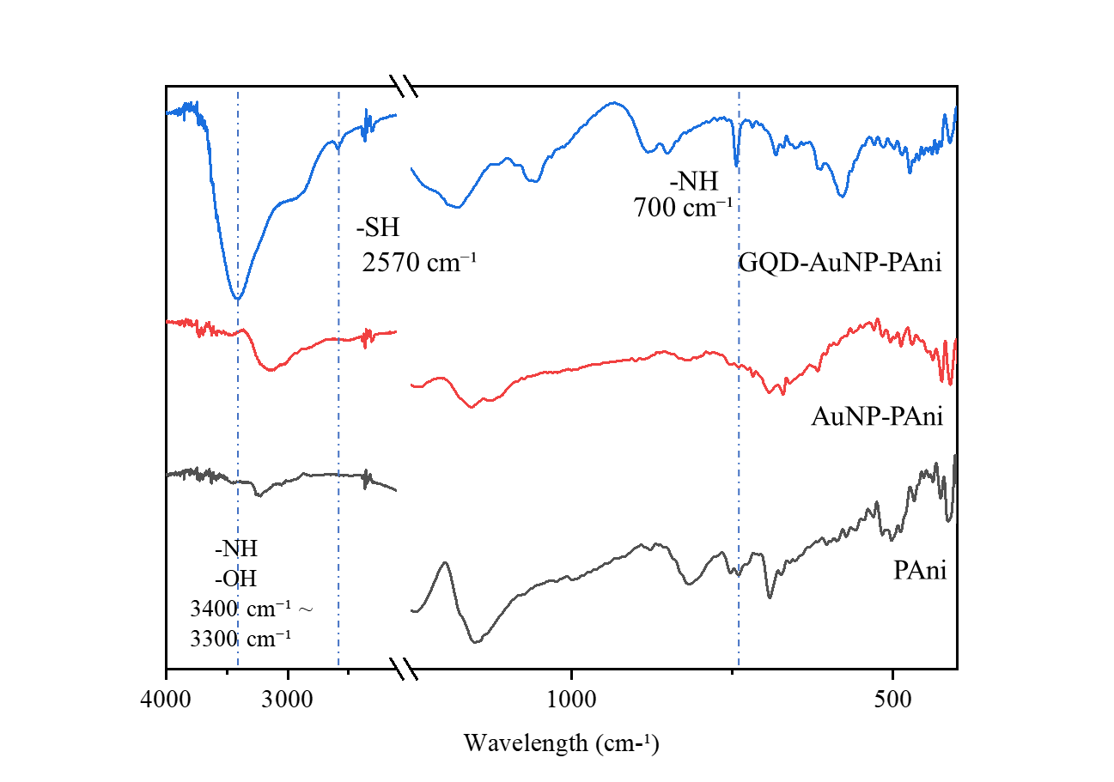
Fig. S1 Analysis of functional groups on the surface of named materials by FT-IR infrared absorption spectra.

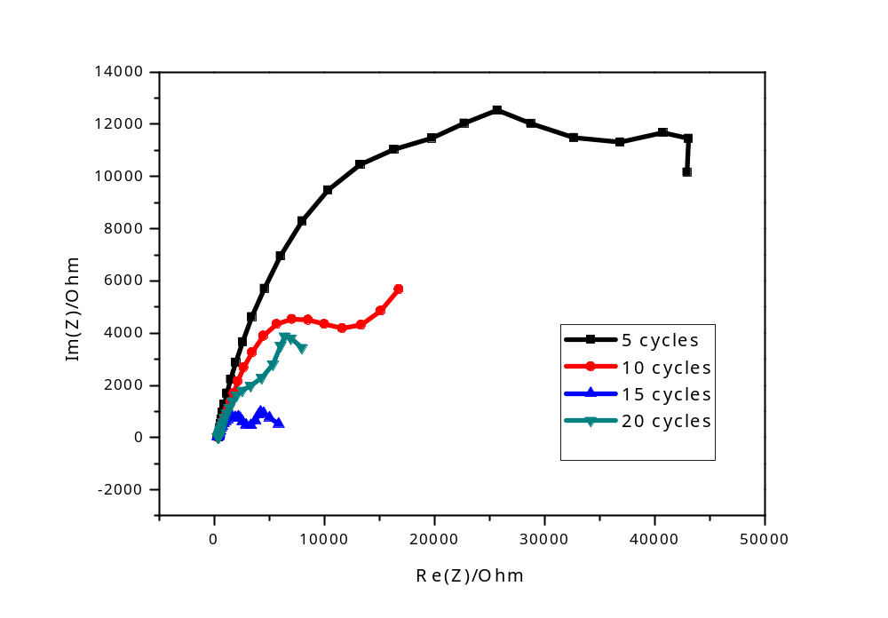
Fig. S2 Impedance analysis of the PAni/PAni@CSR sensor electrode 5 to 20 cycles of electrodeposition.

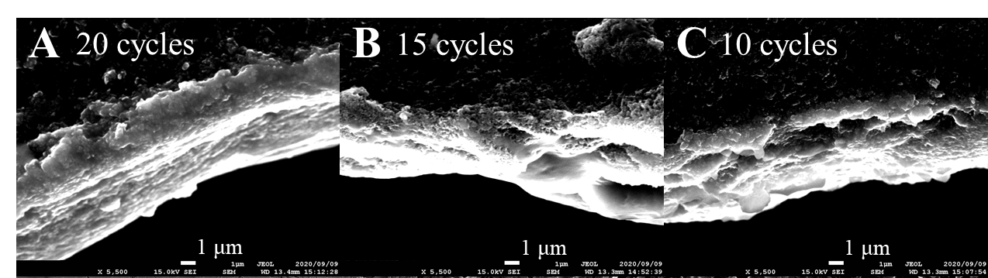
Fig. S3 (A–C) SEM observed the difference in thickness of the polyaniline layer deposited on CSR.

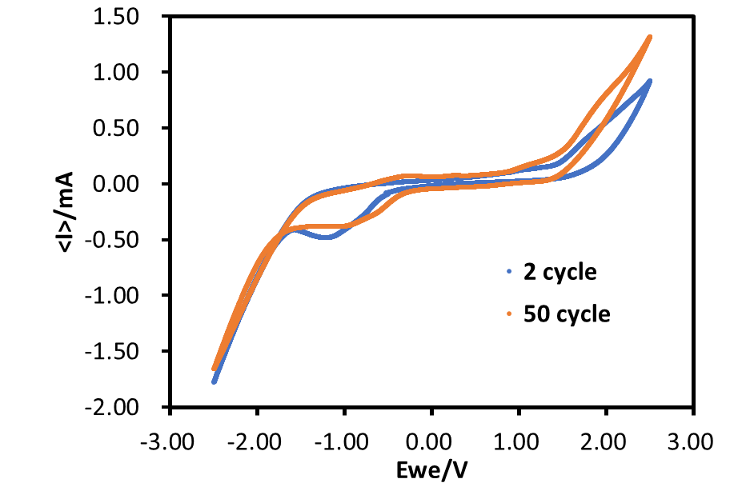
Fig. S4 Cyclic voltammetry analysis of the Ab-N,S-GQDs@AuNP-PAni/PAni@CSR sensor electrode 2 to 50 cycles.

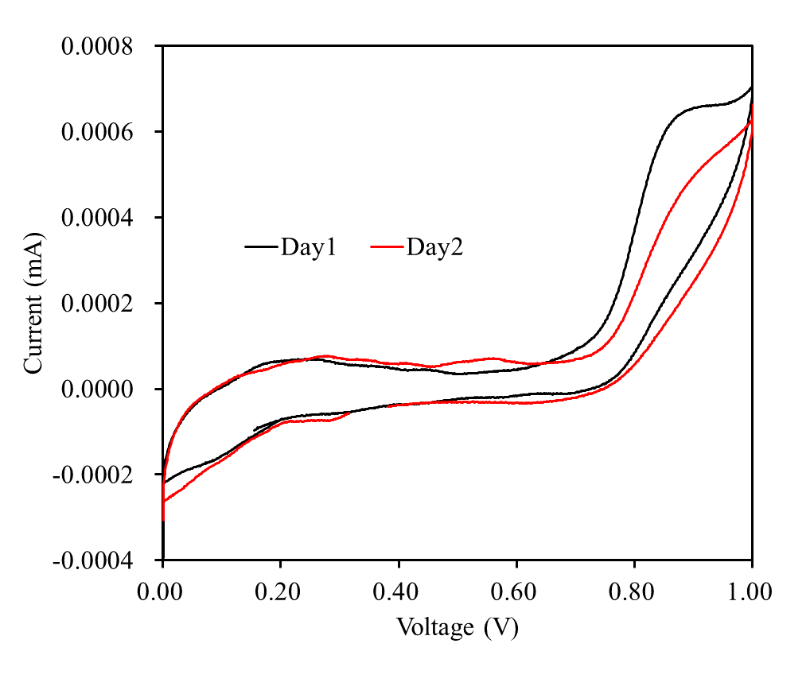
Fig. S5. Cyclic voltammetry of CSR at day1 (black line) and day2 (red line).

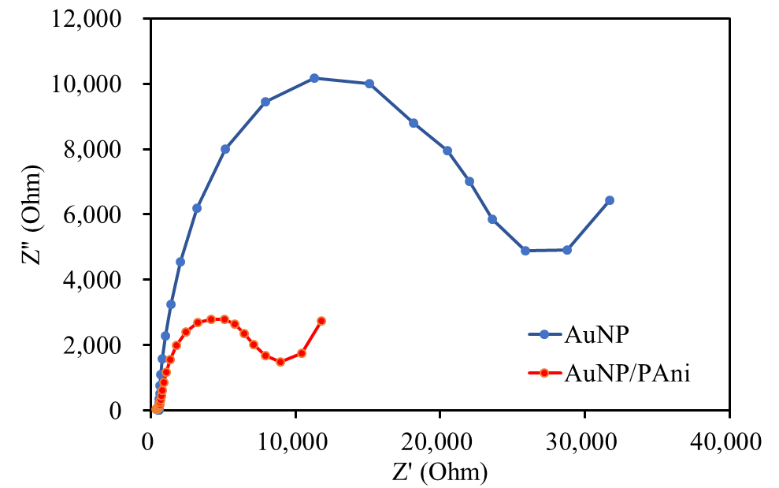
Fig. S6 Comparison of Rct value with AuNP-modified CSR (blue line) and AuNP/PAni-modified CSR (orange line)
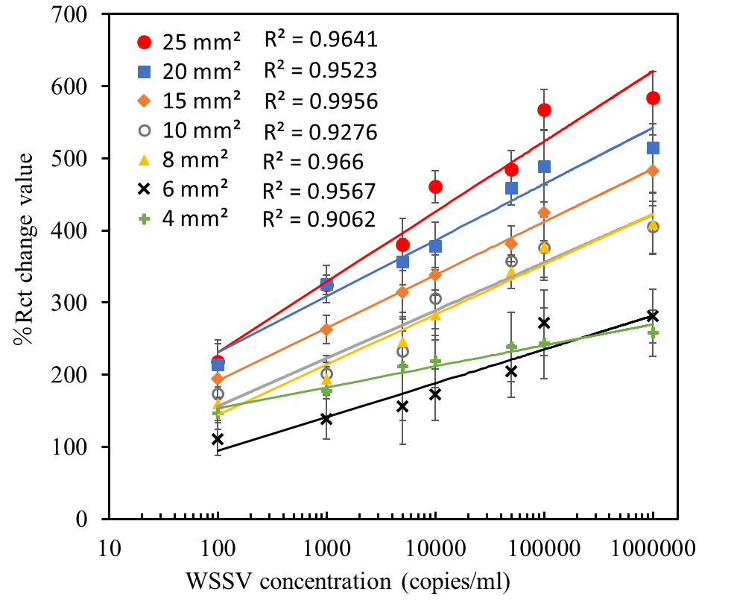
Fig. S7 Detection result of WSSV using different surface area of Ab-GQD@AuPAni/PAni@CSR.

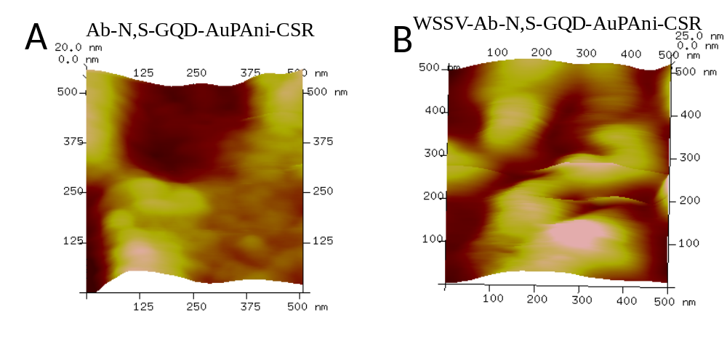
Fig. S8 AFM images of the bare disposable sensor electrode (A) and with WSSV bound electrode (B).

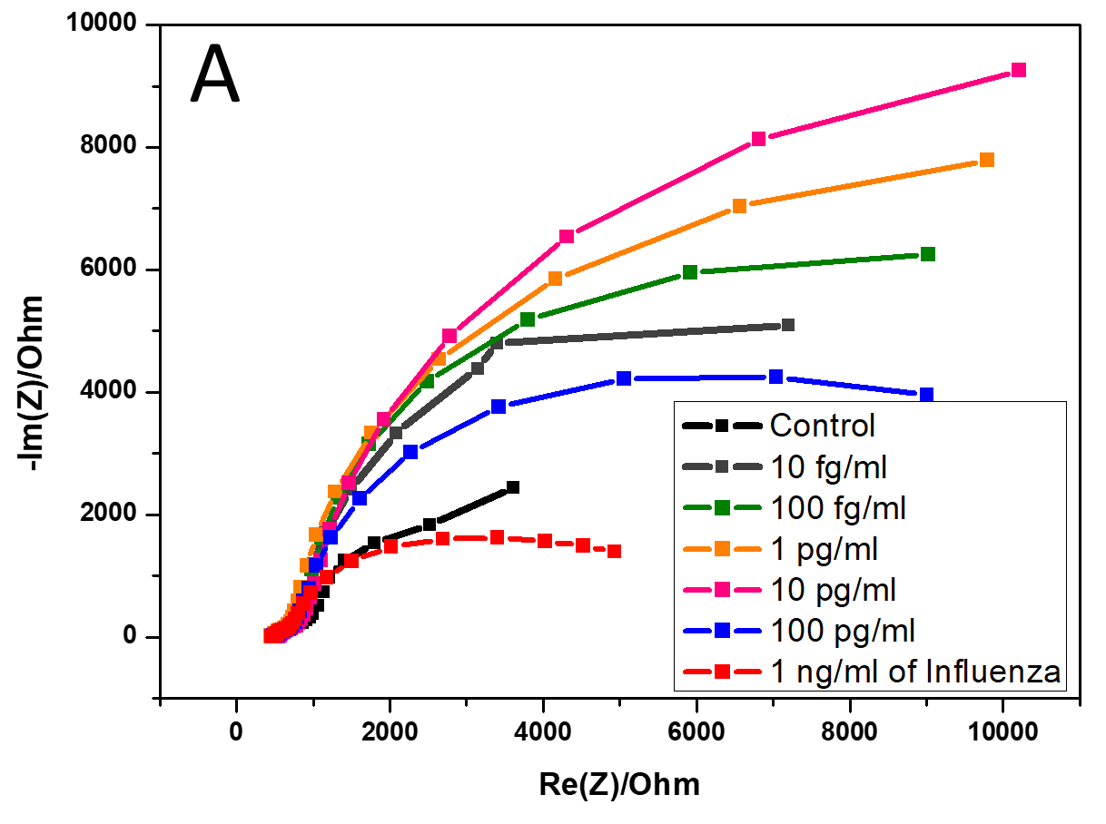
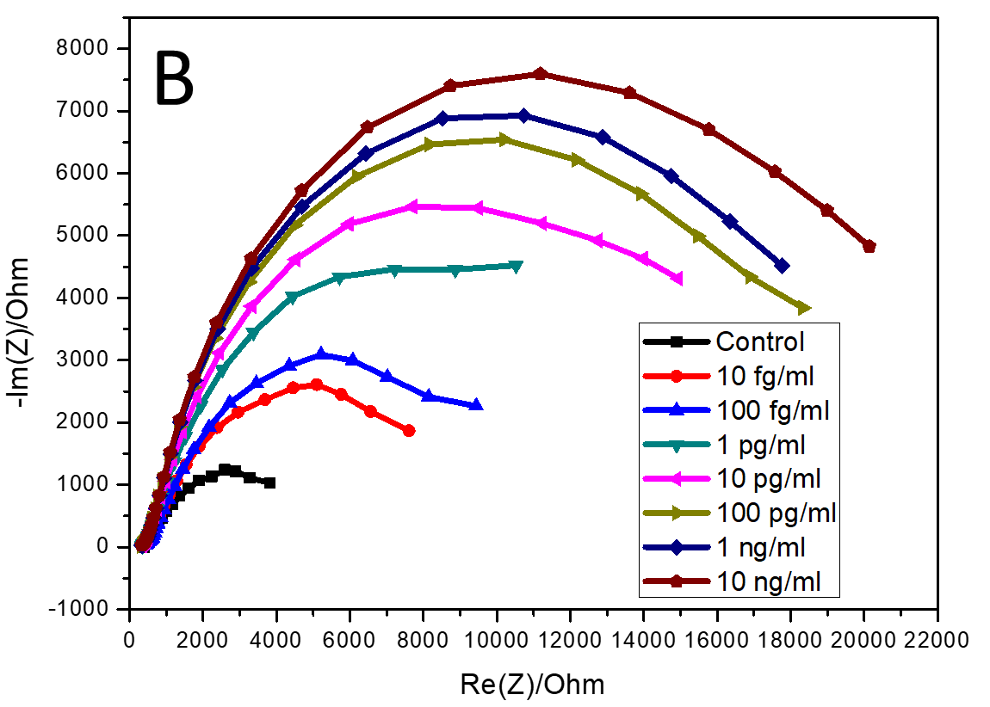
Fig. S9 Nyquist impedance plots of the Ab-N,S-GQDs@AuNP-PAni/PAni@CSR sensor electrode before and after loading A) HEV and B) influenza virus.
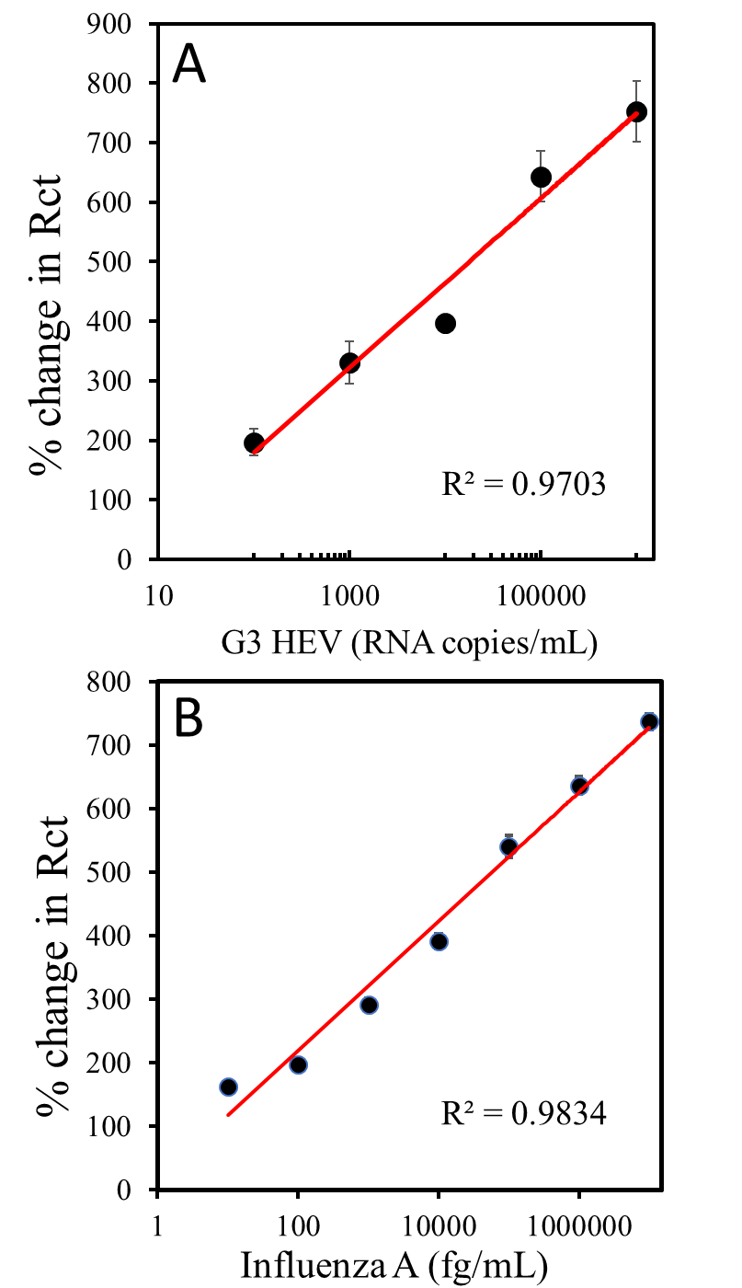
Fig. S10 Detection result of the genotype 3 HEV (A) and Influenza virus A (H1N1) (B) using the Ab-GQD@AuNP-PAni/CSR sensor electrode, bound with their corresponding antibodies.

Correspondence to: Research Institute of Green Science and Technology, Shizuoka University, 836 Ohya Suruga- ku, Shizuoka, 422-8529, Japan. Tel. & fax: +81 54 238 4887. E-mail address: park.enoch@shizuoka.ac.jp (EYP)

