Docking and Molecular Dynamic Simulation of ApoE isoforms to Trem2

Steven Lehrer, MD
Department of Radiation Oncology
Icahn School of Medicine at Mount Sinai
New York
Peter H. Rheinstein, MD, JD, MS
Severn Health Solutions
Severna Park, Maryland

correspondence to Dr. Steven Lehrer, Box 1236 Radiation Oncology, Mount Sinai Medical Center, 1 Gustave L. Levy Place, New York 10029 or steven.lehrer@mssm.edu
Data sources: Data publicly available
Keywords: Alzheimer’s disease, prognosis
Funding sources: none
Conflicts of interest: The authors declare that they have no competing interests.
This work was supported in part through the computational and data resources and staff expertise provided by Scientific Computing and Data at the Icahn School of Medicine at Mount Sinai and supported by the Clinical and Translational Science Awards (CTSA) grant UL1TR004419 from the National Center for Advancing Translational Sciences.

Abstract
Background: Alzheimer’s disease (AD) is a progressive neurodegenerative disorder with limited therapeutic options. The interaction between Triggering Receptor Expressed on Myeloid Cells 2 (TREM2), a critical microglial receptor, and Apolipoprotein E (ApoE), the strongest genetic risk factor for late-onset AD, plays a pivotal role in modulating immune responses in the brain. However, the structural and functional dynamics of TREM2-ApoE isoform interactions (ε2, ε3, and ε4) remain incompletely understood.
Methods: Protein-protein docking using ClusPro was employed to model the interactions between wild-type TREM2 and the three ApoE isoforms (ε2, ε3, ε4) using crystallographic structures. Stability and structural dynamics of these complexes were analyzed using molecular dynamics simulations performed in GROMACS. Key parameters assessed included Root Mean Square Deviation (RMSD) for structural stability and Radius of Gyration for compactness.
Results: Docking results indicated that ApoE ε3 had the lowest energy-weighted score, suggesting the most stable docking conformation. However, molecular dynamics simulations revealed that ApoE ε4 exhibited greater interaction robustness despite lower compactness. ApoE ε2 demonstrated the least stable interaction, characterized by significant variability in structural compactness. These findings highlight isoform-specific differences in TREM2-ApoE interactions, with ApoE ε4 exhibiting unique binding characteristics consistent with its strong association with AD risk.
Conclusion: The therapeutic potential of modulating TREM2-ApoE interactions warrants exploration. Small molecules or biologics that selectively enhance or inhibit these interactions could represent novel strategies for mitigating AD risk or progression, particularly in individuals carrying the ApoE ε4 allele.

Alzheimer’s disease (AD) is a progressive neurodegenerative disorder with limited therapeutic options. Microglia are involved in AD progression [1]. TREM2 (Triggering Receptor Expressed on Myeloid Cells 2), a microglial receptor, has emerged as a key regulator of immune responses in the brain, yet the precise mechanisms through which TREM2 modulates disease progression remain incompletely understood [2-6]. TREM2 variants are strongly associated with altered AD risk. Especially important is the R47H variant, which increases risk of AD, as well as Parkinson’s disease and Frontotemporal dementia [7, 8].
Apolipoprotein E (ApoE), the most important AD risk factor, acts as an agonist to TREM2, meaning it can activate TREM2 signaling pathways [9]. This interaction mediates signal transduction through TREM2, which is crucial for various cellular processes such as phagocytosis, cell growth, and cytokine release [9].
Mai et al demonstrated that the interaction between ApoE and TREM2 may affect the pathogenesis of AD. The presence of the ApoE ε4 allele is the strongest genetic risk factor for late-onset AD, and the TREM2 R47H mutation further influences this interaction, potentially reducing the binding affinity and altering the signaling pathway [10]. The binding between ApoE and TREM2 involves hydrogen bonding, hydrophobic interactions, and electrostatic forces. Variants in TREM2, such as the R47H mutation, can disrupt these interactions, affecting the overall function of TREM2 in the brain [10].
A weakness in the study of Mai et al was that they used protein files from the RCSB Protein Data Bank, but did not use the ApoE ε2 or ε4 isoform files. Mai et al used PYMOL to mutate amino acids in the ApoE ε3 file to mimic the amino acid sequences of the ε2 and ε4 isoforms. A problem with this methodology is that PYMOL is not capable of inferring 3D protein structure from amino acid sequence, and the PYMOL-mutated 3D ε2 and ε4 structures were identical to the original ε3 structure.
In the current study we employed ClusPro to evaluate TREM2 docking of all three ApoE isoforms, which are now available in the RCSB Protein Data Bank. We then performed molecular dynamic simulation with GROMACS to estimate the stability of the ApoE/Trem2 complex with wild type TREM2.
Materials and Methods
The TREM2 protein is composed of three main domains (Figure 1):
Extracellular Domain (amino acids 1-172): This domain contains an immunoglobulin-like V-type domain that binds to various ligands, including glycoproteins, lipids, and apolipoproteins. It is responsible for recognizing pathogen-associated molecular patterns (PAMPs), damage-associated molecular patterns (DAMPs), and cell debris2.
Transmembrane Domain (amino acids 173-195): This domain anchors the TREM2 protein in the cell membrane and is associated with the DNAX-activating protein of 12 kDa (DAP12). The interaction between TREM2 and DAP12 is crucial for signal transduction2.
Intracellular Domain (amino acids 196-230): This short cytoplasmic tail interacts with DAP12 and other signaling molecules, leading to the activation of intracellular signaling pathways. It plays a role in mediating immune responses, such as phagocytosis and cytokine production2.
From the RCSB protein data bank we used:
Crystal structure of MBP-TREM2 Ig domain fusion with fragment, 2-((4-bromophenyl)amino)ethan-1-ol (6XDS).
ApoE ε3 (ApoE3) (1NFN)
ApoE ε2 (ApoE2, D154A MUTATION) (1NFO) The D154A mutation in the ApoE ε2 protein refers to a specific genetic change where the amino acid aspartic acid (D) at position 154 is replaced with alanine (A).
ApoE ε4 (ApoE4), 22K FRAGMENT (1B68)
We used ClusPro, an automated web-based tool for protein-protein docking. It helps predict how two proteins might interact by generating and analyzing multiple possible docking poses. After generating the docking poses, ClusPro groups similar poses into clusters. Each cluster represents a potential interaction mode, with the most populated clusters indicating the most likely interaction scenarios. ClusPro assigns weighted scores to the docking poses based on factors such as electrostatics, desolvation energy, and van der Waals interactions. Lower scores indicate more favorable interactions [11].
In ClusPro, the following terms are used to evaluate docking results and clusters of conformations:
- Cluster: Refers to a group of similar docked conformations generated during the docking process. Clusters are formed based on the spatial proximity of solutions in the docking space. Cluster 0 refers to the cluster with the highest number of similar, low-energy docked poses. Essentially, it represents the most populated cluster of docking results, which often indicates the most favorable docking conformation(s) for the protein-protein interaction being studied.
- Members: Represents the number of docking conformations (solutions) within the cluster. A higher number indicates that more solutions are close to the representative structure of the cluster, signifying robustness.
- Representative: This is the most central or representative docking conformation within the cluster. Often, it is selected as the best solution to represent the entire cluster because it is the closest to the average of all members in that cluster.
- Weighted Score: A score calculated based on the docking energy and other parameters such as van der Waals interactions, electrostatic energy, and desolvation energy. The lower the score, the more favorable the interaction, indicating the likelihood of the docked conformation being energetically favorable.

We used GROMACS (GROningen MAchine for Chemical Simulations), a software package for molecular dynamics simulations. A molecular dynamics (MD) simulation is a computer simulation technique used to study the physical movements of atoms and molecules over time. MD simulation allows observation and analysis of the behavior of complex systems at the atomic level. GROMACS is primarily used to simulate the physical movements of atoms and molecules over time, providing insights into their behavior and interactions. GROMACS is suitable for a wide range of applications, including biomolecular systems like proteins, lipids, and nucleic acids. GROMACS computes RMSD (Root Mean Square Deviation) and Radius of Gyration plots from its simulation.
RMSD plot measures the average deviation between the positions of atoms in the simulated structure and a reference structure (here the initial docked structure Trem2/ApoE). Low RMSD values indicate that the structure remains close to the reference structure, suggesting stability. High RMSD values suggest significant deviations, indicating structural changes or instability. A stable system will show low and consistent RMSD values, while a system undergoing conformational changes will show fluctuations.
Radius of Gyration plot measures the compactness of the structure by calculating the average distance of the atoms from the center of mass. Consistent Radius of Gyration indicates a stable and compact structure. Fluctuations in Radius of Gyration suggest structural changes, unfolding, or expansion of the molecule. Like RMSD, which looks for trends over time, a stable system will show a consistent radius of gyration, while significant changes may indicate structural transitions.
In GROMACS, the all-atom OPLS-AA/L force field and SPC/E water model were used for simulations. System Equilibration was done in two phases. The first phase was conducted under an NVT ensemble (constant Number of particles, Volume, and system Temperature). The second phase was conducted under an NPT ensemble, wherein the Number of particles, Pressure, and Temperature are all constant. This ensemble is also called the "isothermal-isobaric" ensemble, and most closely resembles experimental conditions.

Results
Results of ClusPro docking are in Table 1. ApoE ε3 had the lowest energy weighted score, indicating the most stable docking position. ApoE ε4 had the highest number of members, i.e. similar docked conformations generated during the docking process, indicating that more solutions were close to the representative structure of the cluster, signifying robustness.
Exon 4 of ApoE ε4 docked to the Trem2 intracellular domain (Figure 2). Molecular dynamic simulation results of ApoE ε4 docked to Trem2 showed that the RMSD (Root mean square deviation) quickly rises to a maximum, the radius of gyration less so (Figure 3). The overall structure is not entirely stable or compact.
ApoE ε2 (tyrosine 162, receptor binding domain) docked to the extracellular domain of Trem2 (Figure 4). Molecular dynamic simulation results of ApoE ε2 docked to Trem2 indicated that the RMSD (Root mean square deviation) quickly rises to a maximum, but the radius of gyration is highly, inconsistently variable. The overall structure is less stable and compact than ApoE ε4 docked to Trem2 (Figure 5).
Helix 4 of ApoE ε3 docked to the Trem2 intracellular domain (Figure 6). Molecular dynamic simulation results, ApoE ε3 docked to Trem2, indicate that the RMSD (Root mean square deviation) does not rise to a stable maximum, nor does the radius of gyration. The overall structure is less stable and compact than ApoE ε4 docked to Trem2 or ApoE ε2 docked to Trem2 (Figure 7).

Discussion
This study presents a detailed computational analysis of the interactions between TREM2 and the three ApoE isoforms, providing insights into their stability and structural dynamics. Using advanced molecular docking and molecular dynamic simulations, we evaluated the stability of ApoE isoforms with wild-type TREM2. Our findings underscore the distinct roles of ApoE isoforms in modulating TREM2 function [12], with ApoE ε4 showing the most stable interaction but limited compactness in structural dynamics. These observations align with the established role of ApoE ε4 in increasing Alzheimer's disease (AD) risk and its potential interaction with TREM2 signaling pathways.
Our findings build upon earlier work by Mai et al. [10], who identified potential molecular interactions between TREM2 and ApoE isoforms. However, our approach addresses key methodological gaps by using the actual crystallographic structures of ApoE ε2 and ε4 isoforms, as opposed to relying on mutated models. This methodological refinement enhances the reliability of our docking results and underscores the necessity of accurate structural modeling in computational studies.
Our study complements prior findings that link TREM2 variants, such as R47H, with altered microglial function and increased AD risk. By demonstrating the differential stability of ApoE isoform interactions with wild-type TREM2, our results provide a potential mechanistic basis for the isoform-specific effects observed in both genetic and functional studies.
The observed differences in interaction stability among the ApoE isoforms have significant implications for understanding TREM2-mediated signaling in AD. ApoE ε4's robust yet less compact interaction with TREM2 suggests a dynamic interplay that may modulate microglial activity, contributing to the dysregulation of immune responses in AD. Conversely, the lower stability of ApoE ε2 interactions may reflect protective mechanisms that mitigate pathological TREM2 signaling, consistent with the reduced AD risk associated with this isoform.
Despite the strengths of our study, including the use of ClusPro and GROMACS for docking and simulation analysis, there are notable limitations. First, reliance on computational models, though essential for structural predictions, lacks validation through in vitro or in vivo experimental data [13]. Secondly, while we used crystallographic structures from the RCSB Protein Data Bank, the dynamic nature of protein-ligand interactions might be influenced by post-translational modifications or cellular microenvironments, which are not accounted for in our simulations. Furthermore, the choice of simulation parameters, such as temperature and ion concentration, while standardized, may not fully replicate physiological conditions.
In addition, our study focused solely on the interaction between TREM2 and ApoE isoforms, leaving other potential ligands and co-factors unexamined. Future studies should consider the broader signaling network involving TREM2 and its downstream pathways [14, 15] to provide a more comprehensive understanding of its role in AD pathogenesis. Extending our analysis to include TREM2 variants, such as R47H, and their interactions with ApoE isoforms, would provide a more nuanced understanding of the genetic and functional interplay in AD. Investigating the role of co-factors, such as lipid ligands and downstream signaling molecules, could further elucidate the broader implications of TREM2 signaling in neuroinflammation and AD progression.
Lastly, the therapeutic potential of modulating TREM2-ApoE interactions warrants exploration. Small molecules or biologics that selectively enhance or inhibit these interactions could represent novel strategies for mitigating AD risk or progression, particularly in individuals carrying the ApoE ε4 allele.
Conclusion: This study provides insights into the structural dynamics of TREM2-ApoE isoform interactions, highlighting the stability of these complexes and their potential implications in AD. The observed differences in stability and compactness among the isoforms suggest isoform-specific mechanisms in TREM2-mediated signaling, particularly the strong association of ApoE ε4 with AD risk. While computational approaches offer powerful tools for exploring these interactions, future experimental studies are essential to validate our findings and explore the functional consequences of these interactions in the context of AD pathology. Such integrated approaches could advance the development of targeted therapies aimed at modulating TREM2 signaling in AD and other neurodegenerative disorders.

ApoE | Cluster | Members | Representative | Weighted Score
ε4 | 0 | 84 | Center | -643.1
 |  |  | Lowest Energy | -703.3
ε3 | 0 | 78 | Center | -643.9
 |  |  | Lowest Energy | -756.6
ε2 | 0 | 75 | Center | -747.1
 |  |  | Lowest Energy | -747.1

Table 1. Results of ClusPro protein-protein docking, Apo E isoforms to Trem2. Note that ApoE ε3 had the lowest energy weighted score, indicating the most stable docking position. ApoE ε4 had the highest number of members, indicating that more solutions were close to the representative structure of the cluster, signifying robustness. Cluster refers to a group of similar docked conformations generated during the docking process. Clusters are formed based on the spatial proximity of solutions in the docking space. Cluster 0 refers to the cluster with the highest number of similar, low energy docked poses. Essentially, it represents the most populated cluster of docking results, which often indicates the most favorable docking conformation(s) for the protein-protein interaction being studied.

Figure 1. Trem2 domains. The Trem2 protein is composed of 3 domains. Extracellular (amino acids 1-172); Transmembrane (amino acids 173-195); Intracellular (amino acids 196-230).

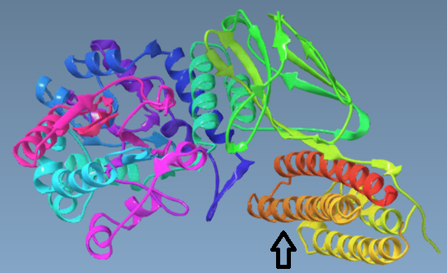
Figure 2. Exon 4 of ApoE ε4 docked to Trem2 intracellular domain. Arrow points to ApoE ε4.

A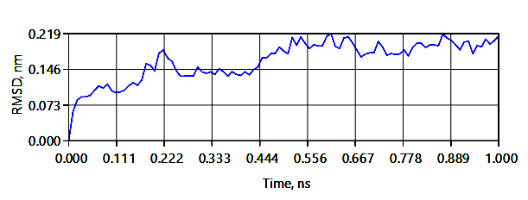
B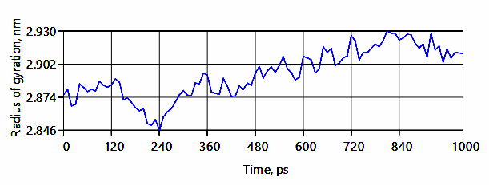

Figure 3. Molecular dynamic simulation results, ApoE ε4 docked to Trem2: A. The RMSD (Root mean square deviation) quickly rises to a maximum, B. the radius of gyration less so. The overall structure is not entirely stable or compact.

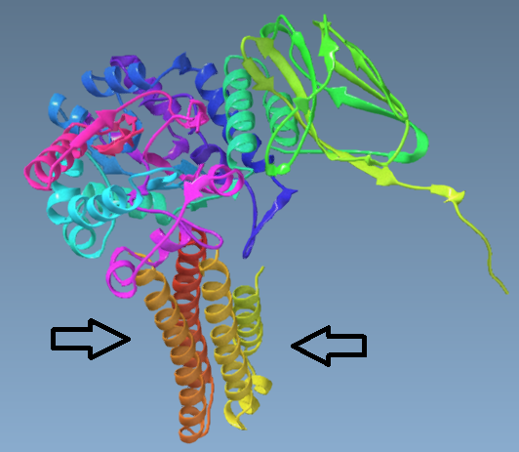
Figure 4. ApoE ε2 tyrosine 162, receptor binding domain, docked to extracellular domain of Trem2. Arrows point to ApoE ε2.

A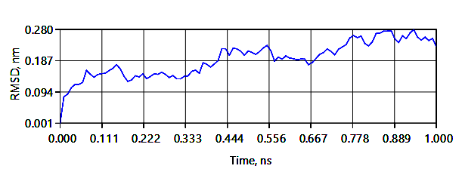
B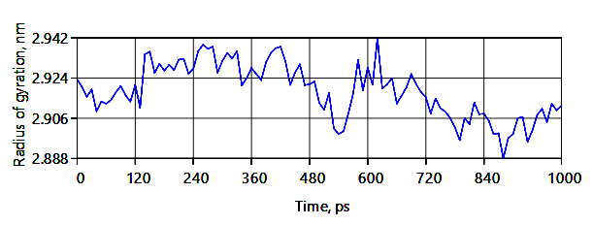

Figure 5. Molecular dynamic simulation results, ApoE ε2 docked to Trem2: A. The RMSD (Root mean square deviation) quickly rises to a maximum, B. the radius of gyration is highly, inconsistently variable. The overall structure is less stable and compact than ApoE ε4 docked to Trem2.

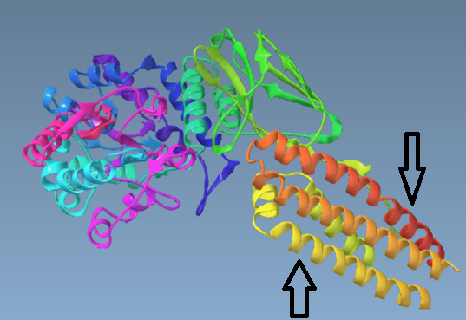
Figure 6. Helix 4 of ApoE ε3 docked to Trem2 intracellular domain. Arrows points to ApoE ε3, down arrow to helix 4.

A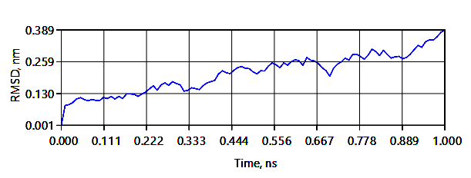
B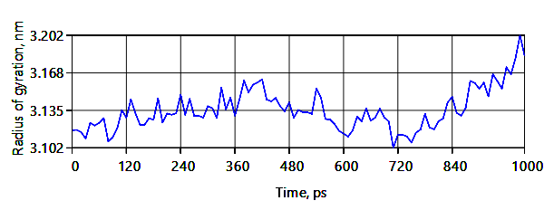

Figure 7. Molecular dynamic simulation results, ApoE ε3 docked to Trem2: A. The RMSD (Root mean square deviation) does not rise to a stable maximum, B. nor does the radius of gyration. The overall structure is less stable and compact than ApoE ε4 docked to Trem2 or ApoE ε2 docked to Trem2.

References
[1] Hansen DV, Hanson JE, Sheng M (2018) Microglia in Alzheimer's disease. J Cell Biol 217, 459-472.
[2] Shi Q, Chang C, Saliba A, Bhat MA (2022) Microglial mTOR activation upregulates Trem2 and enhances β-amyloid plaque clearance in the 5XFAD Alzheimer's disease model. Journal of Neuroscience 42, 5294-5313.
[3] Ellwanger DC, Wang S, Brioschi S, Shao Z, Green L, Case R, Yoo D, Weishuhn D, Rathanaswami P, Bradley J (2021) Prior activation state shapes the microglia response to antihuman TREM2 in a mouse model of Alzheimer’s disease. Proceedings of the National Academy of Sciences 118, e2017742118.
[4] Griciuc A, Patel S, Federico AN, Choi SH, Innes BJ, Oram MK, Cereghetti G, McGinty D, Anselmo A, Sadreyev RI (2019) TREM2 acts downstream of CD33 in modulating microglial pathology in Alzheimer’s disease. Neuron 103, 820-835. e827.
[5] Lee CD, Daggett A, Gu X, Jiang L-L, Langfelder P, Li X, Wang N, Zhao Y, Park CS, Cooper Y (2018) Elevated TREM2 gene dosage reprograms microglia responsivity and ameliorates pathological phenotypes in Alzheimer’s disease models. Neuron 97, 1032-1048. e1035.
[6] Price BR, Sudduth TL, Weekman EM, Johnson S, Hawthorne D, Woolums A, Wilcock DM (2020) Therapeutic Trem2 activation ameliorates amyloid-beta deposition and improves cognition in the 5XFAD model of amyloid deposition. Journal of Neuroinflammation 17, 1-13.
[7] Penney J, Ralvenius WT, Loon A, Cerit O, Dileep V, Milo B, Pao PC, Woolf H, Tsai LH (2024) iPSC‐derived microglia carrying the TREM2 R47H/+ mutation are proinflammatory and promote synapse loss. Glia 72, 452-469.
[8] Rayaprolu S, Mullen B, Baker M, Lynch T, Finger E, Seeley WW, Hatanpaa KJ, Lomen-Hoerth C, Kertesz A, Bigio EH (2013) TREM2 in neurodegeneration: evidence for association of the p. R47H variant with frontotemporal dementia and Parkinson’s disease. Molecular neurodegeneration 8, 1-5.
[9] Jendresen C, Årskog V, Daws MR, Nilsson LNG (2017) The Alzheimer’s disease risk factors apolipoprotein E and TREM2 are linked in a receptor signaling pathway. Journal of Neuroinflammation 14, 59.
[10] Mai Z, Wei W, Yu H, Chen Y, Wang Y, Ding Y (2022) Molecular recognition of the interaction between ApoE and the TREM2 protein. Transl Neurosci 13, 93-103.
[11] Kozakov D, Hall DR, Xia B, Porter KA, Padhorny D, Yueh C, Beglov D, Vajda S (2017) The ClusPro web server for protein–protein docking. Nature protocols 12, 255-278.
[12] Wolfe CM, Fitz NF, Nam KN, Lefterov I, Koldamova R (2018) The role of APOE and TREM2 in Alzheimer′ s disease—current understanding and perspectives. International journal of molecular sciences 20, 81.
[13] Saeidnia S, Manayi A, Abdollahi M (2015) From in vitro experiments to in vivo and clinical studies; pros and cons. Current drug discovery technologies 12, 218-224.
[14] Jendresen C, Årskog V, Daws MR, Nilsson LN (2017) The Alzheimer’s disease risk factors apolipoprotein E and TREM2 are linked in a receptor signaling pathway. Journal of neuroinflammation 14, 1-13.
[15] Shi Y, Holtzman DM (2018) Interplay between innate immunity and Alzheimer disease: APOE and TREM2 in the spotlight. Nature Reviews Immunology 18, 759-772.

