Supplementary Materials

Musical stimuli
Study 1

Take me Out to the Ballgame

Guggisberglied

Study 2
Take me Out to the Ballgame

In the Good Old Summertime

Table S1
Study 1, phase 1. Demographics and frequency of songs individuals reported thinking of when they reflected on their last time in a stadium seeing a live baseball game
 | Female  (N=72) | Male  (N=197) | Overall  (N=270)
Age (years)
Mean (SD) | 46.7 (15.5) | 41.4 (12.9) | 42.8 (13.8)
Median [Min, Max] | 42.0 [22.0, 76.0] | 38.0 [19.0, 84.0] | 38.0 [19.0, 84.0]
Missing | 1 (1.4%) | 3 (1.5%) | 5 (1.9%)
Ethnicity
Asian | 5 (6.9%) | 10 (5.1%) | 15 (5.6%)
Black | 2 (2.8%) | 6 (3.0%) | 8 (3.0%)
Mixed | 3 (4.2%) | 5 (2.5%) | 8 (3.0%)
Other | 1 (1.4%) | 4 (2.0%) | 5 (1.9%)
White | 61 (84.7%) | 171 (86.8%) | 232 (85.9%)
Missing | 0 (0%) | 1 (0.5%) | 2 (0.7%)
Self-rated fan intensity (0 (not at all) to 10 (extremely) scale)
Mean (SD) | 7.72 (2.15) | 7.41 (2.48) | 7.46 (2.44)
Median [Min, Max] | 8.00 [2.00, 10.0] | 8.00 [0, 10.0] | 8.00 [0, 10.0]
Missing | 1 (1.4%) | 2 (1.0%) | 3 (1.1%)
Song
Calling All Angels | 1 (1.4%) | 3 (1.5%) | 4 (1.5%)
Centerfield | 1 (1.4%) | 1 (0.5%) | 2 (0.7%)
God Bless America | 1 (1.4%) | 1 (0.5%) | 2 (0.7%)
Meet the Mets | 1 (1.4%) | 2 (1.0%) | 3 (1.1%)
National Anthem | 2 (2.8%) | 3 (1.5%) | 5 (1.9%)
New York, New York | 3 (4.2%) | 1 (0.5%) | 4 (1.5%)
None | 9 (12.5%) | 46 (23.4%) | 56 (20.7%)
Other | 12 (16.7%) | 34 (17.3%) | 46 (17.0%)
Sweet Caroline | 5 (6.9%) | 10 (5.1%) | 15 (5.6%)
Take Me Out to the Ball Game | 34 (47.2%) | 75 (38.1%) | 109 (40.4%)
Tomahawk Chop | 1 (1.4%) | 2 (1.0%) | 3 (1.1%)
We Are the Champions | 1 (1.4%) | 1 (0.5%) | 2 (0.7%)
We Will Rock You | 1 (1.4%) | 1 (0.5%) | 2 (0.7%)
Go Cubs Go | 0 (0%) | 6 (3.0%) | 6 (2.2%)
I Love LA | 0 (0%) | 3 (1.5%) | 3 (1.1%)
Roll Out the Barrel | 0 (0%) | 3 (1.5%) | 3 (1.1%)
Welcome to the Jungle | 0 (0%) | 2 (1.0%) | 2 (0.7%)
Missing | 0 (0%) | 3 (1.5%) | 3 (1.1%)

Table S2
Study 1. Descriptive statistics of thoughts and feelings of rejection in the Social Media Ostracism Paradigm (SOMP)
 | Communal  (N=51) | Control  (N=55) | F test
Thoughts of exclusion
Mean (SD) | 3.43 (1.15) | 3.32 (1.10) | F = 0.285
Median [Min, Max] | 3.67 [1.33, 5.00] | 3.33 [1.00, 5.00] | p = 0.595
Feelings of exclusion
Mean (SD) | 3.21 (0.984) | 3.06 (1.08) | F = 0.514
Median [Min, Max] | 3.40 [1.40, 5.00] | 2.80 [1.00, 5.00] | p = 0.475

Table S3
Study 1 follow-up demographics of non-baseball fans

 | Communal  (N=23) | Neutral  (N=21)
Age (years)
Mean (SD) | 20.5 (3.40) | 22.3 (6.61)
Median [Min, Max] | 19.0 [18.0, 34.0] | 21.0 [18.0, 47.0]
Gender
Mean (SD) | 1.78 (0.422) | 1.76 (0.539)
Median [Min, Max] | 2.00 [1.00, 2.00] | 2.00 [1.00, 3.00]
Latino/Hispanic
Mean (SD) | 1.87 (0.344) | 1.90 (0.301)
Median [Min, Max] | 2.00 [1.00, 2.00] | 2.00 [1.00, 2.00]
Ethnicity
White or Caucasian | 13 (56.5%) | 8 (38.1%)
Black or African American | 1 (4.3%) | 2 (9.5%)
Asian | 5 (21.7%) | 8 (38.1%)
Other | 2 (8.7%) | 1 (4.8%)
Mixed | 1 (4.3%) | 2 (9.6%)
Missing | 1 (4.3%) | 0 (0%)

Table S4
Study 2. Effects of time and condition on positive affect with covariates included in the model
Effects | Estimate | Standard Error | df | t-value | p-value
(Intercept) | 2.96 | 0.30 | 117.94 | 9.79 | <2e-16***
T2 relative to T1 | -0.18 | 0.08 | 228.00 | -2.17 | 0.03*
T3 relative to T1 | -0.32 | 0.08 | 228.00 | -0.38 | 0.70
Control relative to Communal | -0.16 | 0.17 | 156.40 | -0.94 | 0.35
Pain | -0.11 | 0.13 | 112.00 | -0.89 | 0.38
Age | 0.01 | 0.01 | 112.00 | 1.29 | 0.20
T2 relative to T1 for Control relative to Communal | -0.084 | 0.12 | 228.00 | -0.73 | 0.47
T3 relative to T1 for Control relative to Communal | -0.27 | 0.12 | 228.00 | -2.30 | 0.02*

Table S5
Study 2. Sense of belonging in response to the musical stimulus including covariates in the model
 | Estimate | Standard Error | t-value | p-value
Intercept | 3.24 | 0.44 | 7.30 | <0.001***
Condition | -0.61 | 0.23 | -2.69 | 0.008**
Age | 0.03 | 0.01 | 3.36 | 0.001**
Pain | -0.28 | 0.20 | -1.42 | 0.157

Figure S1
Study 1. Factor analysis of items composing Positive (happy, excited, connected, in tune) and Negative (sad, anxious, self-conscious) Affect assessment
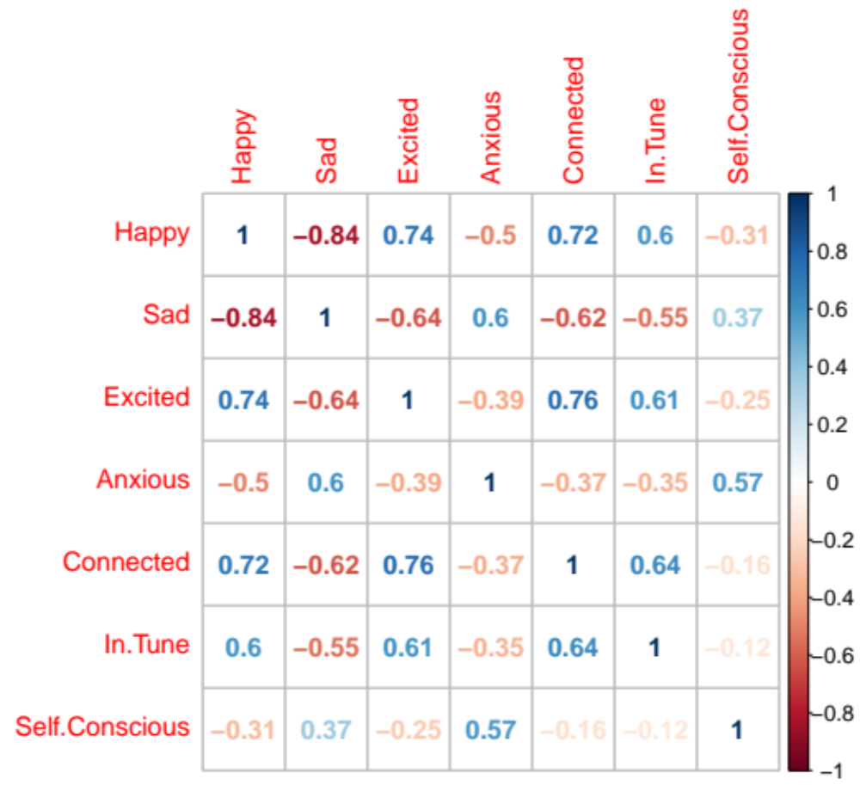

Figure S2
Study 1. Correlation between change score in positive affect and ratings of familiarity with the music presented
