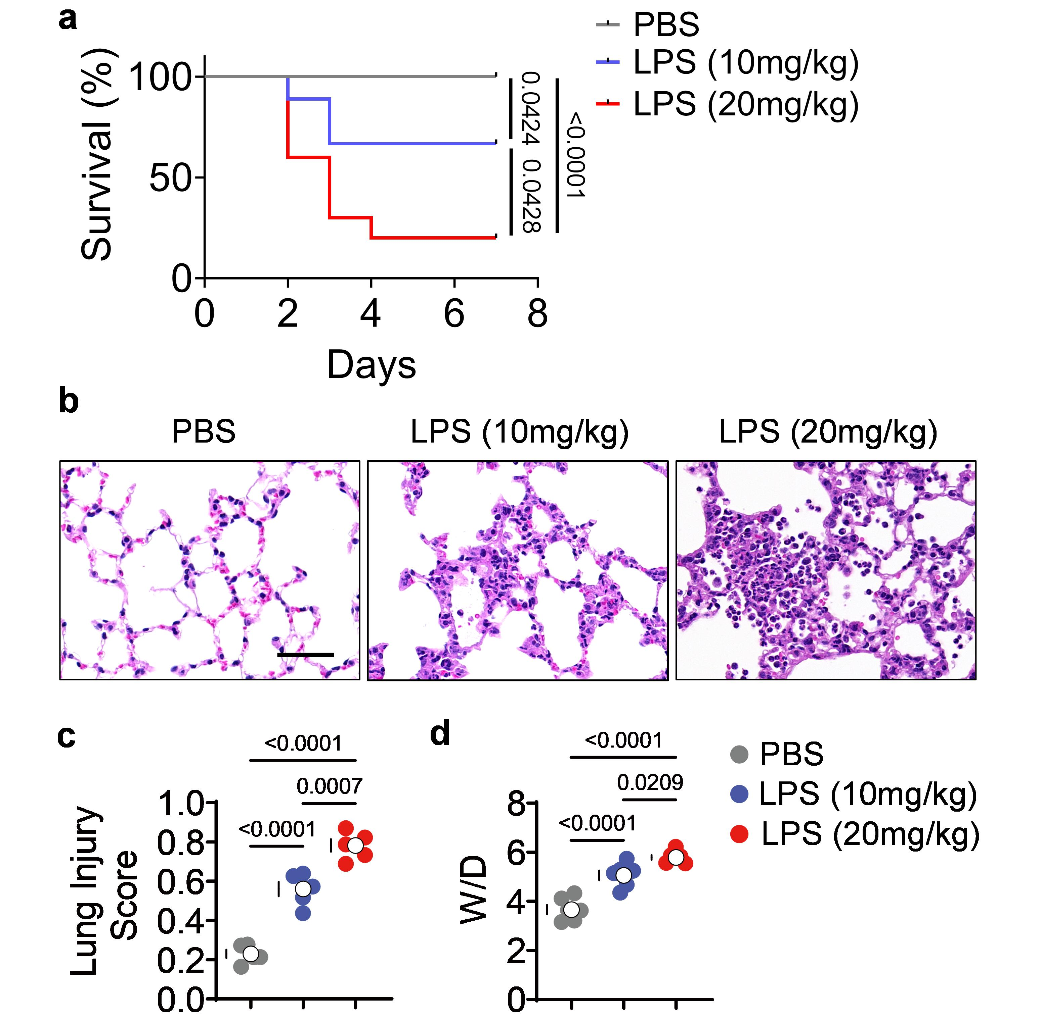
Supplemental Fig. 1 Induction of ALI by intranasal instillation of LPS. a Survival curve following intranasal instillation of LPS with 10mg/kg or 20mg/kg (n = 10 per group). b,c Representative H&E were shown (scale bar: 20 μm) and the lung injury score was determined by examining 15 sections/lung/mice (n = 5 per group). d The lung W/D ratio was assessed (n = 5 per group). Significance was determined by the 1-way ANOVA with Tukey’s post-hoc multiple comparisons test, and survival analysis was performed using the log-rank (Mantel-Cox) test. ALI: acute lung injury; LPS, lipopolysaccharide; H&E, Hematoxylin and eosin; W/D, wet-to-dry.
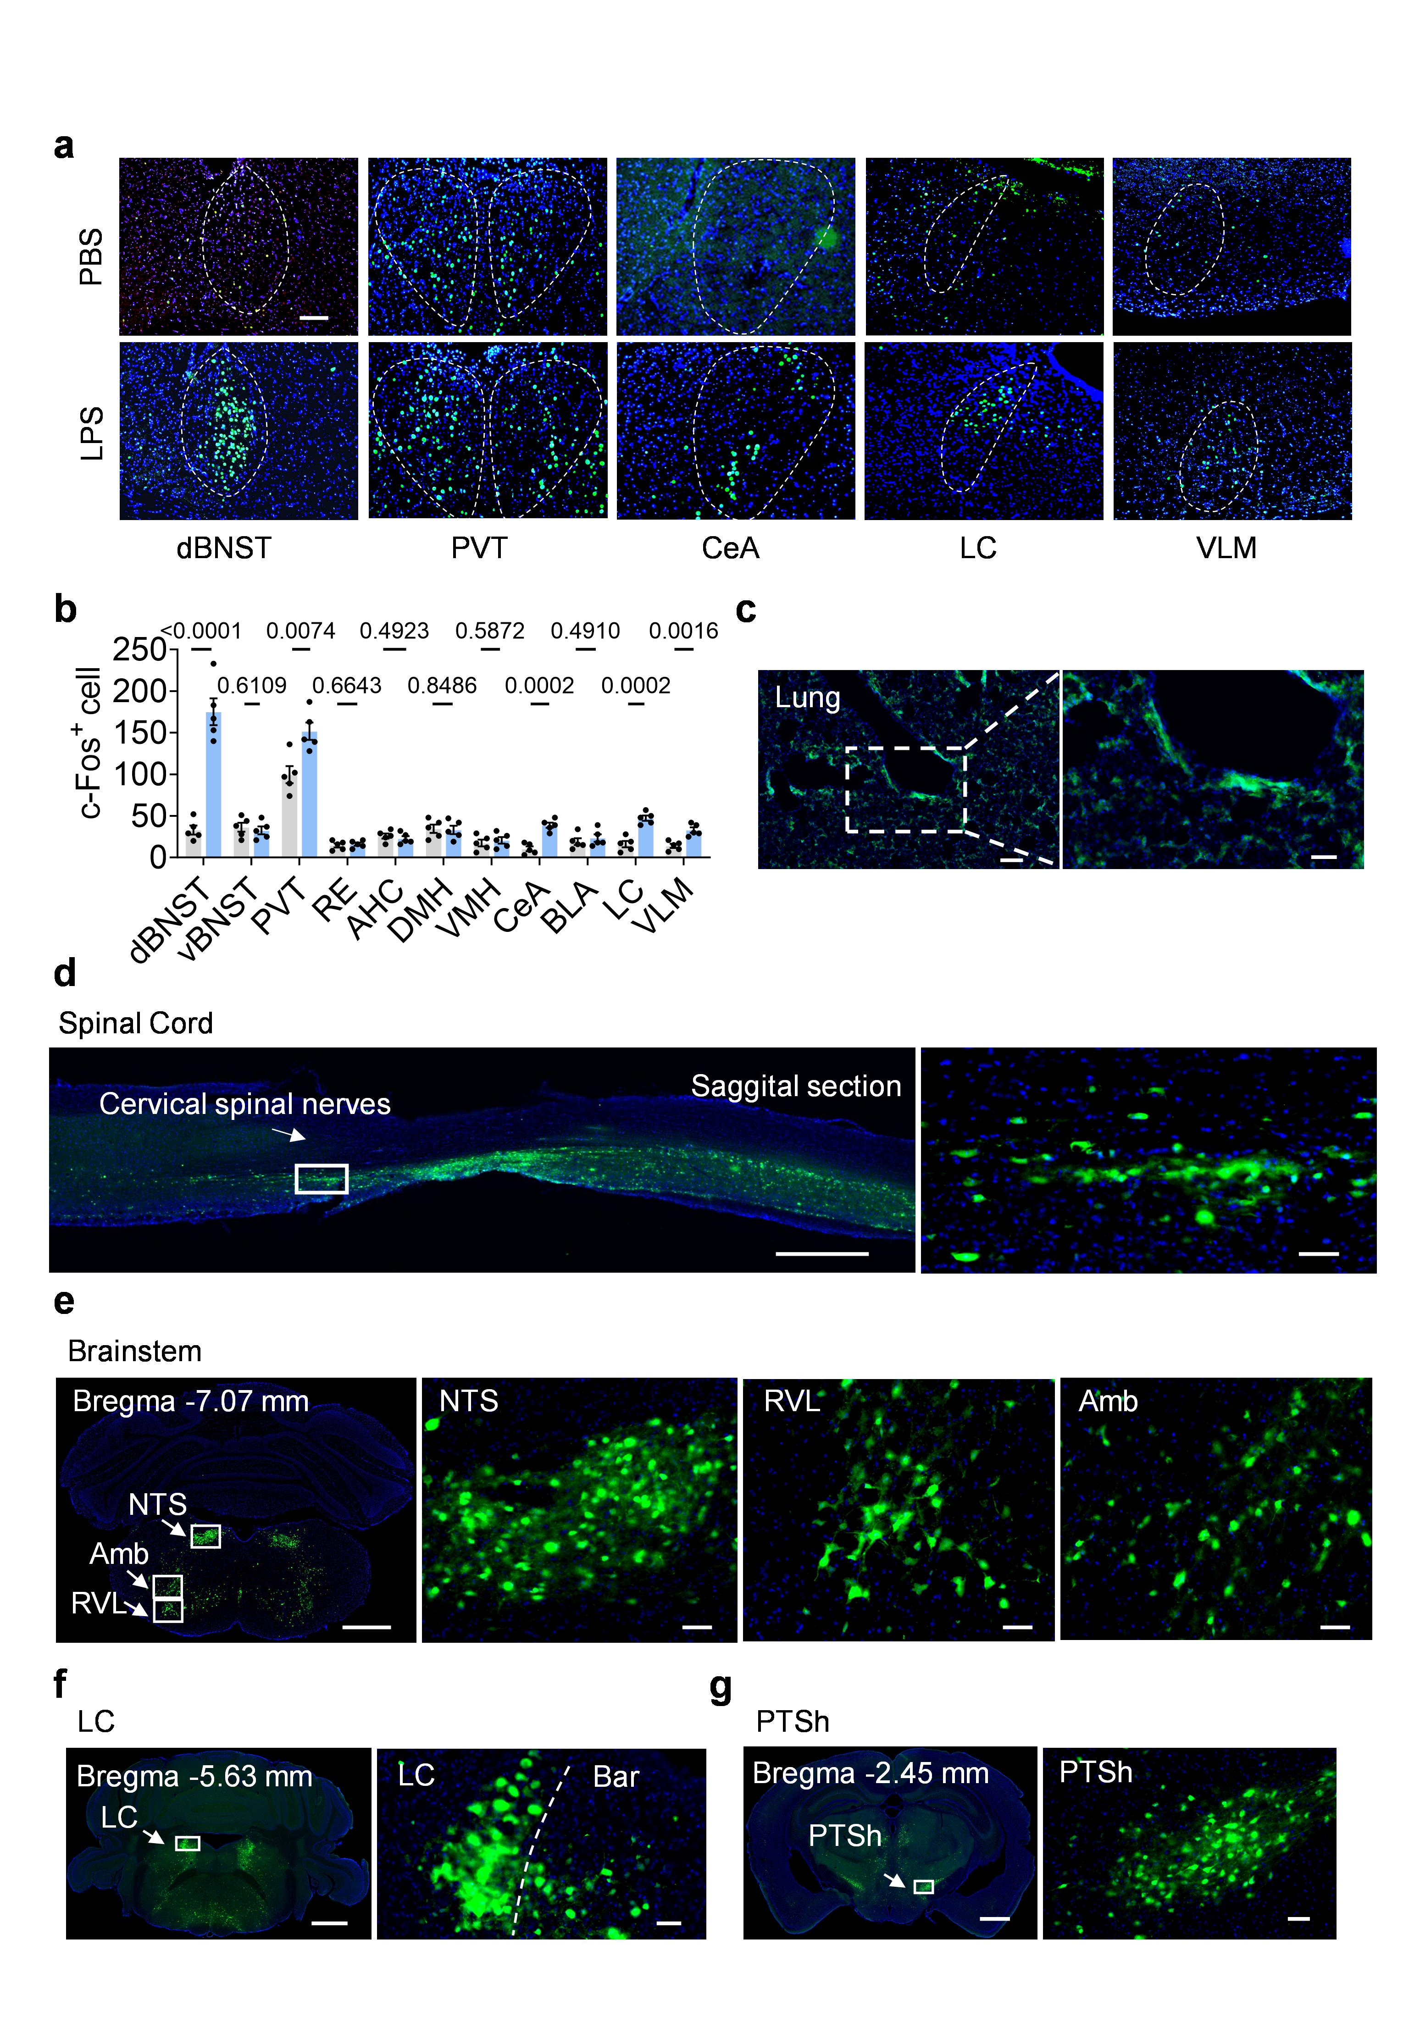
Supplemental Fig. 2 c-Fos expression in brain after ALI and retrograde PRV-531 tracing from the lung. a Representative images of c-Fos expression in brain areas displaying increases in c-Fos⁺ cells following PBS or LPS intranasal instillation, scale bar: 100 μm. b Quantification of c-Fos⁺ neurons in each of the presented brain regions (n = 5 per group). c Representative image of the lung tissue expressing PRV (green). Scale bar: 50 μm. d-g Selected regions in brain and spinal cord that were labeled by PRV. Scale bars: 1 mm (left), 50 μm (right). Significance was determined by the Student’s t-test. dBNST, dorsal bed nucleus of stria terminalis; vBNST, ventral bed nucleus of stria terminals; PVT, paraventricular nucleus of thalamus; CeA, central amygdaloid nucleus; LC, locus coeruleus; VLM, ventrolateral medulla; LPS, lipopolysaccharide; PRV, pseudo-rabies virus; NTS, nucleus tractus solitarius; RVL, rostroventrolateral reticular nucleus; Amb, ambiguus nucleus; Bar, Barrington’s nucleus; PTSh, lateral paragigantocellular nucleus.

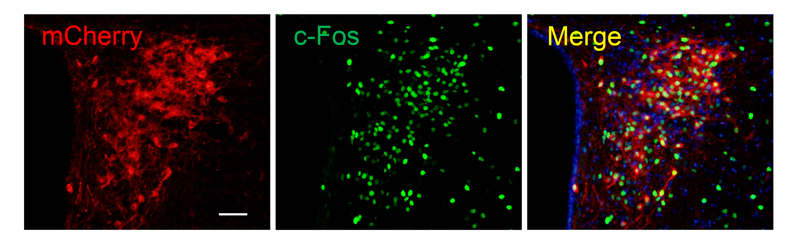Supplemental Fig. 3 CRH^{PVN} neurons expressing DREADD are activated after CNO injection. Representative images showing staining of c-Fos (green) and mCherry (red) in the PVN 90 min after intraperitoneal injection of CNO in mice injected with AAV expressing a Cre-dependent activating DREADD construct. Scale bar: 50 μm. CNO, clozapine-N-oxide; CRH, corticotropin-releasing hormone; PVN, paraventricular nucleus.

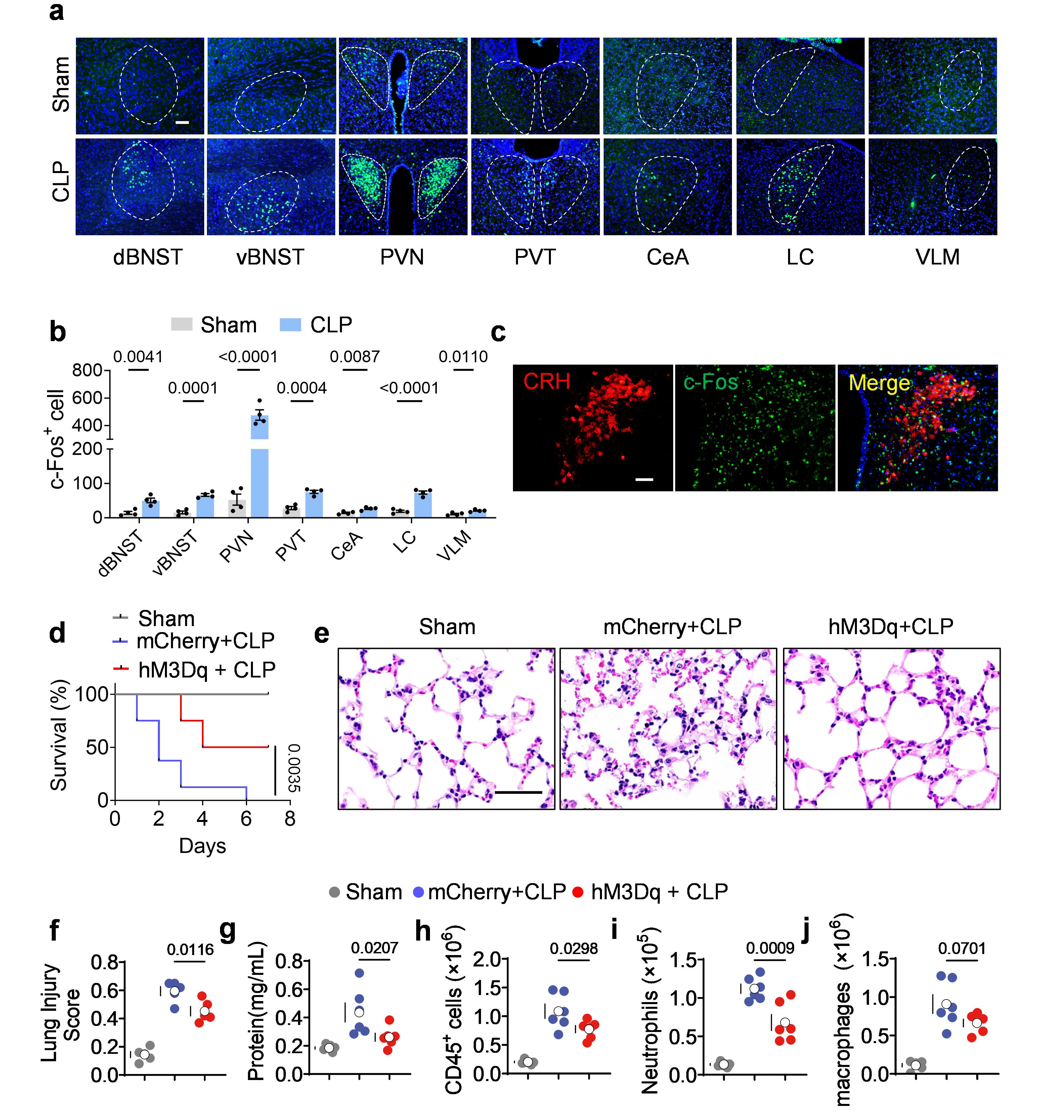
Supplemental Fig. 4 CRH^{PVN} neurons activation attenuates CLP-induced ALI and improves survival rate. a Representative images of c-Fos expression in brain areas displaying increases in several c-Fos⁺ cells for CLP vs. sham, scale bar = 100 μm. b Quantification of c-Fos⁺ neurons in each of the presented brain regions (n = 4 per group). c Representative images of c-Fos expression in the PVN after CLP at 3h, scale bar: 50μm. d Survival curve of control and hM3Dq (expressing excitatory DREADD) mice received CNO from day 1 to day 5 following CLP or Sham (n = 8 per group). e-f Lungs were removed at 24 h after CLP and stained with H&E. Representative H&E are shown (scale bar: 50 μm) and the lung injury score was determined by examining 15 sections/lung/mice (n = 5 per group). g BCA detected total protein in the BALF (n = 6 per group). h-j The number of CD45⁺ leukocytes (h), neutrophils (i) and macrophages (j) in BALF of CLP mice was counted by flow cytometry analysis (n = 6 per group). Significance was determined by the Student’s t-test and 1-way ANOVA with Tukey’s post-hoc multiple comparisons test, and survival analysis was performed using Log-rank (Mantel-Cox) test. CLP, cecal ligation and puncture; ALI, acute lung injury; CRH, corticotropin-releasing hormone; dBNST, dorsal bed nucleus of stria terminalis; vBNST, ventral bed nucleus of stria terminalis; PVN, hypothalamic paraventricular nucleus; PVT, paraventricular nucleus of thalamus; CeA, central amygdaloid nucleus; LC, locus coeruleus; VLM, ventrolateral medulla; H&E, Hematoxylin and eosin.

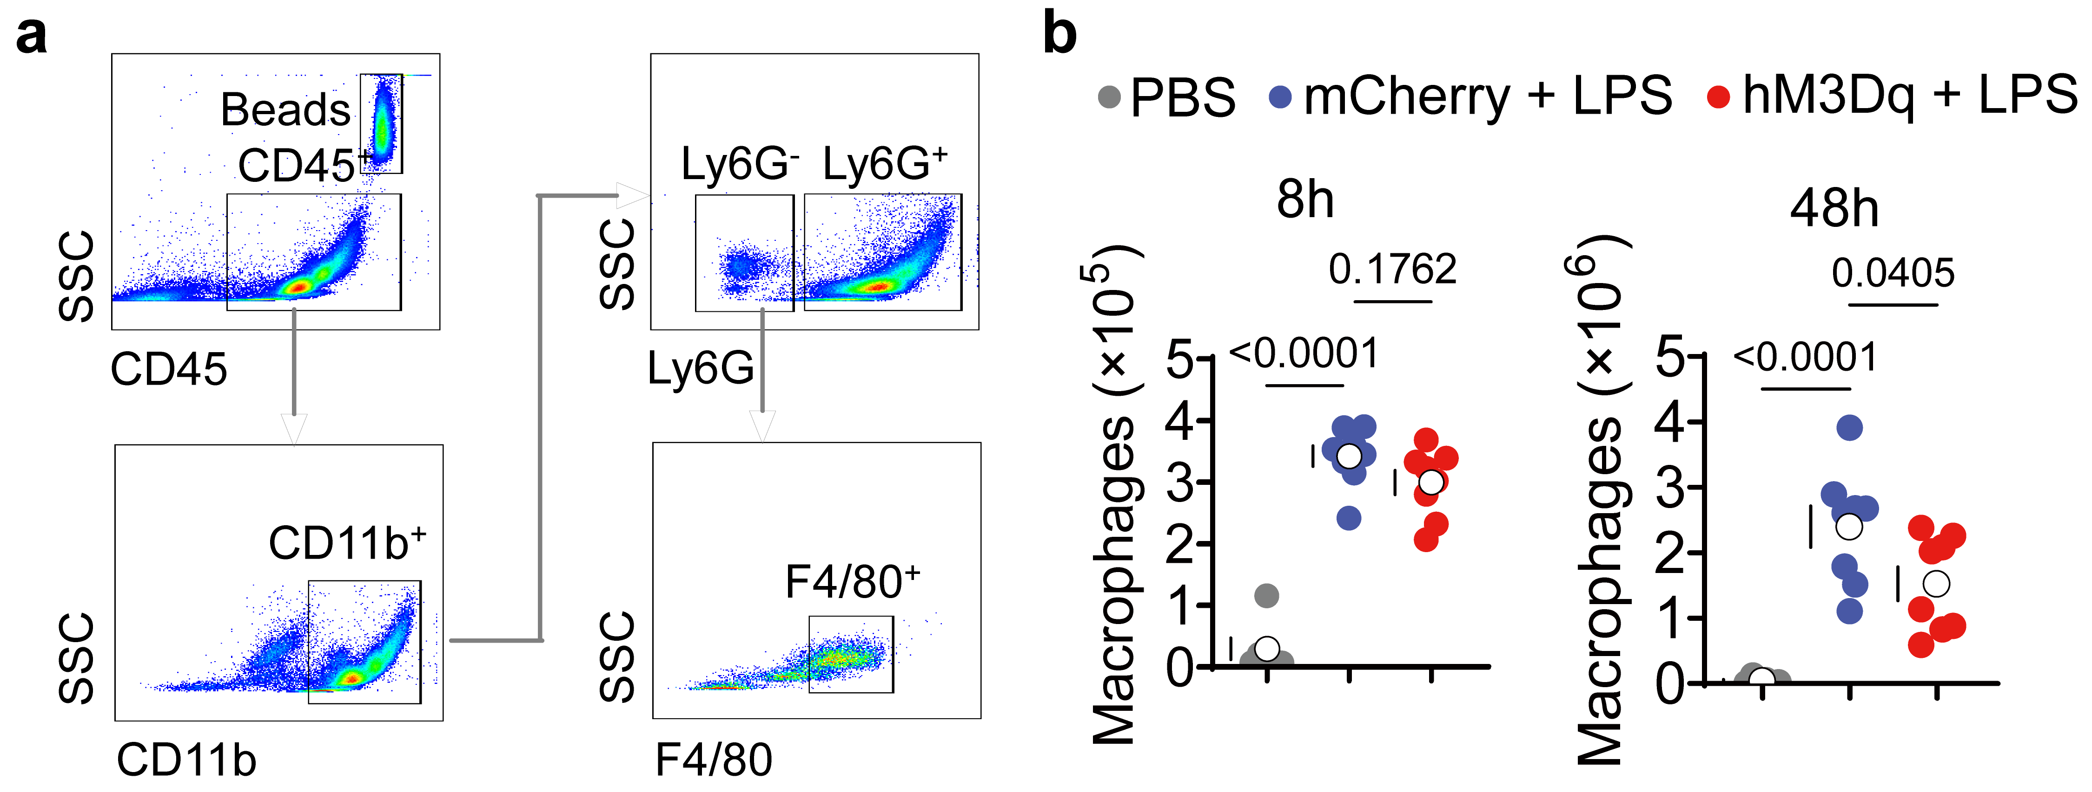
Supplemental Fig. 5 CRH^{PVN} neurons barely influence macrophage infiltration during ALI. a Gating strategy for neutrophils and macrophages counts in BALF. b The number of BALF macrophages in PBS-treated mice, LPS-treated control mice, and LPS-treated hM3Dq mice at 8 h and 4 8h (n = 8 per group). Significance was determined by 1-way ANOVA with Tukey’s post-hoc multiple comparisons test. ALI, acute lung injury; BALF, bronchoalveolar lavage fluid; LPS, lipopolysaccharide; CRH, corticotropin-releasing hormone; PVN, paraventricular nucleus.

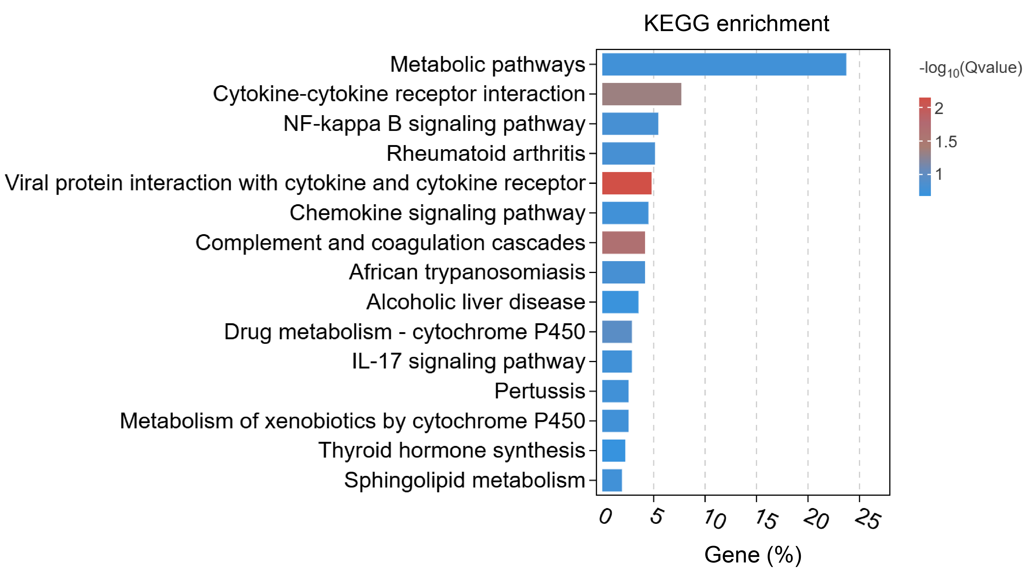
Supplemental Fig. 6 Lung RNA sequencing of control mice and hM3Dq mice treated with LPS. Bar graph of top 15 KEGG pathway enrichment analysis in lung RNA-seq between control mice and hM3Dq mice treated with LPS. LPS, lipopolysaccharide.

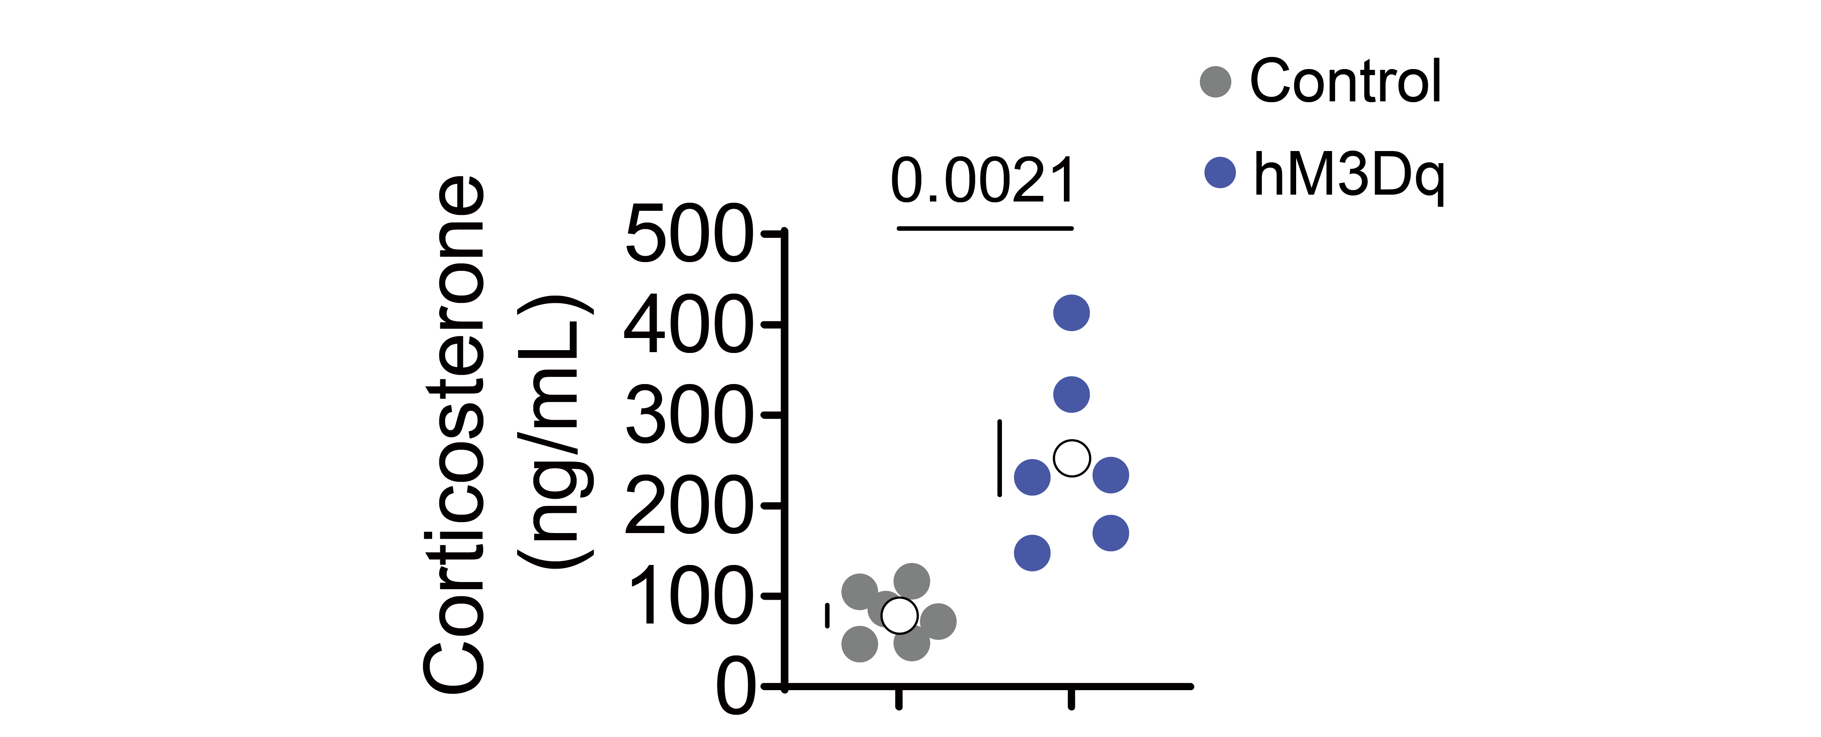
Supplemental Fig. 7 Plasma corticosterone levels after PVN^{CRH} neurons activation. Plasma corticosterone levels at 4h after intraperitoneal CNO injection (n = 6 per group) in hM3Dq mice. Significance was determined by the Student’s t-test. CNO, clozapine-N-oxide.

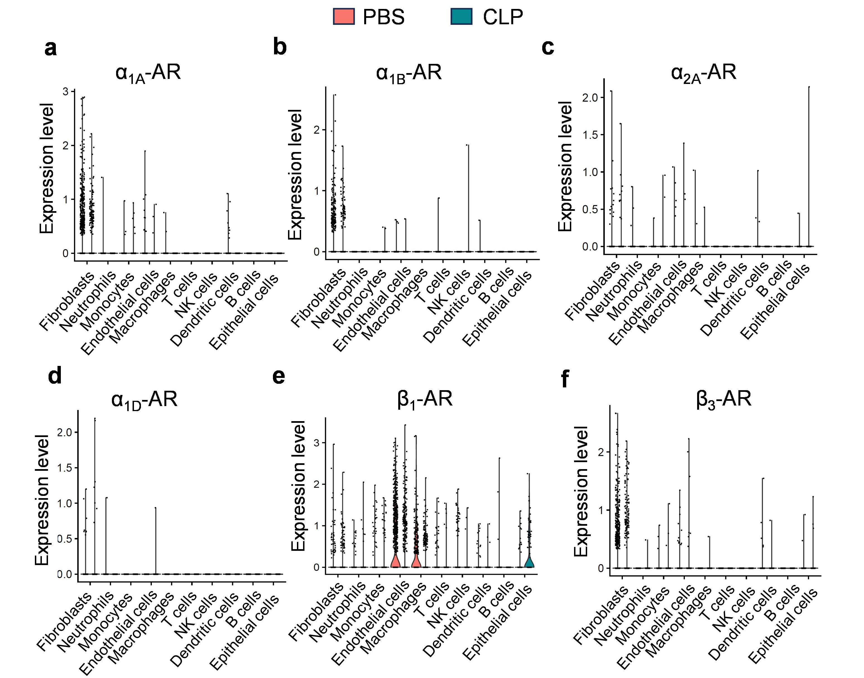
Supplemental Fig. 8 Public single-cell sequencing from the lung of CLP mice demonstrates the expression of adrenergic receptors in different types of cells. a-f Violin plot showing the expression of α_{1A}-AR (a), α_{1B}-AR (b), α_{2A}-AR (c), α_{1D}-AR (d), β₁-AR (e) and β₃-AR (f) in each cell type from public data (GSE207651). CLP, cecal ligation and puncture.
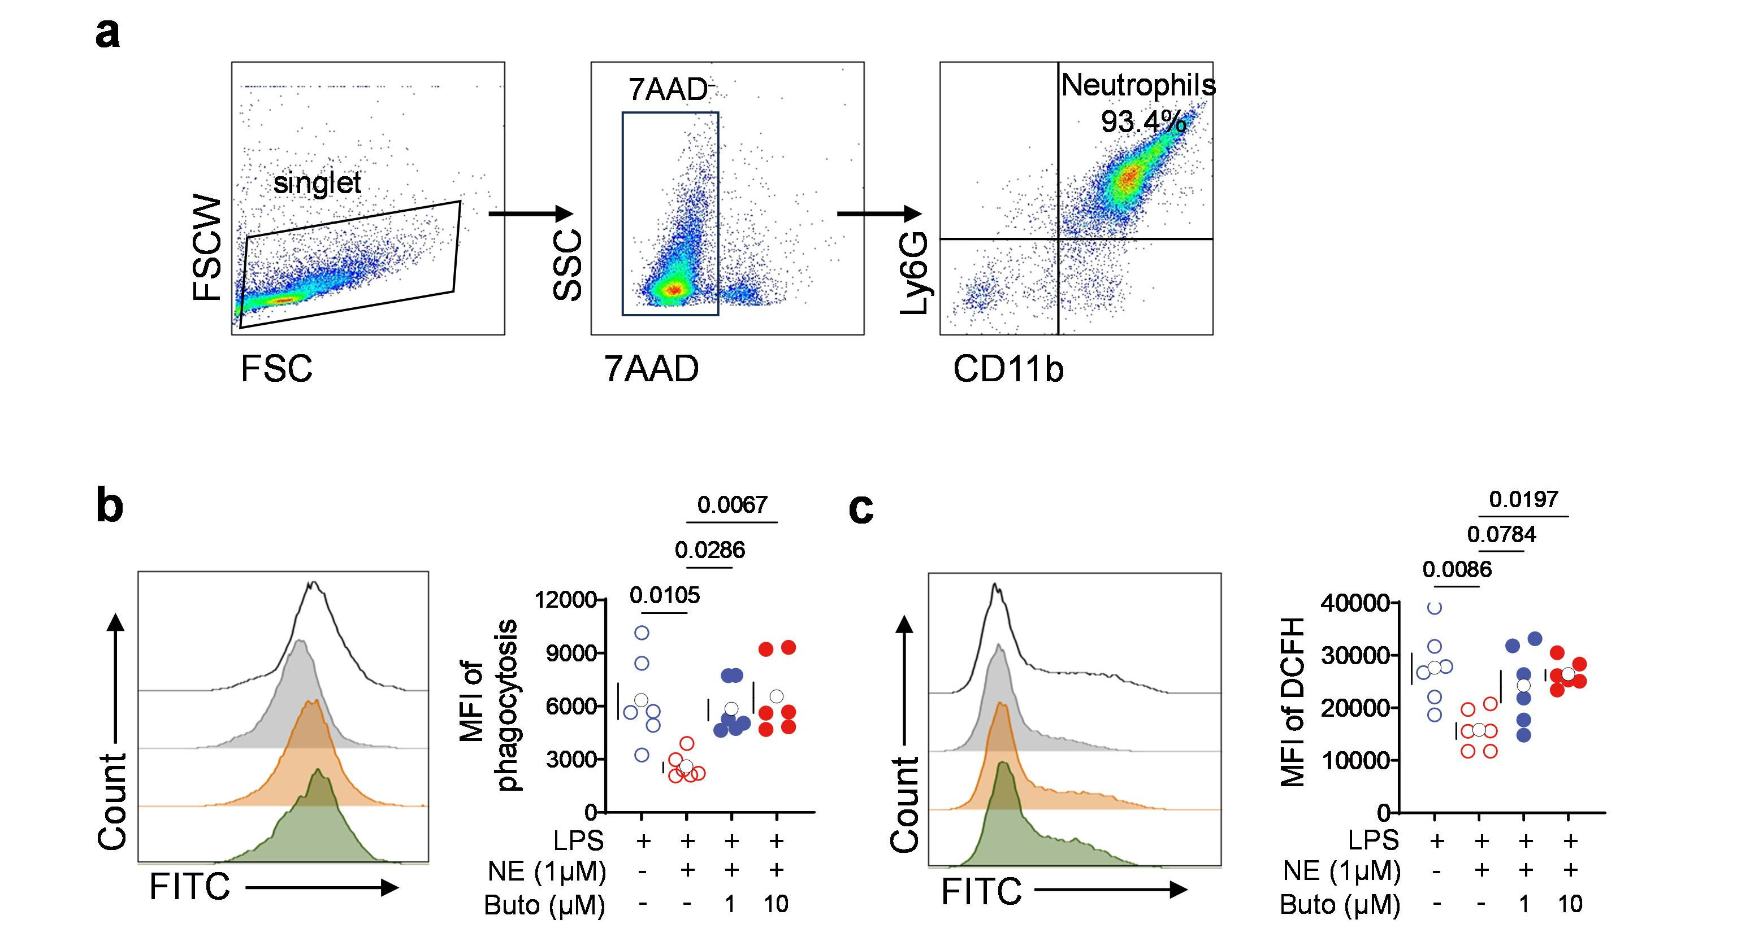Supplemental Fig. 9 The effect of NE on the functions of neutrophils through β₂-AR. a Flow cytometry analysis of the purity of neutrophils sorted from mice bone marrow. (b-c) BMNs were pretreated with NE (1 μmol/ml) and butoxamine (selective β₂-AR antagonist, 1 and 10 μmol/ml). The samples were analyzed for phagocytosis b and ROS generation c (n = 6 per group). Significance was determined by 1-way ANOVA followed by Tukey’s post-hoc multiple comparisons test. BMNs, bone marrow-derived neutrophils; NE, norepinephrine; β₂-AR, β₂-adrenoceptor receptor
Supplementary Table 1. Primer sequences used in quantitative PCR
Gene | Sence (5’-3’) | Antisense (5’-3’)
Il6 | CTGCAAGAGACTTCCATCCAG | AGTGGTATAGACAGGTCTGTTGG
Il1b | TGGATGCTCTCATCAGGACAG | GAAATGCCACCTTTTGACAGTG
Tnf | AGGCGGTGCCTATGTCTCAG | GCTCCTCCACTTGGTGGTTT
Gapdh | TGGTCCTCAGTGCCCAAG | CTGCCCAGAACATCATCCCT

Supplementary Table2. Key resources table
Reagent or resource | Source |  | Identifier
Antibodies
FcBlock (anti-CD16/32) | BD Biosciences |  | Cat# 553141
APC-Cy7 Anti-mice CD45  (clone 30-F11) | BD Biosciences |  | Cat# 557659
FITC Anti-mice CD11b  (clone M1/70) | BD Biosciences |  | Cat# 557396
PE-Cy7 Anti-mice Ly-6G  (clone 1A8) | BD Biosciences |  | Cat# 560601
BV421 Anti-mice F4/80  (clone T45-2342) | BD Biosciences |  | Cat# 565411
Rabbit anti-c-Fos | Abcam |  | Cat# ab190289
Rabbit anti-CRF | Abcam |  | Cat# ab272391
Mice anti-c-Fos | Abcam |  | Cat# ab302667
Rabbit anti-BETA2-AR | Abcam |  | Cat# ab182136
Rabbit anti-CitH3 | Abcam |  | Cat# ab5103
Rat anti-Ly6G | Biolegend |  | Cat# 127601
Mice anti-TH antibody | Santa Cruz |  | Cat# sc-7847
Rabbit anti-MPO | Abcam |  | Cat# ab208670
β-Arrestin2(C16D9)  Rabbit mAb | CST |  | Cat# 3857S
IκBα(44D4) Rabbit mAb | CST |  | Cat# 4812S
Phospho- IκBα(Ser32)  Rabbit mAb | CST |  | Cat# 2859S
NF-κB p65 Rabbit mAb | CST |  | Cat# 8242S
Phospho-NF-κB  p65(Ser536) Rabbit mAb | CST |  | Cat# 3033S
β-Actin(13E5) Rabbit mAb | CST |  | 4970S
Alexa488 Goat anti-Rabbit | Thermo Fisher |  | Cat# A-11008
Alexa594 Goat anti-Mice | Thermo Fisher |  | Cat# A-11005
Alexa594 Goat anti-Rat | Thermo Fisher |  | Cat# A-11007
Biotin Goat anti-Rat | Thermo Fisher |  | Cat# 31830
Biotin Goat anti-Rabbit | Thermo Fisher |  | Cat# 31822
Virus strains
AAV2/9-Ef1α-DIO-hM3Dq-mcherry | BrainVTA |  | Cat# PT-0042
AAV2/9-Ef1α-DIO-hM4Di- -mCherry | BrainVTA |  | Cat# PT-0043
AAV2/9-Ef1α-DIO-mCherry | BrainVTA |  | Cat# PT-0013
Chemicals, peptides, and recombinant proteins
E. coli LPS O55:B5 | Sigma-Aldrich |  | Cat# L2880
DAPI | SouthernBiotech |  | Cat# 0100-20
RBC lysis buffer | eBioscience |  | Cat# 00-4333-57
SYBR qPCR SuperMix | oncoprotein |  | Cat# E301
CNO | Sigma-Aldrich |  | Cat# C0832
TRlzol | Thermo Fisher |  | Cat# 15596026
BSA | Servicebio |  | Cat# GC305006-100 g
L-Ascorbic acid | Sigma-Aldrich |  | Cat# A4403
6-OHDA | Sigma-Aldrich |  | Cat# H4381
DCFH-DA | Thermo Fisher |  | Cat# 88-5930-74
Norepinephrine | Selleck |  | Cat# S9507
Butoxamine | Sigma-Aldrich |  | Cat# B1385
ICI-118551 | MCE |  | Cat#HY-13951
Salbutamol | Selleck |  | Cat# S5494
Critical commercial assays
Mice corticosterone | ARBOR ASSAYS |  | Cat# K014-H1
Mice norepinephrine | Abnova |  | Cat# KA1877
Mouse TNF-alpha  Quantikine ELISA Kit | R&D Systems |  | Cat# MTA00B
MojoSortTM Mice Neutrophil Isolation Kit | BioLegend |  | Cat# 480058
Phagocytosis Assay Kit | Cayman Chemical |  | Cat# 500290
RevertAid first-strand complementary DNA (cDNA) synthesis kits | TIANGEN |  | Cat# KR123
Experimental models: Organisms/strains
C57BL/6J mice | The Jackson Laboratory |  | Cat# JAX: 000664
CRH-IRES-Cre | The Jackson Laboratory |  | Cat# JAX: 12704
Software and algorithms
FlowJo software | BD BioSciences |  | https://www.flowjo.com/
GraphPad Prism | Dotmatics |  | https://www.graphpad.com/
Other
Precision Count Beads™ | BioLegend |  | Cat# 424902

