Key for Figure S1: Best standards (P12, ONS incidence or ONS prevalence) on right vertical axis, alternative dataset on left vertical basis. Designated best standards are shown in columns, complementary SS are shown in rows. Pillar 1 & 2 time series is shown as pink lines, ONSCISE incidence as green, ONSCISE prevalence as blue.
Abbreviations used in this document:
111calls: phone calls to NHS111 advice service categorised as COVID-19 related
111web: visits to NHS111 website categorised as COVID-19 related
BA1 : Omicron variant in BA1 group
BA2 : Omicron variants in BA2 group
BestET : epidemic trackers (ET) judged to be ‘best’ (most timely or least biased)
C19PRinH or C19PrimaryRinH : counts of patients who were in hospital for primary reason being COVID-19 infection
CompSS: Complementary surveillance system
HospAdm: counts of persons in hospital who newly tested positive for COVID-19
EDSS : (accident and) Emergency department surveillance system
GPIH : General practice in-hours services, counts of patients consulting about COVID-19 infection (syndromically)
ONS : Office for National Statistics
ONSCISE: ONS coronavirus infection survey in England
ONSincid: ONS incidence
ONSprev: ONS prevalence
P12 : Pillar 1 and 2 framework counts of laboratory confirmed Covid-19 cases (“most timely” best epidemic tracker)
Zoe or ZoeApp: Zoe mobile phone application which was a wellbeing and health self-tracker adapted for tracking symptoms with and without COVID-19 infection

For Figures S1-S3: The variants which were concurrently dominated are shown by a horizontal line at bottom of each panel which is colour coded as follows:

 | Delta |  | BA1 |  | BA2

Figure S1. Time series overlain from 1 Sept 2021 to 19 June 2022 inclusive, page 1 of 3 in this figure

Page 1: ONSCISE prevalence and ONS incidence plotted together. Prevalence is blue line and right hand axis, ONS incidence is black line and plotted against values on left hand axis. Both time series are plotted against reporting date (horizontal axis).

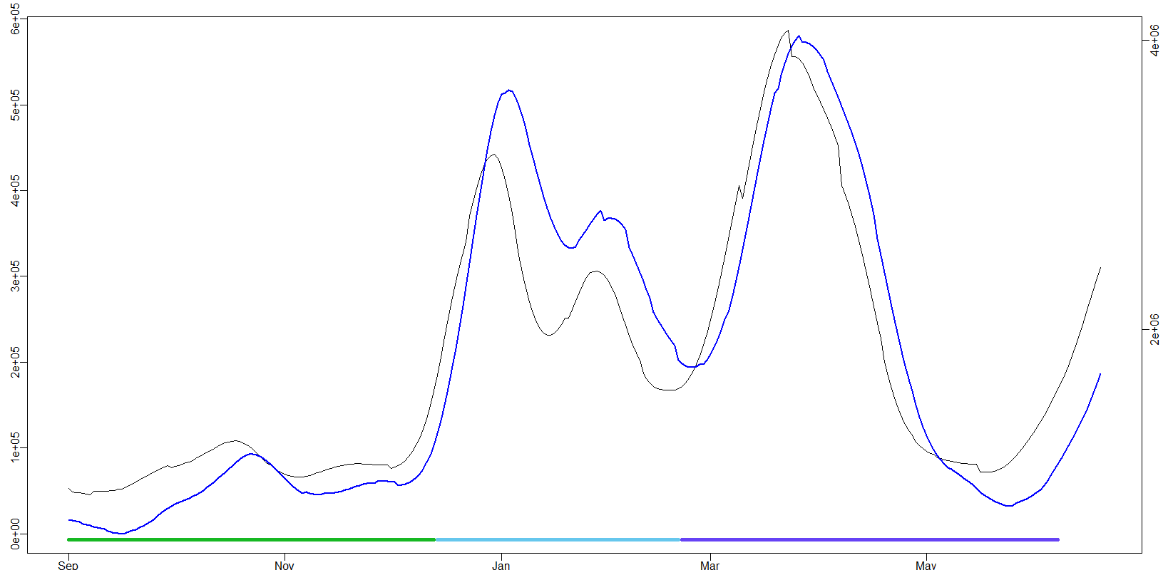

Figure S1. Time series overlain from 1 Sept 2021 to 19 June 2022 inclusive, page 2 of 3 in figure
Pillar 1 & 2, pink ONSCISE incidence, green ONSCISE prevalence, blue
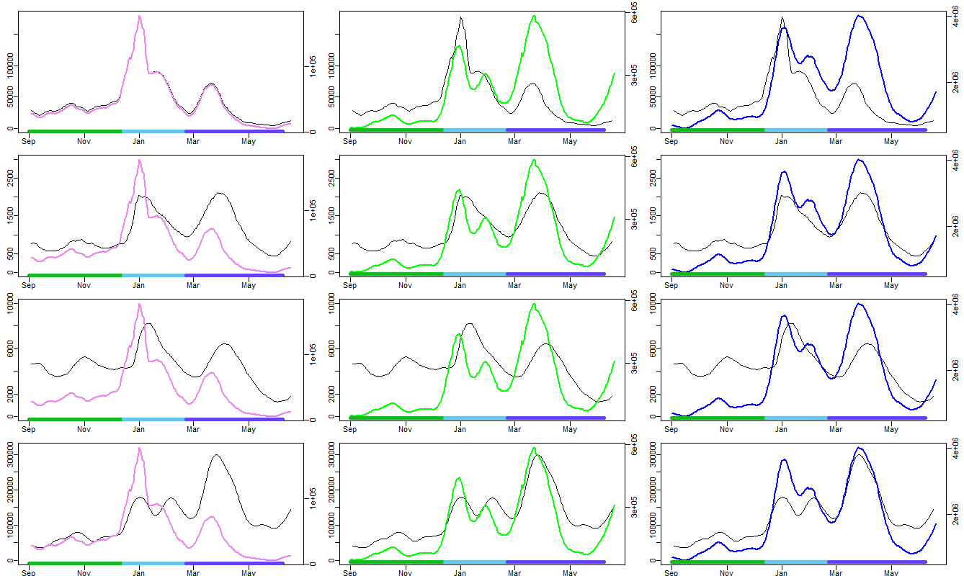

ZoeApp

C19 primary RinH

Pillar 1 & 2

Figure S1. Time series overlain from 1 Sept 2021 to 19 June 2022 inclusive, page 3 of 3 in figure
Pillar 1 & 2, pink ONSCISE incidence, green ONSCISE prevalence, blue

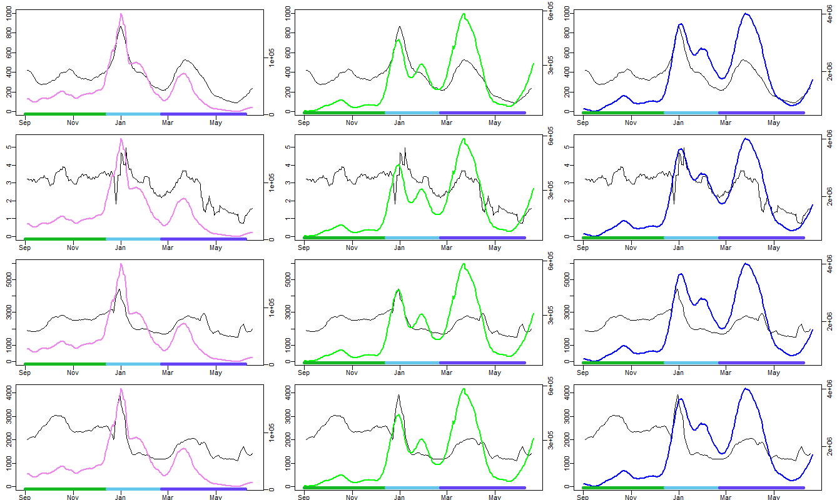

NHS 111 website

NHS 111 calls

GP in Hours

EDSS
Figure S2. Moving 31 day window correlation statistics for Incidence, selected CompSS against ONSincid.

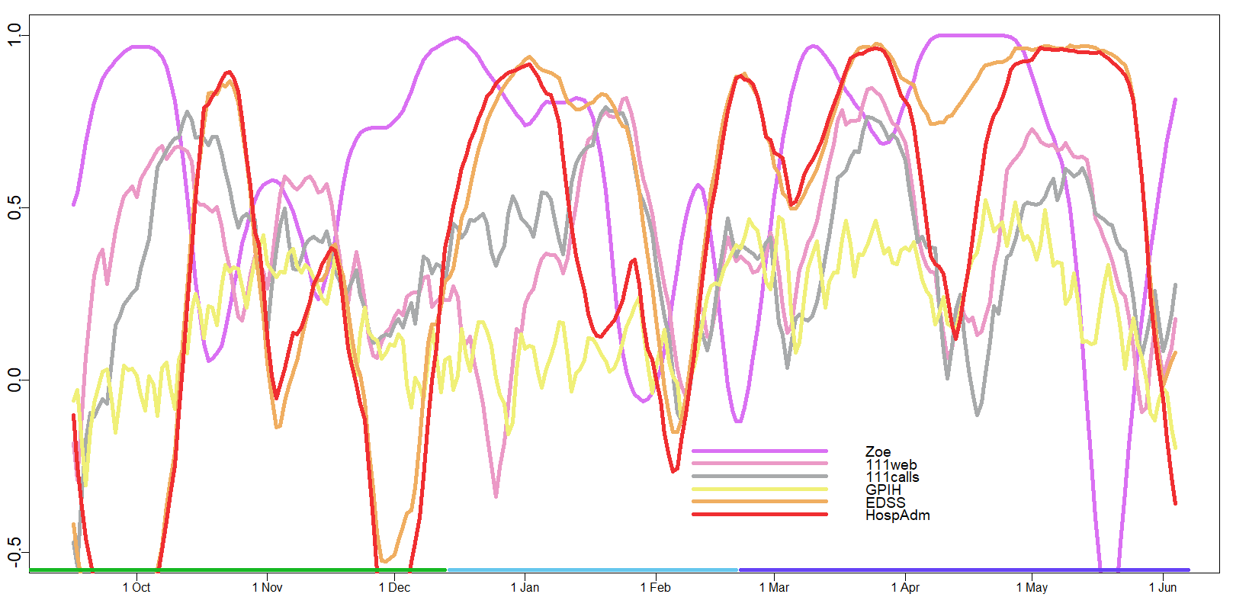
Note: Correlation value (lines) plotted is for day 16 in the moving 31 day long window. Dates are indicated by first date of each month in 2021-2022 period. Colour coding for dominant variant is horizontal line at bottom of figure, according to legend on page one of this appendix.
Figure S3. Moving 31 day window correlation statistics for prevalence, selected CompSS against ONSprev.
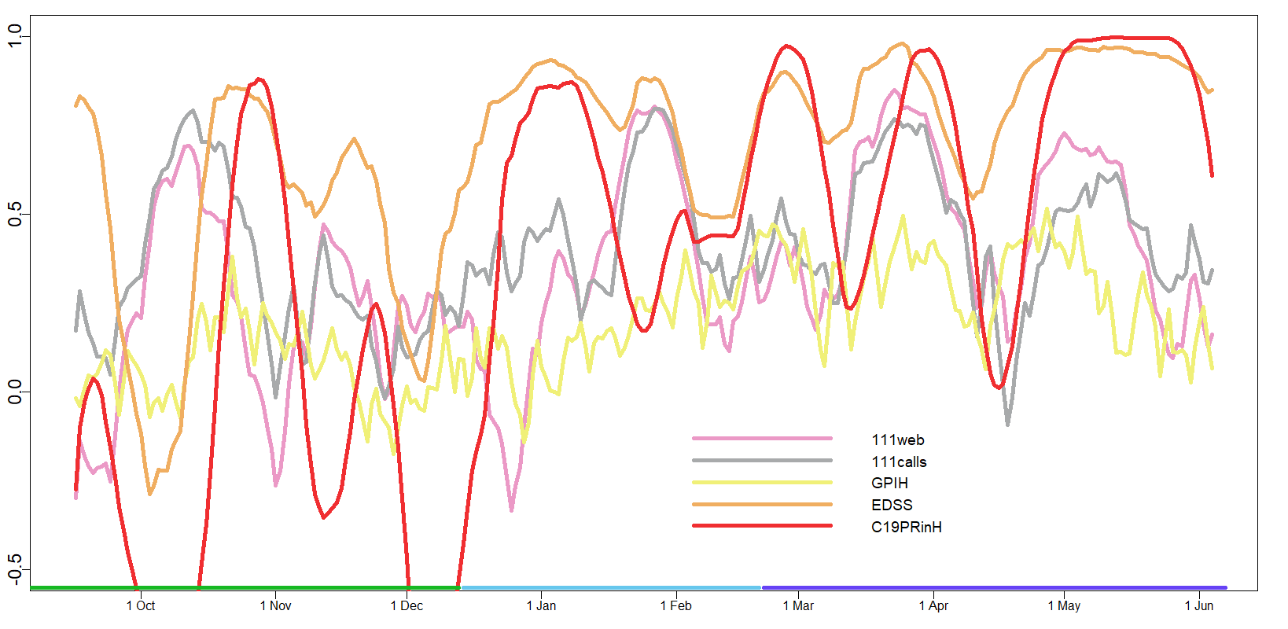

Note: Correlation value (lines) plotted is for day 16 in the moving 31 day long window. Dates are indicated by first date of each month in 2021-2022 period. Colour coding for dominant variant is is horizontal line at bottom of figure, according to legend on page one of this appendix.

