Deciphering Soil Microbial Dynamics in Pennsylvania Grasslands with Goldenrods (Solidago sp).

Lily A. Kelleher^{1,2}, Zachary Anderson², Jeffery A. Stratford³, Caroline S. Fortunato²

- Department of Biology, West Chester University, West Chester, PA, USA, 19383.
- Department of Biology, Widener University, Chester, PA, USA, 19013.
- Department of Biology and Earth Systems Science, Wilkes University, Wilkes-Barre, PA, 18766.
Corresponding author: Lily A. Kelleher (lk925530@wcupa.edu)
Supplementary Data:

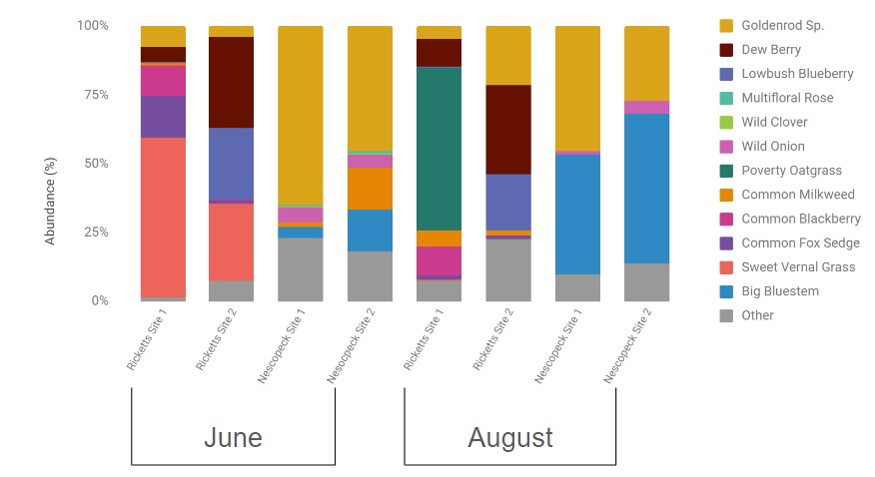
Supplementary Fig.1: Percent plant species composition across grasslands. Stacked bar chart representing the relative abundance of plant species at each sampling site.

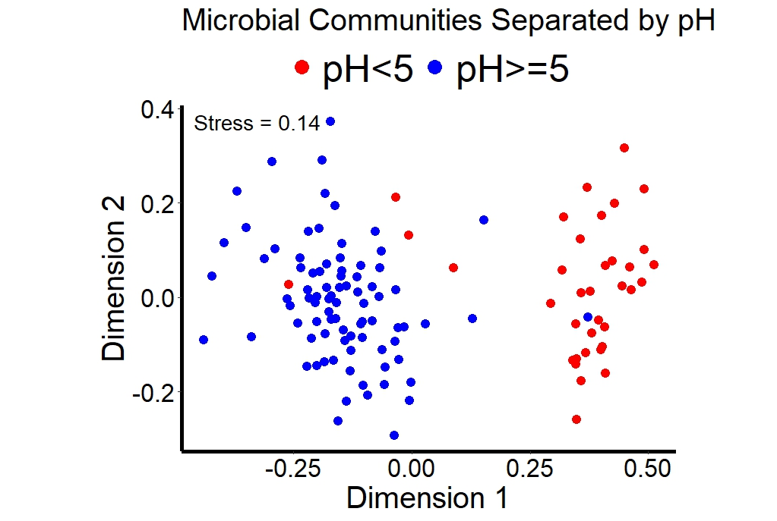
Supplementary Fig.2: Microbial communities separated by soil pH. This nMDS diagram shows all 120 soil samples. Each color presents a different pH range. There were 88 soil samples that had a pH of 5 or higher and 32 soil samples that had a pH below 5 (p=0.0265).

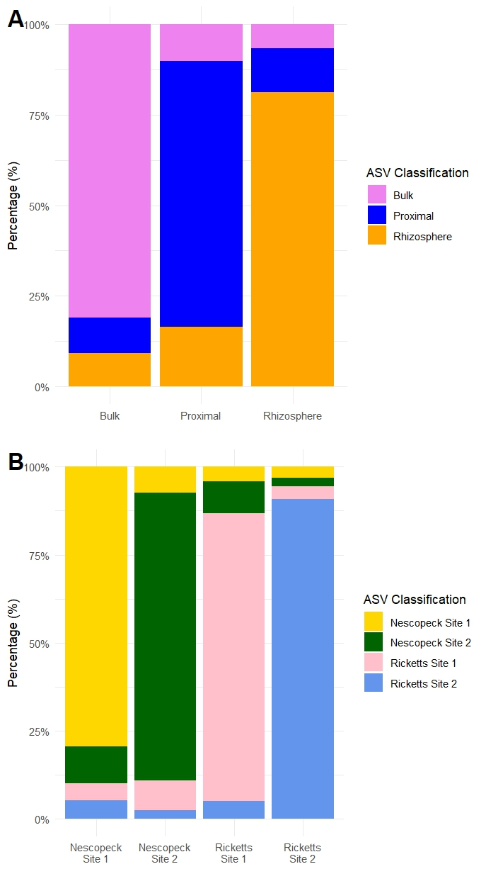
Supplementary Fig.3: Percentage of sequences in ASVs classified by soil type and grassland. A) ASVs classified by soil type of rhizosphere, proximal and bulk soil. B) ASVs classified by sampling sites of Nescopeck Site 1 and 2 and Ricketts Site 1 and 2.

Comparison | df | SumOfSqs | R2 | F | p-value
Soil Type Overall | 2 | 1.955 | 0.051 | 3.114 | 0.002
Bulk vs. Rhizosphere |  | 1.212 | 0.053 | 4.602 | 0.003
Proximal vs. Rhizosphere |  | 1.039 | 0.038 | 3.288 | 0.2174
Bulk vs. Proximal |  | 0.375 | 0.017 | 1.173 | 0.008
Soil Type pH Five and Above Overall | 2 | 1.055 | 0.067 | 2.114 | 0.001
Bulk vs. Rhizosphere |  | 1.054 | 0.534 | 3.654 | 0.003
Proximal vs. Rhizosphere |  | 1.039 | 0.079 | 2.287 | 1
Bulk vs. Proximal |  | 1.760 | 0.023 | 1.174 | 0.003
Soil Type pH Below Five Overall | 2 | 1.345 | 0.124 | 1.897 | 0.042
Bulk vs. Rhizosphere |  | 1.453 | 0.655 | 3.756 | 0.978
Proximal vs. Rhizosphere |  | 1.113 | 0.101 | 3.908 | 0.365
Bulk vs. Proximal |  | 1.895 | 0.124 | 2.009 | 0.071
Soil Type Ricketts Site 1 | 2 | 1.134 | 0.127 | 1.659 | 0.337
Bulk vs. Rhizosphere |  | 1.054 | 0.129 | 2.008 | 0.790
Proximal vs. Rhizosphere |  | 1.231 | 0.303 | 1.049 | 1
Bulk vs. Proximal |  | 1.668 | 0.175 | 1.349 | 0.326
Soil Type Ricketts Site 2 | 2 | 2.156 | 0.087 | 0.127 | 0.263
Bulk vs. Rhizosphere |  | 2.897 | 0.090 | 1.945 | 0.272
Proximal vs. Rhizosphere |  | 1.896 | 0.655 | 1.227 | 1
Bulk vs. Proximal |  | 2.113 | 0.122 | 1.808 | 0.683
Soil Type Nescopeck Site 1 | 2 | 1.945 | 0.145 | 1.767 | 0.098
Bulk vs. Rhizosphere |  | 1.975 | 0.132 | 2.007 | 0.286
Proximal vs. Rhizosphere |  | 1.046 | 0.769 | 1.977 | 1
Bulk vs. Proximal |  | 3.077 | 0.349 | 0.986 | 0.225
Soil Type Nescopeck Site 3 | 2 | 2.007 | 0.023 | 0.875 | 0.151
Bulk vs. Rhizosphere |  | 0.876 | 1.678 | 2.957 | 0.803
Proximal vs. Rhizosphere |  | 1.876 | 0.675 | 1.745 | 0.301
Bulk vs. Proximal |  | 0.335 | 0.007 | 0.546 | 0.904
Soil Type Ricketts Site 1 & 2 | 2 | 0.586 | 0.022 | 0.896 | 0.552
Ricketts bulk vs. rhizosphere |  | 0.341 | 0.018 | 1.054 | 0.935
Ricketts bulk vs proximal |  | 0.312 | 0.017 | 0.971 | 1
Ricketts proximal vs rhizosphere |  | 0.212 | 0.014 | 0.628 | 1
Soil Type Nescopeck Site 1 & 3 | 2 | 0.712 | 0.078 | 1.486 | 0.022
Nescopeck bulk vs. rhizosphere |  | 0.283 | 0.043 | 1.122 | 0.804
Nescopeck bulk vs proximal |  | 0.402 | 0.064 | 1.706 | 0.091
Nescopeck proximal vs rhizosphere |  | 0.388 | 0.078 | 1.703 | 0.099
June vs. August | 1 | 0.883 | 0.023 | 2.756 | 0.003
2021 vs. 2022 | 1 | 0.484 | 0.013 | 1.497 | 0.083
pH Overall  High pH (Above 5) vs. Low pH (Below 5) | 1 | 1.109 | 0.054 | 1.846 | 0.027
Site Overall | 3 | 1.485 | 0.038 | 1.544 | 0.018
Ricketts Site 1 vs. Ricketts Site 2 |  | 0.638 | 0.024 | 1.968 | 0.091
Ricketts Site 1 vs. Nescopeck Site 2 |  | 0.422 | 0.020 | 1.344 | 0.783
Ricketts Site 1 vs. Nescopeck Site 1 |  | 0.520 | 0.025 | 1.635 | 0.315
Ricketts Site 2 vs. Nescopeck Site 2 |  | 0.463 | 0.026 | 1.432 | 0.659
Ricketts Site 2 vs. Nescopeck Site 1 |  | 0.454 | 0.026 | 1.380 | 0.692
Nescopeck Site 2 vs. Nescopeck Site 1 |  | 0.374 | 0.032 | 1.197 | 1
Site Overall Bulk Soil Only | 3 | 5.103 | 0.365 | 2.951 | 0.004
Ricketts Site 1 Bulk vs. Ricketts Site 2 Bulk |  | 1.372 | 0.332 | 6.460 | 0.006
Ricketts Site 1 Bulk vs. Nescopeck Site 2 Bulk |  | 0.442 | 0.154 | 1.999 | 0.006
Ricketts Site 1 Bulk vs. Nescopeck Site 1 Bulk |  | 0.401 | 0.139 | 1.769 | 0.006
Ricketts Site 2 Bulk vs. Nescopeck Site 2Bulk |  | 0.613 | 0.378 | 2.427 | 0.001
Ricketts Site 2 Bulk vs. Nescopeck Site 1 Bulk |  | 0.639 | 0.407 | 2.748 | 0.006
Nescopeck Site 2 Bulk vs. Nescopeck Site 1 Bulk |  | 0.871 | 0.604 | 6.011 | 0.043
Site Overall Proximal Soil Only | 3 | 1.193 | 0.109 | 4.046 | 0.001
Ricketts Site 1 Proximal vs. Ricketts Site 2 Proximal |  | 1.370 | 0.148 | 4.684 | 0.001
Ricketts Site 1 Proximal vs. Nescopeck Site 2 Proximal |  | 0.822 | 0.134 | 3.262 | 0.008
Ricketts Site 1 Proximal vs. Nescopeck Site 1 Proximal |  | 1.478 | 0.281 | 6.252 | 0.001
Ricketts Site 2 Proximal vs. Nescopeck Site 2 Proximal |  | 0.834 | 0.130 | 0.899 | 0.028
Ricketts Site 2 Proximal vs. Nescopeck Site 1 Proximal |  | 0.871 | 0.601 | 6.011 | 0.006
Nescopeck Site 2 Proximal vs. Nescopeck Site 1 Proximal |  | 0.842 | 0.618 | 6.463 | 0.293
Site Overall Rhizosphere Soil Only | 3 | 0.983 | 0.087 | 3.156 | 0.001
Ricketts Site 1 Rhizosphere vs. Ricketts Site 2 Rhizosphere |  | 2.473 | 0.259 | 9.783 | 0.006
Ricketts Site 1 Rhizosphere vs. Nescopeck Site 2 Rhizosphere |  | 0.503 | 0.085 | 1.932 | 0.008
Ricketts Site 1 Rhizosphere vs. Nescopeck Site 1 Rhizosphere |  | 1.512 | 0.294 | 6.235 | 0.002
Ricketts Site 2 Rhizosphere vs. Nescopeck Site 2 Rhizosphere |  | 0.114 | 0.312 | 0.907 | 0.006
Ricketts Site 2 Rhizosphere vs. Nescopeck Site 1 Rhizosphere |  | 0.125 | 0.243 | 0.641 | 0.003
Nescopeck Site 2 Rhizosphere vs. Nescopeck Site 1 Rhizosphere |  | 0.174 | 0.343 | 1.045 | 0.249
Supplementary Table 1: P-values from all permanova tests. Values highlighted in bold are significant values.
Comparison | p-value | df | chi-squared
Soil Type (Bulk, Proximal, Rhizosphere) | 0.4234 | 2 | 1.7189
Ricketts vs. Nescopeck | 0.07934 | 1 | 3.0784
June vs. August | 0.2253 | 1 | 1.47
Sampling Site | 0.1281 | 3 | 5.7763
2021 vs. 2022 | 0.1479 | 1 | 2.0938
pH | 0.2343 | 1 | 11.574
Supplementary Table 2: P-values for alpha diversity tests. Significance values for Shannon diversity were calculated using a Kruskal-Wallis test.
Comparison | p-value | df | chi-squared
Soil Type (Bulk, Proximal, Rhizosphere) | 0.5214 | 2 | 1.3024
Ricketts vs. Nescopeck | 0.1849 | 1 | 1.7577
June vs. August | 0.69 | 1 | 0.15912
Sampling Site | 0.2664 | 3 | 2.6455
2021 vs. 2022 | 0.4979 | 1 | 0.45947
pH | 0.3423 | 1 | 8.6735
Supplementary Table 2: P-values for alpha diversity tests. Significance values for species richness were calculated using a Kruskal-Wallis test.

